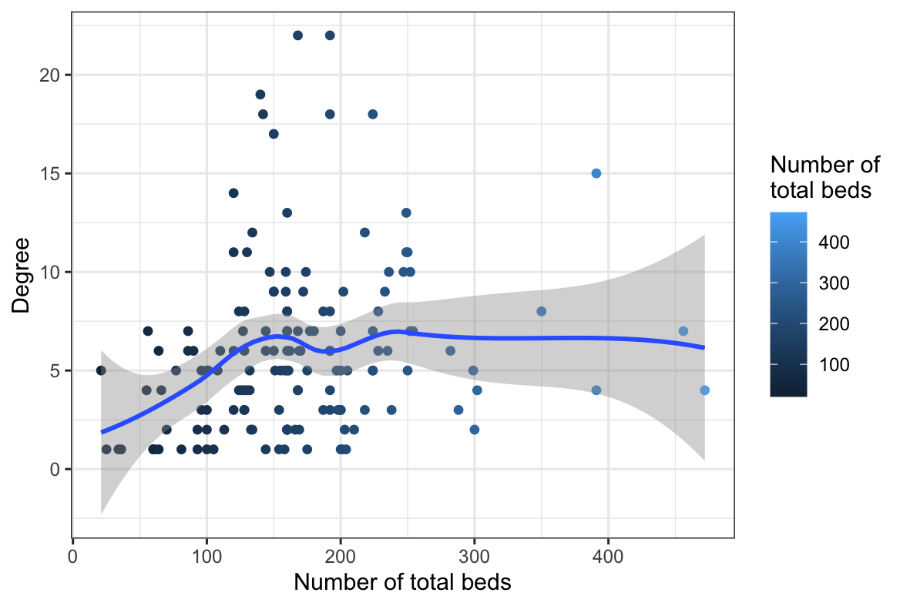
Figure S1. Degree of connectivity of long-term care homes in Greater Toronto Area, Ontario by number of total beds.

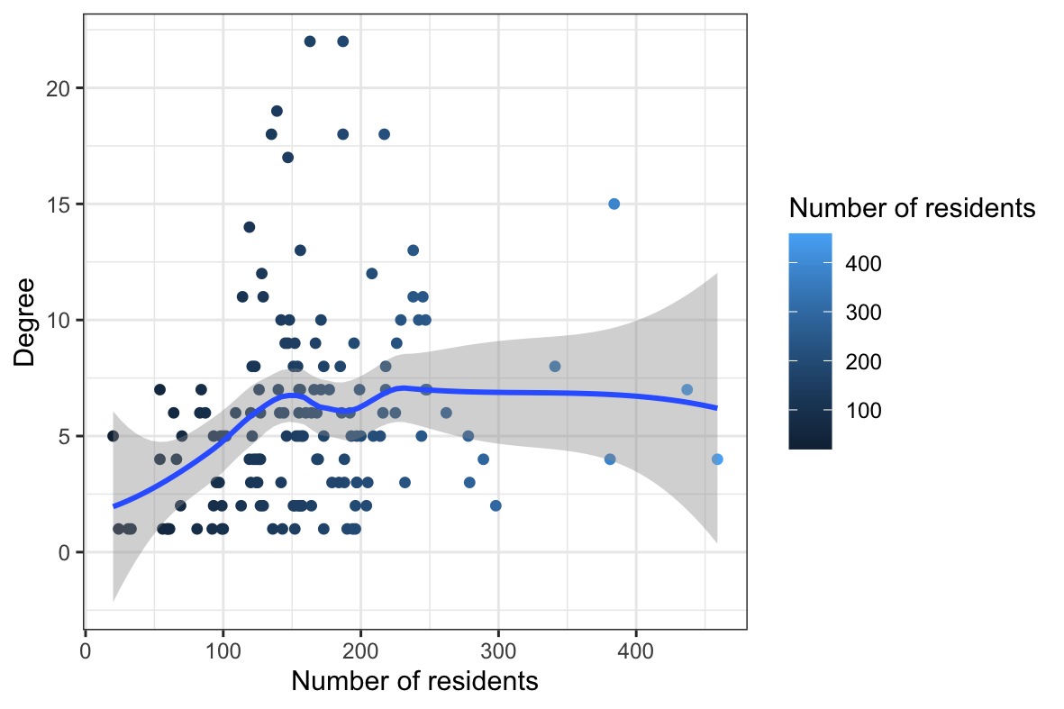
Figure S2. Degree of connectivity of long-term care homes in Greater Toronto Area, Ontario by number of residents.

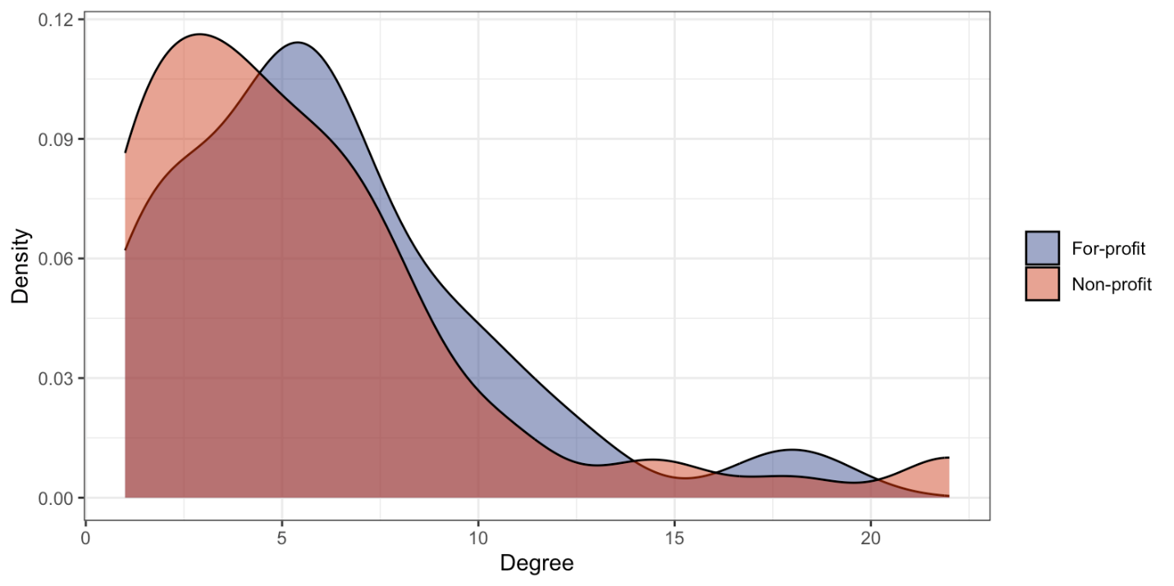
Figure S3. Degree of connectivity of long-term care homes in Greater Toronto Area, Ontario by for-profit status.

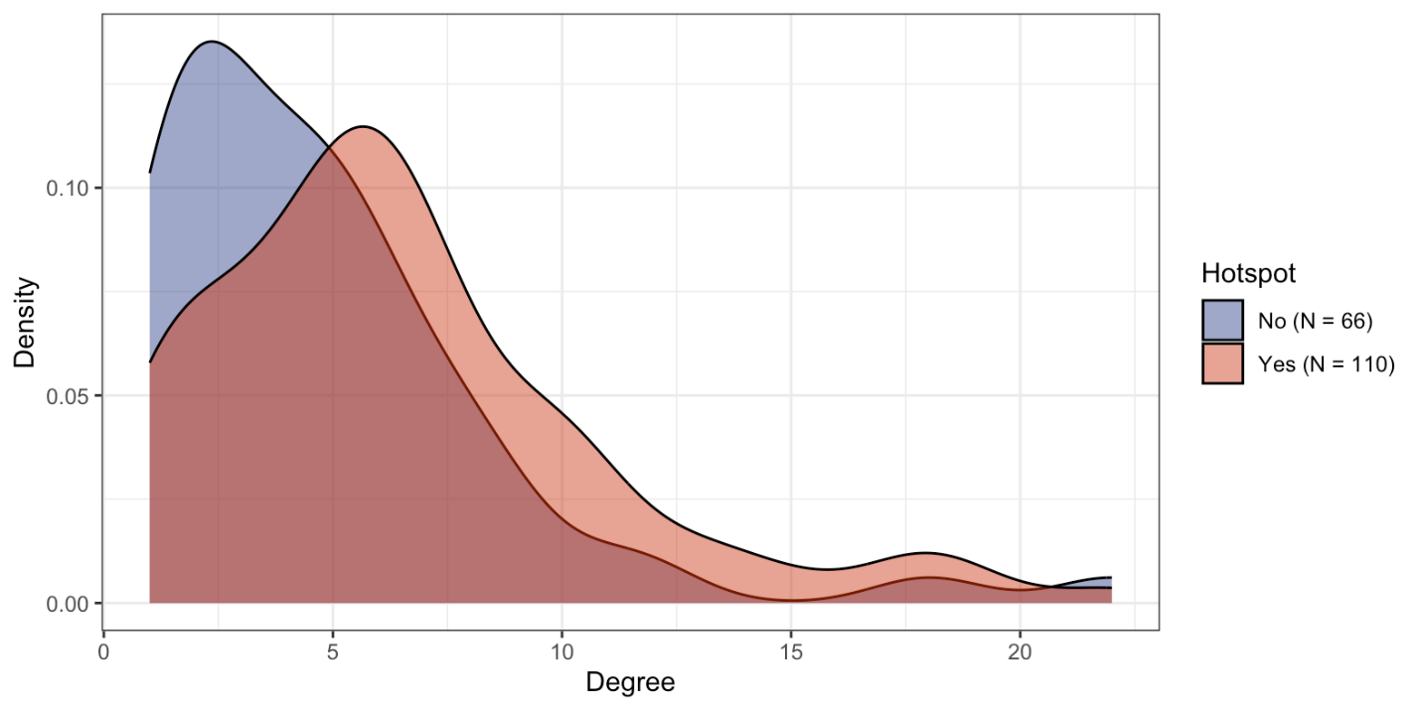Figure S4. Degree of connectivity of long-term care homes in Greater Toronto Area, Ontario by hotspot status.

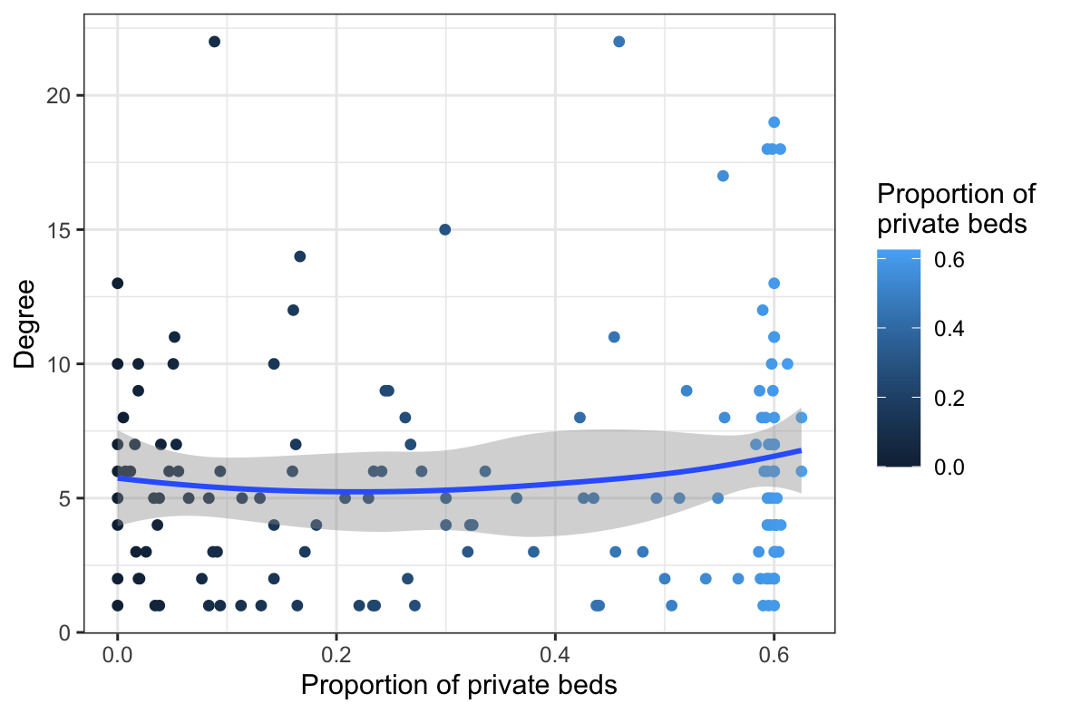
Figure S5. Degree of connectivity of long-term care homes in Greater Toronto Area, Ontario by proportion of private beds.

