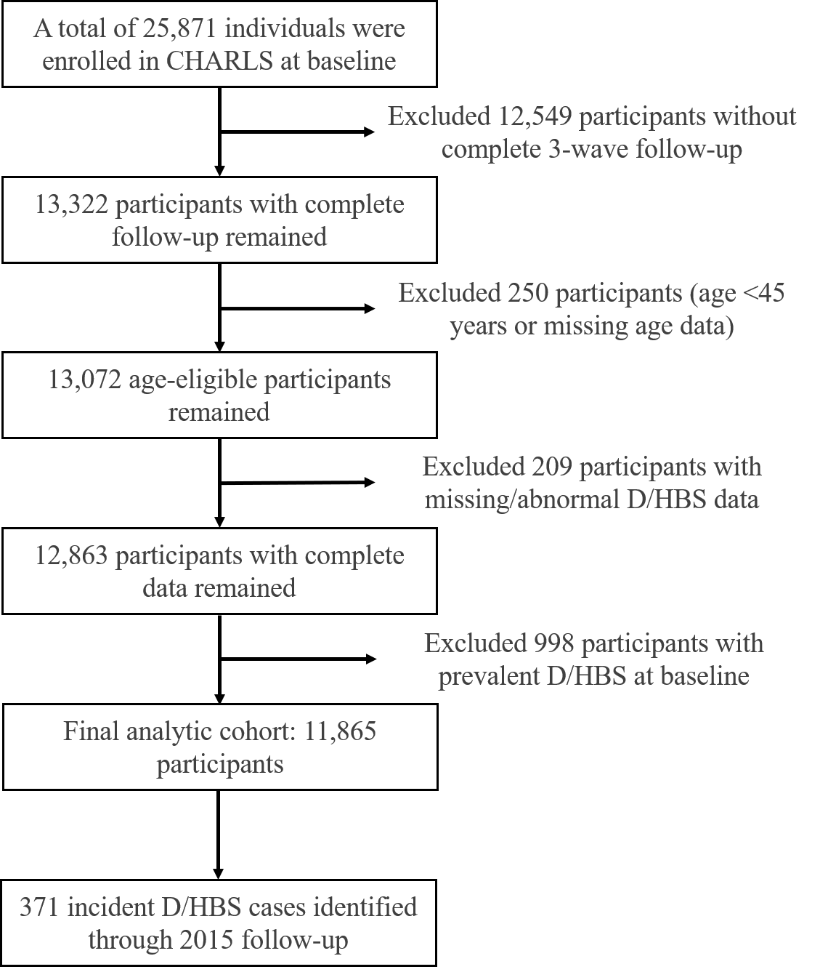
Fig. S1. Participant Flow Diagram

Fig. S2. Distribution of NL, PM₁, PM_{2.5}, PM₁₀, NO₂, O₃, BC, NH₄⁺, OM, SO₄²⁻, NO₃⁻, NDVI.

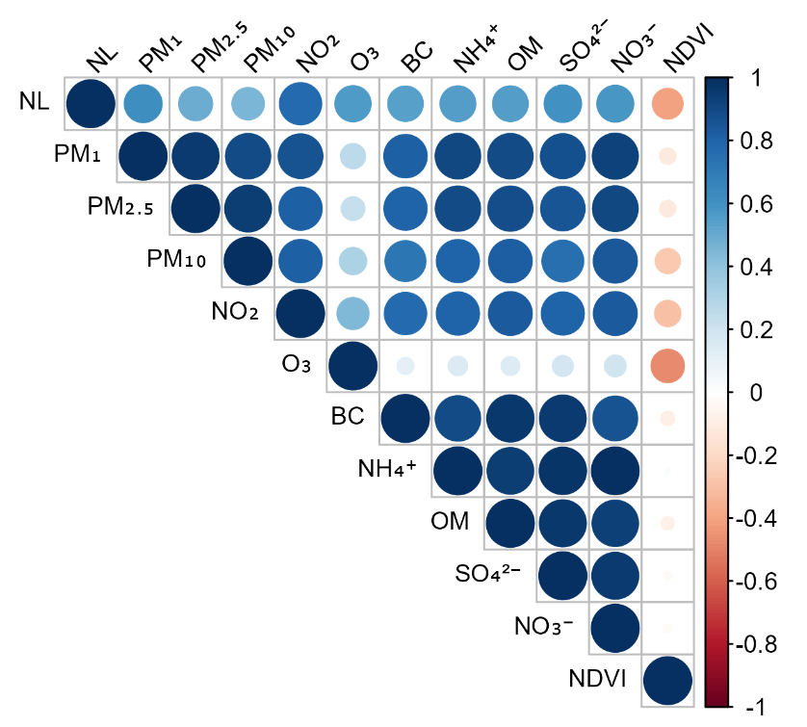
Fig. S3. Independent variables correlation matrix plot.

Table S1. Variables selected by lasso cox regression with corresponding coefficients*
Variable | Coefficient
NL | 0.056
PM1 | -0.030
PM_{2.5} | -0.006
PM₁₀ | 0.003
NO₂ | 0.013
O₃ | -0.055
BC | 0.071
NH₄⁺ | -0.443
OM | -0.033
SO₄²⁻ | -0.146
NO₃⁻ | 0.446
NDVI | -0.006
Abbreviations: NL = nighttime light; PM₁ = particulate matter with an aerodynamic diameter ≤1 μm; PM_{2.5} = particulate matter with an aerodynamic diameter ≤2.5 μm; PM₁₀ = particulate matter with an aerodynamic diameter ≤10 μm; NO₂ = nitrogen dioxide; O₃ = ozone; BC = black carbon; NH₄⁺ = ammonium; OM = organic matter; SO₄²⁻ = sulfate; NO₃⁻ = nitrate; NDVI = normalized difference vegetation index.
* Variables were selected using Lasso Cox regression with 5-fold cross-validation (α = 1), and the optimal regularization parameter was determined by minimizing the cross-validation error (λ_{min} = 0.00002). Coefficients represent the log hazard ratios: positive values indicate increased risk, negative values indicate reduced risk.

Table S2. Associations of NL, air pollutants, and NDVI with risk of D/HBS
Exposures | Model 1 |  |  | Model 2 |  |  |  | Model 3
Exposures | HRs (95% CIs) | P |  | HRs (95% CIs) | P |  |  | HRs (95% CIs) | P
NL
Q1 | 1.00 (Ref.) |  |  | 1.00 (Ref.) |  |  |  | 1.00 (Ref.)
Q2 | 1.13 (0.82, 1.56) | 0.438 |  | 1.13 (0.82, 1.56) | 0.442 |  |  | 1.16 (0.84, 1.60) | 0.368
Q3 | 1.23 (0.90, 1.69) | 0.201 |  | 1.22 (0.89, 1.68) | 0.214 |  |  | 1.23 (0.89, 1.69) | 0.204
Q4 | 1.44 (1.06, 1.95) | 0.020 |  | 1.42 (1.04, 1.92) | 0.025 |  |  | 1.41 (1.04, 1.92) | 0.027
Per IQR increase | 1.16 (1.07, 1.26) | <0.001 |  | 1.16 (1.06, 1.26) | <0.001 |  |  | 1.15 (1.06, 1.26) | 0.001
P for trend |  | <0.001 |  |  | <0.001 |  |  |  | 0.001
PM₁
Q1 | 1.00 (Ref.) |  |  | 1.00 (Ref.) |  |  |  | 1.00 (Ref.)
Q2 | 1.40 (1.02, 1.92) | 0.035 |  | 1.37 (1.00, 1.88) | 0.047 |  |  | 1.38 (1.01, 1.89) | 0.045
Q3 | 1.11 (0.81, 1.52) | 0.504 |  | 1.12 (0.81, 1.53) | 0.496 |  |  | 1.13 (0.82, 1.54) | 0.460
Q4 | 1.39 (1.03, 1.89) | 0.031 |  | 1.38 (1.02, 1.87) | 0.037 |  |  | 1.40 (1.03, 1.89) | 0.030
Per IQR increase | 1.14 (0.97, 1.34) | 0.106 |  | 1.14 (0.97, 1.34) | 0.109 |  |  | 1.15 (0.98, 1.35) | 0.084
P for trend |  | 0.106 |  |  | 0.109 |  |  |  | 0.087
PM_{2.5}
Q1 | 1.00 (Ref.) |  |  | 1.00 (Ref.) |  |  |  | 1.00 (Ref.)
Q2 | 1.57 (1.14, 2.16) | 0.006 |  | 1.56 (1.13, 2.15) | 0.006 |  |  | 1.56 (1.13, 2.14) | 0.007
Q3 | 1.30 (0.94, 1.79) | 0.119 |  | 1.31 (0.94, 1.81) | 0.107 |  |  | 1.29 (0.93, 1.79) | 0.123
Q4 | 1.44 (1.05, 1.97) | 0.025 |  | 1.43 (1.04, 1.97) | 0.027 |  |  | 1.46 (1.06, 2.01) | 0.020
Per IQR increase | 1.16 (1.07, 1.26) | 0.147 |  | 1.13 (0.96, 1.34) | 0.150 |  |  | 1.14 (0.97, 1.35) | 0.117
P for trend |  | 0.147 |  |  | 0.150 |  |  |  | 0.123
PM₁₀
Q1 | 1.00 (Ref.) |  |  | 1.00 (Ref.) |  |  |  | 1.00 (Ref.)
Q2 | 1.58 (1.14, 2.19) | 0.006 |  | 1.53 (1.10, 2.13) | 0.011 |  |  | 1.48 (1.07, 2.06) | 0.019
Q3 | 1.11 (0.79, 1.55) | 0.563 |  | 1.11 (0.79, 1.56) | 0.547 |  |  | 1.11 (0.79, 1.56) | 0.543
Q4 | 1.65 (1.20, 2.26) | 0.002 |  | 1.62 (1.18, 2.23) | 0.003 |  |  | 1.61 (1.17, 2.22) | 0.003
Per IQR increase | 1.12 (0.97, 1.28) | 0.118 |  | 1.11 (0.97, 1.27) | 0.135 |  |  | 1.12 (0.98, 1.29) | 0.103
P for trend |  | 0.118 |  |  | 0.135 |  |  |  | 0.113
NO₂
Q1 | 1.00 (Ref.) |  |  | 1.00 (Ref.) |  |  |  | 1.00 (Ref.)
Q2 | 0.98 (0.71, 1.36) | 0.921 |  | 0.99 (0.72, 1.36) | 0.939 |  |  | 0.99 (0.71, 1.36) | 0.929
Q3 | 1.02 (0.75, 1.40) | 0.886 |  | 1.04 (0.76, 1.41) | 0.828 |  |  | 1.05 (0.77, 1.44) | 0.753
Q4 | 1.43 (1.07, 1.92) | 0.016 |  | 1.42 (1.06, 1.90) | 0.018 |  |  | 1.44 (1.07, 1.92) | 0.015
Per IQR increase | 1.27 (1.08, 1.49) | 0.004 |  | 1.26 (1.07, 1.48) | 0.006 |  |  | 1.26 (1.07, 1.48) | 0.005
P for trend |  | 0.004 |  |  | 0.006 |  |  |  | 0.005
O₃
Q1 | 1.00 (Ref.) |  |  | 1.00 (Ref.) |  |  |  | 1.00 (Ref.)
Q2 | 1.00 (0.75, 1.35) | 0.977 |  | 0.99 (0.74, 1.33) | 0.937 |  |  | 0.98 (0.73, 1.31) | 0.883
Q3 | 1.04 (0.78, 1.38) | 0.800 |  | 1.03 (0.77, 1.37) | 0.866 |  |  | 1.01 (0.76, 1.36) | 0.920
Q4 | 1.04 (0.79, 1.38) | 0.779 |  | 1.02 (0.77, 1.35) | 0.881 |  |  | 1.00 (0.75, 1.33) | 0.997
Per IQR increase | 0.98 (0.86, 1.12) | 0.731 |  | 0.97 (0.85, 1.11) | 0.641 |  |  | 0.96 (0.84, 1.09) | 0.512
P for trend |  | 0.731 |  |  | 0.641 |  |  |  | 0.519
BC
Q1 | 1.00 (Ref.) |  |  | 1.00 (Ref.) |  |  |  | 1.00 (Ref.)
Q2 | 1.05 (0.77, 1.44) | 0.762 |  | 1.06 (0.77, 1.44) | 0.732 |  |  | 1.07 (0.78, 1.47) | 0.671
Q3 | 1.04 (0.78, 1.39) | 0.793 |  | 1.05 (0.79, 1.41) | 0.721 |  |  | 1.07 (0.80, 1.43) | 0.663
Q4 | 1.17 (0.88, 1.56) | 0.286 |  | 1.18 (0.89, 1.57) | 0.257 |  |  | 1.20 (0.90, 1.60) | 0.217
Per IQR increase | 1.05 (0.88, 1.26) | 0.580 |  | 1.06 (0.89, 1.26) | 0.535 |  |  | 1.07 (0.89, 1.27) | 0.474
P for trend |  | 0.580 |  |  | 0.535 |  |  |  | 0.459
NH₄⁺
Q1 | 1.00 (Ref.) |  |  | 1.00 (Ref.) |  |  |  | 1.00 (Ref.)
Q2 | 1.54 (1.12, 2.12) | 0.008 |  | 1.50 (1.09, 2.06) | 0.013 |  |  | 1.47 (1.07, 2.02) | 0.018
Q3 | 1.06 (0.77, 1.48) | 0.714 |  | 1.06 (0.77, 1.48) | 0.715 |  |  | 1.07 (0.77, 1.49) | 0.672
Q4 | 1.57 (1.16, 2.12) | 0.004 |  | 1.56 (1.15, 2.12) | 0.004 |  |  | 1.56 (1.15, 2.11) | 0.004
Per IQR increase | 1.23 (1.03, 1.47) | 0.020 |  | 1.24 (1.04, 1.47) | 0.018 |  |  | 1.24 (1.04, 1.48) | 0.016
P for trend |  | 0.020 |  |  | 0.018 |  |  |  | 0.015
OM
Q1 | 1.00 (Ref.) |  |  | 1.00 (Ref.) |  |  |  | 1.00 (Ref.)
Q2 | 1.42 (1.04, 1.95) | 0.027 |  | 1.42 (1.04, 1.94) | 0.027 |  |  | 1.42 (1.04, 1.94) | 0.029
Q3 | 1.23 (0.91, 1.67) | 0.179 |  | 1.26 (0.93, 1.71) | 0.141 |  |  | 1.28 (0.94, 1.73) | 0.118
Q4 | 1.25 (0.92, 1.68) | 0.154 |  | 1.25 (0.92, 1.69) | 0.149 |  |  | 1.26 (0.93, 1.71) | 0.133
Per IQR increase | 1.13 (0.96, 1.34) | 0.149 |  | 1.14 (0.96, 1.34) | 0.141 |  |  | 1.14 (0.97, 1.35) | 0.120
P for trend |  | 0.149 |  |  | 0.141 |  |  |  | 0.118
SO₄²⁻
Q1 | 1.00 (Ref.) |  |  | 1.00 (Ref.) |  |  |  | 1.00 (Ref.)
Q2 | 1.05 (0.77, 1.44) | 0.749 |  | 1.04 (0.76, 1.43) | 0.798 |  |  | 1.02 (0.75, 1.40) | 0.889
Q3 | 0.89 (0.65, 1.21) | 0.442 |  | 0.89 (0.66, 1.22) | 0.470 |  |  | 0.91 (0.67, 1.24) | 0.547
Q4 | 1.29 (0.97, 1.71) | 0.075 |  | 1.30 (0.98, 1.72) | 0.069 |  |  | 1.28 (0.97, 1.70) | 0.083
Per IQR increase | 1.19 (0.99, 1.42) | 0.059 |  | 1.19 (1.00, 1.42) | 0.051 |  |  | 1.20 (1.00, 1.43) | 0.047
P for trend |  | 0.059 |  |  | 0.051 |  |  |  | 0.044
NO₃⁻
Q1 | 1.00 (Ref.) |  |  | 1.00 (Ref.) |  |  |  | 1.00 (Ref.)
Q2 | 1.57 (1.14, 2.16) | 0.006 |  | 1.53 (1.11, 2.11) | 0.010 |  |  | 1.50 (1.09, 2.07) | 0.013
Q3 | 0.91 (0.65, 1.29) | 0.613 |  | 0.92 (0.65, 1.30) | 0.618 |  |  | 0.92 (0.65, 1.31) | 0.647
Q4 | 1.74 (1.29, 2.36) | <0.001 |  | 1.74 (1.28, 2.36) | <0.001 |  |  | 1.74 (1.28, 2.35) | <0.001
Per IQR increase | 1.29 (1.09, 1.52) | 0.003 |  | 1.29 (1.09, 1.52) | 0.003 |  |  | 1.29 (1.09, 1.52) | 0.002
P for trend |  | 0.003 |  |  | 0.003 |  |  |  | 0.002
NDVI
Q1 | 1.00 (Ref.) |  |  | 1.00 (Ref.) |  |  |  | 1.00 (Ref.)
Q2 | 0.83 (0.63, 1.08) | 0.168 |  | 0.84 (0.64, 1.10) | 0.206 |  |  | 0.85 (0.65, 1.12) | 0.244
Q3 | 0.50 (0.36, 0.69) | <0.001 |  | 0.51 (0.37, 0.71) | <0.001 |  |  | 0.52 (0.37, 0.72) | <0.001
Q4 | 0.99 (0.76, 1.29) | 0.934 |  | 1.00 (0.77, 1.30) | 0.985 |  |  | 1.01 (0.77, 1.32) | 0.954
Per IQR increase | 0.98 (0.91, 1.06) | 0.664 |  | 0.99 (0.91, 1.06) | 0.694 |  |  | 0.99 (0.92, 1.06) | 0.715
P for trend |  | 0.664 |  |  | 0.694 |  |  |  | 0.718
Abbreviations: D/HBS = Diabetes or high blood sugar; NL = nighttime light; PM₁ = particulate matter with an aerodynamic diameter ≤1 μm; PM_{2.5} = particulate matter with an aerodynamic diameter ≤2.5 μm; PM₁₀ = particulate matter with an aerodynamic diameter ≤10 μm; NO₂ = nitrogen dioxide; O₃ = ozone; BC = black carbon; NH₄⁺ = ammonium; OM = organic matter; SO₄²⁻ = sulfate; NO₃⁻ = nitrate; NDVI = normalized difference vegetation index.
Model 1 was adjusted for age and gender. Model 2 included additional adjustments for marital status and education level. Model 3 further controlled for smoking status, alcohol consumption, sleep state and residential area.

