Citywide park renovations and changes in perceived stress: a quasi-experimental study among low-income communities in New York City
Supplementary Material 1
Authors: Rachel L. Thompson, Katarzyna E. Wyka, Kelly R. Evenson, Lorna E. Thorpe, Glen D. Johnson, Brian T. Pavilonis, and Terry T.-K. Huang

Table of Contents
Figure 1. Residual plots validating assumptions for linear regression
Table 1. Overall association between study park use and change in perceived stress among adult PARCS study participants
Table 2. Changes in perceived stress over time among adult PARCS study participants in intervention vs. control groups after excluding single influential outlier
Table 3. Changes in perceived stress over time among adult PARCS study participants in intervention vs. control groups after excluding participants with follow-up surveys collected during and after March 2020 (COVID-19 pandemic)
Table 4. Changes in perceived stress over time among adult PARCS study participants in intervention vs. control groups after additionally adjusting for study park use
Table 5. Changes in perceived stress over time among adult PARCS study participants by intervention status and study park use at follow-up, with high study park use defined as “> Once per week” and low study park use defined as “≤ Once per week”
Table 6. Changes in perceived stress over time among adult PARCS study participants by intervention status and study park use at follow-up, with high study park use defined as “> Once per month” and low study park use defined as “≤ Once per month”
Figure 1. Residual plots validating assumptions for linear regression (from main model)
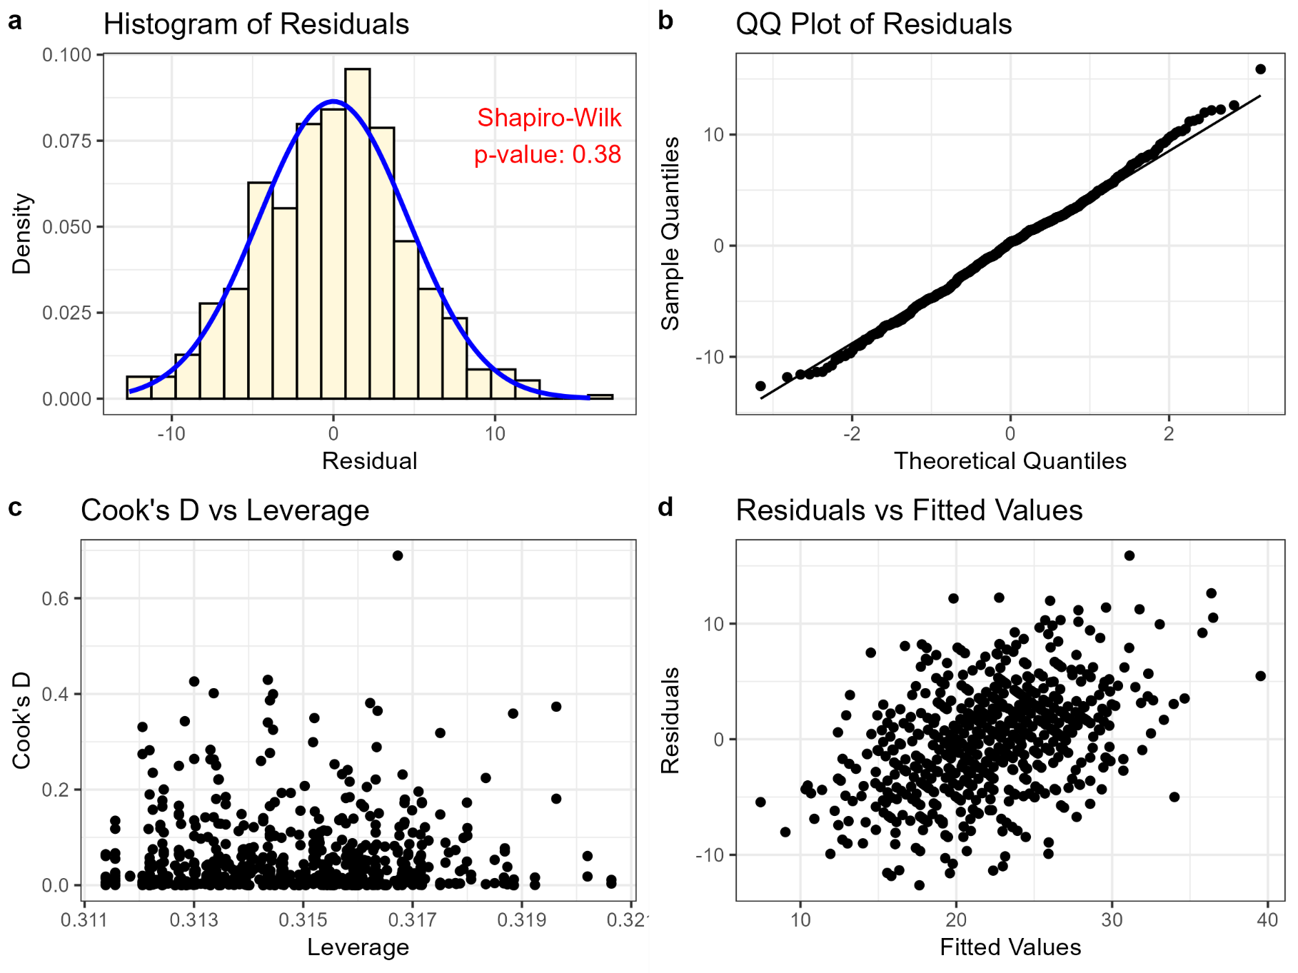
Table 1. Overall association between study park use and change in perceived stress among adult PARCS study participants
High Study Park Use at Follow-Up  (≥ Once per week)  (n = 173) |  |  | Low Study Park Use at Follow-Up  (< Once per week)  (n = 140) |  |  | Difference  (High – Low)
Pre-Renovation¹ | Post-Renovation¹ | Change  (95% CI) ² | Pre-Renovation¹ | Post-Renovation¹ | Change  (95% CI) ² | Difference Estimate  (95% CI)^{2,3} | p-value
23.07 (6.97) | 19.61 (7.54) | -3.45 (-5.00, -1.91) | 24.77 (7.69) | 22.29 (8.67) | -2.48 (-4.20, -0.77) | -0.97 (-2.73, 0.79) | 0.28
¹Mean (SD)
²Estimated using linear mixed effects regression models
³Difference in change in mean PSS score among individuals with high study park use at follow-up minus the change in mean PSS score among individuals with low study park use at follow-up
Abbreviations – PSS: Perceived Stress Scale; PARCS: Physical Activity and Redesigned Community Spaces; DID: Difference-in-Difference

Table 2. Changes in perceived stress over time among adult PARCS study participants in intervention vs. control groups after excluding single influential outlier*
 | Intervention  (n = 161) |  |  | Control  (n = 151) |  |  | Difference-in-Differences
 | Pre-Renovation¹ | Post-Renovation¹ | Change  (95% CI) ² | Pre-Renovation¹ | Post-Renovation¹ | Change  (95% CI) ² | DID Estimator (95% CI)^{2,3} | p-value
Overall Sample | 23.22 (6.85) | 20.20 (7.99) | -3.01 (-4.60, -1.43) | 24.45 (7.81) | 21.28 (8.08) | -3.16 (-4.80, -1.52) | 0.15 (-1.59, 1.89) | 0.87
Age at Baseline
18-34y | 24.39 (6.84) | 22.08 (8.91) | -2.32 (-5.05, 0.42) | 25.93 (6.84) | 20.92 (9.12) | -5.01 (-7.85, -2.17) | 2.70 (-0.31, 5.70) | 0.078
35-49y | 22.96 (6.34) | 18.95 (6.86) | -4.01 (-6.54, -1.48) | 24.13 (8.12) | 21.87 (7.46) | -2.26 (-4.77, 0.25) | -1.75 (-4.47, 0.97) | 0.21
50-78y | 22.15 (7.49) | 19.70 (8.04) | -2.45 (-5.48, 0.58) | 22.99 (8.34) | 20.76 (7.77) | -2.23 (-5.53, 1.08) | -0.22 (-3.63, 3.20) | 0.90
Marital Status at Baseline
Never married | 23.69 (7.18) | 21.04 (7.73) | -2.65 (-4.89, -0.41) | 26.36 (8.58) | 21.64 (8.61) | -4.72 (-7.13, -2.31) | 2.07 (-0.44, 4.58) | 0.11
Married | 22.75 (5.99) | 21.57 (6.67) | -1.19 (-4.34, 1.96) | 24.08 (6.11) | 21.83 (7.27) | -2.25 (-4.96, 0.46) | 1.06 (-2.10, 4.22) | 0.51
Divorced, separated, or  widowed | 22.77 (7.09) | 17.33 (9.01) | -5.44 (-8.51, -2.37) | 20.64 (7.46) | 19.43 (8.24) | -1.22 (-4.91, 2.48) | -4.22 (-7.88, -0.56) | 0.024
Study Park Use at Follow-Up
High (≥ Once per week) | 23.14 (6.93) | 19.01 (7.41) | -4.13 (-6.21, -2.05) | 22.98 (7.07) | 20.31 (7.67) | -2.67 (-4.91, -0.43) | -1.46 (-3.79, 0.87) | 0.22
Low (< Once per week) | 23.32 (6.79) | 21.83 (8.50) | -1.49 (-3.92, 0.94) | 26.10 (8.31) | 22.38 (8.44) | -3.72 (-6.10, -1.34) | 2.23 (-0.36, 4.82) | 0.092
¹Mean (SD)
²Estimated using linear mixed effects regression models adjusted for education, public housing, and marital status at baseline
³The DID estimator represents the difference in change in mean PSS score in the intervention group minus the control group
*The outlier was identified based on Cook’s D > 0.5
Abbreviations – PSS: Perceived Stress Scale; PARCS: Physical Activity and Redesigned Community Spaces; DID: Difference-in-Difference

Table 3. Changes in perceived stress over time among adult PARCS study participants in intervention vs. control groups after excluding participants with follow-up surveys collected during and after March 2020 (COVID-19 pandemic)
 | Intervention  (n = 134) |  |  | Control  (n = 145) |  |  | Difference-in-Differences
 | Pre-Renovation¹ | Post-Renovation¹ | Change  (95% CI) ² | Pre-Renovation¹ | Post-Renovation¹ | Change  (95% CI) ² | DID Estimator (95% CI)^{2,3} | p-value
Overall Sample | 23.28 (6.59) | 19.95 (8.22) | -3.33 (-5.07, -1.59) | 24.41 (7.84) | 21.18 (8.16) | -3.23 (-4.90, -1.56) | -0.10 (-1.93, 1.74) | 0.92
Age at Baseline
18-34y | 24.38 (6.24) | 21.60 (9.26) | -2.78 (-5.95, 0.39) | 25.93 (6.84) | 20.92 (9.12) | -5.01 (-7.84, -2.18) | 2.23 (-1.00, 5.47) | 0.18
35-49y | 22.94 (6.16) | 18.41 (7.66) | -4.52 (-7.27, -1.77) | 24.02 (8.15) | 21.79 (7.62) | -2.23 (-4.84, 0.37) | -2.29 (-5.18, 0.60) | 0.12
50-78y | 22.66 (7.45) | 20.34 (7.67) | -2.32 (-5.45, 0.80) | 22.93 (8.45) | 20.53 (7.75) | -2.40 (-5.74, 0.94) | 0.08 (-3.41, 3.56) | 0.97
Marital Status at Baseline
Never married | 23.67 (6.73) | 20.93 (8.55) | -2.74 (-5.24, -0.24) | 26.36 (8.58) | 21.64 (8.61) | -4.72 (-7.13, -2.31) | 1.98 (-0.66, 4.63) | 0.14
Married | 22.94 (5.92) | 21.08 (6.59) | -1.86 (-5.32, 1.59) | 24.30 (6.14) | 21.74 (7.39) | -2.56 (-5.34, 0.22) | 0.69 (-2.69, 4.07) | 0.69
Divorced, separated, or  widowed | 22.95 (7.03) | 17.36 (8.56) | -5.58 (-8.81, -2.36) | 19.52 (6.79) | 18.86 (8.28) | -0.66 (-4.56, 3.23) | -4.92 (-8.77, -1.07) | 0.012
Study Park Use at Follow-Up
High (≥ Once per week) | 23.18 (6.76) | 19.06 (7.17) | -4.12 (-6.34, -1.90) | 22.85 (6.94) | 20.04 (7.69) | -2.81 (-5.10, -0.52) | -1.31 (-3.73, 1.12) | 0.29
Low (< Once per week) | 23.44 (6.38) | 21.36 (9.56) | -2.09 (-4.87, 0.70) | 26.17 (8.45) | 22.47 (8.54) | -3.71 (-6.14, -1.27) | 1.62 (-1.20, 4.44) | 0.26
¹Mean (SD)
²Estimated using linear mixed effects regression models adjusted for education, public housing, and marital status at baseline
³The DID estimator represents the difference in change in mean PSS score in the intervention group minus the control group
Abbreviations – PSS: Perceived Stress Scale; PARCS: Physical Activity and Redesigned Community Spaces; DID: Difference-in-Difference

Table 4. Changes in perceived stress over time among adult PARCS study participants in intervention vs. control groups after additionally adjusting for study park use
 | Intervention  (n = 162) |  |  | Control  (n = 151) |  |  | Difference-in-Differences
 | Pre-Renovation¹ | Post-Renovation¹ | Change  (95% CI) ² | Pre-Renovation¹ | Post-Renovation¹ | Change  (95% CI) ² | DID Estimator (95% CI)^{2,3} | p-value
Overall Sample | 23.25 (6.85) | 20.37 (8.23) | -2.88 (-4.48, -1.29) | 24.45 (7.81) | 21.28 (8.08) | -3.16 (-4.82, -1.51) | 0.28 (-1.48, 2.03) | 0.75
Age at Baseline
18-34y | 24.39 (6.84) | 22.08 (8.91) | -2.32 (-5.08, 0.45) | 25.93 (6.84) | 20.92 (9.12) | -5.01 (-7.89, -2.14) | 2.70 (-0.34, 5.73) | 0.082
35-49y | 23.06 (6.34) | 19.39 (7.66) | -3.67 (-6.21, -1.13) | 24.13 (8.12) | 21.87 (7.46) | -2.26 (-4.80, 0.28) | -1.41 (-4.14, 1.33) | 0.31
50-78y | 22.15 (7.49) | 19.70 (8.04) | -2.45 (-5.51, 0.62) | 22.99 (8.34) | 20.76 (7.77) | -2.23 (-5.57, 1.11) | -0.22 (-3.67, 3.23) | 0.90
Marital Status at Baseline
Never married | 23.76 (7.16) | 21.37 (8.21) | -2.39 (-4.64, -0.14) | 26.36 (8.58) | 21.64 (8.61) | -4.72 (-7.16, -2.28) | 2.33 (-0.20, 4.85) | 0.071
Married | 22.75 (5.99) | 21.57 (6.67) | -1.19 (-4.37, 1.99) | 24.08 (6.11) | 21.83 (7.27) | -2.25 (-4.98, 0.49) | 1.06 (-2.13, 4.26) | 0.51
Divorced, separated or  widowed | 22.77 (7.09) | 17.33 (9.01) | -5.44 (-8.54, -2.34) | 20.64 (7.46) | 19.43 (8.24) | -1.22 (-4.95, 2.52) | -4.22 (-7.92, -0.53) | 0.025
¹Mean (SD)
²Estimated using linear mixed effects regression models adjusted for education, public housing, and marital status at baseline, and study park use at follow-up
³The DID estimator represents the difference in change in mean PSS score in the intervention group minus the control group
Abbreviations – PSS: Perceived Stress Scale; PARCS: Physical Activity and Redesigned Community Spaces; DID: Difference-in-Difference

Table 5. Changes in perceived stress over time among adult PARCS study participants by intervention status and study park use at follow-up, with high study park use defined as “> Once per week” and low study park use defined as “≤ Once per week”
Overall Sample
 |  | Intervention | Control |  | Difference
 |  | (n = 162)¹ | (n = 151)¹ |  | (Intervention - Control)²
Study Park Use at Follow-Up
High (> Once per week) (n = 133) |  | -3.49 (-5.84, -1.14) | -2.21 (-4.88, -0.46) |  | -1.28 (-3.99, 1.43)
Low (≤ Once per week) (n = 180) |  | -2.36 (-4.54, -0.18) | -3.76 (-5.87, -1.65) |  | 1.39 (-0.92, 3.71)
Difference (High - Low)³ |  | -1.13 (-3.57, 1.31) | 1.54 (-1.05, 4.14) |  | 3-way interaction⁴  p = 0.14
Age 18-34y
 |  | Intervention | Control |  | Difference
 |  | (n = 54)¹ | (n = 50)¹ |  | (Intervention - Control)²
Study Park Use at Follow-Up
High (> Once per week) (n = 35) |  | -2.99 (-6.65, 0.67) | -5.73 (-9.49, -1.97) |  | 2.74 (-2.51, 7.99)
Low (≤ Once per week) (n = 69) |  | -1.98 (-4.56, 0.61) | -4.64 (-7.34, -1.94) |  | 2.66 (-1.08, 6.40)
Difference (High - Low)³ |  | -1.01 (-5.49, 3.47) | -1.09 (-5.72, 3.55) |  | 3-way interaction⁴  p = 0.98
Age 35-49y
 |  | Intervention | Control |  | Difference
 |  | (n = 64)¹ | (n = 64)¹ |  | (Intervention - Control)²
Study Park Use at Follow-Up
High (> Once per week) (n = 55) |  | -4.94 (-7.88, -2.01) | -0.56 (-3.55, 2.42) |  | -4.38 (-8.57, -0.19)
Low (≤ Once per week) (n = 73) |  | -2.67 (-5.26, -0.09) | -3.50 (-6.05, -0.95) |  | 0.83 (-2.81, 4.46)
Difference (High - Low)³ |  | -2.27 (-6.18, 1.64) | 2.93 (-0.99, 6.86) |  | 3-way interaction⁴  p = 0.066
Age 50-78y
 |  | Intervention | Control |  | Difference
 |  | (n = 44)¹ | (n = 37)¹ |  | (Intervention - Control)²
Study Park Use at Follow-Up
High (> Once per week) (n = 43) |  | -2.40 (-5.28, 0.48) | -1.12 (-5.27, 3.03) |  | -1.28 (-6.33, 3.77)
Low (≤ Once per week) (n = 38) |  | -2.54 (-6.55, 1.47) | -2.90 (-6.14, 0.33) |  | 0.36 (-4.79, 5.51)
Difference (High - Low)³ |  | 0.14 (-4.80, 5.08) | 1.78 (-3.48, 7.04) |  | 3-way interaction⁴  p = 0.65
Estimates in table are from linear mixed effects regression models adjusted for education, public housing, and marital status at baseline
¹Mean change in PSS (post-renovation mean – pre-renovation mean) and 95% CI
²Difference in mean change in PSS between intervention and control groups and 95% CI
³Difference in mean change in PSS between high and low park use groups and 95% CI
⁴p-value is for 3-way interaction between intervention status x time x study park use at follow-up
Abbreviations – PSS: Perceived Stress Scale; PARCS: Physical Activity and Redesigned Community Spaces
Table 6. Changes in perceived stress over time among adult PARCS study participants by intervention status and study park use at follow-up, with high study park use defined as “> Once per month” and low study park use defined as “≤ Once per month”
Overall Sample
 |  | Intervention | Control |  | Difference
 |  | (n = 162)¹ | (n = 151)¹ |  | (Intervention - Control)²
Study Park Use at Follow-Up
High (> Once per month) (n = 204) |  | -3.80 (-5.78, -1.82) | -3.20 (-5.23, -1.16) |  | -0.60 (-2.77, 1.56)
Low (≤ Once per month) (n = 109) |  | -1.20 (-3.89, 1.49) | -3.10 (-5.92, -0.29) |  | 1.90 (-1.06, 4.87)
Difference (High - Low)³ |  | -2.60 (-5.14, -0.06) | -0.09 (-2.74, 2.55) |  | 3-way interaction⁴  p = 0.18
Age 18-34y
 |  | Intervention | Control |  | Difference
 |  | (n = 54)¹ | (n = 50)¹ |  | (Intervention - Control)²
Study Park Use at Follow-Up
High (> Once per month) (n = 66) |  | -4.57 (-7.38, -1.75) | -5.27 (-7.84, -2.70) |  | 0.70 (-3.11, 4.51)
Low (≤ Once per month) (n = 38) |  | 0.50 (-2.65, 3.65) | -4.36 (-8.48, -0.24) |  | 4.86 (-0.33, 10.04)
Difference (High - Low)³ |  | -5.06 (-9.29, -0.84) | -0.91 (-5.77, 3.95) |  | 3-way interaction⁴  p = 0.20
Age 35-49y
 |  | Intervention | Control |  | Difference
 |  | (n = 64)¹ | (n = 64)¹ |  | (Intervention - Control)²
Study Park Use at Follow-Up
High (> Once per month) (n = 76) |  | -4.75 (-7.25, -2.25) | -1.64 (-4.14, 0.86) |  | -3.10 (-6.64, 0.43)
Low (≤ Once per month) (n = 52) |  | -2.09 (-5.11, 0.94) | -3.16 (-6.19, -0.14) |  | 1.08 (-3.20, 5.35)
Difference (High - Low)³ |  | -2.66 (-6.59, 1.26) | 1.52 (-2.41, 5.44) |  | 3-way interaction⁴  p = 0.14
Age 50-78y
 |  | Intervention | Control |  | Difference
 |  | (n = 44)¹ | (n = 37)¹ |  | (Intervention - Control)²
Study Park Use at Follow-Up
High (> Once per month) (n = 62) |  | -2.20 (-4.74, 0.33) | -2.57 (-5.66, 0.51) |  | 0.37 (-3.62, 4.36)
Low (≤ Once per month) (n = 19) |  | -3.73 (-9.55, 2.10) | -1.51 (-5.96, 2.94) |  | -2.22 (-9.55, 5.12)
Difference (High - Low)³ |  | 1.52 (-4.83, 7.88) | -1.06 (-6.48, 4.35) |  | 3-way interaction⁴  p = 0.54
Estimates in table are from linear mixed effects regression models adjusted for education, public housing, and marital status at baseline
¹Mean change in PSS (post-renovation mean – pre-renovation mean) and 95% CI
²Difference in mean change in PSS between intervention and control groups and 95% CI
³Difference in mean change in PSS between high and low park use groups and 95% CI
⁴p-value is for 3-way interaction between intervention status x time x study park use at follow-up
Abbreviations – PSS: Perceived Stress Scale; PARCS: Physical Activity and Redesigned Community Spaces

