Supplementary Figure 1. Predicted results for the five countries with the greatest potential for improvement in RD prevalence among children and adolescents. (A) Iran (Islamic Republic of). (B) Oman. (C) Spain. (D) Saudi Arabia. (E) Paraguay. Abbreviations: RD, refraction disorders.
Supplementary Figure 2. Predicted results for the five countries with the greatest potential for improvement in RD DALYs among children and adolescents. (A) Iran (Islamic Republic of). (B) Oman. (C) Spain. (D) Saudi Arabia. (E) Paraguay. Abbreviations: RD, refraction disorders; DALYs, disability-adjusted life years.

Supplementary Figure 3. Predicted results for the five countries with the greatest potential for improvement in RD prevalence among the elderly (excluding India). (A) Angola. (B) Bangladesh. (C) Gabon. (D) Congo. Abbreviations: RD, refraction disorders.

Supplementary Figure 4. Predicted results for the five countries with the greatest potential for improvement in RD DALYs among the elderly (excluding India). (A) Bangladesh. (B) Congo. (C) Oman. (D) Nepal. Abbreviations: RD, refraction disorders; DALYs, disability-adjusted life years.

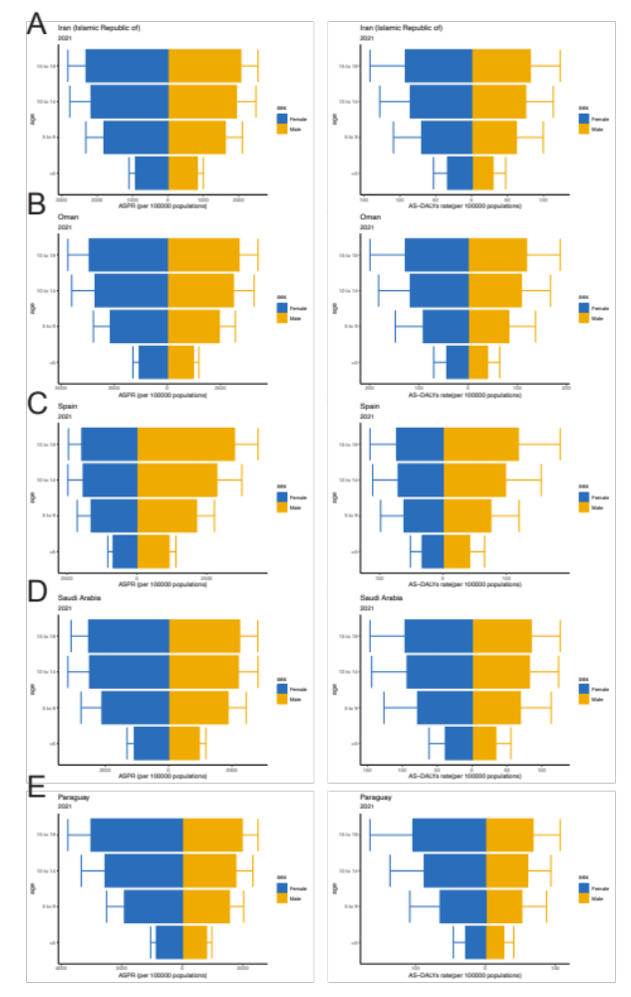
Supplementary Figure 5. Subgroup distribution by age and sex of ASPR and AS-DALYs rate among children and adolescents in five countries with the greatest potential for improvement, 2021. (A) Iran (Islamic Republic of); (B) Oman; (C) Spain; (D) Saudi Arabia; (E) Paraguay. ASPR, age-standardized prevalence rate; AS-DALYs, age-standardized disability-adjusted life years.

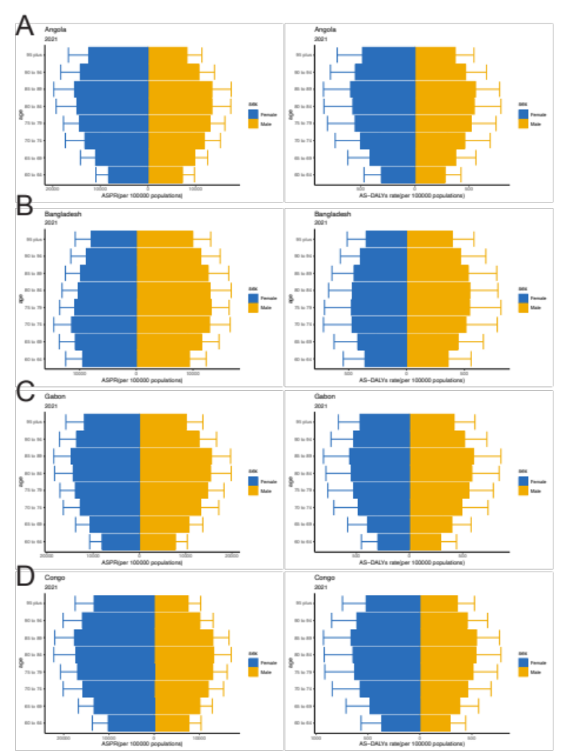
Supplementary Figure 6. Subgroup distribution by age and sex of ASPR and AS-DALYs rate among old adults in five countries with the greatest potential for improvement, 2021 (excluding India). (A) Angola; (B) Bangladesh; (C) Gabon; (D) Congo. ASPR, age-standardized prevalence rate; AS-DALYs, age-standardized disability-adjusted life years.

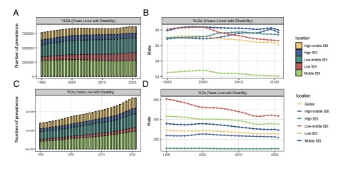
Supplementary Figure 7. YLDs and age-standardized YLDs rate for RD from 1990 to 2021, globally and across SDI regions. (A) YLDs in children and adolescents. (B) Age-standardized YLDs rate in children and adolescents. (C) YLDs in the elderly. (D) Age-standardized YLDs rate in the elderly. Abbreviations: SDI, Socio-demographic Index; RD, refraction disorders; AS-YLDs, age-standardized years lived with disability.

Supplementary Figure 8. The relationship between AS-YLDs rate for RD in children and adolescents (A), AS-YLDs rate for RD in the elderly (B), and SDI in 204 countries and territories in 2021. Abbreviations: RD, refraction disorders; AS-YLDs, age-standardized years lived with disability; SDI, Socio-demographic Index.

Supplementary Figure 9. AS-YLDs rate for RD in children and adolescents (A) and the elderly (B) in 204 countries and territories in 2021. Abbreviations: RD, refraction disorders; AS-YLDs, age-standardized years lived with disability.

Supplementary Figure 10. Health inequality regression and concentration curves for RD from 1990 to 2021, globally. (A) Regression and concentration curve of AS-YLDs rate for children and adolescents. (B) Regression and concentration curve of AS-YLDs rate for the elderly. Abbreviations: RD, refraction disorders; AS-YLDs, age-standardized years lived with disability.

Supplementary Figure 11. Frontier analysis of AS-YLDs rate for RD based on SDI in 2021. (A) children and adolescents. (B) the elderly. Abbreviations: SDI, Socio-demographic Index; RD, refraction disorders; AS-YLDs，age-standardized years lived with disability .

Supplementary Figure 12. Changes in RD YLDs from 1990 to 2019 by population-level determinants, including population growth, aging, and epidemiological shifts, globally and across SDI quintiles. (A) Changes in YLDs for children and adolescents. (B) Changes in YLDs for the elderly. Abbreviations: RD, refraction disorders; YLDs, years lived with disability; SDI, Socio-demographic Index

Supplementary Figure 13. Predicted RD YLDs and age-standardized YLDs rate from 2022 to 2030: (A) global RD YLDs and AS-YLDs rate for children and adolescents, (B) RD YLDs and AS-YLDs rate for children and adolescents in China and India, (C) global RD YLDs and AS-YLDs rate for the elderly, and (D) RD YLDs and AS-YLDs rate for the elderly in China and India. Abbreviations: RD, refraction disorders; AS-YLDs, age-standardized years lived with disability.

Supplementary Figure 14. Predicted results for the five countries with the greatest potential for improvement in RD YLDs among children and adolescents. (A) Iran (Islamic Republic of). (B) Oman. (C) Spain. (D) Saudi Arabia. (E) Paraguay. Abbreviations: RD, refraction disorders; YLDs, years lived with disability.

Supplementary Figure 15. Predicted results for the five countries with the greatest potential for improvement in RD YLDs among the elderly (excluding India). (A) Bangladesh. (B) Congo. (C) Oman. (D) Nepal. Abbreviations: RD, refraction disorders; YLDs, years lived with disability.
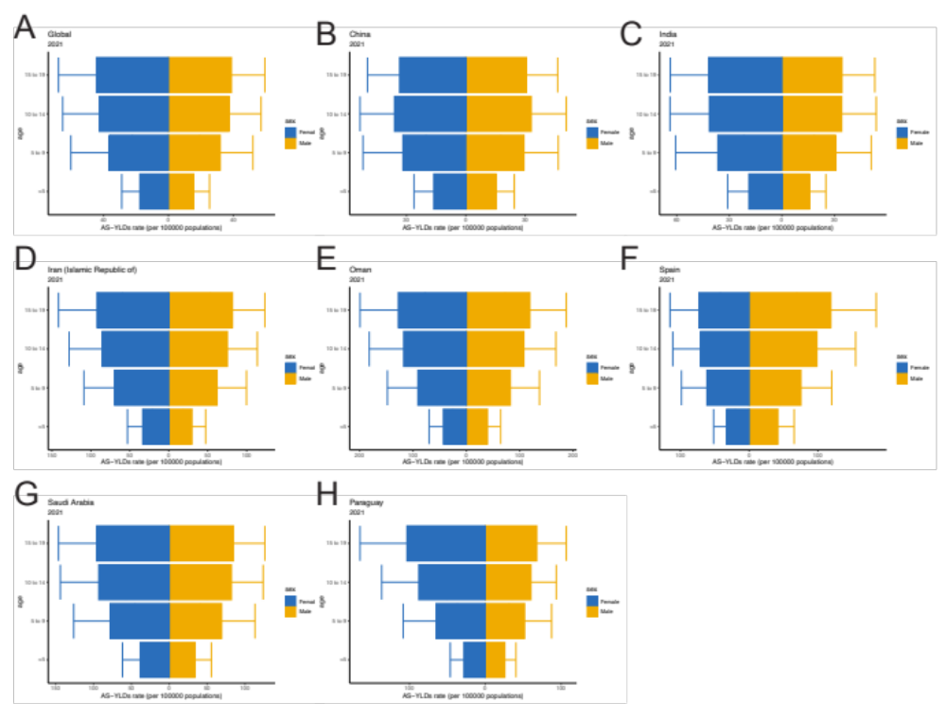
Supplementary Figure 16. Subgroup distribution by age and sex of AS-YLDs rate among children and adolescents stratified by region, 2021: (A) Global; (B) China; (C) India; (D) Iran (Islamic Republic of); (E) Oman; (F) Spain; (G) Saudi Arabia; (H) Paraguay. AS-YLDs, age-standardized years lived with disability.

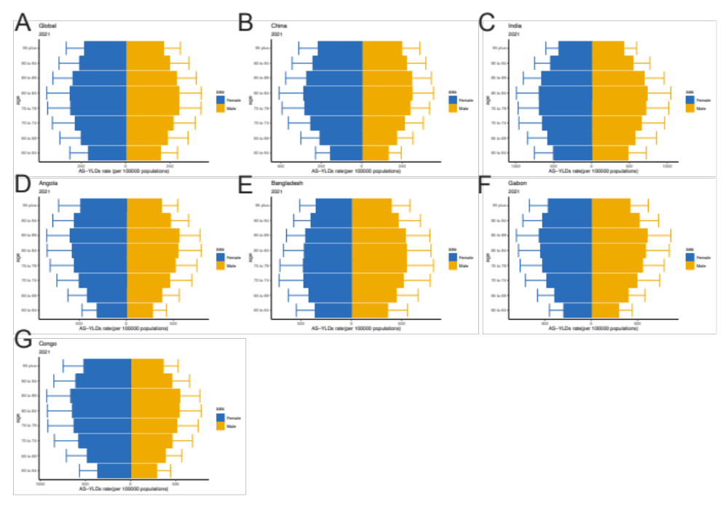
Supplementary Figure 17. Subgroup distribution by age and sex of AS-YLDs rate among old adults stratified by region, 2021 (excluding India). (A) Global; (B) China; (C) India; (D) Angola; (E) Bangladesh; (F) Gabon; (G) Congo. AS-YLDs, age-standardized years lived with disability.

