Supplementary Material
for

Analysis of factors driving HPV vaccination coverage and associated cost savings in the United States

Shanshan Wang, MSPH ^{1*}
Sanjana Muthukrishnan, MA¹
Sabiha Quddus, MS ¹
Susan H. Manning, PhD ¹
Heather M. Brandt, PhD ²

1 Center for Healthcare Economics and Policy, FTI Consulting, Washington, DC
2 HPV Cancer Prevention Program, Epidemiology and Cancer Control Department, St. Jude Children's Research Hospital, 262 Danny Thomas Place, Memphis, TN

*Corresponding author: susan.manning@fticonsulting.com

Supplementary Material

S1. State-wise Medicaid Eligibility Criteria (Age 6-18, Expansion States vs. Non-expansion States)
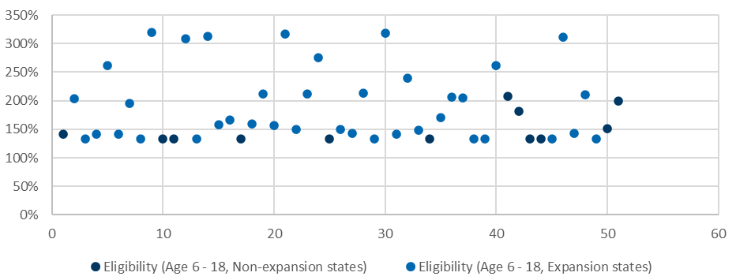
Source: Medicaid, Children's Health Insurance Program, & Basic Health Program Eligibility Levels, Medicaid.gov, 2022.[1]

S2. State-wise HPV Vaccine Uptake Rates (2021)
State | HPV Vaccine Initiation (2021) | HPV Vaccine Completion (2021)
U.S. Average | 76.90% | 61.70%
Alabama | 78.50% | 62.50%
Alaska | 70.30% | 56.20%
Arizona | 81.30% | 61.70%
Arkansas | 73.20% | 56.80%
California | 81.70% | 69.00%
Colorado | 80.00% | 69.20%
Connecticut | 77.90% | 66.40%
Delaware | 83.50% | 68.90%
District Of Columbia | 89.60% | 79.40%
Florida | 67.70% | 49.00%
Georgia | 78.60% | 60.90%
Hawaii | 83.80% | 69.30%
Idaho | 78.80% | 61.60%
Illinois | 76.60% | 62.20%
Indiana | 72.10% | 55.20%
Iowa | 79.20% | 66.10%
Kansas | 76.50% | 64.30%
Kentucky | 70.30% | 57.00%
Louisiana | 81.10% | 63.90%
Maine | 77.50% | 61.50%
Maryland | 85.50% | 71.90%
Massachusetts | 89.30% | 75.00%
Michigan | 79.00% | 64.70%
Minnesota | 79.90% | 65.70%
Mississippi | 56.20% | 32.70%
Missouri | 76.20% | 59.30%
Montana | 75.30% | 52.60%
Nebraska | 82.70% | 61.90%
Nevada | 76.10% | 56.50%
New Hampshire | 84.60% | 72.30%
New Jersey | 65.40% | 54.80%
New Mexico | 80.90% | 57.90%
New York | 75.90% | 64.40%
North Carolina | 85.00% | 67.80%
North Dakota | 83.80% | 72.20%
Ohio | 72.40% | 62.20%
Oklahoma | 72.40% | 56.70%
Oregon | 82.30% | 67.00%
Pennsylvania | 77.70% | 68.70%
Rhode Island | 90.10% | 83.20%
South Carolina | 81.80% | 62.10%
South Dakota | 87.40% | 74.70%
Tennessee | 75.30% | 56.50%
Texas | 71.30% | 51.50%
Utah | 80.90% | 61.40%
Vermont | 83.40% | 66.70%
Virginia | 77.30% | 64.90%
Washington | 79.00% | 67.80%
West Virginia | 70.50% | 56.40%
Wisconsin | 82.40% | 63.30%
Wyoming | 64.80% | 48.00%
Source: National Center for Immunization and Respiratory Diseases, The 2021 National Immunization Survey - Teen, U.S. Department of Health and Human Services (DHHS), 2021, Centers for Disease Control and Prevention. [2]
In 2021, half of the non-Medicaid expansion states had a higher vaccine initiation rate than the national average of 76.90%, including South Dakota (87.4%), North Carolina (85%), Wisconsin (82.4%), South Carolina (81.8%), Georgia (78.6%), and Alabama (78.5%). Among these, five states also had a higher vaccine completion rate than the national average of 61.70%.[2]

S3. HPV Vaccine Initiation (Non-Medicaid Expansion States)
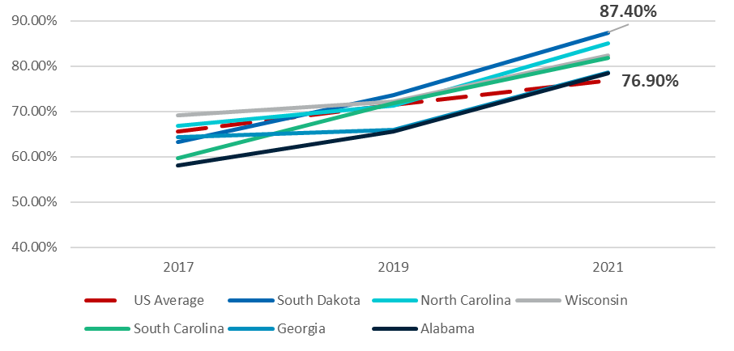
Source: National Center for Immunization and Respiratory Diseases, The 2021 National Immunization Survey - Teen, U.S. Department of Health and Human Services (DHHS), 2021, Centers for Disease Control and Prevention. [2]
Wisconsin had higher HPV vaccine initiation rates than the national average in each year from 2017 to 2021. South Dakota was lower than the national average in 2017 and 2018 but surpassed it in 2019. Alabama only achieved a higher-than-average initiation rate in 2021. North Carolina, South Carolina, and Georgia had no consistent trend, with some years being above average and others below.[2]

S4. HPV Vaccine Completion (Non-Medicaid Expansion States)
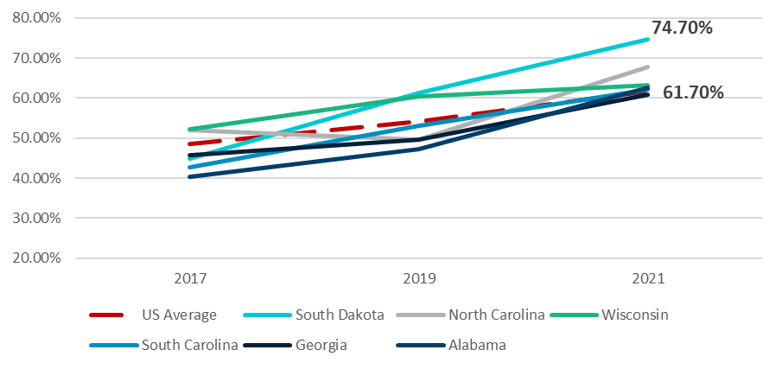
Source: National Center for Immunization and Respiratory Diseases, The 2021 National Immunization Survey - Teen, U.S. Department of Health and Human Services (DHHS), 2021, Centers for Disease Control and Prevention. [2]

S5. Regression Results for Impact of Demographic and Policy Factors on HPV Vaccine Initiation and Completion (Sensitivity Analysis)
Variable | Initiation (percentage points) | Completion (percentage points)
Percentage of the population living in rural geographic regions | -0.08 | -0.49*
Number of Pediatricians per 100,000 children | 0.00** | 0.01***
Number of childhood vaccines required by each state | -1.27*** | -0.71***
Percentage of children aged 13-17 who received at least one dose of the meningococcal vaccine | 25.26*** | 20.54***
Medicaid income eligibility criteria (as % of FPL) for children aged 6 – 18 | 1.54*** | 1.60***
Percentage of parents in a state who are college graduates or higher | 0.22 | 20.32***
Percentage of public insurance among children under the age of 19 per county | 2.88*** | 4.06***
Number of VFCs per 100,000 children | 0.004*** | 0.01***
COVID-19 death rates per 100,000 population in 2021 | -0.08*** | -0.09***

References

1. Medicaid.gov. Medicaid, Children's Health Insurance Program, & Basic Health Program Eligibility Levels. 2022; Available from: https://www.medicaid.gov/medicaid/national-medicaid-chip-program-information/medicaid-childrens-health-insurance-program-basic-health-program-eligibility-levels/index.html.
2. National Center for Immunization and Respiratory Diseases, The 2021 National Immunization Survey - Teen, U.S. Department of Health and Human Services (DHHS), Editor. 2022, Centers for Disease Control and Prevention: Atlanta, GA.

