Supplementary Tables & Figures

Supplementary Table 1: Key terms and codes used in regular expression searches.

Housing Instability | Low Income
boarding home, boarding house, chaotic housing, complicated housing, correctional facil*, couch surf, evict, foreclos*, fragily housed, group home, hoarder, homeless, hostel, housing (concern, crisis, insecur*, issue, instability), inadequate hous*, issue with hous*, kicked out of house, lost home, lack of stable housing, mortgage assist, [space]motel[space], [space]nfa[space], no fixed address, on street, prison, public housing, rent geared/rent-geared, rooming (house, home), rough sleeping, shelter, sleeping rough[space], social hous*, subsidized hous*, supportive hous*, tenuous housing, trouble with housing, transitional hous*, underhous*, unstable hous* | affordable med, bankruptcy, cannot afford, comfort (closet, fund), difficulty maintaining employment, disability income, employment difficulties, financial (concern, constraint, difficult, issue, strain, stress), fixed income, food insecurity, grocery card, income (concern, security, support), job loss, lack of (income, resources), limited income, losing job, loss of job, lost job, low income, low personal income, low household income, minimal income, money (issue, struggle), no income, not afford, not employed, odsp, on disability, ontario works, [space]ow[space], poverty, refer to income security, struggling with income, unable to afford, unemploy, unstable employ, welfare

Supplementary Table 2: Hyper-parameters associated with the extreme gradient boosting model, and the generating distributions used to sample hyper-parameter values for each hyper-parameter optimization experiment.

Model | Hyper-parameter | Abbreviation | Default Value | Generating Distribution
Extreme Gradient Boosting Model | Number of Boosting Rounds | “trees” | None | Categorical (100, 250, 500, 1000, 2500, 5000)
 | Learning Rate | “lr” | 0.3 | Categorical (1.0, 0.1, 0.01, 0.001, 0.0001, 0.00001)
 | Maximum Tree Depth | “depth” | 6 | Categorical (1, 2 ,3, 5, 7, 10, 15)
 | Minimum Leaf Weight | “cw” | 1 | Categorical (1)
 | Gamma Regularization | “gamma” | None | Categorical (0, 0.1, 1.0)
 | Alpha Regularization | “alpha” | 0 | Categorical (0, 0.1, 1.0)
 | Lambda Regularization | “lambda” | 1 | Categorical (0, 0.1, 1.0)
 | Row Sample Fraction | “rowsample” | 1 | Categorical (0.1, 0.25, 0.50, 1.0)
 | Column Sample Fraction | “colsample” | 1 | Categorical (0.1, 0.25, 0.50, 1.0)

Supplementary Figure 1: LOESS smoothed calibration curve, estimated on the randomly selected held-out test dataset for the a) housing cohort and b) income cohort.
a) b)
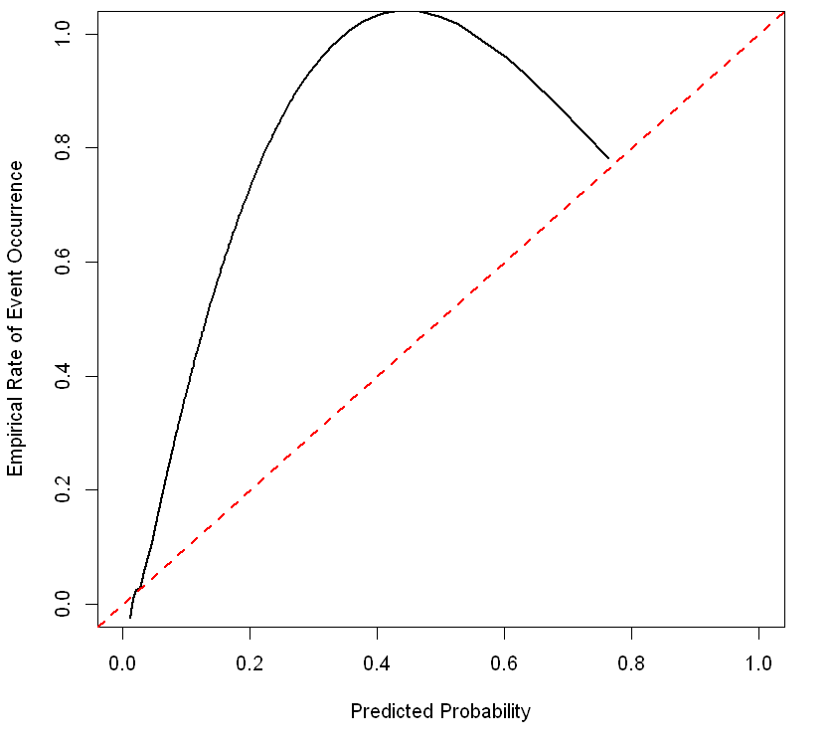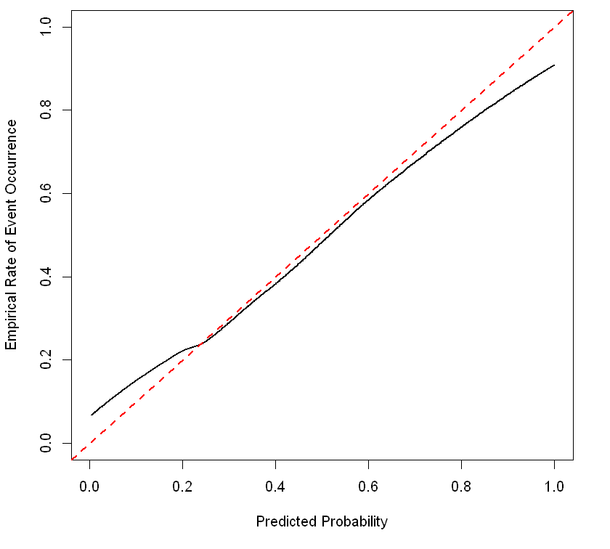

Supplementary Figure 2: Area Under the Curve (AUC) estimated on a randomly chosen validation dataset in the a) housing cohort and b) income cohort, for each of the N=50 budgeted hyper-parameter optimization experiments.

a) b)
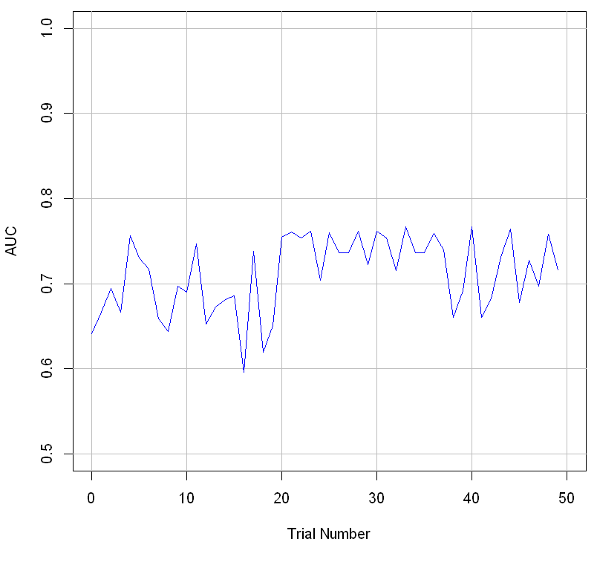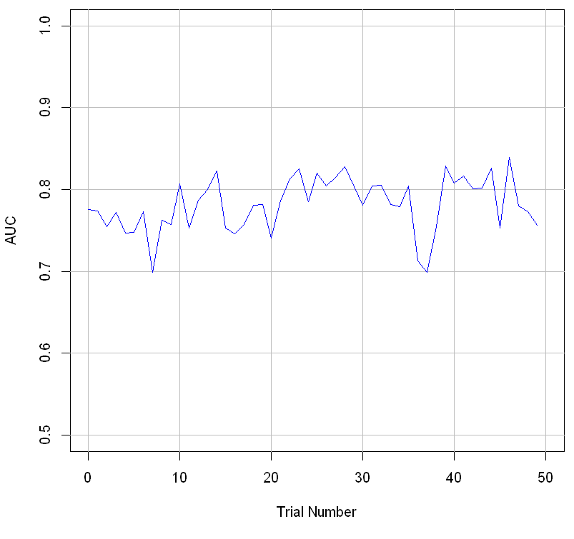
Supplementary Table 3: Distribution of outcome, age, and sex in the training/validation/test datasets for the housing cohort.

 | Training Dataset  (N=7031) | Validation Dataset (N=2308) | Test Dataset (N=2455)
Housing Instability
Yes | 393 (5.6%) | 141 (6.1%) | 162 (6.6%)
No | 6638 (94.4%) | 2167 (93.9%) | 2293 (93.4%)
Mean age in years (SD) | 44.4 (14.8) | 44.9 (15.1) | 45.4 (15.4)
Sex
Female | 4086 (58.1%) | 1297 (56.2%) | 1403 (57.1%)
Male | 2945 (41.9%) | 1011 (43.8%) | 1052 (42.9%)
SD=standard deviation

Supplementary Table 4: Distribution of outcome, age, and sex in the training/validation/test datasets for the income cohort.

 | Training Dataset  (N=6285) | Validation Dataset  (N=2091) | Test Dataset  (N=2078)
Low Income
Yes | 1970 (31.3%) | 644 (30.8%) | 630 (30.3%)
No | 4315 (68.7%) | 1447 (69.2%) | 1448 (69.7%)
Mean age in years (SD) | 45.2 (14.7) | 44.4 (14.6) | 45.0 (14.9)
Sex
Female | 3530 (56.2%) | 1166 (55.8%) | 1109 (53.4%)
Male | 2755 (43.8%) | 925 (44.2%) | 969 (46.6%)
SD=standard deviation

Supplementary Table 5: Validation dataset AUC metric, hyper-parameter optimization time, and optimally identified hyper-parameter configurations for the tree Parzen estimator experiments, applied to the binary XGBoost classifier in the housing and income cohorts.
Cohort | Experiment | Validation AUC | Hyper-Parameter Optimization Time  (Hours) | Optimal Hyper-Parameter Configuration
Housing | Tree Parzen Estimator | 0.839 | 3.83 | trees=5000; lr=0.001; depth=10; cw=1; gamma=0.1; lambda=0.0; alpha=1.0; colsample=0.25; subsample=1.0
Income | Tree Parzen Estimator | 0.767 | 4.41 | trees=500; lr=0.1; depth=5; cw=1; gamma=0.0; lambda=1.0; alpha=0.1; colsample=0.25; subsample=1.0

AUC=area under the curve

Supplementary Table 6: Count and proportion of completed HEQ surveys between 2013 and 2021 (study time period).

Year of HEQ completion | Patients completing HEQ,  n (%) | Patients completing HEQ & indicating housing instability, n (%) | Patients completing HEQ & indicating low income, n (%)
2013 | 220 (1) | 11 (6) | 59 (37)
2014 | 5046 (29) | 241 (5) | 1098 (29)
2015 | 4025 (23) | 215 (6) | 1034 (33)
2016 | 1517 (9) | 79 (6) | 389 (33)
2017 | 1643 (10) | 84 (6) | 402 (32)
2018 | 2038 (12) | 109 (7) | 474 (32)
2019 | 1899 (11) | 91 (6) | 355 (27)
2020 | 668 (4) | 16 (3) | 88 (20)
2021 | 128 (1) | 5 (5) | 24 (29)
HEQ=Health Equity Questionnaire

Supplementary Table 7: Confusion matrix between patient-reported housing insecurity and both the a) XGBoost model and b) REGEX / pattern-matching predicted housing insecurity on the randomly selected held-out test dataset.

 |  | Patient Self-Reported Outcome (HEQ)
 |  | Housing instability: No | Housing instability: Yes
XGBoost Predicted Outcome | Housing instability: No | 2292 | 157
XGBoost Predicted Outcome | Housing instability: Yes | 1 | 5
a)

 |  | Patient Self-Reported Outcome (HEQ)
 |  | Housing instability: No | Housing instability: Yes
REGEX Predicted Outcome | Housing instability: No | 2243 | 115
REGEX Predicted Outcome | Housing instability: Yes | 50 | 47
b)

HEQ=Health Equity Questionnaire, REGEX=regular expression

Supplementary Table 8: Discrimination statistics for the housing instability XGBoost model stratified by age group and sex.

Metric | All Patients | Males | Females | Aged 18-39 | Aged 40-65 | Aged >65
Sensitivity,  95% CI (lower, upper) | 3.1  (0.4, 5.7) | 2.3  (-0.9, 5.5) | 3.9  (-0.4, 8.3) | 0  (0, 0) | 5.2  (0.8, 9.7) | 0  (0, 0)
Specificity,  95% CI (lower, upper) | 99.9  (99.9, 100) | 99.9  (99.7, 100) | 100  (100, 100) | 100  (100, 100) | 99.9  (99.7, 100) | 100  (100, 100)
PPV,  95% CI (lower, upper) | 83.3  (53.5, 100) | 66.7  (13.3, 100) | 100  (100, 100) | n/a | 83.3  (53.5, 100) | n/a
NPV,  95% CI (lower, upper) | 93.6  (92.6, 94.6) | 92.0  (90.3, 93.6) | 94.8  (93.6, 96.0) | 95.5  (94.2, 96.7) | 91.5  (89.9, 93.2) | 94.2  (91.7, 96.8)
Note: n/a indicates calculation of PPV was not available due to small number of cases in the low income cohort were unavailable when stratified.
CI=confidence interval, NPV=negative predictive value, PPV=positive predictive value

Supplementary Table 9. Discrimination statistics for the housing instability REGEX classifier stratified by age group and sex.

Metric | All Patients | Males | Females | Aged 18-39 | Aged 40-65 | Aged >65
Sensitivity,  95% CI (lower, upper) | 29.0  (22.0, 36.0) | 37.2  (27.0, 47.4) | 19.7  (10.8, 28.7) | 29.2  (16.3, 42.0) | 29.2  (20.1, 38.3) | 27.8  (7.1, 48.5)
Specificity,  95% CI (lower, upper) | 97.8  (97.2, 98.4) | 98.2  (97.4, 99.1) | 97.5  (96.7, 98.4) | 97.7  (96.8, 98.6) | 97.7  (96.7, 98.6) | 98.6  (97.3, 99.9)
PPV,  95% CI (lower, upper) | 48.5  (38.5, 58.4) | 65.3  (52.0, 78.6) | 31.3  (18.1, 44.4) | 37.8  (22.2, 53.5) | 54.9  (41.2, 68.6) | 55.6  (23.1, 88.0)
NPV,  95% CI (lower, upper) | 95.1  (94.3, 96.0) | 94.6  (93.2, 96.0) | 95.5  (94.4, 96.6) | 96.7  (95.6, 97.8) | 93.4  (91.9, 94.9) | 95.7  (93.4, 98.0)
CI=confidence interval, NPV=negative predictive value, PPV=positive predictive value, REGEX=regular expression

Supplementary Table 10: Confusion matrix between patient-reported low income and both the a) XGBoost model and b) REGEX / pattern-matching predicted low income on the randomly selected held-out test dataset.

 |  | Patient Self-Reported Outcome (HEQ)
 |  | Low income: No | Low income: Yes
XGBoost Predicted Outcome | Low income: No | 1350 | 367
XGBoost Predicted Outcome | Low income: Yes | 98 | 263
a)

 |  | Patient Self-Reported Outcome (HEQ)
 |  | Low income: No | Low income: Yes
REGEX Predicted Outcome | Low income: No | 1368 | 519
REGEX Predicted Outcome | Low income: Yes | 80 | 111
b)

HEQ=Health Equity Questionnaire, REGEX=regular expression

Supplementary Table 11: Discrimination statistics for the low income XGBoost model stratified by age group and sex.

Metric | All Patients | Males | Females | Aged 18-39 | Aged 40-65 | Aged >65
Sensitivity,  95% CI (lower, upper) | 41.7  (37.9, 45.6) | 46.0  (40.2, 51.8) | 38.2  (33.1, 43.3) | 38.4  (32.7, 44.1) | 48.1  (42.2, 53.9) | 29.6  (19.0, 40.2)
Specificity,  95% CI (lower, upper) | 93.2  (91.9, 94.5) | 93.3  (91.4, 95.1) | 93.2  (91.4, 95.0) | 93.6  (91.7, 95.5) | 92.6  (90.5, 94.6) | 94.3  (90.8, 97.7)
PPV,  95% CI (lower, upper) | 72.9  (68.3, 77.4) | 74.2  (67.7, 80.6) | 71.6  (65.1, 78.1) | 72.1  (64.9, 79.4) | 74.3  (68.0, 80.6) | 67.7  (51.3, 84.2)
NPV,  95% CI (lower, upper) | 78.6  (76.7, 80.6) | 80.4  (77.6, 83.2) | 77.1  (74.4, 79.8) | 78.0  (75.1, 80.9) | 79.9  (77.0, 82.8) | 76.6  (71.0, 82.3)
CI=confidence interval, NPV=negative predictive value, PPV=positive predictive value

Supplementary Table 12: Discrimination statistics for the low income REGEX model stratified by age group and sex.

Metric | All Patients | Males | Females | Aged 18-39 | Aged 40-65 | Aged >65
Sensitivity,  95% CI (lower, upper) | 17.6  (14.6, 20.6) | 20.2  (15.6, 24.9) | 15.5  (11.6, 19.3) | 15.9  (11.6, 20.3) | 21.6  (16.8, 26.3) | 8.5  (2.0, 14.9)
Specificity,  95% CI (lower, upper) | 94.5  (93.3, 95.7) | 94.6  (92.9, 96.3) | 94.4  (92.8, 96.0) | 94.9  (93.2, 96.6) | 93.2  (91.2, 95.2) | 97.7  (95.5, 99.9)
PPV,  95% CI (lower, upper) | 58.1  (51.1, 65.1) | 61.1  (51.2, 70.9) | 55.2  (45.3, 65.2) | 57.1  (46.1, 68.2) | 58.7  (49.2, 68.1) | 60.0  (29.6, 90.4)
NPV,  95% CI (lower, upper) | 72.5  (70.5, 74.5) | 73.8  (70.9, 76.7) | 71.4  (68.6, 74.2) | 72.4  (69.4, 75.5) | 72.3  (69.5, 75.7) | 72.3  (66.6, 78.1)
CI=confidence interval, NPV=negative predictive value, PPV=positive predictive value, REGEX=regular expression

