Supplementary Content
Supplement 1 Forest plot showing the association between luminal B and mortality of breast cancer compared with Luminal A. 2
Supplement 2 Forest plot showing the association between Lumpectomy with radiation and mortality of breast cancer. 2
Supplement 3 Forest plot showing the association between chemotherapy with trastuzumab and mortality of breast cancer. 4
Supplement 4 Forest plot showing the association between high allostatic load and mortality of breast cancer. 4
Supplement 5 Forest plot showing the association between advance ECOG PS and mortality of breast cancer. 4
Supplement 6 Forest plot showing the association between hormonal therapy and mortality of breast cancer. 5
Supplement 7 Forest plot showing the association between surgery therapy and mortality of breast cancer. 5
Supplement 8 Forest plot showing the association between chemotherapy and mortality of breast cancer. 6
Supplement 9 Forest plot showing the association between PR positive and mortality of breast cancer. 6
Supplement 10 Forest plot showing the association between ER positive and mortality of breast cancer. 7
Supplement 11 Forest plot showing the association between HIV positive and mortality of breast cancer. 7
Supplement 12 Forest plot showing the association between lymph node positive and mortality of breast cancer 8
Supplement 13 Forest plot showing the association between diabetes and mortality of breast cancer 8
Supplement 14 Forest plot showing the association between large tumor size and mortality of breast cancer 9
Supplement 15 Forest plot showing the association between advanced grade and mortality of breast cancer 10
Supplement 16 Forest plot showing the association between advanced stage and mortality of breast cancer 11
Supplement 17 Forest plot showing the association between postmenopausal and mortality of breast cancer 12
Supplement 18 Forest plot showing the association between obese and mortality of breast cancer 12
Supplement 19 Forest plot showing the association between black race and mortality of breast cancer 13
Supplement 20 Forest plot showing the effects of age on mortality of breast cancer. 14
Supplement 21 Forest plot showing the effects of highest education on mortality of breast cancer. 15
Supplement 22 Forest plot showing the effects of smoking status on mortality of breast cancer. 15
Supplement 23 Characteristics of studies included in the systematic review and meta-analysis. 16
Supplement 24 Risk of bias assessment of studies included in the meta-analysis by the Newcastle-Ottawa Scale 24
Supplement 25 Full Search Strings Used in Each Database 28
Supplement 26: Meta-regression outputs 28

Supplement 1 Forest plot showing the association between luminal B and mortality of breast cancer compared with Luminal A.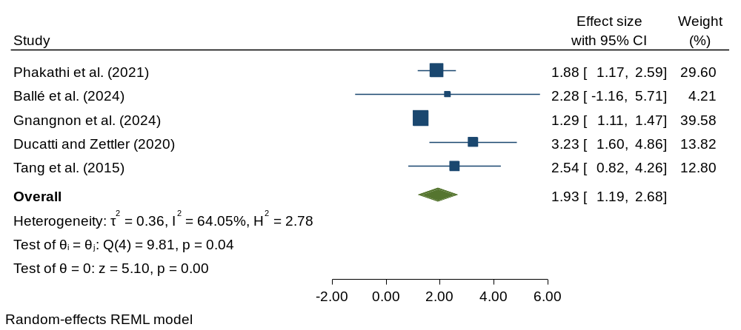
Supplement 2 Forest plot showing the association between Lumpectomy with radiation and mortality of breast cancer.
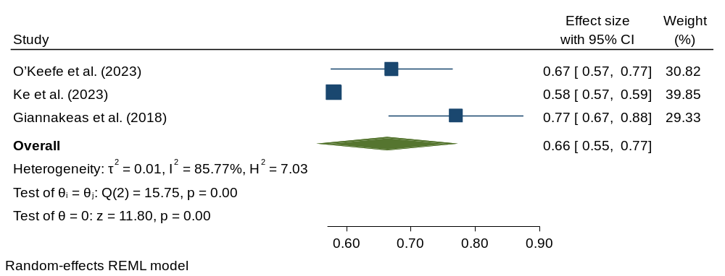

Supplement 3 Forest plot showing the association between chemotherapy with trastuzumab and mortality of breast cancer.
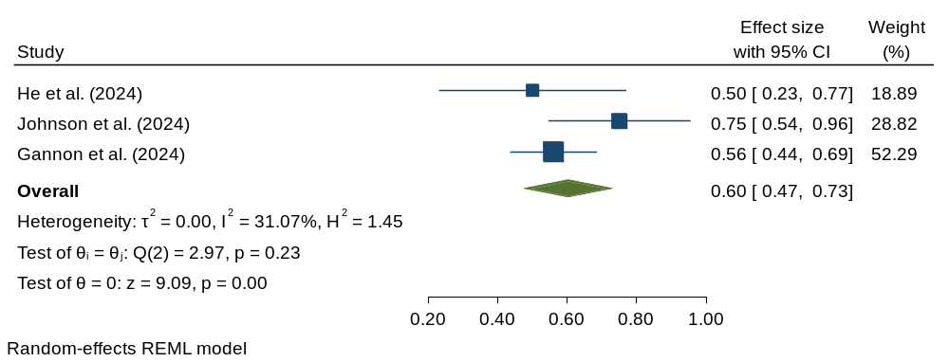
Supplement 4 Forest plot showing the association between high allostatic load and mortality of breast cancer.
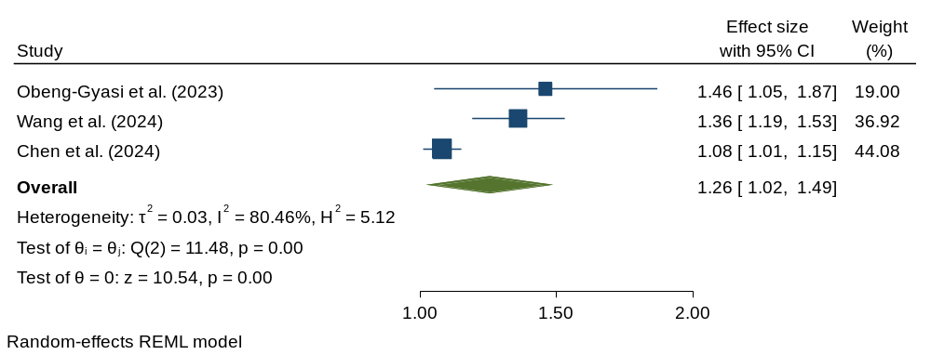
Supplement 5 Forest plot showing the association between advance ECOG PS and mortality of breast cancer.
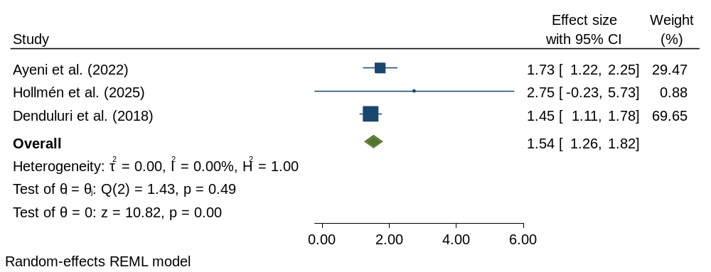
Supplement 6 Forest plot showing the association between hormonal therapy and mortality of breast cancer.
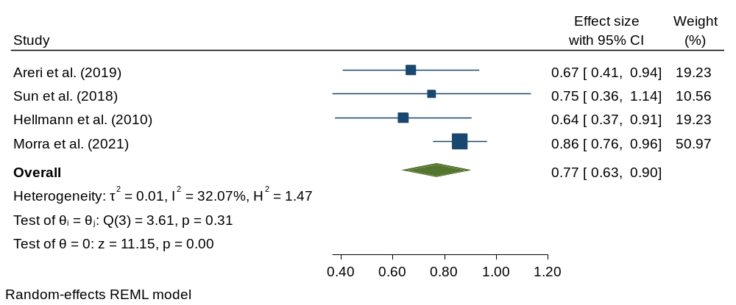
Supplement 7 Forest plot showing the association between surgery therapy and mortality of breast cancer.
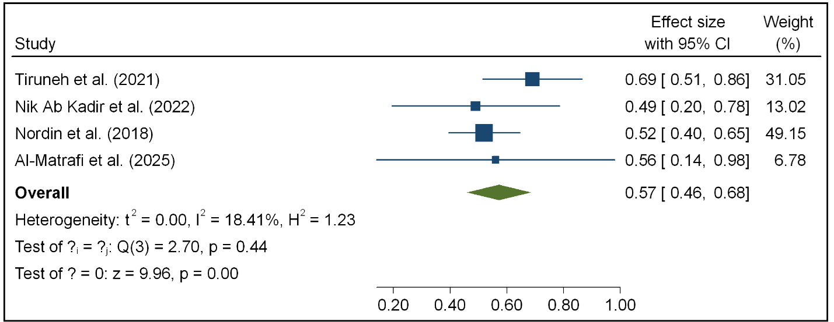

Supplement 8 Forest plot showing the association between chemotherapy and mortality of breast cancer.
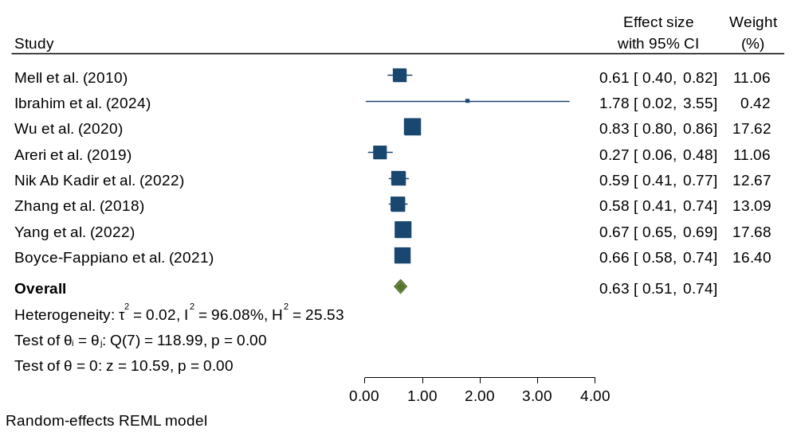
Supplement 9 Forest plot showing the association between PR positive and mortality of breast cancer.
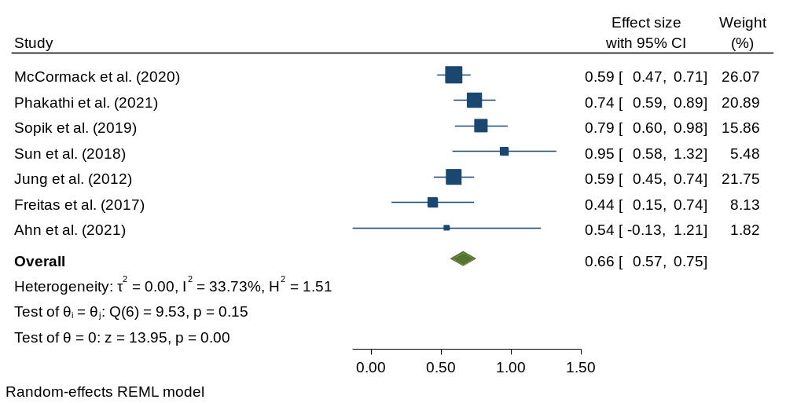

Supplement 10 Forest plot showing the association between ER positive and mortality of breast cancer.
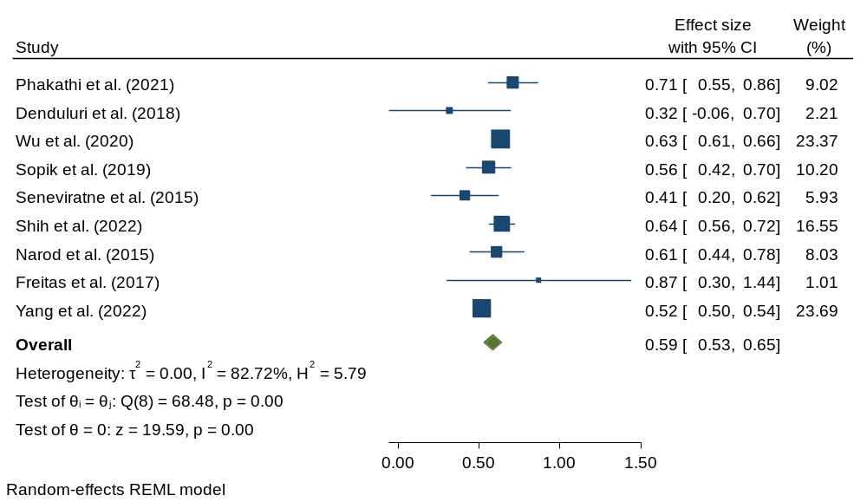
Supplement 11 Forest plot showing the association between HIV positive and mortality of breast cancer.
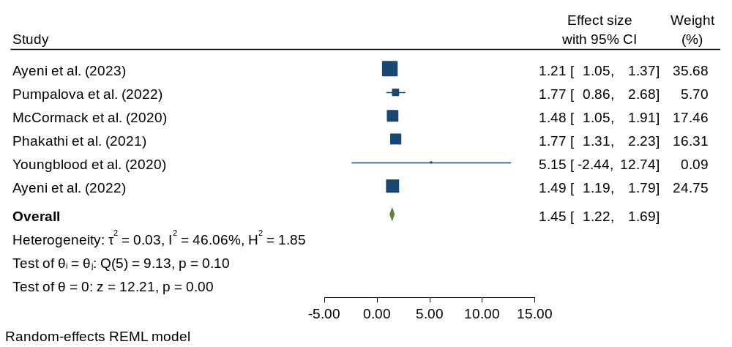

Supplement 12 Forest plot showing the association between lymph node positive and mortality of breast cancer
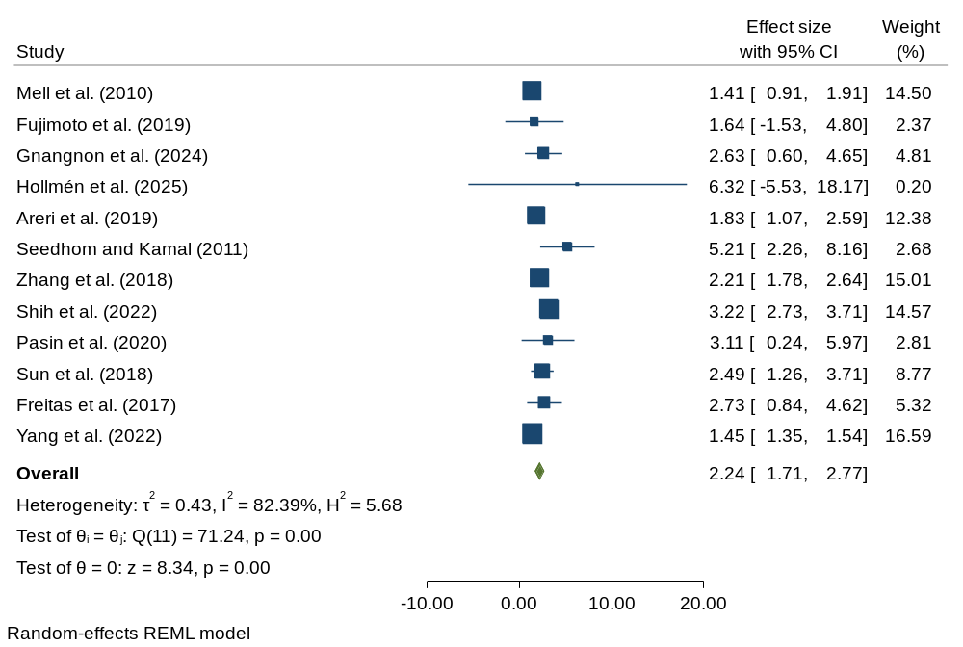
Supplement 13 Forest plot showing the association between diabetes and mortality of breast cancer
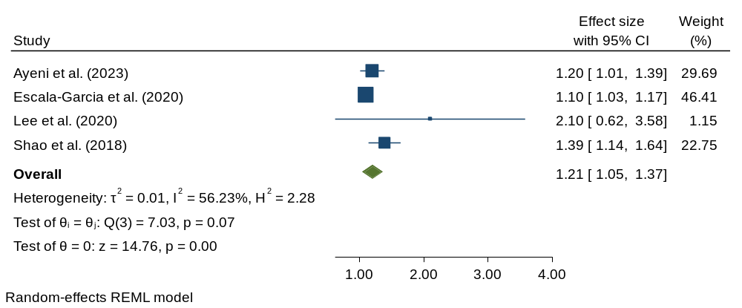

Supplement 14 Forest plot showing the association between large tumor size and mortality of breast cancer
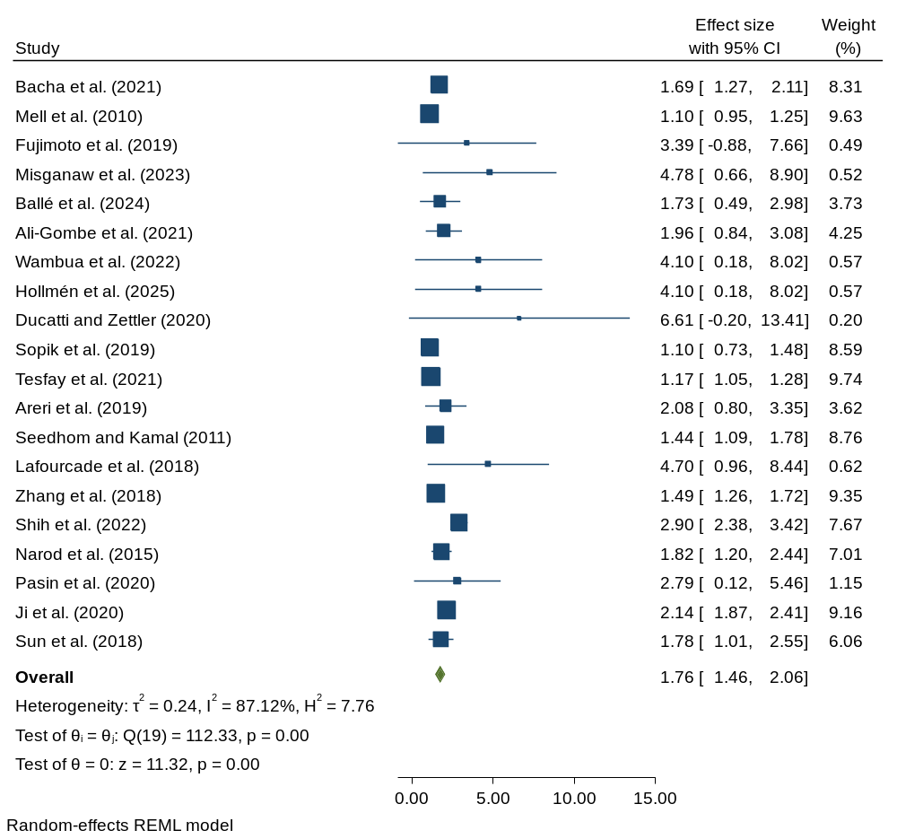
Supplement 15 Forest plot showing the association between advanced grade and mortality of breast cancer
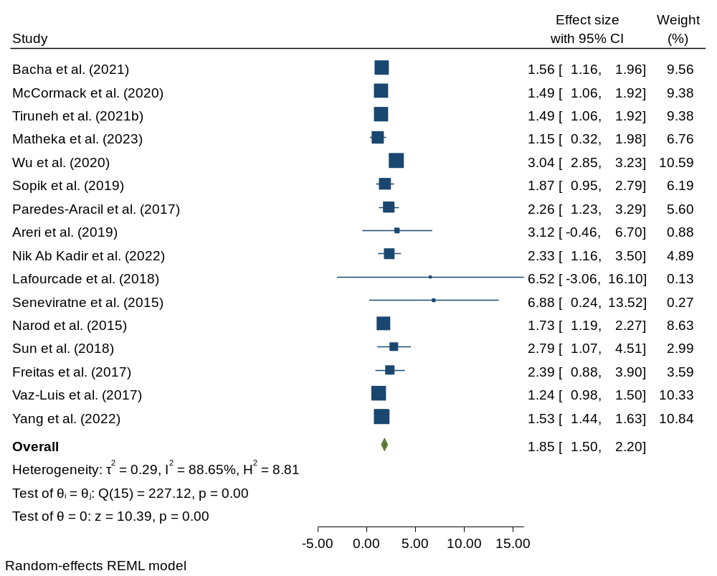

Supplement 16 Forest plot showing the association between advanced stage and mortality of breast cancer
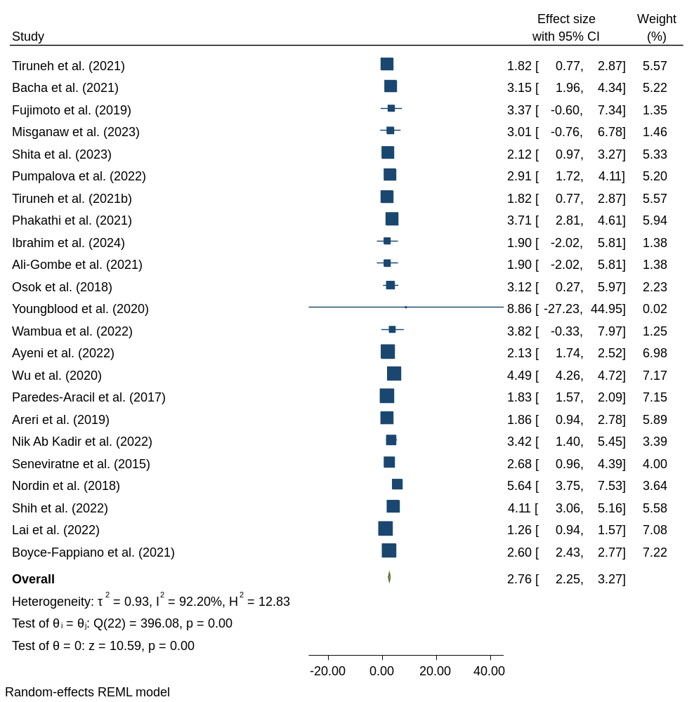

Supplement 17 Forest plot showing the association between postmenopausal and mortality of breast cancer
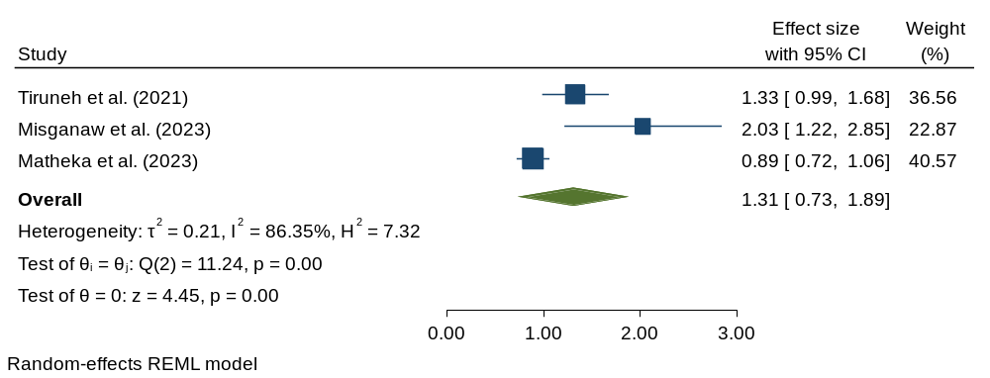
Supplement 18 Forest plot showing the association between obese and mortality of breast cancer
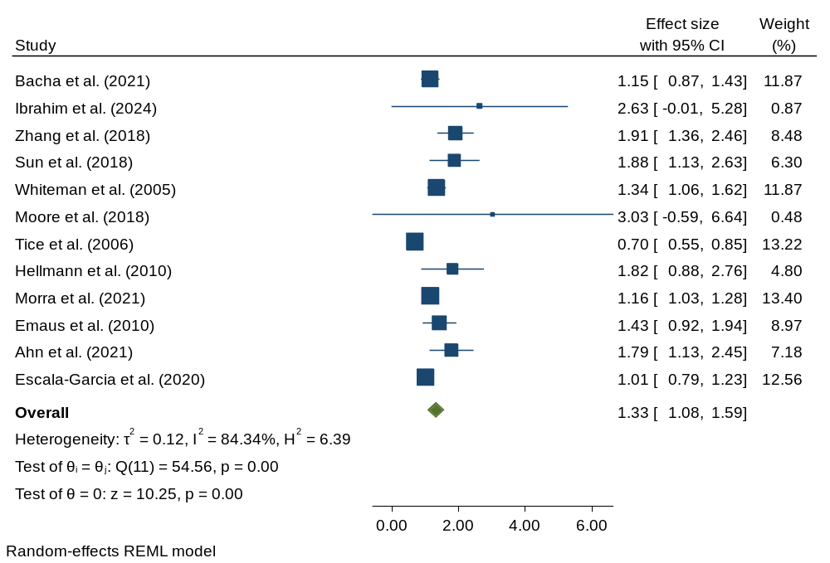

Supplement 19 Forest plot showing the association between black race and mortality of breast cancer
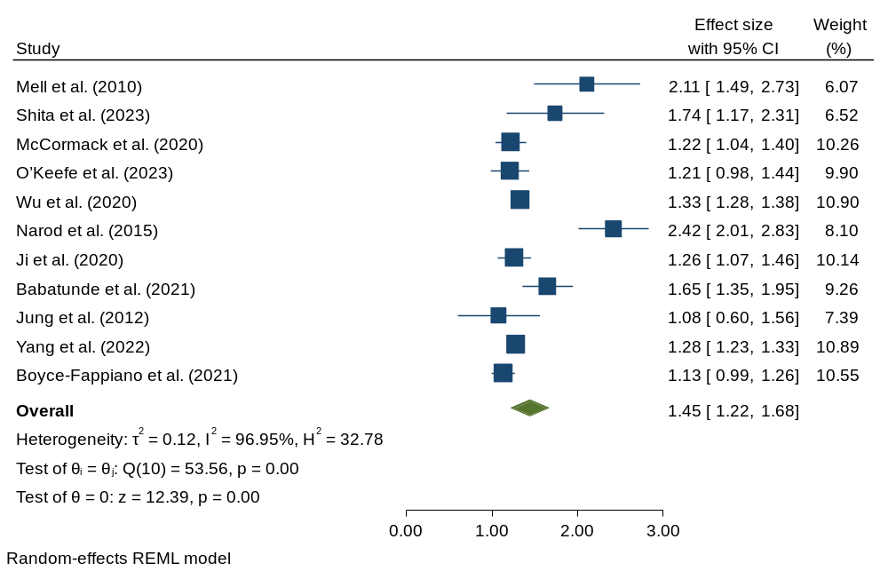

Supplement 20 Forest plot showing the effects of age on mortality of breast cancer.
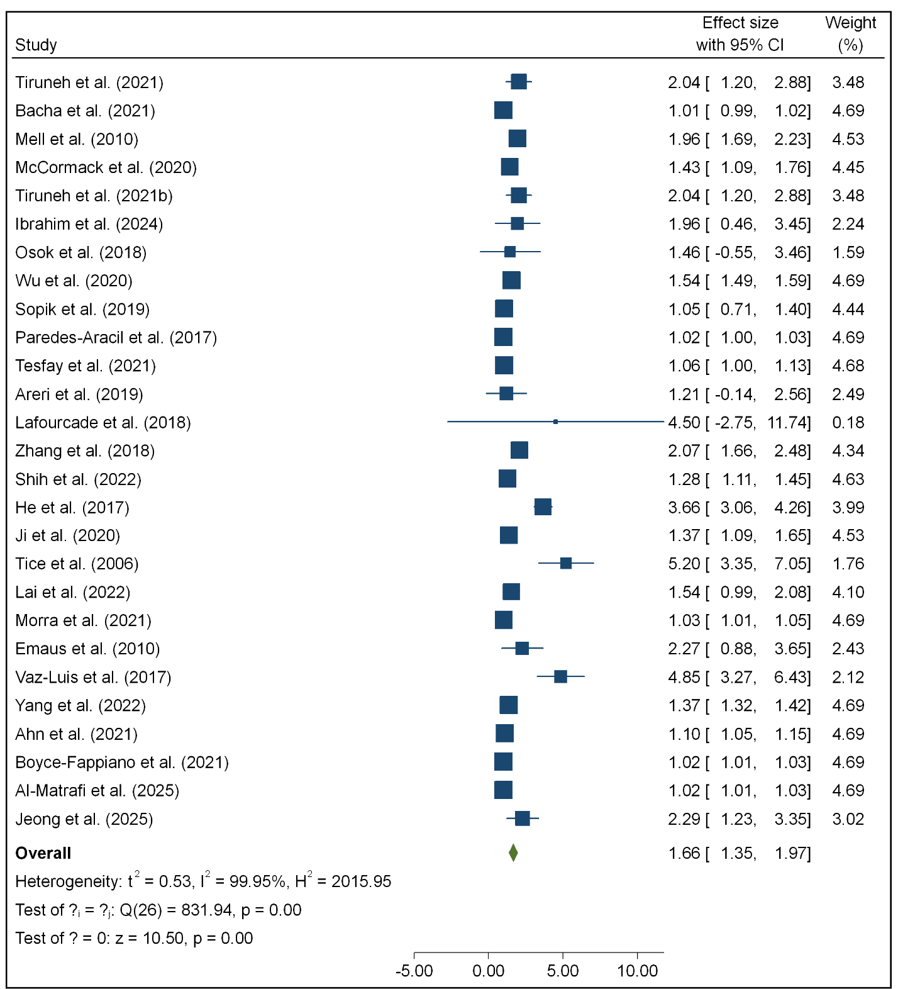

Supplement 21 Forest plot showing the effects of highest education on mortality of breast cancer.
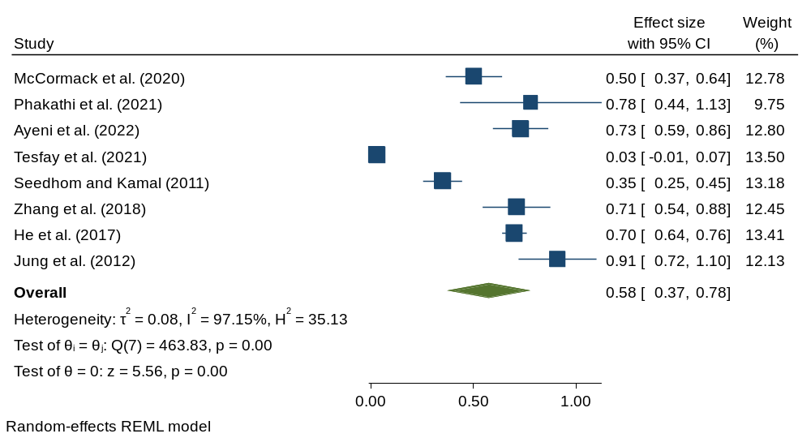
Supplement 22 Forest plot showing the effects of smoking status on mortality of breast cancer.
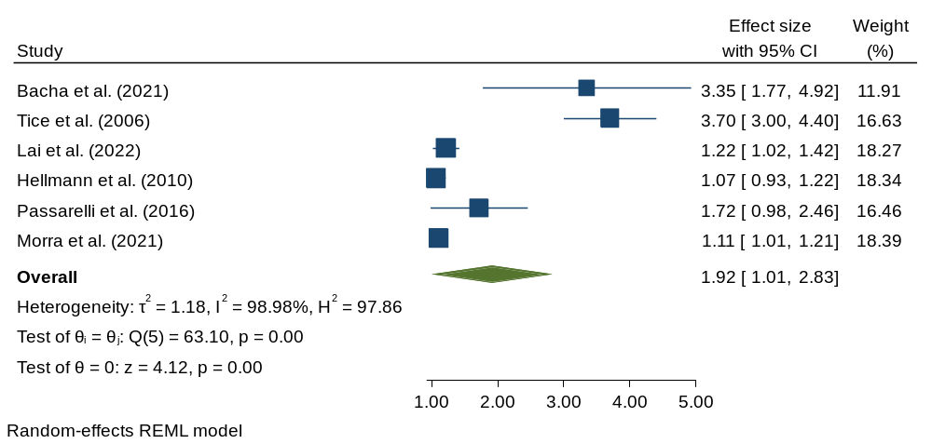

Supplement 23 Characteristics of studies included in the systematic review and meta-analysis.
Authors | Country | Sample size | Number of Death | Stage of Breast Cancer | Confounders Adjusted for and OR or HR  (95%CI)
Tiruneh et al. (2021a) | Ethiopia | 482 | 124 | Stage I–IV | Age: Old: aHR=2.04 (1.36-3.05)  Menopausal status: Post: aHR=1.33 (1.03-1.72)  Stage: advanced: aHR=1.82(1.52-3.62)  Surgical therapy: Yes: aHR=0.69(0.54-0.89)
Bacha et al. (2021) | Ethiopia | 642 | 447 | Stage I–IV | Age: Old: aHR=1.01 (1.00–1.03)  Stage: advanced: aHR=3.15(2.17-4.55)  Obese: Yes: aHR=1.15(0.91-147)  Grade: advanced: aHR=1.56(1.20-2.00)  Large tumor size: aHR=1.69 (1.33–2.17)  Current smoking: Yes: aHR= 3.35 (2.12-5.27)
Mell et al. (2010) | USA | 1231 | 230 | NR | Age: Old: aHR=1.96 (1.70-2.25)  Comorbid disease: Yes: aHR=3.01 (2.22-4.09)  Low SES: Yes: aHR=1.65 (1.23-2.21)  Tumor size: aHR= 1.10 (0.95-1.26)  Black race: Yes: aHR=2.11 (1.58-2.82)  Chemotherapy: Yes: aHR= 0.61 (0.43-0.86)  Lymph node positive: Yes: aHR= 1.41 (1.00-2.00)
Fujimoto et al. (2019) | Brazil | 161 | 44 | Stage I–IV | Tumor size: aHR= 3.39 (1.18-9.71)  Large number of involved lymph nodes: aHR= 1.64 (0.40-6.73)  Stage :advanced: aHR= 3.37 (1.24-9.18)
Misganaw et al. (2023) | Ethiopia | 410 | 143 | Stage I–IV | Residence: Rural: aHR=2.71 (1.44–5.09)  Stage: advanced: aHR= 3.01(1.05-8.59)  Menopause: Post: aHR= 2.03(1.37-3.00)  Hormone therapy: No: aHR= 2.19(1.52, 3.16)  Large tumor size: aHR= 4.78(2.19-10.43)  Comorbidity: Yes: aHR= 1.5(1.01-2.21)
Shita et al. (2023) | Ethiopia | 302 | 67 | Stage I–IV | Residence: Rural: aHR=1.74 (1.26–2.4)  Stage: advanced: aHR= 2.12(1.26-3.55)
Ayeni et al. (2023) | South Africa | 3261 | 1410 | NR | Cerebrovascular disease: Yes: aHR= 1.43 (1.17–1.76)  Diabetes: Yes: aHR= 1.20 (1.03–1.41)  HIV positive: Yes: aHR= 1.21 (1.06–1.38)  Comorbidity: Yes: aHR= 1.26 (1.13–1.40)
Pumpalova et al. (2022) | South Africa | 1260 |  | Stage I–IV | Stage: advanced: aHR= 2.91 (1.95-4.34)  HIV positive: Yes: aHR= 1.77 (1.08-2.90)
McCormack et al. (2020) | Namibia, Nigeria, South Africa, Uganda, and Zambia | 2156 | 879 | NR | Age: Old: aHR=1.43 (1.14–1.81)  Negative PR: Yes: aHR= 1.69 (1.38-2.06)  HIV positive: Yes: aHR= 1.48 (1.12-1.98)  Grade: advanced: aHR=1.49(1.12-1.98)  Education: No formal: aHR=1.99(1.52-2.61)  Residence: Rural: aHR=1.22 (1.05–1.41)  Socioeconomic: Low: aHR=1.51 (1.24–1.94)
Tiruneh et al. (2021b) | Ethiopia | 482 | 125 | Stage I–IV | Age: Old: aHR= 2.04 (1.36, 3.05)  Menopause: Post: aHR= 1.33 (1.03, 1.72)  Stage: advanced: aHR= 1.82 (1.52, 3.62)  Grade: advanced: aHR=1.49(1.12-1.98)  Surgical therapy: Yes: aHR= 0.69 (0.54, 0.89)
Phakathi et al. (2021) | South Africa | 1019 | 446 | Stage I–IV | HIV positive: Yes: aHR= 1.77 (1.37–2.28)  Stage: advanced: aHR= 3.71 (2.92–4.72)  Education: Higher: aHR= 0.78 (0.51–1.20)  Positive ER: Yes: aHR= 0.71 (0.57–0.88)  Positive PR: Yes: aHR= 0.74 (0.60–0.90)  Subtype: Luminal B vs Luminal A: aHR: 1.88 (1.30–2.72)
Ballé et al. (2024) | Ethiopia | 79 | 33 | NR | Large tumor size: aHR= 1.73 (0.89–3.38)  Subtype: Luminal B vs Luminal A: aHR: 2.28 (0.67–7.76)
O’Keefe et al. (2023) | USA | 29,515 | 208 |  | Black race: Yes: aHR= 1.21 (1.01–1.46)  Lumpectomy with radiation: aHR= 0.67 (0.58-0.77)
Ke et al. (2023) | China | 205788 | 30341 | NR | Lumpectomy with radiation: aHR= 0.58(0.57-0.59)
Giannakeas et al. (2018) | Canada | 140366 | 3271 | NR | Lumpectomy with radiation: aHR= 0.77 (0.67-0.88)
He et al. (2024) | China | 625 | 87 | NR | Chemotherapy with trastuzumab: aHR= 0.50 (0.30–0.84)
Johnson et al. (2024) | USA | 1184 |  | NR | Chemotherapy with trastuzumab: yes: aHR= 0.75 (0.57–0.98)
Gannon et al. (2024) | England | 5238 |  | NR | Chemotherapy with trastuzumab: yes: aHR= 0.56 ( 0.45–0.70)
Ibrahim et al. (2024) | Nigeria | 265 | 161 | Stage I–IV | Age: Old: aOR= 1.956 (1.341-4.333)  Obesity: Yes: aOR= 2.635 (1.485-6.778)  Stage: advanced: aOR= 1.895 (1.146-8.974)  Chemotherapy: No: aOR= 1.785 (1.092-4.63)
Ali-Gombe et al. (2021) | Nigeria | 378 |  | Stage I–IV | Large tumor size: aHR= 1.96(1.14-3.37)  Stage: advanced: aOR= 1.895 (1.146-8.974)
Matheka et al. (2023) | Kenya | 131 | 40 | NR | Menopause: Postmenopausal: aHR= 0.89(0.75-1.09)  Grade: advanced: aHR=1.15(0.59-2.25)
Osok et al. (2018) | Kenya | 481 | 50 | Stage I–IV | Age: Old: aOR= 1.46 (0.61-4.62)  Stage: advanced: aHR= 3.12 (1.37-7.07)
Gnangnon et al. (2024) | Benin | 319 | 40 | NR | Metastases: Yes: aHR= 3.64 (2.36-5.62)  Luminal B vs Luminal A: yes: aHR= 1.29 (1.12-1.48)  Lymph node invasion: yes: aHR= 2.63 (1.12-5.17)
Youngblood et al. (2020) | Malawi | 100 |  | Stage I–IV | HIV positive: Yes: aHR= 5.15 (1.58–16.76)  Stage: advanced: aHR= 8.86 (1.07–73.25)  Negative immunohistochemical profile: yes: aHR= 7.80 (1.39–43.69)
Wambua et al. (2022) | Kenya | 116 | 43 | Stage I–IV | Stage: advanced: aHR= 3.82 (1.5–9.8)  Metastases: Yes: aHR= 4.4 (2.1–9.4)  Large tumor size: aHR= 4.10 (1.76–9.59)
Ayeni et al. (2022) | South Africa | 2367 | 728 | Stage I–IV | HIV positive: Yes: aHR= 1.49 (1.22–1.83)  Higher education: aHR= 0.73 (0.61–0.88)  Stage: advanced: aHR= 2.13 (1.77–2.56)  ECOG PS: advanced: aHR= 1.73 (1.29–2.32)  Treatment received: No: 3.83 (2.98–4.92)
Hollmén et al. (2025) | Finland | 458 | 41 | NR | ECOG PS: advanced: aHR= 2.75 (1.07–7.03)  Large tumor size: aHR= 4.10 (1.76–9.59)  Large lymph node status: aHR= 6.32 (1.58–25.28)
Denduluri et al. (2018) | USA | 876 | 485 | NR | ECOG PS: advanced: aHR= 1.45 (1.15-1.82)  Negative ER: Yes: aHR= 3.14 (1.15-8.62)
Ducatti and Zettler (2020) | Brazil | 404 | 51 | NR | Metastases: Yes: aHR= 4.11 (2.06–8.21)  Luminal B vs Luminal A: aHR: 3.23 (1.54–6.79)  Large tumor size: aHR= 6.61 (2.69–16.3)
Tang et al. (2015) | China | 2138 |  | NR | Luminal B vs Luminal A: aHR: 2.54(1.35-4.79)
Wu et al. (2020) | China | 293199 | 24260 | Stage I–IV | Age: Old: aHR=1.54 (1.49–1.59)  Black race: Yes: aHR= 1.33(1.29–1.38)  Grade: advanced: aHR= 3.042 (2.86–3.24)  Stage: advanced: aHR=4.49(4.269–4.731)  Negative ER: Yes: aHR= 1.58 (1.524–1.641)  Chemotherapy: Yes: aHR= 0.83 (0.806–0.858)  Radiotherapy: Yes: aHR= 0.74 (0.720–0.763)
Sopik et al. (2019) | Canada | 2312 | 484 | NR | Negative ER: Yes: aHR= 1.79 (1.41–2.33)  Grade: advanced: aHR= 1.87 (1.16–3.01)  Negative PR: Yes: aHR= 1.27 (0.99–1.58)  Large tumor size: aHR=1.10(0.79–1.54)  Age: Old: aHR=1.05 (0.76–1.45)
Paredes-Aracil et al. (2017) | Spain | 287 | 55 | Stage I–IV | Age: Old: aHR=1.02 (1.01-1.04)  History of breast cancer: Yes: aHR=4.78 (1.82-12.57  Grade: advanced: aHR=2.26 (1.45-3.51)  Stage : advanced: aHR=1.83 (1.59-2.11)
Tesfay et al. (2021) | Ethiopia | 186 | 22 | NR | Age: Old: aHR=1.06 (1.01-1.14)  Large tumor size: aHR=1.17(1.06-1.29)  Pathology type: LIC vs LCIS: aHR=6.92(1.82-8.50)  Higher Education: aHR= 0.03(0.01-0.09)
Areri et al. (2019) | Ethiopia | 627 | 169 | Stage I–IV | Age: Old: aHR=1.21 (0.77-3.47)  Stage advanced: aHR= 1.86 (1.24-3.08)  Histology grade: advanced: aHR=3.12 (1.20-8.36)  Lymph node status: Yes: aHR=1.83 (1.22-2.74)  Large tumor size: aHR= 2.08(1.17-3.72)  Chemotherapy: Yes: aHR= 0.27(0.13-0.56)  Hormone therapy: Yes: aHR= 0.67(0.45-0.98)
Obeng-Gyasi et al. (2023) | USA | 4459 |  | NR | High Allostatic Load: aHR= 1.46(1.11-1.93)
Wang et al. (2024) | USA | 1722 |  | NR | High Allostatic Load: aHR= 1.36 (1.20, 1.54)
Chen et al. (2024) | USA | 4459 |  | NR | High Allostatic Load: aHR= 1.08 (1.02–1.16)
Seedhom and Kamal (2011) | Egypt | 1207 | 367 | NR | Large tumor size: aHR= 1.44(1.11-1.80)  Higher Education: aHR= 0.35(0.27-0.46)  Lung metastasis: aHR= 2.31(1.22-4.37)  Large number of involved lymph nodes: aHR= 5.21(3.1-9.0)
Nik Ab Kadir et al. (2022) | Malaysia | 1006 | 485 | Stage I–IV | Histology grade: advanced: aHR=2.33 (1.43-3.78)  Stage advanced: aHR= 3.42 (1.95, 6.00)  Surgical therapy: Yes: aHR= 0.49 (0.28, 0.87)  Chemotherapy: Yes: aHR= 0.59 (0.44, 0.79)  Radiotherapy: Yes: aHR= 0.70 (0.51, 0.96)
Lafourcade et al. (2018) | France | 2708 | 212 | NR | Grade: advanced: aHR=6.52 (2.02, 21.18)  Age: Old: aHR=4.50 (1.29-15.78)  Large tumor size: aHR= 4.70(2.27,9.75)
Zhang et al. (2018) | China | 4886 | 1104 | NR | Large number of involved lymph nodes: aHR= 2.21 (1.82–2.68)  Age: Old: aHR= 2.07 (1.70–2.52)  Grade: advanced: aHR= 1.91 (1.44–2.53)  Large tumor size: aHR= 1.49(1.28–1.74)  Education: Higher: aHR= 0.71(0.56–0.89)  Chemotherapy: Yes: aHR= 0.58(0.44–0.77)
Seneviratne et al. (2015) | New Zealand | 1767 | 258 | Stage I–IV | Stage advanced: aHR= 2.68 (1.47, 4.90)  Grade: advanced: aHR= 6.88 (2.92, 16.2)  Negative ER: Yes: aHR= 2.43 (1.49, 3.97)
Nordin et al. (2018) | Malaysia | 598 | 257 | Stage I–IV | Surgical therapy: No: aHR= 0.52 (0.41, 0.66)  Stage advanced: aHR= 5.64 (4.06, 7.84)
Shih et al. (2022) | Taiwan | 49426 | 2591 | Stage I–IV | Stage: advanced: aHR=4.11 (3.19, 5.28)  Age: Old: aHR=1.28 (1.12, 1.46)  Large number of involved lymph nodes: aHR= 3.22 (2.77–3.75)  Negative ER: Yes: aHR= 1.56 (1.38, 1.78)  Large tumor size: aHR= 2.90 (2.43-3.47)
Narod et al. (2015) | Canada | 108196 | 3571 | NR | Black race: Yes: aHR= 2.42 (2.05-2.87)  Negative ER: Yes: aHR= 1.64 (1.25, 2.17)  Grade: advanced: aHR= 1.73 (1.27-2.36)  Large tumor size: aHR= 1.82 (1.30-2.54)
He et al. (2017) | Sweden | 12243 | 361 | NR | Age: Old: aHR=3.66 (3.11–4.31)  Higher Education: aHR= 0.70(0.64-0.76)
Pasin et al. (2020) | Turkey | 465 | 155 | NR | Large tumor size: aHR= 2.79 (1.20-6.54)  Large number of involved lymph nodes: aHR= 3.11 (1.37–7.10)
Ji et al. (2020) | China | 1310 | 219 | NR | Age: Old: aHR= 1.37 ((1.12-1.67)  Black race: Yes: aHR= 1.261(1.08-1.47)  Large tumor size: aHR= 2.14 (1.89-2.43)
Babatunde et al. (2021) |  | 3286 | 639 | NR | Black race: Yes: aHR= 1.65(1.38-1.97)
Sun et al. (2018) | China | 1017 | 115 | NR | Large tumor size: aHR= 1.78 (1.16-2.70)  Large number of involved lymph nodes: aHR= 2.49 (1.56–4.01)  Grade: advanced: aHR= 2.79 (1.56-5.00)  BMI: Obese: Yes: aHR= 1.88 (1.28-2.78)  Negative PR: Yes: aHR= 1.05 (0.72-1.55)  Hormone therapy: Yes: aHR= 0.75(0.46-1.23)
Whiteman et al. (2005) | USA | 3924 | 1347 | NR | BMI: Obese: Yes: aHR= 1.34 (1.09-1.65)
Moore et al. (2018) | USA | 5394 | 514 | NR | BMI: Obese: Yes: aHR= 3.03 (1.10-8.33)
Tice et al. (2006) | USA | 17748 | 1889 | NR | Age: Old: aHR= 5.2 (3.7-7.4)  Current smoking: Yes: aHR= 3.7(3.1-4.5)  BMI: Obese: Yes: aHR:= 0.7 (0.6-0.9)
Lai et al. (2022) | China | 54614 | 6280 | Stage I–IV | Current smoking: Yes: aHR= 1.22(1.04-1.44)  Age: Old: aHR= 1.54 (1.09-2.18)  Stage: advanced: aHR=1.26 (0.99, 1.62)  Drinking alcohol: Yes: aHR=3.93 (1.51-10.18)
Hellmann et al. (2010) | Denmark | 528 | 323 | NR | Drinking alcohol: Yes: aHR=1.39 (0.77-2.52)  Current smoking: Yes: aHR= 1.07(0.94-1.23)  BMI: Obese: Yes: aHR= 1.82 (1.11-2.99)  Hormone therapy: Yes: aHR= 0.64 (0.43-0.96)  Physical activity: Yes: aHR=  0.83 (0.55-1.27)
Jung et al. (2012) | China | 557 | 403 | NR | Black race: Yes: aHR= 1.08(0.71-1.67)  Higher Education: aHR= 0.91(0.74-1.12)  Chronic pulmonary disease: Yes: aHR= 1.71 (11.01–2.88)  Negative PR: Yes: aHR= 1.69 (1.33–2.16)
Passarelli et al. (2016) | USA | 20691 | 2894 | NR | Current smoking: Yes: aHR= 1.72 (1.13-2.60)
Morra et al. (2021) | USA | 121435 | 8554 | NR | Age: Old: aHR= 1.03 (1.01-1.05)  BMI: Obese: Yes: aHR= 1.16 (1.04-1.29)  Hormone therapy: Yes: aHR= 0.86 (0.76-0.97)  Current smoking: Yes: aHR= 1.11 (1.02-1.21)  Physical activity: Yes: aHR=  0.40 (0.13-1.19)
Emaus et al. (2010) | Norway | 1364 | 355 | NR | BMI: Obese: Yes: aHR= 1.43 (1.01-2.02)  Age: Old: aHR= 2.27 (1.27-4.04)  Physical activity: Yes: aHR=  0.92 (0.71-1.19)
Freitas et al. (2017) | Brazil | 2273 | 634 | NR | Grade: advanced: aHR= 2.39 (1.31-4.33)  Committed lymph nodes: Yes: aHR= 2.73 (1.43-5.20)  Negative ER: Yes: aHR= 1.15 (0.62-2.13)  Negative PR: Yes: aHR= 2.27 (1.21-4.24)
Vaz‐Luis et al. (2017) | USA | 3317 | 710 | NR | Age: Old: aHR= 4.85 (3.52-6.68)  Size of metastatic: Distant: yes: aHR= 2.52 (1.40-4.54)  Grade: advanced: aHR= 1.24 (1.01-1.52)
Yang et al. (2022) | China | 38810 | 2205 | NR | Age: Old: aHR= 1.37 (1.32-1.42)  Black race: Yes: aHR= 1.28(1.23-1.33)  Lymph node positive: Yes: aHR= 1.45 (1.36-1.55)  Histological grade: advanced: aHR= 1.53 (1.44-1.63)  Negative ER: Yes: aHR= 1.93 (1.87-2.01)  Chemotherapy: Yes: aHR= 0.67 (0.65-0.69)
Ahn et al. (2021) | Korea | 2562 | 30 | NR | Age: Old: aHR= 1.10 (1.02-1.11)  BMI: Obese: Yes: aHR= 1.79 (1.03-1.35)  Negative PR: Yes: aHR= 1.85 (0.65-5.23)
Escala-Garcia et al. (2020) | Europe | 86627 | 7054 | NR | Drinking alcohol: Yes: aHR= 1.10 (0.76–1.60)  BMI: Obese: Yes: aHR= 1.01 (0.81–1.25)  Current smoking: Yes: aHR= 1.07 (0.83–1.38)  DM: Yes: aHR= 1.10 (1.04–1.18)
Lee et al. (2020) | USA | 587 | 75 | NR | DM: Yes: aHR= 2.10 (1.02–3.98)
Shao et al. (2018) | USA | 8041 | 1357 | NR | DM: Yes: aHR= 1.39 (1.16-1.66)
Boyce-Fappiano et al. (2021) | USA | 1192294 | 50626 | Stage I–IV | Age: Old: aHR= 1.57 (1.19-2.07)  Black race: Yes: aHR= 1.13(1.01-1.28)  Stage: advanced: aHR=2.60 (2.44, 2.78)  Chemotherapy: Yes: aHR= 0.66 (0.59–0.75)
Al-Matrafi et al. (2025) | Scotland | 303 | - | Stage I–IV | Age: Old: aHR= 1.02 (1.01-1.03)  Surgery: Yes: aHR= 0.56 (0.05-0.39)  Tumour grade: advanced: aHR= 3.64(2.12-6.26)
Hollmén et al. (2025) | Turkey | 458 | 38 | Stage I–IV | Radiotherapy: No: aHR= 5.22(2.34-11.65)  Stage: advanced: aHR= 2.31 (1.04–5.15)
Jeong et al. (2025) | Korea | 4350 | 131 | Stage I–IV | Age: Old: aHR= 2.29 (1.46–3.59)  Household income level: High: aHR= 0.83(0.53–1.32)  Charlson comorbidity index: higher: aHR= 1.78 (1.10–2.87)
Keys: aHR adjusted hazard ratio; aOR adjusted odds ratio, CVD cerebrovascular; NR: Not reported
Supplement 24 Risk of bias assessment of studies included in the meta-analysis by the Newcastle-Ottawa Scale
Authors (year) | Selection (4) |  |  |  | Comparability of Cohorts (2) |  | Outcome (3) |  |  | Total
Authors (year) | Representativeness of exposed cohort | Selection of non-exposed cohort | Ascertainment of exposure | Demonstration that outcome of interest was not present at the start of study | Study control for age and sex | Additional factors; controlled for ≥ 2 variables including comorbidities | Assessment of outcome | Was follow-up long enough for outcomes to occur | Adequacy of follow up of cohorts | Total
Tiruneh et al. (2021a) | 1 | 1 | 1 | 1 | 1 |  | 1 | 1 | 1 | 8
Bacha et al. (2021) | 1 | 1 | 1 | 1 | 1 |  | 1 | 1 | 1 | 8
Mell et al. (2010) | 1 | 1 | 1 | 1 | 1 |  | 1 | 1 | 1 | 8
Fujimoto et al. (2019) | 1 | 1 | 1 | 1 | 1 |  | 1 | 1 | 1 | 8
Misganaw et al. (2023) | 1 | 1 | 1 | 1 | 1 |  | 1 | 1 | 1 | 8
Shita et al. (2023) | 1 | 1 | 1 | 1 | 1 |  | 1 | 1 | 1 | 8
Ayeni et al. (2023) | 1 | 1 | 1 | 1 | 1 |  | 1 | 1 | 1 | 8
Pumpalova et al. (2022) | 1 | 1 | 1 | 1 | 1 |  | 1 | 1 | 1 | 8
McCormack et al. (2020) | 1 | 1 | 1 | 1 | 1 |  | 1 | 1 | 1 | 8
Phakathi et al. (2021) | 1 | 1 | 1 | 1 | 1 |  | 1 | 1 | 1 | 8
Ballé et al. (2024) | 1 | 1 | 1 | 1 | 2 |  | 1 | 1 | 1 | 9
O’Keefe et al. (2023) | 1 | 1 | 1 | 1 | 0 |  | 1 | 1 | 1 | 7
Ke et al. (2023) | 1 | 1 | 1 | 1 | 2 |  | 1 | 1 | 1 | 9
Giannakeas et al. (2018) | 1 | 1 | 1 | 1 | 2 |  | 1 | 1 | 1 | 9
He et al. (2024) | 1 | 1 | 1 | 1 | 1 |  | 1 | 1 | 1 | 8
Johnson et al. (2024) | 1 | 1 | 1 | 1 | 0 |  | 1 | 1 | 1 | 7
Gannon et al. (2024) | 1 | 1 | 1 | 1 | 1 |  | 1 | 1 | 1 | 8
Ibrahim et al. (2024) | 1 | 1 | 1 | 1 | 2 |  | 1 | 1 | 1 | 9
Ali-Gombe et al. (2021) | 1 | 1 | 1 | 1 | 2 |  | 1 | 1 | 1 | 9
Matheka et al. (2023) | 1 | 1 | 1 | 1 | 1 |  | 1 | 1 | 1 | 8
Osok et al. (2018) | 1 | 1 | 1 | 1 | 1 |  | 1 | 1 | 1 | 8
Gnangnon et al. (2024) | 1 | 1 | 1 | 1 | 1 |  | 1 | 1 | 1 | 8
Youngblood et al. (2020) | 1 | 1 | 1 | 1 | 1 |  | 1 | 1 | 1 | 8
Wambua et al. (2022) | 1 | 1 | 1 | 1 | 2 |  | 1 | 1 | 1 | 9
Ayeni et al. (2022) | 1 | 1 | 1 | 1 | 2 |  | 1 | 1 | 1 | 9
Hollmén et al. (2025) | 1 | 1 | 1 | 1 | 2 |  | 1 | 1 | 1 | 9
Denduluri et al. (2018) | 1 | 1 | 1 | 1 | 0 |  | 1 | 1 | 1 | 7
Ducatti and Zettler (2020) | 1 | 1 | 1 | 1 | 1 |  | 1 | 1 | 1 | 8
Tang et al. (2015) | 1 | 1 | 1 | 1 | 2 |  | 1 | 1 | 1 | 9
Wu et al. (2020) | 1 | 1 | 1 | 1 | 2 |  | 1 | 1 | 1 | 9
Sopik et al. (2019) | 1 | 1 | 1 | 1 | 1 |  | 1 | 1 | 1 | 8
Paredes-Aracil et al. (2017) | 1 | 1 | 1 | 1 | 2 |  | 1 | 1 | 1 | 9
Tesfay et al. (2021) | 1 | 1 | 1 | 1 | 1 |  | 1 | 1 | 1 | 8
Areri et al. (2019) | 1 | 1 | 1 | 1 | 0 |  | 1 | 1 | 1 | 7
Obeng-Gyasi et al. (2023) | 1 | 1 | 1 | 1 | 1 |  | 1 | 1 | 1 | 8
Wang et al. (2024) | 1 | 1 | 1 | 1 | 1 |  | 1 | 1 | 1 | 8
Chen et al. (2024) | 1 | 1 | 1 | 1 | 1 |  | 1 | 1 | 1 | 8
Seedhom and Kamal (2011) | 1 | 1 | 1 | 1 | 1 |  | 1 | 1 | 1 | 8
Nik Ab Kadir et al. (2022) | 1 | 1 | 1 | 1 | 1 |  | 1 | 1 | 1 | 8
Lafourcade et al. (2018) | 1 | 1 | 1 | 1 | 2 |  | 1 | 1 | 1 | 9
Zhang et al. (2018) | 1 | 1 | 1 | 1 | 2 |  | 1 | 1 | 1 | 9
Seneviratne et al. (2015) | 1 | 1 | 1 | 1 | 1 |  | 1 | 1 | 1 | 8
Nordin et al. (2018) | 1 | 1 | 1 | 1 | 1 |  | 1 | 1 | 1 | 8
Shih et al. (2022) | 1 | 1 | 1 | 1 | 1 |  | 1 | 1 | 1 | 8
Narod et al. (2015) | 1 | 1 | 1 | 1 | 1 |  | 1 | 1 | 1 | 8
He et al. (2017) | 1 | 1 | 1 | 1 | 2 |  | 1 | 1 | 1 | 9
Pasin et al. (2020) | 1 | 1 | 1 | 1 | 2 |  | 1 | 1 | 1 | 9
Ji et al. (2020) | 1 | 1 | 1 | 1 | 2 |  | 1 | 1 | 1 | 9
Babatunde et al. (2021) | 1 | 1 | 1 | 1 | 0 |  | 1 | 1 | 1 | 7
Sun et al. (2018) | 1 | 1 | 1 | 1 | 1 |  | 1 | 1 | 1 | 8
Whiteman et al. (2005) | 1 | 1 | 1 | 1 | 2 |  | 1 | 1 | 1 | 9
Moore et al. (2018) | 1 | 1 | 1 | 1 | 2 |  | 1 | 1 | 1 | 9
Tice et al. (2006) | 1 | 1 | 1 | 1 | 1 |  | 1 | 1 | 1 | 8
Lai et al. (2022) | 1 | 1 | 1 | 1 | 2 |  | 1 | 1 | 1 | 9
Hellmann et al. (2010) | 1 | 1 | 1 | 1 | 1 |  | 1 | 1 | 1 | 8
Jung et al. (2012) | 1 | 1 | 1 | 1 | 0 |  | 1 | 1 | 1 | 7
Passarelli et al. (2016) | 1 | 1 | 1 | 1 | 1 |  | 1 | 1 | 1 | 8
Morra et al. (2021) | 1 | 1 | 1 | 1 | 2 |  | 1 | 1 | 1 | 9
Emaus et al. (2010) | 1 | 1 | 1 | 1 | 2 |  | 1 | 1 | 1 | 9
Freitas et al. (2017) | 1 | 1 | 1 | 1 | 1 |  | 1 | 1 | 1 | 8
Vaz‐Luis et al. (2017) | 1 | 1 | 1 | 1 | 1 |  | 1 | 1 | 1 | 8
Yang et al. (2022) | 1 | 1 | 1 | 1 | 1 |  | 1 | 1 | 1 | 8
Ahn et al. (2021) | 1 | 1 | 1 | 1 | 2 |  | 1 | 1 | 1 | 9
Escala-Garcia et al. (2020) | 1 | 1 | 1 | 1 | 2 |  | 1 | 1 | 1 | 9
Lee et al. (2020) | 1 | 1 | 1 | 1 | 2 |  | 1 | 1 | 1 | 9
Shao et al. (2018) | 1 | 1 | 1 | 1 | 0 |  | 1 | 1 | 1 | 7
Boyce-Fappiano et al. (2021) | 1 | 1 | 1 | 1 | 1 |  | 1 | 1 | 1 | 8
Al-Matrafi et al. (2025) | 1 | 1 | 1 | 1 | 2 |  | 1 | 1 | 1 | 9
Hollmén et al. (2025) | 1 | 1 | 1 | 1 | 1 |  | 1 | 1 | 1 | 8
Jeong et al. (2025) | 1 | 1 | 1 | 1 | 1 |  | 1 | 1 | 1 | 8

Supplement 25 Full Search Strings Used in Each Database
Database | Search String
MEDLINE | ("Breast Neoplasms"[Mesh] OR "breast cancer" OR "breast carcinoma") AND ("mortality"[Mesh] OR "death" OR "survival") AND ("predictor" OR "risk factor" OR "determinant")
EMBASE | (‘breast cancer’/exp OR ‘breast tumor’:ti,ab) AND (‘mortality’/exp OR death:ti,ab OR survival:ti,ab) AND (‘risk factor’/exp OR predictor:ti,ab)
Scopus | TITLE-ABS-KEY ("breast cancer" OR "breast neoplasms") AND TITLE-ABS-KEY ("mortality" OR "death" OR "survival") AND TITLE-ABS-KEY ("risk factor" OR "predictor")
Cochrane Library | ("breast cancer" OR "breast neoplasms") in Title Abstract Keyword AND ("mortality" OR "death" OR "survival") AND ("risk factor" OR "predictor")
Web of Science | TS=("breast cancer" OR "breast neoplasms") AND TS=("mortality" OR "death" OR "survival") AND TS=("risk factor" OR "predictor")
Google Scholar | Searched using: "breast cancer" AND "mortality" AND ("predictor" OR "risk factor")

Supplement 26: Meta-regression outputs
Predictor Variable | Coefficient (β) | Std. Error | p-value | Interpretation
Region (LMIC vs. HIC) | 0.21 | 0.09 | 0.018 | Region influences effect heterogeneity
Sample Size (>1000) | -0.15 | 0.06 | 0.012 | Sample size influences effect heterogeneity
Publication Year | 0.02 | 0.01 | 0.085 | Not significant
Keys: HIC: high-income countries; LMIC: Lower-medium income countries

References
Ahn, S. J., Yoon, C. I., Paik, P. S., Yoo, T.-K., Park, N., Lee, E. S., Choi, J. E., Jeong, J., Youn, H. J., & Park, W.-C. (2021). Analysis of risk factors associated with survival in human epidermal growth factor receptor 2-positive ductal carcinoma in situ using Korean Breast Cancer Society Database. Annals of Surgical Treatment and Research, 101(6), 315-321.
Al-Matrafi, A. R., Bedair, K. F., Srinivasan, S., Palmer, C., Campbell, A., Hayward, C., Pearson, E. R., & Petty, R. D. (2025). Clinical and pharmacogenomic predictors of survival in tamoxifen treated breast cancer female patients: a real-world study. BMC cancer, 25(1), 1-10.
Ali-Gombe, M., Mustapha, M. I., Folasire, A., Ntekim, A., & Campbell, O. B. (2021). Pattern of survival of breast cancer patients in a tertiary hospital in South West Nigeria. ecancermedicalscience, 15.
Areri, H. A., Shibabaw, W., Mulugeta, T., Asmare, Y., & Yirga, T. (2019). Survival status and predictors of mortality among Breast Cancer patients in Adult Oncology Unit at Black Lion Specialized Hospital, Addis Ababa, Ethiopia, 2018. bioRxiv, 636431.
Ayeni, O. A., Joffe, M., Mapanga, W., Chen, W. C., O’Neil, D. S., Phakathi, B., Nietz, S., Buccimazza, I., Čačala, S., & Stopforth, L. W. (2023). Multimorbidity and overall survival among women with breast cancer: results from the South African Breast Cancer and HIV Outcomes Study. Breast Cancer Research, 25(1), 7.
Ayeni, O. A., O'Neil, D. S., Pumpalova, Y. S., Chen, W. C., Nietz, S., Phakathi, B., Buccimazza, I., Čačala, S., Stopforth, L. W., & Farrow, H. A. (2022). Impact of HIV infection on survival among women with stage I‐III breast cancer: results from the South African breast cancer and HIV outcomes study. International Journal of Cancer, 151(2), 209-221.
Babatunde, O. A., Eberth, J. M., Felder, T., Moran, R., Truman, S., Hebert, J. R., Zhang, J., & Adams, S. A. (2021). Social determinants of racial disparities in breast cancer mortality among Black and White Women. Journal of Racial and Ethnic Health Disparities, 8(1), 147-156.
Bacha, R. H., Jabir, Y. N., Asebot, A. G., & Liga, A. D. (2021). Risk Factors Affecting Survival Time of Breast Cancer Patients: The case of Southwest Ethiopia. Journal of Research in Health Sciences, 21(4), e00532.
Ballé, J. K., Vetter, M., Kenea, T. W., Eber-Schulz, P., Reibold, C., Ziegenhorn, H.-V., Stückrath, K., Wickenhauser, C., Addissie, A., & Santos, P. (2024). PAM50 breast cancer subtypes and survival of patients in rural Ethiopia without adjuvant treatment: a prospective observational study. BMC cancer, 24(1), 1127.
Boyce-Fappiano, D., Bedrosian, I., Shen, Y., Lin, H., Gjyshi, O., Yoder, A., Shaitelman, S., & Woodward, W. (2021). Evaluation of overall survival and barriers to surgery for patients with breast cancer treated without surgery: a National Cancer Database analysis. NPJ Breast Cancer, 7(1), 1-9.
Chen, J., Elsaid, M. I., Handley, D., Anderson, L., Andersen, B. L., Carson, W. E., Beane, J. D., Kim, A., Skoracki, R., & Pawlik, T. M. (2024). Allostatic load as a predictor of postoperative complications in patients with breast cancer. NPJ Breast Cancer, 10(1), 44.
Denduluri, N., Lyman, G. H., Wang, Y., Morrow, P. K., Barron, R., Patt, D., Bhowmik, D., Li, X., Bhor, M., & Fox, P. (2018). Chemotherapy dose intensity and overall survival among patients with advanced breast or ovarian cancer. Clinical breast cancer, 18(5), 380-386.
Ducatti, D. F., & Zettler, C. G. (2020). Main prognostic and predictive immunohistochemical factors in breast cancer: a retrospective cohort study. Mastology, 30, 1-8.
Emaus, A., Veierød, M. B., Tretli, S., Finstad, S. E., Selmer, R., Furberg, A.-S., Bernstein, L., Schlichting, E., & Thune, I. (2010). Metabolic profile, physical activity, and mortality in breast cancer patients. Breast cancer research and treatment, 121(3), 651-660.
Escala-Garcia, M., Morra, A., Canisius, S., Chang-Claude, J., Kar, S., Zheng, W., Bojesen, S. E., Easton, D., Pharoah, P. D., & Schmidt, M. K. (2020). Breast cancer risk factors and their effects on survival: a Mendelian randomisation study. BMC medicine, 18(1), 1-10.
Freitas, R. d., Nunes, R. D., Martins, E., Curado, M. P., Freitas, N. M. A., Soares, L. R., & Oliveira, J. C. (2017). Prognostic factors and overall survival of breast cancer in the city of Goiania, Brazil: a population-based study. Revista do Colégio Brasileiro de Cirurgiões, 44, 435-443.
Fujimoto, R. H. P., Koifman, R. J., & Silva, I. F. d. (2019). Sobrevida do câncer de mama e fatores preditivos: um estudo de base hospitalar do oeste amazônico, Brasil. Ciência & Saúde Coletiva, 24(1), 261-273.
Gannon, M. R., Dodwell, D., Miller, K., Medina, J., Clements, K., Horgan, K., Park, M. H., & Cromwell, D. A. (2024). Survival following adjuvant trastuzumab-based treatment among older patients with HER2-positive early invasive breast cancer: A national population-based cohort study using routine data. European Journal of Cancer, 211, 114309.
Giannakeas, V., Sopik, V., & Narod, S. A. (2018). Association of radiotherapy with survival in women treated for ductal carcinoma in situ with lumpectomy or mastectomy. JAMA network open, 1(4), e181100-e181100.
Gnangnon, F. H. R., Parenté, A., Aboubakar, M., Kiki-Migan, Y., Totah, T., Gbessi, D. G., Tonato-Bagnan, J. A., Laleye, A., Preux, P.-M., & Denakpo, J. L. (2024). Prognostic factors and overall survival of breast cancer in Benin: a hospital-based study. BMC women's health, 24(1), 295.
He, W., Sofie Lindström, L., Hall, P., & Czene, K. (2017). Cause‐specific mortality in women with breast cancer in situ. International Journal of Cancer, 140(11), 2414-2421.
He, X., Ji, J., Qdaisat, A., Esteva, F. J., & Yeung, S.-C. J. (2024). Long-term overall survival of patients who undergo breast-conserving therapy or mastectomy for early operable HER2-Positive breast cancer after preoperative systemic therapy: an observational cohort study. The Lancet Regional Health–Americas, 32.
Hellmann, S. S., Thygesen, L. C., Tolstrup, J. S., & Grønbæk, M. (2010). Modifiable risk factors and survival in women diagnosed with primary breast cancer. European journal of cancer prevention, 19(5), 366-373.
Hollmén, M., Löyttyniemi, E., Juhanoja, E., Vihinen, P., & Sundvall, M. (2025). High comorbidity and tumor proliferation predict survival of localized breast cancer patients after curative surgery: a retrospective analysis of real-world data in Finland. Surgical Oncology, 102188.
Ibrahim, A. O., Omonijo, A., Agbesanwa, T. A., Alabi, A. K., Elegbede, O. T., Olusuyi, K. M., Yusuf, M., Afolabi-Obe, E. A., Erinomo, O., & Babalola, O. F. (2024). A 14-Year Analysis of Breast Cancer Risk Factors and Its Determinants of Mortality in Rural Southwestern Nigeria. Clinical Medicine Insights: Oncology, 18, 11795549241288197.
Jeong, S. H., Chun, S. M., Lee, H., Kim, M., & Leigh, J.-H. (2025). Impact of diagnosis-to-treatment interval on mortality in patients with early-stage breast cancer: a retrospective nationwide Korean cohort. BMC women's health, 25(1), 1-11.
Ji, F., Yang, C.-Q., Li, X.-L., Zhang, L.-L., Yang, M., Li, J.-Q., Gao, H.-F., Zhu, T., Cheng, M.-Y., & Li, W.-P. (2020). Risk of breast cancer-related death in women with a prior cancer. Aging (Albany NY), 12(7), 5894.
Johnson, K. C., Ni, A., Quiroga, D., Pariser, A. C., Sudheendra, P. K., Williams, N. O., Sardesai, S. D., Cherian, M., Stover, D. G., & Gatti-Mays, M. (2024). The survival benefit of adjuvant trastuzumab with or without chemotherapy in the management of small (T1mic, T1a, T1b, T1c), node negative HER2+ breast cancer. NPJ Breast Cancer, 10(1), 49.
Jung, S. Y., Rosenzweig, M., Sereika, S. M., Linkov, F., Brufsky, A., & Weissfeld, J. L. (2012). Factors associated with mortality after breast cancer metastasis. Cancer Causes & Control, 23(1), 103-112.
Ke, S., Wang, W., Li, B., Feng, X., Yan, D., & Liu, J. (2023). Superior survival for breast-conserving therapy over mastectomy in patients with breast cancer: A population-based SEER database analysis across 30 years. Frontiers in Oncology, 12, 1032063.
Lafourcade, A., His, M., Baglietto, L., Boutron-Ruault, M.-C., Dossus, L., & Rondeau, V. (2018). Factors associated with breast cancer recurrences or mortality and dynamic prediction of death using history of cancer recurrences: the French E3N cohort. BMC cancer, 18(1), 1-9.
Lai, Y.-C., Chen, Y.-H., Wu, Y.-C., Liang, F.-W., Wang, J.-J., Lim, S.-W., & Ho, C.-H. (2022). The Association between Smoking and Mortality in Women with Breast Cancer: A Real-World Database Analysis. Cancers, 14(19), 4565.
Lee, K. N., Torres, M. A., Troeschel, A. N., He, J., Gogineni, K., & McCullough, L. E. (2020). Type 2 diabetes, breast cancer specific and overall mortality: associations by metformin use and modification by race, body mass, and estrogen receptor status. PloS one, 15(5), e0232581.
Matheka, M., Mutebi, M., Sayed, S., Shah, J., & Shaikh, A. J. (2023). Metastatic breast cancer in Kenya: survival, prognosis and management at a tertiary referral centre. ecancermedicalscience, 17.
McCormack, V., McKenzie, F., Foerster, M., Zietsman, A., Galukande, M., Adisa, C., Anele, A., Parham, G., Pinder, L. F., & Cubasch, H. (2020). Breast cancer survival and survival gap apportionment in sub-Saharan Africa (ABC-DO): a prospective cohort study. The Lancet Global Health, 8(9), e1203-e1212.
Mell, L. K., Jeong, J. H., Nichols, M. A., Polite, B. N., Weichselbaum, R. R., & Chmura, S. J. (2010). Predictors of competing mortality in early breast cancer. Cancer, 116(23), 5365-5373.
Misganaw, M., Zeleke, H., Mulugeta, H., & Assefa, B. (2023). Mortality rate and predictors among patients with breast cancer at a referral hospital in northwest Ethiopia: A retrospective follow-up study. PloS one, 18(1), e0279656.
Moore, A. H., Trentham-Dietz, A., Burns, M., Gangnon, R. E., Greenberg, C. C., Vanness, D. J., Hampton, J., Wu, X.-C., Anderson, R. T., & Lipscomb, J. (2018). Obesity and mortality after locoregional breast cancer diagnosis. Breast cancer research and treatment, 172(3), 647-657.
Morra, A., Jung, A. Y., Behrens, S., Keeman, R., Ahearn, T. U., Anton-Culver, H., Arndt, V., Augustinsson, A., Auvinen, P. K., & Beane Freeman, L. E. (2021). Breast cancer risk factors and survival by tumor subtype: pooled analyses from the Breast Cancer Association Consortium. Cancer epidemiology, biomarkers & prevention, 30(4), 623-642.
Narod, S. A., Iqbal, J., Giannakeas, V., Sopik, V., & Sun, P. (2015). Breast cancer mortality after a diagnosis of ductal carcinoma in situ. JAMA oncology, 1(7), 888-896.
Nik Ab Kadir, M. N., Yaacob, N. M., Yusof, S. N., Ab Hadi, I. S., Musa, K. I., Mohd Isa, S. A., Bahtiar, B., Adam, F., Yahya, M. M., & Hairon, S. M. (2022). Development of Predictive Models for Survival among Women with Breast Cancer in Malaysia. International Journal of Environmental Research and Public Health, 19(22), 15335.
Nordin, N., Yaacob, N. M., Abdullah, N. H., & Hairon, S. M. (2018). Survival time and prognostic factors for breast cancer among women in north-east peninsular Malaysia. Asian Pacific Journal of Cancer Prevention: APJCP, 19(2), 497.
O’Keefe, T. J., Chau, H., Harismendy, O., & Wallace, A. M. (2023). Risk factors for breast cancer mortality after ductal carcinoma in situ diagnosis differ from those for invasive recurrence. Surgery, 173(2), 305-311.
Obeng-Gyasi, S., Elsaid, M. I., Lu, Y., Chen, J., Carson, W. E., Ballinger, T. J., & Andersen, B. L. (2023). Association of allostatic load with all-cause mortality in patients with breast cancer. JAMA network open, 6(5), e2313989-e2313989.
Osok, D., Karanja, S., Kombe, Y., Njuguna, E., & Todd, J. (2018). Assessing factors associated with survival among cervical cancer patients in Kenya: a retrospective follow-up study. The East African Health Research Journal, 2(2), 118.
Paredes-Aracil, E., Palazón-Bru, A., Folgado-de la Rosa, D. M., Ots-Gutiérrez, J. R., Compañ-Rosique, A. F., & Gil-Guillén, V. F. (2017). A scoring system to predict breast cancer mortality at 5 and 10 years. Scientific reports, 7(1), 1-8.
Pasin, O., Dirican, A., Ankarali, H., Disci, R., & Karanlik, H. (2020). Assessment of death risk of breast cancer patients with joint frailty models. Saudi Medical Journal, 41(5), 491.
Passarelli, M. N., Newcomb, P. A., Hampton, J. M., Trentham-Dietz, A., Titus, L. J., Egan, K. M., Baron, J. A., & Willett, W. C. (2016). Cigarette smoking before and after breast cancer diagnosis: mortality from breast cancer and smoking-related diseases. Journal of Clinical Oncology, 34(12), 1315.
Phakathi, B., Nietz, S., Cubasch, H., Dickens, C., Dix-Peek, T., Joffe, M., Neugut, A. I., Jacobson, J., Duarte, R., & Ruff, P. (2021). Survival of South African women with breast cancer receiving anti-retroviral therapy for HIV. The Breast, 59, 27-36.
Pumpalova, Y. S., Ayeni, O. A., Chen, W. C., Buccimazza, I., Cačala, S., Stopforth, L. W., Farrow, H. A., Mapanga, W., Nietz, S., & Phakathi, B. (2022). The impact of breast cancer treatment delays on survival among South African women. The oncologist, 27(3), e233-e243.
Seedhom, A. E., & Kamal, N. N. (2011). Factors affecting survival of women diagnosed with breast cancer in El-Minia Governorate, Egypt. International journal of preventive medicine, 2(3), 131.
Seneviratne, S., Campbell, I., Scott, N., Lawrenson, R., Shirley, R., & Elwood, J. (2015). Risk factors associated with mortality from breast cancer in Waikato, New Zealand: a case-control study. Public Health, 129(5), 549-554.
Shao, S., Gill, A. A., Zahm, S. H., Jatoi, I., Shriver, C. D., McGlynn, K. A., & Zhu, K. (2018). Diabetes and overall survival among breast cancer patients in the US military health system. Cancer epidemiology, biomarkers & prevention, 27(1), 50-57.
Shih, N.-C., Kung, P.-T., Kuo, W.-Y., & Tsai, W.-C. (2022). Association of treatment delay and stage with mortality in breast cancer: a nationwide cohort study in Taiwan. Scientific reports, 12(1), 1-10.
Shita, A., Yalew, A. W., Seife, E., Afework, T., Tesfaw, A., Gufue, Z. H., Rabe, F., Taylor, L., Kantelhardt, E. J., & Getachew, S. (2023). Survival and predictors of breast cancer mortality in South Ethiopia: A retrospective cohort study. PloS one, 18(3), e0282746.
Sopik, V., Sun, P., & Narod, S. A. (2019). Predictors of time to death after distant recurrence in breast cancer patients. Breast cancer research and treatment, 173(2), 465-474.
Sun, L., Zhu, Y., Qian, Q., & Tang, L. (2018). Body mass index and prognosis of breast cancer: An analysis by menstruation status when breast cancer diagnosis. Medicine, 97(26).
Tang, L.-C., Jin, X., Yang, H.-Y., He, M., Chang, H., Shao, Z.-M., & Di, G.-H. (2015). Luminal B subtype: a key factor for the worse prognosis of young breast cancer patients in China. BMC cancer, 15, 1-7.
Tesfay, B., Getinet, T., & Derso, E. A. (2021). Survival analysis of Time to Death of Breast Cancer Patients: in case of Ayder Comprehensive Specialized Hospital Tigray, Ethiopia. Cogent Medicine, 8(1), 1908648.
Tice, J. A., Kanaya, A., Hue, T., Rubin, S., Buist, D. S., LaCroix, A., Lacey, J. V., Cauley, J. A., Litwack, S., & Brinton, L. A. (2006). Risk factors for mortality in middle-aged women. Archives of internal medicine, 166(22), 2469-2477.
Tiruneh, M., Tesfaw, A., & Tesfa, D. (2021a). Survival and predictors of mortality among breast cancer patients in Northwest Ethiopia: a retrospective cohort study. Cancer Management and Research, 13, 9225.
Tiruneh, M., Tesfaw, A., & Tesfa, D. (2021b). Survival and predictors of mortality among breast cancer patients in Northwest Ethiopia: a retrospective cohort study. Cancer Management and Research, 9225-9234.
Vaz‐Luis, I., Lin, N. U., Keating, N. L., Barry, W. T., Winer, E. P., & Freedman, R. A. (2017). Factors Associated with Early Mortality Among Patients with De Novo Metastatic Breast Cancer: A Population‐Based Study. The oncologist, 22(4), 386-393.
Wambua, M. D., Degu, A., & Tegegne, G. T. (2022). Treatment outcomes and its associated factors among breast cancer patients at Kitui Referral Hospital. SAGE Open Medicine, 10, 20503121211067857.
Wang, F., Skiba, M. B., Follis, S., Liu, N., Bidulescu, A., Mitra, A. K., Mouton, C. P., Qi, L., & Luo, J. (2024). Allostatic load and risk of invasive breast cancer among postmenopausal women in the US. Preventive Medicine, 178, 107817.
Whiteman, M. K., Hillis, S. D., Curtis, K. M., McDonald, J. A., Wingo, P. A., & Marchbanks, P. A. (2005). Body mass and mortality after breast cancer diagnosis. Cancer Epidemiology Biomarkers & Prevention, 14(8), 2009-2014.
Wu, S.-G., Yang, S.-P., Zhang, W.-W., Wang, J., Lian, C.-L., Chen, Y.-X., & He, Z.-Y. (2020). The longitudinal risk of mortality between invasive ductal carcinoma and metaplastic breast carcinoma. Scientific reports, 10(1), 1-9.
Yang, S. X., Hewitt, S. M., & Yu, J. (2022). Locoregional tumor burden and risk of mortality in metastatic breast cancer. NPJ Precision Oncology, 6(1), 1-7.
Youngblood, V. M., Nyirenda, R., Nyasosela, R., Zuze, T., Yang, Y., Kudowa, E., Moses, A., Kincaid, J., Kajombo, C., & Kampani, C. (2020). Outcomes and prognostic factors for women with breast cancer in Malawi. Cancer Causes & Control, 31, 393-402.
Zhang, M., Peng, P., Gu, K., Cai, H., Qin, G., Shu, X. O., & Bao, P. (2018). Time-varying effects of prognostic factors associated with long-term survival in breast cancer. Endocrine-related cancer, 25(5), 509-521.

