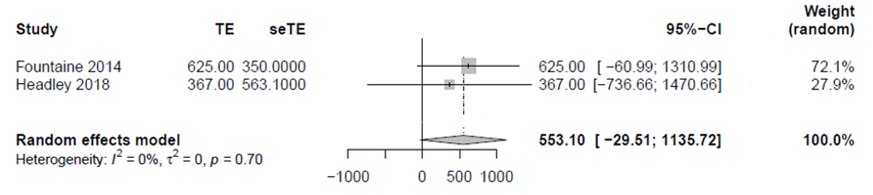
Supplementary Figure 1. A meta-analysis of sedentary time per workday from two studies

