Real-world risk stratification for coronary heart disease: a one-year prediction model using Health Information Exchange data

Additional file 2: Supplementary Tables and Figures
Table of Contents
1 Supplementary Table 1. 2
2 Supplementary Table 2. 4
3 Supplementary Figure 1. 4
4 Supplementary Figure 2. 5
5 Supplementary Figure 3. 6
6 Supplementary Figure 4. 7
7 Supplementary Figure 5. 8
8 Supplementary Figure 6. 8

Supplementary Table 1.
List of the top 80 important features, their odds ratios, and importances in the model.
Age(years) | Prospective cohort | Case ª (N=15,781) | n% | Control ^{b} (N=1,024,391) | n% | Odds ratio | Importance  (×10⁻³)
<19 | 215,842 | 21 | 0.13 | 215,821 | 21.07 | 0.02 | 64.61
19-34 | 186,586 | 162 | 1.03 | 186,424 | 18.20 | 0.05 | 59.67
35-49 | 178,568 | 854 | 5.41 | 177,714 | 17.35 | 0.27 | 33.45
50-64 | 240,285 | 4,328 | 27.43 | 235,957 | 23.03 | 1.26 | 13.27
65-74 | 132,265 | 5,035 | 31.91 | 127,230 | 12.42 | 3.30 | 35.20
75-84 | 61,150 | 3,710 | 23.51 | 57,440 | 5.61 | 5.17 | 42.66
>85 | 25,476 | 1,671 | 10.59 | 23,805 | 2.32 | 4.98 | 48.51
Gender
Male | 461,013 | 8,897 | 56.38 | 452,116 | 44.14 | 1.64 | 13.8
Female | 579,159 | 6,884 | 43.62 | 572,275 | 55.86 | 1.64 | 13.8
Chronic disease
Heart failure (CVD) | 12,961 | 1,528 | 9.68 | 11,433 | 1.12 | 9.50 | 4.07
Atrial fibrillation and flutter (CVD) | 27,418 | 2,305 | 14.61 | 25,113 | 2.45 | 6.81 | 3.59
Cardiomyopathy (CVD) | 5,243 | 601 | 3.81 | 4,642 | 0.45 | 6.70 | 2.14
Nonrheumatic aortic valve disorders (CVD) | 9,356 | 901 | 5.71 | 8,455 | 0.83 | 7.28 | 1.7
Paroxysmal tachycardia (CVD) | 7,381 | 400 | 2.53 | 6,981 | 0.68 | 3.79 | 1.1
Complications and ill-defined descriptions of heart disease (CVD) | 10,886 | 947 | 6.00 | 9,939 | 0.97 | 6.52 | 0.63
Atrioventricular and left bundle-branch block (CVD) | 5,018 | 472 | 2.99 | 4,546 | 0.44 | 6.93 | 0.4
Nonrheumatic mitral valve disorders (CVD) | 11,397 | 837 | 5.30 | 10,560 | 1.03 | 5.38 | 0.21
Chronic obstructive pulmonary disease | 38,390 | 2,618 | 16.59 | 35,772 | 3.49 | 5.50 | 6.47
Occlusion and stenosis of precerebral artery, not result in cerebral infarction | 6,701 | 708 | 4.49 | 5,993 | 0.59 | 7.98 | 2.04
Chronic kidney disease | 21,228 | 1,728 | 10.95 | 19,500 | 1.90 | 6.34 | 1.6
Angina pectoris | 1,620 | 221 | 1.40 | 1,399 | 0.14 | 10.39 | 1.49
Other peripheral vascular diseases | 11,853 | 936 | 5.93 | 10,917 | 1.07 | 5.85 | 1.41
Overweight and obesity | 85,694 | 2,461 | 15.59 | 83,233 | 8.13 | 2.09 | 1.21
Hypothyroidism | 74,878 | 2,298 | 14.56 | 72,580 | 7.09 | 2.23 | 0.91
Aortic aneurysm and dissection | 4,934 | 452 | 2.86 | 4,482 | 0.44 | 6.71 | 0.66
Acute disease
Acute myocardial infarction | 1,821 | 437 | 2.77 | 1,384 | 0.14 | 21.05 | 4.7
Pain in throat and chest | 52,346 | 1,758 | 11.14 | 50,588 | 4.94 | 2.41 | 2.49
Abnormalities of breathing | 46,075 | 2,022 | 12.81 | 44,053 | 4.30 | 3.27 | 1.62
Other soft tissue diseases | 82,254 | 2,295 | 14.54 | 79,959 | 7.81 | 2.01 | 1.09
Abnormal findings on diagnostic imaging of lung | 12,909 | 775 | 4.91 | 12,134 | 1.18 | 4.31 | 0.83
Other functional intestinal disorders | 24,985 | 682 | 4.32 | 24,303 | 2.37 | 1.86 | 0.67
Elevated blood glucose level | 27,916 | 805 | 5.10 | 27,111 | 2.65 | 1.98 | 0.66
Cough | 56,272 | 1,430 | 9.06 | 54,842 | 5.35 | 1.76 | 0.62
Abnormalities of heart beat | 26,145 | 977 | 6.19 | 25,168 | 2.46 | 2.62 | 0.61
Disease events
Essential (primary) hypertension | 56,678 | 2,235 | 14.16 | 54,443 | 5.31 | 2.76 | 3.37
Type 2 diabetes mellitus without complications | 29,296 | 1,467 | 9.30 | 27,829 | 2.72 | 2.76 | 3.57
Chronic obstructive pulmonary disease | 10,682 | 856 | 5.42 | 9,826 | 0.96 | 2.92 | 0.95
Hyperlipidemia | 647 | 48 | 0.30 | 599 | 0.06 | 5.94 | 1.08
Health status
Presence of cardiac and vascular implants and grafts | 6,010 | 742 | 4.70 | 5,268 | 0.51 | 1.19 | 5.86
Tobacco use | 19,356 | 505 | 3.20 | 18,851 | 1.84 | 1.30 | 1.54
Body mass index>30 | 59,753 | 1,775 | 11.25 | 57,978 | 5.66 | 1.15 | 1.7
Personal history of certain other diseases | 39,993 | 1,791 | 11.35 | 38,202 | 3.73 | 1.20 | 1.27
Encounter for other aftercare and medical care | 16,139 | 761 | 4.82 | 15,378 | 1.50 | 1.08 | 1.11
Do not resuscitate | 6,034 | 309 | 1.96 | 5,725 | 0.56 | 1.64 | 0.92
Other postprocedural states | 31,456 | 1,041 | 6.60 | 30,415 | 2.97 | 1.20 | 0.88
Personal history of malignant neoplasm | 30,741 | 1,295 | 8.21 | 29,446 | 2.87 | 1.21 | 0.82
Presence of other functional implants | 21,607 | 993 | 6.29 | 20,614 | 2.01 | 1.18 | 0.77
Lab test
Erythrocyte distribution width RBC | 61,238 | 2,089 | 13.24 | 59,149 | 5.77 | 1.06 | 1.76
Platelets in Blood | 73,342 | 2,274 | 14.41 | 71,068 | 6.94 | 1.06 | 1.5
Basophils in Blood | 63,453 | 1,801 | 11.41 | 61,652 | 6.02 | 1.09 | 1.48
Cholesterol in high-density lipoprotein | 29,979 | 961 | 6.09 | 29,018 | 2.83 | 1.83 | 1.36
Anion gap in Serum or Plasma | 58,451 | 2,000 | 12.67 | 56,451 | 5.51 | 1.07 | 1.29
Hemoglobin A1c/Hemoglobin.total in Blood | 19,086 | 1,069 | 6.77 | 18,017 | 1.76 | 2.02 | 1.26
Glomerular filtration rate predicted among non-blacks | 17,453 | 891 | 5.65 | 16,562 | 1.62 | 1.08 | 1.11
Magnesium in Serum or Plasma | 21,903 | 1,051 | 6.66 | 20,852 | 2.04 | 1.12 | 1.09
Triglyceride in Serum or Plasma | 35,821 | 1,099 | 6.96 | 34,722 | 3.39 | 1.49 | 0.99
Eosinophils in Blood | 68,390 | 2,002 | 12.69 | 66,388 | 6.48 | 1.09 | 0.96
Glomerular filtration rate predicted among blacks | 33,897 | 1,339 | 8.48 | 32,558 | 3.18 | 1.08 | 0.95
Cholesterol in Serum or Plasma | 44,206 | 1,309 | 8.29 | 42,897 | 4.19 | 1.70 | 0.89
Estimated average glucose | 6,744 | 464 | 2.94 | 6,280 | 0.61 | 3.08 | 0.83
Glucose in Capillary blood | 14,137 | 667 | 4.23 | 13,470 | 1.31 | 1.01 | 0.67
INR in Blood by Coagulation assay | 12,865 | 864 | 5.47 | 12,001 | 1.17 | 1.09 | 0.65
Medication
Nitrate Vasodilator | 4,197 | 997 | 6.32 | 3,200 | 0.31 | 1.28 | 42.04
Loop Diuretic | 18,799 | 1,911 | 12.11 | 16,888 | 1.65 | 1.10 | 25.79
P2Y12 Platelet Inhibitor | 2,980 | 470 | 2.98 | 2,510 | 0.25 | 1.14 | 22.46
Dihydropyridine Calcium Channel Blocker | 27,093 | 1,861 | 11.79 | 25,232 | 2.46 | 1.10 | 14.29
Biguanide | 29,234 | 1,856 | 11.76 | 27,378 | 2.67 | 1.08 | 11.32
Insulin Analog | 13,795 | 1,110 | 7.03 | 12,685 | 1.24 | 1.05 | 10.70
Angiotensin 2 Receptor Blocker | 26,001 | 1,672 | 10.60 | 24,329 | 2.37 | 1.09 | 9.58
Alpha-Adrenergic Blocker | 22,996 | 1,678 | 10.63 | 21,318 | 2.08 | 1.07 | 9.33
Thiazide Diuretic | 39,616 | 1,902 | 12.05 | 37,714 | 3.68 | 1.08 | 8.36
Anticholinergic | 23,007 | 1,320 | 8.36 | 21,687 | 2.12 | 1.05 | 4.82
l-Thyroxine | 47,601 | 1,976 | 12.52 | 45,625 | 4.45 | 1.06 | 4.60
Anti-epileptic Agent | 44,055 | 1,664 | 10.54 | 42,391 | 4.14 | 1.02 | 4.52
Vitamin K Antagonist | 11,009 | 1,051 | 6.66 | 9,958 | 0.97 | 1.05 | 4.42
Osmotic Laxative | 25,411 | 1,249 | 7.91 | 24,162 | 2.36 | 1.06 | 2.20
Sulfonylurea | 13,524 | 1,028 | 6.51 | 12,496 | 1.22 | 1.08 | 2.12
Calcium Channel Blocker | 9,246 | 706 | 4.47 | 8,540 | 0.83 | 1.09 | 1.97
Antiarrhythmic | 14,160 | 764 | 4.84 | 13,396 | 1.31 | 1.09 | 1.75
Factor Xa Inhibitor | 6,911 | 567 | 3.59 | 6,344 | 0.62 | 1.08 | 1.09
Xanthine Oxidase Inhibitor | 6,889 | 572 | 3.62 | 6,317 | 0.62 | 1.10 | 0.93
Potassium Salt | 14,850 | 968 | 6.13 | 13,882 | 1.36 | 1.09 | 0.77
Utilization
Mean of medical cost(s) | - | 4,797.06 | - | 2,056.16 | - | 1.00 | 19.1
Mean of outpatient visit(s) | - | 10.27 | - | 5.16 | - | 1.05 | 16.62
Mean of emergency visit(s) | - | 0.65 | - | 0.45 | - | 1.07 | 8.81
Mean of inpatient day(s) | - | 1.41 | - | 0.52 | - | 1.00 | 3.18
Mean of inpatient admission(s) | - | 0.22 | - | 0.09 | - | 1.51 | 1.3
ª Case is the patients with future one year CHD.
^{b} Control is the people without future one year CHD but with other conditions similar to the case group.

Supplementary Table 2.
The performance of the 1-year CHD risk pre-judgement model in the prospective cohort, summarized in PPV, sensitivity, and mean relative risk.
 | Very low | Low | Medium | High | Very high | Total
Number of patients | 960,021 | 70,676 | 8,888 | 554 | 19 | 1,040,158
True Positives | 8,367 | 5,506 | 1,668 | 216 | 11 | 15,768
PPV (%) | 0.87 | 7.79 | 18.77 | 38.99 | 57.89 | 1.6
Sensitivity (%) | 0.53 | 0.35 | 0.11 | 0.01 | 0.00 | -
Mean Relative Risk | 0.57 | 5.14 | 12.38 | 25.72 | 38.19 | -

Supplementary Figure 1.
The AUC comparisons of the model performance in the prospective cohort. 1. Ensemble learning, 2. XGBoost, 3. Lasso, 4. Boosting, 5. Feed-forward neural network, 6. Random forest, 7. KNN, 8. Naïve bayes.
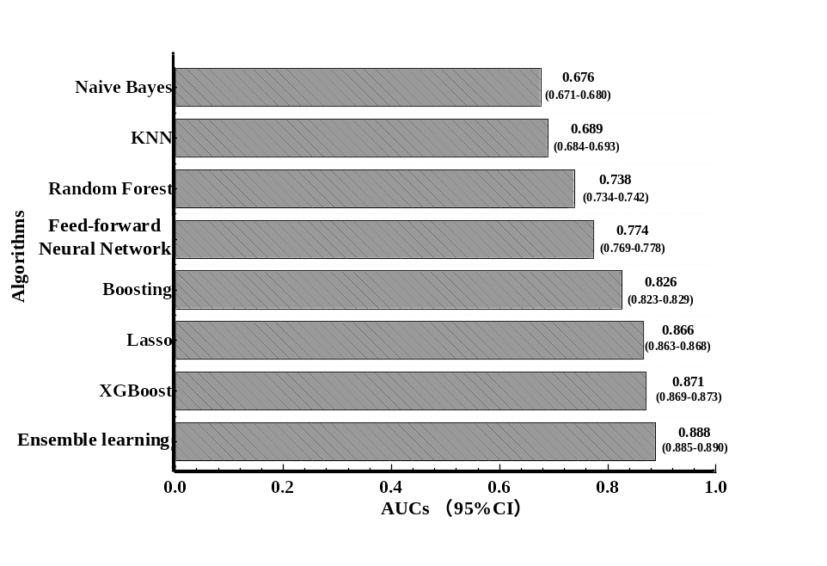

Supplementary Figure 2.
The ROC derived from the prospective cohorts (XGBoost).
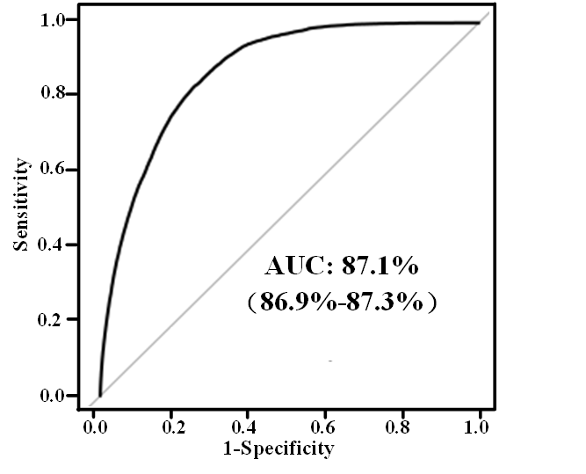

Supplementary Figure 3.
The model calibration performance.
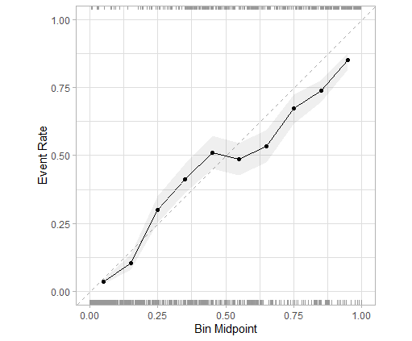

Supplementary Figure 4.
The TreeSHAP values of the significant features. Each row represents a significant feature, and each point is the TreeSHAP value of a sample. Redder sample points the feature value is larger, and bluer sample points indicate that the feature value is smaller; the abscissae represent the TreeSHAP values.
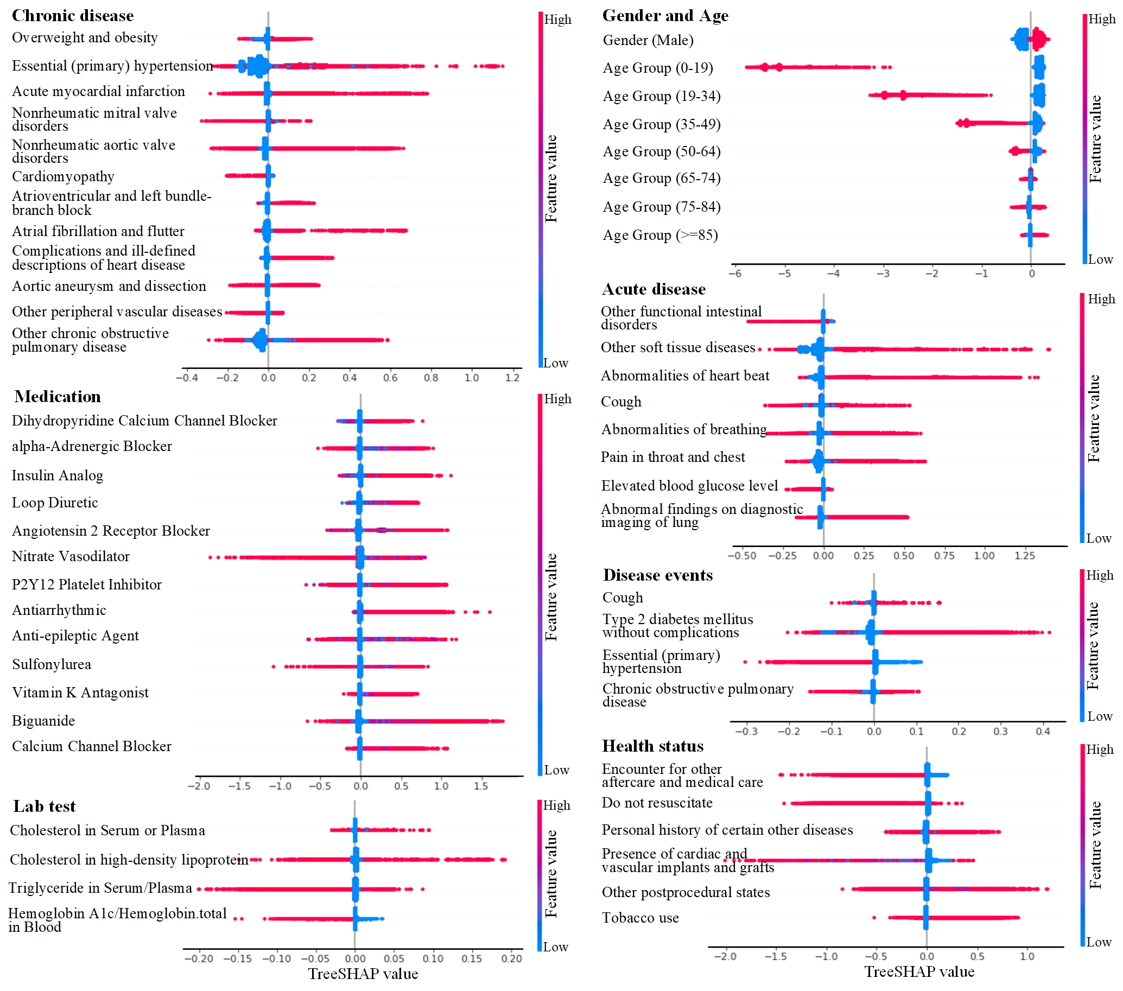

Supplementary Figure 5.
The distribution of age and gender (male) subgroups at five risk level in the prospective cohort.
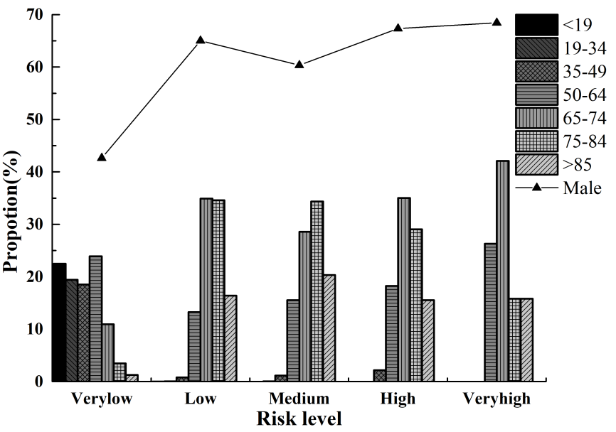

Supplementary Figure 6.
Time-to-CHD diagnosis curves of the chronic disease subgroup in the low/ very low and high/ very high-risk population of prospective cohort.
