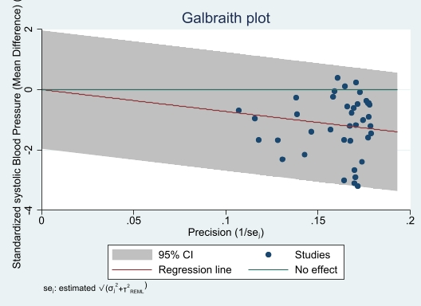
A - Galbraith plot for assessing heterogeneity of community-based interventions' results on the difference in mean systolic blood pressure using a random-effects model
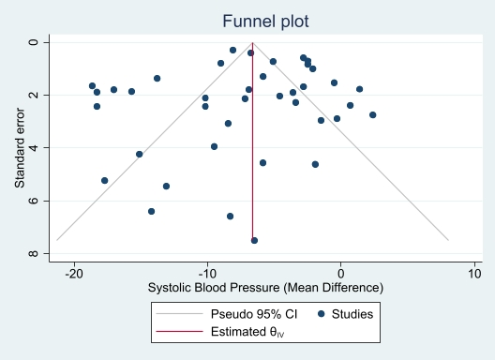
B - Funnel plot for assessing publication bias in studies on the effect of community-based interventions on the difference in mean systolic blood pressure using a random-effects model
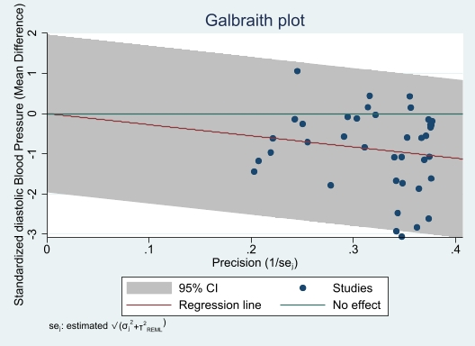
Figure 6: Galbraith Plot for assessing heterogeneity in the results of community-based interventions on the difference in mean diastolic blood pressure based on the random-effects model
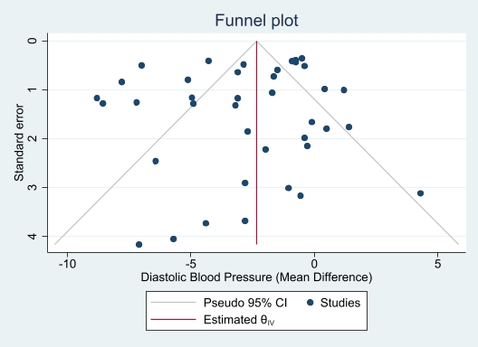
Figure 7: Funnel Plot for assessing publication bias in the studies of the impact of community-based interventions on the difference in mean diastolic blood pressure based on the random-effects model

