Expanded Voluntary Counselling and Testing Services in Türkiye: Insights from an HIV Model

Z. Melisa Erdogan*, Emine Yaylali
Istanbul Technical University, Department of Industrial Engineering, Faculty of Management, Istanbul, Türkiye

Supplementary Material

Compartmental Model

$\frac{dS_{h}}{dt}=\frac{1}{w}S_{VCT} - σ_{1}S_{h}- β_{1}S_{h} (\frac{U+(1-ε_{1}) I_{VCT}+ (1-ε_{1}) I_{others}+(1-ε_{2})T}{N}\text{)}$ (1)
$\frac{dS_{l}}{dt}=\frac{1}{w}S_{others} - σ_{2}S_{l}- β_{2}S_{l} (\frac{U+ (1-ε_{1})I_{VCT}+ {(1-ε_{1})I}_{others}+(1-ε_{2})T}{N}\text{)}$ (2)
$\frac{dS_{VCT}}{dt}= σ_{1}S_{h}-\frac{1}{w}S_{VCT}-(1-ψ) β_{1}S_{VCT} (\frac{U+(1-ε_{1}) I_{VCT}+ (1-ε_{1})I_{others}+(1-ε_{2})T}{N}\text{)}$ (3)
$\frac{dS_{others}}{dt}=σ_{2}S_{l}-\frac{1}{w}S_{others}- β_{2}S_{others} (\frac{U+(1-ε_{1}) I_{VCT}+ (1-ε_{1})I_{others}+(1-ε_{2})T}{N}\text{)}$ (4)
$$\frac{dU}{dt}=β_{1}{(S}_{h}+(1 - ψ)S_{VCT}) (\frac{U+\left(1-ε_{1}\right)I_{VCT}+\left(1-ε_{1}\right)I_{others}+\left(1-ε_{2}\right)T}{N}\text{)}$$
$\text{+}β_{2}{(S}_{l}+ S_{others})(\frac{U+\left(1-ε_{1}\right)I_{VCT}+\left(1-ε_{1}\right)I_{others}+\left(1-ε_{2}\right)T}{N}\text{)-}{ δ}_{1}U\text{-}δ_{2}U$ (5)
$\frac{dI_{VCT}}{dt}= δ_{1}U-αI_{VCT}$ (6)
$\frac{dI_{others}}{dt}= δ_{2}U-αI_{others}$ (7)
$\frac{dT}{dt}=αI_{VCT}+ αI_{others}$ (8)

Each equation shows the change in the related compartment. The values for each compartment are obtained after the solution of the system of differential equations. The descriptions of each parameter are given in Table S1.

Table S1. Parameter list

Symbol | Definition | Value | Source
Initial Value
HIV – unaware high risk | Initial number of individuals for high risk susceptibles | 1,660,596 | Calculation based on sub-populations
Subpopulations | SW | 100,000 | Based on Ankara Chamber of Commerce (ACC) [1]
 | MSM | 232,935 | [2]
 | PWID | 264,250 | [3]
 | Partners of PLWH | 38,399 | [4]
 | People with multiple sexual partners | 663,935 | Calculated using [5,6]
 | Mobile workers | 120,359 | Calculated using [7–10]
HIV – unaware low risk | Initial number of individuals for low risk susceptibles | 61,120,143 | Calculated using [6] and other compartments
HIV + unaware | Initial number of individuals for low risk susceptibles | 20,261 | [11] and calculation
HIV - aware tested by VCT | Initial number of HIV - individuals who tested by VCT | 0 | Assumption
HIV - aware tested by others | Initial number of HIV- individuals who tested by other healthcare setting | 0 | Assumption
HIV + aware tested by VCT | Initial number of HIV + individuals who tested by VCT | 105 | Calculation
HIV + aware tested by others | Initial number of HIV + individuals who tested by other healthcare setting | 4,597 | Calculation
ART | Initial number of individuals who receive ART treatment for HIV | 13,851 | [11] and calculation
Transitions between compartments
β₁ | Rate of movement from HIV - Unaware High risk to HIV + Unaware (Force of Infection for high risk individuals) | Calibrated (0.5247)
β₂ | Rate of movement from HIV - Unaware Low risk to HIV + Unaware (Force of Infection for low risk individuals) | Calibrated (0.2339)
σ₁ | Rate of movement from HIV - Unaware High risk to HIV - Aware tested by VCT | 0.00206 | [12] and calculation
σ₂ | Rate of movement from HIV - Unaware Low risk to HIV - Aware tested by others | 0.13241 | [12] and calculation
δ₁ | Rate of movement from HIV + Unaware to HIV + Aware tested by VCT | 0.00434 | [12] and calculation
δ₂ | Rate of movement from HIV + Unaware to HIV + Aware tested by others | 0.19086 | [4,12] and calculation
Ψ | Reduction in transmission for HIV - Aware individuals tested by VCT | 0.219 | Calculation based on Bernoulli formula (Table S2)
ε₁ | Reduction in transmission for HIV + Aware individuals | 0.53 | [13]
ε₂ | Reduction in transmission for HIV + on ART individuals | 0.96 | [14]
w | Average duration (years) that uninfected individuals remain identified after testing | 2 | [15]
α | Rate of movement from HIV +aware compartments to ART compartment | 74.7% | [11]
Validation
HIV diagnosed cases | Annual number of HIV diagnosed cases between 2019-2023 |  | [4]

Bernoulli Model

$p= 1- {\left\{\left(1-π\right)+ π {\left(1-α\right)}^{n} {\left(1-\left(1-Φ\right)α\right)}^{k}\right\}}^{m}$ (9)
The Bernoulli model estimates the risk of HIV acquisition. Pinkerton and Abramson [16] defined this as HIV risk or probability of HIV transmission. This process starts with per-act probability of HIV transmission which indicates the risk of transmission/acquisition between an infected and non-infected pair of individuals after a risky act. Then, with the addition of behavioral parameters such as condom use, the number of partners as well as HIV prevalence, joint probability of HIV transmission is calculated in the equation 9.
Table S2. Parameter list for Bernoulli model
Symbol | Definition | Value | Source
$$π$$ | HIV prevalence | 0.00046 | Calculated from [4,6]
$$α$$ | Per act transmission probability of unprotected sexual intercourse | 0.0161 | Calculated from [17]
$$Φ$$ | Condom effectiveness | 0.9 | [18]
$$n$$ | Number of acts of unprotected sexual intercourse | 37.7 | Calculated from [19,20]
$$k$$ | Number of acts of protected sexual intercourse | 58.9 | Calculated from [19,20]
$$m$$ | Number of partners | 60.26 | Calculated from [19]
- | Change in behaviour after VCT | 37% | Calculated from [21,22]

Calculations
HIV prevalence was calculated by dividing the total number of diagnosed HIV cases reported by the Ministry of Health by the estimated size of the population at risk, assumed to be individuals aged 15 years and older from national population statistics.

$$π = \frac{Total number of diagnosed HIV cases}{Total population}$$

The estimated per-act probability of acquiring HIV through different sexual exposure routes (namely, receptive anal intercourse, insertive anal intercourse, receptive penile–vaginal intercourse, insertive penile–vaginal intercourse) was used to define the parameter $α$. These estimates represent the risk of transmission from sexual contact with an HIV-infected partner, assuming no condom use.
$$α = (138 + 11 + 8 + 4) / 10000 = 0.0161$$

According to an internet-based survey conducted in Turkey [20], the mean number of sexual intercourses per week before the COVID-19 pandemic was 1.86. Thus, we estimated the total annual number of sexual intercourses as 1.86*52 = 96.72. Overall rate of condom use in total survey participants was reported as 61% by another survey [19]. Based on this, we calculated the number of protected and unprotected sexual acts as follows:
$$k = 96.72 * 0.61 = 58.9$$
$$n = 96.72 - 58.9 = 37.7$$
The average number of sexual partners, as reported in [19], was also used. Since the survey targeted vulnerable populations, we used data specific to female sex workers (FSW), men who have sex with men (MSM), and intravenous (IV) drug users. The survey reported the average and range of sexual partners participants had in the last month. To estimate the annual number of partners, we first calculated the proportion of each risk group within the total high-risk population and used these proportions as weights. We then multiplied the number of partners for each risk group by these weights to obtain the weighted annual number of partners. The total number of partners is the sum of all these weighted annual numbers.

$$m = \sum_{risk groups}{weighted annual number of partners }$$

The assumed behavioural change following voluntary counselling and testing (VCT) was informed by two sources. In [21], individuals were randomly assigned to receive either VCT services or health information. The study found that, the proportion of individuals reporting unprotected sexual intercourse was reduced by 35% for men and 39% for women after receiving VCT service. We used the average of these reductions ((39+35)/2 = 37). As a supporting source, [22] showed a 38% reduction in self-reported unprotected anal or vaginal intercourse following a safer-sex counselling intervention among HIV-positive individuals.
The overall change in the transmission is found after calculating the HIV transmission with and without VCT services and comparing the reduction in HIV transmission after VCT. This value is used in the compartmental model.
The overall change in HIV transmission was determined by applying the Bernoulli model to estimate transmission rates with and without VCT services, and then calculating the reduction attributable to VCT. This reduction was incorporated into the compartmental model.
We also performed a one-way sensitivity analysis on the parameters used in the Bernoulli model, varying each parameter by +20% and -20%. Then, we used the new value of the overall change in the transmission (i.e. the effect of VCT centres on HIV transmission) to obtain model results. Figure S1 demonstrates how each parameter influences the model’s key outcome: 50- to 74-fold efficiency gain for a 2-fold and 4-fold increase in test centres, respectively.
Condom effectiveness was the most impactful parameter, with efficiency ranging from 48.8% to 51% under a 2-fold increase in testing centres, and from 72% to 75.3% under a 4-fold increase. For the other parameters, the efficiency remained around 50% and 73.5%, which are close to the main results. These findings indicate that our conclusions are robust to uncertainties in the parameters of the Bernoulli model.
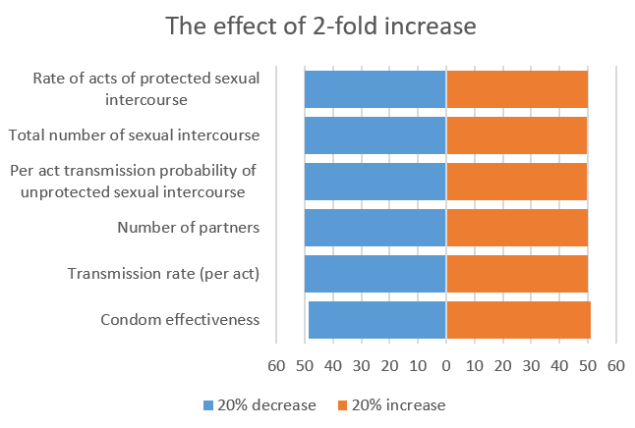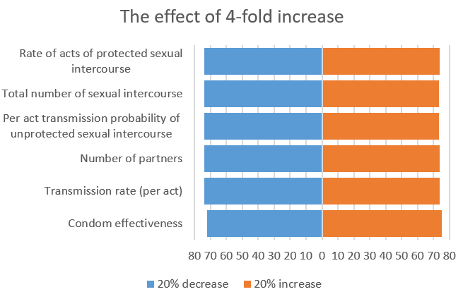
Figure S1. The effect of Bernoulli parameters on the overall efficiency of VCT strategy compared to other facilities.

Calibration method (ABC-SMC)

We defined three pools which include accepted parameter sets in the intermediate populations. Pool A and B includes the parameters having distance less than 25th and 50th quartile of the intermediate population while pool C corresponds to whole population. $xA, xB,xC$ are the mean values while $CA, CB$ and $CC$ corresponds to covariance of related pool. The fused mean and covariance values for kernel is presented as $x_{cov}$ and $C^{-1}$, respectively. We assigned equal weights ($w_{1},w_{2},w_{3}$) to the pairs. $r^{t}$ takes 0 or 1 based on the random probabilities and $cr$ shows the correlation between rejected parameters ie. whose distance is not less than the threshold value.
$C^{-1}=w_{1}{CA}^{-1}+\left(w_{2}\right){CB}^{-1}+({1-w_{1}-w}_{2}){CC}^{-1} + r^{t} * cr$ (1)
$x_{cov}=C(w_{1}A^{-1}xA+w_{2}B^{-1}xB+(1-w_{1}-w_{2})C^{-1}xC)$ (2)
Table S3. The details for calibration process A. Computational details of ABC algorithms B. 2- and 4- year error terms C. Target values and estimations
A.
 |  | N = 500 particles & 10 runs |  |  | N = 5000 particles & 1 run
Total # of accepted |  | 5000 |  |  | 5000
Computational time |  | Avr. 6.20 minutes per run (1.03 hours total) |  |  | 3.28 hours total
Acceptance Rate |  | 0.409 |  |  | 0.429
# Population |  | 5 |  |  | 5
Average $β_{1}$ (peak) |  | 0.5065 (0.5247) |  |  | 0.4880 (0.4840)
Average $β_{2}$ (peak) |  | 0.2340 (0.2339) |  |  | 0.2344 (0.2347)
B.
 | N = 500 particles & 10 runs |  |  | N = 5000 particles & 1 run
 | Average |  | Peak | Average |  | Peak
$$β_{1}$$ | 0.5065 |  | 0.5247 | 0.4880 |  | 0.4840
$β_{2}$ | 0.2340 |  | 0.2339 | 0.2344 |  | 0.2347
2-year MAE* | 130.5 |  | 124.5 | 131.5 |  | 129.5
4-year MAE** | 611.75 |  | 611.25 | 611.50 |  | 611.75
2-year MAPE (%) | 2.33 |  | 2.22 | 2.35 |  | 2.32
4-year MAPE (%) | 16.75 |  | 16.76 | 16.74 |  | 16.75
C.
Target  (reported cases) |  | N = 500 particles & 10 runs |  |  | N = 5000 particles & 1 run
Target  (reported cases) |  |  | Average | Peak | Average | Peak
- | $$β_{1}$$ |  | 0.5065 | 0.5247 | 0.4880 | 0.4840
- | $$β_{2}$$ |  | 0.2340 | 0.2339 | 0.2344 | 0.2347
4298 | 2019 |  | 4281 | 4283 | 4281 | 4281
3203 | 2020 |  | 4640 | 4644 | 4639 | 4641
4285 | 2021 |  | 5034 | 5040 | 5032 | 5035
5710 | 2022 |  | 5466 | 5476 | 5464 | 5468

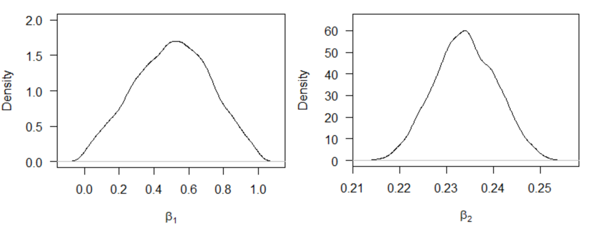

Figure S2. Posterior distributions for calibrated parameters

Model Results
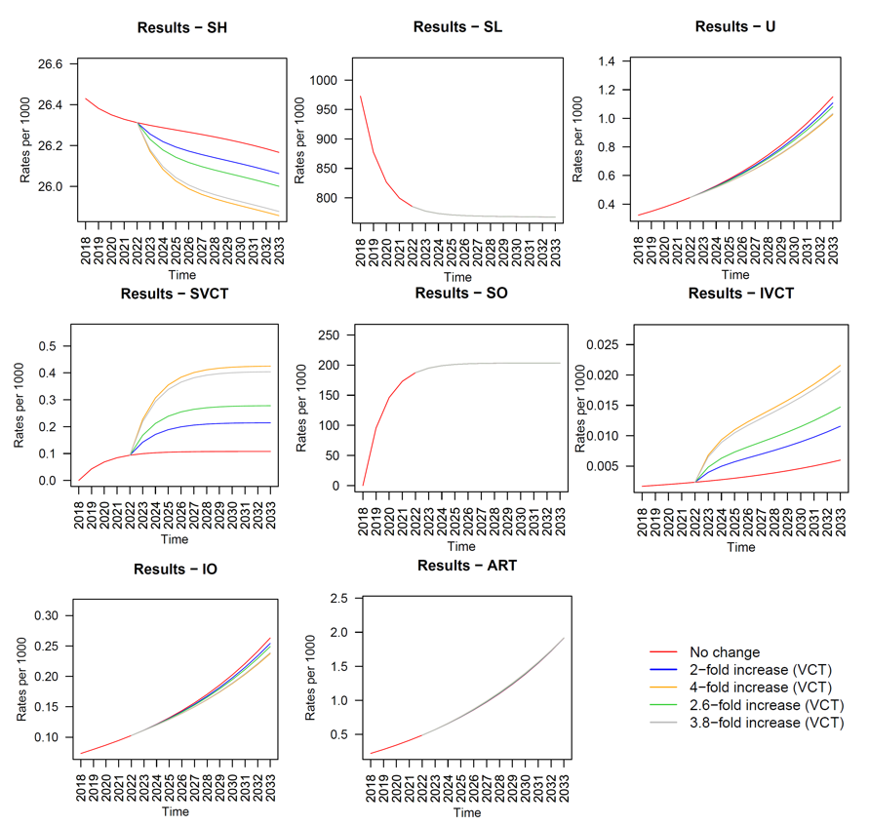
Figure S3. Scenario 2 results
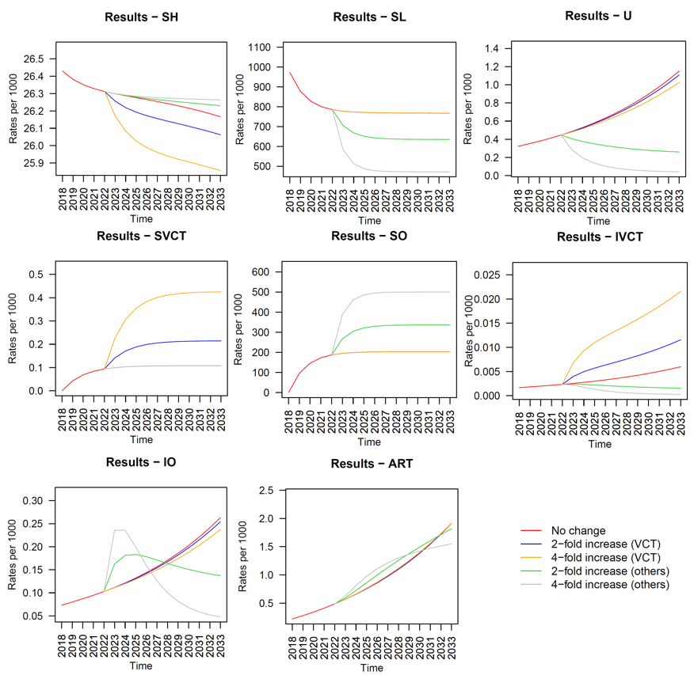
Figure S4. Scenario 3 results
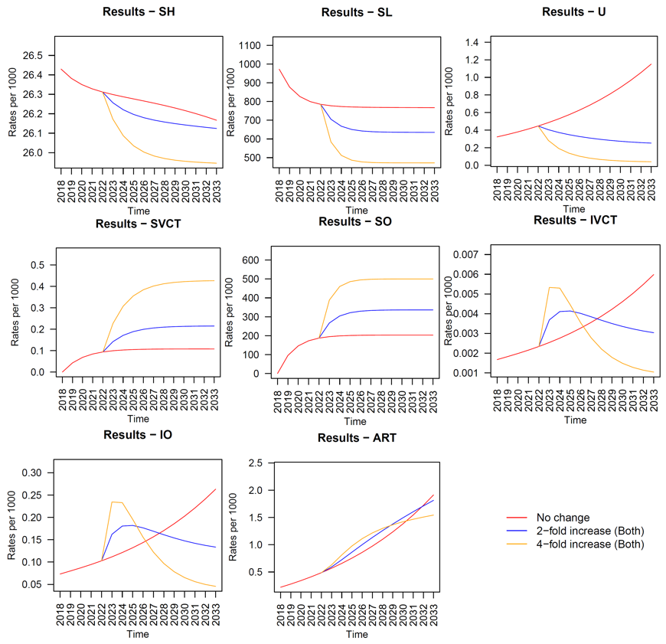
Figure S5. Scenario 4 results

Sensitivity Analysis
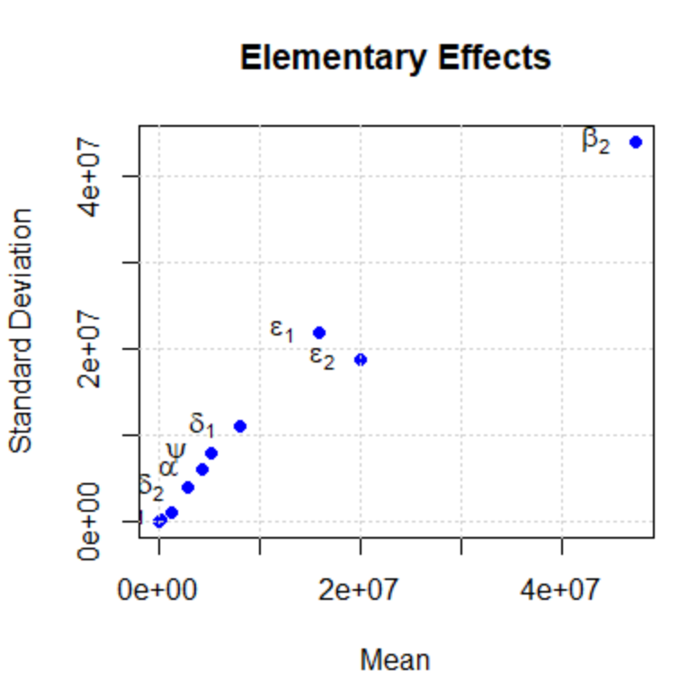
Figure S6. Sensitivity analysis

Uncertainty analysis
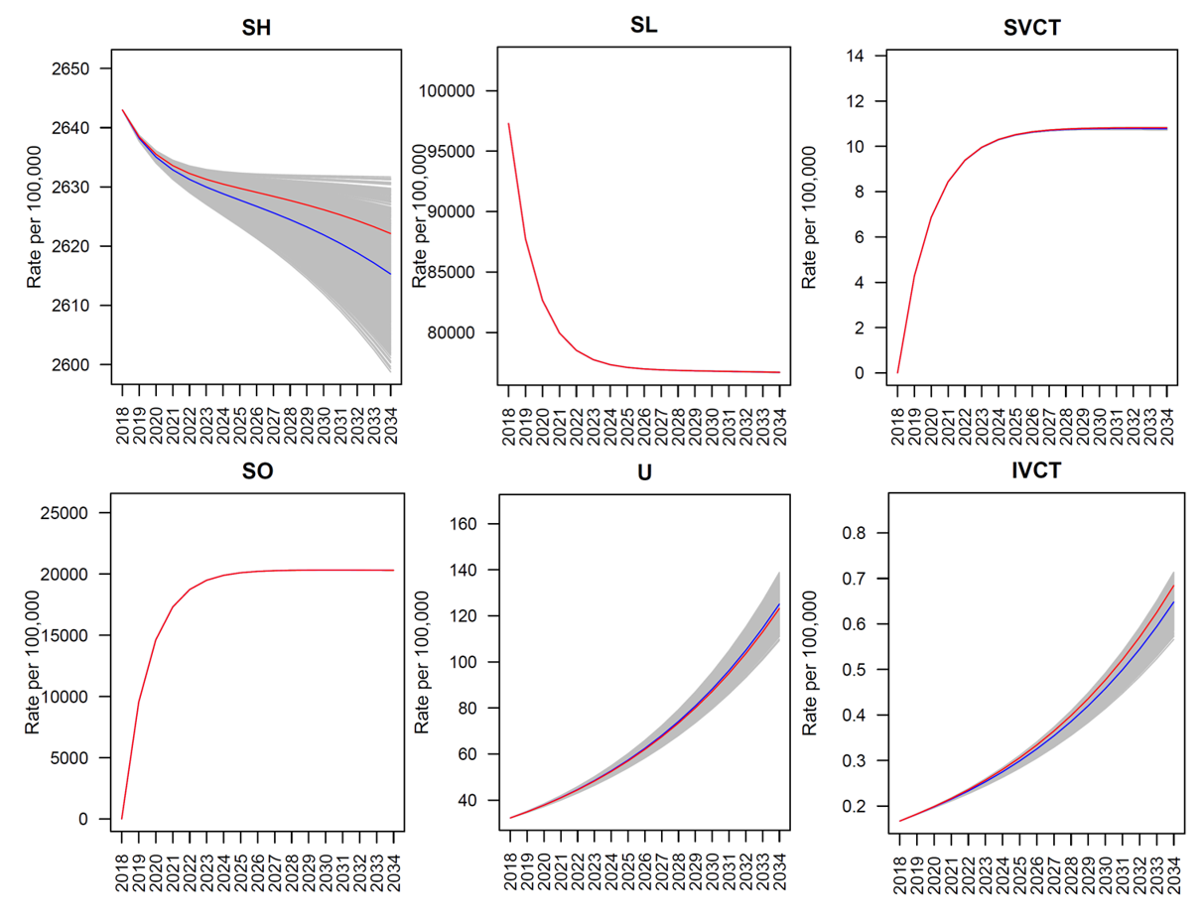
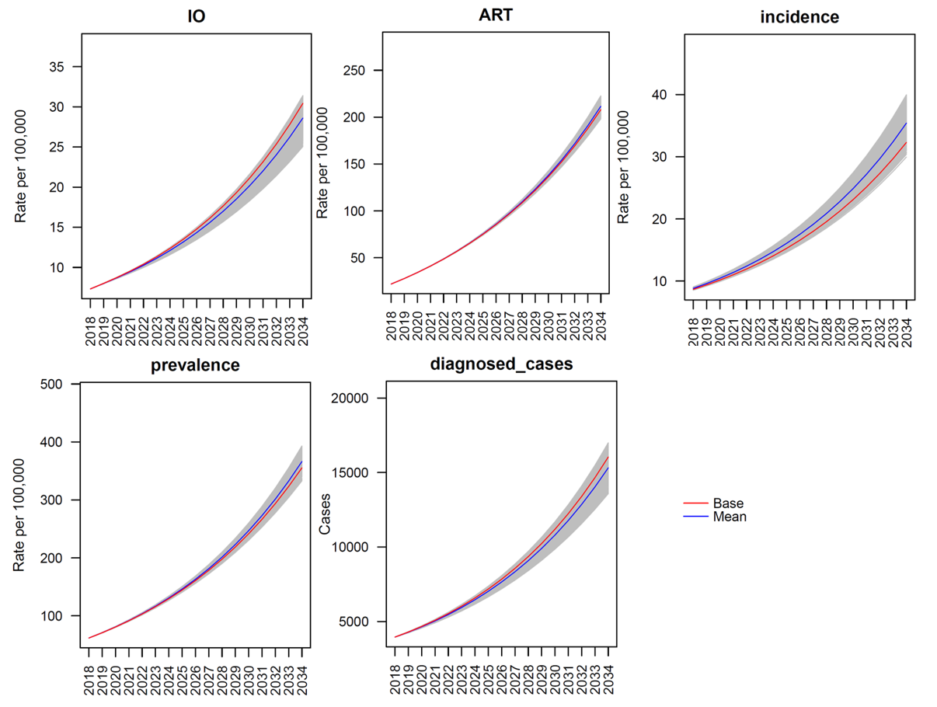
Figure S7. Uncertainty representations after 1000 randomly selected particles
Model performance
Based on the protocol dates of each VCT centre, ranging from 2016 to 2018, we have a short period of time to compare the actual and predicted data. Due to Covid-19 disruptions in 2020 and 2021, reported cases are lower than the predictions. In both 2019 and 2023, the predictions are very close to the reported data.

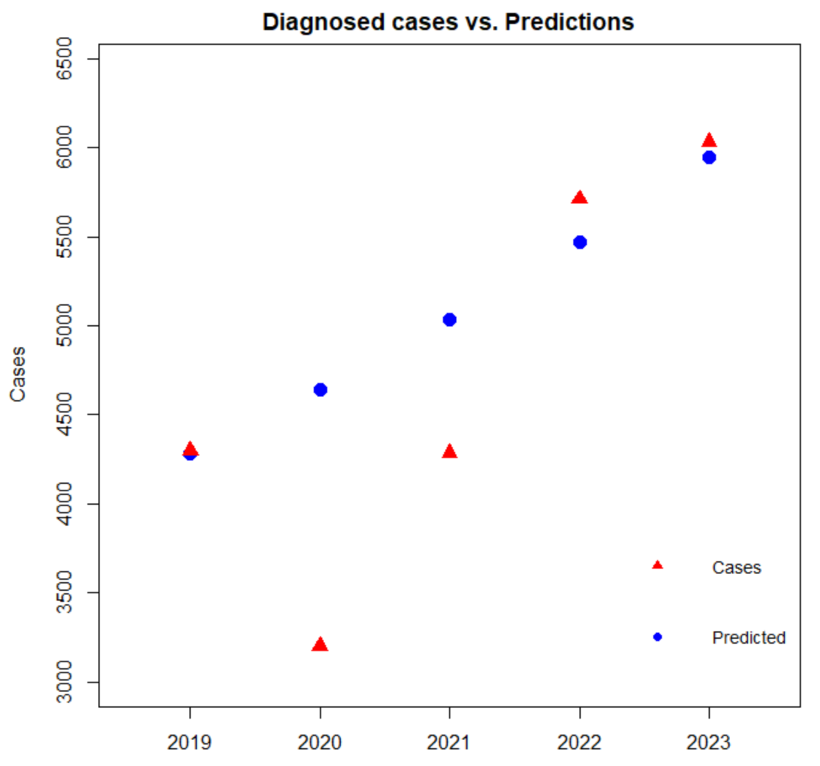
Figure S8. Comparison between model predictions and reported cases

References

1. Beduk T, Unlu H, Duyan V. AIDS knowledge and risky sexual behaviors among registered female sex workers in Turkey. Turk J Med Sci. 2011;41(3):521–31.
2. Marcus U, Hickson F, Weatherburn P, Schmidt AJ. Prevalence of HIV among MSM in Europe: Comparison of self-reported diagnoses from a large scale internet survey and existing national estimates. BMC Public Health. 2012 Nov 14;12(1):1–9.
3. Institute for Health Metrics and Evaluation (IHME). Global Burden of Disease (GBD) Drug use disorders [Internet]. 2018. Available from: https://vizhub.healthdata.org/gbd-compare/#%0A
4. Turkish Ministry of Health PHI. HIV-AIDS Statistics [Internet]. 2024. Available from: https://hsgm.saglik.gov.tr/depo/birimler/bulasici-hastaliklar-ve-erken-uyari-db/Dokumanlar/Istatistikler/hiv-aids-2023.pdf
5. Hacettepe University Institute of Population Studies. 2018 Turkey Demographic and Health Survey. Ankara; 2019.
6. Turkish Statistical Institute. Results of address-based population registration system [Internet]. 2018 [cited 2024 Mar 3]. Available from: https://biruni.tuik.gov.tr/medas/?locale=tr
7. Ekran News. Tır şoförü krizine çözüm önerisi [Internet]. 2023 [cited 2024 Mar 5]. Available from: https://www.ekranhaber.com/tir-soforu-krizine-cozum-onerisi-yas-sarti-dusurulmeli
8. Independent Turkish. Türk denizcilerin önünü dalgalar değil, İngilizce bilmemek kesiyor: 130 bin Türk gemiciden ancak 3 bini yabancı gemilerde çalışıyor [Internet]. 2021 [cited 2024 Oct 15]. Available from: https://www.indyturk.com/node/337516/türk-denizcilerin-önünü-dalgalar-değil-i̇ngilizce-bilmemek-kesiyor-130-bin-türk
9. OECD. OECD Tourism Trends and Policies 2022 [Internet]. Paris; 2022. Available from: https://doi.org/10.1787/a8dd3019-en
10. Yeh E. Turkey: HIV and Risky Behavior among Mobile Workers. Europe and Central Asia knowledge brief. 2011;38.
11. Yaylali E, Erdogan ZM, Calisir F, Gokengin D, Korten V, Tabak F, et al. Modeling the future of HIV in Turkey: Cost-effectiveness analysis of improving testing and diagnosis. PLoS One. 2023 Jun;18(6):e0286254.
12. Sahin Ozdemir E. Türkiye’de HIV/AIDS Epidemiyolojisi [Internet]. 2021. Available from: https://www.ekmud.org.tr/sunum/indir/1476-turkiyede-hiv-aids-epidemiyoljisi
13. Marks G, Crepaz N, Senterfitt JW, Janssen RS. Meta-analysis of high-risk sexual behavior in persons aware and unaware they are infected with HIV in the United States: implications for HIV prevention programs. J Acquir Immune Defic Syndr [Internet]. 2005 Aug 1 [cited 2024 Jul 26];39(4):446–53. Available from: https://pubmed.ncbi.nlm.nih.gov/16010168/
14. Cohen MS, Chen YQ, McCauley M, Gamble T, Hosseinipour MC, Kumarasamy N, et al. Prevention of HIV-1 Infection with Early Antiretroviral Therapy. New England Journal of Medicine [Internet]. 2011 Aug 11 [cited 2024 Jul 26];365(6):493–505. Available from: https://www.nejm.org/doi/full/10.1056/NEJMoa1105243
15. Stavert R. The Cost-effectiveness of Alternative HIV Intervention Portfolios in South Africa [Internet]. Yale Medicine Thesis Digital Library. 2009 [cited 2024 Jan 1]. Available from: http://elischolar.library.yale.edu/ymtdl/168
16. Pinkerton SD, Abramson PR. The Bernoulli-Process Model of HIV Transmission. Handbook of Economic Evaluation of HIV Prevention Programs [Internet]. 1998 [cited 2021 Oct 31];13–32. Available from: https://link.springer.com/chapter/10.1007/978-1-4899-1878-9_2
17. Patel, P., Borkowf CB, Brooks JT, Lasry A, Lansky A, Mermin J. Estimating per-act HIV transmission risk: a systematic review. AIDS. 2014;28(10):1509–19.
18. Pinkerton SD, Chesson HW, Layde PM, Group. the NI of MHMHPT. Utility of Behavioral Changes as Markers of Sexually Transmitted Disease Risk Reduction in Sexually Transmitted Disease/HIV Prevention Trials. J Acquir Immune Defic Syndr (1988). 2002;31(1):71–9.
19. AIDS Prevention Society, Human Resource Development Foundation, AMATEM Bakırköy Research and Training Hospital for Psychiatry Neurology and Neurosurgery. HIV Bio-Behavioral Survey among Vulnerable Populations İstanbul 2010 Survey Report [Internet]. 2010 [cited 2024 Jul 23]. Available from: https://www.ikgv.org/pdf/HIV_Biobehavioral_Survey_Istanbul_2010_v2.pdf
20. Karsiyakali N, Sahin Y, Ates HA, Okucu E, Karabay E. Evaluation of the Sexual Functioning of Individuals Living in Turkey During the COVID-19 Pandemic: An Internet-Based Nationwide Survey Study. Sex Med [Internet]. 2021;9(1):100279–100279. Available from: https://doi.org/10.1016/j.esxm.2020.10.007
21. Coates TJ, Grinstead OA, Gregorich SE, Sweat MD, Kamenga MC, Sangiwa G, et al. Efficacy of voluntary HIV-1 counselling and testing in individuals and couples in Kenya, Tanzania, and Trinidad: a randomised trial. The Lancet. 2000 Jul 8;356(9224):103–12.
22. Richardson JL, Milam J, McCutchan A, Susan S, Bolan R, Weiss J, et al. Effect of brief safer-sex counseling by medical providers to HIV-1 seropositive patients a multi-clinic assessment. AIDS. 2004;18(8):1179–86.

