Supplement
eAppendix 1. Definitions Details
eAppendix 2. Sample size
eTable 1. Association Between Ionizing Radiation Exposure and Multiple Myeloma
eTable 2. Association Between Cosmetology-Related Chemical Exposure and Multiple Myeloma
eTable 3. Association Between Carcinogenic Organic Solvent Exposure and Multiple Myeloma
eTable 4. Association Between Pesticide Exposure and Multiple Myeloma
eTable 5. Association Between Agricultural Work and Multiple Myeloma

eAppendix 1. Definitions Details
- Pesticide Exposure: Considered to be present when there is frequent or recurrent occupational contact with agricultural chemicals, such as fungicides, insecticides, or herbicides, either via direct application, mixing, or contaminated spaces (1).

- Agricultural Occupation: These include any situation associated with soil treatment, livestock farming, greenhouse work, and crop cultivation. These occupations typically involve contact with biological agents and agricultural chemicals (2).

- Ionizing Radiation Exposure: Includes occupational exposure (e.g., radiologic technologists and lab workers), diagnostic radiation (frequent X-rays or CT scans), and therapeutic radiation (e.g., previous cancer treatment) (3)(4).

- Organic Solvent Exposure: Involves contact with industrial chemicals used in manufacturing, painting, degreasing, and dry cleaning, such as carbon tetrachloride or benzene. Benzene, in particular, is a well-known Hematotoxin and leukemogenic substance. Positive jobs were those that required any of the previous practices (5)(6).

- Cosmetics (e.g, Hair dye exposure) was defined as the presence of applied hair dye, including both occupational and personal use, i.e., dyeing their hair or dyeing the hair of others (e.g., hairdressers) (7)(8).

eAppendix 2. Sample size
Objective
The goal of this sample size estimation was to ensure adequate statistical power to detect a meaningful association between key occupational/environmental exposures and the risk of developing multiple myeloma (MM) in a 1:1 matched case–control design.

Conceptual Framework
This study evaluates whether specific exposures—pesticides, radiation, organic solvents, agricultural work, and hair dye use—increase the odds of developing MM. The required sample size for a case–control study hinges on three key components:
- P₂ (exposure prevalence among controls): Estimated from existing literature.
- Anticipated odds ratio (OR): Based on previous epidemiological studies.
- Desired power and significance level: Typically, 80% power and α = 0.05.

Step 1: Estimate Exposure Among Controls (P₂)
From published case–control studies on environmental/occupational MM risk factors, such as Kachuri et al. (2014) (9), the baseline prevalence of pesticide exposure among controls was commonly reported around:
P₂ = 20% (0.20) (9).
Step 2: Choose a Clinically Significant Odds Ratio (OR)
Multiple studies report moderate effect sizes between occupational exposures and MM development, typically in the range of:
OR = 2.0
This OR is also a threshold often used to define clinically actionable risk in environmental epidemiology.
Step 3: Derive P₁ (Exposure Among Cases)
Using the OR definition:
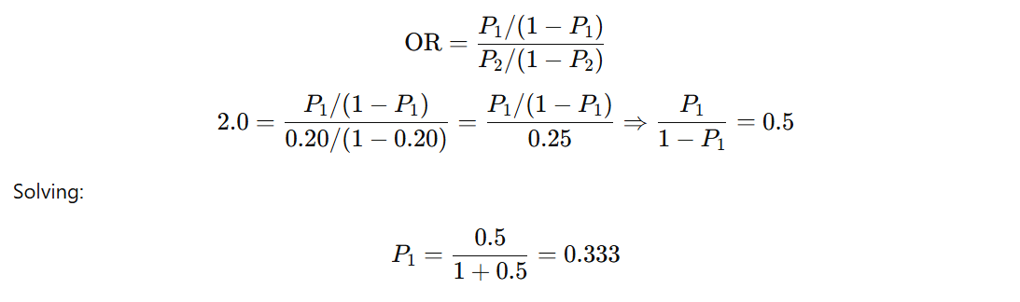

Thus, P₁ = 33.3%

Step 4: Plug into Fleiss Formula (with Continuity Correction)
Using the standard sample size formula for the unmatched case–control design (10):
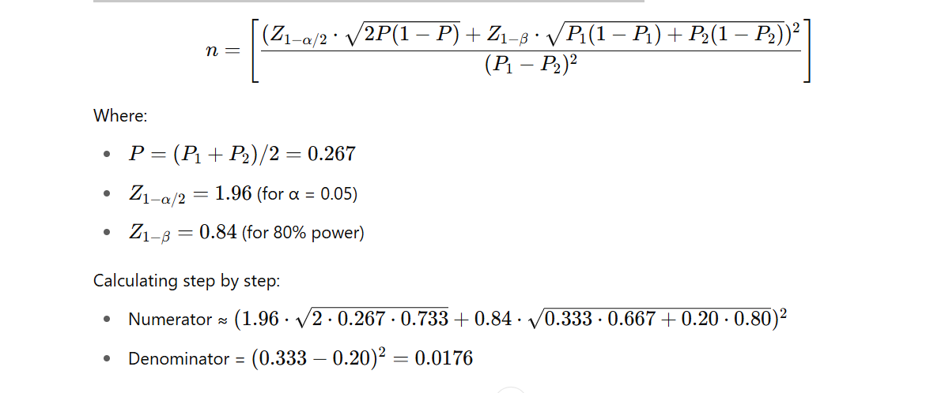

Estimated:
n ≈ 172 participants per group
Thus, a total of 344 participants (172 cases + 172 controls) is the minimum required.
Step 5: Justification of Final Sample Size
The final analytic dataset includes:
- 227 MM cases
- 176 matched controls
This exceeds the minimum requirement, enhancing power and reducing the likelihood of Type II errors. This also strengthens subgroup analysis (e.g., QOL domains) by offering greater stability of estimates in multivariable models.

eTable 1. Association Between Ionizing Radiation Exposure and Multiple Myeloma
Variable | Adjusted Odds ratio (CI) | P value
History of Radiation Exposure | 2.32 (1.42–3.79) | 0.001
age | 1.02 (1.00–1.04) | 0.089
gender | 0.88 (0.57–1.35) | 0.557
BMI | 0.88 (0.83–0.92) | > 0.001
Type of community | 0.75 (0.51–1.10) | 0.138
Hospital Setting | 0.32 (0.08–1.31) | 0.114
Autoimmune Disease | 0.90 (0.28–2.91) | 0.857
HTN | 0.60 (0.38–0.93) | 0.024
Dexamethasone | 0.89 (0.54–1.49) | 0.663
Albumin | 1.18 (0.80–1.74) | 0.401
CI: Confidence Interval, OR: Odds Ratio, BMI: Body Mass Index , HTN: Hypertension

eTable 2. Association Between Cosmetology-Related Chemical Exposure and Multiple Myeloma
Variable | Adjusted Odds ratio (CI) | P value
History of Cosmetology | 2.84(1.55–5.21) | 0.001
age | 1.01 (1.00–1.03) | 0.046
gender | 0.91 (0.59–1.40) | 0.675
BMI | 0.87 (0.83–0.92) | > 0.001
Type of community | 0.72 (0.49–1.0) | 0.111
Hospital Setting | 0.25 (0.06–1.05) | 0.058
Autoimmune Disease | 0.82 (0.25–2.68) | 0.753
HTN | 0.58 (0.35–0.95) | 0.032
Dexamethasone | 0.96 (0.57–1.60) | 0.877
Diabetes-mellitus | 1.07 (0.64–1.79) | 0.785
CI: Confidence Interval, OR: Odds Ratio, BMI: Body Mass Index , HTN: Hypertension

eTable 3. Association Between Carcinogenic Organic Solvent Exposure and Multiple Myeloma
Variable | Adjusted Odds ratio (CI) | P value
History of Carcinogenic Organic | 2.88(1.49– 5.58) | 0.002
age | 1.01(.99– 1.03) | 0.111
gender | 0.78(.51–1.21) | 0.282
BMI | 0.88(.84– .93) | > 0.001
Type of community | 0.75(.51– 1.1) | 0.155
Hospital Setting | .25(.06 –1.06) | 0.061
Autoimmune Disease | 0.84(.25– 2.74) | 0.774
HTN | 0.56(.34 –.92) | 0.023
Dexamethasone | 0.79(.47– 1.32) | 0.374
Diabetes-mellitus | 1.12(.67 –1.87) | 0.659
CI: Confidence Interval, OR: Odds Ratio , BMI: Body Mass Index , HTN: Hypertension

eTable 4. Association Between Pesticide Exposure and Multiple Myeloma
Variable | Adjusted Odds ratio (CI) | P value
History of pesticide | 1.789 (1.033–3.096) | 0.038
age | 1.013 (0.994–1.032) | 0.185
gender | 0.844 (0.549–1.295) | 0.437
BMI | 0.879 (0.834–0.926) | > 0.001
Type of community | 0.768 (0.522–1.130) | 0.18
Hospital Setting | 0.244 (0.061–0.986) | 0.048
Autoimmune Disease | 0.823 (0.254–2.682) | 0.748
HTN | 0.576 (0.356–0.932) | 0.025
Dexamethasone | 0.890 (0.537–1.475) | 0.651
Diabetes-mellitus | 1.135 (0.684–1.883) | 0.624
CI: Confidence Interval, OR: Odds Ratio , BMI: Body Mass Index , HTN: Hypertension

eTable 5. Association Between Agricultural Work and Multiple Myeloma
Variable | Adjusted Odds ratio (CI) | P value
History of Agriculture farming | 1.673 (1.033–2.709) | 0.036
age | 1.013 (0.995–1.032) | 0.169
gender | 0.885 (0.579–1.353) | 0.573
BMI | 0.881 (0.837–0.929) | > 0.001
Type of community | 0.774 (0.526–1.138) | 0.193
Hospital Setting | 0.244 (0.060–0.991) | 0.048
Autoimmune Disease | 0.805 (0.248–2.612) | 0.718
HTN | 0.580 (0.359–0.939) | 0.027
Dexamethasone | 0.830 (0.500–1.378) | 0.471
Diabetes-mellitus | 1.106 (0.666–1.836) | 0.698
CI: Confidence Interval, OR: Odds Ratio , BMI: Body Mass Index , HTN: Hypertension

Key References
1. Tual S, Busson A, Boulanger M, Renier M, Piel C, Pouchieu C, et al. Occupational exposure to pesticides and multiple myeloma in the AGRICAN cohort. Cancer Causes Control. 2019 Nov;30(11):1243–1250. doi: 10.1007/s10552-019-01230-x.
2. Demers PA, Vaughan TL, Schommer RR, Lyon JL, Blair A, Swanson GM, et al. A case–control study of multiple myeloma and occupation. Am J Ind Med. 1993 Apr;23(4):629–639. doi:10.1002/ajim.4700230410.
3. Smith-Bindman R, Chu PW, Huang J, Menezes RG, Hsia RY, Moghadassi M, et al. Trends in use of computed tomography and associated radiation exposure and estimated cancer risk among US adults, 2000 to 2021. JAMA Intern Med. 2025 Apr;185(4):457–467. doi:10.1001/jamainternmed.2025.0505. PMID: 40227719; PMCID: PMC11997853.
4. Berrington de González A, Darby S. Risk of cancer from diagnostic X-rays: estimates for the UK and 14 other countries. Lancet. 2004 Jan 31;363(9406):345–351. doi:10.1016/S0140-6736(04)15433-0.
5. Gold LS, Stewart PA, Milliken K, Purdue M, Severson R, Seixas N, et al. The relationship between multiple myeloma and occupational exposure to six chlorinated solvents. Occup Environ Med. 2011 Jun;68(6):391–399. doi:10.1136/oem.2009.054809.
6. Wong O, Raabe GK. Multiple myeloma and benzene exposure in a multinational cohort of more than 250,000 petroleum workers. Regul Toxicol Pharmacol. 1997 Oct;26(2):188–199. doi:10.1006/rtph.1997.1162.
7. Herrinton LJ, Weiss NS, Koepsell TD, Daling JR, Taylor JW, Lyon JL, et al. Exposure to hair-coloring products and the risk of multiple myeloma. Am J Public Health. 1994 Jul;84(7):1142–1144. doi:10.2105/ajph.84.7.1142.
8. Brown LM, Everett GD, Burmeister LF, Blair A. Hair dye use and multiple myeloma in white men. Am J Public Health. 1992 Dec;82(12):1673–1674. doi:10.2105/ajph.82.12.1673.
Key References
9. Kachuri L et al. (2014). Pesticide exposure and MM risk. J Occup Environ Med.
10. Fleiss JL, Levin B, Paik MC. (2013). Statistical Methods for Rates and Proportions. Wiley.

