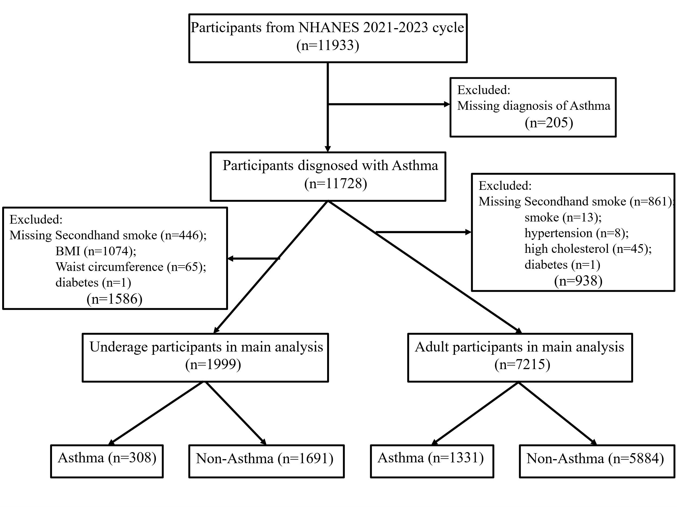
Fig. S1 Flow chart of the study population selection process (NHANES 2021-2023). BMI, body mass index; NHANES, National Health and Nutrition Examination Survey.

