Difference in association between dioxin-like compounds and all-cause mortality among non-menopause and menopausal women: A prospective cohort study
Shuaixing Song ^{a, b}, Yulin Wang ^{c}, Xukuan Zhang ^{d}, Xiaozhuan Liu ª *
ª Center for Clinical Single-Cell Biomedicine, Henan Provincial People's Hospital, People's Hospital of Zhengzhou University, Zhengzhou, China.
^{b} Department of Medical Statistics and Epidemiology, School of Public Health, Sun Yat-sen University, Guangzhou, China.
^{c} College of Public Health, Zhengzhou University, Zhengzhou, China.
^{d} Department of Maternal and Child Health, School of Public Health, Tongji Medical College, Huazhong University of Science and Technology, Wuhan, China

Supplementary Materials
CONTENTS

Table S1. Serum concentrations of analyzed DLCs in adults 1
Table S2. Hazard ratios (95% CI) of all‐cause mortality according to 9 DLCs concentrations among participants according to serum DLCs quartile. 1
Table S3. Sex differences in serum DLCs concentrations 3
Table S4. Sex-stratified analysis of the association between serum DLCs and all-cause mortality according to serum DLCs quartile. 4
Table S5. Differences in dioxin concentrations between dead and surviving female populations 7
Table S6. Characteristics of baseline data for women with different menstrual status 8
Figure S1. Spearman correlation map of serum concentrations of 9 dlc in individual participants 10
Figure S2. Dose-response relationship between DLCs and population-wide risk of all-cause mortality 11
Figure S3. Survival curves for populations with different concentrations of DLCs 12

Table S1. Serum concentrations of analyzed DLCs in adults
Characteristic | Mean | Minimum | P₂₅ | Median | P₇₅ | Maximum | Normtest.W ¹ | Mormtest.p ¹
PCB066 | 0.026 | 0.001 | 0.013 | 0.025 | 0.032 | 0.918 | 0.375 | <0.001
PCB074 | 0.075 | 0.004 | 0.021 | 0.042 | 0.093 | 1.370 | 0.636 | <0.001
PCB105 | 0.027 | 0.001 | 0.016 | 0.021 | 0.027 | 1.055 | 0.366 | <0.001
PCB118 | 0.100 | 0.005 | 0.024 | 0.050 | 0.117 | 3.805 | 0.458 | <0.001
PCB156 | 0.048 | 0.001 | 0.021 | 0.030 | 0.060 | 2.421 | 0.448 | <0.001
HXCDD | 237.303 | 8.770 | 59.080 | 172.350 | 333.700 | 4108.700 | 0.767 | <0.001
OCDD | 2699.731 | 217.700 | 969.800 | 1826.800 | 3260.600 | 54609.600 | 0.602 | <0.001
PNCDF | 43.632 | 5.090 | 17.110 | 32.400 | 57.520 | 638.000 | 0.750 | <0.001
HPCDF | 60.960 | 6.290 | 30.160 | 48.200 | 72.250 | 1769.800 | 0.409 | <0.001
¹ Shapiro-Wilk normal test results

Table S2. Hazard ratios (95% CI) of all‐cause mortality according to 9 DLCs concentrations among participants according to serum DLCs quartile.
Characteristic | Model 1 |  |  | Model 2
Characteristic | HR¹ | 95% CI¹ | p-value | HR¹ | 95% CI¹ | p-value
DL-PCBs
PCB066.q4
Q1 | — | — |  | — | —
Q2 | 0.87 | 0.71, 1.08 | 0.212 | 0.94 | 0.76, 1.17 | 0.582
Q3 | 0.99 | 0.78, 1.24 | 0.904 | 1.02 | 0.82, 1.28 | 0.833
Q4 | 1.47 | 1.07, 2.01 | 0.016 | 1.55 | 1.14, 2.10 | 0.005
PCB074.q4
Q1 | — | — |  | — | —
Q2 | 0.55 | 0.35, 0.85 | 0.008 | 0.54 | 0.35, 0.84 | 0.006
Q3 | 0.84 | 0.61, 1.16 | 0.291 | 0.83 | 0.61, 1.12 | 0.225
Q4 | 1.26 | 0.92, 1.73 | 0.148 | 1.28 | 0.92, 1.78 | 0.147
PCB105.q4
Q1 | — | — |  | — | —
Q2 | 0.93 | 0.72, 1.19 | 0.559 | 1.01 | 0.81, 1.26 | 0.927
Q3 | 0.77 | 0.57, 1.06 | 0.110 | 0.81 | 0.60, 1.10 | 0.182
Q4 | 1.27 | 0.95, 1.70 | 0.102 | 1.29 | 1.00, 1.67 | 0.047
PCB118.q4
Q1 | — | — |  | — | —
Q2 | 0.66 | 0.41, 1.05 | 0.076 | 0.67 | 0.43, 1.05 | 0.079
Q3 | 0.83 | 0.61, 1.12 | 0.220 | 0.94 | 0.68, 1.30 | 0.711
Q4 | 1.27 | 0.87, 1.83 | 0.212 | 1.44 | 0.99, 2.09 | 0.057
PCB156.q4
Q1 | — | — |  | — | —
Q2 | 0.91 | 0.65, 1.26 | 0.566 | 0.87 | 0.62, 1.20 | 0.388
Q3 | 1.30 | 1.0, 1.71 | 0.055 | 1.21 | 0.91, 1.61 | 0.183
Q4 | 1.88 | 1.41, 2.49 | <0.001 | 1.62 | 1.21, 2.18 | 0.001
PCDD
HXCDD.q4
Q1 | — | — |  | — | —
Q2 | 0.78 | 0.57, 1.05 | 0.105 | 0.81 | 0.59, 1.10 | 0.169
Q3 | 0.80 | 0.60, 1.06 | 0.120 | 0.84 | 0.64, 1.10 | 0.201
Q4 | 1.22 | 0.96, 1.54 | 0.102 | 1.25 | 1.01, 1.54 | 0.037
OCDD.q4
Q1 | — | — |  | — | —
Q2 | 0.91 | 0.67, 1.24 | 0.558 | 0.92 | 0.69, 1.23 | 0.581
Q3 | 1.13 | 0.88, 1.44 | 0.345 | 1.18 | 0.93, 1.50 | 0.165
Q4 | 1.35 | 1.04, 1.76 | 0.023 | 1.41 | 1.11, 1.79 | 0.004
PCDF
PNCDF.q4
Q1 | — | — |  | — | —
Q2 | 0.80 | 0.59, 1.07 | 0.133 | 0.84 | 0.61, 1.14 | 0.263
Q3 | 0.89 | 0.69, 1.14 | 0.338 | 0.89 | 0.69, 1.16 | 0.398
Q4 | 1.31 | 1.09, 1.59 | 0.005 | 1.37 | 1.14, 1.65 | <0.001
HPCDF.q4
Q1 | — | — |  | — | —
Q2 | 1.16 | 0.92, 1.47 | 0.206 | 1.23 | 0.96, 1.58 | 0.094
Q3 | 0.95 | 0.73, 1.22 | 0.672 | 1.02 | 0.80, 1.30 | 0.873
Q4 | 1.19 | 0.95, 1.48 | 0.122 | 1.18 | 0.96, 1.44 | 0.116
¹HR = Hazard Ratio, CI = Confidence Interval
Model 1：adjust for gender and age；
Model 2：adjusting for gender, age, race, education level, BMI, smoking and alcohol consumption；

Table S3. Sex differences in serum DLCs concentrations
Characteristic | Male, N = 1656 (49%)¹ | Female, N = 1867 (51%)¹ | p-value²
PCB066 | 0.03 (0.01, 0.03) | 0.02 (0.01, 0.03) | 0.304
PCB074 | 0.03 (0.02, 0.06) | 0.05 (0.02, 0.10) | <0.001
PCB105 | 0.02 (0.01, 0.03) | 0.02 (0.02, 0.03) | <0.001
PCB118 | 0.04 (0.02, 0.07) | 0.06 (0.03, 0.13) | <0.001
PCB156 | 0.03 (0.02, 0.06) | 0.03 (0.02, 0.06) | 0.131
HXCDD | 164.37 (47.03, 285.99) | 172.86 (60.38, 317.96) | 0.238
OCDD | 1,283.80 (758.63, 2,310.65) | 2,022.97 (1,126.53, 3,550.03) | <0.001
PNCDF | 29.70 (17.32, 50.70) | 30.90 (16.90, 55.31) | 0.607
HPCDF | 51.40 (31.72, 76.83) | 45.50 (28.50, 67.70) | <0.001
¹Median (IQR)
²Wilcoxon rank-sum test for complex survey samples

Table S4. Sex-stratified analysis of the association between serum DLCs and all-cause mortality according to serum DLCs quartile.
 | Group |  | Characteristic |  | HR¹ |  | 95% CI¹ |  | p-value
 | PCB066 |  | Male-adjusted
 |  |  | Q1 |  | — |  | —
 |  |  | Q2 |  | 0.94 |  | 0.67, 1.32 |  | 0.725
 |  |  | Q3 |  | 0.97 |  | 0.70, 1.33 |  | 0.836
 |  |  | Q4 |  | 1.51 |  | 0.96, 2.36 |  | 0.075
 |  |  | Female-adjusted
 |  |  | Q1 |  | — |  | —
 |  |  | Q2 |  | 1.10 |  | 0.78, 1.55 |  | 0.584
 |  |  | Q3 |  | 1.30 |  | 0.99, 1.71 |  | 0.063
 |  |  | Q4 |  | 1.83 |  | 1.22, 2.73 |  | 0.003
 | PCB074 |  | Male-adjusted
 |  |  | Q1 |  | — |  | —
 |  |  | Q2 |  | 0.66 |  | 0.41, 1.07 |  | 0.092
 |  |  | Q3 |  | 1.06 |  | 0.66, 1.69 |  | 0.821
 |  |  | Q4 |  | 1.48 |  | 0.91, 2.40 |  | 0.116
 |  |  | Female-adjusted
 |  |  | Q1 |  | — |  | —
 |  |  | Q2 |  | 0.45 |  | 0.19, 1.06 |  | 0.068
 |  |  | Q3 |  | 0.68 |  | 0.38, 1.23 |  | 0.201
 |  |  | Q4 |  | 1.25 |  | 0.68, 2.29 |  | 0.475
 | PCB105 |  | Male-adjusted
 |  |  | Q1 |  | — |  | —
 |  |  | Q2 |  | 1.37 |  | 1.00, 1.89 |  | 0.050
 |  |  | Q3 |  | 1.00 |  | 0.67, 1.49 |  | 0.994
 |  |  | Q4 |  | 1.26 |  | 0.86, 1.84 |  | 0.236
 |  |  | Female-adjusted
 |  |  | Q1 |  | — |  | —
 |  |  | Q2 |  | 0.97 |  | 0.64, 1.45 |  | 0.866
 |  |  | Q3 |  | 0.82 |  | 0.46, 1.45 |  | 0.493
 |  |  | Q4 |  | 1.89 |  | 1.26, 2.82 |  | 0.002
 | PCB118 |  | Male-adjusted
 |  |  | Q1 |  | — |  | —
 |  |  | Q2 |  | 0.71 |  | 0.41, 1.23 |  | 0.222
 |  |  | Q3 |  | 1.31 |  | 0.82, 2.10 |  | 0.266
 |  |  | Q4 |  | 1.43 |  | 0.85, 2.41 |  | 0.180
 |  |  | Female-adjusted
 |  |  | Q1 |  | — |  | —
 |  |  | Q2 |  | 1.03 |  | 0.55, 1.93 |  | 0.937
 |  |  | Q3 |  | 0.93 |  | 0.50, 1.74 |  | 0.824
 |  |  | Q4 |  | 2.44 |  | 1.35, 4.42 |  | 0.003
 | PCB156 |  | Male-adjusted
 |  |  | Q1 |  | — |  | —
 |  |  | Q2 |  | 1.06 |  | 0.58, 1.96 |  | 0.841
 |  |  | Q3 |  | 1.53 |  | 0.85, 2.75 |  | 0.153
 |  |  | Q4 |  | 1.72 |  | 0.96, 3.08 |  | 0.070
 |  |  | Female-adjusted
 |  |  | Q1 |  | — |  | —
 |  |  | Q2 |  | 1.09 |  | 0.58, 2.06 |  | 0.793
 |  |  | Q3 |  | 1.46 |  | 0.88, 2.43 |  | 0.148
 |  |  | Q4 |  | 2.49 |  | 1.46, 4.28 |  | <0.001
 | HXCDD |  | Male-adjusted
 |  |  | Q1 |  | — |  | —
 |  | Q2 |  | 0.64 |  | 0.40, 1.02 |  | 0.058
 |  | Q3 |  | 0.79 |  | 0.53, 1.17 |  | 0.236
 |  | Q4 |  | 1.08 |  | 0.72, 1.62 |  | 0.705
 |  | Female-adjusted
 |  | Q1 |  | — |  | —
 |  | Q2 |  | 1.02 |  | 0.56, 1.86 |  | 0.955
 |  | Q3 |  | 0.83 |  | 0.53, 1.30 |  | 0.417
 |  | Q4 |  | 1.39 |  | 0.93, 2.07 |  | 0.107
OCDD |  | Male-adjusted
 |  | Q1 |  | — |  | —
 |  | Q2 |  | 0.91 |  | 0.58, 1.42 |  | 0.682
 |  | Q3 |  | 1.14 |  | 0.72, 1.82 |  | 0.569
 |  | Q4 |  | 1.33 |  | 0.78, 2.26 |  | 0.295
 |  | Female-adjusted
 |  | Q1 |  | — |  | —
 |  | Q2 |  | 0.77 |  | 0.39, 1.52 |  | 0.453
 |  | Q3 |  | 1.01 |  | 0.60, 1.70 |  | 0.957
PNCDF |  | Male-adjusted
 |  | Q1 |  | — |  | —
 |  | Q2 |  | 0.79 |  | 0.44, 1.41 |  | 0.421
 |  | Q3 |  | 1.01 |  | 0.59, 1.72 |  | 0.977
 |  | Q4 |  | 1.37 |  | 0.86, 2.17 |  | 0.186
 |  | Female-adjusted
 |  | Q1 |  | — |  | —
 |  | Q2 |  | 1.12 |  | 0.68, 1.85 |  | 0.654
 |  | Q3 |  | 0.87 |  | 0.54, 1.39 |  | 0.555
 |  | Q4 |  | 1.61 |  | 1.07, 2.44 |  | 0.023
HPCDF |  | Male-adjusted
 |  | Q1 |  | — |  | —
 |  | Q2 |  | 1.12 |  | 0.73, 1.73 |  | 0.607
 |  | Q3 |  | 1.16 |  | 0.76, 1.78 |  | 0.478
 |  | Q4 |  | 1.05 |  | 0.75, 1.47 |  | 0.771
 |  | Female-adjusted
 |  | Q1 |  | — |  | —
 |  | Q2 |  | 1.26 |  | 0.90, 1.77 |  | 0.174
 |  | Q3 |  | 0.80 |  | 0.51, 1.26 |  | 0.345
 |  | Q4 |  | 1.18 |  | 0.77, 1.80 |  | 0.441
¹HR = Hazard Ratio, CI = Confidence Interval

Table S5. Differences in dioxin concentrations between dead and surviving female populations
Characteristic | Survive, N = 852 (76%)¹ | Mortality, N = 387 (24%)¹ | p-value²
PCB066 | 0.02 (0.01, 0.03) | 0.03 (0.02, 0.03) | <0.001
PCB074 | 0.05 (0.02, 0.09) | 0.13 (0.08, 0.22) | <0.001
PCB105 | 0.02 (0.01, 0.02) | 0.03 (0.02, 0.06) | <0.001
PCB118 | 0.05 (0.03, 0.11) | 0.16 (0.08, 0.28) | <0.001
PCB156 | 0.03 (0.02, 0.05) | 0.07 (0.05, 0.11) | <0.001
HXCDD | 160.20 (64.51, 307.53) | 373.41 (217.18, 592.85) | <0.001
OCDD | 1,792.36 (1,049.43, 3,277.46) | 3,731.74 (2,270.45, 6,145.09) | <0.001
PNCDF | 30.45 (15.80, 52.29) | 65.03 (37.91, 102.77) | <0.001
HPCDF | 46.38 (29.40, 65.67) | 47.58 (32.24, 76.38) | 0.044
¹Median (IQR)
²Wilcoxon rank-sum test for complex survey samples

Table S6. Characteristics of baseline data for women with different menstrual status
Characteristic | All women  N = 1239 (100%)¹ | Menstrual status group
Characteristic | All women  N = 1239 (100%)¹ | Non-menopause  N = 437 (41%)¹ | Spontaneous menopause  N = 419 (30%)¹ | Hysterectomy  N = 383 (29%)¹ | p-value²
Age | 52 (38, 64) | 35 (28, 44) | 60 (53, 70) | 62 (52, 70) | <0.001
Age.group |  |  |  |  | <0.001
20-39 years | 295 (26.28%) | 282 (60.15%) | 4 (1.04%) | 9 (4.23%)
40-59 years | 356 (37.35%) | 144 (37.68%) | 115 (40.57%) | 97 (33.47%)
60+ years | 588 (36.37%) | 11 (2.17%) | 300 (58.39%) | 277 (62.30%)
Race/ethnicity |  |  |  |  | <0.001
Non-Hispanic White | 660 (73.82%) | 212 (69.17%) | 225 (75.63%) | 223 (78.59%)
Non-Hispanic Black | 223 (9.91%) | 80 (10.60%) | 58 (7.06%) | 85 (11.95%)
Mexican American | 255 (5.79%) | 106 (9.60%) | 94 (3.62%) | 55 (2.59%)
Multiracial/other | 101 (10.48%) | 39 (10.62%) | 42 (13.69%) | 20 (6.87%)
Education |  |  |  |  | <0.001
Less than high school | 395 (20.96%) | 110 (16.93%) | 158 (22.94%) | 127 (24.67%)
High school or equivalent | 294 (25.79%) | 93 (21.59%) | 94 (25.83%) | 107 (31.79%)
College or above | 550 (53.25%) | 234 (61.48%) | 167 (51.23%) | 149 (43.53%)
BMI |  |  |  |  | <0.001
Normal | 408 (39.03%) | 173 (45.76%) | 107 (30.10%) | 128 (38.81%)
Obesity | 443 (32.18%) | 156 (32.42%) | 156 (34.79%) | 131 (29.06%)
Overweight | 388 (28.79%) | 108 (21.82%) | 156 (35.11%) | 124 (32.13%)
Smoking status |  |  |  |  | 0.017
Never smoker | 728 (55.52%) | 265 (57.26%) | 240 (54.91%) | 223 (53.67%)
Current smoker | 232 (22.79%) | 108 (27.77%) | 62 (18.35%) | 62 (20.31%)
Former smoker | 279 (21.69%) | 64 (14.97%) | 117 (26.74%) | 98 (26.03%)
Alcohol intake |  |  |  |  | 0.004
Non-drinker | 593 (41.80%) | 171 (33.73%) | 220 (48.78%) | 202 (46.03%)
1-5 drinks/month | 487 (42.36%) | 210 (49.81%) | 145 (36.19%) | 132 (38.18%)
5-10 drinks/month | 45 (4.48%) | 20 (5.70%) | 10 (2.16%) | 15 (5.20%)
10+ drinks/month | 114 (11.35%) | 36 (10.76%) | 44 (12.88%) | 34 (10.58%)
¹Median (IQR); n (unweighted) (%)
²Wilcoxon rank-sum test for complex survey samples; chi-squared test with Rao & Scott's second-order correction

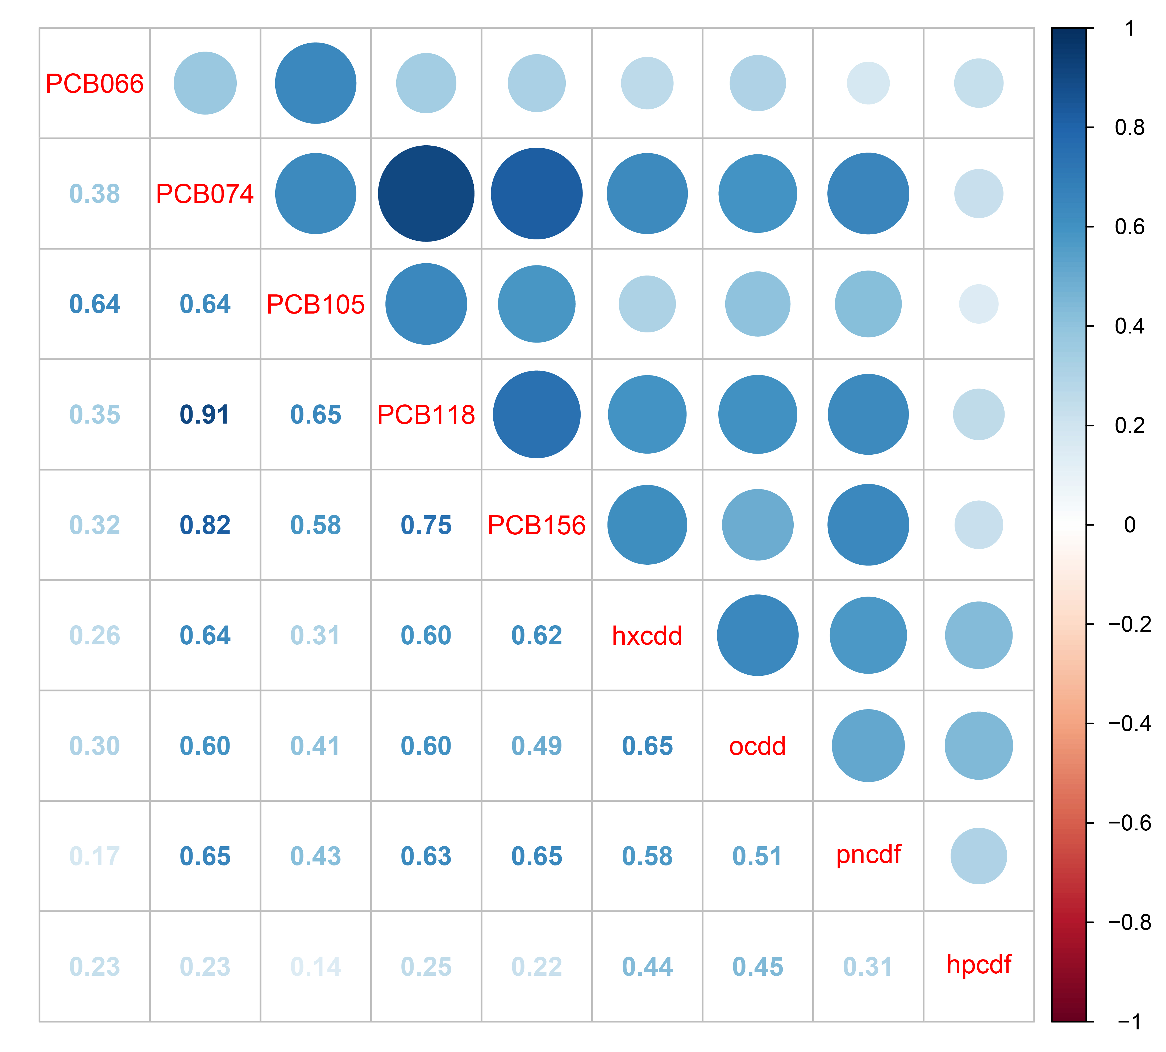

Figure S1. Spearman correlation map of serum concentrations of 9 dlc in individual participants
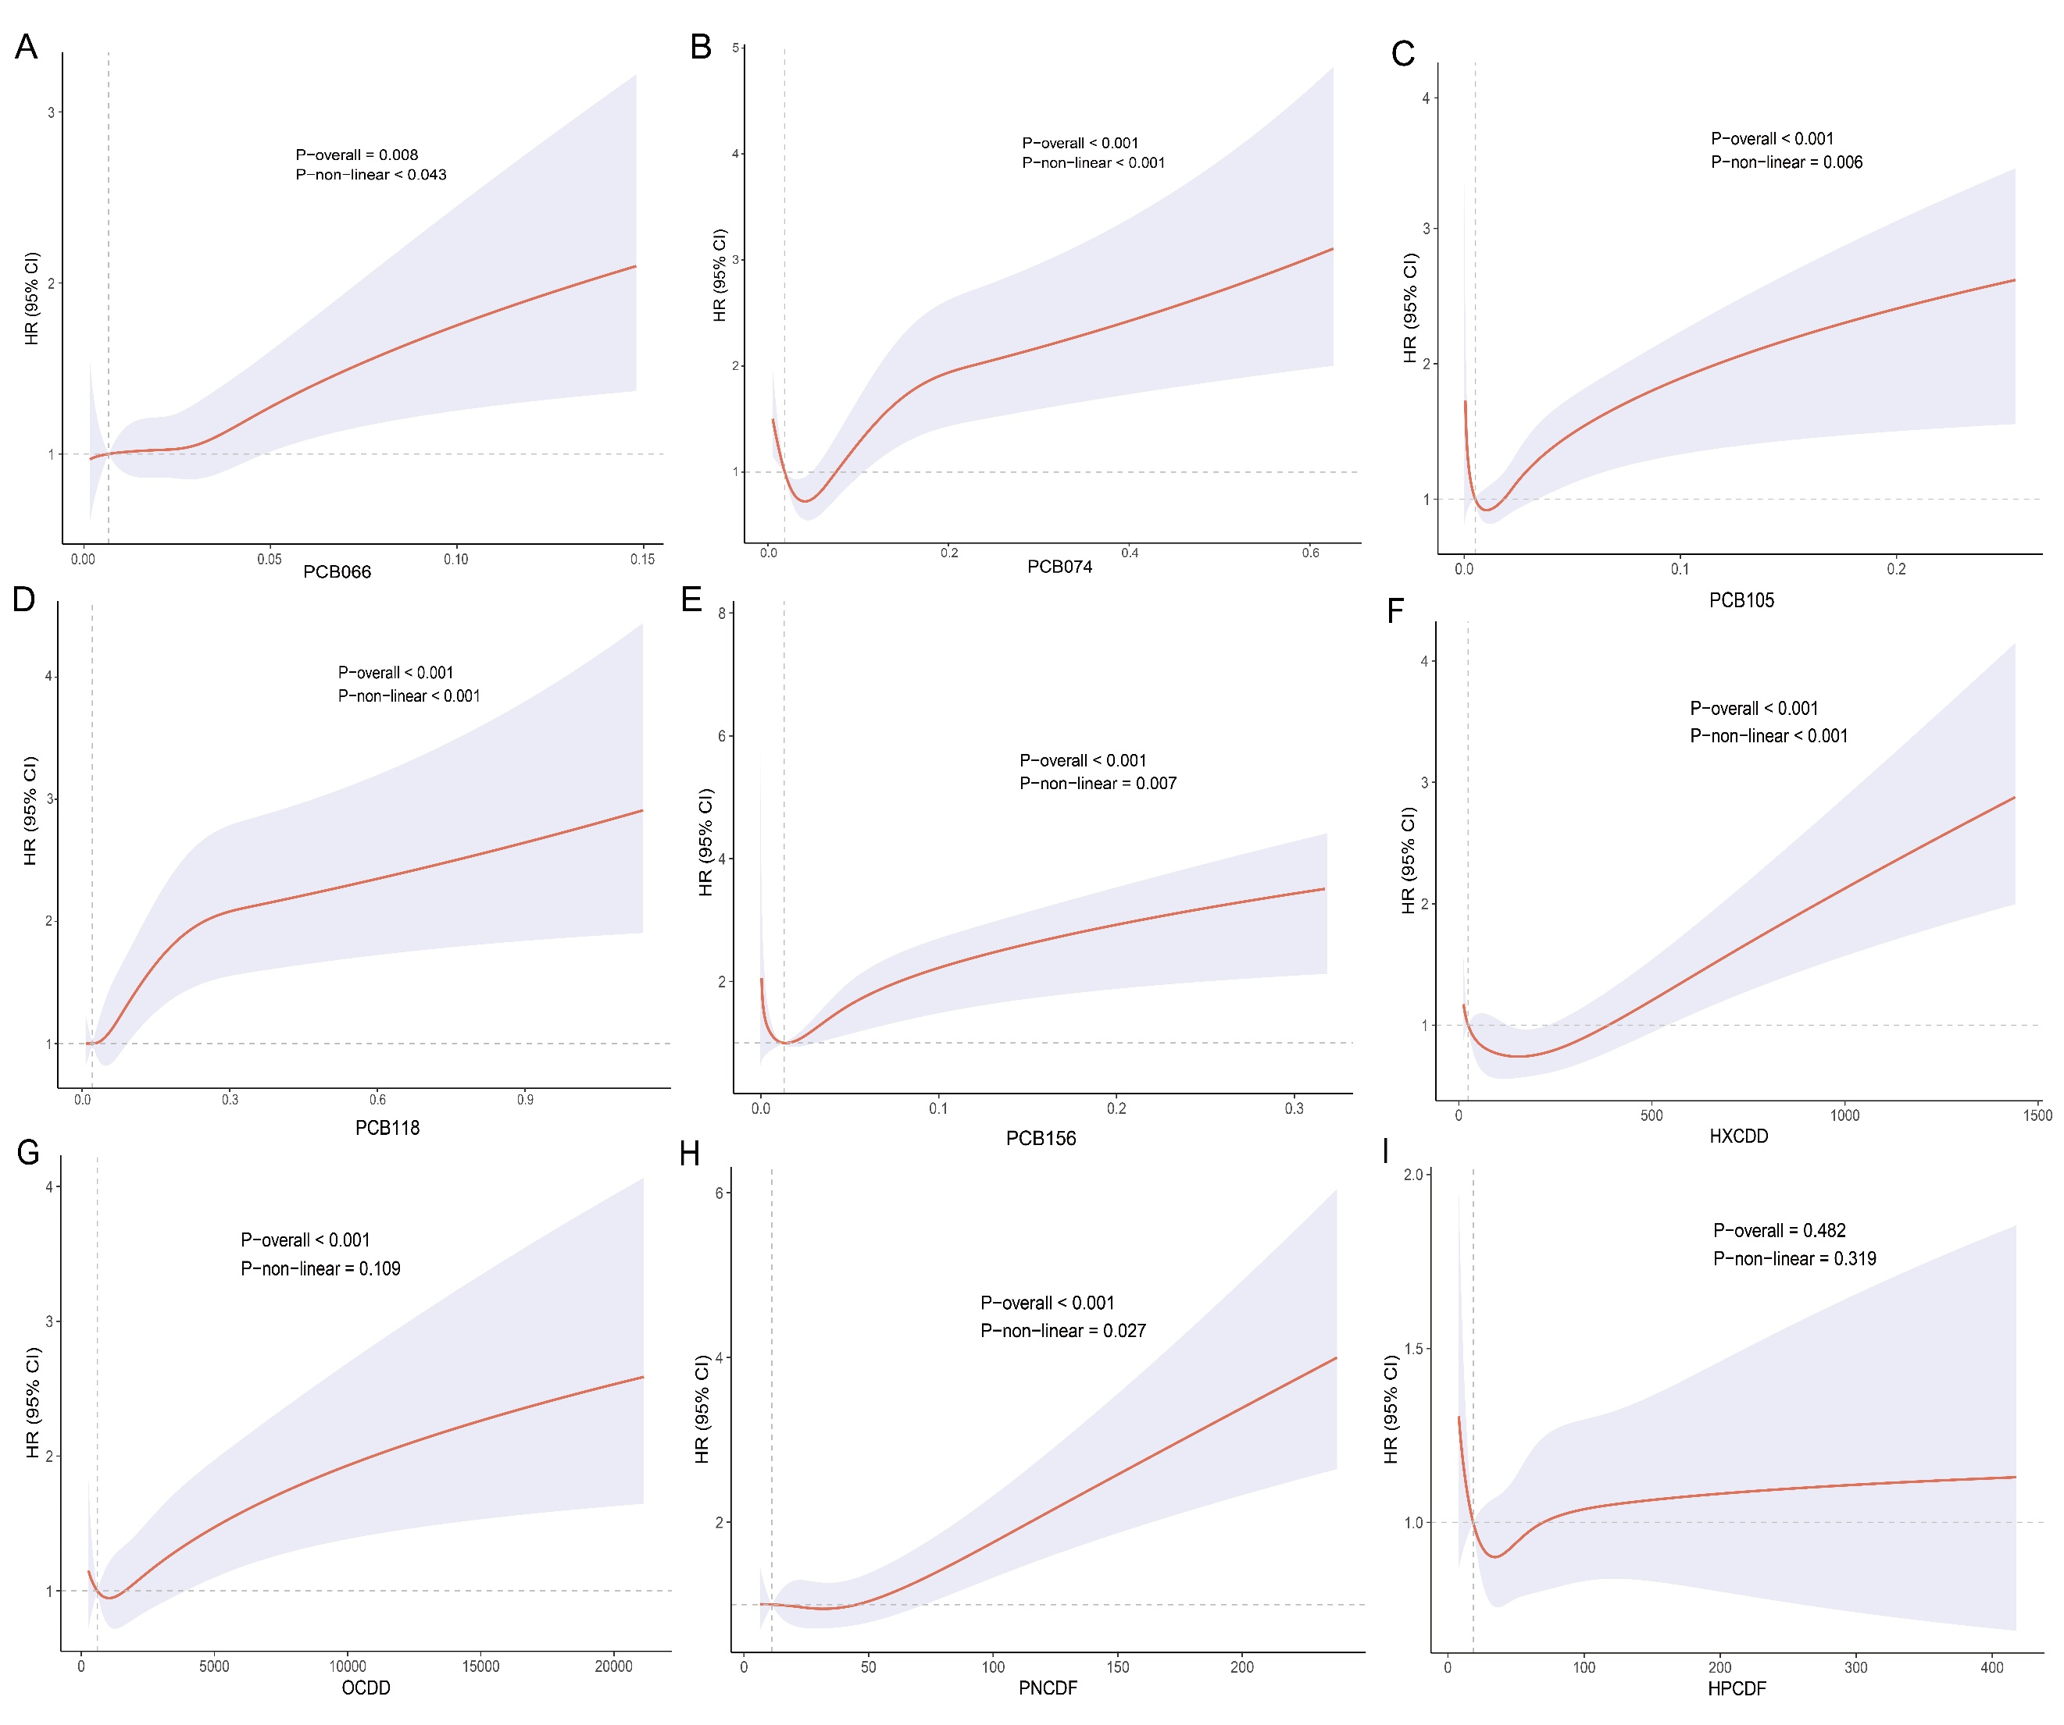

Figure S2. Dose-response relationship between DLCs and population-wide risk of all-cause mortality

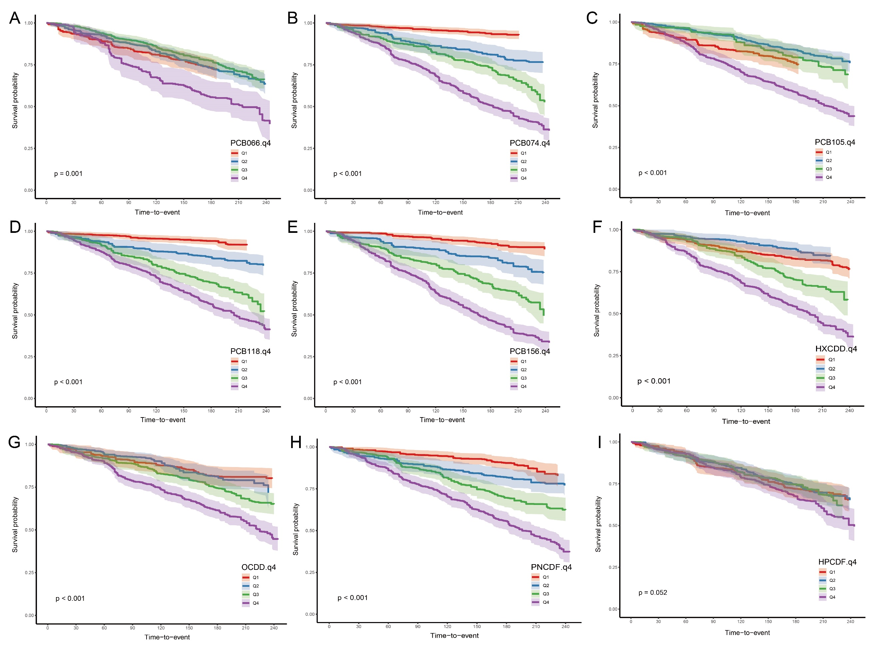

Figure S3. Survival curves for populations with different concentrations of DLCs

