Supplementary files
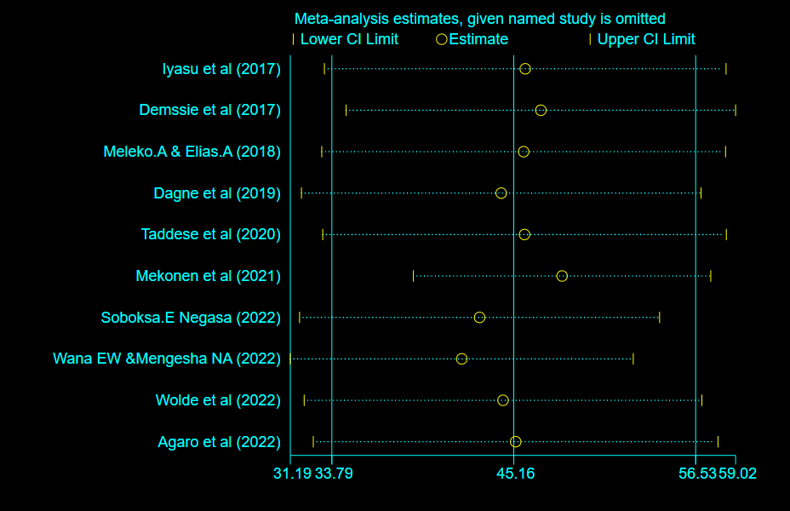
S. Fig.1: Sensitivity analysis plot for the pooled prevalence of hand washing practice among mothers in Ethiopia,2022.
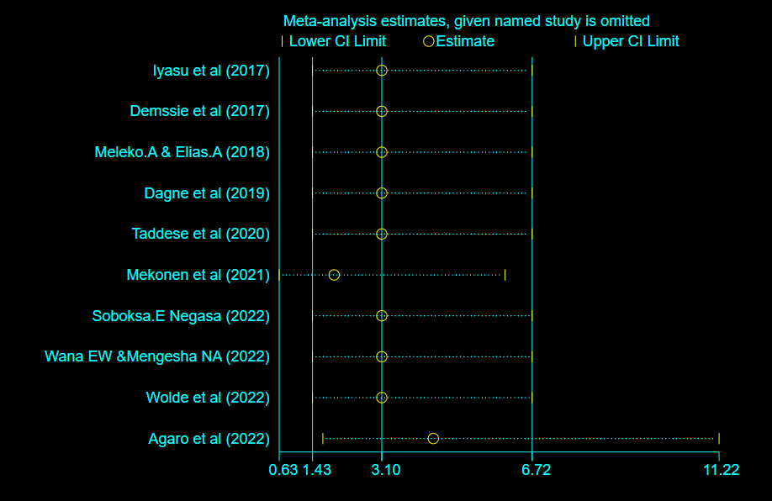
S. Fig.2: Sensitivity analysis plot for factor age (15-24) of hand washing practice among mothers in Ethiopia, 2022.
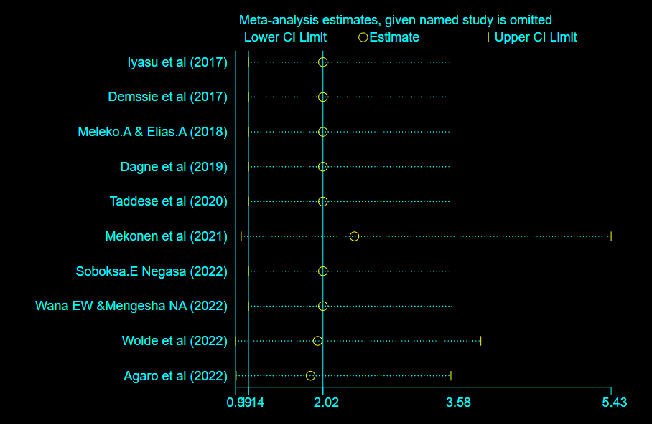
S. Fig.3: Sensitivity analysis plot for factor age (25-34) of hand washing practice among mothers in Ethiopia, 2022.

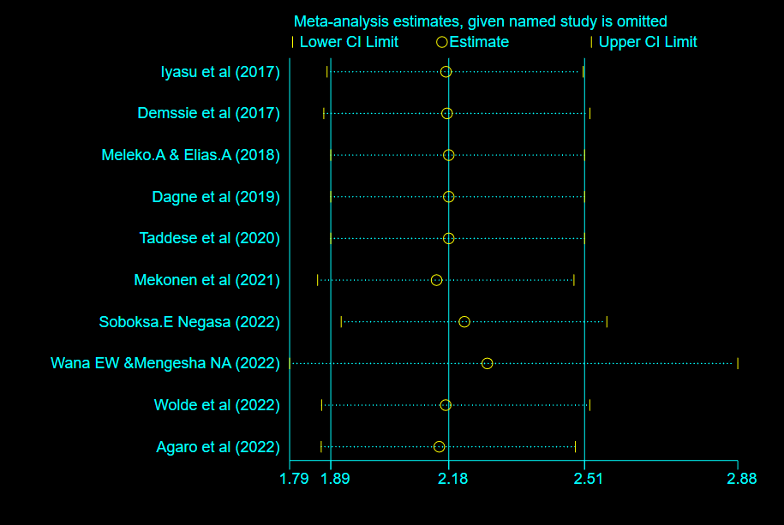
S. Fig.4: Sensitivity analysis plot for factor educational status (primary) of hand washing practice among mothers in Ethiopia, 2022.

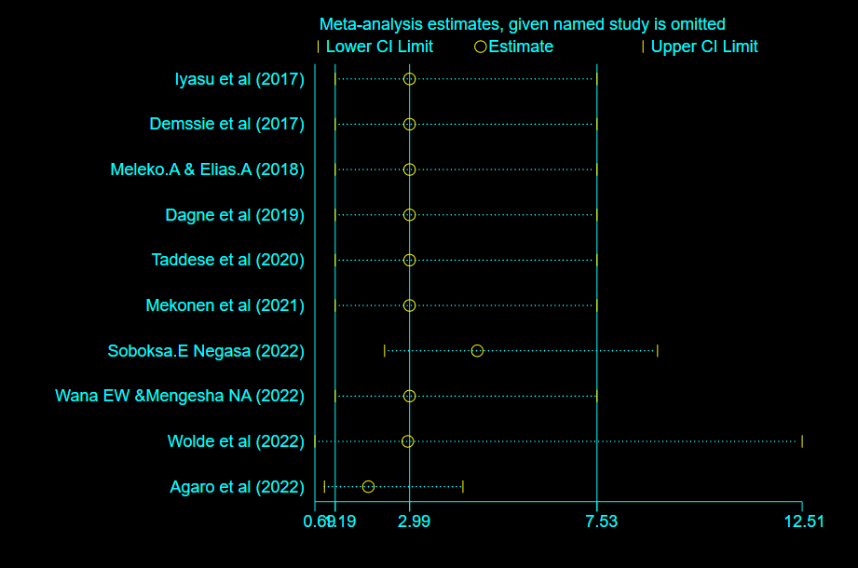
S. Fig.5: Sensitivity analysis plot for factor educational status (secondary and above) of hand washing practice among mothers in Ethiopia, 2022.

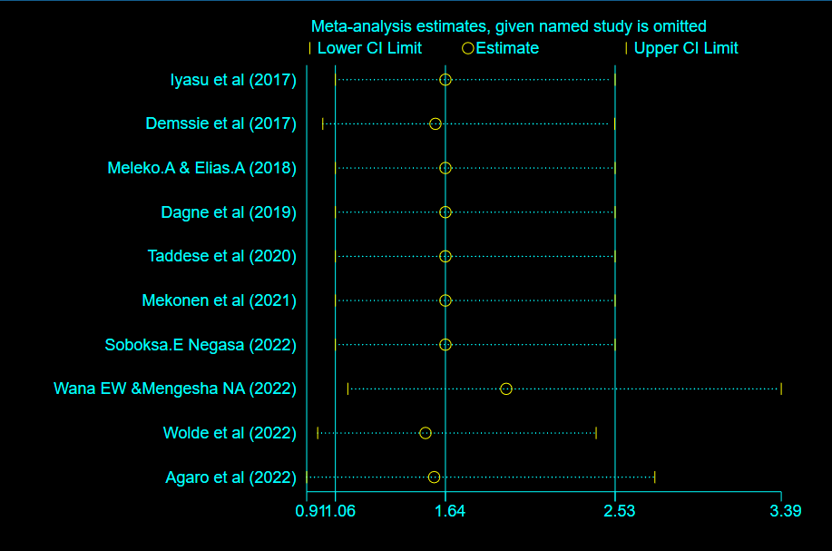
S. Fig.6: Sensitivity analysis plot for factor family size of hand washing practice among mothers in Ethiopia, 2022.

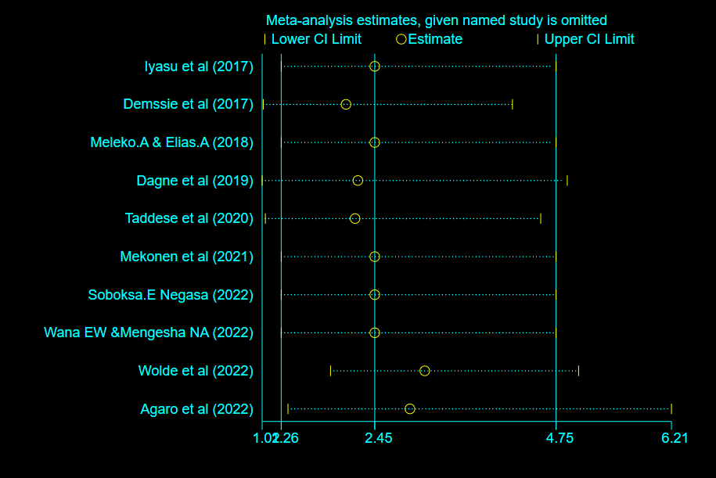
S. Fig.7: Sensitivity analysis plot for factor knowledge of hand washing practice among mothers in Ethiopia, 2022.

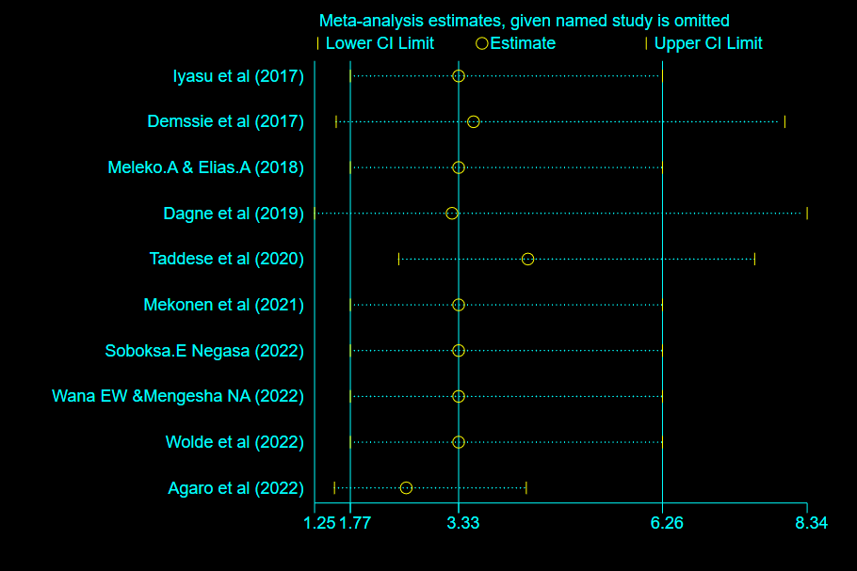
S. Fig.8: Sensitivity analysis plot for factor attitude of hand washing practice among mothers in Ethiopia, 2022.

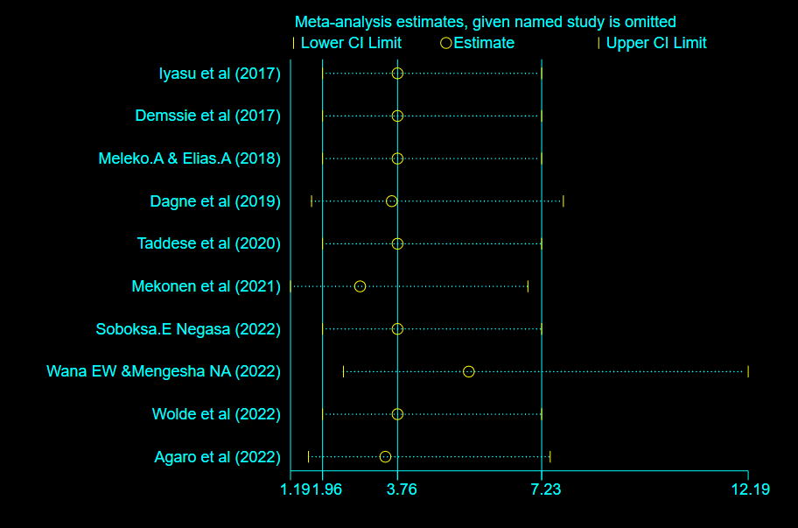
S. Fig.9: Sensitivity analysis plot for factor water availability of hand washing practice among mothers in Ethiopia, 2022.
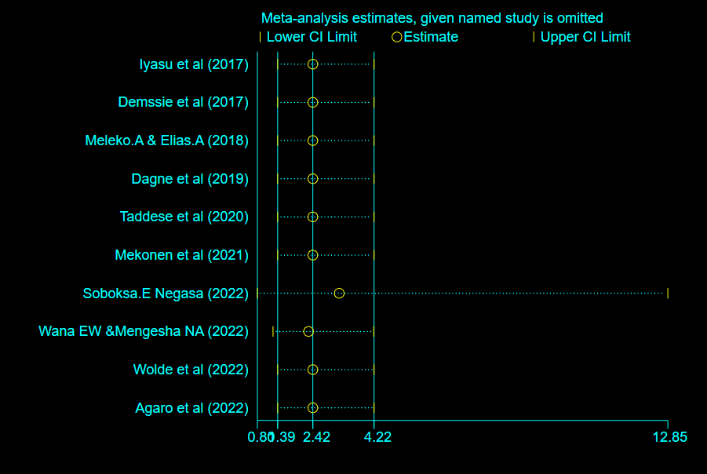
S. Fig.10: Sensitivity analysis plot for factor rich wealth index of hand washing practice among mothers in Ethiopia, 2022.

