Supplement

Isometric log-ratio (ILR)
Let M be a compositional vector with m components. Since M is a m-simplex space, that is, $M=\left\{{(M}_{1},…, M_{m}\right): M_{i}>0, i=1,2,…,m, \sum_{i=1}^{m}{M_{i}=1}\}$, modelling directly to M may produce distorted results (Aitchison, 1982). Egozue et al. (2023) introduced the isometric log-ratio (ilr) transformation technique as a means to tackle this problem. The ilr transformation converts compositional data from the simplex $S^{m}$ to the real Euclidean space $R^{m−1}$ (Egozcue et al., 2003).
Let's denote the coordinates of the ilr transformation as $Z$, represented by $Z=(Z_{1},Z_{2}, …, Z_{m−1})$. For coordinate I,
$$Z_{i}=\sqrt{\frac{m−i}{m−i+1}}ln\frac{M_{i}}{{(\prod_{j=i+1}^{m}{M_{j}})}^{\frac{1}{m−i}}}$$
The advantage of the ilr transformation is that it can be expressed and interpreted as the average of pairwise log differences, that is
$$Z_{i}=\sqrt{\frac{m−i}{m−i+1}}ln\frac{M_{i}}{{\left(\prod_{j=i+1}^{m}{M_{j}}\right)}^{\frac{1}{m−i}}}=\sqrt{\frac{1}{\left(m−i+1\right)\left(m−i\right)}}\sum_{j=i+1}^{m}{\ln\left(\frac{M_{i}}{M_{j}}\right)}=\sqrt{\frac{1}{\left(m−i+1\right)\left(m−i\right)}}\sum_{j=i+1}^{m}{(ln\left(M_{i}\right)−ln⁡(M_{j}))}$$
In this paper, the time spent in SB, LPA, MVPA, and sleeping were converted into a three-dimensional coordinate, denoted as Z, using the ILR transformation, where
$$Z=\left(\sqrt{\frac{3}{4}}\ln{\frac{MVPA}{{\left(Sleep∗SB∗LPA\right)}^{\frac{1}{3}}}} ,\sqrt{\frac{2}{3}}\ln{\frac{LPA}{{\left(Sleep∗SB\right)}^{\frac{1}{2}}}} ,\sqrt{\frac{1}{2}}\ln{\frac{Sleep}{SB}}\right)$$

Compositional Mediation Cox Model
Consider a random sample of size n drawn from a population. Let t represents survival time, s represents censoring status, $h_{0}(t)$ represent baseline hazard, M denotes a vector of m compositional mediators, T represents an exposure variable, and X be a set of covariates that potentially influence the mediators, exposure, and survival time. Based on the aforementioned ILR calculation, we proposed a compositional mediation Cox model below:
Step 1: Building Cox proportional hazards function $h(t)$ on exposure T and ILR coordinates Z
$$h\left(t\right)=h_{0}\left(t\right)∗exp⁡(\sum_{i=1}^{m−1}{β_{i}Z_{i}}+cT+γX)$$
Where $β_{i}$ is the coefficient of $Z_{i}$, c is the coefficient of T, and $γ$ is the vector of coefficient of X. By replacing $Z_{i}$using $M_{i}$, the equation will be simplified to
$$h\left(t\right)=h_{0}\left(t\right)∗exp⁡(\sum_{i=1}^{m}{{β_{i}}^{'}{ln(M}_{i})}+cT+γX)$$
Where
$${β_{i}}^{'}=\left\{\begin{aligned}β_{i}\sqrt{\frac{\left(m−i\right)}{\left(m−i+1\right)}}−min⁡(i−1,1)\sum_{j=1}^{i−1}{β_{j}\sqrt{\frac{1}{\left(m−j+1\right)\left(m−j\right)}}}, 1≤i \text{≤ m-1 } \\ −\sum_{j=1}^{m−1}{β_{j}\sqrt{\frac{1}{\left(m−j+1\right)\left(m−j\right)}}}, &i \text{= m}\end{aligned}\right.$$
Step 2: Building linear regression $M_{i}$ on exposure T
$$ln\left(M_{i}\right)=α_{0i}+α_{1i}T+γ_{i}X$$
where $α_{0i}$ is the intercept, $α_{1i}$ is the coefficient of T, and$γ_{i}$ is the vector of coefficient of X.
From step 1 and step 2, we get the indirect effect hazards ratio (HR) on exposure T through $M_{i}$ is $e^{α_{1i}{β_{i}}^{'} }$. Further, the total indirect effect HR (ATEHR), total direct effect HR (TDEHR), and total effect HR (TEHR) are $e^{\sum_{i=1}^{m}{α_{1i}{β_{i}}^{'}}}$, $e^{c}$, and $e^{\sum_{i=1}^{m}{α_{1i}{β_{i}}^{'}}+c}$, respectively. Furthermore, the proportion of individual indirect effect, total indirect effect, and direct effect to the total effect are $\frac{α_{1i}{β_{i}}^{'}}{\sum_{i=1}^{m}{α_{1i}{β_{i}}^{'}}+c}$, $\frac{\sum_{i=1}^{m}{α_{1i}{β_{i}}^{'}}}{\sum_{i=1}^{m}{α_{1i}{β_{i}}^{'}}+c}$, and $\frac{c}{\sum_{i=1}^{m}{α_{1i}{β_{i}}^{'}}+c}$.
In our study, we tried to determine the effect of diabetes on mortality mediated by daily physical activity, including MVPA, LPA, SB, and sleep, after adjusting for covariate we mentioned above. Adjusted HR with 95% confidence intervals (CIs) for mortality were computed.
Compositional Isotemporal Substitution Cox Model
Let t represents survival time, s represents censoring status, $h_{0}(t)$ represent baseline hazard, M denotes a vector of m compositional mediators, and X be a set of covariates that potentially influence the exposure and survival time, then we can build a Cox model as below:
$$h\left(t,Z\right)=h_{0}\left(t\right)∗exp⁡(\sum_{i=1}^{m−1}{β_{i}Z_{i}}+γX)$$
Where $β_{i}$ is the coefficient of $Z_{i}$, and $γ$ is the vector of coefficient of X. By replacing $Z_{i}$ using $M$, the equation will be simplified to
$$h\left(t,M\right)=h_{0}\left(t\right)∗exp⁡(\sum_{i=1}^{m}{{β_{i}}^{'}{ln(M}_{i})}+γX)$$
Where
$${β_{i}}^{'}=\left\{\begin{aligned}β_{i}\sqrt{\frac{\left(m−i\right)}{\left(m−i+1\right)}}−min⁡(i−1,1)\sum_{j=1}^{i−1}{β_{j}\sqrt{\frac{1}{\left(m−j+1\right)\left(m−j\right)}}}, 1≤i \text{≤ m-1 } \\ −\sum_{j=1}^{m−1}{β_{j}\sqrt{\frac{1}{\left(m−j+1\right)\left(m−j\right)}}}, &i \text{= m}\end{aligned}\right.$$
Further, the HR for reallocation of compositional data from one components to another, and keep the remaining components constant is (i.e. replace $M_{j}$ by $M_{k}$)
$$HR= \frac{exp⁡({β_{j}}^{'}\ln\left(M_{j}−∆t\right)+{β_{k}}^{'}\ln\left(M_{k}+∆t\right))}{exp⁡({β_{j}}^{'}\ln\left(M_{j}\right)+{β_{k}}^{'}\ln\left(M_{k}\right))}$$
In our study, we aimed to calculate HR of mortality for reallocation of fixed durations of time between one component and remaining components (e.g., exchange between MVPA and remaining time) in diabetes populations.
Life Expectancy – Cohort Life Table
Let t represents survival time, s represents censoring status, $h_{0}(t,a)$ represent baseline hazard at age a (A chronic disease is diagnosed at age a, such as diabetes in our paper), M denotes a vector of m compositional data which transformed by ILR into a Z vector containing m-1 dimentions in Euclidean space, and X be a set of covariates that potentially influence the exposure and survival time, then we first build Cox regression model in each age to calculate $h_{0}(t,a)$: for subject who diagnosed chronic disease at that age $h\left(t,Z,a\right)=h_{0}\left(t,a\right)∗exp⁡(\sum_{i=1}^{m−1}{β_{i,a}Z_{i}}+γ_{a}X)$
Where $β_{i,a}$ is the coefficient of $Z_{i}$, and $γ_{a}$ is the vector of coefficient of X. After that, we build another Cox regression model for whole subject to calculate all coefficients：
$$h\left(t,Z\right)=h_{0}\left(t\right)∗exp⁡(\sum_{i=1}^{m−1}{β_{i}Z_{i}}+γX)$$
Where $β_{0}$ is the intercept, $β_{i}$ is the coefficient of $Z_{i}$, and $γ$ is the vector of coefficient of X. Then the life expectancy (LE) for each subject is:
$$LE= \int_{t=0}^{∞}{exp⁡(−h_{0}\left(t,a\right)∗exp⁡(\sum_{i=1}^{m−1}{β_{i}Z_{i}}+γX))}dt$$
Afterward, the years of life lost/gain and the corresponding 95% CIs were computed by taking the disparity between the two survival curves' respective areas.
In our study, our aim was to determine the years of life lost or gained in the next 10 years when replacing a specific physical activity substitute others in diabetes population. The calculation of the years of life gain/lost in the next 10 years followed these steps:
First, we calculated the initial years of life in the next 10 years:
$${LE}_{1}= \int_{t=0}^{10}{exp⁡(−h_{0}\left(t,a\right)∗exp⁡(βZ+γX))}dt$$
Where
$$Z=\left(\sqrt{\frac{1}{2}}\ln{\frac{MVPA}{SB+LPA+sleep}}\right)$$
If n minutes of SB or LPA or sleep was replaced by MVPA, then the new years of life in the next 10 years was:
$${LE}_{2}= \int_{t=0}^{10}{exp⁡(−h_{0}\left(t,a\right)∗exp⁡(βZ^{'}+γX))}dt$$
Where
$$Z^{'}=\left(\sqrt{\frac{1}{2}}\ln{\frac{MVPA+n}{SB+LPA+sleep−n}}\right)$$
Finally, the years of life gain/lost in the next 10 years was
$${LE}_{2}−{LE}_{1}$$
To enhance the accuracy of estimates by leveraging cohort information fully, baseline hazard ratio for each age group among diabetes populationwas estimated using the entire UK Biobank (UKB) population, while other parameters were estimated based on the accelerometer population. The baseline hazard ratio for diagnosed diabetes in each age group are shown in Figure S1.

Table S1 Variables used for defining type 2 diabetes
Category | Data-Field | Description
Self-reported data
 | 2976 | Age diabetes diagnosed
 | 31 | Sex
 | 21000 | Ethnic background
 | 20002 | Non-cancer illness code, self-reported
 | 6177 | Medication for cholesterol, blood pressure or diabetes
 | 6153 | Medication for cholesterol, blood pressure, diabetes, or take exogenous hormones
 | 20003 | Treatment/medication code
 | 4041 | Gestational diabetes only
 | 20009 | Interpolated Age of participant when non-cancer illness first diagnosed
 | 2986 | Started insulin within one year diagnosis of diabetes
Hospital inpatient records
 | 41271 | Diagnoses - ICD9
 | 41281 | Date of first in-patient diagnosis - ICD9
 | 41270 | Diagnoses - ICD10
 | 41280 | Date of first in-patient diagnosis - ICD10
Blood biochemistry
 | 30740 | Glucose
 | 30750 | Glycated haemoglobin (HbA1c)

Figure S1: Participants Selection Flowchart
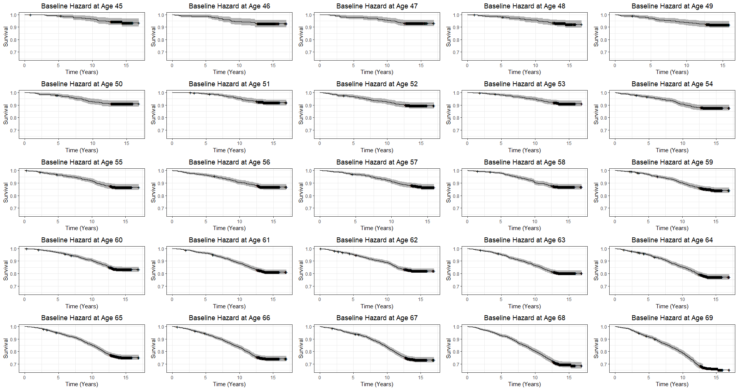
Figure S2: Age Stratified baseline hazard ratio among diabetes population

Table S2: Expected life gain (Years) in the upcoming decade from Replacing remaining time to MVPA
Age | 10 Min | 20 Min | 30 Min | 40 Min | 50 Min | 60 Min
45 | 0.026 | 0.038 | 0.045 | 0.049 | 0.053 | 0.055
46 | 0.051 | 0.073 | 0.086 | 0.095 | 0.102 | 0.107
47 | 0.051 | 0.074 | 0.087 | 0.096 | 0.103 | 0.108
48 | 0.057 | 0.082 | 0.097 | 0.107 | 0.115 | 0.121
49 | 0.093 | 0.134 | 0.158 | 0.175 | 0.187 | 0.196
50 | 0.093 | 0.134 | 0.158 | 0.175 | 0.187 | 0.196
51 | 0.051 | 0.073 | 0.086 | 0.095 | 0.102 | 0.107
52 | 0.142 | 0.205 | 0.243 | 0.269 | 0.288 | 0.302
53 | 0.094 | 0.136 | 0.160 | 0.177 | 0.190 | 0.199
54 | 0.183 | 0.266 | 0.315 | 0.348 | 0.373 | 0.393
55 | 0.183 | 0.265 | 0.315 | 0.348 | 0.373 | 0.392
56 | 0.227 | 0.329 | 0.391 | 0.433 | 0.464 | 0.488
57 | 0.208 | 0.302 | 0.359 | 0.397 | 0.426 | 0.449
58 | 0.212 | 0.308 | 0.366 | 0.405 | 0.435 | 0.458
59 | 0.267 | 0.389 | 0.463 | 0.513 | 0.551 | 0.581
60 | 0.292 | 0.427 | 0.508 | 0.564 | 0.606 | 0.639
61 | 0.365 | 0.535 | 0.639 | 0.711 | 0.765 | 0.807
62 | 0.449 | 0.661 | 0.791 | 0.882 | 0.949 | 1.002
63 | 0.495 | 0.732 | 0.879 | 0.982 | 1.059 | 1.120
64 | 0.556 | 0.826 | 0.995 | 1.114 | 1.204 | 1.274
65 | 0.563 | 0.839 | 1.013 | 1.135 | 1.228 | 1.301
66 | 0.655 | 0.985 | 1.195 | 1.345 | 1.459 | 1.550
67 | 0.670 | 1.007 | 1.223 | 1.376 | 1.493 | 1.586
68 | 0.753 | 1.150 | 1.409 | 1.597 | 1.741 | 1.857
69 | 0.802 | 1.239 | 1.529 | 1.742 | 1.907 | 2.041

Table S3: Expected life gain (Years) in the upcoming decade from Replacing remaining time to SB
Age | 20 Min | 40 Min | 60 Min | 80 Min | 100 Min | 120 Min | 140 Min | 160 Min | 180 Min | 200 Min | 220 Min | 240 Min
45 | -0.001 | -0.002 | -0.004 | -0.005 | -0.006 | -0.008 | -0.009 | -0.011 | -0.013 | -0.015 | -0.016 | -0.018
46 | -0.002 | -0.005 | -0.007 | -0.010 | -0.013 | -0.016 | -0.019 | -0.022 | -0.025 | -0.029 | -0.032 | -0.036
47 | -0.002 | -0.005 | -0.008 | -0.010 | -0.013 | -0.016 | -0.019 | -0.023 | -0.026 | -0.030 | -0.034 | -0.038
48 | -0.003 | -0.006 | -0.009 | -0.012 | -0.015 | -0.018 | -0.022 | -0.026 | -0.030 | -0.034 | -0.038 | -0.043
49 | -0.005 | -0.009 | -0.014 | -0.020 | -0.025 | -0.031 | -0.037 | -0.043 | -0.050 | -0.056 | -0.064 | -0.071
50 | -0.005 | -0.010 | -0.015 | -0.020 | -0.026 | -0.031 | -0.038 | -0.044 | -0.051 | -0.058 | -0.065 | -0.073
51 | -0.003 | -0.005 | -0.008 | -0.011 | -0.014 | -0.017 | -0.021 | -0.024 | -0.028 | -0.032 | -0.036 | -0.040
52 | -0.008 | -0.016 | -0.024 | -0.032 | -0.041 | -0.051 | -0.061 | -0.071 | -0.082 | -0.093 | -0.105 | -0.118
53 | -0.005 | -0.010 | -0.016 | -0.022 | -0.028 | -0.034 | -0.040 | -0.047 | -0.054 | -0.062 | -0.070 | -0.078
54 | -0.010 | -0.021 | -0.032 | -0.044 | -0.056 | -0.069 | -0.083 | -0.097 | -0.111 | -0.127 | -0.143 | -0.160
55 | -0.011 | -0.022 | -0.033 | -0.045 | -0.058 | -0.071 | -0.084 | -0.099 | -0.113 | -0.129 | -0.146 | -0.163
56 | -0.014 | -0.028 | -0.042 | -0.058 | -0.074 | -0.090 | -0.108 | -0.126 | -0.145 | -0.165 | -0.186 | -0.208
57 | -0.013 | -0.026 | -0.040 | -0.054 | -0.069 | -0.085 | -0.101 | -0.118 | -0.136 | -0.154 | -0.174 | -0.194
58 | -0.013 | -0.027 | -0.042 | -0.057 | -0.072 | -0.088 | -0.105 | -0.123 | -0.142 | -0.161 | -0.182 | -0.203
59 | -0.017 | -0.036 | -0.054 | -0.074 | -0.094 | -0.116 | -0.138 | -0.161 | -0.185 | -0.210 | -0.237 | -0.264
60 | -0.020 | -0.040 | -0.061 | -0.083 | -0.106 | -0.130 | -0.155 | -0.181 | -0.208 | -0.237 | -0.266 | -0.298
61 | -0.026 | -0.053 | -0.081 | -0.110 | -0.140 | -0.171 | -0.204 | -0.237 | -0.273 | -0.309 | -0.348 | -0.388
62 | -0.033 | -0.068 | -0.104 | -0.141 | -0.179 | -0.219 | -0.261 | -0.304 | -0.348 | -0.395 | -0.444 | -0.494
63 | -0.039 | -0.079 | -0.121 | -0.164 | -0.209 | -0.255 | -0.302 | -0.352 | -0.403 | -0.457 | -0.512 | -0.570
64 | -0.046 | -0.094 | -0.143 | -0.193 | -0.246 | -0.300 | -0.356 | -0.413 | -0.473 | -0.535 | -0.599 | -0.666
65 | -0.049 | -0.098 | -0.150 | -0.203 | -0.258 | -0.314 | -0.372 | -0.433 | -0.495 | -0.559 | -0.626 | -0.695
66 | -0.061 | -0.124 | -0.188 | -0.254 | -0.322 | -0.392 | -0.464 | -0.538 | -0.614 | -0.692 | -0.772 | -0.855
67 | -0.064 | -0.129 | -0.195 | -0.264 | -0.335 | -0.407 | -0.481 | -0.558 | -0.636 | -0.717 | -0.801 | -0.886
68 | -0.081 | -0.163 | -0.246 | -0.332 | -0.419 | -0.508 | -0.598 | -0.691 | -0.785 | -0.882 | -0.981 | -1.081
69 | -0.094 | -0.189 | -0.285 | -0.383 | -0.482 | -0.583 | -0.685 | -0.789 | -0.895 | -1.002 | -1.111 | -1.222

Sensitivity analysis 1: Excluding participants with self-reported poor health:
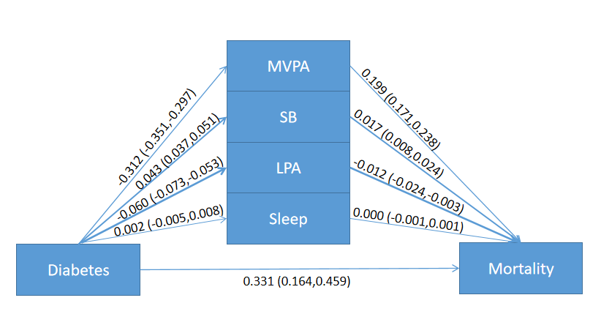
Figure S3 The effect of diabetes to mortality mediated by daily engagement in physical activity using compositional mediation model

Table S4 The effects of diabetes on mortality mediated by daily engagement in physical activity
 | HR | Proportion
Total indirect effect | 1.225 (1.196, 1.257) | 38.34%
MVPA | 1.220 (1.186, 1.268) | 37.24%
SB | 1.017 (1.008, 1.025) | 3.13%
LPA | 0.988 (0.976, 0.997) | -2.32%
Sleep | 1.000 (0.999, 1.001) | 0.01%
Direct effect | 1.386 (1.189, 1.605) | 61.66%
Total effect | 1.699 (1.465, 1.970) | 100%

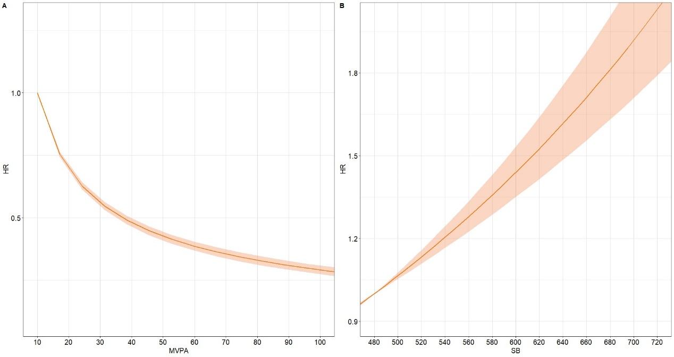
Figure S4 Expected hazard ratios based on the proportional cox model with diabetes participants against daily time (in minutes) spent in A: Moderate-to-vigorous physical activity (MVPA); and B: Sedentary behavior (SB). Time is exchanged between the component on the X-axis and the remaining components. Model adjusted for age, gender, ethnicity, BMI, smoking status, drinking status, and education

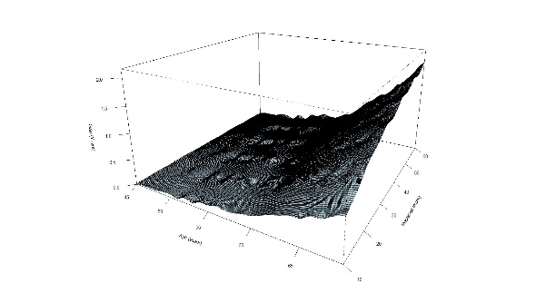 | 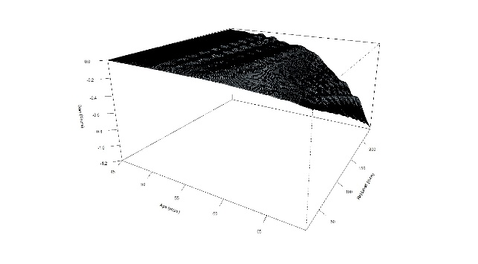
Figure S5 Expected life gain in the upcoming decade from A). Replacing remaining time to MVPA and B). Replacing remaining time to SB

Sensitivity analysis 2: Excluding participants with common chronic diseases:
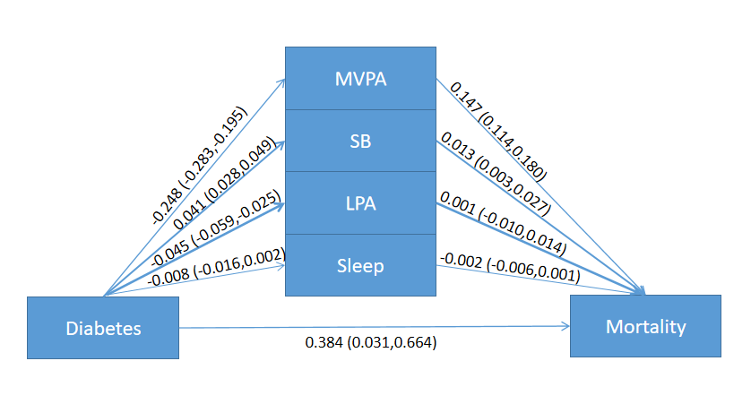
Figure S6 The effect of diabetes to mortality mediated by daily engagement in physical activity using compositional mediation model

Table S5 The effects of diabetes on mortality mediated by daily engagement in physical activity
 | HR | Proportion
Total indirect effect | 1.174 (1.134, 1.221) | 29.81%
MVPA | 1.158 (1.121, 1.198) | 27.05%
SB | 1.013 (1.003, 1.027) | 2.44%
LPA | 1.001 (0.990, 1.014) | 0.22%
Sleep | 0.998 (0.994, 1.001) | -0.42%
Direct effect | 1.458 (1.080, 1.964) | 71.19%
Total effect | 1.711 (1.273, 2.289) | 100%

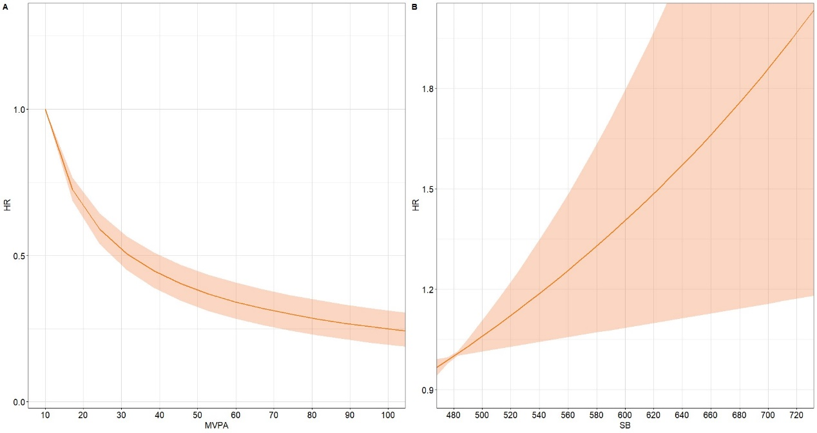
Figure S7 Expected hazard ratios based on the proportional cox model with diabetes participants against daily time (in minutes) spent in A: Moderate-to-vigorous physical activity (MVPA); and B: Sedentary behavior (SB). Time is exchanged between the component on the X-axis and the remaining components. Model adjusted for age, gender, ethnicity, BMI, smoking status, drinking status, and education

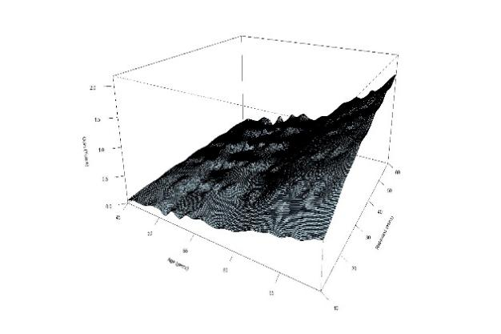 | 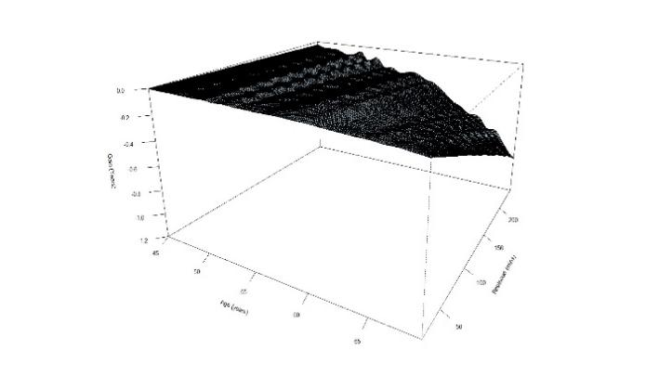
Figure S8 Expected life gain in the upcoming decade from A). Replacing remaining time to MVPA and B). Replacing remaining time to SB

Sensitivity analysis 3: Among participants BMI >23.9:
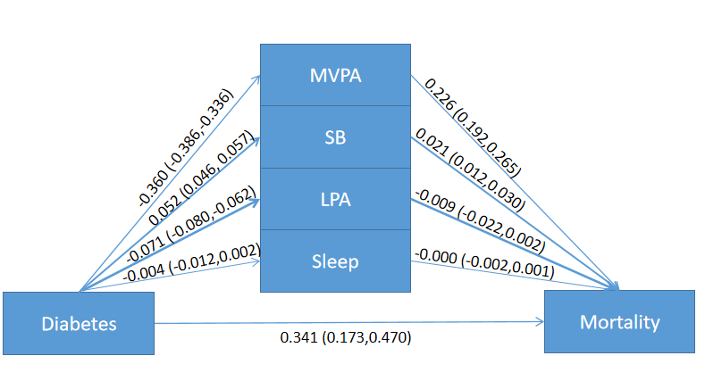
Figure S9 The effect of diabetes to mortality mediated by daily engagement in physical activity using compositional mediation model

Table S6 The effects of diabetes on mortality mediated by daily engagement in physical activity
 | HR | Proportion
Total indirect effect | 1.269 (1.231, 1.306) | 41.50%
MVPA | 1.254 (1.212, 1.303) | 39.13%
SB | 1.021 (1.012, 1.031) | 3.60%
LPA | 0.991 (0.979, 1.002) | -1.59%
Sleep | 1.000 (0.998, 1.001) | -0.07%
Direct effect | 1.403 (1.216, 1.618) | 58.50%
Total effect | 1.779 (1.568, 2.049) | 100%

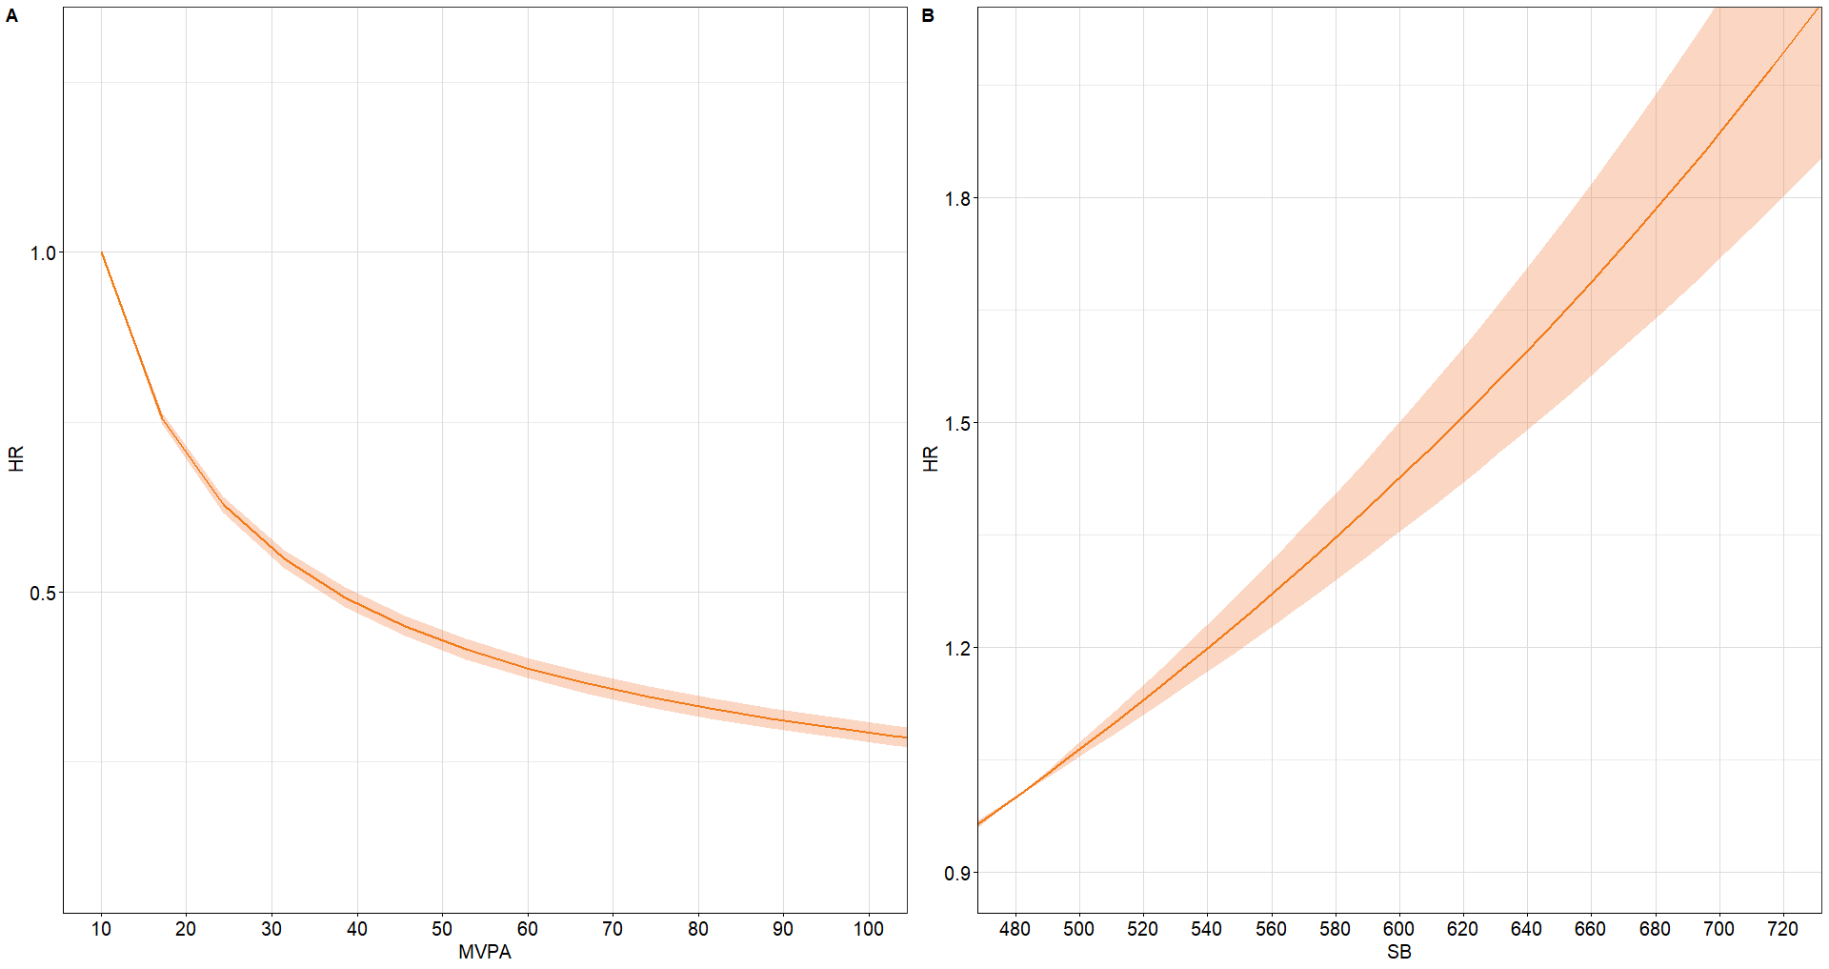
Figure S10 Expected hazard ratios based on the proportional cox model with diabetes participants against daily time (in minutes) spent in A: Moderate-to-vigorous physical activity (MVPA); and B: Sedentary behavior (SB). Time is exchanged between the component on the X-axis and the remaining components. Model adjusted for age, gender, ethnicity, BMI, smoking status, drinking status, and education

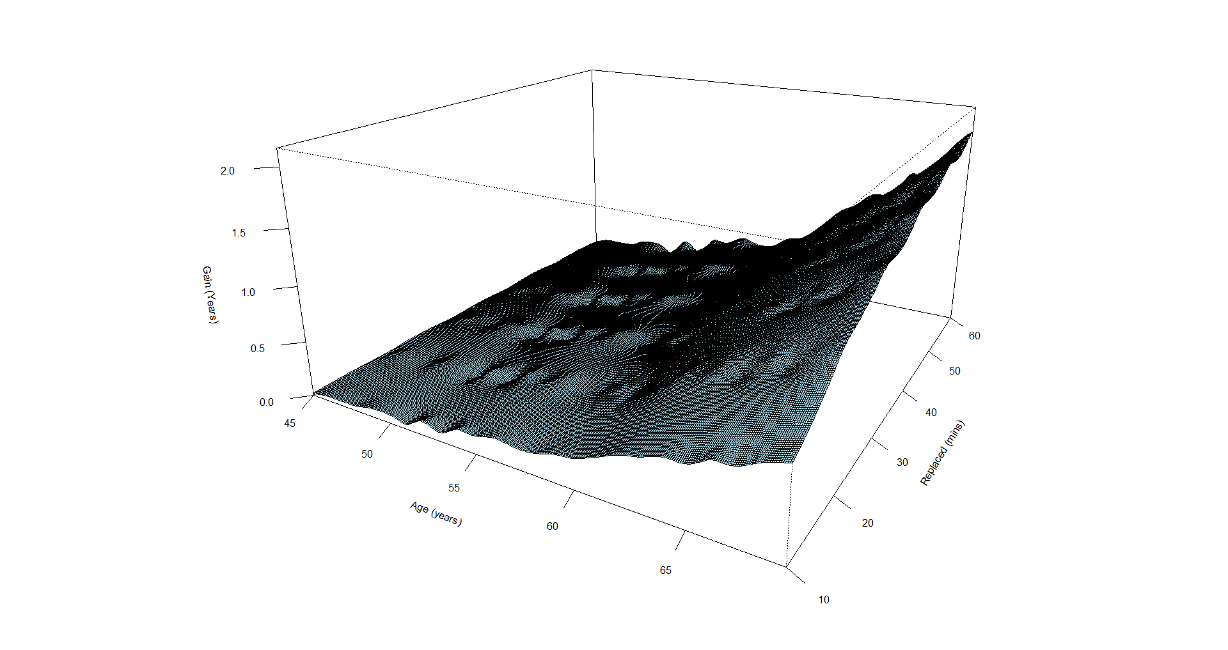 | 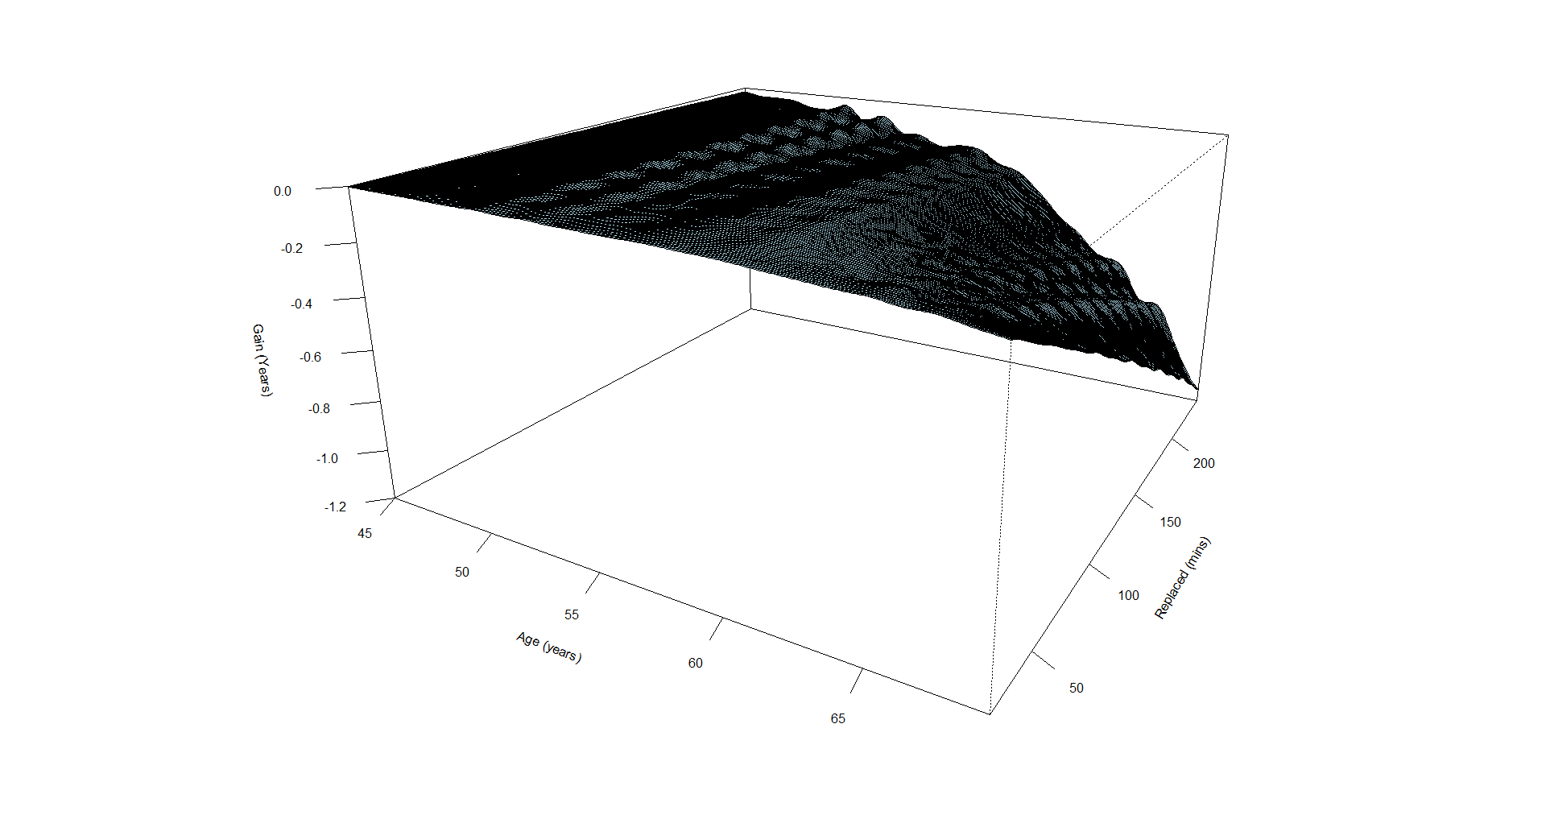
Figure S11 Expected life gain in the upcoming decade from A). Replacing remaining time to MVPA and B). Replacing remaining time to SB

Sensitivity analysis 4: Multiple imputation:
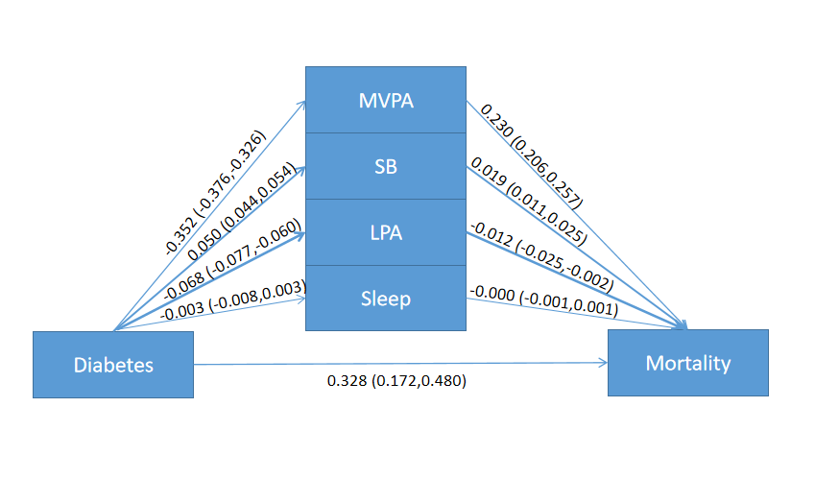
Figure S12 The effect of diabetes to mortality mediated by daily engagement in physical activity using compositional mediation model

Table S7 The effects of diabetes on mortality mediated by daily engagement in physical activity
 | HR | Proportion
Total indirect effect | 1.255 (1.227, 1.283) | 40.82%
MVPA | 1.258 (1.229, 1.293) | 40.67%
SB | 1.019 (1.011, 1.025) | 3.29%
LPA | 0.989 (0.976, 0.998) | -2.04%
Sleep | 1.000 (0.999, 1.001) | -0.05%
Direct effect | 1.390 (1.223, 1.555) | 59.18%
Total effect | 1.745 (1.548, 1.952) | 100%

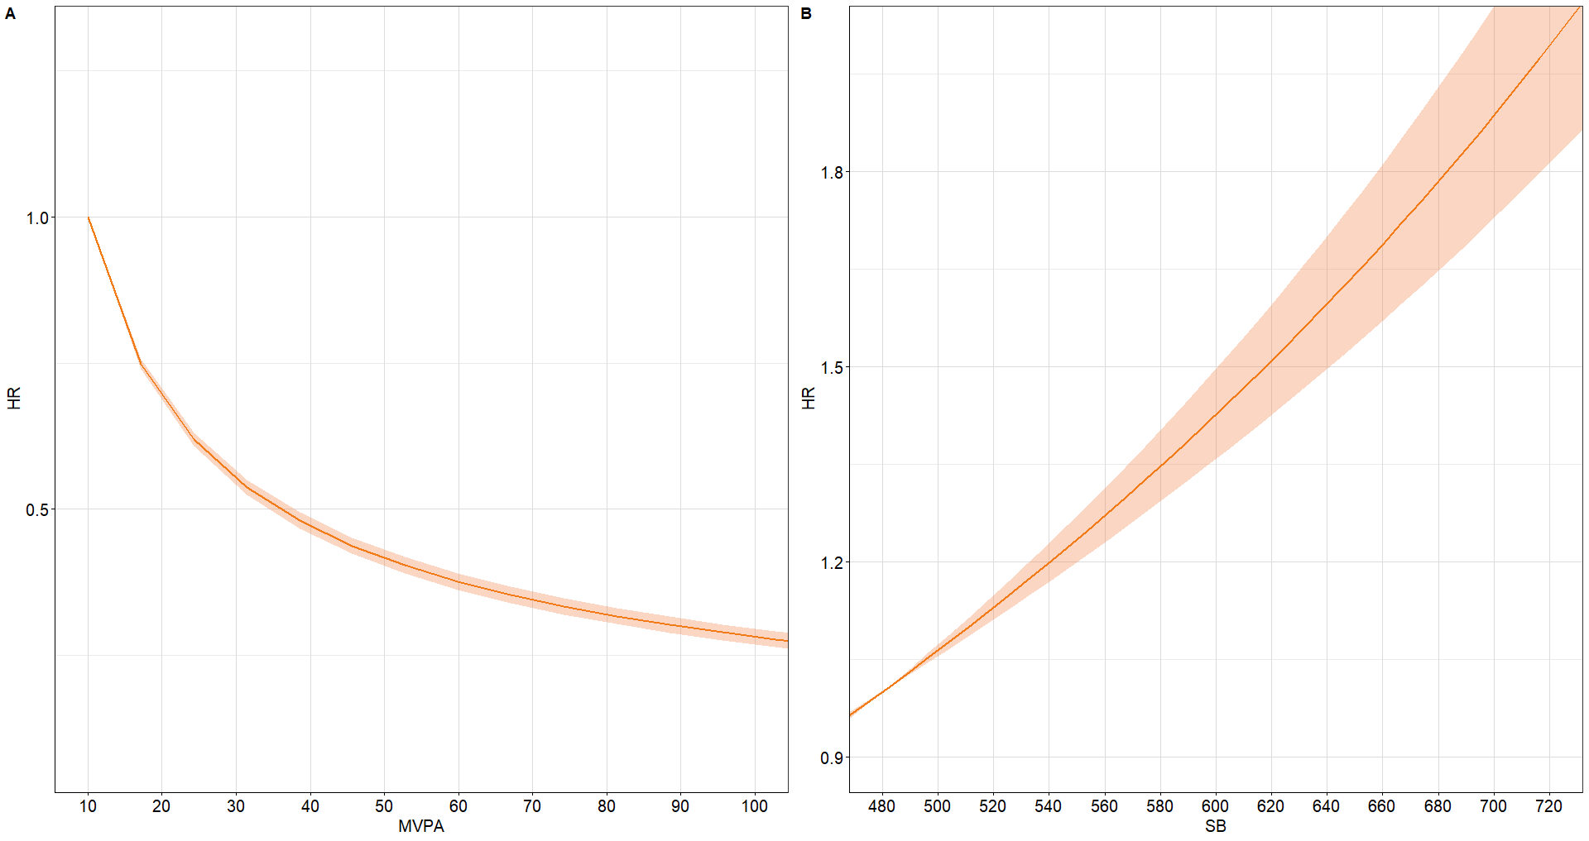
Figure S13 Expected hazard ratios based on the proportional cox model with diabetes participants against daily time (in minutes) spent in A: Moderate-to-vigorous physical activity (MVPA); and B: Sedentary behavior (SB). Time is exchanged between the component on the X-axis and the remaining components. Model adjusted for age, gender, ethnicity, BMI, smoking status, drinking status, and education

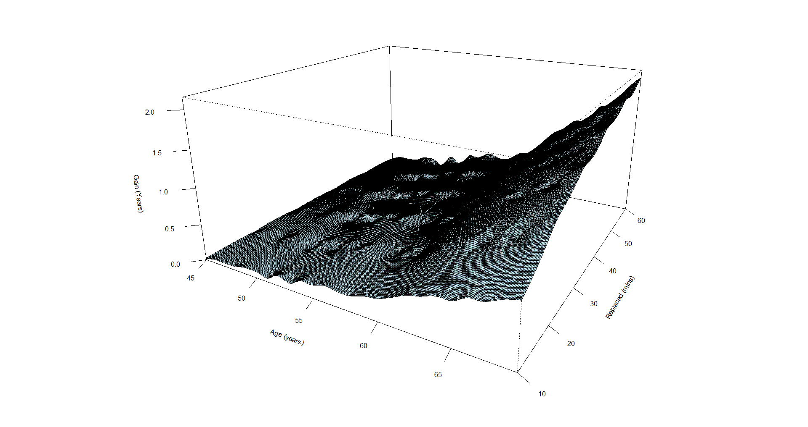 | 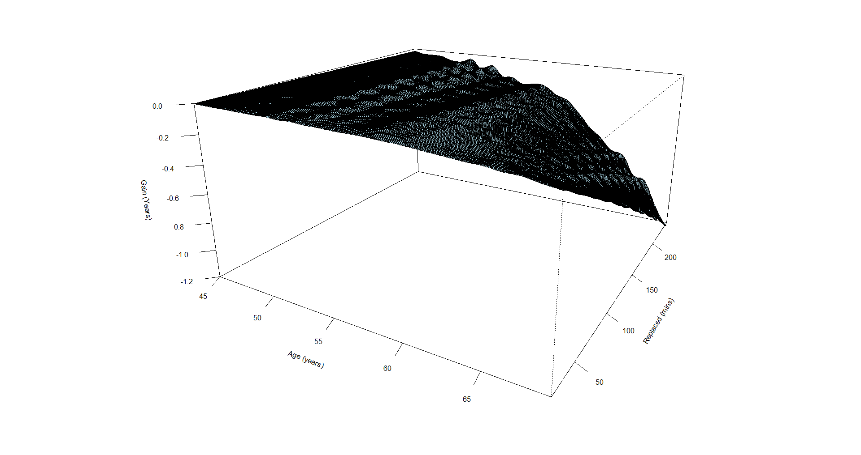
Figure S14 Expected life gain in the upcoming decade from A). Replacing remaining time to MVPA and B). Replacing remaining time to SB

Sensitivity analysis 5: Zero values for MVPA were imputed by adding 0.001

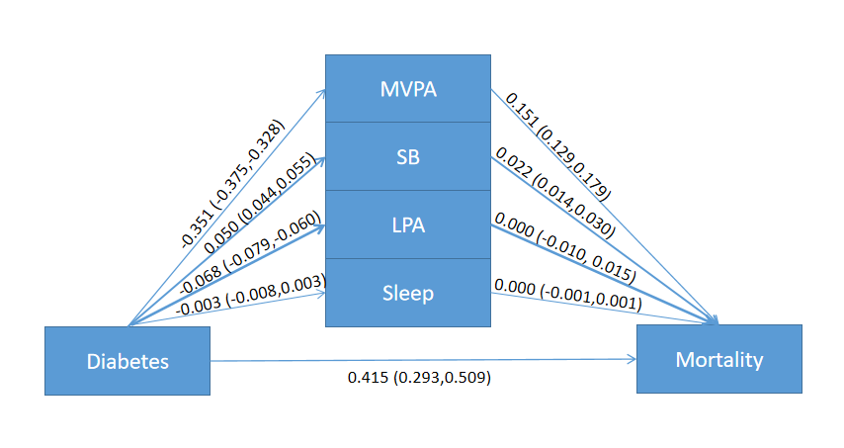
Figure S15 The effect of diabetes to mortality mediated by daily engagement in physical activity using compositional mediation model

Table S8 The effects of diabetes on mortality mediated by daily engagement in physical activity
 | HR | Proportion
Total indirect effect | 1.189 (1.167, 1.217) | 29.45%
MVPA | 1.163 (1.137, 1.196) | 25.68%
SB | 1.022 (1.014, 1.030) | 3.75%
LPA | 1.000 (0.990, 1.015) | 0.02%
Sleep | 1.000 (1.000, 1.000) | 0.01%
Direct effect | 1.514 (1.340, 1.664) | 70.55%
Total effect | 1.800 (1.588, 1.987) | 100%

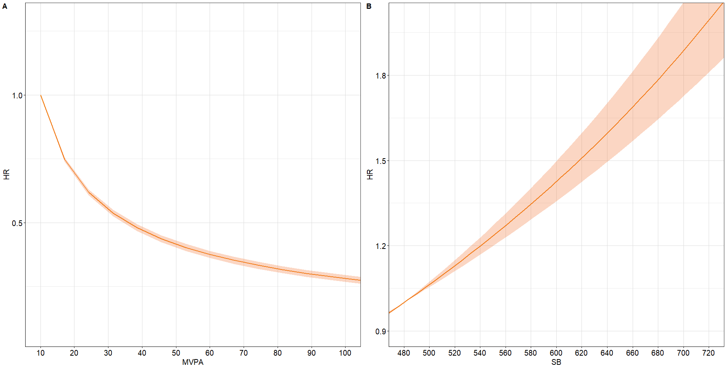
Figure S16 Expected hazard ratios based on the proportional cox model with diabetes participants against daily time (in minutes) spent in A: Moderate-to-vigorous physical activity (MVPA); and B: Sedentary behavior (SB). Time is exchanged between the component on the X-axis and the remaining components. Model adjusted for age, gender, ethnicity, BMI, smoking status, drinking status, and education

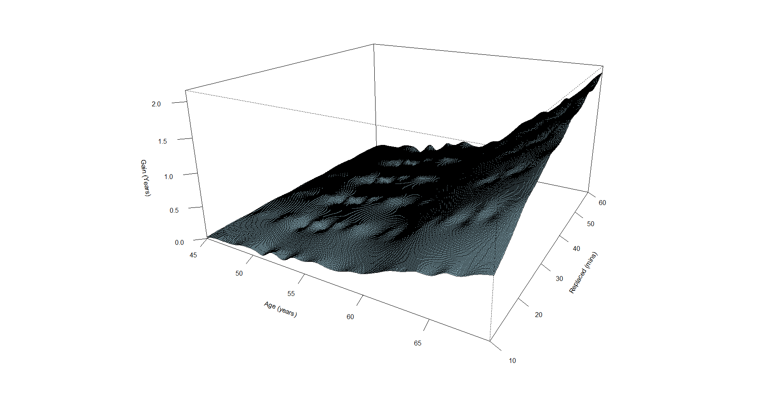 | 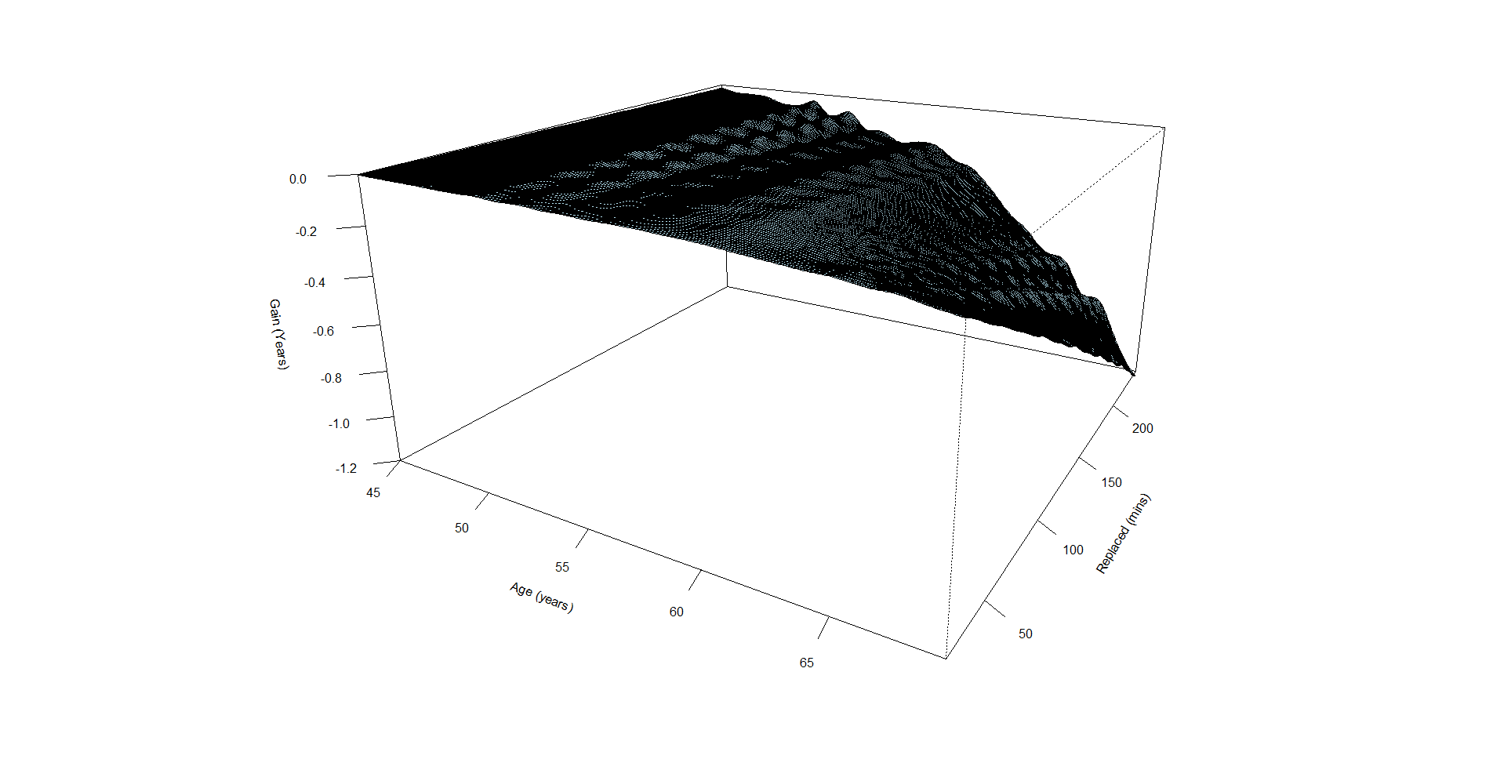
Figure S17 Expected life gain in the upcoming decade from A). Replacing remaining time to MVPA and B). Replacing remaining time to SB

Sensitivity analysis 6: Whole Population based age stratified baseline hazard ratio

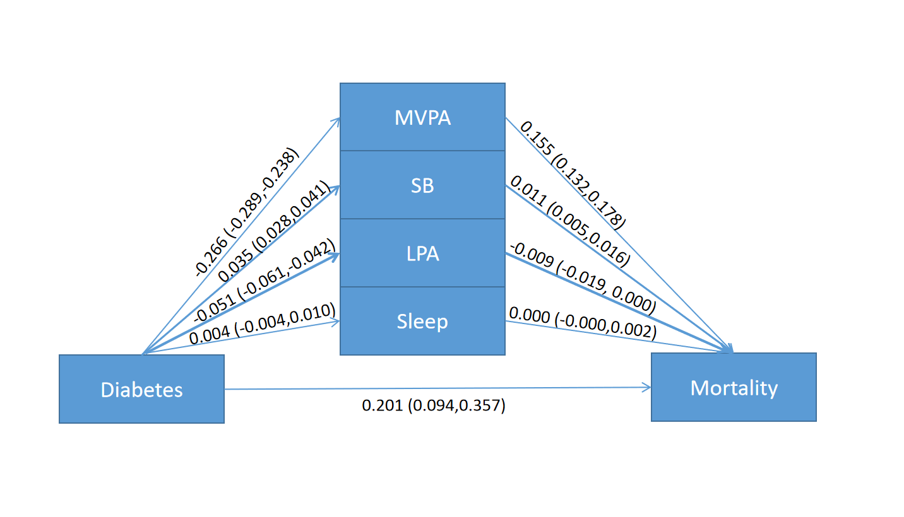
Figure S18 The effect of diabetes to mortality mediated by daily engagement in physical activity using compositional mediation model

Table S9: The effects of diabetes on mortality mediated by daily engagement in physical activity
 | HR | Proportion
Total indirect effect | 1.170 (1.143, 1.197) | 41.90%
MVPA | 1.258 (1.218, 1.295) | 40.64%
SB | 1.019 (1.011, 1.027) | 3.33%
LPA | 0.989 (0.976, 1.000) | -1.96%
Sleep | 1.000 (0.998, 1.001) | 0.00%
Direct effect | 1.389 (1.190, 1.608) | 58.10%
Total effect | 1.759 (1.519, 2.023) | 100%

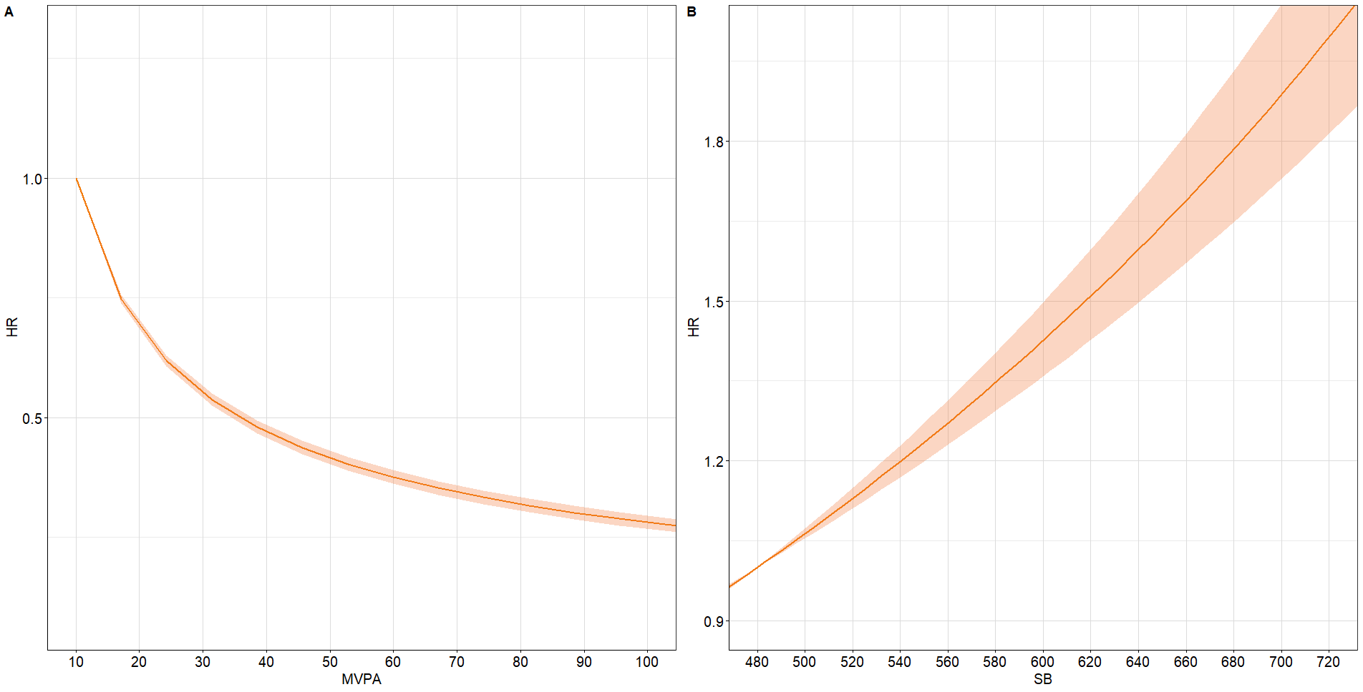
Figure S19 Expected hazard ratios based on the proportional cox model with diabetes participants against daily time (in minutes) spent in A: Moderate-to-vigorous physical activity (MVPA); and B: Sedentary behavior (SB). Time is exchanged between the component on the X-axis and the remaining components. Model adjusted for age, gender, ethnicity, BMI, smoking status, drinking status, and education

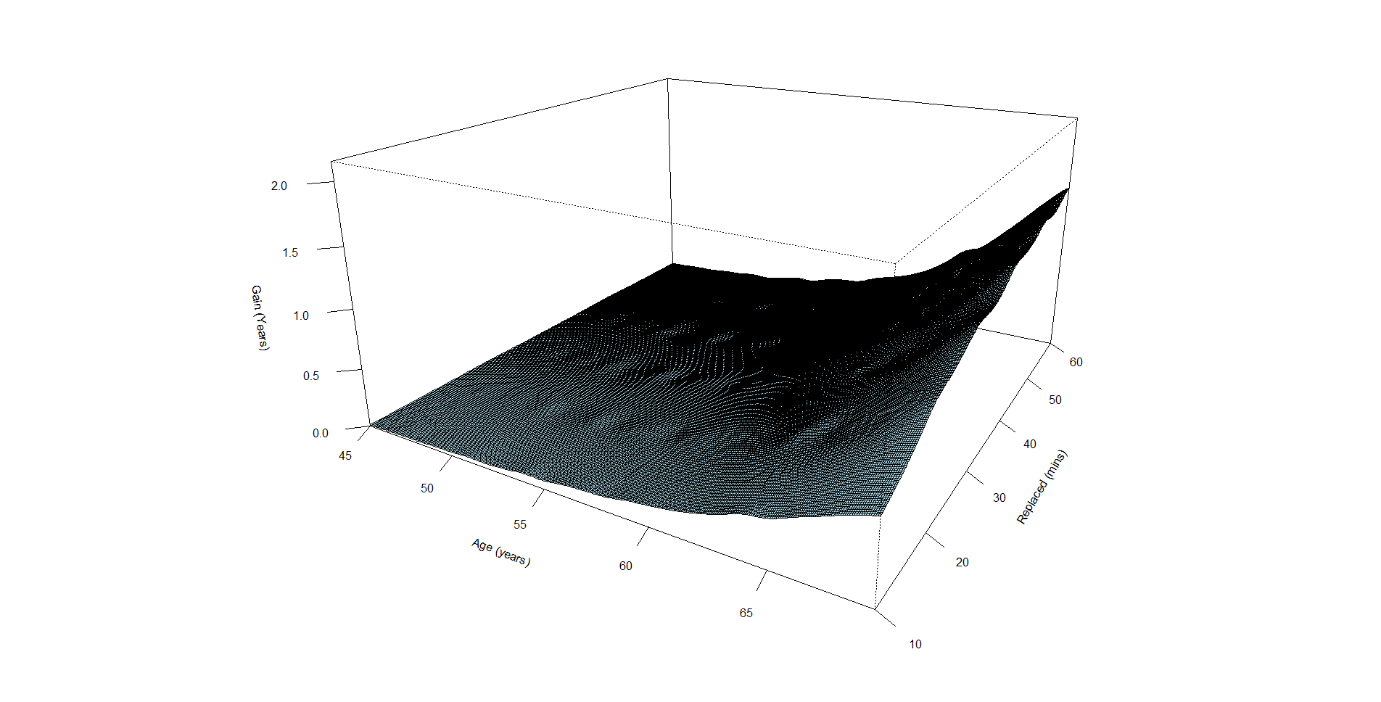 | 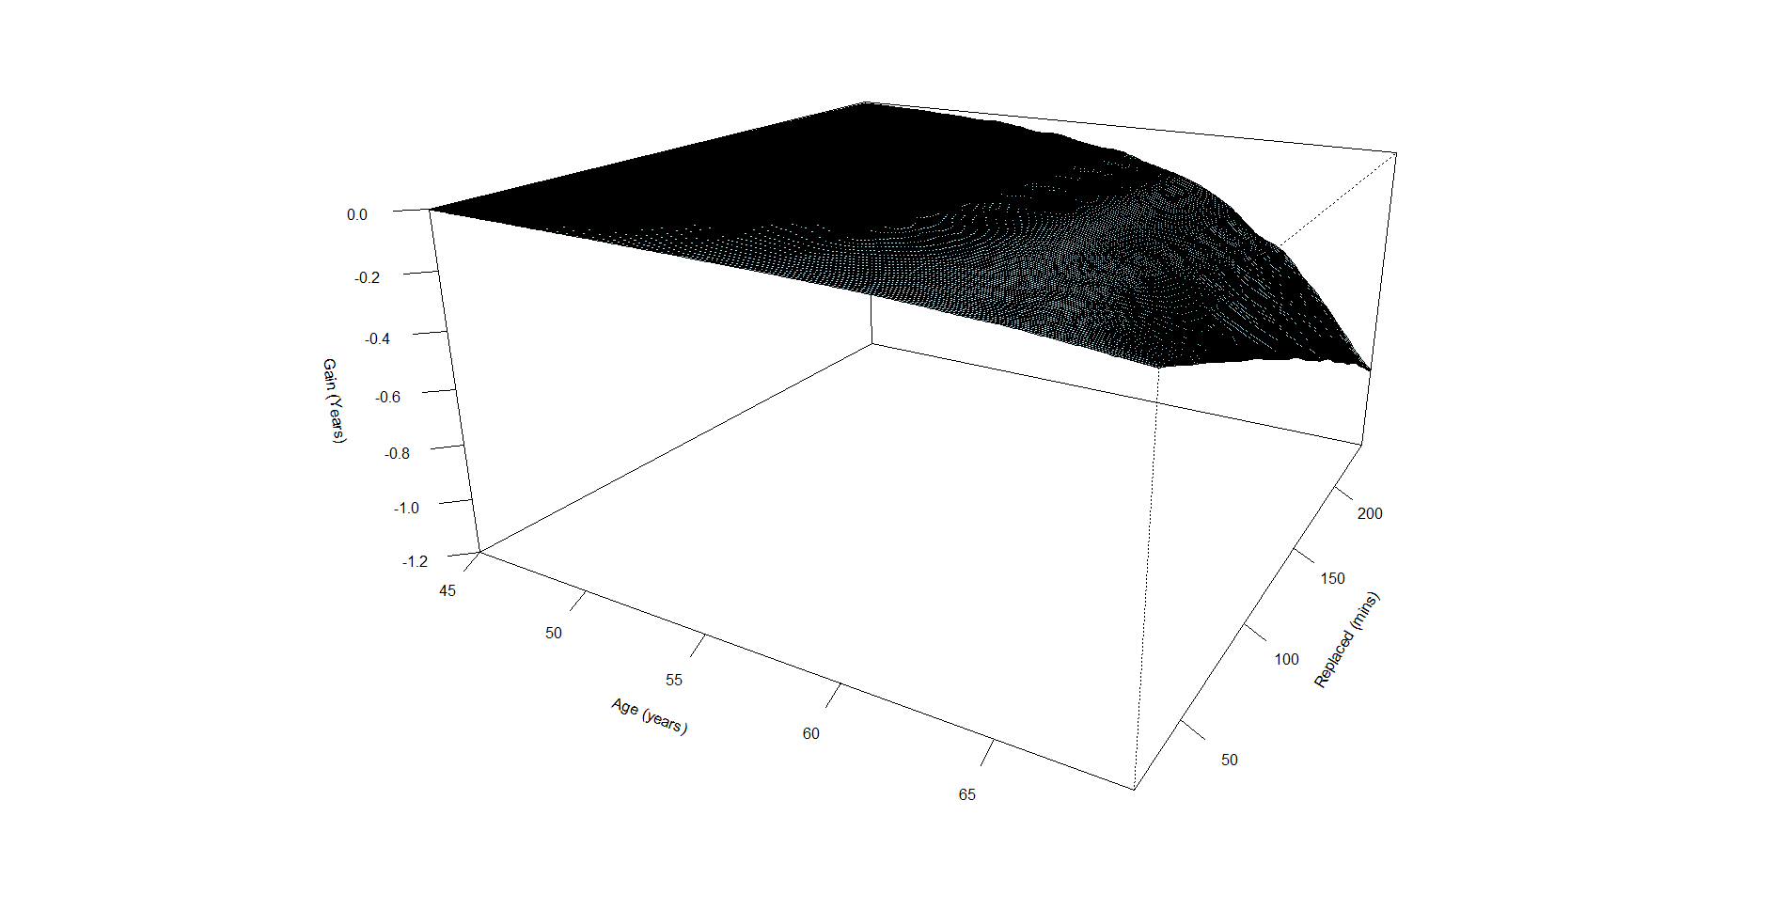
Figure S20 Expected life gain in the upcoming decade from A). Replacing remaining time to MVPA and B). Replacing remaining time to SB

Sensitivity analysis 7: Incorporating additional covariates—including the Townsend Deprivation Index, diet quality, health status, C-reactive protein, systolic blood pressure, diastolic blood pressure, and loneliness—into the model
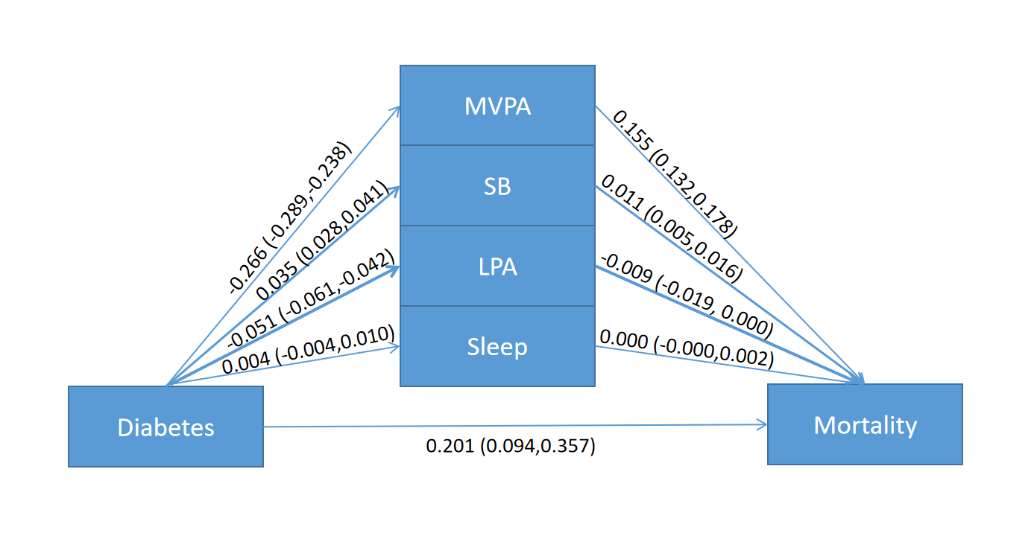
Figure S21 The effect of diabetes to mortality mediated by daily engagement in physical activity using compositional mediation model

Table S10 The effects of diabetes on mortality mediated by daily engagement in physical activity
 | HR | Proportion
Total indirect effect | 1.170 (1.143, 1.197) | 43.83%
MVPA | 1.168 (1.141, 1.195) | 43.29%
SB | 1.011 (1.005, 1.016) | 3.06%
LPA | 0.991 (0.981, 1.000) | -2.64%
Sleep | 1.000 (1.000, 1.002) | 0.09%
Direct effect | 1.223 (1.099, 1.429) | 56.17%
Total effect | 1.431 (1.289, 1.661) | 100%

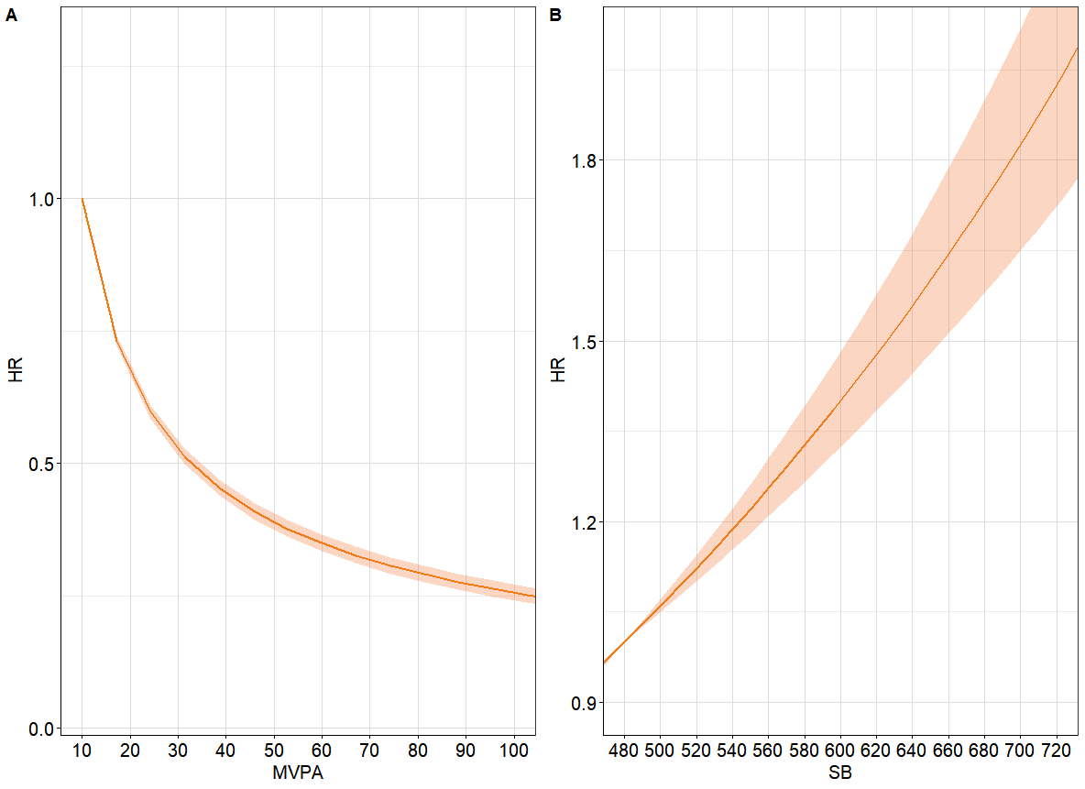
Figure S22 Expected hazard ratios based on the proportional cox model with diabetes participants against daily time (in minutes) spent in A: Moderate-to-vigorous physical activity (MVPA); and B: Sedentary behavior (SB). Time is exchanged between the component on the X-axis and the remaining components. Model adjusted for age, gender, ethnicity, BMI, smoking status, drinking status, and education

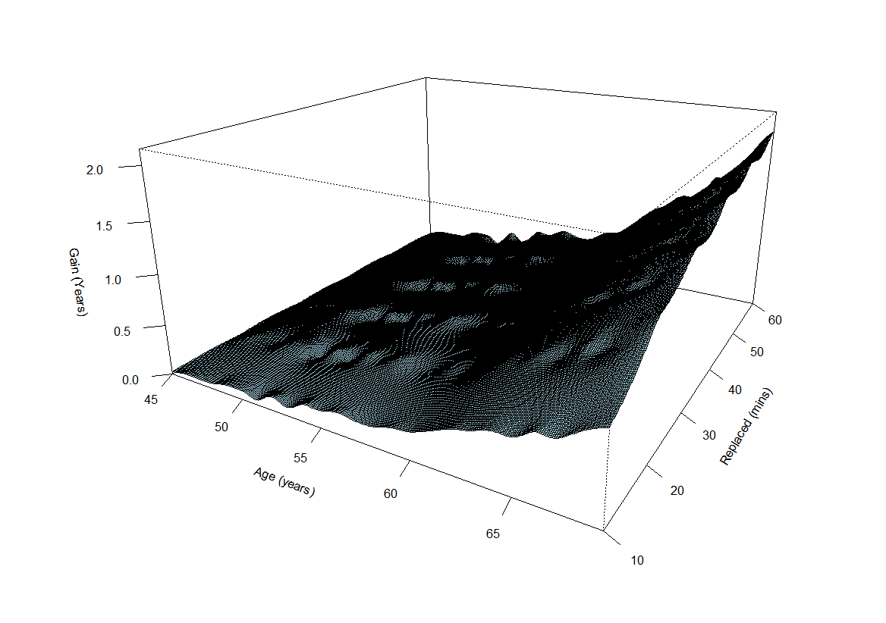 | 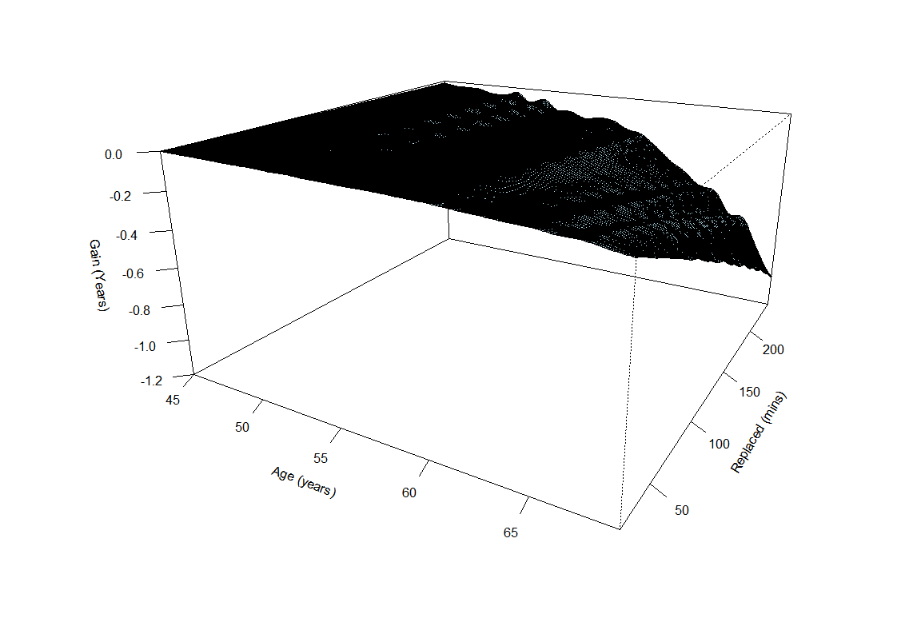
Figure S23 Expected life gain in the upcoming decade from A). Replacing remaining time to MVPA and B). Replacing remaining time to SB

