Supplement File

Table S1. Definition of cognitive reserve and cognition. 2
Fig. S1. Sample flowchart 5
Table S2. Fit statistics compared to typical cutoff values 6
Table S4. Fit statistics for trajectory models for cognitive function. 9
Table S5. Comparison of baseline characteristics between participants included (n = 3,460) and excluded due to loss to follow-up (n = 214) 10
Fig. S2. Trajectories of cognitive scores by increasing age among older adults with completed all three waves cognitive function data. 11
Table S6. Multivariate Logistic Regression Analyses with Cognitive function Trajectory Groups from all three waves. 12
Table S7. Multivariate Logistic Regression Analyses with Cognitive function Trajectory Groups without including weights. 13
Fig.S3. Stratified analysis and interaction for the association of CR and cognitive function trajectory group. 14

Table S1. Definition of cognitive reserve and cognition.
Variables | Items or questions | Definition
Disability | Dressing, bathing, eating, getting out of bed and going to the toilet. | Those who answered ‘I have difficulty, but I can still do it’, ‘Yes, I have difficulty and need help’, or ‘I can't do it’ to one or more of the five tasks were categorized as having a disability
Dementia | Have you been diagnosed with Memory-related disease（such as Alzheimer's disease, brain atrophy, Parkinson's disease）by a doctor? | Yes
Cognitive function
Memory function
 | Immediate word recall | 0-5
 | Delayed word recall | 0-5
Orientation function
 | Year at the time of the survey | 0-1
 | Month at the time of the survey | 0-1
 | Day at the time of the survey | 0-1
 | Day of week at the time of the survey | 0-1
 | Season at the time of the survey | 0-1
Executive function | Serial 7s subtraction | 0-5
 | drawings | 0-1
Cognitive reserve
Early-life CR | Mother's education | No formal education, primary, junior high, high school or above
Early-life CR | Father's education | No formal education, primary, junior high, high school or above
Early-life CR | Father's occupation ª | No work, farming, non-farming
Early-life CR | Mother's occupation ª | No work, farming, non-farming
Early-life CR | When you were a child before age 17 was there ever a time when your family did not have enough food to eat? | YES / NO
Early-life CR | When you were a child before age 17, compared to the average family in the same community/village at that time, how was your family’s financial situation? | A much worse off than them, somewhat worse off than them  same as them, somewhere better off than them,  a much better off than them.
Early-life CR | What is the highest level of education has completed for you? | No formal education, primary, junior high, high school or above
Middle-life CR | Which of the following category did your job belong to? | No work, farming, non-farming
Middle-life CR | Health Insurance | Publicly Funded Healthcare, Commercial Health Insurance, Urban Employee Basic Medical Insurance, Urban and Rural Resident Basic Medical Insurance, Urban Resident Basic Medical Insurance, New Rural Cooperative Medical Scheme, Medical Assistance, Long-term Care, No Health Insurance, Health Insurance for the Unemployed
Middle-life CR | What is your marital status? | Never Married, widowed, divorced/Separated, married
Middle-life CR | Family income ^{b} | Quintile
Late-life CR | What is the current number of surviving children? | 0,1,≥2
Late-life CR | Who are you currently living with? | Living alone or not living alone.
Late-life CR | Have you done any of these activities in the last month? (social activities) | Interacted with friends; Provided help to family, friends, or neighbors who do not live with you; Went to a sport, social, or other kind of club; Took part in a community-related organization; Done voluntary or charity work; Cared for a sick or disabled adult who does not live with you
Late-life CR | Have you done any of these activities in the last month? (intellectual activities) | Played Ma-jiang, played chess, played cards, went to community club; Attended an educational or training course; Stock investment; Used the Internet; intellectual activity
Late-life CR | When is not living with you, how often do you contact with him/her on phone/by message/ on wechat/ by mail/ by email? | Less than once a month, and greater than or equal to once a month.

Notes: It does not classify people based on their current employment status (given that some are retired), but rather on their lifetime occupation: those who have worked exclusively in agriculture (>10 days without any non-agricultural work) throughout their lives are classified as being involved in agriculture; individuals who have worked in non-agricultural work for more than 10 days (regardless of whether or not they have also worked in agriculture) are categorized as non-agricultural workers.
Net after-tax income for each household is based on household income (shared by sample individuals in the same household). Gross annual income of farm households includes wages, bonus income, or pensions paid by household members, as well as income from farming, income from self-employment activities, public transfers, and other types of transfer sources (e.g., parents, children, relatives).

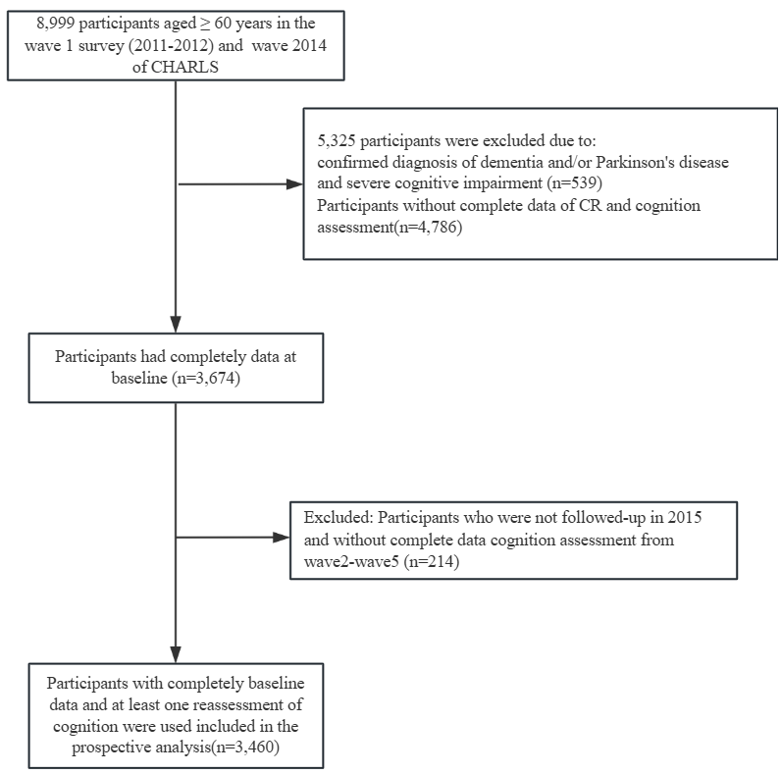

Fig. S1. Sample flowchart

Table S2. Fit statistics compared to typical cutoff values
Statistic | χ²/df | GFI | AGFI | SRMR | RMSEA | NFI | CFI | IFI
Cutoff value | <10.00 | >0.90 | >0.90 | <0.08 | <0.08 | >0.90 | >0.90 | >0.90
Estimated value | 5.615 | 0.979 | 0.971 | 0.081 | 0.038 | 0.99 | 0.99 | 1.00
Notes: Comparisons between estimated fit statistics and commonly accepted cutoff values indicates that RMSEA is lower than accepted cutoffs (indicating acceptable fit) whereas CFI is slightly below the cutoff (indicating slight misfit) and SRMR is slightly above the cutoff (indicating slight misfit) [1]. Each fit statistic has different advantages and disadvantages, and therefore inconsistencies are fairly common. The diverse nature of cognitive tests included in the estimation of cognitive reserve, covering a variety of domains may yield lower intercorrelations between some of the items and could explain some level of misfit as indicated by CFI and SRMR [2]. However, these values are still close to cutoffs, and combined with RMSEA indicate acceptable fit.
1. Hu L, Bentler PM. Cutoff criteria for fit indexes in covariance structure analysis: Conventional criteria versus new alternatives. Structural Equation Modeling: A Multidisciplinary Journal. 1999 Jan 1;6(1):1–55.
2. West, Stephen G., et al. Model fit and model selection in structural equation modeling. Handbook of structural equation modeling, 2012, 1: 209-231

Table S3 Decision Matrix for the Retention of Low-Loading Variables of CR
Specific Variable | Core Reason for Retention | Explanation for Low Loading
Starvation History | Early malnutrition (e.g., during the famine in the 1950s and 1960s in China) is a cumulative neurodevelopmental risk factor that affects brain structure (e.g., reduced hippocampal volume) and the lifelong foundation of cognitive reserve through epigenetic mechanisms. In the CHARLS cohort, the association between starvation history and cognitive decline in later life has been confirmed by epidemiological studies [1]. | Starvation history is a binary variable.
Mother's Work, Father's Education, Family Economic Status | Parental socioeconomic status (SES) is a carrier of intergenerational transmission of cognitive reserve. Father's education reflects family cognitive stimulation resources (e.g., books, educational investment), and mother's occupation (especially in the historical context of agricultural labor) may affect children's early cognitive opportunities through family division of labor [2]. | Limited by the coarseness of historical occupational classifications.  Cultural specificity: In the study sample (Chinese middle-aged and elderly population), women's occupational data may have low loading due to incomplete historical records (e.g., rural women mostly engaged in unrecorded household/agricultural labor), but it is still a core component of SES in theory.
Marital Status, Living Alone | In traditional Chinese family structures, marital status (e.g., widowhood) and living alone may directly affect social support networks and cognitive stimulation opportunities [3]. | Low loading may be due to the high prevalence of "married" status (84.3% in the sample, Table 1) leading to insufficient statistical variability. Living alone is a binary variable.
Number of Children, Frequency of Communication | Number of children and frequency of interaction are core indicators of intergenerational support, consistent with the Chinese cultural norm of "raising children for old age support." Although "number of surviving children" may not have a direct linear association with cognitive reserve, it reflects family size and potential caregiving resources, especially in rural areas [4]. | Sample mostly consists of rural elderly individuals.  Classifying the frequency of communication with children as a binary variable (e.g., once a month) provides very limited information. It does not take into account the details of communication frequency, quality, duration, or content. This may lead to a low factor loading.
Intellectual Activities, Leisure Activities | Although the loading for "late-life intellectual activities" is not high, it is a crucial direct proxy indicator for late-life cognitive reserve [5]. Removing this variable would result in a missing dimension of late-life CR in the SEM model, violating the principle that "multidimensional constructs need multiple indicators for measurement" [6].  In terms of actual contribution: The association of this variable with the "high stable cognitive group" is significant in logistic regression (OR=1.48, 95% CI 1.14-1.92, Table 3), indicating its contribution to model predictive power beyond its loading value. | Limited by the number of questionnaire items; need to expand the assessment dimensions.

We included some factors with low loadings mainly because these factors are theoretically important to the model and may be indispensable constructs in the research framework[7]. At the same time, the existing data may not fully capture their complexity, and sample characteristics may also lead to lower loadings than expected. Additionally, these factors are included to ensure overall model fit or to comprehensively explore their performance in the early stages of the research. Even though their loadings are low, they may still hold significant value in practical applications[8]. Therefore, the inclusion of these factors is likely a result of the combined influence of theoretical considerations, data limitations, sample characteristics, model requirements, and practical significance.

1. Chen X, Xue B, Hu Y. Cognitive reserve over life course and 7-year trajectories of cognitive decline: results from China health and retirement longitudinal study. BMC Public Health. 2022;22:231.
2. Skoblow HF, Proulx CM, Akpolat R, Palermo F. Early-Life Socioeconomic Position and Later-Life Cognitive Functioning: A Meta-Analysis. Social Science & Medicine. 2024;:117267.
3. Saywell I, Foreman L, Child B, Phillips-Hughes AL, Collins-Praino L, Baetu I. Influence of cognitive reserve on cognitive and motor function in α-synucleinopathies: A systematic review and multilevel meta-analysis. Neuroscience & Biobehavioral Reviews. 2024;161:105672.
4. Yang Y, Yao M, Zhang M, He X, Liu L, Luan Y, et al. Cognitive function moderates the mediation of resilience in the relationship between perceived receipt of filial piety and loneliness among community-dwelling older adults with multiple long-term conditions. Sci Rep. 2025;15:5647.
5. Durrani R, Friedrich MG, Schulze KM, Awadalla P, Balasubramanian K, Black SE, et al. Effect of Cognitive Reserve on the Association of Vascular Brain Injury With Cognition. Neurology. 2021;97:e1707–16.
6. David W. Gerbing, James C. Anderson. An Updated Paradigm for Scale Development Incorporating Unidimensionality and Its Assessment. Journal of Marketing Research. 1988;25:186–92.
7.Bollen KA. When Good Loadings Go Bad: Robustness in Factor Analysis. Struct Equ Modeling. 2020;27(4):515-524. 8.Jordan P, Spiess M. Rethinking the Interpretation of Item Discrimination and Factor Loadings. Educ Psychol Meas. 2019;79(6):1103-1132.

Table S4. Fit statistics for trajectory models for cognitive function.
Group | Avepp(%) | OCC | Group membership | BIC | E_{k}
1Group (3) | 100.00 | . | 100.00 |  | 0.000
2Group (3 3) | 92.78-95.17 | 18.3-13.9 | 41.31-58.69 | 2086.70 | 0.802
3Group (3 3 3) | 90.15-84.46-90.12 | 30.7-8.1-15.7 | 22.99-40.30-36.71 | 512.33 | 0.741
4Group (3 3 3 3) | 84.82-77.22-79.02-85.71 | 35.5-9.8-6.8-18.1 | 13.58-25.79-35.74-24.89 | 114.31 | 0.685
5Group (3 3 3 3 3) | 76.66-72.28-70.51-74.61-82.95 | 48.1-12.9-7.7-6.1-18.8 | 6.39-16.86-23.81-32.39-20.55 | 6.21 | 0.646
6Group (3 3 3 3 3 3) | 77.99-70.53-63.36-62.58-73.39-83.34 | 50.3-12.2-14.8-9.5-6.0-20.0 | 6.58-16.42-10.46-14.94-31.60-20.00 | 40.94 | 0.636
Notes: BIC = Bayesian information criterion; AvePP = Fair posterior probability; OCC = Odds of correct classification.
¹ Defines the shape parameters of the trajectory groups: 0 = intercept only, 1 = linear, 2 = quadratic, 3 = cubic.
² Group AvePP of assignment: Based on the maximum probability assignment rule, each individual will be assigned to a group according to the largest posterior probability. For all the individuals assigned to a certain group, an AvePP will be calculated. For each trajectory group, an AvePP of assignment > 0.7 is indicative of good certainty of group assignments.
³ OCC: The numerator is the odds of a correct classification into a certain group based on the model, and the denominator is the correct classification into that group based on random assignment, essentially, OCC = [b/(1-b)]/[a/(1-a)]. For each trajectory group, OCC >= 5 suggests high assignment accuracy.

Table S5. Comparison of baseline characteristics between participants included (n = 3,460) and excluded due to loss to follow-up (n = 214)
Variables | Total  (n = 3674) | Baseline  (n = 3460) | Loss to  Follow-up (n = 214) | p
Age, Mean ± SD | 66.9 ± 5.7 | 66.6 ± 5.5 | 71.6 ± 7.2 | < 0.001
Male, n (%) | 2072 (56.4) | 1984 (57.3) | 88 (41.1) | < 0.001
Rural residence, n (%) | 2708 (73.7) | 2523 (72.9) | 185 (86.4) | < 0.001
Self-report health, n (%) |  |  |  | 0.006
Very good | 156 (4.2) | 143 (4.1) | 13 (6.1)
Good | 884 (24.1) | 812 (23.5) | 72 (33.6)
Fair | 1863 (50.7) | 1773 (51.3) | 90 (42.1)
Poor | 568 (15.5) | 539 (15.6) | 29 (13.6)
Very poor | 201 (5.5) | 191 (5.5) | 10 (4.7)
Comorbidity, n (%)ª |  |  |  | 0.387
0 | 902 (24.6) | 857 (24.8) | 45 (21)
1 | 1039 (28.3) | 972 (28.1) | 67 (31.3)
≥2 | 1733 (47.2) | 1631 (47.1) | 102 (47.7)
ADL, n (%) |  |  |  | < 0.001
0 | 2957 (80.5) | 2812 (81.3) | 145 (67.8)
1 | 390 (10.6) | 356 (10.3) | 34 (15.9)
≥2 | 327 (8.9) | 292 (8.4) | 35 (16.4)
BMI (kg/m²), n (%) |  |  |  | 0.069
Underweight | 268 (8.2) | 244 (8) | 24 (13.1)
Normal | 1788 (55.0) | 1688 (55) | 100 (54.6)
Overweight | 885 (27.2) | 839 (27.3) | 46 (25.1)
Obese | 310 (9.5) | 297 (9.7) | 13 (7.1)
Drinking, n (%) |  |  |  | < 0.001
Never | 2055 (56.0) | 1909 (55.2) | 146 (68.2)
Former | 430 (11.7) | 403 (11.7) | 27 (12.6)
Current | 1187 (32.3) | 1146 (33.1) | 41 (19.2)
Smoking, n (%) |  |  |  | 0.047
Never | 1946 (53.0) | 1816 (52.5) | 130 (60.7)
Former | 459 (12.5) | 440 (12.7) | 19 (8.9)
Current | 1269 (34.5) | 1204 (34.8) | 65 (30.4)
Visual impairment, n (%) | 586 (16.0) | 561 (16.2) | 25 (11.7) | 0.079
Hearing impairment, n (%) | 592 (16.1) | 527 (15.2) | 65 (30.4) | < 0.001
Sleep disorder, n (%) | 1855 (50.5) | 1731 (50) | 124 (57.9) | 0.025
Hospitalization, n (%) | 394 (10.7) | 359 (10.4) | 35 (16.4) | 0.006
Total Cognition, Mean ± SD | 11.7 ± 3.2 | 11.9 ± 3.1 | 8.6 ± 2.9 | < 0.001
Gait time(s), Mean ± SD | 1.8 ± 0.9 | 1.8 ± 0.9 | 2.2 ± 1.3 | < 0.001

Fig. S2. Trajectories of cognitive scores by increasing age among older adults with completed all three waves cognitive function data.
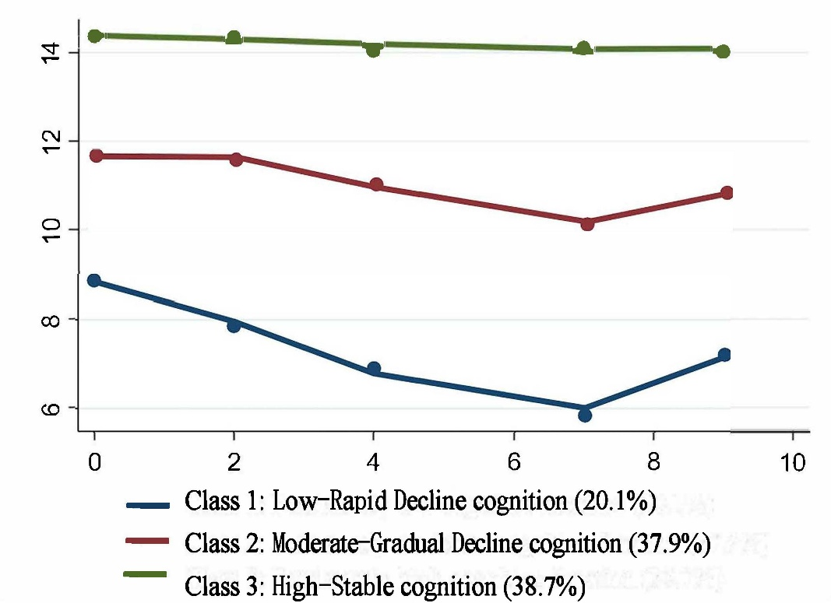

Notes: The horizontal axis represents time, and the vertical axis represents the average cognitive scores of the trajectory groups.

Table S6. Multivariate Logistic Regression Analyses with Cognitive function Trajectory Groups from all three waves.
Variables | Crude model |  | Model 1 |  | Model 2
Variables | Moderate-Gradual Decline | High-Stable cognition | Moderate-Gradual Decline | High-Stable cognition | Moderate-Gradual Decline | High-Stable cognition
Early-life CR
Tertile 1 | 1(Ref) | 1(Ref) | 1(Ref) | 1(Ref) | 1(Ref) | 1(Ref)
Tertile 2 | 2.23 (1.73~2.89)*** | 5.79 (4.27~ 7.84)*** | 2.05 (1.58~2.67)*** | 5.05 (3.66~ 6.96)*** | 1.95 (1.47~2.6)*** | 5 (3.5~ 7.14)
Tertile 3 | 4.8 (3.73~6.18)*** | 23.27 (17.39~ 31.15)*** | 4.45 (3.41~5.81)*** | 17.37 (12.71~ 23.73)*** | 4.58 (3.42~6.14)*** | 17.1 (12.05~ 24.27)***
Continuous | 3.05 (2.59~3.58)*** | 6.79 (5.71~ 8.08)*** | 2.9 (2.45~3.43)*** | 5.69 (4.74~ 6.84)*** | 2.93 (2.44~3.53)*** | 5.5 (4.48~ 6.75)***
Middle-life CR
Tertile 1 | 1(Ref) | 1(Ref) | 1(Ref) | 1(Ref) | 1(Ref) | 1(Ref)
Tertile 2 | 1.19 (0.95~1.5) | 2.03 (1.54~ 2.66)*** | 1.05 (0.83~1.33) | 1.61 (1.21~ 2.15)** | 1.1 (0.84~1.44) | 1.8 (1.29~ 2.51)**
Tertile 3 | 2.07 (1.53~2.8)*** | 9.53 (6.89~ 13.16)*** | 1.4 (0.99~1.98) | 3.54 (2.44~ 5.14)*** | 1.51 (1.02~2.23)* | 3.96 (2.56~ 6.12)***
Continuous | 1.38 (1.23~1.55)*** | 2.85 (2.51~ 3.24)*** | 1.17 (1.02~1.35)* | 1.85 (1.58~ 2.17)*** | 1.21 (1.02~1.44)* | 1.93 (1.6~ 2.34)***
Late-life CR
Tertile 1 | 1(Ref) | 1(Ref) | 1(Ref) | 1(Ref) | 1(Ref) | 1(Ref)
Tertile 2 | 0.77 (0.61~0.97)* | 0.76 (0.6~ 0.96)** | 0.87 (0.68~1.1) | 0.94 (0.72~ 1.22) | 0.87 (0.67~1.13) | 0.89 (0.66~ 1.19)
Tertile 3 | 0.91 (0.71~1.18) | 1.19 (0.92~ 1.54) | 1.08 (0.83~1.41) | 1.52 (1.14~ 2.02)** | 1.12 (0.83~1.51) | 1.48 (1.07~ 2.04)*
Continuous | 0.95 (0.86~1.06) | 1.07 (0.97~ 1.19) | 1.03 (0.92~1.15) | 1.19 (1.06~ 1.34)** | 1.03 (0.91~1.17) | 1.16 (1.01~ 1.33)*
Total CR
Tertile 1 | 1(Ref) | 1(Ref) | 1(Ref) | 1(Ref) | 1(Ref) | 1(Ref)
Tertile 2 | 1.46 (1.15~1.86)** | 2.62 (1.93~ 3.54)*** | 1.52 (1.19~1.95)** | 2.76 (2.01~ 3.79)*** | 1.46 (1.11~1.91)** | 2.86 (2.01~ 4.08)***
Tertile 3 | 2.89 (2.22~3.76)*** | 12.96 (9.5~ 17.67)*** | 2.75 (2.06~3.66)*** | 9 (6.4~ 12.66)*** | 2.91 (2.11~4.01)*** | 8.79 (5.98~ 12.92)***
Continuous | 1.39 (1.29~1.49)*** | 2.14 (1.98~ 2.32)*** | 1.38 (1.27~1.5)*** | 1.99 (1.82~ 2.19)*** | 1.43 (1.3~1.57)*** | 2.02 (1.81~ 2.25)***
Notes, P＜0.05*, P＜0.01**, P＜0.001*** ; Data are OR [95% CI]; ref: Low-Rapid Decline cognition
Model 1: adjusted for age, gender, residence; Model 2: additionally adjusted for smoking and drinking, sleep, BMI, Self-Rated Health Status, Comorbidities, Hearing and Vision, Depression Symptoms, Hospitalization, and Gait time.

Table S7. Multivariate Logistic Regression Analyses with Cognitive function Trajectory Groups without including weights.
Variables | Crude model |  | Model 1 |  | Model 2
Variables | Moderate-Gradual  Decline | High-  Stable cognition | Moderate-  Gradual Decline | High-  Stable cognition | Moderate-  Gradual Decline | High-  Stable cognition
Early-life | 2.95  (2.56~3.4)  *** | 6.72  (5.76~7.84)  *** | 2.69  (2.33~3.12)  *** | 5.43  (4.61~ 6.39)  *** | 2.81  (2.38~3.31)  *** | 5.4  (4.49~6.49)  ***
Middle-life | 1.46  (1.31~1.62)  *** | 2.9  (2.59~3.25)  *** | 1.2  (1.06~1.35)  ** | 1.83(1.59~ 2.1)  *** | 1.27  (1.05~1.53)  * | 1.94  (1.59~2.38)  ***
Late-life | 0.93  (0.85~1.02) | 1.02  (0.93~1.12) | 1.02  (0.93~1.13) | 1.18  (1.06~ 1.32)  ** | 1.04  (0.93~1.16) | 1.15  (1.01~1.3)  *
Total CR | 1.39  (1.3~1.49)  *** | 2.13  (1.98~2.28)  *** | 1.36  (1.26~1.46)  *** | 1.95  (1.8~2.12)  *** | 1.44  (1.32~1.58)  *** | 2.00  (1.81~2.21)  ***
Notes, P＜0.05*, P＜0.01**, P＜0.001*** ; Data are OR [95% CI]; ref: Low-Rapid Decline cognition
Model 1: adjusted for age, gender, residence;
Model 2: additionally adjusted for smoking and drinking, sleep, BMI, Self-Rated Health Status, Comorbidities, Hearing and Vision, Depression Symptoms, Hospitalization, and Gait time.

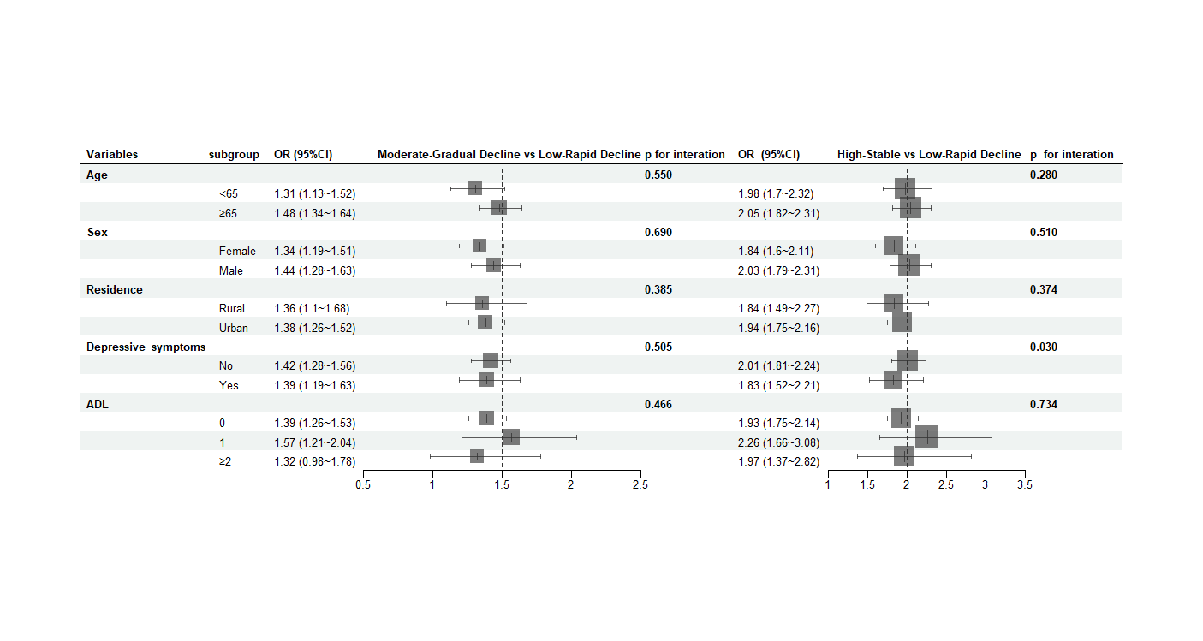

Fig.S3. Stratified analysis and interaction for the association of CR and cognitive function trajectory group.

