SUPPLEMENTAL MATERIAL
Candidate predictor measurement
Gender, age, physical activity and current smoking status were determined by self-report. Height, weight and waist were measured by standard protocol; and body mass index (BMI) was calculated as weight (in kilograms) divided by height (in meters) squared. We followed the WHO definition of “physical activity”, that is, any bodily movement produced by skeletal muscles that requires energy expenditure [1].
Blood pressure (systolic and diastolic) and heart rate were measured in seated participants after a 5-minute rest. The diagnostic criteria for hypertension were defined as follows: a systolic blood pressure (SBP) >= 140 mmHg and/or a diastolic blood pressure (DBP) >= 90 mmHg or anti-hypertension treatment according to the World Health Organization (WHO) definition of hypertension.
Diabetes was defined as a fasting glucose ≥ 126 mg/dL, nonfasting glucose ≥ 200 mg/dL, or the use of hypoglycemic medications.
Serum measurements were made from fasting serum and plasma.
QTc prolongation and ST wave abnormality were determined from a 12-lead electrocardiogram. QT interval was corrected for heart rate according to the Bazett formula, and QTc interval >450ms for men and >460ms for women was considered prolonged. An ST-wave abnormality was defined as having Minnesota codes 4-1 through 4-3 or codes 4-2 through 5-3.
Modeling strategy
We selected the RSF, Lasso-Cox, and boosted Cox models because they represent commonly used and complementary machine learning approaches for survival analysis.
- RSF is a non-parametric ensemble learning method that can capture complex non-linear relationships and variable interactions.
- Lasso Cox regression introduces L1 regularization to perform feature selection and reduce overfitting, especially in high-dimensional data.
- Boosted Cox regression combines the interpretability of Cox models with the enhanced predictive power from gradient boosting, making it effective for capturing weak but additive signals across variables.
Explanation of survival models
In our study, we employed the R package survex to interpret the machine learning survival models [2]. The survex package focuses on the field of survival analysis and provides tools for interpreting survival analysis models. survex is a model-agnostic tool that extends the functionalities of the DALEX package to accommodate the unique aspects of survival analysis. It provides both global and local explanation methods, such as SurvSHAP(t) and SurvLIME, to assess variable importance and the effect of individual predictors on model predictions. The package standardizes the prediction interface for various survival models, facilitating consistent and comprehensive interpretability across different modeling approaches.
References
- WHO Health topics: physical activity. http://www.who.int/topics/physical_activity/en/ (accesed 17 Jun 2025)

- Spytek M, Krzyziński M, Langbein SH, Baniecki H, Wright MN, Biecek P: survex: an R package for explaining machine learning survival models. Bioinformatics. 2023, 39(12). https://doi.org/10.1093/bioinformatics/btad723

Captions and legends of supplementary table and figure
Supplementary table 1. Parameter of the machine learning models
All hyperparameters were determined according to the best accuracy by 5-fold cross-validation. Cox proportional hazards model (Cox model), random survival forests model (RSF model), lasso Cox regression model (Lasso Cox model), boosted Cox regression model (Boosted Cox model).
Supplementary table 2 Univariate analysis of sudden cardiac death risk by Cox proportional hazards model.
SCD, sudden cardiac death; BMI, body mass index; SBP, systolic blood pressure; DBP, diastolic blood pressure; FBG, fasting blood-glucose; TG, triglyceride; TC, total cholesterol; Scr, serum creatinine; BUN, blood urea nitrogen.
Supplementary figure 1 Imputation process for missing values.
(1) Create 5 copies of the training dataset (which includes missing variables.
(2) The missing values in the data set were assigned using the Random Forest method. After the imputation has been completed, a total of 5 imputed datasets are returned.
(3) Average the 5 imputed values for the given missing value in the original train dataset to derive the final imputed dataset.
Supplementary figure 2 Cumulative incidence plots and cumulative number of events of sudden cardiac death across study populations.
Supplementary figure 3 Cumulative hazard of sudden cardiac death across study populations.
Supplementary figure 4 Feature Selection in Sudden Cardiac Death Risk Prediction via Random Survival Forest
Supplementary figure 5 Calibration of sudden death risk prediction models in the training dataset and the validation dataset.
Cox proportional hazards model (Cox model), random survival forests model (RSF model), lasso Cox regression model (Lasso Cox model), boosted Cox regression model (Boosted Cox model).
Supplementary figure 6 Convenient application for clinical utility.
The convenient application of the RSF model (Tool 1) and Cox model (Tool 2) with 11 features is available for sudden cardiac death prediction.
Supplementary table 1. Parameter of the machine learning models
Model | Parameter
Feature selection: Cox model
Cox model | Gender: Coef=-0.2824; Age: Coef=0.1066; Physical activity: Coef=-0.7019; Smoke: Coef=0.5309; Diabetes: Coef=1.1837; Scr: Coef=0.0013; QTc prolongation: Coef=0.5090; ST wave abnormality: Coef=0.6886.
Fine-gray model | Gender: Coef=-0.2583; Age: Coef=0.0991; Physical activity: Coef=-0.6482; Smoke: Coef=0.5252; Diabetes: Coef=1.1804; Scr: Coef=0.0011; QTc prolongation: Coef=0.5107; ST wave abnormality: Coef=0.7264.
RSF model | ntree = 500, nodesize = 134, mtry = 1, nsplit = 1
Lasso Cox model | alpha=1, lambda.min=0.0038
CoxBoost model | optimal.step=2
Feature selection: RSF model
Cox model | Age: Coef=0.1032; Diabetes: Coef=1.1702; Physical activity: Coef=-0.6600; Scr: Coef=0.0012; ST wave abnormality: Coef=0.8181.
Fine-gray model | Age: Coef=0.0958; Diabetes: Coef=1.1645; Physical activity: Coef=--0.6094; Scr: Coef=0.0011; ST wave abnormality: Coef=0.8461.
RSF model | ntree = 500, nodesize = 180,mtry = 1, nsplit = 1
Lasso Cox model | alpha=1, lambda.min=0.0038
CoxBoost model | optimal.step=2
All hyperparameters were determined according to the best accuracy by 5-fold cross-validation. Cox proportional hazards model (Cox model), random survival forests model (RSF model), lasso Cox regression model (Lasso Cox model), boosted Cox regression model (Boosted Cox model).

Supplementary table 2 Univariate analysis of sudden cardiac death risk by Cox proportional hazards model.
Characteristics | Non-SCDs  (15,796) | SCDs  (224) | HR (95%CI) | P
Gender (%)
Male | 7148 (45.17) | 117 (52.23) | 0.74 (0.57-0.96) | 0.023
Female | 8677 (54.83) | 107 (47.77)
Age, years  (median (IQR)) | 73.00 (69.00, 78.00) | 78.00 (73.00, 84.00) | 1.10 (1.10-1.10) | <0.0001
Heart rate/min (median (IQR)) | 70.00 (63.00, 78.00) | 72.00 (64.00, 81.00) | 1.10 (1.10-1.10) | 0.0059
BMI, kg/m² (median (IQR)) | 25.78 (23.51, 28.04) | 25.63 (23.51, 28.02) | 0.99 (0.96-1.00) | 0.7100
Waist, cm (median (IQR)) | 90.00 (84.00, 96.00) | 90.00 (84.00, 96.25) | 1.00 (0.99-1.00) | 0.3300
SBP (mmHg) | 130.00 (120.00, 138.00) | 130.00 (122.00, 134.50) | 1.00 (0.99-1.00) | 0.3600
DBP (mmHg) | 80.00 (72.00, 82.00) | 80.00 (80.00, 82.00) | 1.00 (0.99-1.00) | 0.8300
Physical activity (%)
No | 4907 (31.01) | 107 (47.77) | 0.47 (0.36-0.61) | <0.0001
Yes | 10918 (68.99) | 117 (52.23)
Smoke (%)
No | 10881 (68.76) | 133 (59.38) | 1.50 (1.20-2.00) | 0.0022
Yes | 4944 (31.24) | 91 (40.62)
Diabetes (%)
No | 11337 (71.64) | 96 (42.86) | 3.40 (2.60-4.50) | <0.0001
Yes | 4488 (28.36) | 128 (57.14)
Hypertension (%)
No | 4999 (31.59) | 52 (23.21) | 1.50 (1.10-2.10) | 0.0083
Yes | 10826 (68.41) | 172 (76.79)
FBG, mmol/L (median (IQR)) | 5.46 (4.98, 6.23) | 5.68 (4.94, 7.08) | 1.10 (1.10-1.20) | <0.0001
TG, mmol/L (median (IQR)) | 1.38 (1.00, 1.96) | 1.39 (1.02, 1.95) | 0.95 (0.84-1.10) | 0.4700
TC, mmol/L (median (IQR)) | 5.18 (4.50, 5.90) | 5.17 (4.29, 5.85) | 0.92 (0.81-1.00) | 0.2000
Scr, μmol/L (median (IQR)) | 62.00 (52.00, 74.00) | 68.50 (58.00, 83.00) | 1.00 (1.00-1.00) | 0.0066
BUN, mmol/L (median (IQR)) | 5.36 (4.51, 6.36) | 6.01 (5.11, 7.34) | 1.00 (1.00-1.00) | 0.2600
QTc prolongation (%)
No | 15273 (96.51) | 207 (92.41) | 2.3 (1.4-3.8) | <0.0001
Yes | 552 (3.49) | 17 (7.59)
ST wave change
No | 15509 (98.00) | 209 (93.30) | 3.5 (2.1-5.9) | <0.0001
Yes | 316 (2.00) | 15 (6.70)
SCD, sudden cardiac death; BMI, body mass index; SBP, systolic blood pressure; DBP, diastolic blood pressure; FBG, fasting blood-glucose; TG, triglyceride; TC, total cholesterol; Scr, serum creatinine; BUN, blood urea nitrogen.

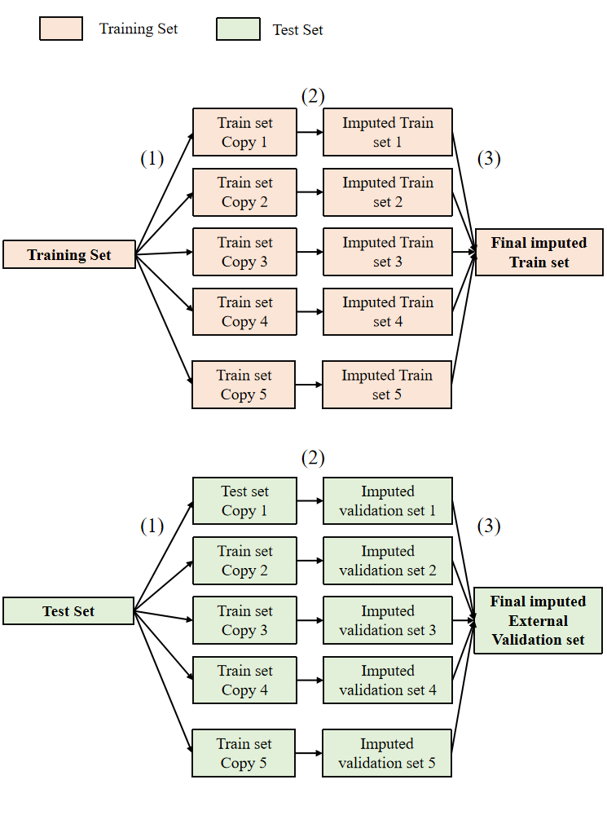
Supplementary figure 1 Imputation process for missing values.
The missing data are as follows:
Heart rate: 34 (0.11%), BMI: 32 (0.10%), Waist: 25 (0.08%), SBP: 27 (0.09%), DBP: 27 (0.09%), Physical activity: 32 (0.10%), Smoker: 32 (0.10%), FBG: 80 (0.26%).
(1) Create 5 copies of the train dataset (which includes missing variables.
(2) The missing values in the data set were assigned using the Random Forest method. After the imputation has been completed, a total of 5 imputed datasets are returned.
(3) Average the 5 imputed values for the given missing value in the original train dataset to derive final imputed dataset.

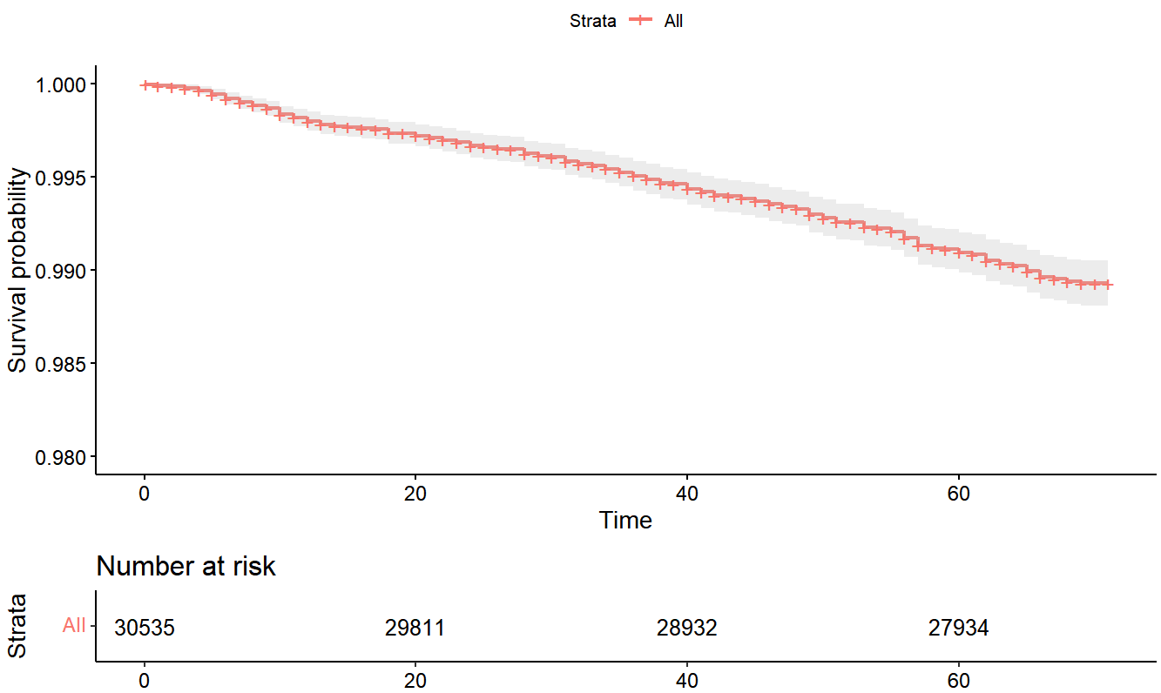
Supplementary figure 2 Cumulative incidence plots and cumulative number of events of sudden cardiac death across study populations.

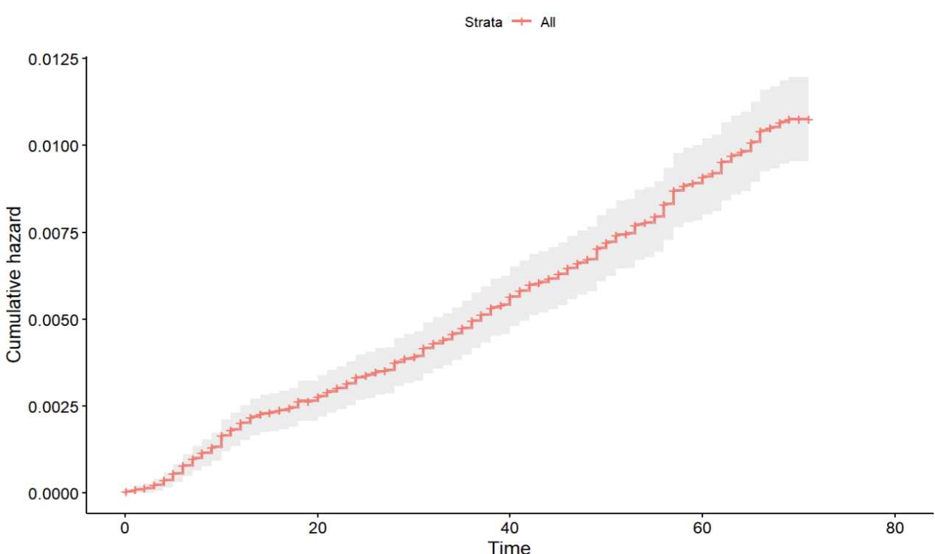Supplementary figure 3 Cumulative hazard of sudden cardiac death across study populations.

Supplementary figure 4 Feature Selection in Sudden Cardiac Death Risk Prediction via Random Survival Forest.

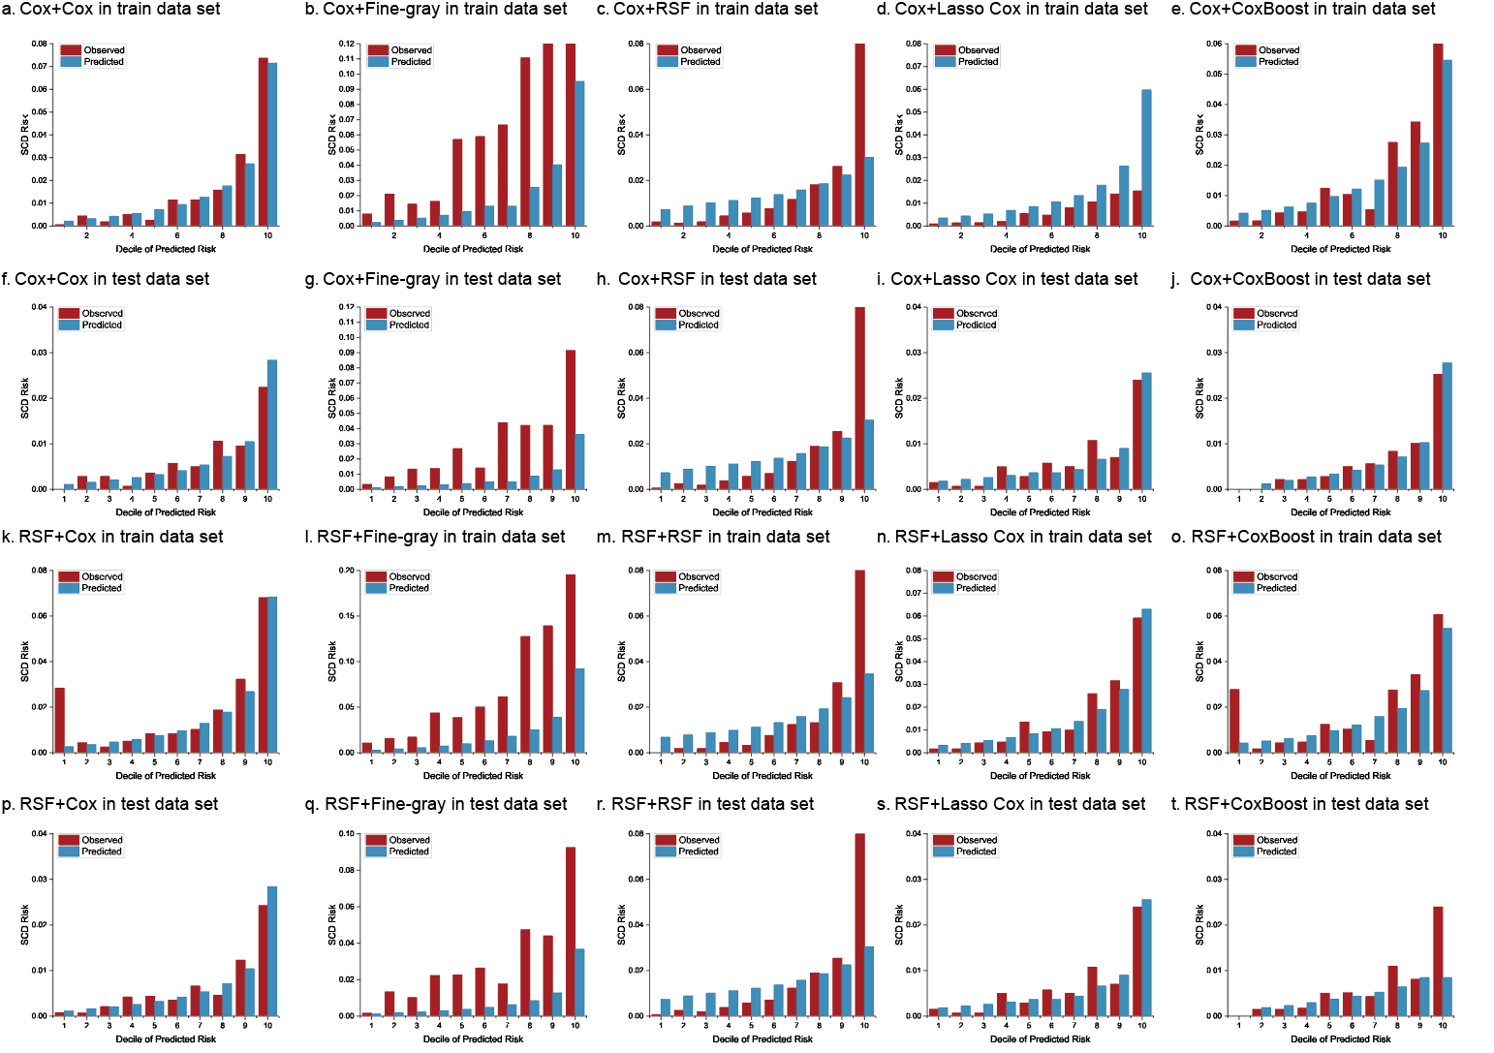
Supplementary figure 5 Calibration of sudden death risk prediction models in the training dataset and the validation dataset.
Cox proportional hazards model (Cox model), random survival forests model (RSF model), lasso Cox regression model (Lasso Cox model), boosted Cox regression model (Boosted Cox model).

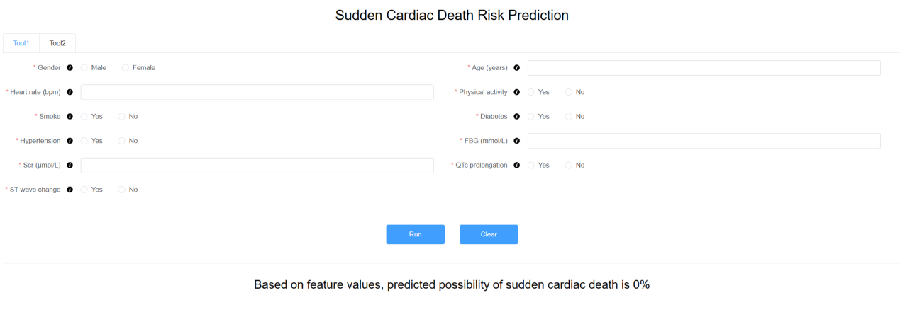
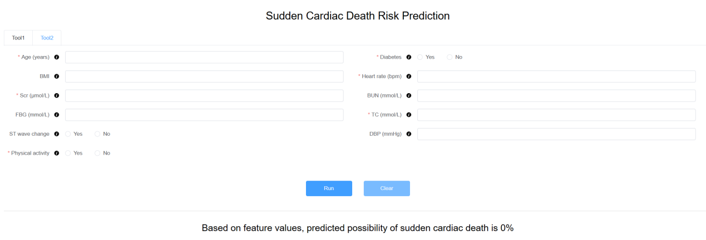
Supplementary figure 6 Convenient application for clinical utility.
The convenient application of the RSF model (Tool 1, the above of picture) and Cox model (Tool 2, the below of picture) with 11 features is available for sudden cardiac death prediction.

