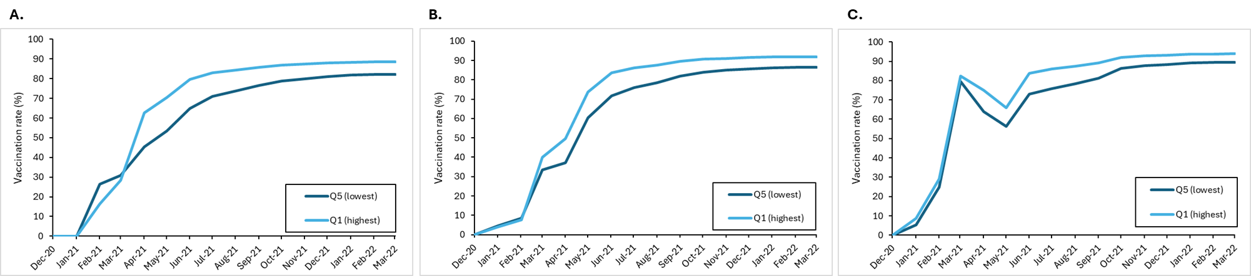
Figure S1. Cumulative monthly vaccination rate of eligible individuals in (A) Manitoba, (B) Ontario, and (C) Newfoundland by income quintile (Dec 2020-Mar 2022). Q5 is the lowest income quintile and Q1 is the highest income quintile. Rates were calculated using the eligible population in each month as the denominator; as eligibility expanded over time, this may result in apparent dips in the cumulative curves.

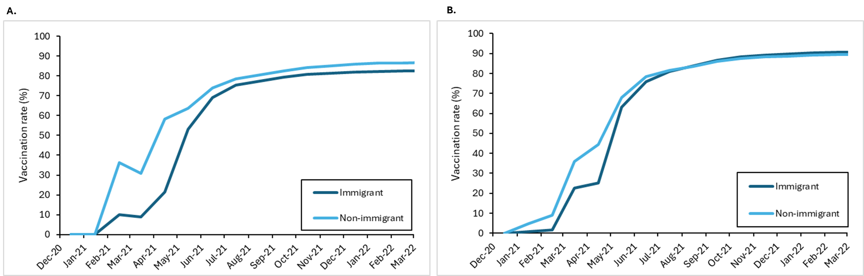
Figure S2. Cumulative monthly vaccination rate of eligible individuals in (A) Manitoba and (B) Ontario by immigration status (Dec 2020-Mar 2022). Anyone who was born in Canada or immigrated more than 15 years ago was classified as an non-immigrant. Anyone who immigrated to Canada in the last 15 years was considered an immigrant. Rates were calculated using the eligible population in each month as the denominator; as eligibility expanded over time, this may result in apparent dips in the cumulative curves.

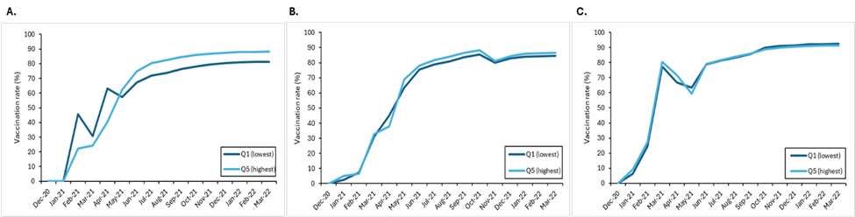
Figure S3. Cumulative monthly population vaccination rate by proportion of visible minorities in (A) Manitoba, (B) Ontario, and (C) Newfoundland (Dec 2020-Mar 2022). Q5 is the quintile with the highest proportion of individuals identifying as a visible minority. Rates were calculated using the eligible population in each month as the denominator; as eligibility expanded over time, this may result in apparent dips in the cumulative curves.

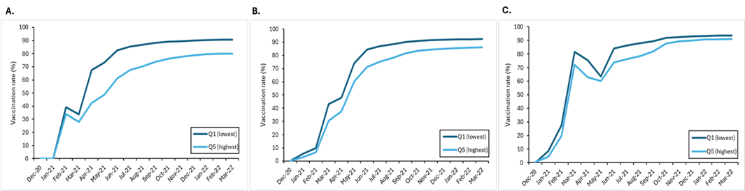

Figure S4. Cumulative monthly population vaccination rate by education achievement level in (A) Manitoba, (B) Ontario, and (C) Newfoundland by education level (Dec 2020-Mar 2022). Q5 is the highest proportion of adults without a high school diploma. Rates were calculated using the eligible population in each month as the denominator; as eligibility expanded over time, this may result in apparent dips in the cumulative curves.

