Supplementary Materials
Table of contents
Protocol 2
Supplementary Figure S1. Case numbers of among women with cervical cancer by age group in 1990 and 2021. 7
Supplementary Figure S2. Temporal trend of age-standardized rate of cervical cancer among the entire population from 1990 to 2021 at global level. 8
Supplementary Figure S3. Average annual percent change of age-standardized rate of cervical cancer in women from 1990 to 2021, stratified by age. 9
Supplementary Figure S4. Temporal trend of age-standardized rate of cervical cancer in elderly people from 1990 to 2021 at global and SDI levels. 11
Supplementary Figure S5. Average annual percent change of age-standardized rates of cervical cancer among women aged over 60 years from 204 countries according to the SDI from 1990 to 2021. 12
Supplementary Figure S6. Regional age-standardized rate of cervical cancer in elderly people aged over 60 years in 1990 and 2021, and ranked descending order of rate in 2021. 14
Supplementary Figure S7. Average annual percent changes of age-standardized rate of cervical cancer in elderly people aged over 60 years from 1990 to 2021 at region levels. 16
Supplementary Figure S8. Maps showing age-standardized rate of cervical cancer among people aged over 60 years in 2021. 18
Supplementary Table S1. Age standardized incidence and AAPC of cervical cancer in people aged over 60 years old at global and SDI region level, 1990-2021 21
Supplementary Table S2. Age standardized prevalence and AAPC of cervical cancer in people aged over 60 years old at global and SDI region level, 1990-2021 23
Supplementary Table S3. Age standardized mortality and AAPC of cervical cancer in people aged over 60 years old at global and SDI region level, 1990-2021 25
Supplementary Table S4. Age standardized incidence and AAPC of cervical cancer in elderly people from 1990 to 2021 at region level 27
Supplementary Table S5. Age standardized prevalence and AAPC of cervical cancer in elderly people from 1990 to 2021 at region level 29
Supplementary Table S6. Age standardized mortality and AAPC of cervical cancer in elderly people from 1990 to 2021 at region level 31
Supplementary Table S7. Age standardized incidence and AAPC of cervical cancer in people aged over 60 years old between 1990-2021 in 204 countries and territories. 33
Supplementary Table S8. Age standardized prevalence and AAPC of cervical cancer in people aged over 60 years old between 1990-2021 in 204 countries and territories. 48
Supplementary Table S9. Age standardize mortality and AAPC of cervical cancer in people aged over 60 years old between 1990-2021 in 204 countries and territories. 63
Supplementary Table S10. Global prediction of incidence, prevalence and mortality of cervical cancer among women aged over 60 years to 2035 using BAPC model with 95%CI. 79

Protocol
- Introduction
Cervical cancer is one of the leading causes of cancer-related mortality and the incidence of new cancer cases among women worldwide. Over the past decade, advancements in the prevention and treatment of cervical cancer have yielded encouraging outcomes. However, existing studies have not thoroughly examined the changes in incidence, prevalence, and mortality among elderly women over the past decades, both globally and across different countries. This oversight neglects the significant burden of cervical cancer among older women and the complexities involved in managing the disease within this demographic. The substantial burden of cervical cancer in elderly women may pose a significant challenge to the elimination of cervical cancer.
The Global Burden of Diseases, Injuries, and Risk Factors Study (GBD) study is a comprehensive effort to quantify the comparative magnitude of health loss due to diseases, injuries, and risk factors. To ensure comprehensive and accurate estimates, the GBD study leverages a diverse array of data sources, including administrative records, censuses, vital registration systems, disease registries, literature reviews, and environmental monitoring data.¹ The establishment of the GBD database is a complex and iterative process that involves the collection, harmonization, and analysis of an extensive array of data sources. For instance, ST-GPR modeling was employed to smooth estimates over age, time, and location in areas with incomplete datasets.² Epidemiological data with known biases, such as alternative case definitions or measurement methods, were adjusted using correction factors estimated through network meta-regressions with MR-BRT.² DisMod-MR 2.1 integrates diverse data sources, adjusts for biases, and produces consistent estimates of disease metrics like prevalence, incidence, and mortality, ensuring reliable global health analyses.² GBD provides a global perspective on the health challenges faced by populations, enabling evidence-based decision-making for policymakers, researchers, and health practitioners.
- Methods and analysis
  - Study design
The study is designed as a cross-sectional study. This study utilizes data from the GBD 2021 to describe the burden of cervical cancer among elderly women across age-specific groups (60+ years, five-year age groups) on both global and regional scales.
  - The objectives of the study
This study aims to examine the trends in incidence, prevalence, and mortality rates of cervical cancer among elderly women from 1990 to 2021. Additionally, it seeks to predict the global incidence, prevalence, and mortality of cervical cancer from 2021 to 2035, based on GBD data spanning 1990 to 2021. Furthermore, the study investigates disparities in the burden of cervical cancer across countries with varying Socio-Demographic Index (SDI) levels.
  - Data collection procedure
    - Data collection
Data is obtained from publicly available Global Burden of Diseases, Injuries, and Risk Factors Study (GBD) 2021, updated on May 16, 2024.
    - Population
Women aged over 60 years with cervical cancer (classified under International Classification of Diseases tenth edition [ICD-10] code C53) are included in the analysis. The population is stratified into eight five-year age groups: 60-64, 65-69, 70-74, 75-79, 80-84, 85-89, and 90+.
    - Location
This study encompasses 5 SDI regions, 21 regions and 204 countries and territories.
    - Measures and metrics
The study presents the number and rate of incidence, prevalence, and mortality, along with their corresponding 95% uncertainty intervals (UIs).
  - Statistical analysis
This study utilizes age-standardized rates (ASR) per 100,000 person-years and extract the 95% uncertainty interval (UI) from the database to quantify the burden of cervical cancer. The ASR represents the ratio per 100,000 individuals following a standardized global age structure, allowing for the mitigation of aging effects as much as possible. ASR of cervical cancer burden (per 100,000 population), including age-standardized incidence rate (ASIR), age-standardized prevalence rate (ASPR), age-standardized mortality rate (ASMR) in this study, is calculated using the following formula:
$$ASR=\frac{\sum{a_{i}w_{i}}}{\sum{w_{i}}} ×100,000$$
where $a_{i}$ denotes the age-specific rate in the $i^{th}$ age subgroup and $w_{i}$ represents the number of individuals in the same age class of the GBD world age-standard population came from the GBD Study 2021 Population Estimates.
In addition, this study calculates the average annual percentage change (AAPC) and the corresponding 95% CI using Joinpoint regression analysis to demonstrate the 32-year trend in incidence, prevalence and mortality. The specified time interval is considered for assigning weights to the length of each segment, with model selection based on the Weighted BIC method, a maximum of 6–7 joinpoints allowed by default, and the heteroscedastic/correlated errors option set to constant variance (homoscedasticity). The formula of AAPC is as follows:
$$AAPC=\left\{exp\left(\frac{\sum{w_{i}b_{i}}}{\sum{w_{i}}}\right)-1\right\}×100$$
where $w_{i}$ indicates the length of each segment in the range of years, while the $b_{i}$ is the slope coefficient for each segment in the desired range of years. The AAPC value denotes the percentage annual change (increase, decrease, or no change). If annual percentage change estimates and 95% CI are both >0 (or both <0), we consider the corresponding rate to be in an upward (or downward) trend.
As the age-standardized rates did not follow a normal distribution, non-parametric tests were applied. In addition, the Locally Weighted Scatterplot Smoothing (Loess) model (see Figure 5, Figure S5) was employed purely for visualization purposes to illustrate nonlinear trends, and its inclusion does not affect the overall trend interpretation. The Loess model was implemented with default parameters, including a span of 0.75 (controlling the neighborhood proportion), degree = 2 (local quadratic polynomial), and family = "gaussian" (least-squares fitting rather than robust loess). Spearman correlation analysis was further performed to explore the relationship between age-standardized rates and the SDI quintile.
To project cervical cancer trends through 2035, we employed the Bayesian Age–Period–Cohort (BAPC) model. This approach extends the conventional log-linear Age–Period–Cohort (APC) model within a Bayesian framework. In the classical APC formulation, the logarithm of the expected rate is decomposed additively into age, period, and cohort effects³. This analysis used annually estimated data (1990–2021) from the Global Burden of Disease Study (GBD), with the BAPC model fitted in 1-year intervals to align with the available estimates.
APC expression is as follows: log(μᵢⱼ) = αᵢ + βⱼ + γₖ + δ
Where:
• αᵢ represents the age effect (i = 1, …, I),
• βⱼ represents the period effect (j = 1, …, J),
• γₖ represents the cohort effect (k = j − i + I, k = 1, …, K),
• δ represents the intercept term.
Due to the linear dependence among age, period, and cohort effects (e.g., cohort k = j − i), the model suffers from the classic non-identifiability issue. To address this problem, the BAPC model treats αᵢ, βⱼ, and γₖ as random parameters and assigns them smooth prior distributions to constrain their structures.
The BAPC model is grounded in Bayesian statistical theory, where in unknown parameters—representing age, period, and cohort effects—are treated as random variables and assigned prior distributions⁴. Using Bayes‘ theorem, these prior distributions are updated by incorporating information from the observed data to derive posterior distributions, thus enabling probabilistic inference⁵.
In modeling temporal trends of disease incidence, prevalence and mortality, it is generally assumed that effects from adjacent age groups, time periods, or birth cohorts exhibit continuity and smoothness⁵. For instance, cervical cancer mortality rates are not expected to vary erratically between consecutive age groups. To capture this smoothness, the BAPC model imposes structural constraints on the age, period, and cohort parameters through second-order random walk (RW2) priors. The priors assume that the second differences of the parameters follow a normal distribution with mean zero⁵.
Let a set of parameters be denoted as $α$= ($α$₁, …, $α$T). The RW2 prior equation:
$$f\left(α|κ_{α}\right)∝κ_{α}^{\frac{L-2}{2}}\exp\left(-\frac{κ_{α}}{2}\sum_{i=3}^{I}{(}α_{i}-2α_{i-1}+α_{i-2})^{2}\right)=κ_{α}^{\frac{L-2}{2}}\exp\left(-\frac{1}{2}α^{T}Qα\right)$$
$$Q=κ_{a}\left(\begin{matrix}1 & -2 & 1 & \\ -2 & 5 & -4 & 1 \\ 1 & -4 & 6 & -4 \\ ⋱ & ⋱ & ⋱ & ⋱ \\ 1 & -4 & 6 & -4 \\ 1 & -4 & 5 & -2 \\ 1 & -2 & 1 & \end{matrix}\right)$$
In the Bayesian inference procedure implemented in this study, RW2 priors are applied to smooth the three temporal parameters in the APC model. This allows the combination of prior knowledge with observed data to yield a posterior distribution that reflects medically plausible trends⁶. Since cervical cancer burden indicator may evolve gradually over time, the RW2 prior promotes estimates that are consistent with such slow, structured changes—aligning well with the emphasis in epidemiological research on capturing stable long-term patterns^{5,7}. Furthermore, the BAPC is particularly effective at emphasizing long-term trends while reducing short-term fluctuations⁵. This matches the overarching goal of this study: to reliably identify and project persistent trends in cervical cancer burden.
Statistical significance is considered if P < 0.05. All statistical analyses are done using Joinpoint 5.2.0.0 April 2024 and R software version 4.3.1.
- Ethics statement
For GBD studies, the Institutional Review Board of the University of Washington reviewed and approved a waiver of informed consent (https://www.healthdata.org/research-analysis/gbd).
Reference
1 GBD protocol | Institute for Health Metrics and Evaluation. https://www.healthdata.org/research-analysis/about-gbd/protocol (accessed Jan 9, 2025).
2 Ferrari AJ, Santomauro DF, Aali A, et al. Global incidence, prevalence, years lived with disability (YLDs), disability-adjusted life-years (DALYs), and healthy life expectancy (HALE) for 371 diseases and injuries in 204 countries and territories and 811 subnational locations, 1990–2021: a systematic analysis for the Global Burden of Disease Study 2021. The Lancet 2024; 403: 2133–61.
3 Robertson C, Boyle P. Age–period–cohort analysis of chronic disease rates. I: modelling approach. Statistics in Medicine 1998; 17: 1305–23.
4 Du Z, Chen W, Xia Q, Shi O, Chen Q. Trends and projections of kidney cancer incidence at the global and national levels, 1990-2030: a Bayesian age-period-cohort modeling study. Biomark Res 2020; 8: 16.
5 Riebler A, Held L. Projecting the future burden of cancer: Bayesian age–period–cohort analysis with integrated nested Laplace approximations. Biometrical Journal 2017; 59: 531–49.
6 Liu Y, Zhang C, Wang Q, et al. Temporal Trends in the Disease Burden of Colorectal Cancer with Its Risk Factors at the Global and National Level from 1990 to 2019, and Projections Until 2044. Clin Epidemiol 2023; 15: 55–71.
7 Riebler A, Sørbye SH, Simpson D, Rue H. An intuitive Bayesian spatial model for disease mapping that accounts for scaling. Stat Methods Med Res 2016; 25: 1145–65.

Supplementary Figure S1. Case numbers of among women with cervical cancer by age group in 1990 and 2021. (A) incidence. (B) prevalence. (C) mortality.
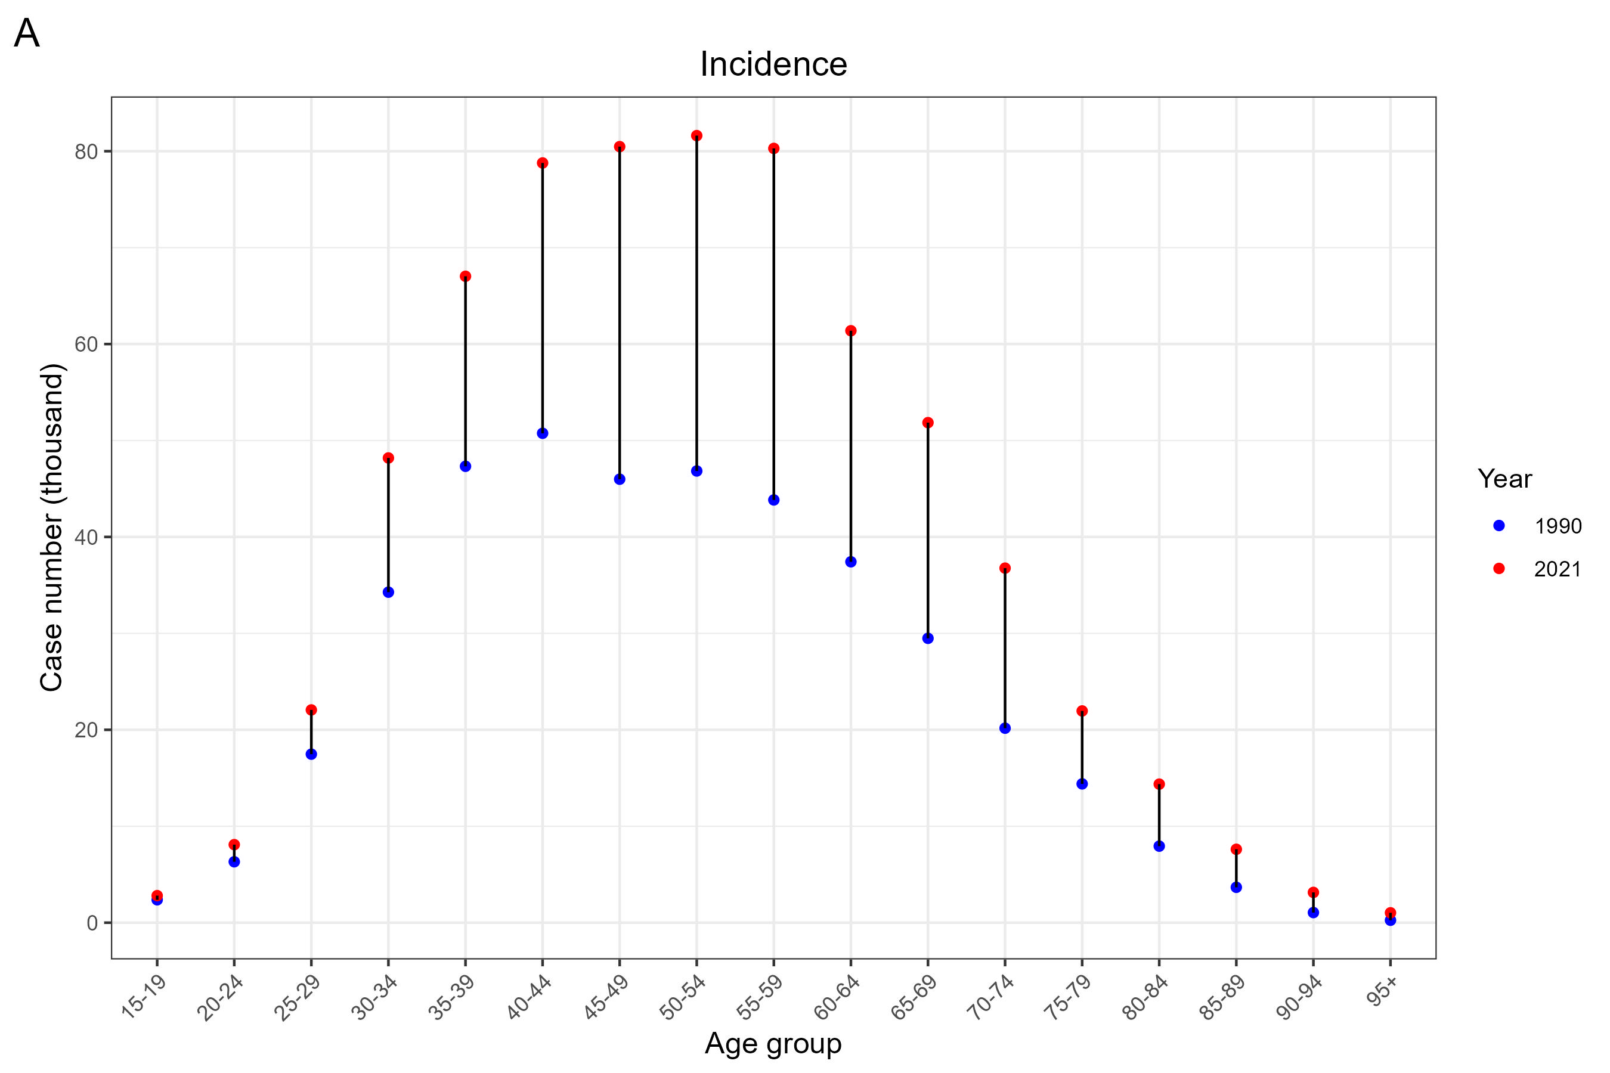
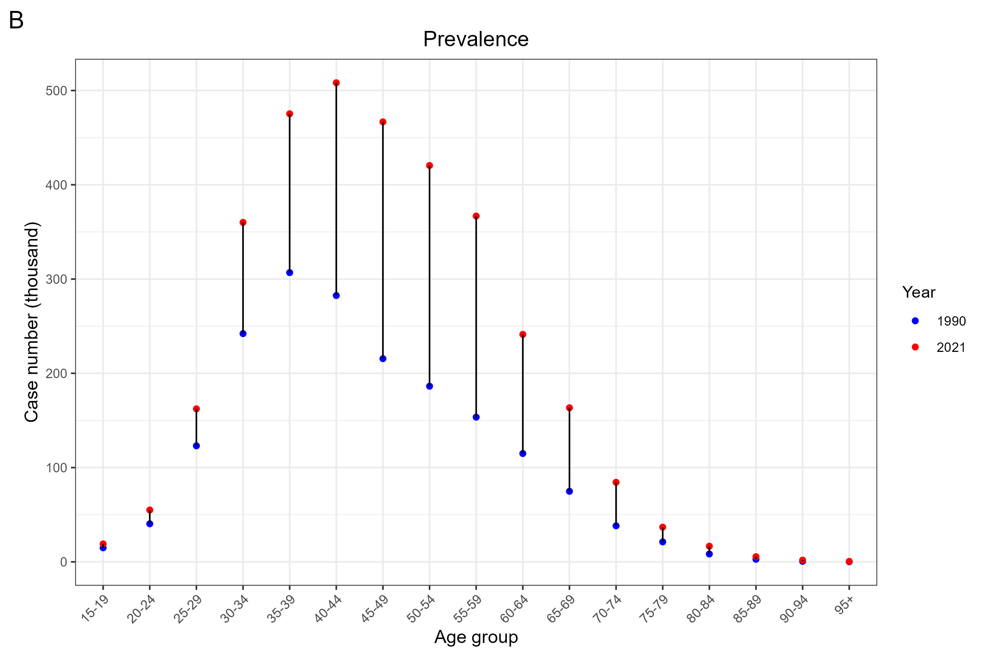
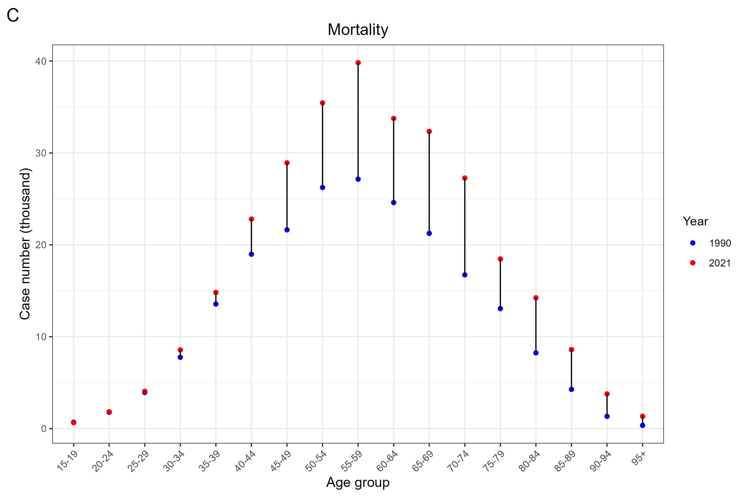

Supplementary Figure S2. Temporal trend of age-standardized rate of cervical cancer among the entire population from 1990 to 2021 at global level. (A) Age-standardized incidence rate. (B) Age-standardized prevalence rate. (C) Age-standardized mortality rate. The ribbon represents the 95%UI. UI, uncertainty interval.
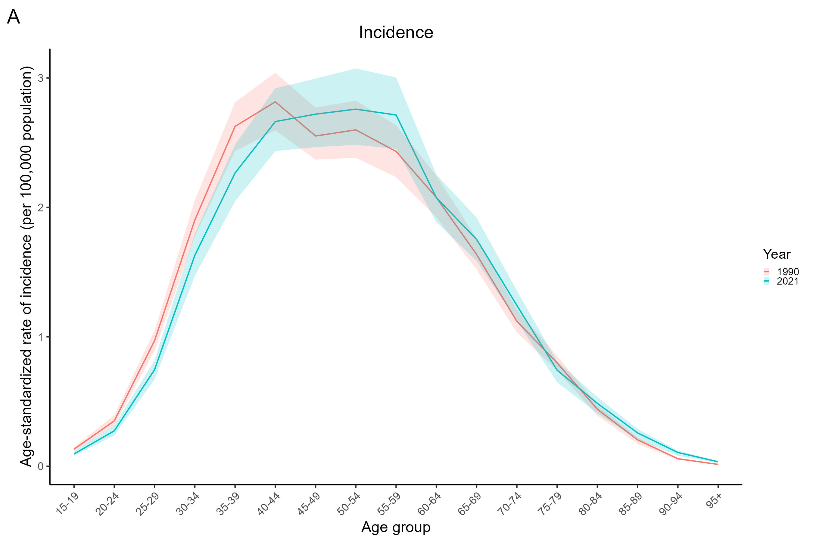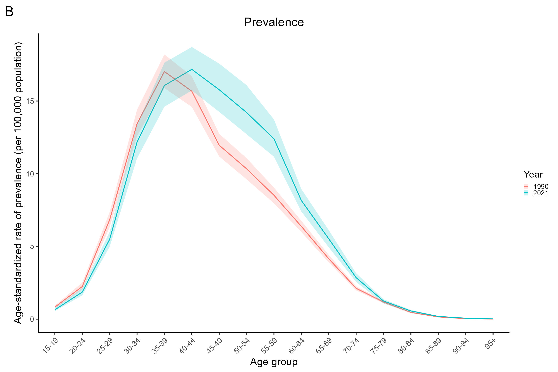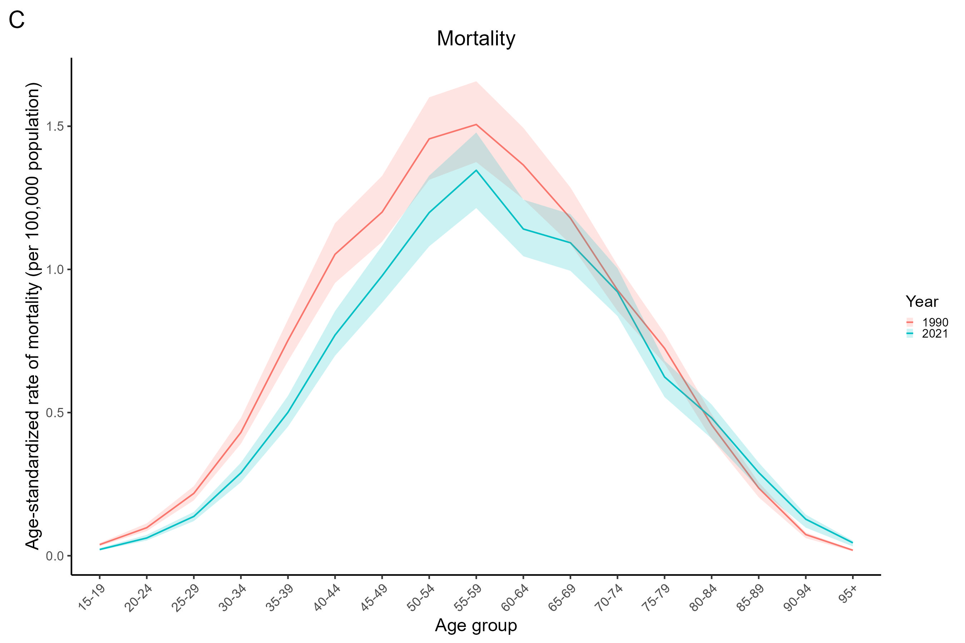

Supplementary Figure S3. Average annual percent change of age-standardized rate of cervical cancer in women from 1990 to 2021, stratified by age. (A) Age-standardized incidence rate. (B) Age-standardized prevalence rate. (C) Age-standardized mortality rate. The error bar represents 95%CI. ASIR, age-standardized incidence rate; ASPR, age-standardized prevalence rate; ASMR, age-standardized mortality rate; CI, confidence interval.
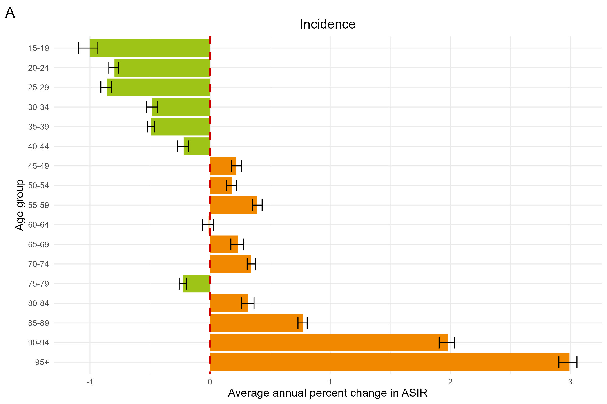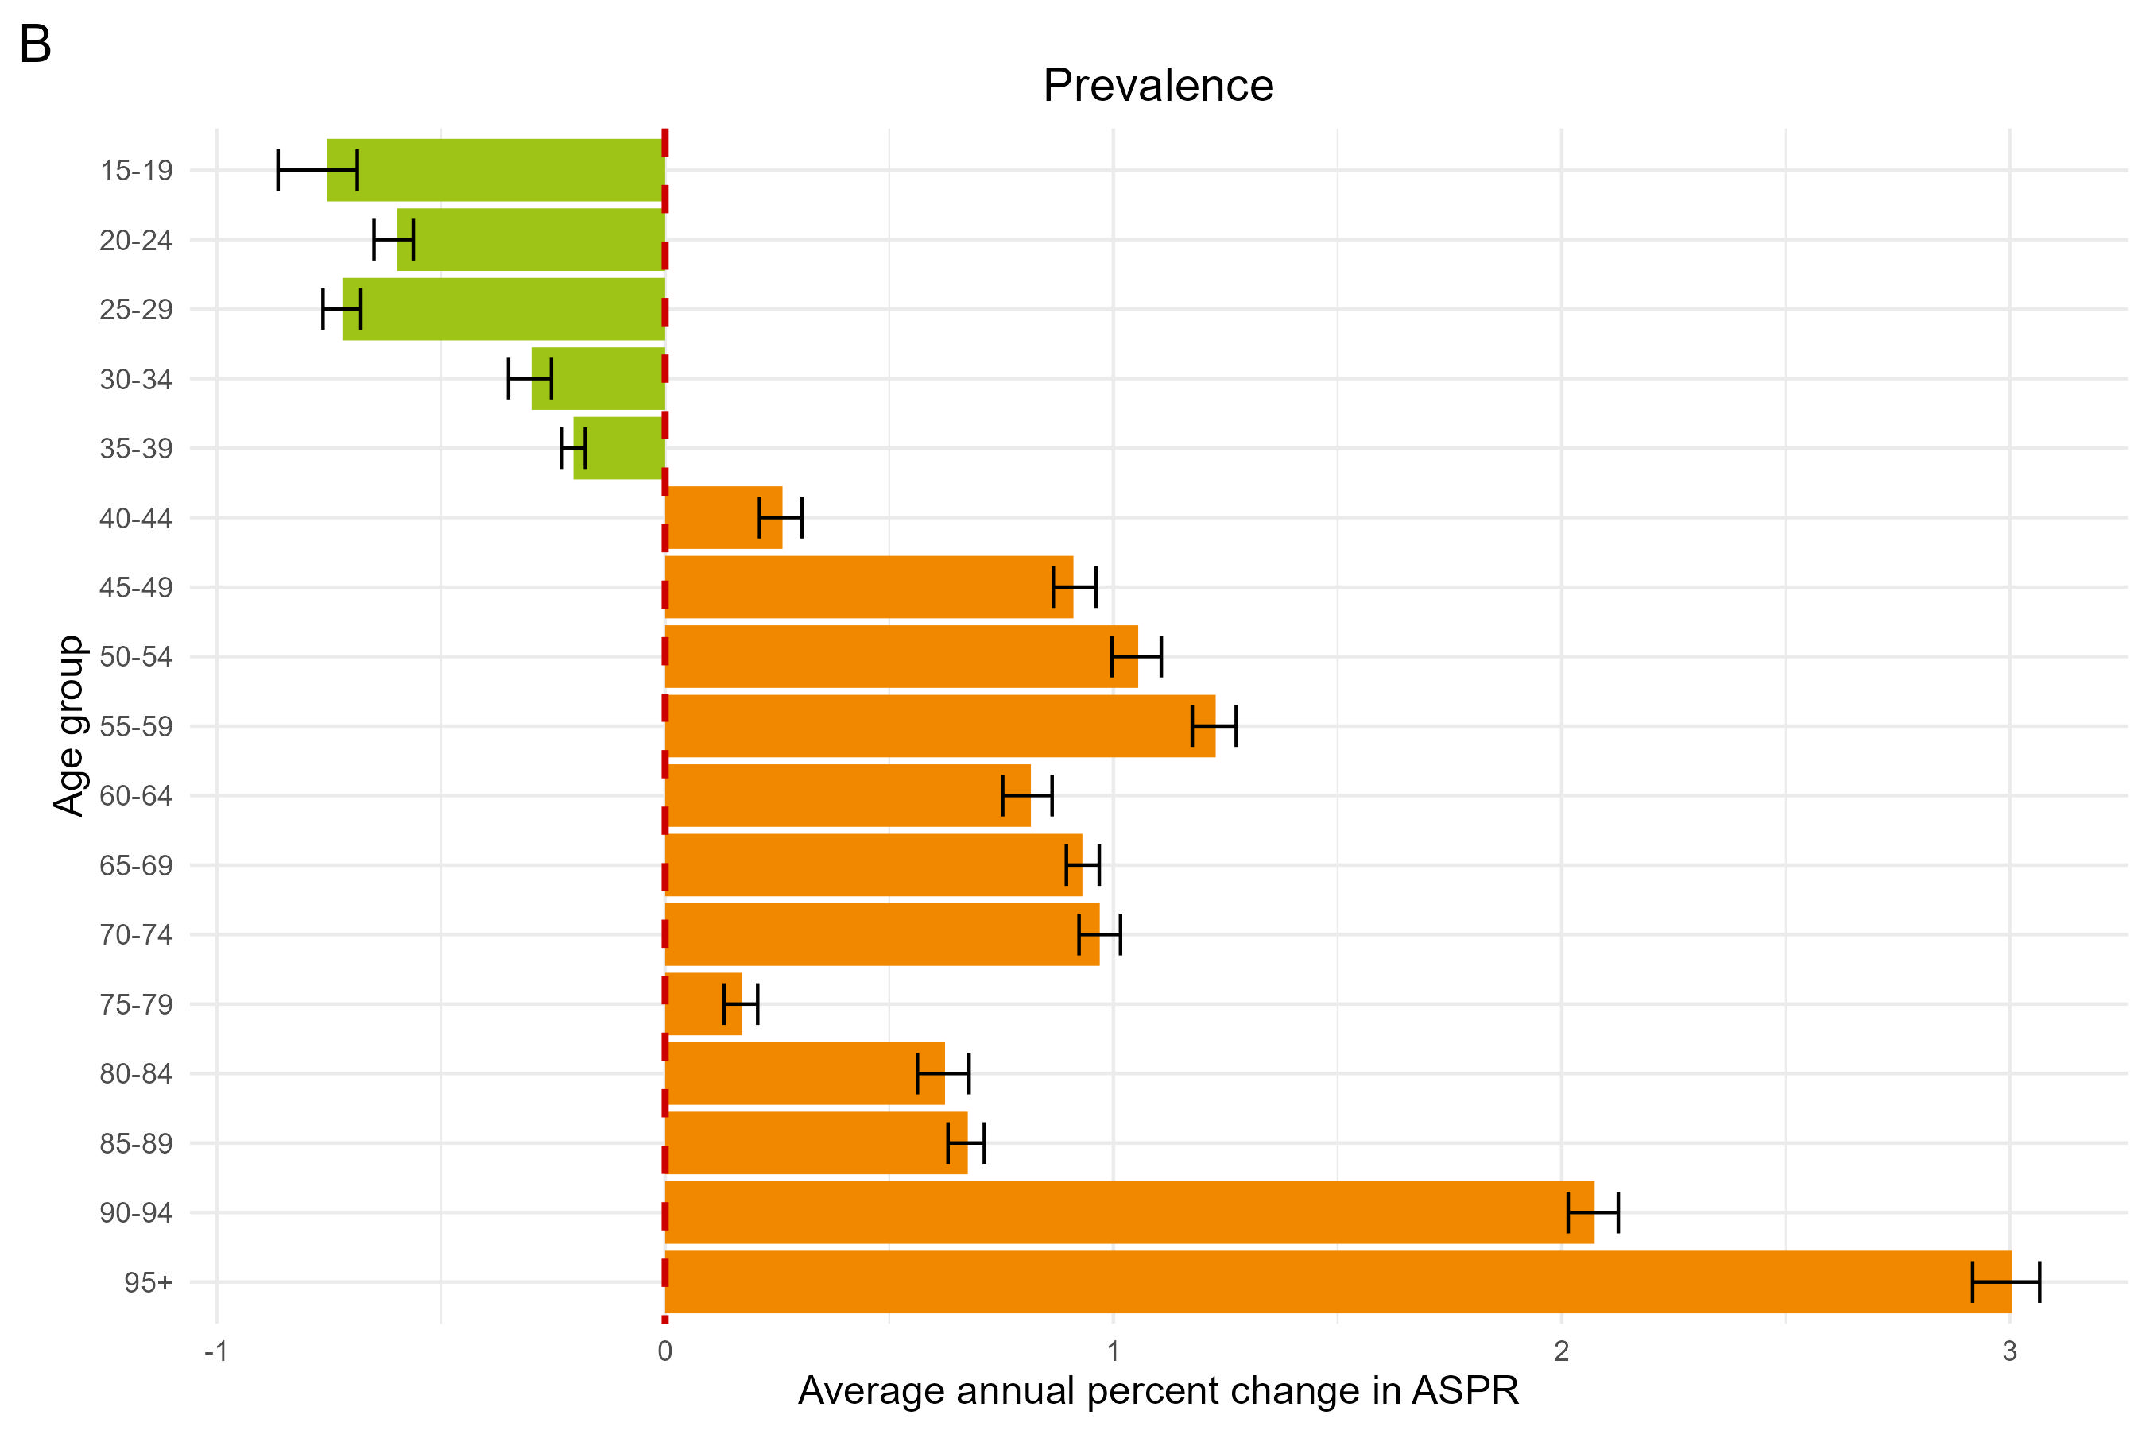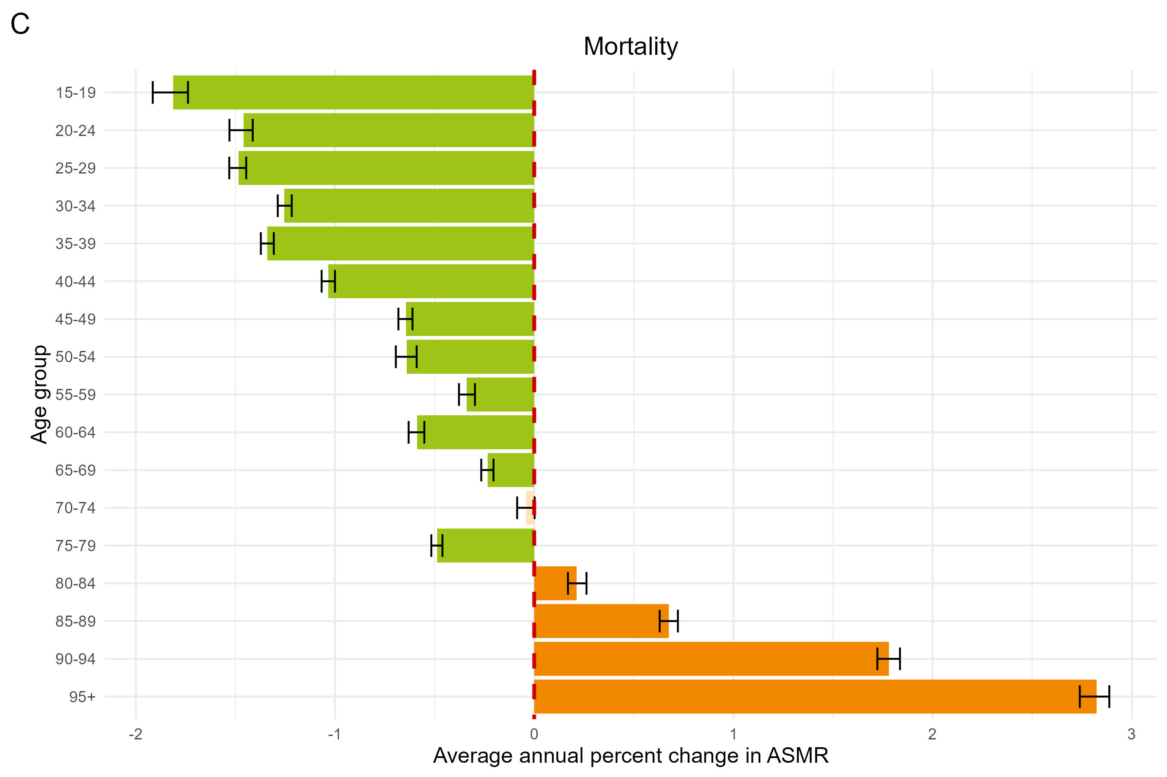

Supplementary Figure S4. Temporal trend of age-standardized rate of cervical cancer in elderly people from 1990 to 2021 at global and SDI levels. (A) Age-standardized incidence rate. (B) Age-standardized prevalence rate. (C) Age-standardized mortality rate. SDI, sociodemographic index.
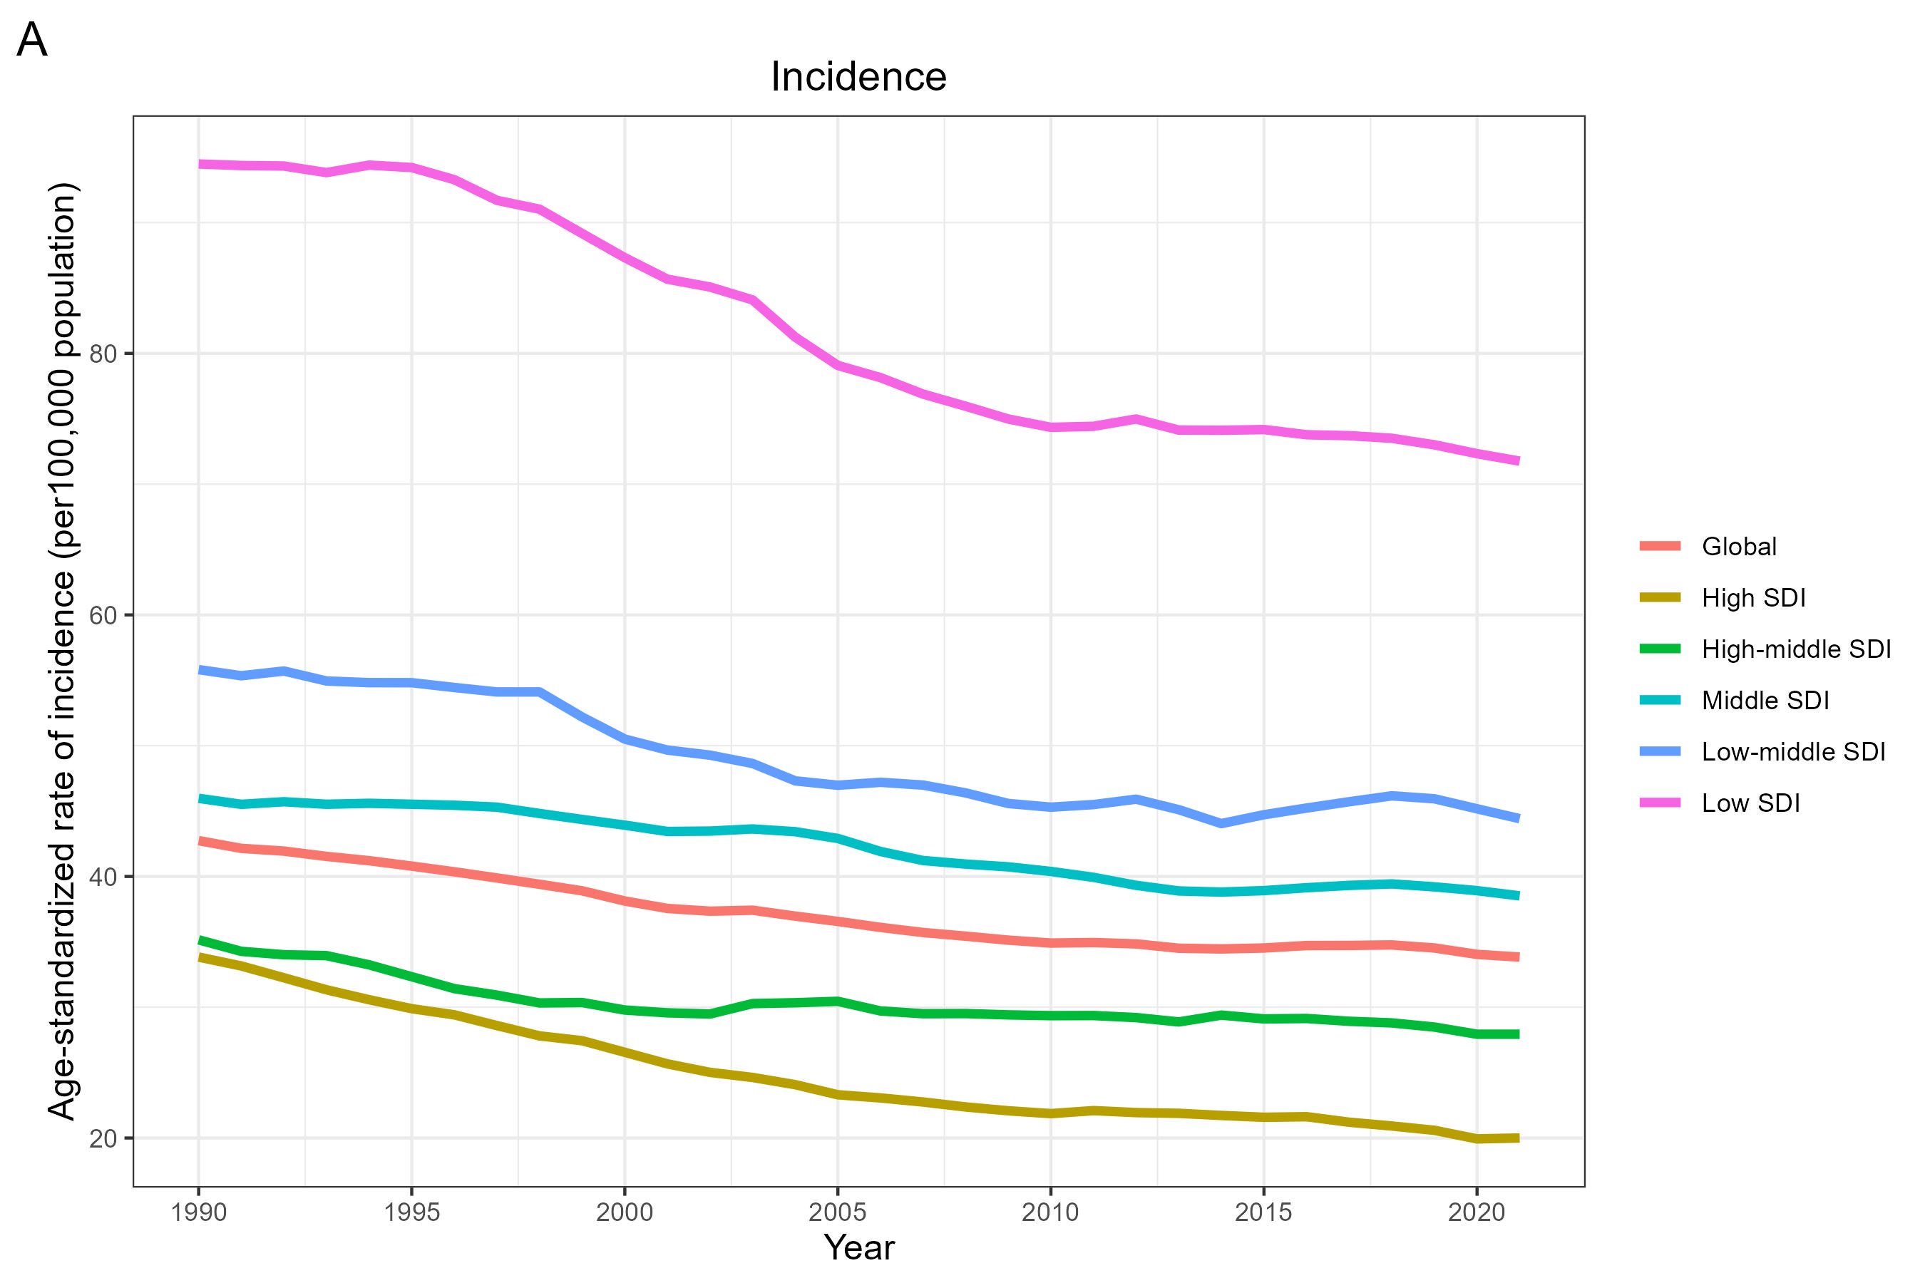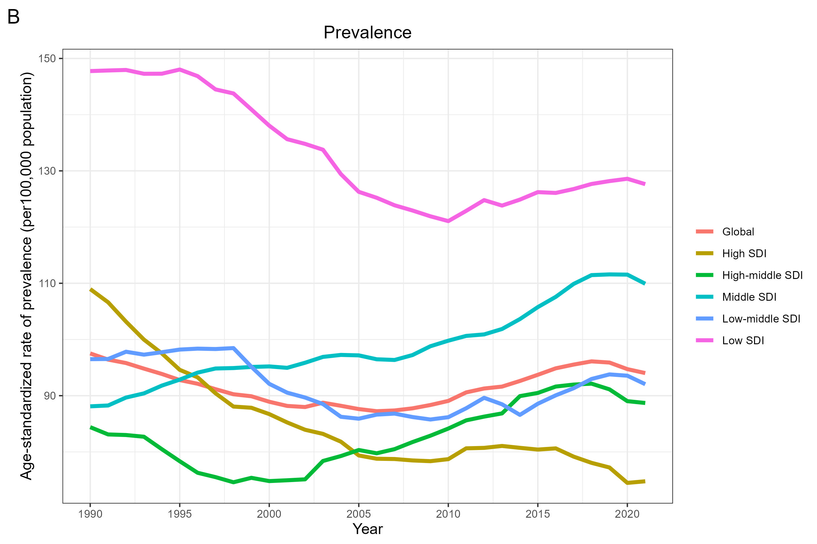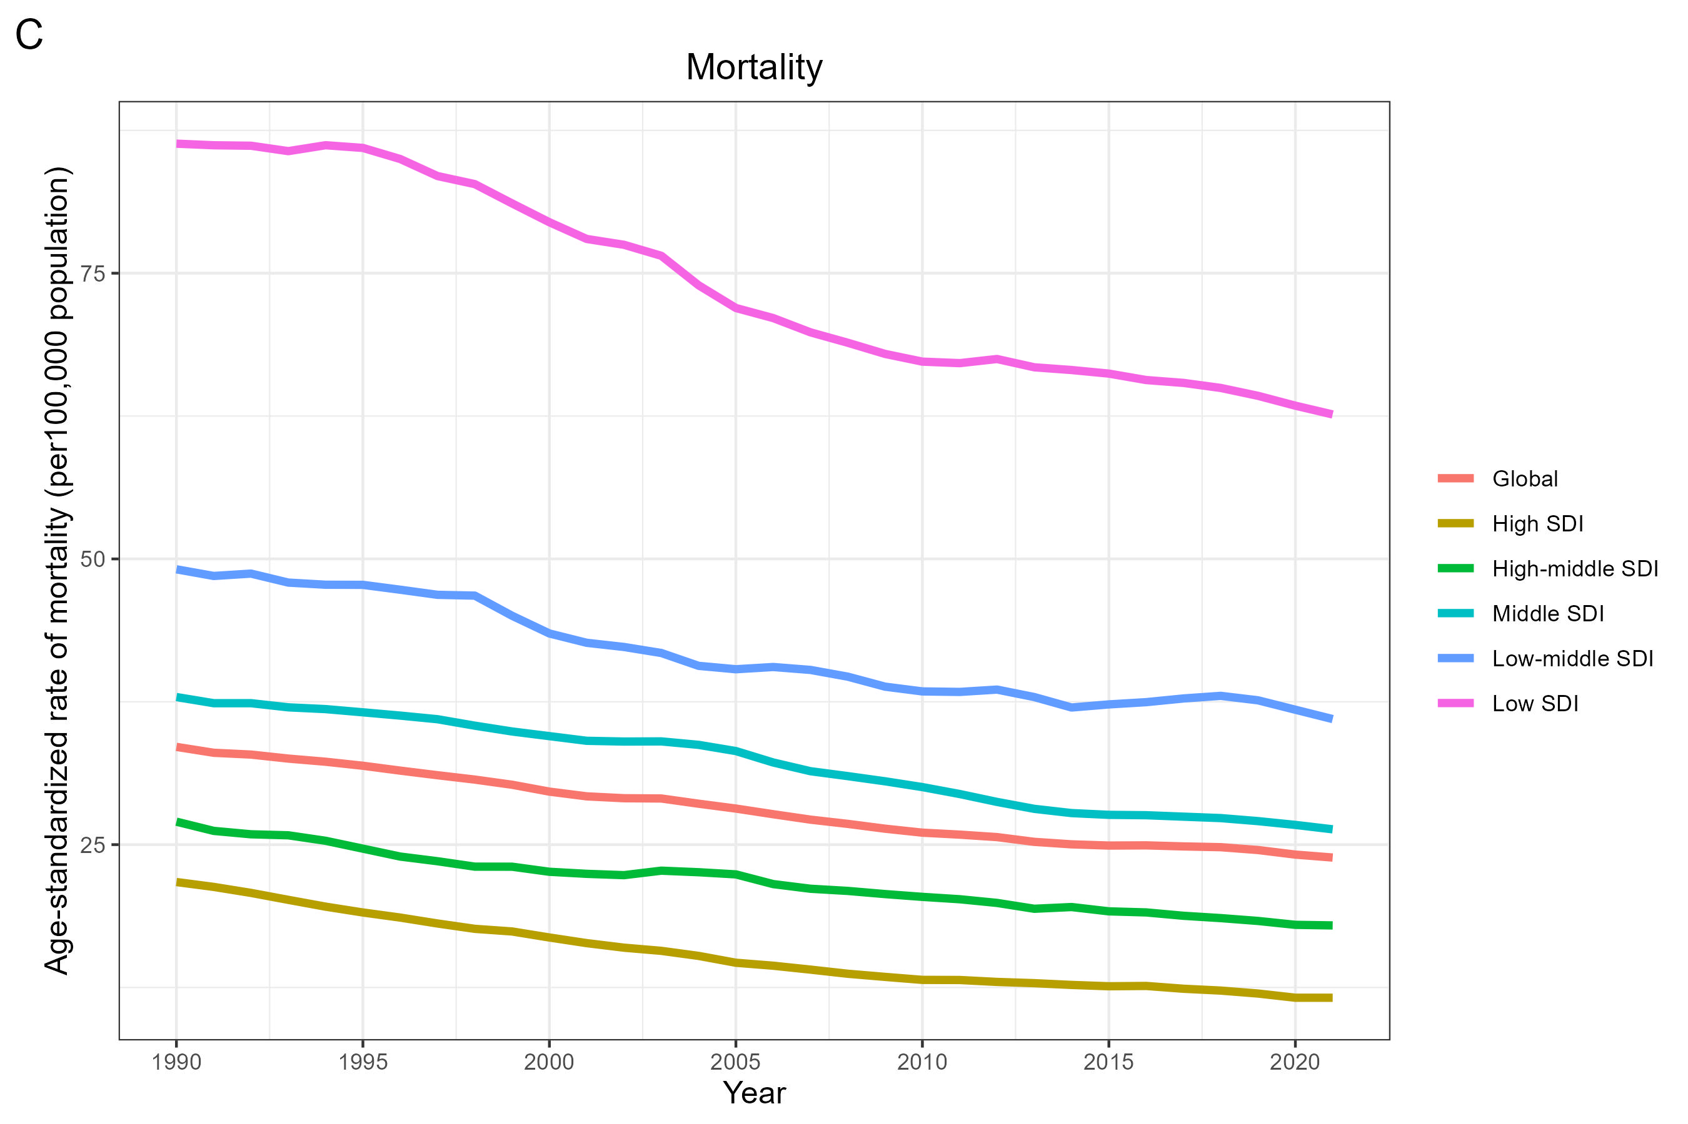
Supplementary Figure S5. Average annual percent change of age-standardized rates of cervical cancer among women aged over 60 years from 204 countries according to the SDI from 1990 to 2021. (A) Age-standardized incidence rate. (B) Age-standardized prevalence rate. (C) Age-standardized mortality rate. SDI, sociodemographic index; ρ, the Spearman rank correlation coefficient; p, P value.
*The LOWESS (Locally Weighted Scatterplot Smoothing) regression model is utilized to generate a fitted curve based on the data points in the scatter plot. Spearman correlation analysis is utilized to explore the relationship between ASR and SDI.
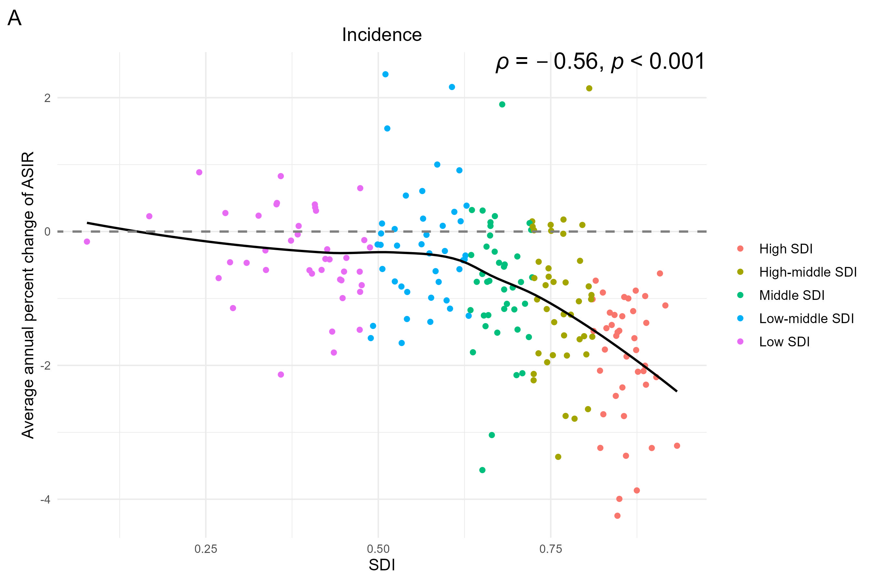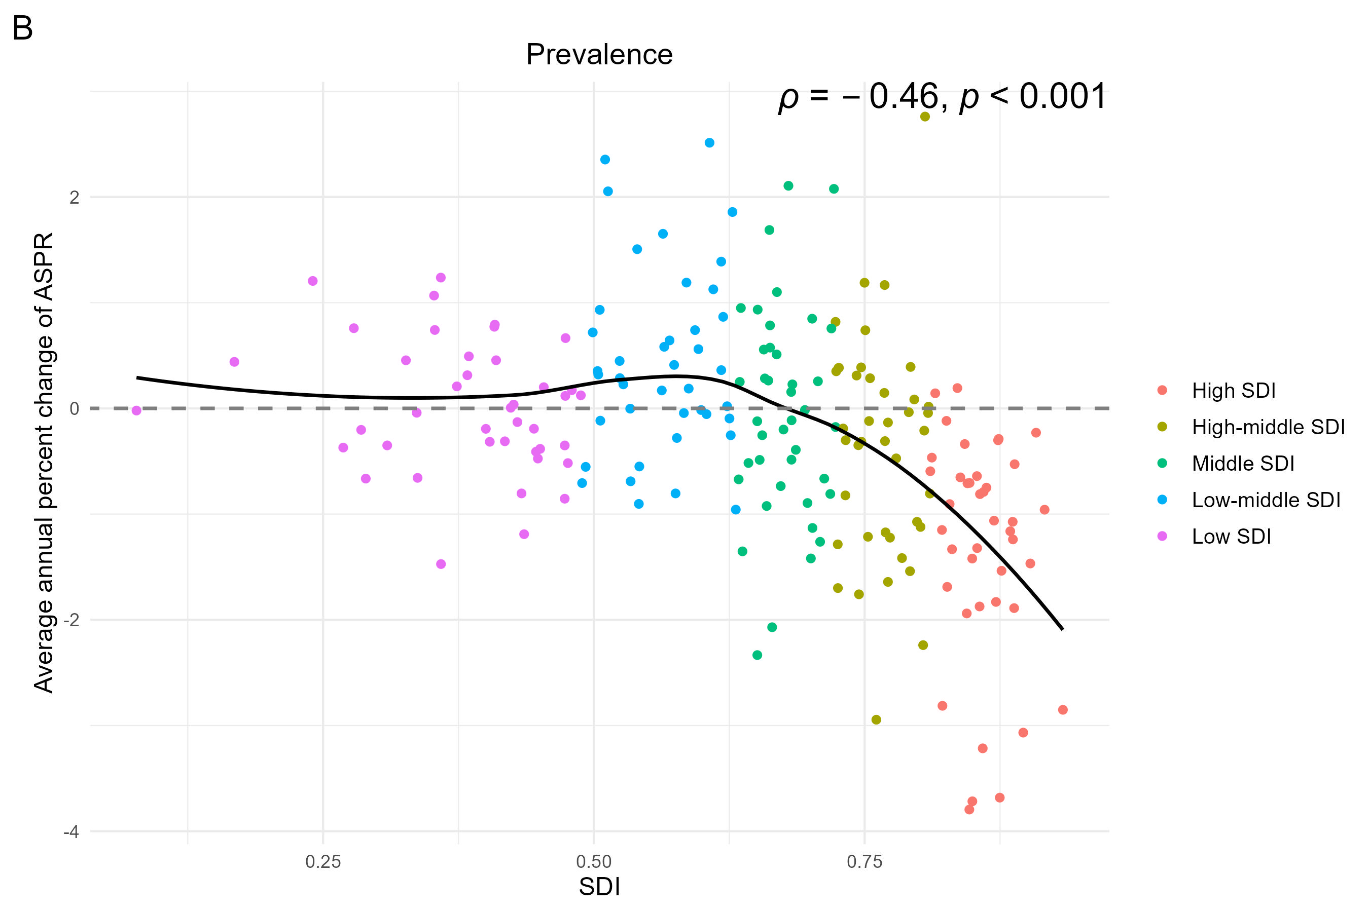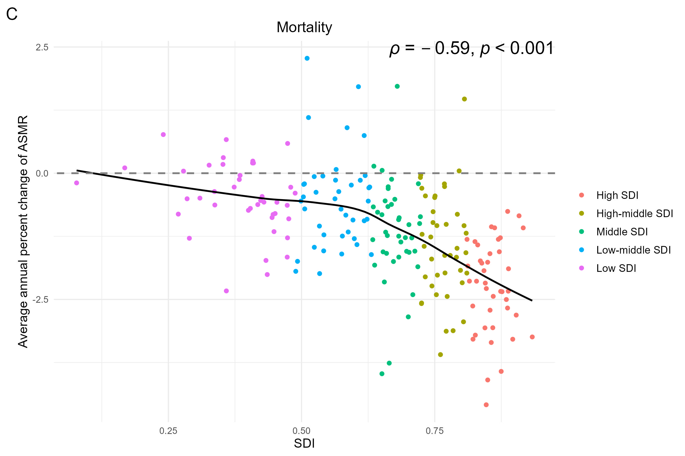
Supplementary Figure S6. Regional age-standardized rate of cervical cancer in elderly people aged over 60 years in 1990 and 2021, and ranked descending order of rate in 2021. (A) Age-standardized incidence rate. (B) Age-standardized prevalence rate. (C) Age-standardized mortality rate.
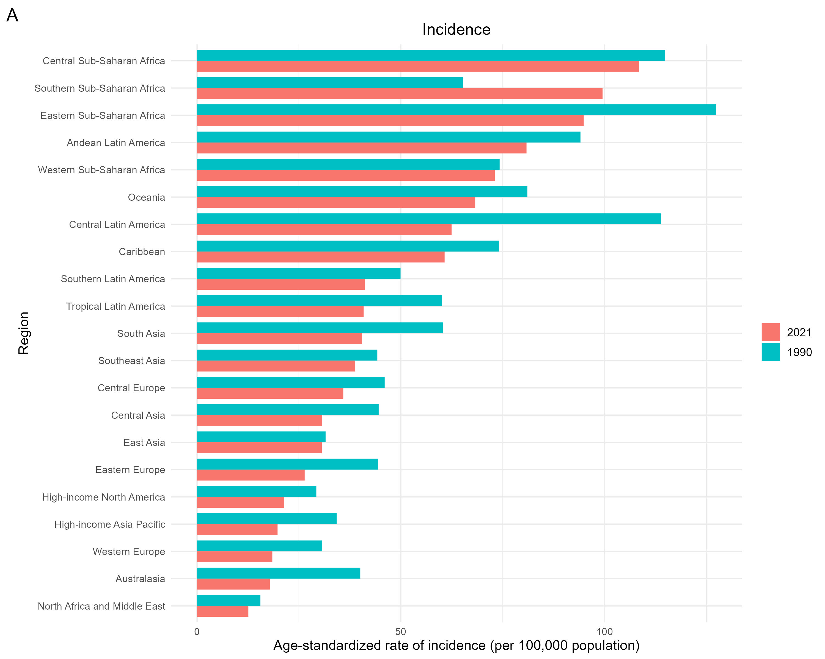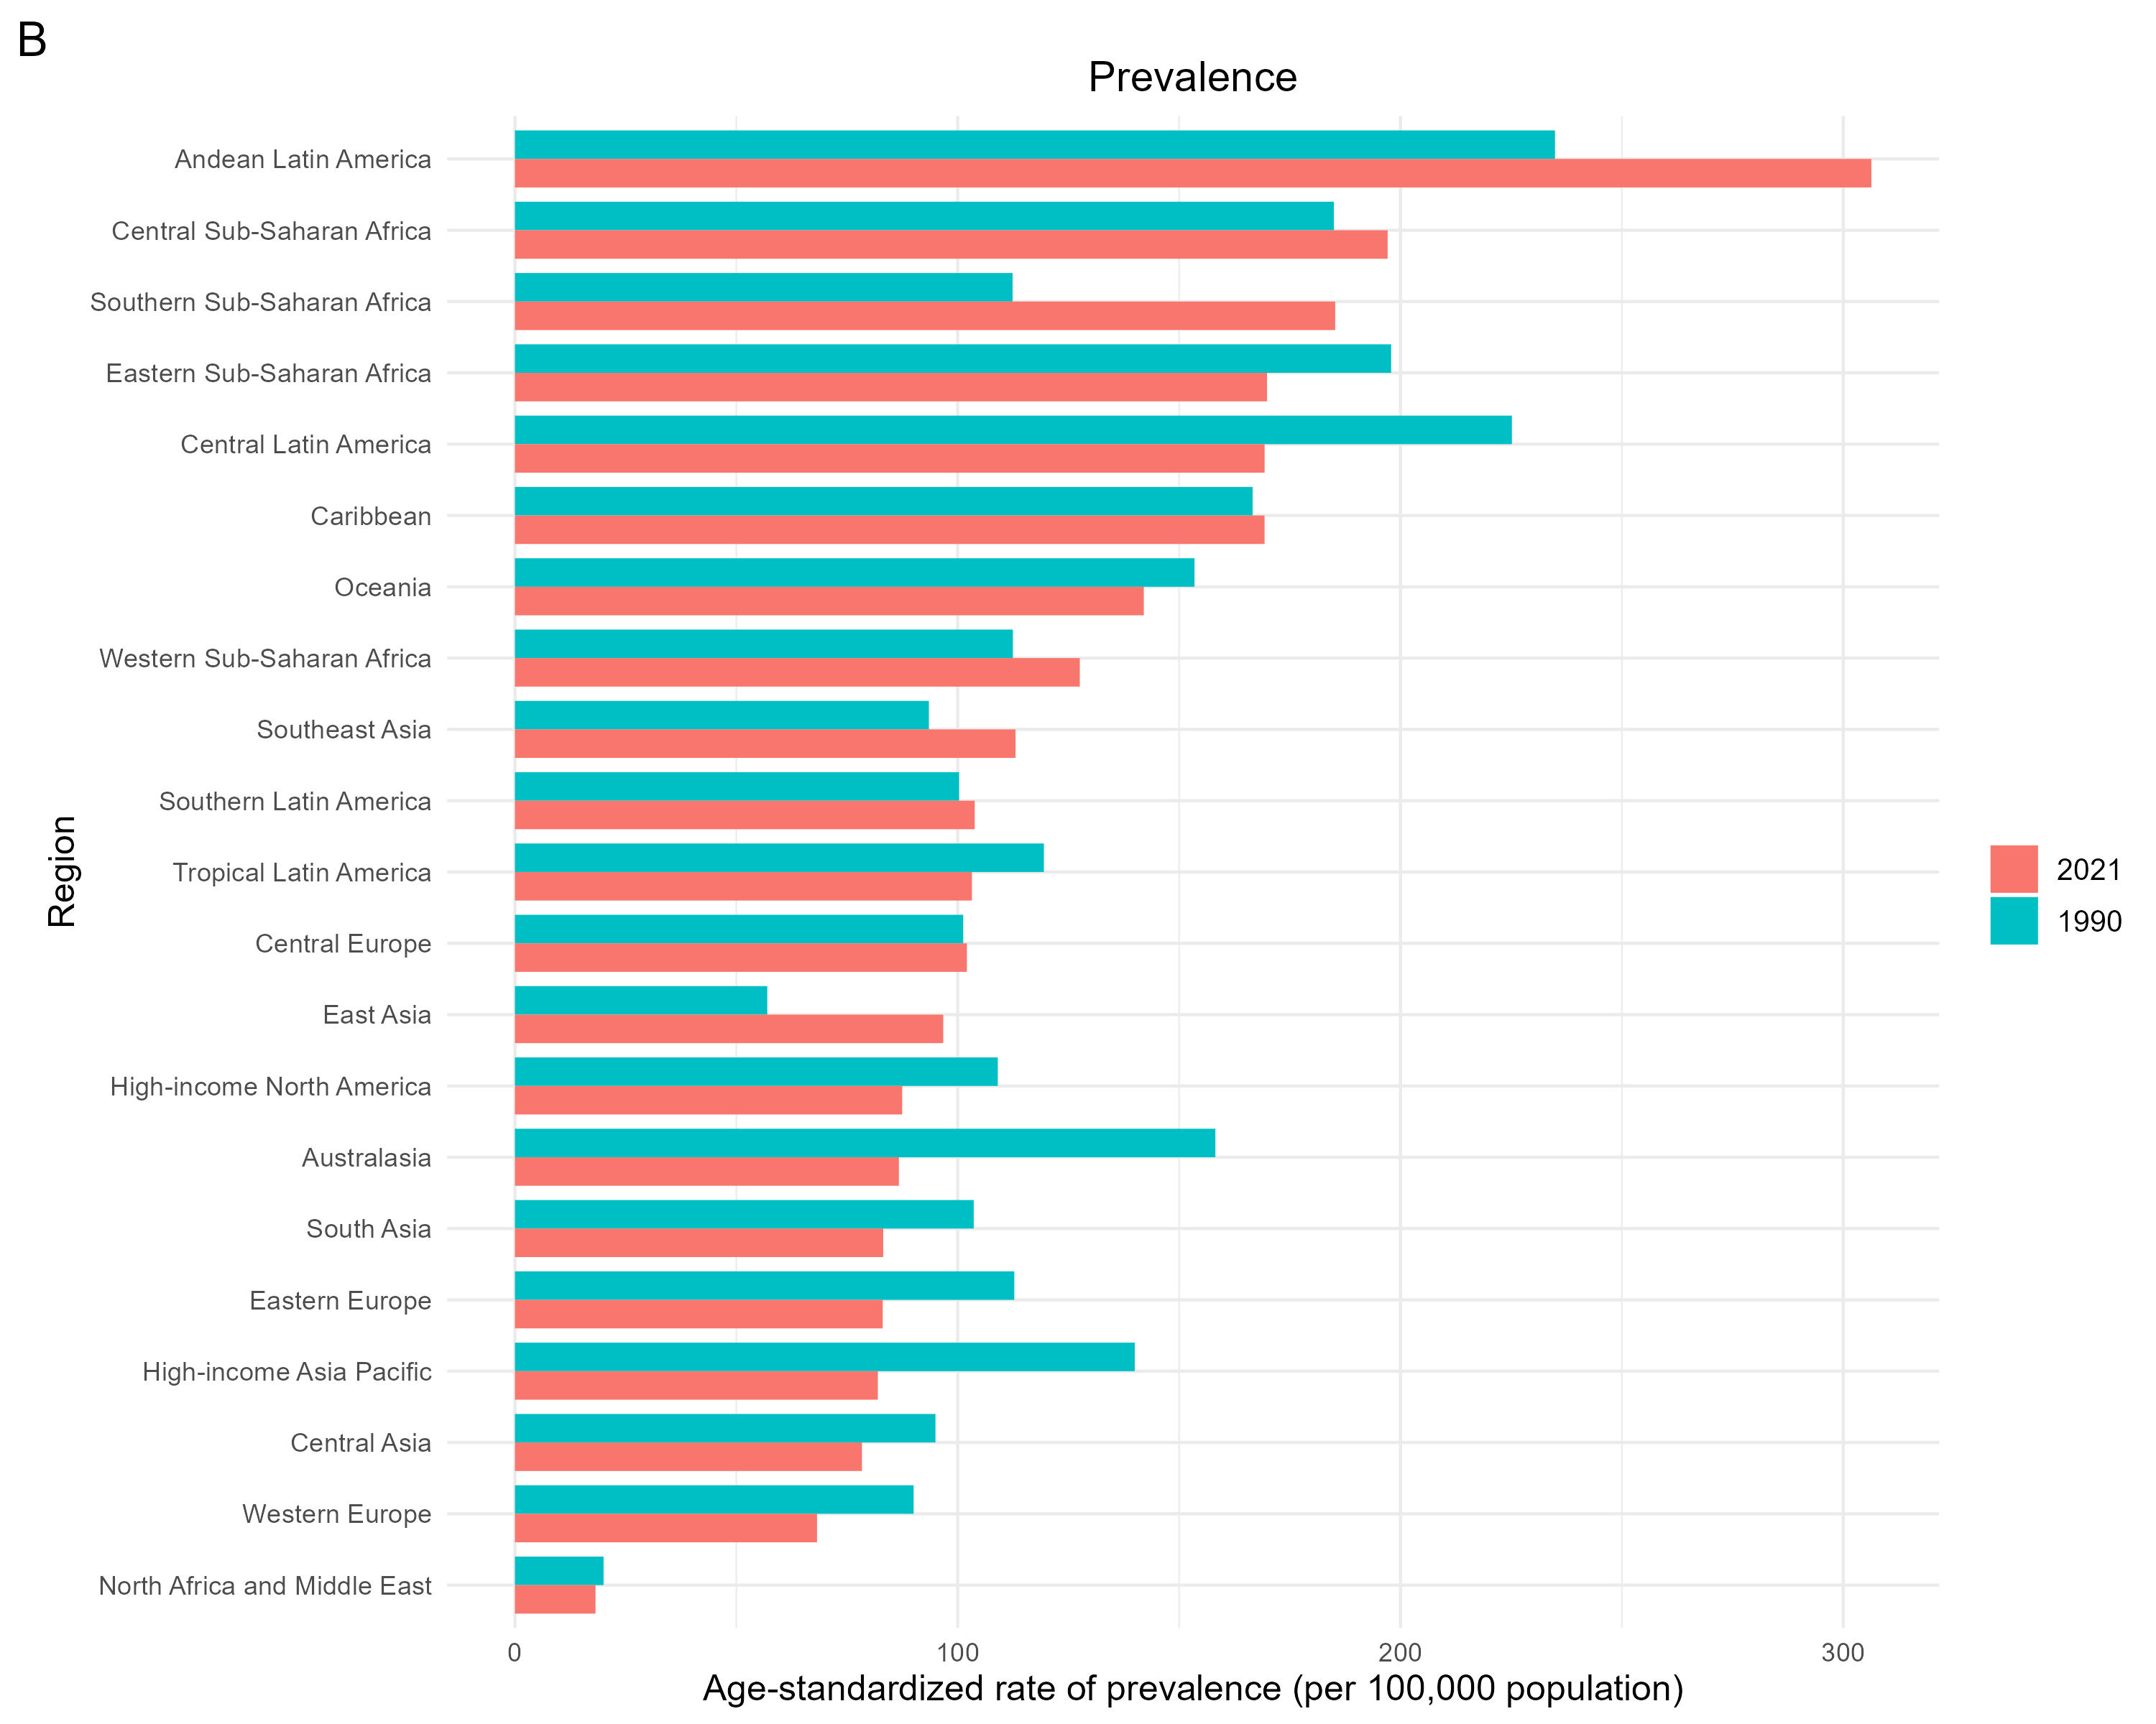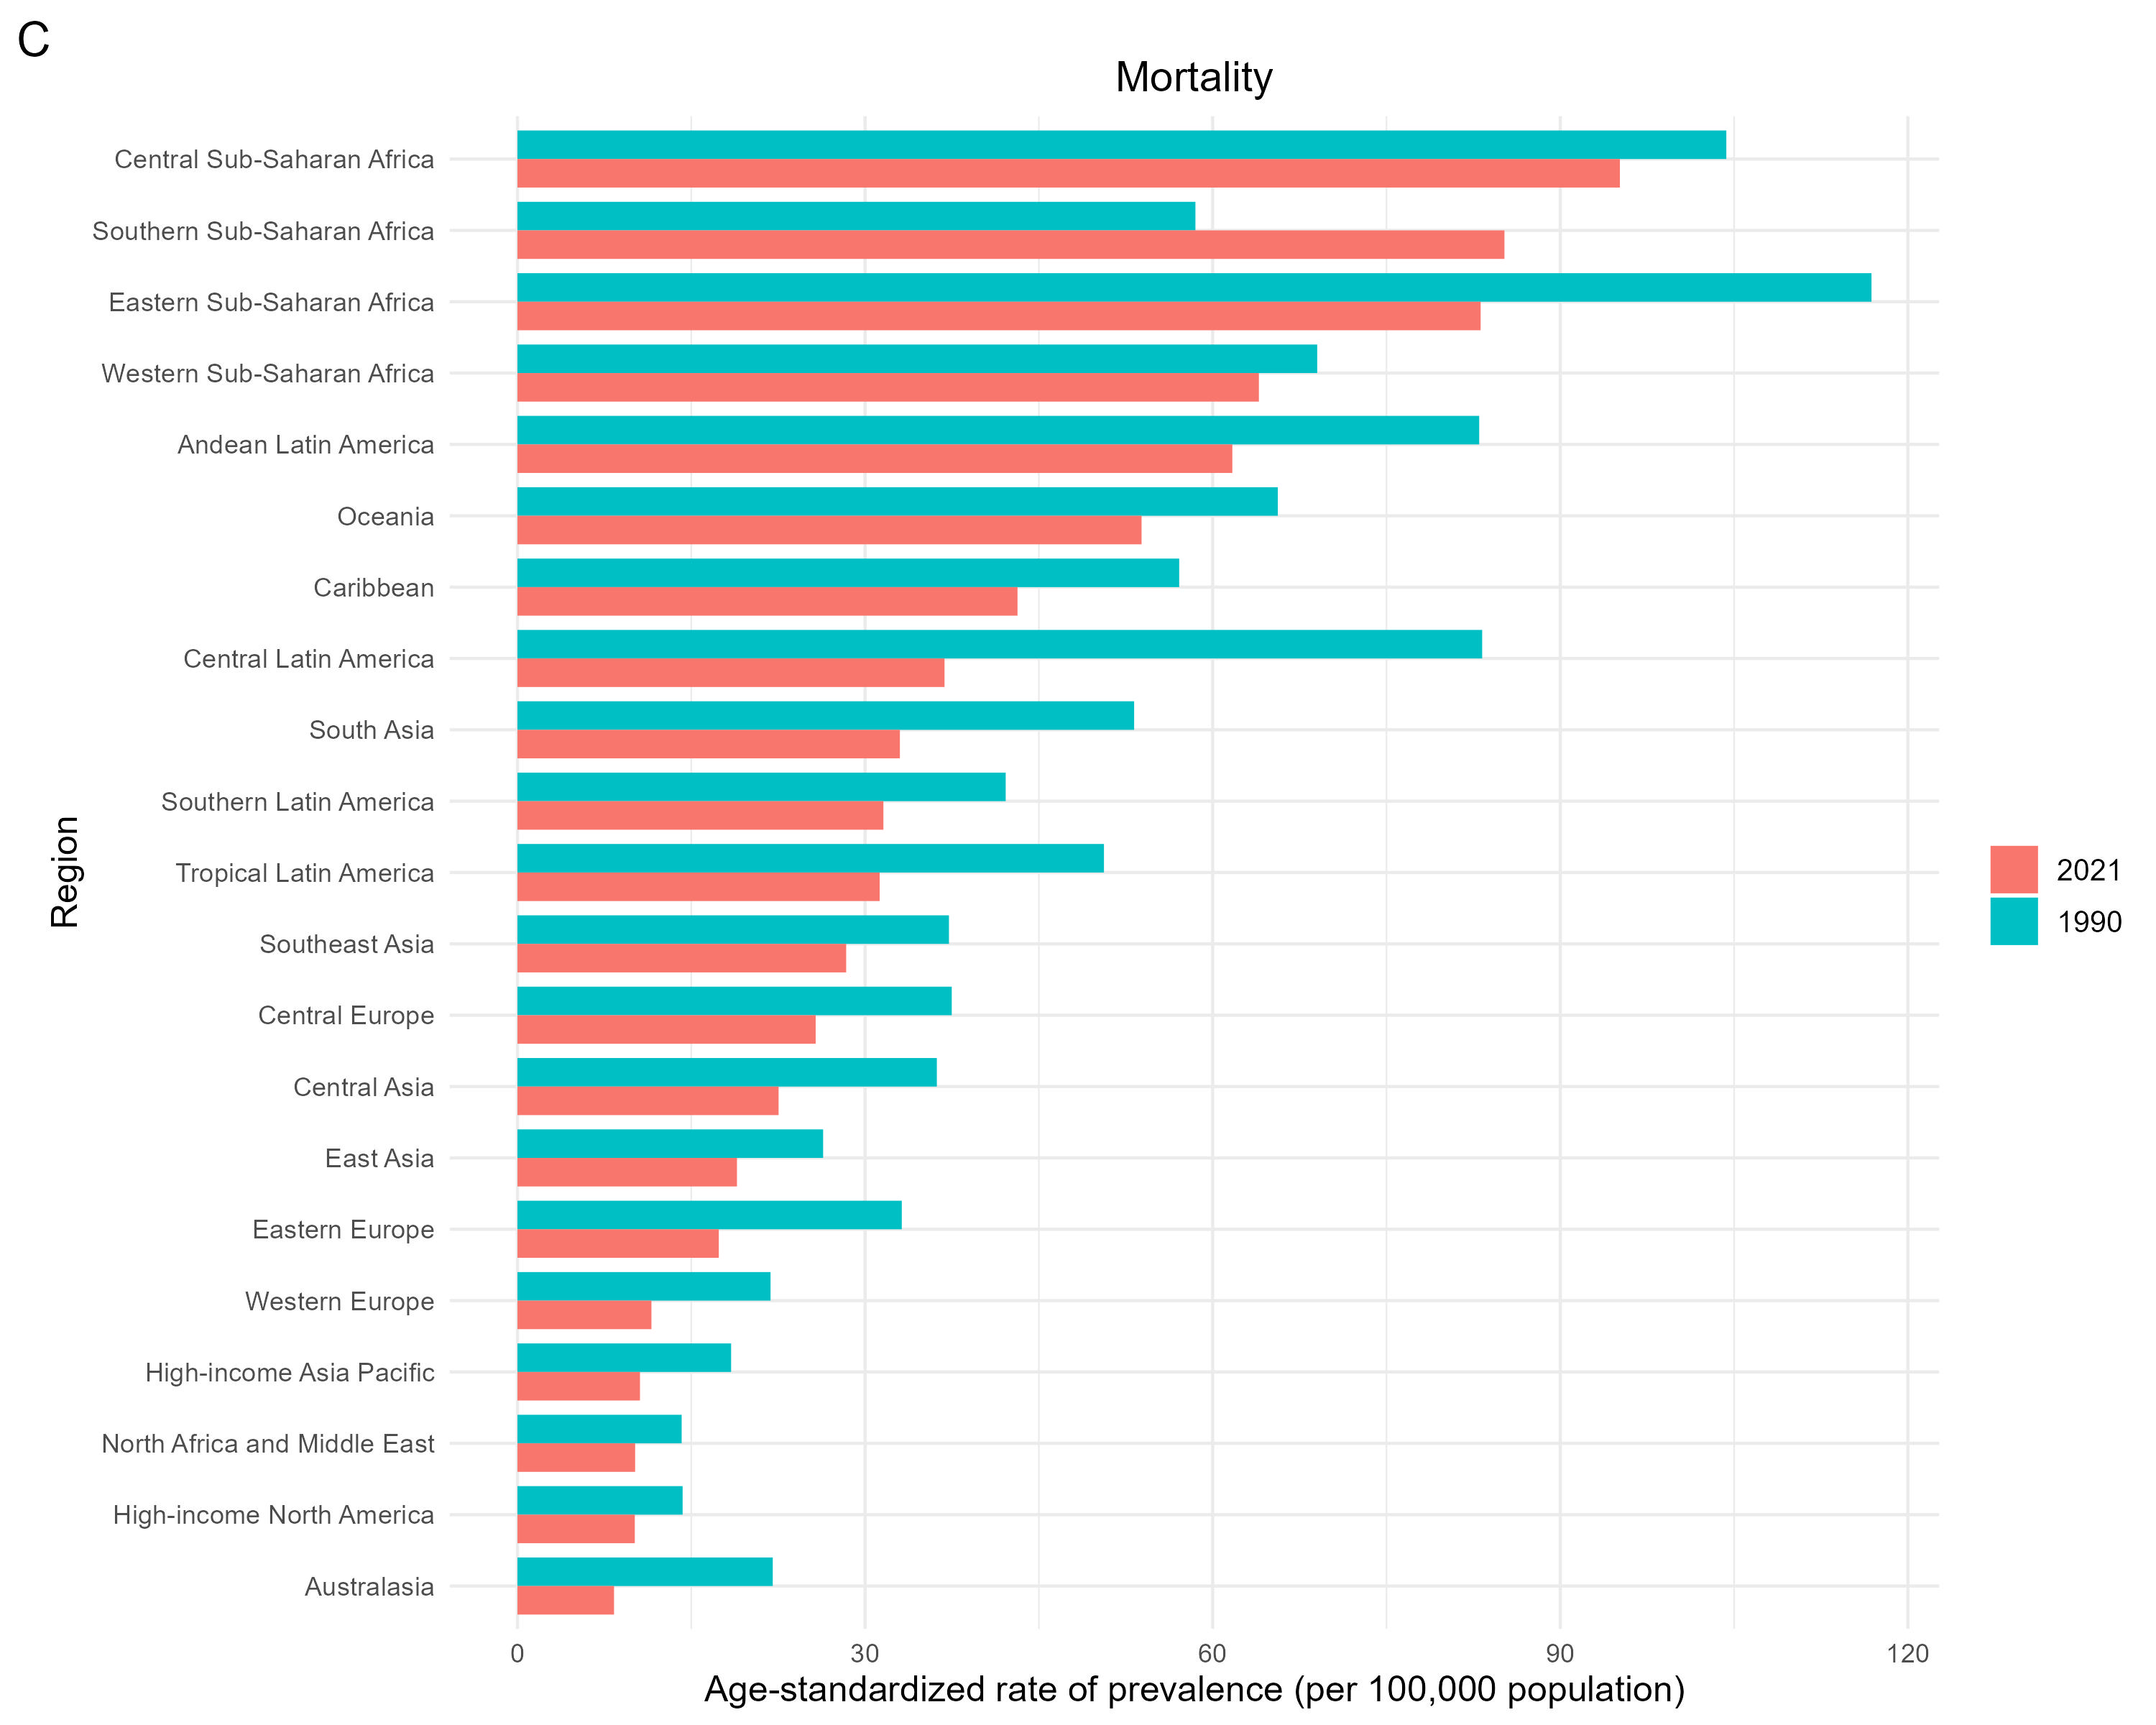

Supplementary Figure S7. Average annual percent changes of age-standardized rate of cervical cancer in elderly people aged over 60 years from 1990 to 2021 at region levels. (A) Age-standardized incidence rate. (B) Age-standardized prevalence rate. (C) Age-standardized mortality rate. The error bar represents the 95%CI. ASIR, age-standardized incidence rate; ASPR, age-standardized prevalence rate; ASMR, age-standardized mortality rate; CI, confidence interval.
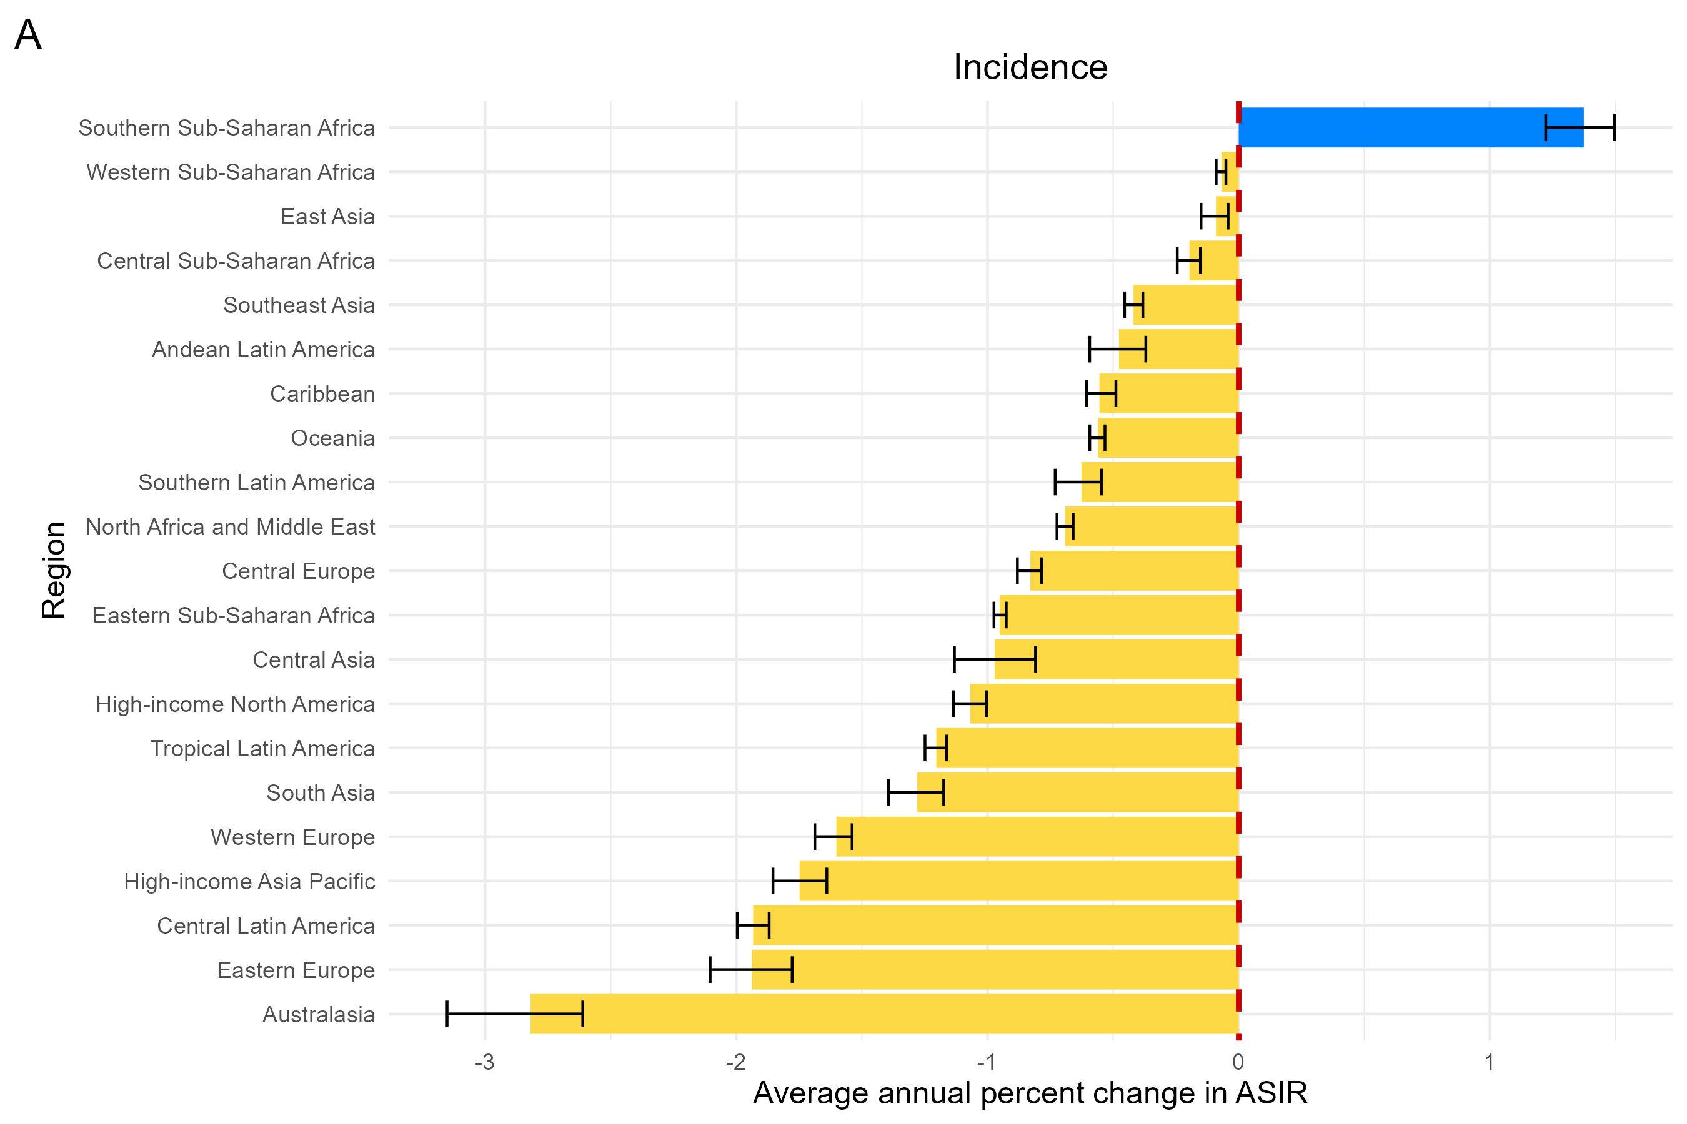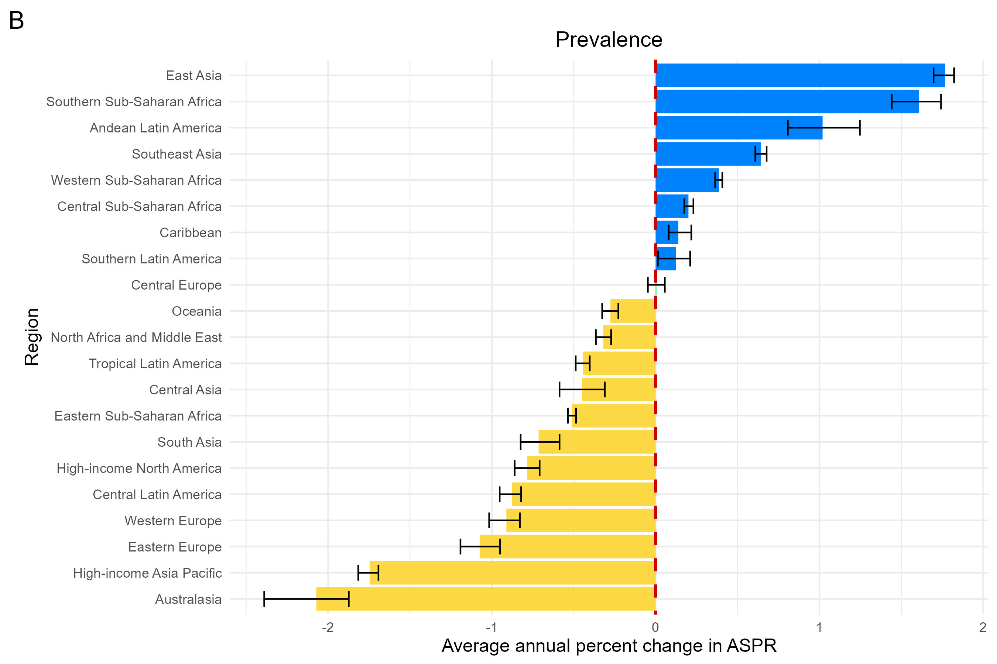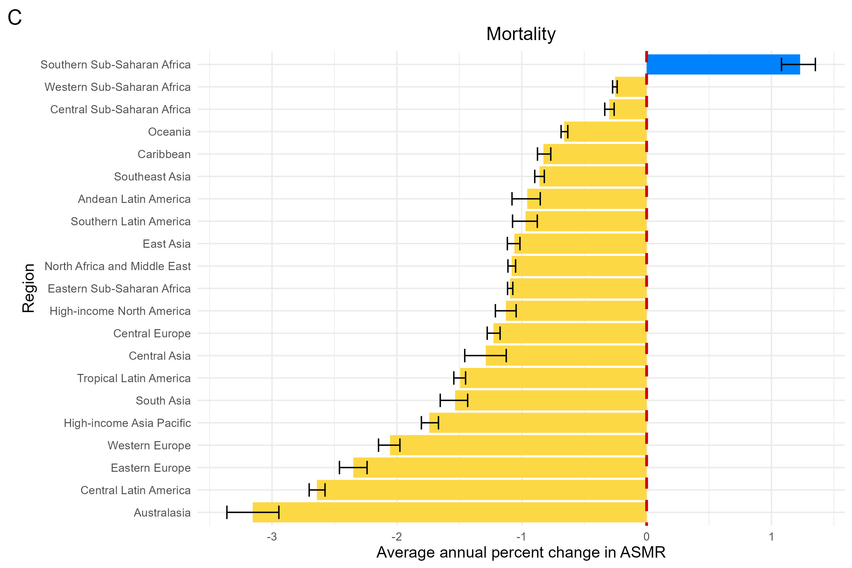

Supplementary Figure S8. Maps showing age-standardized rate of cervical cancer among people aged over 60 years in 2021. (A) Age-standardized incidence rate. (B) Age-standardized prevalence rate. (C) Age-standardized mortality rate. ASIR, age-standardized incidence rate; ASPR, age-standardized prevalence rate; ASMR, age-standardized mortality rate; CI, confidence interval.
Supplementary Table S1. Age standardized incidence and AAPC of cervical cancer in people aged over 60 years old at global and SDI region level, 1990-2021
 | Incidence (95% UI)
 | Cases in 1990 (000s) | Cases in 2021 (000s) | Age-standardized rate in 1990 (per100,000) | Age-standardized rate in 2021 (per100,000) | AAPCs in rate,1990-2021 (%/year) | P value
Global | 114.4 (105.3 to 123.4) | 198.1 (176.5 to 216.6) | 42.74 (39.34 to 46.1) | 33.84 (30.15 to 37) | -0.75 (-0.77 to -0.73) | <0.001
Age group
60-64 | 37.4 (34.7 to 40.5) | 61.4 (55.8 to 66.7) | 2.08 (1.92 to 2.24) | 2.07 (1.89 to 2.25) | -0.01 (-0.06 to 0.03) | 0.456
65-69 | 29.5 (27.4 to 31.7) | 51.9 (46.9 to 56.8) | 1.64 (1.52 to 1.76) | 1.75 (1.59 to 1.92) | 0.23 (0.17 to 0.28) | <0.001
70-74 | 20.2 (18.6 to 21.8) | 36.8 (33.2 to 40.1) | 1.12 (1.03 to 1.21) | 1.24 (1.12 to 1.36) | 0.34 (0.31 to 0.38) | <0.001
75-79 | 14.4 (13.3 to 15.4) | 22 (19.2 to 24) | 0.8 (0.74 to 0.85) | 0.74 (0.65 to 0.81) | -0.22 (-0.26 to -0.19) | <0.001
80-84 | 7.9 (7 to 8.6) | 14.4 (12.1 to 15.8) | 0.44 (0.39 to 0.48) | 0.49 (0.41 to 0.53) | 0.32 (0.26 to 0.37) | <0.001
85-89 | 3.7 (3.1 to 4) | 7.6 (6.1 to 8.5) | 0.2 (0.17 to 0.22) | 0.26 (0.21 to 0.29) | 0.77 (0.73 to 0.81) | <0.001
90-94 | 1 (0.9 to 1.2) | 3.1 (2.4 to 3.6) | 0.06 (0.05 to 0.06) | 0.11 (0.08 to 0.12) | 1.98 (1.91 to 2.04) | <0.001
95+ | 0.3 (0.2 to 0.3) | 1 (0.7 to 1.2) | 0.01 (0.01 to 0.02) | 0.03 (0.02 to 0.04) | 2.99 (2.9 to 3.06) | <0.001
SDI region
High SDI | 28.4 (26.1 to 29.9) | 29.6 (25.7 to 32.1) | 33.84 (31.17 to 35.64) | 20 (17.39 to 21.71) | -1.71 (-1.75 to -1.68) | <0.001
High-middle SDI | 25.8 (23.9 to 27.8) | 39.7 (33.9 to 45.7) | 35.15 (32.47 to 37.81) | 27.94 (23.89 to 32.2) | -0.71 (-0.81 to -0.63) | <0.001
Middle SDI | 29 (26.1 to 32) | 67.7 (58.7 to 76.6) | 45.97 (41.39 to 50.71) | 38.52 (33.43 to 43.62) | -0.55 (-0.57 to -0.54) | <0.001
Low-middle SDI | 19.2 (16 to 22.5) | 40.1 (35.2 to 44.9) | 55.81 (46.42 to 65.47) | 44.42 (39.08 to 49.8) | -0.72 (-0.78 to -0.67) | <0.001
Low SDI | 11.8 (9.7 to 14.7) | 20.9 (17.4 to 24.8) | 94.48 (77.81 to 117.4) | 71.76 (59.84 to 85.37) | -0.86 (-0.89 to -0.81) | <0.001
AAPC, average annual percent change; SDI, sociodemographic index; UI, uncertainty interval.

Supplementary Table S2. Age standardized prevalence and AAPC of cervical cancer in people aged over 60 years old at global and SDI region level, 1990-2021
 | Prevalence (95% UI)
 | Cases in 1990 (000s) | Cases in 2021 (000s) | Age-standardized rate in 1990 (per100,000) | Age-standardized rate in 2021 (per100,000) | AAPCs in rate,1990-2021 (%/year) | P value
Global | 261 (243.6 to 277.5) | 550.5 (492.3 to 607.1) | 97.52 (91.03 to 103.7) | 94.02 (84.09 to 103.69) | -0.11 (-0.14 to -0.09) | <0.001
Age group
60-64 | 115 (107.9 to 121.8) | 241.3 (218.8 to 264.6) | 6.38 (5.99 to 6.76) | 8.16 (7.4 to 8.94) | 0.82 (0.75 to 0.86) | <0.001
65-69 | 74.8 (70.3 to 79.6) | 163.5 (146.1 to 181.1) | 4.15 (3.9 to 4.42) | 5.53 (4.94 to 6.12) | 0.93 (0.9 to 0.97) | <0.001
70-74 | 38.2 (35.7 to 40.8) | 84.4 (75.7 to 93.4) | 2.12 (1.98 to 2.26) | 2.85 (2.56 to 3.16) | 0.97 (0.92 to 1.02) | <0.001
75-79 | 21.2 (19.6 to 22.6) | 36.8 (32 to 40.5) | 1.18 (1.09 to 1.25) | 1.24 (1.08 to 1.37) | 0.17 (0.13 to 0.21) | <0.001
80-84 | 8.4 (7.2 to 9) | 16.6 (13.6 to 18.6) | 0.46 (0.4 to 0.5) | 0.56 (0.46 to 0.63) | 0.62 (0.56 to 0.68) | <0.001
85-89 | 2.7 (2.3 to 3) | 5.5 (4.3 to 6.2) | 0.15 (0.13 to 0.16) | 0.19 (0.15 to 0.21) | 0.68 (0.63 to 0.71) | <0.001
90-94 | 0.6 (0.5 to 0.7) | 1.8 (1.4 to 2.1) | 0.03 (0.03 to 0.04) | 0.06 (0.05 to 0.07) | 2.07 (2.01 to 2.13) | <0.001
95+ | 0.1 (0.1 to 0.1) | 0.5 (0.4 to 0.6) | 0.01 (0.01 to 0.01) | 0.02 (0.01 to 0.02) | 3 (2.92 to 3.07) | <0.001
SDI region
High SDI | 91.3 (84.1 to 97.7) | 110.6 (97.9 to 120.9) | 108.97 (100.28 to 116.56) | 74.77 (66.22 to 81.73) | -1.22 (-1.27 to -1.18) | <0.001
High-middle SDI | 62 (56.7 to 67.8) | 126 (107.5 to 146.7) | 84.4 (77.13 to 92.21) | 88.7 (75.71 to 103.28) | 0.14 (0.04 to 0.21) | 0.014
Middle SDI | 55.6 (50.4 to 61.4) | 193.1 (166 to 223.3) | 88.11 (79.95 to 97.36) | 109.92 (94.49 to 127.1) | 0.75 (0.72 to 0.77) | <0.001
Low-middle SDI | 33.2 (27.7 to 38.7) | 83 (73.2 to 93.5) | 96.5 (80.35 to 112.3) | 92.04 (81.19 to 103.68) | -0.15 (-0.21 to -0.06) | 0.002
Low SDI | 18.5 (15.3 to 22.7) | 37.1 (30.7 to 44.4) | 147.75 (122.14 to 181.77) | 127.64 (105.6 to 152.42) | -0.44 (-0.48 to -0.4) | <0.001
AAPC, average annual percent change; SDI, sociodemographic index; UI, uncertainty interval.

Supplementary Table S3. Age standardized mortality and AAPC of cervical cancer in people aged over 60 years old at global and SDI region level, 1990-2021
 | Mortality (95% UI)
 | Cases in 1990 (000s) | Cases in 2021 (000s) | Age-standardized rate in 1990 (per100,000) | Age-standardized rate in 2021 (per100,000) | AAPCs in rate,1990-2021 (%/year) | P value
Global | 89.8 (82 to 97.8) | 139.8 (124.5 to 153) | 33.55 (30.62 to 36.54) | 23.87 (21.26 to 26.13) | -1.09 (-1.11 to -1.07) | <0.001
Age group
60-64 | 24.6 (22.4 to 26.9) | 33.8 (30.9 to 36.8) | 1.36 (1.25 to 1.49) | 1.14 (1.05 to 1.24) | -0.59 (-0.63 to -0.55) | <0.001
65-69 | 21.2 (19.6 to 23.2) | 32.3 (29.4 to 35.3) | 1.18 (1.09 to 1.29) | 1.09 (1 to 1.19) | -0.23 (-0.27 to -0.2) | <0.001
70-74 | 16.7 (15.4 to 18.3) | 27.3 (24.8 to 29.7) | 0.93 (0.85 to 1.02) | 0.92 (0.84 to 1) | -0.04 (-0.09 to 0) | 0.066
75-79 | 13.1 (12.1 to 14) | 18.5 (16.4 to 20.1) | 0.72 (0.67 to 0.78) | 0.62 (0.55 to 0.68) | -0.49 (-0.52 to -0.46) | <0.001
80-84 | 8.2 (7.3 to 8.9) | 14.2 (12.1 to 15.6) | 0.46 (0.41 to 0.49) | 0.48 (0.41 to 0.53) | 0.21 (0.17 to 0.26) | <0.001
85-89 | 4.3 (3.7 to 4.6) | 8.6 (7 to 9.6) | 0.24 (0.2 to 0.26) | 0.29 (0.24 to 0.33) | 0.68 (0.63 to 0.72) | <0.001
90-94 | 1.3 (1.1 to 1.5) | 3.8 (2.9 to 4.2) | 0.07 (0.06 to 0.08) | 0.13 (0.1 to 0.14) | 1.78 (1.72 to 1.84) | <0.001
95+ | 0.3 (0.3 to 0.4) | 1.3 (1 to 1.5) | 0.02 (0.01 to 0.02) | 0.05 (0.03 to 0.05) | 2.82 (2.74 to 2.89) | <0.001
SDI region
High SDI | 18.2 (16.6 to 19.2) | 17.2 (14.6 to 18.8) | 21.73 (19.84 to 22.96) | 11.6 (9.87 to 12.69) | -2.03 (-2.07 to -2) | <0.001
High-middle SDI | 19.8 (18.3 to 21.4) | 25.5 (21.7 to 29.3) | 27.01 (24.88 to 29.13) | 17.93 (15.29 to 20.61) | -1.32 (-1.35 to -1.28) | <0.001
Middle SDI | 23.9 (21.5 to 26.5) | 46.3 (40.3 to 52) | 37.91 (34.02 to 41.94) | 26.34 (22.94 to 29.59) | -1.15 (-1.18 to -1.14) | <0.001
Low-middle SDI | 16.9 (14 to 19.9) | 32.5 (28.5 to 36.5) | 49.09 (40.75 to 57.9) | 35.99 (31.57 to 40.48) | -0.98 (-1.05 to -0.93) | <0.001
Low SDI | 10.8 (8.9 to 13.4) | 18.2 (15.2 to 21.7) | 86.34 (70.96 to 107.26) | 62.64 (52.25 to 74.48) | -1.02 (-1.05 to -0.99) | <0.001
AAPC, average annual percent change; SDI, sociodemographic index; UI, uncertainty interval.

Supplementary Table S4. Age standardized incidence and AAPC of cervical cancer in elderly people from 1990 to 2021 at region level
 | Incidence (95% UI)
 | Cases in 1990 (000s) | Cases in 2021 (000s) | Age-standardized rate in 1990 (per100,000) | Age-standardized rate in 2021 (per100,000) | AAPCs in rate,1990-2021 (%/year) | P value
Andean Latin America | 1.2 (0.9 to 1.4) | 3.1 (2.3 to 4) | 94.09 (76.25 to 114.35) | 80.85 (60.03 to 106.09) | -0.48 (-0.59 to -0.37) | <0.001
Australasia | 0.7 (0.6 to 0.8) | 0.7 (0.5 to 0.8) | 40.06 (32.93 to 47.7) | 17.88 (13.71 to 22.68) | -2.82 (-3.15 to -2.61) | <0.001
Caribbean | 1.2 (1.1 to 1.4) | 2.2 (1.8 to 2.6) | 74.12 (63.98 to 86.27) | 60.74 (49.93 to 73.11) | -0.55 (-0.61 to -0.49) | <0.001
Central Asia | 1.6 (1.4 to 1.7) | 1.7 (1.5 to 2) | 44.56 (40.96 to 48.08) | 30.73 (26.89 to 35.08) | -0.97 (-1.13 to -0.81) | <0.001
Central Europe | 5.3 (4.9 to 5.7) | 6.2 (5.5 to 6.9) | 46.04 (42.45 to 49.55) | 35.89 (31.83 to 40.13) | -0.83 (-0.88 to -0.78) | <0.001
Central Latin America | 5.7 (5.4 to 6) | 10.5 (9.1 to 12) | 113.81 (106.95 to 119.86) | 62.46 (53.9 to 71.32) | -1.93 (-2 to -1.87) | <0.001
Central Sub-Saharan Africa | 1.5 (1 to 2.2) | 3.5 (2.3 to 5.2) | 114.87 (77.64 to 165.86) | 108.47 (70.77 to 160.08) | -0.2 (-0.24 to -0.15) | <0.001
East Asia | 17.1 (14.1 to 20.7) | 44.5 (33.3 to 57) | 31.54 (25.89 to 38.03) | 30.6 (22.85 to 39.14) | -0.09 (-0.15 to -0.04) | 0.001
Eastern Europe | 11 (10.2 to 12) | 8.1 (7.2 to 9) | 44.38 (40.88 to 48.14) | 26.4 (23.58 to 29.48) | -1.94 (-2.1 to -1.78) | <0.001
Eastern Sub-Saharan Africa | 5.3 (4.2 to 6.7) | 9.3 (7.4 to 11.5) | 127.37 (100.6 to 160.69) | 94.88 (76.1 to 117.15) | -0.95 (-0.97 to -0.93) | <0.001
High-income Asia Pacific | 5 (4.4 to 5.5) | 6.3 (5 to 7.4) | 34.25 (30.24 to 37.66) | 19.75 (15.59 to 23.21) | -1.75 (-1.85 to -1.64) | <0.001
High-income North America | 7.8 (7.1 to 8.3) | 10.2 (9.1 to 11) | 29.28 (26.73 to 31.05) | 21.38 (19.11 to 23.05) | -1.07 (-1.14 to -1) | <0.001
North Africa and Middle East | 1.5 (1.2 to 1.9) | 3.3 (2.7 to 3.9) | 15.55 (12.89 to 19.64) | 12.6 (10.34 to 15.02) | -0.69 (-0.72 to -0.66) | <0.001
Oceania | 0.1 (0.1 to 0.2) | 0.3 (0.2 to 0.4) | 81.06 (59.35 to 116.3) | 68.27 (50.01 to 96.9) | -0.56 (-0.59 to -0.53) | <0.001
South Asia | 18.6 (14.5 to 22.4) | 37.1 (31.9 to 42.8) | 60.31 (47.07 to 72.78) | 40.48 (34.74 to 46.65) | -1.28 (-1.39 to -1.17) | <0.001
Southeast Asia | 6.9 (5.7 to 8.3) | 16.8 (13.9 to 20.3) | 44.25 (36.69 to 53.27) | 38.81 (31.95 to 46.82) | -0.42 (-0.45 to -0.38) | <0.001
Southern Latin America | 1.7 (1.4 to 1.9) | 2.6 (2.1 to 3.1) | 49.94 (42.76 to 57.94) | 41.18 (33.63 to 49.29) | -0.63 (-0.73 to -0.55) | <0.001
Southern Sub-Saharan Africa | 1.2 (1 to 1.6) | 4.1 (3.5 to 4.8) | 65.22 (52.2 to 86.22) | 99.51 (85.04 to 115.8) | 1.37 (1.22 to 1.5) | <0.001
Tropical Latin America | 3.5 (3.2 to 3.8) | 7.4 (6.5 to 8.1) | 60.11 (54.97 to 64.87) | 40.87 (36.24 to 44.75) | -1.2 (-1.25 to -1.16) | <0.001
Western Europe | 13.7 (12.4 to 14.7) | 11.9 (10.1 to 13.3) | 30.59 (27.72 to 32.97) | 18.48 (15.68 to 20.65) | -1.6 (-1.69 to -1.54) | <0.001
Western Sub-Saharan Africa | 3.8 (3.1 to 4.5) | 8.3 (6.7 to 10.2) | 74.25 (60.54 to 88.95) | 73.06 (58.36 to 89) | -0.07 (-0.09 to -0.05) | <0.001
AAPC, average annual percent change; UI, uncertainty interval.

Supplementary Table S5. Age standardized prevalence and AAPC of cervical cancer in elderly people from 1990 to 2021 at region level
 | Prevalence (95% UI)
location | Cases in 1990 (000s) | Cases in 2021 (000s) | Age-standardized rate in 1990 (per100,000) | Age-standardized rate in 2021 (per100,000) | AAPCs in rate,1990-2021 (%/year) | P value
Andean Latin America | 2.9 (2.2 to 3.7) | 11.6 (8.2 to 16) | 234.89 (179.34 to 297.58) | 306.35 (217.66 to 421.98) | 1.02 (0.81 to 1.25) | <0.001
Australasia | 2.7 (2.2 to 3.3) | 3.2 (2.4 to 4.2) | 158.19 (127.36 to 191.3) | 86.71 (64.21 to 114.03) | -2.07 (-2.39 to -1.87) | <0.001
Caribbean | 2.8 (2.3 to 3.3) | 6.1 (4.9 to 7.5) | 166.61 (140.57 to 197.77) | 169.3 (136.17 to 207.64) | 0.14 (0.08 to 0.22) | 0.001
Central Asia | 3.4 (3 to 3.8) | 4.5 (3.8 to 5.3) | 94.98 (83.63 to 108.6) | 78.38 (66.15 to 93.01) | -0.45 (-0.59 to -0.31) | <0.001
Central Europe | 11.6 (10.4 to 12.9) | 17.6 (15 to 20.4) | 101.25 (90.58 to 112.45) | 102.07 (87.11 to 118.66) | 0.01 (-0.05 to 0.06) | 0.811
Central Latin America | 11.3 (10.4 to 12.2) | 28.5 (24.1 to 33.5) | 225.16 (208.19 to 243.37) | 169.31 (143.06 to 198.68) | -0.88 (-0.95 to -0.82) | <0.001
Central Sub-Saharan Africa | 2.5 (1.6 to 3.6) | 6.4 (4.1 to 9.6) | 184.96 (123.73 to 267.68) | 197.1 (125.08 to 294) | 0.2 (0.18 to 0.23) | <0.001
East Asia | 30.9 (25.7 to 37.1) | 140.8 (104.8 to 183) | 56.99 (47.35 to 68.33) | 96.73 (71.97 to 125.73) | 1.77 (1.7 to 1.82) | <0.001
Eastern Europe | 28 (24.6 to 32.4) | 25.4 (22.3 to 29) | 112.78 (99.17 to 130.43) | 83.07 (72.96 to 94.91) | -1.07 (-1.19 to -0.95) | <0.001
Eastern Sub-Saharan Africa | 8.3 (6.5 to 10.4) | 16.6 (13.2 to 20.5) | 197.89 (156.27 to 248.56) | 169.86 (135.31 to 210.08) | -0.51 (-0.54 to -0.49) | <0.001
High-income Asia Pacific | 20.5 (17.9 to 23.3) | 26.2 (19.9 to 32.1) | 139.99 (121.7 to 159) | 81.96 (62.47 to 100.52) | -1.75 (-1.82 to -1.69) | <0.001
High-income North America | 29.2 (26.8 to 31.3) | 41.8 (37.7 to 45.6) | 109.05 (100.14 to 117.16) | 87.46 (78.9 to 95.38) | -0.78 (-0.86 to -0.71) | <0.001
North Africa and Middle East | 1.9 (1.6 to 2.4) | 4.8 (3.9 to 5.7) | 20.02 (16.68 to 25.01) | 18.2 (14.79 to 21.79) | -0.32 (-0.36 to -0.27) | <0.001
Oceania | 0.2 (0.2 to 0.3) | 0.5 (0.4 to 0.8) | 153.48 (111.15 to 220.25) | 142.03 (103.08 to 199.54) | -0.28 (-0.33 to -0.23) | <0.001
South Asia | 31.9 (25.1 to 38.3) | 76.3 (65.1 to 88.6) | 103.62 (81.42 to 124.42) | 83.18 (70.97 to 96.59) | -0.71 (-0.82 to -0.59) | <0.001
Southeast Asia | 14.6 (12.1 to 17.9) | 49.1 (39.2 to 60.7) | 93.49 (76.97 to 114.22) | 113.06 (90.31 to 139.91) | 0.64 (0.61 to 0.68) | <0.001
Southern Latin America | 3.3 (2.7 to 4.1) | 6.6 (5.1 to 8.3) | 100.31 (81.67 to 124.35) | 103.84 (80.35 to 131.4) | 0.12 (0.01 to 0.21) | 0.03
Southern Sub-Saharan Africa | 2.1 (1.6 to 2.7) | 7.6 (6.4 to 8.9) | 112.4 (89.34 to 148.84) | 185.25 (156.53 to 216.47) | 1.61 (1.44 to 1.74) | <0.001
Tropical Latin America | 6.9 (6.2 to 7.6) | 18.6 (16.5 to 20.7) | 119.46 (107.34 to 131.96) | 103.21 (91.64 to 115.18) | -0.44 (-0.49 to -0.4) | <0.001
Western Europe | 40.3 (35.7 to 45.2) | 43.9 (37.5 to 49.8) | 90.05 (79.8 to 101.03) | 68.23 (58.29 to 77.49) | -0.91 (-1.02 to -0.83) | <0.001
Western Sub-Saharan Africa | 5.7 (4.6 to 6.9) | 14.6 (11.5 to 17.9) | 112.46 (91.37 to 135.55) | 127.57 (100.97 to 156.64) | 0.39 (0.36 to 0.41) | <0.001
AAPC, average annual percent change; UI, uncertainty interval.

Supplementary Table S6. Age standardized mortality and AAPC of cervical cancer in elderly people from 1990 to 2021 at region level
 | Mortality (95% UI)
location | Cases in 1990 (000s) | Cases in 2021 (000s) | Age-standardized rate in 1990 (per100,000) | Age-standardized rate in 2021 (per100,000) | AAPCs in rate,1990-2021 (%/year) | P value
Andean Latin America | 1 (0.8 to 1.2) | 2.3 (1.7 to 3.1) | 83 (67.21 to 100.31) | 61.7 (45.42 to 81.17) | -0.96 (-1.08 to -0.85) | <0.001
Australasia | 0.4 (0.3 to 0.4) | 0.3 (0.2 to 0.4) | 22.03 (18.28 to 25.97) | 8.33 (6.39 to 10.37) | -3.15 (-3.36 to -2.95) | <0.001
Caribbean | 0.9 (0.8 to 1.1) | 1.6 (1.3 to 1.9) | 57.11 (48.9 to 68.04) | 43.16 (35.23 to 52.41) | -0.83 (-0.87 to -0.77) | <0.001
Central Asia | 1.3 (1.2 to 1.4) | 1.3 (1.1 to 1.5) | 36.2 (33.39 to 38.98) | 22.54 (19.77 to 25.74) | -1.29 (-1.46 to -1.12) | <0.001
Central Europe | 4.3 (4 to 4.6) | 4.4 (3.9 to 4.9) | 37.48 (34.68 to 40.31) | 25.74 (22.9 to 28.61) | -1.23 (-1.28 to -1.17) | <0.001
Central Latin America | 4.2 (3.9 to 4.4) | 6.2 (5.3 to 7.1) | 83.26 (78.37 to 87.51) | 36.86 (31.71 to 41.94) | -2.64 (-2.7 to -2.58) | <0.001
Central Sub-Saharan Africa | 1.4 (0.9 to 2) | 3.1 (2 to 4.6) | 104.33 (70.63 to 150.27) | 95.14 (61.97 to 140.76) | -0.3 (-0.34 to -0.26) | <0.001
East Asia | 14.3 (11.8 to 17.3) | 27.6 (20.7 to 35.2) | 26.38 (21.74 to 31.82) | 18.94 (14.24 to 24.15) | -1.06 (-1.12 to -1.01) | <0.001
Eastern Europe | 8.2 (7.6 to 8.9) | 5.3 (4.7 to 5.9) | 33.17 (30.72 to 35.77) | 17.38 (15.48 to 19.39) | -2.35 (-2.46 to -2.24) | <0.001
Eastern Sub-Saharan Africa | 4.9 (3.8 to 6.2) | 8.1 (6.6 to 10) | 116.86 (91.96 to 147.55) | 83.13 (67.02 to 102.42) | -1.09 (-1.11 to -1.07) | <0.001
High-income Asia Pacific | 2.7 (2.4 to 2.9) | 3.4 (2.6 to 3.9) | 18.44 (16.41 to 20.07) | 10.57 (8.16 to 12.31) | -1.74 (-1.8 to -1.67) | <0.001
High-income North America | 3.8 (3.4 to 4.1) | 4.8 (4.2 to 5.2) | 14.25 (12.83 to 15.15) | 10.13 (8.89 to 10.97) | -1.13 (-1.21 to -1.04) | <0.001
North Africa and Middle East | 1.4 (1.1 to 1.7) | 2.7 (2.2 to 3.2) | 14.17 (11.71 to 18.03) | 10.16 (8.31 to 12.12) | -1.08 (-1.11 to -1.05) | <0.001
Oceania | 0.1 (0.1 to 0.1) | 0.2 (0.2 to 0.3) | 65.62 (47.93 to 95.24) | 53.86 (39.26 to 76.81) | -0.66 (-0.69 to -0.63) | <0.001
South Asia | 16.4 (12.8 to 19.9) | 30.3 (26 to 35) | 53.22 (41.49 to 64.47) | 33.01 (28.31 to 38.2) | -1.53 (-1.65 to -1.43) | <0.001
Southeast Asia | 5.8 (4.8 to 7) | 12.3 (10.2 to 14.8) | 37.24 (30.63 to 44.72) | 28.37 (23.43 to 34.11) | -0.86 (-0.9 to -0.82) | <0.001
Southern Latin America | 1.4 (1.2 to 1.6) | 2 (1.6 to 2.4) | 42.14 (36.16 to 48.86) | 31.58 (25.71 to 37.62) | -0.97 (-1.07 to -0.88) | <0.001
Southern Sub-Saharan Africa | 1.1 (0.9 to 1.4) | 3.5 (3 to 4.1) | 58.51 (46.52 to 77.95) | 85.18 (72.63 to 99.22) | 1.23 (1.08 to 1.35) | <0.001
Tropical Latin America | 2.9 (2.7 to 3.2) | 5.6 (4.9 to 6.2) | 50.62 (46.06 to 54.8) | 31.26 (27.5 to 34.28) | -1.49 (-1.54 to -1.45) | <0.001
Western Europe | 9.8 (8.8 to 10.6) | 7.4 (6.2 to 8.3) | 21.84 (19.6 to 23.64) | 11.56 (9.59 to 12.97) | -2.06 (-2.15 to -1.98) | <0.001
Western Sub-Saharan Africa | 3.5 (2.9 to 4.2) | 7.3 (5.9 to 8.8) | 69.02 (56.68 to 82.77) | 63.99 (51.56 to 77.39) | -0.25 (-0.27 to -0.24) | <0.001
AAPC, average annual percent change; UI, uncertainty interval.

Supplementary Table S7. Age standardized incidence and AAPC of cervical cancer in people aged over 60 years old between 1990-2021 in 204 countries and territories.
 | Incidence (95% UI)
 | Cases in 1990 | Cases in 2021 | Age-standardized rate in 1990 (per100,000) | Age-standardized rate in 2021 (per100,000) | AAPCs in rate,1990-2021 (%/year) | P value
Afghanistan | 150.3 (78.9 to 260.6) | 146.9 (77.9 to 234) | 38.91 (20.41 to 67.45) | 32.36 (17.16 to 51.55) | -0.57 (-0.6 to -0.54) | <0.001
Albania | 23.6 (16.7 to 33.1) | 46.7 (29.3 to 69.5) | 18.31 (12.93 to 25.66) | 15.01 (9.41 to 22.35) | -0.75 (-0.94 to -0.59) | <0.001
Algeria | 174.5 (113.2 to 261.4) | 334 (209.7 to 502) | 23.11 (14.99 to 34.62) | 16.04 (10.07 to 24.11) | -1.25 (-1.31 to -1.15) | <0.001
American Samoa | 0.6 (0.4 to 0.9) | 1.4 (0.9 to 2.2) | 50.37 (32.59 to 74.14) | 50.45 (32.22 to 76.1) | 0.07 (0.01 to 0.14) | 0.032
Andorra | 0.5 (0.3 to 0.8) | 0.9 (0.5 to 1.4) | 12.84 (7.4 to 20.86) | 9.01 (5.32 to 14.37) | -1.19 (-1.39 to -1.01) | <0.001
Angola | 228.3 (138.5 to 357.1) | 675.8 (394.7 to 1097.9) | 111.08 (67.37 to 173.76) | 97.47 (56.93 to 158.34) | -0.39 (-0.44 to -0.34) | <0.001
Antigua and Barbuda | 2.6 (2.1 to 3.1) | 5 (4.2 to 6) | 65.16 (53.87 to 78.24) | 71.52 (59.47 to 85.51) | 0.1 (-0.36 to 0.45) | 0.466
Argentina | 967.8 (779 to 1193) | 1761.6 (1369 to 2215.8) | 41.13 (33.11 to 50.7) | 43.4 (33.73 to 54.59) | 0.15 (0 to 0.28) | 0.043
Armenia | 87.1 (78.1 to 96.8) | 104.1 (88.2 to 122.5) | 44.12 (39.56 to 49.03) | 29.75 (25.21 to 35) | -1.46 (-1.73 to -1.24) | <0.001
Australia | 587.4 (470.9 to 713.4) | 596.8 (448.3 to 771.5) | 41.21 (33.04 to 50.05) | 19.29 (14.49 to 24.93) | -2.46 (-2.69 to -2.21) | <0.001
Austria | 361.6 (293.2 to 440.1) | 229.3 (173.7 to 291.7) | 37.05 (30.04 to 45.09) | 18.19 (13.78 to 23.14) | -2.33 (-2.5 to -2.15) | <0.001
Azerbaijan | 103.3 (81.1 to 130.8) | 156.1 (113.4 to 205.1) | 29.13 (22.86 to 36.88) | 22.17 (16.1 to 29.13) | -0.84 (-0.92 to -0.72) | <0.001
Bahamas | 7.3 (6 to 8.7) | 15 (11.7 to 19.1) | 72.57 (59.88 to 86.82) | 54.86 (42.59 to 69.68) | -0.82 (-1.07 to -0.61) | <0.001
Bahrain | 2.2 (1.5 to 3.2) | 6.2 (4 to 9.3) | 26.78 (17.51 to 39.06) | 14.98 (9.68 to 22.27) | -1.85 (-1.95 to -1.75) | <0.001
Bangladesh | 1326.7 (769.2 to 2103.8) | 2831.2 (1666.7 to 4435.1) | 56.68 (32.86 to 89.88) | 35.15 (20.7 to 55.07) | -1.41 (-1.52 to -1.28) | <0.001
Barbados | 23.8 (19.9 to 28) | 34.1 (25 to 44.2) | 106.16 (88.84 to 124.94) | 89.22 (65.31 to 115.63) | -0.55 (-0.7 to -0.41) | <0.001
Belarus | 476.3 (385 to 581.9) | 293.8 (216.2 to 387.6) | 42.39 (34.27 to 51.79) | 21.04 (15.49 to 27.76) | -2.8 (-3.43 to -2.3) | <0.001
Belgium | 322.2 (253.8 to 402.6) | 283.6 (210.3 to 363.9) | 27.1 (21.35 to 33.86) | 17.48 (12.96 to 22.43) | -1.27 (-1.44 to -1.06) | <0.001
Belize | 5.3 (4.4 to 6.3) | 16.7 (13.4 to 20.4) | 92.33 (76.93 to 109.4) | 98.94 (79.65 to 120.85) | 0.29 (0.04 to 0.59) | 0.029
Benin | 100.9 (65.6 to 150.1) | 243.4 (149.4 to 364.8) | 83.98 (54.57 to 124.94) | 79.72 (48.94 to 119.48) | -0.14 (-0.18 to -0.11) | <0.001
Bermuda | 2.4 (1.9 to 3.1) | 2.8 (2 to 3.8) | 53.35 (41.26 to 68.02) | 27.24 (19.45 to 37.9) | -2.08 (-2.24 to -1.92) | <0.001
Bhutan | 9 (5 to 14.3) | 15.4 (8.7 to 24.7) | 68.06 (37.26 to 107.32) | 42.81 (24.07 to 68.68) | -1.47 (-1.49 to -1.44) | <0.001
Bolivia (Plurinational State of) | 327.6 (202.3 to 482.4) | 709.6 (420 to 1085.8) | 164.56 (101.65 to 242.32) | 119.48 (70.72 to 182.81) | -1.03 (-1.05 to -1) | <0.001
Bosnia and Herzegovina | 98.8 (75 to 127.6) | 133.9 (93.8 to 184.4) | 34.74 (26.39 to 44.87) | 28.11 (19.7 to 38.72) | -0.68 (-0.8 to -0.57) | <0.001
Botswana | 39.8 (23.1 to 62.3) | 87.1 (52.5 to 140.6) | 108.63 (63.01 to 170.22) | 90.47 (54.52 to 146) | -0.75 (-0.92 to -0.6) | <0.001
Brazil | 3373.7 (3079.4 to 3645.7) | 7040.6 (6235.4 to 7710) | 59.7 (54.49 to 64.51) | 39.97 (35.4 to 43.78) | -1.25 (-1.3 to -1.21) | <0.001
Brunei Darussalam | 3.7 (2.4 to 5.5) | 9.3 (6.2 to 13.4) | 72.4 (47.43 to 106.11) | 44.86 (29.95 to 64.74) | -1.57 (-1.7 to -1.47) | <0.001
Bulgaria | 355.8 (291.9 to 429) | 443 (347 to 554.2) | 38.74 (31.78 to 46.72) | 39.29 (30.77 to 49.14) | -0.03 (-0.15 to 0.08) | 0.512
Burkina Faso | 275.1 (177.2 to 410.6) | 503 (307.8 to 756.8) | 104.74 (67.48 to 156.36) | 91.21 (55.8 to 137.22) | -0.46 (-0.51 to -0.42) | <0.001
Burundi | 208.3 (127.7 to 315.8) | 255.2 (155 to 400.5) | 142.65 (87.48 to 216.29) | 100.23 (60.86 to 157.33) | -1.14 (-1.18 to -1.11) | <0.001
Cabo Verde | 16.4 (10.7 to 23.8) | 24.5 (15.3 to 36.5) | 99.31 (64.62 to 143.86) | 77.31 (48.21 to 115.18) | -0.82 (-0.87 to -0.77) | <0.001
Cambodia | 168.7 (105.4 to 260.5) | 386.5 (236.2 to 597.6) | 57.66 (36.03 to 89.05) | 43.54 (26.61 to 67.32) | -0.9 (-0.91 to -0.89) | <0.001
Cameroon | 253.2 (165.1 to 371) | 675 (391.6 to 1059.1) | 98.82 (64.42 to 144.79) | 94.86 (55.04 to 148.84) | -0.13 (-0.16 to -0.1) | <0.001
Canada | 566 (452.4 to 694.2) | 896.3 (677.4 to 1139.3) | 23.74 (18.98 to 29.12) | 17.51 (13.24 to 22.26) | -0.88 (-1.14 to -0.71) | <0.001
Central African Republic | 96.4 (60.6 to 143.7) | 160.6 (95.3 to 247.7) | 146.33 (92.09 to 218.15) | 126.49 (75.03 to 195.09) | -0.47 (-0.51 to -0.43) | <0.001
Chad | 142.9 (88.4 to 215) | 308 (188.9 to 479.3) | 84.22 (52.11 to 126.72) | 110.44 (67.74 to 171.88) | 0.89 (0.86 to 0.92) | <0.001
Chile | 568.1 (459.4 to 694.1) | 654.1 (504.6 to 823.4) | 83.27 (67.34 to 101.75) | 35.54 (27.42 to 44.74) | -2.76 (-2.84 to -2.67) | <0.001
China | 15915.4 (12887.3 to 19370.5) | 42916.5 (31644.2 to 55407.7) | 30.47 (24.67 to 37.08) | 30.63 (22.59 to 39.55) | 0.02 (-0.03 to 0.07) | 0.338
Colombia | 915.8 (752.4 to 1105.2) | 2175.1 (1604.9 to 2812.5) | 87.4 (71.8 to 105.47) | 56.21 (41.47 to 72.68) | -1.41 (-1.51 to -1.32) | <0.001
Comoros | 15.2 (9.1 to 23.8) | 32.1 (18.5 to 51.1) | 132.34 (79.38 to 207.11) | 104.02 (59.93 to 165.6) | -0.8 (-0.86 to -0.75) | <0.001
Congo | 101.5 (62.1 to 153.9) | 176.5 (99.5 to 277.5) | 144.54 (88.39 to 219.13) | 119.03 (67.08 to 187.12) | -0.59 (-0.64 to -0.52) | <0.001
Cook Islands | 0.2 (0.1 to 0.3) | 0.4 (0.2 to 0.6) | 31.49 (20.21 to 46.74) | 21.26 (13.19 to 32.07) | -1.24 (-1.27 to -1.22) | <0.001
Costa Rica | 92.4 (74 to 113.2) | 171.6 (129.5 to 221.3) | 85.75 (68.67 to 105.04) | 44.98 (33.94 to 58) | -2.15 (-2.47 to -1.87) | <0.001
Croatia | 255.3 (203.3 to 313.9) | 225.9 (168.7 to 293.1) | 52.6 (41.89 to 64.66) | 33.15 (24.75 to 43.01) | -1.56 (-1.99 to -1.1) | <0.001
Cuba | 380.6 (305.1 to 471.6) | 682.9 (513 to 891) | 58.39 (46.82 to 72.36) | 52.17 (39.2 to 68.07) | -0.3 (-0.46 to -0.17) | <0.001
Cyprus | 14.4 (8.9 to 21) | 24.3 (15.8 to 35.3) | 24.74 (15.29 to 36.13) | 17.17 (11.21 to 24.98) | -1.21 (-1.34 to -1.08) | <0.001
Czechia | 451.5 (371.6 to 540) | 376.4 (299.7 to 471.9) | 40.76 (33.55 to 48.75) | 23.76 (18.92 to 29.78) | -1.76 (-1.91 to -1.63) | <0.001
Cote d'Ivoire | 102.5 (63.6 to 153) | 280.2 (163.7 to 442.5) | 53.88 (33.45 to 80.4) | 49.34 (28.83 to 77.92) | -0.27 (-0.33 to -0.23) | <0.001
Democratic People's Republic of Korea | 385.9 (229.7 to 612.7) | 787.8 (475.3 to 1243.8) | 33.11 (19.7 to 52.57) | 32.61 (19.67 to 51.48) | -0.05 (-0.07 to -0.04) | <0.001
Democratic Republic of the Congo | 1049.8 (638.7 to 1623) | 2435 (1440 to 3881.2) | 111.58 (67.88 to 172.5) | 110.85 (65.55 to 176.69) | -0.04 (-0.1 to 0.01) | 0.105
Denmark | 302.2 (245.1 to 366.7) | 156.6 (119.6 to 197.5) | 50.31 (40.79 to 61.03) | 19.3 (14.74 to 24.34) | -3.23 (-3.49 to -3.06) | <0.001
Djibouti | 7.3 (4.3 to 11.5) | 30.7 (17.3 to 49.8) | 109.48 (64.78 to 171.34) | 101.54 (57.13 to 164.58) | -0.24 (-0.3 to -0.19) | <0.001
Dominica | 5.1 (3.5 to 7.2) | 4.9 (3.2 to 7.3) | 108.27 (74.67 to 153.7) | 88.1 (57.97 to 129.38) | -0.67 (-0.7 to -0.65) | <0.001
Dominican Republic | 111.2 (80.6 to 152.4) | 340.4 (216.1 to 511.3) | 51.03 (36.98 to 69.93) | 53.6 (34.02 to 80.52) | 0.15 (0.07 to 0.23) | 0.001
Ecuador | 247.5 (202.8 to 297.9) | 672.6 (481.7 to 899) | 78.55 (64.37 to 94.55) | 62.91 (45.05 to 84.1) | -0.74 (-0.97 to -0.53) | <0.001
Egypt | 94.3 (62.2 to 143.2) | 416.9 (272.7 to 606.3) | 6.43 (4.24 to 9.76) | 12.3 (8.04 to 17.89) | 2.16 (1.99 to 2.3) | <0.001
El Salvador | 171 (130.2 to 220.8) | 465.3 (318.7 to 643.8) | 89.83 (68.4 to 116.01) | 104.23 (71.4 to 144.23) | 0.61 (0.45 to 0.75) | <0.001
Equatorial Guinea | 14.6 (8.8 to 23.3) | 29.2 (15.5 to 48.8) | 122.62 (73.65 to 195.7) | 95.15 (50.61 to 158.82) | -0.75 (-0.82 to -0.68) | <0.001
Eritrea | 101 (60.3 to 154.3) | 230.7 (135 to 365.6) | 160.15 (95.57 to 244.56) | 132.59 (77.62 to 210.13) | -0.63 (-0.65 to -0.61) | <0.001
Estonia | 108.1 (86.5 to 132.1) | 85.4 (64 to 111.5) | 60.85 (48.68 to 74.39) | 38.44 (28.8 to 50.17) | -1.56 (-1.83 to -1.27) | <0.001
Eswatini | 20 (11.8 to 30.8) | 60.6 (33.2 to 101.7) | 111.37 (65.56 to 171.52) | 153.55 (84.16 to 257.7) | 1 (0.95 to 1.05) | <0.001
Ethiopia | 1739.2 (1175.2 to 2691.3) | 2061.6 (1448.2 to 3019.8) | 171.13 (115.64 to 264.82) | 87.43 (61.41 to 128.06) | -2.14 (-2.17 to -2.11) | <0.001
Fiji | 23.5 (15.2 to 34.9) | 53.9 (32.7 to 82.9) | 125.9 (81.33 to 186.87) | 108.35 (65.74 to 166.76) | -0.47 (-0.55 to -0.37) | <0.001
Finland | 112.2 (89.6 to 138.1) | 98.9 (73.8 to 128.2) | 19.46 (15.55 to 23.96) | 10.98 (8.19 to 14.23) | -1.87 (-2.02 to -1.74) | <0.001
France | 1837.5 (1495.1 to 2220.6) | 1805.6 (1343 to 2314.3) | 28.9 (23.52 to 34.93) | 18.22 (13.55 to 23.36) | -1.4 (-1.53 to -1.29) | <0.001
Gabon | 40.8 (25 to 62.4) | 57.2 (33 to 91.5) | 105.08 (64.47 to 160.82) | 91.56 (52.75 to 146.41) | -0.35 (-0.42 to -0.29) | <0.001
Gambia | 11.5 (7.4 to 17.1) | 38.6 (23.3 to 59.7) | 63.48 (40.87 to 93.83) | 68.24 (41.15 to 105.57) | 0.31 (0.16 to 0.51) | 0.014
Georgia | 231 (198.1 to 266.3) | 197.7 (165 to 232.9) | 45.38 (38.91 to 52.3) | 39.87 (33.27 to 46.95) | -0.45 (-0.74 to -0.15) | 0.007
Germany | 3880.1 (3155.6 to 4681.6) | 2584.1 (1950.3 to 3274) | 37.95 (30.87 to 45.79) | 19.24 (14.52 to 24.38) | -2.18 (-2.36 to -1.98) | <0.001
Ghana | 291.9 (184.8 to 440.1) | 918.3 (538.1 to 1419.7) | 80.69 (51.09 to 121.66) | 85.95 (50.37 to 132.88) | 0.19 (0.16 to 0.22) | <0.001
Greece | 340.7 (284.8 to 400.1) | 316.4 (254 to 378.2) | 31.16 (26.05 to 36.59) | 19.47 (15.63 to 23.27) | -1.61 (-1.74 to -1.48) | <0.001
Greenland | 1.7 (1.2 to 2.4) | 1.5 (0.9 to 2.2) | 89.05 (61.32 to 125.42) | 36.62 (23.51 to 55.23) | -2.73 (-2.84 to -2.6) | <0.001
Grenada | 5.6 (4.4 to 7.1) | 7.7 (5.9 to 9.8) | 101.25 (78.33 to 127.76) | 104.14 (80.17 to 133.35) | 0.23 (0.04 to 0.49) | 0.023
Guam | 2.1 (1.5 to 2.8) | 3.2 (2.2 to 4.5) | 49.01 (35.29 to 66.04) | 21.97 (14.57 to 30.49) | -2.65 (-2.86 to -2.48) | <0.001
Guatemala | 138.7 (117.9 to 162) | 626.7 (500.7 to 770) | 70 (59.51 to 81.81) | 87.9 (70.23 to 107.99) | 0.54 (0.25 to 0.78) | 0.002
Guinea | 246.5 (149.6 to 372.7) | 347.7 (218.6 to 529.6) | 122.37 (74.28 to 185.03) | 112.71 (70.88 to 171.67) | -0.28 (-0.31 to -0.26) | <0.001
Guinea-Bissau | 25.9 (16.2 to 39.3) | 54.8 (33.7 to 81.3) | 116.84 (73.09 to 177.58) | 132.83 (81.76 to 197.26) | 0.43 (0.41 to 0.44) | <0.001
Guyana | 24.6 (19.1 to 31.2) | 34.8 (24.8 to 47.6) | 107.02 (83.06 to 135.38) | 82.58 (58.73 to 112.86) | -0.63 (-1.02 to -0.27) | 0.002
Haiti | 323.7 (205.6 to 485.9) | 521.7 (319.3 to 800.4) | 168.49 (106.99 to 252.86) | 123.46 (75.56 to 189.41) | -0.99 (-1.02 to -0.97) | <0.001
Honduras | 70.7 (46.5 to 103.9) | 371.6 (203.5 to 593) | 58.76 (38.67 to 86.38) | 92.25 (50.52 to 147.21) | 1.54 (1.39 to 1.67) | <0.001
Hungary | 488.8 (393.4 to 601.2) | 463.3 (359.9 to 591.5) | 41.57 (33.45 to 51.13) | 29.56 (22.96 to 37.73) | -1.04 (-1.18 to -0.9) | <0.001
Iceland | 5.5 (4.3 to 6.9) | 6 (4.4 to 7.7) | 27.46 (21.31 to 34.73) | 15.21 (11.22 to 19.76) | -2.09 (-2.38 to -1.89) | <0.001
India | 16343.5 (12672.9 to 19850.2) | 32377.2 (27545.3 to 37879) | 65.03 (50.42 to 78.98) | 42.75 (36.37 to 50.01) | -1.35 (-1.48 to -1.23) | <0.001
Indonesia | 2113.3 (1538.1 to 2809.7) | 5039.1 (3522.2 to 6708.2) | 37.05 (26.97 to 49.26) | 34.52 (24.13 to 45.95) | -0.23 (-0.23 to -0.21) | <0.001
Iran (Islamic Republic of) | 162.7 (133.7 to 204.4) | 366.3 (298 to 432.6) | 11.26 (9.25 to 14.15) | 7.85 (6.39 to 9.27) | -1.16 (-1.23 to -1.1) | <0.001
Iraq | 42.7 (27.2 to 64.3) | 128.4 (79.6 to 193.5) | 9.07 (5.78 to 13.64) | 9.38 (5.81 to 14.13) | 0.14 (0.09 to 0.19) | <0.001
Ireland | 80.5 (64.4 to 98.9) | 80.9 (60.9 to 105) | 27.05 (21.63 to 33.21) | 15.24 (11.47 to 19.78) | -1.77 (-2.03 to -1.48) | <0.001
Israel | 72.5 (57.4 to 90.4) | 132.9 (99.8 to 171) | 20.71 (16.4 to 25.83) | 15.44 (11.59 to 19.86) | -0.95 (-1.29 to -0.64) | <0.001
Italy | 872.8 (755.5 to 983.9) | 2213.2 (1766.8 to 2621.1) | 12.8 (11.08 to 14.43) | 22.18 (17.7 to 26.26) | 2.14 (1.91 to 2.38) | <0.001
Jamaica | 126 (100.1 to 155.1) | 176.4 (124.9 to 239.7) | 101.3 (80.48 to 124.65) | 85.63 (60.63 to 116.34) | -0.49 (-0.61 to -0.36) | <0.001
Japan | 4251.9 (3728.8 to 4662.9) | 4888.8 (3805.5 to 5776.8) | 34.01 (29.83 to 37.3) | 19.96 (15.53 to 23.58) | -1.59 (-1.67 to -1.51) | <0.001
Jordan | 11.5 (7.5 to 17.2) | 32.8 (21 to 49.6) | 16.75 (10.87 to 24.98) | 8.38 (5.36 to 12.67) | -2.13 (-2.41 to -1.99) | <0.001
Kazakhstan | 593.2 (507.6 to 683.4) | 345.9 (282.9 to 410.8) | 58.76 (50.28 to 67.7) | 25.58 (20.93 to 30.39) | -2.22 (-2.71 to -1.8) | <0.001
Kenya | 259 (187.7 to 372.4) | 768.1 (526.2 to 1044.2) | 54.13 (39.22 to 77.83) | 54.54 (37.36 to 74.14) | 0.04 (0 to 0.09) | 0.048
Kiribati | 4.6 (2.9 to 6.9) | 8.8 (5.5 to 13.1) | 196.26 (124.5 to 293.06) | 183.73 (115.04 to 272.48) | -0.21 (-0.22 to -0.2) | <0.001
Kuwait | 5.2 (4 to 6.5) | 7 (5.1 to 9.3) | 23.05 (17.73 to 29.07) | 6.03 (4.42 to 8) | -4.25 (-4.42 to -4.07) | <0.001
Kyrgyzstan | 133.6 (110.3 to 159.1) | 135.6 (106.8 to 172.1) | 57.12 (47.19 to 68.02) | 40.97 (32.26 to 52) | -1.15 (-1.48 to -0.89) | <0.001
Lao People's Democratic Republic | 76.8 (46.1 to 120.4) | 102.4 (64 to 157.7) | 61.81 (37.08 to 96.96) | 37.68 (23.55 to 58.02) | -1.59 (-1.61 to -1.57) | <0.001
Latvia | 120.3 (97.9 to 145.3) | 87.3 (66.9 to 111.2) | 38.6 (31.4 to 46.62) | 25.91 (19.86 to 33) | -1.44 (-1.75 to -1.09) | <0.001
Lebanon | 23.9 (15.6 to 35.6) | 38.7 (25.3 to 57) | 17.77 (11.56 to 26.4) | 9.65 (6.32 to 14.22) | -1.95 (-2.03 to -1.9) | <0.001
Lesotho | 57.7 (34.3 to 91.9) | 150.1 (83.1 to 236.5) | 89.11 (52.93 to 141.8) | 183.43 (101.49 to 288.97) | 2.35 (2.27 to 2.42) | <0.001
Liberia | 55.9 (36.2 to 83.1) | 105.2 (62.4 to 159.8) | 88.46 (57.26 to 131.37) | 100.71 (59.71 to 152.98) | 0.41 (0.36 to 0.46) | <0.001
Libya | 31.6 (19.8 to 49) | 84.4 (52.2 to 129.6) | 30.32 (18.98 to 47.08) | 30.43 (18.81 to 46.72) | 0.02 (-0.06 to 0.1) | 0.662
Lithuania | 198.6 (161 to 240.7) | 183.5 (139.4 to 237) | 53.5 (43.37 to 64.84) | 38.05 (28.91 to 49.13) | -0.98 (-1.16 to -0.82) | <0.001
Luxembourg | 10.6 (8.9 to 12.6) | 9.3 (7.5 to 11.3) | 24.97 (20.89 to 29.58) | 13.23 (10.63 to 16.09) | -2.09 (-2.24 to -1.94) | <0.001
Madagascar | 313.8 (197.1 to 469) | 570.8 (312.6 to 884.6) | 110.64 (69.47 to 165.32) | 93.67 (51.3 to 145.16) | -0.58 (-0.62 to -0.53) | <0.001
Malawi | 257 (163.6 to 387.7) | 515.3 (304.6 to 805.9) | 107.84 (68.66 to 162.68) | 109.96 (64.99 to 171.97) | 0.08 (0.05 to 0.12) | <0.001
Malaysia | 374 (239.9 to 543.3) | 990.1 (642.2 to 1430.8) | 68.09 (43.67 to 98.91) | 55.31 (35.87 to 79.93) | -0.8 (-0.98 to -0.62) | <0.001
Maldives | 1.9 (1.1 to 2.9) | 2.9 (1.9 to 4.3) | 48.86 (27.39 to 75.03) | 16.99 (10.96 to 25.54) | -3.56 (-3.71 to -3.4) | <0.001
Mali | 214 (140.4 to 312.6) | 367.5 (226.7 to 557.6) | 95.49 (62.68 to 139.5) | 77 (47.51 to 116.82) | -0.7 (-0.72 to -0.66) | <0.001
Malta | 6.7 (5.3 to 8.4) | 8.8 (6.6 to 11.4) | 21.87 (17.1 to 27.5) | 12.68 (9.44 to 16.38) | -1.84 (-2.1 to -1.66) | <0.001
Marshall Islands | 0.7 (0.5 to 1.1) | 1.3 (0.8 to 2) | 75.89 (48.72 to 112.07) | 68.62 (39.83 to 106.77) | -0.33 (-0.34 to -0.31) | <0.001
Mauritania | 63.4 (40 to 94.2) | 122.9 (73.8 to 188.7) | 103.76 (65.45 to 154.32) | 97.66 (58.65 to 149.97) | -0.19 (-0.23 to -0.16) | <0.001
Mauritius | 25.1 (21.1 to 29.4) | 44 (36.2 to 52.8) | 50.66 (42.64 to 59.44) | 32.7 (26.92 to 39.19) | -1.58 (-1.86 to -1.2) | <0.001
Mexico | 3499.8 (3310.7 to 3671.4) | 4338 (3673.1 to 5006.5) | 136.41 (129.04 to 143.1) | 52.02 (44.05 to 60.04) | -3.04 (-3.15 to -2.95) | <0.001
Micronesia (Federated States of) | 2.6 (1.6 to 3.9) | 3.1 (1.9 to 4.8) | 84.75 (52.32 to 129.47) | 67.19 (41.24 to 103.28) | -0.75 (-0.77 to -0.73) | <0.001
Monaco | 1.3 (0.8 to 2) | 1.4 (0.8 to 2.1) | 24.74 (14.9 to 38.37) | 20.47 (12.53 to 31.62) | -0.63 (-0.64 to -0.6) | <0.001
Mongolia | 39.9 (26.6 to 58.3) | 73.9 (49.8 to 104.6) | 58.72 (39.18 to 85.86) | 50.26 (33.86 to 71.18) | -0.56 (-0.7 to -0.43) | <0.001
Montenegro | 12.8 (9.2 to 17.8) | 21.3 (15.1 to 29.1) | 28.93 (20.71 to 40.28) | 28.83 (20.4 to 39.34) | 0.1 (-0.02 to 0.19) | 0.081
Morocco | 219.5 (139.1 to 326.4) | 524 (324.1 to 792.8) | 26.17 (16.59 to 38.92) | 24.76 (15.31 to 37.45) | -0.19 (-0.22 to -0.16) | <0.001
Mozambique | 414 (255.6 to 617.4) | 863.7 (489.3 to 1433.2) | 118.65 (73.24 to 176.94) | 127.34 (72.13 to 211.29) | 0.24 (0.2 to 0.27) | <0.001
Myanmar | 753.4 (471.4 to 1148.3) | 1044.4 (648.3 to 1663) | 51.63 (32.31 to 78.7) | 30.77 (19.1 to 48.99) | -1.67 (-1.68 to -1.65) | <0.001
Namibia | 25.4 (15.2 to 39.3) | 71.6 (42.1 to 112.1) | 57.87 (34.73 to 89.77) | 76.4 (44.97 to 119.58) | 0.92 (0.85 to 0.97) | <0.001
Nauru | 0.2 (0.1 to 0.3) | 0.3 (0.2 to 0.5) | 97.64 (60.85 to 148.03) | 86.24 (49.65 to 132.73) | -0.42 (-0.44 to -0.39) | <0.001
Nepal | 332.9 (192.5 to 529) | 615.5 (367.2 to 957) | 65.36 (37.79 to 103.86) | 41.04 (24.48 to 63.8) | -1.5 (-1.52 to -1.47) | <0.001
Netherlands | 386.5 (310.4 to 470.2) | 407.4 (309.2 to 518.4) | 25.74 (20.67 to 31.31) | 16.8 (12.75 to 21.37) | -1.36 (-1.54 to -1.18) | <0.001
New Zealand | 98.7 (79.9 to 121.1) | 60.6 (47.1 to 75.2) | 34.36 (27.82 to 42.17) | 10.39 (8.08 to 12.9) | -3.99 (-4.24 to -3.8) | <0.001
Nicaragua | 95.7 (68.5 to 129.1) | 266.9 (176.9 to 380) | 102.48 (73.36 to 138.25) | 83.23 (55.14 to 118.48) | -0.75 (-0.88 to -0.62) | <0.001
Niger | 130.6 (79.7 to 198.2) | 460.4 (278 to 726.1) | 91.37 (55.74 to 138.68) | 97.78 (59.04 to 154.23) | 0.23 (0.17 to 0.29) | <0.001
Nigeria | 1522.7 (1135.5 to 2022.6) | 3025.3 (2093.1 to 4254.9) | 59.1 (44.07 to 78.5) | 55.93 (38.7 to 78.66) | -0.2 (-0.22 to -0.17) | <0.001
Niue | 0.1 (0.1 to 0.2) | 0.1 (0.1 to 0.1) | 66.66 (41.74 to 100.44) | 53.85 (33.26 to 82.16) | -0.7 (-0.72 to -0.67) | <0.001
North Macedonia | 43.7 (33.1 to 57.4) | 81.2 (56.4 to 113.3) | 35.7 (27.01 to 46.93) | 34.71 (24.1 to 48.4) | 0.01 (-0.07 to 0.09) | 0.807
Northern Mariana Islands | 0.7 (0.4 to 1) | 2.4 (1.6 to 3.4) | 111.31 (70.85 to 167.54) | 83.72 (56.28 to 119.8) | -0.76 (-0.9 to -0.58) | <0.001
Norway | 143.2 (126.2 to 159) | 136.5 (113.6 to 157.3) | 28.07 (24.74 to 31.17) | 20.32 (16.91 to 23.4) | -1.1 (-1.28 to -0.94) | <0.001
Oman | 6.4 (3.9 to 10.2) | 10 (6.3 to 15) | 18.93 (11.55 to 30.13) | 10.59 (6.68 to 15.89) | -1.85 (-1.93 to -1.78) | <0.001
Pakistan | 572.9 (413.8 to 764.3) | 1276.2 (868.9 to 1802.7) | 20.31 (14.67 to 27.1) | 20.07 (13.66 to 28.35) | -0.03 (-0.05 to -0.01) | 0.004
Palau | 1.2 (0.8 to 1.9) | 2.2 (1.4 to 3.2) | 198.01 (124.62 to 307.76) | 157.42 (100.26 to 232.07) | -0.75 (-0.79 to -0.72) | <0.001
Palestine | 4.8 (3 to 7.4) | 8.4 (5.5 to 12.4) | 8.48 (5.22 to 13.02) | 5.77 (3.77 to 8.5) | -1.26 (-1.36 to -1.18) | <0.001
Panama | 94.1 (75.3 to 116.4) | 169.9 (122.2 to 224.1) | 106.99 (85.57 to 132.29) | 59.71 (42.93 to 78.74) | -2.12 (-2.35 to -1.89) | <0.001
Papua New Guinea | 68.7 (41.1 to 111.9) | 144.3 (85 to 245.2) | 71.75 (42.96 to 116.93) | 60.62 (35.69 to 103.02) | -0.57 (-0.62 to -0.53) | <0.001
Paraguay | 107.5 (75.6 to 148) | 312.2 (195.2 to 462.8) | 76.81 (53.99 to 105.72) | 82.93 (51.86 to 122.94) | 0.32 (0.22 to 0.43) | <0.001
Peru | 579 (422.4 to 772.3) | 1681.4 (1088 to 2455.5) | 81.27 (59.28 to 108.4) | 79.07 (51.16 to 115.47) | -0.06 (-0.24 to 0.11) | 0.529
Philippines | 419.9 (356.3 to 544.9) | 1432 (1132.4 to 1790.3) | 24.34 (20.65 to 31.58) | 26.8 (21.19 to 33.5) | 0.31 (0.23 to 0.38) | <0.001
Poland | 1649.3 (1529.5 to 1774.4) | 1737.6 (1493.1 to 1965) | 47.67 (44.21 to 51.29) | 30.53 (26.23 to 34.52) | -1.49 (-1.58 to -1.38) | <0.001
Portugal | 416.1 (331.2 to 518.3) | 476.3 (355.2 to 613.7) | 38.96 (31.01 to 48.53) | 26.97 (20.11 to 34.74) | -1.16 (-1.32 to -1.02) | <0.001
Puerto Rico | 84.4 (66.7 to 105.2) | 129 (93.8 to 171.2) | 33.75 (26.67 to 42.05) | 24.45 (17.78 to 32.46) | -0.91 (-1.31 to -0.67) | <0.001
Qatar | 0.7 (0.5 to 1.1) | 4.3 (2.7 to 6.6) | 24.97 (15.67 to 37.65) | 15.5 (9.84 to 23.72) | -1.5 (-1.82 to -1.18) | <0.001
Republic of Korea | 706.9 (515.7 to 945.5) | 1295.5 (853.3 to 1858.8) | 34.89 (25.45 to 46.66) | 18.94 (12.48 to 27.18) | -2 (-2.15 to -1.89) | <0.001
Republic of Moldova | 188.7 (161.6 to 219.4) | 151.5 (124.9 to 182.9) | 55.01 (47.11 to 63.94) | 30.83 (25.43 to 37.21) | -1.82 (-2.03 to -1.62) | <0.001
Romania | 1107 (899.4 to 1347.1) | 1669 (1304.4 to 2115.6) | 53.93 (43.81 to 65.63) | 57.24 (44.74 to 72.55) | 0.18 (0.05 to 0.29) | 0.012
Russian Federation | 6078.5 (5778.1 to 6356.9) | 5837.8 (5157.6 to 6468.5) | 37.7 (35.84 to 39.43) | 27.9 (24.65 to 30.91) | -1.01 (-1.26 to -0.79) | <0.001
Rwanda | 294.5 (188.1 to 436.9) | 401.1 (231.3 to 633.8) | 164.31 (104.96 to 243.75) | 93.74 (54.06 to 148.12) | -1.81 (-1.86 to -1.76) | <0.001
Saint Kitts and Nevis | 4 (3.3 to 4.7) | 4.1 (3.2 to 5.1) | 133.15 (111.64 to 157.4) | 84.77 (66.17 to 105.85) | -1.35 (-1.53 to -1.13) | <0.001
Saint Lucia | 7.1 (6 to 8.5) | 11.3 (8.7 to 14.2) | 111.91 (94.07 to 132.66) | 70.47 (54.19 to 89.05) | -1.51 (-1.76 to -1.3) | <0.001
Saint Vincent and the Grenadines | 7.3 (6.1 to 8.7) | 7.6 (6.1 to 9.2) | 140.21 (117.18 to 166.58) | 83.42 (67.18 to 101.45) | -1.8 (-2.08 to -1.61) | <0.001
Samoa | 2.6 (1.6 to 3.9) | 4.5 (2.6 to 6.8) | 49.51 (30.74 to 75.03) | 50.86 (29.91 to 77.93) | 0.09 (0.08 to 0.1) | <0.001
San Marino | 0.3 (0.2 to 0.5) | 0.3 (0.2 to 0.5) | 12.84 (8.06 to 19.43) | 6.72 (3.61 to 11.11) | -2.29 (-2.59 to -2.11) | <0.001
Sao Tome and Principe | 4.6 (3 to 6.7) | 7.1 (4.4 to 10.8) | 105.37 (69.56 to 152.76) | 109.33 (67.31 to 164.53) | 0.12 (0.08 to 0.16) | <0.001
Saudi Arabia | 21 (13 to 32.2) | 44.8 (28.2 to 69) | 7.95 (4.95 to 12.22) | 6.32 (3.98 to 9.75) | -0.73 (-0.78 to -0.67) | <0.001
Senegal | 151 (96.8 to 225.9) | 435.1 (269.6 to 669.7) | 83.19 (53.34 to 124.48) | 93.54 (57.95 to 143.96) | 0.4 (0.3 to 0.49) | <0.001
Serbia | 429 (288.8 to 629.5) | 578.2 (383 to 831) | 52.77 (35.52 to 77.43) | 46.43 (30.75 to 66.73) | -0.44 (-0.53 to -0.32) | <0.001
Seychelles | 3.8 (2.6 to 5.5) | 5.1 (3.4 to 7.3) | 92.35 (62.48 to 131.35) | 67.93 (44.91 to 97.29) | -1.01 (-1.37 to -0.79) | <0.001
Sierra Leone | 87.1 (55.8 to 130.6) | 199.3 (121.3 to 303.8) | 74.62 (47.82 to 111.88) | 96.25 (58.61 to 146.77) | 0.83 (0.8 to 0.86) | <0.001
Singapore | 61.9 (49.6 to 75.7) | 113.5 (85.6 to 144.8) | 44.8 (35.91 to 54.82) | 19.89 (15 to 25.37) | -2.76 (-3.09 to -2.54) | <0.001
Slovakia | 181.4 (127.4 to 249.8) | 217.5 (143.2 to 319.6) | 39.26 (27.57 to 54.05) | 29.15 (19.2 to 42.84) | -1.01 (-1.14 to -0.9) | <0.001
Slovenia | 82.9 (65.4 to 103.3) | 99 (72.4 to 130.8) | 42.03 (33.14 to 52.32) | 30.77 (22.49 to 40.63) | -1.25 (-1.43 to -1.09) | <0.001
Solomon Islands | 5 (3 to 8.2) | 12.4 (7.7 to 19.3) | 79.48 (46.89 to 129.23) | 69.62 (43.02 to 108) | -0.42 (-0.5 to -0.33) | <0.001
Somalia | 187.6 (110.7 to 296.3) | 573.9 (341.3 to 905.7) | 157.18 (92.75 to 248.2) | 149.38 (88.84 to 235.74) | -0.15 (-0.17 to -0.11) | <0.001
South Africa | 731.8 (574.5 to 1026.7) | 2937.3 (2495.7 to 3411.4) | 50.98 (40.02 to 71.52) | 88.27 (75 to 102.52) | 1.9 (1.71 to 2.07) | <0.001
South Sudan | 133.5 (77.9 to 212.3) | 223.7 (131.3 to 355.4) | 111.96 (65.28 to 178.03) | 120.93 (71 to 192.12) | 0.28 (0.24 to 0.32) | <0.001
Spain | 1335.9 (1058.3 to 1651.8) | 1306.2 (957.1 to 1702.1) | 31.99 (25.34 to 39.56) | 19.39 (14.21 to 25.27) | -1.55 (-1.67 to -1.46) | <0.001
Sri Lanka | 169.6 (112 to 247) | 480.8 (279.7 to 757.6) | 27.54 (18.18 to 40.09) | 23.93 (13.92 to 37.7) | -0.37 (-0.55 to -0.24) | <0.001
Sudan | 77.6 (46 to 127.4) | 110.4 (65.4 to 173.4) | 15.58 (9.24 to 25.58) | 11.75 (6.96 to 18.46) | -0.9 (-0.92 to -0.89) | <0.001
Suriname | 16 (11.1 to 22.1) | 30 (18.9 to 45) | 103.17 (71.77 to 142.16) | 69.96 (44.12 to 105.05) | -1.17 (-1.35 to -0.99) | <0.001
Sweden | 241.4 (198.7 to 289.5) | 232.7 (176.2 to 291.6) | 21.88 (18.01 to 26.24) | 16.39 (12.41 to 20.54) | -0.96 (-1.15 to -0.81) | <0.001
Switzerland | 244.9 (190.3 to 305.6) | 145.9 (105.9 to 189.6) | 31.58 (24.54 to 39.41) | 12 (8.71 to 15.59) | -3.2 (-3.33 to -3.09) | <0.001
Syrian Arab Republic | 25 (17.3 to 36.4) | 61.8 (41.1 to 89.8) | 8.99 (6.22 to 13.06) | 7.96 (5.29 to 11.56) | -0.43 (-0.5 to -0.36) | <0.001
Taiwan (Province of China) | 824.2 (673.6 to 1000.4) | 843 (639.5 to 1084.7) | 91.7 (74.94 to 111.3) | 27.54 (20.89 to 35.44) | -3.87 (-3.98 to -3.77) | <0.001
Tajikistan | 52.8 (36.7 to 72) | 65.3 (40.2 to 98.4) | 28.13 (19.51 to 38.31) | 19.19 (11.8 to 28.91) | -1.31 (-1.41 to -1.19) | <0.001
Thailand | 1554.4 (1082.6 to 2108.8) | 3902.8 (2513.5 to 5807.3) | 71.88 (50.06 to 97.51) | 50 (32.2 to 74.4) | -1.16 (-1.24 to -1.07) | <0.001
Timor-Leste | 6.4 (3.9 to 10.4) | 21.6 (13.5 to 33.1) | 47.98 (28.9 to 77.58) | 38.95 (24.32 to 59.72) | -0.72 (-0.79 to -0.65) | <0.001
Togo | 59.1 (38.6 to 87.7) | 231.4 (136.5 to 358.5) | 86.22 (56.25 to 127.94) | 97.21 (57.33 to 150.6) | 0.36 (0.33 to 0.39) | <0.001
Tokelau | 0.1 (0 to 0.1) | 0.1 (0 to 0.1) | 81.54 (50.44 to 125.51) | 58.25 (35.31 to 90.42) | -1.08 (-1.1 to -1.07) | <0.001
Tonga | 3.8 (2.4 to 5.6) | 5.3 (3.3 to 8) | 113.35 (72.81 to 167.99) | 102.14 (63.29 to 154.85) | -0.36 (-0.39 to -0.31) | <0.001
Trinidad and Tobago | 50 (42.2 to 58.7) | 84.6 (62.7 to 110.4) | 91.14 (76.97 to 107.01) | 61.99 (45.95 to 80.91) | -1.24 (-1.38 to -1.07) | <0.001
Tunisia | 52.9 (34.4 to 79.1) | 123.1 (73.7 to 192.7) | 18.3 (11.9 to 27.35) | 14.11 (8.44 to 22.09) | -0.87 (-0.92 to -0.81) | <0.001
Turkey | 324.1 (204.8 to 494.4) | 685.2 (450.9 to 1014.6) | 14.96 (9.45 to 22.81) | 10.78 (7.09 to 15.97) | -1.08 (-1.15 to -1) | <0.001
Turkmenistan | 53.6 (46.1 to 61.7) | 87.5 (65.3 to 113.6) | 38.93 (33.5 to 44.83) | 32.03 (23.9 to 41.6) | -0.53 (-0.73 to -0.28) | <0.001
Tuvalu | 0.4 (0.3 to 0.6) | 0.5 (0.3 to 0.7) | 91.51 (57.87 to 136) | 67.26 (42.17 to 101.72) | -0.99 (-1.01 to -0.97) | <0.001
Uganda | 417.5 (260.9 to 622.7) | 894.6 (550.9 to 1351.2) | 110.86 (69.29 to 165.37) | 97.75 (60.2 to 147.65) | -0.41 (-0.46 to -0.35) | <0.001
Ukraine | 3852.9 (3108.3 to 4710.4) | 1431.8 (924.2 to 2111.9) | 60.29 (48.64 to 73.71) | 21.33 (13.77 to 31.46) | -3.37 (-3.68 to -3.08) | <0.001
United Arab Emirates | 11.3 (6.9 to 17.8) | 41.5 (26.9 to 62.6) | 75.37 (46.04 to 119.29) | 48.76 (31.55 to 73.48) | -1.48 (-1.96 to -1.11) | <0.001
United Kingdom | 2685.3 (2505.3 to 2824.6) | 1215.5 (1077.3 to 1312.4) | 38.81 (36.2 to 40.82) | 13.91 (12.33 to 15.02) | -3.35 (-3.46 to -3.23) | <0.001
United Republic of Tanzania | 764.3 (491.7 to 1126.1) | 1392.3 (861.9 to 2138.3) | 119.65 (76.97 to 176.29) | 95.52 (59.14 to 146.71) | -0.73 (-0.75 to -0.71) | <0.001
United States Virgin Islands | 3.6 (2.4 to 5.3) | 3.5 (2.2 to 5.4) | 67.93 (45.3 to 99.31) | 25.97 (16.44 to 39.58) | -3.23 (-3.5 to -3.06) | <0.001
United States of America | 7262.1 (6619.2 to 7698.8) | 9315.7 (8314.1 to 10045.3) | 29.81 (27.18 to 31.61) | 21.84 (19.49 to 23.55) | -1 (-1.11 to -0.93) | <0.001
Uruguay | 126.6 (101.7 to 155.7) | 183.6 (141.5 to 231.6) | 43.05 (34.57 to 52.93) | 44.44 (34.25 to 56.07) | 0.13 (-0.12 to 0.38) | 0.349
Uzbekistan | 281.7 (226.6 to 342.7) | 582 (447.3 to 754.2) | 33.56 (27 to 40.84) | 34.35 (26.4 to 44.51) | 0.08 (-0.08 to 0.21) | 0.256
Vanuatu | 2.1 (1.2 to 3.3) | 5.5 (3.4 to 8.4) | 66.25 (39.96 to 106.49) | 55.72 (34.96 to 85.26) | -0.6 (-0.66 to -0.54) | <0.001
Venezuela (Bolivarian Republic of) | 622 (524.7 to 727) | 1937.2 (1386 to 2625.9) | 104.13 (87.83 to 121.7) | 92.71 (66.33 to 125.67) | -0.29 (-0.42 to -0.15) | <0.001
Viet Nam | 1251.1 (796.5 to 1887.9) | 3367.5 (2074.9 to 5181.4) | 42.68 (27.17 to 64.4) | 47.93 (29.53 to 73.75) | 0.39 (0.29 to 0.48) | <0.001
Yemen | 50.1 (28.3 to 88.8) | 114.7 (68.1 to 184.2) | 17.33 (9.78 to 30.71) | 14.33 (8.52 to 23.02) | -0.6 (-0.62 to -0.57) | <0.001
Zambia | 195.9 (128.3 to 291.6) | 456.5 (266.1 to 787.6) | 138.41 (90.65 to 206) | 117.58 (68.55 to 202.89) | -0.56 (-0.59 to -0.53) | <0.001
Zimbabwe | 325.4 (210.1 to 474.1) | 780.5 (485.4 to 1176.2) | 134.79 (87.03 to 196.36) | 166.56 (103.58 to 251.01) | 0.65 (0.57 to 0.73) | <0.001
AAPC, average annual percent change; UI, uncertainty interval.

Supplementary Table S8. Age standardized prevalence and AAPC of cervical cancer in people aged over 60 years old between 1990-2021 in 204 countries and territories.
 | Prevalence (95% UI)
 | Cases in 1990 | Cases in 2021 | Age-standardized rate in 1990 (per100,000) | Age-standardized rate in 2021 (per100,000) | AAPCs in rate,1990-2021 (%/year) | P value
Afghanistan | 182.3 (94.9 to 313.8) | 174.7 (89.6 to 281.7) | 47.18 (24.57 to 81.21) | 38.48 (19.75 to 62.06) | -0.66 (-0.69 to -0.62) | <0.001
Albania | 49.4 (32.8 to 73.2) | 134.8 (79.6 to 216.3) | 38.34 (25.43 to 56.77) | 43.35 (25.58 to 69.55) | 0.26 (0.12 to 0.39) | <0.001
Algeria | 223.3 (142.7 to 333.6) | 479.1 (299.9 to 728.9) | 29.57 (18.9 to 44.19) | 23.01 (14.4 to 35.01) | -0.92 (-0.99 to -0.83) | <0.001
American Samoa | 1.4 (0.8 to 2.1) | 3.4 (2 to 5.4) | 108.34 (66.85 to 167.43) | 118.73 (70.74 to 188.42) | 0.35 (0.26 to 0.44) | <0.001
Andorra | 1.4 (0.8 to 2.4) | 2.8 (1.5 to 4.6) | 38.52 (20.95 to 65.61) | 29.44 (16.19 to 48.33) | -1.06 (-1.3 to -0.92) | <0.001
Angola | 355 (214.3 to 566.3) | 1264.1 (713.4 to 2143.1) | 172.72 (104.25 to 275.51) | 182.32 (102.9 to 309.09) | 0.2 (0.12 to 0.28) | <0.001
Antigua and Barbuda | 5.8 (4.3 to 7.7) | 16.1 (11.7 to 21.6) | 147.23 (108.85 to 196.32) | 228.21 (166.65 to 305.78) | 1.19 (0.62 to 1.62) | <0.001
Argentina | 1921.5 (1434.9 to 2572.3) | 4252.2 (2977.6 to 5842.4) | 81.66 (60.98 to 109.32) | 104.77 (73.36 to 143.95) | 0.82 (0.68 to 0.93) | <0.001
Armenia | 209.6 (163.5 to 268.1) | 277.7 (207.2 to 367.7) | 106.15 (82.81 to 135.82) | 79.34 (59.21 to 105.07) | -1.13 (-1.4 to -0.94) | <0.001
Australia | 2364.2 (1858.7 to 2930.4) | 2961.5 (2153.3 to 3960.6) | 165.87 (130.41 to 205.6) | 95.71 (69.59 to 128) | -1.94 (-2.34 to -1.69) | <0.001
Austria | 939.2 (671.5 to 1278.2) | 787.9 (550.1 to 1082.5) | 96.25 (68.81 to 130.98) | 62.51 (43.64 to 85.88) | -1.32 (-1.56 to -1.05) | <0.001
Azerbaijan | 208.7 (150.8 to 283.1) | 403 (269.7 to 579.8) | 58.83 (42.52 to 79.81) | 57.23 (38.29 to 82.33) | -0.02 (-0.1 to 0.1) | 0.663
Bahamas | 17.4 (12.9 to 23.3) | 43.4 (30.4 to 61.3) | 172.65 (128.16 to 231.71) | 158.29 (110.81 to 223.4) | -0.21 (-0.45 to 0.07) | 0.118
Bahrain | 3 (2 to 4.4) | 10.3 (6.6 to 15.8) | 36.33 (23.49 to 53.14) | 24.73 (15.74 to 37.91) | -1.21 (-1.34 to -1.09) | <0.001
Bangladesh | 2184.4 (1233.3 to 3534.4) | 6156 (3499.9 to 9832.5) | 93.33 (52.69 to 151) | 76.44 (43.46 to 122.09) | -0.55 (-0.65 to -0.42) | <0.001
Barbados | 54.4 (40.5 to 72.1) | 105.8 (70.4 to 151) | 242.36 (180.33 to 321.37) | 276.94 (184.18 to 395.18) | 0.39 (0.15 to 0.58) | 0.006
Belarus | 1179.9 (846.8 to 1573.6) | 1005.4 (671 to 1415.8) | 105.02 (75.37 to 140.06) | 72.01 (48.06 to 101.41) | -1.42 (-1.76 to -1.07) | <0.001
Belgium | 825.4 (586.3 to 1131.6) | 938 (661.7 to 1276.6) | 69.41 (49.31 to 95.17) | 57.81 (40.78 to 78.69) | -0.64 (-0.97 to -0.34) | <0.001
Belize | 11.7 (8.7 to 15.4) | 49 (34.9 to 65.6) | 203.11 (152.06 to 268.66) | 290.32 (207.04 to 388.4) | 1.13 (0.88 to 1.35) | <0.001
Benin | 154 (98.8 to 234.4) | 417.2 (249.8 to 642.9) | 128.2 (82.28 to 195.16) | 136.67 (81.81 to 210.59) | 0.21 (0.17 to 0.24) | <0.001
Bermuda | 6.8 (4.8 to 9.6) | 10.7 (7 to 15.7) | 152.52 (106.3 to 212.95) | 105.64 (69.49 to 155.43) | -1.15 (-1.29 to -1.04) | <0.001
Bhutan | 15.1 (8.1 to 24.2) | 31 (17.1 to 51.3) | 113.42 (61.13 to 182.29) | 86.16 (47.48 to 142.58) | -0.85 (-0.88 to -0.82) | <0.001
Bolivia (Plurinational State of) | 689.5 (415.7 to 1076.2) | 2040.1 (1141.5 to 3321.7) | 346.37 (208.83 to 540.61) | 343.49 (192.2 to 559.28) | -0.02 (-0.04 to 0.01) | 0.217
Bosnia and Herzegovina | 239.6 (167.6 to 335.1) | 382.7 (243 to 574.3) | 84.27 (58.97 to 117.88) | 80.36 (51.03 to 120.59) | -0.18 (-0.33 to -0.07) | 0.002
Botswana | 66 (37.2 to 106.1) | 155.5 (89.8 to 258.8) | 180.21 (101.49 to 289.68) | 161.5 (93.26 to 268.79) | -0.52 (-0.68 to -0.35) | <0.001
Brazil | 6697.7 (6014.8 to 7412.4) | 17791.2 (15810.5 to 19895.4) | 118.51 (106.43 to 131.16) | 101.01 (89.77 to 112.96) | -0.49 (-0.53 to -0.44) | <0.001
Brunei Darussalam | 9.2 (5.6 to 14.1) | 28.8 (17.7 to 45.1) | 178.2 (109.08 to 273.54) | 139.72 (85.55 to 218.4) | -0.81 (-0.9 to -0.72) | <0.001
Bulgaria | 962.5 (714.2 to 1279.8) | 1258.3 (877.7 to 1730.6) | 104.81 (77.77 to 139.36) | 111.59 (77.84 to 153.48) | 0.15 (0.01 to 0.28) | 0.028
Burkina Faso | 433.5 (275.3 to 669.1) | 851.5 (509.8 to 1307.9) | 165.07 (104.82 to 254.78) | 154.4 (92.45 to 237.15) | -0.2 (-0.3 to -0.13) | 0.001
Burundi | 312.9 (190.7 to 485.6) | 440.3 (257.6 to 707.5) | 214.35 (130.65 to 332.59) | 172.95 (101.18 to 277.91) | -0.66 (-0.72 to -0.6) | <0.001
Cabo Verde | 26.8 (16.8 to 40.1) | 51.3 (30.6 to 81.1) | 161.63 (101.73 to 242.28) | 161.7 (96.6 to 255.77) | 0 (-0.04 to 0.03) | 0.869
Cambodia | 312.9 (185.9 to 506.6) | 976.7 (564.6 to 1579.7) | 106.95 (63.54 to 173.19) | 110.03 (63.6 to 177.96) | 0.12 (0.1 to 0.13) | <0.001
Cameroon | 413.8 (258.1 to 623.7) | 1220.2 (683.1 to 1991.2) | 161.48 (100.73 to 243.41) | 171.49 (96 to 279.84) | 0.17 (0.14 to 0.21) | <0.001
Canada | 2083 (1494.2 to 2826) | 3960 (2785.1 to 5378) | 87.38 (62.68 to 118.55) | 77.37 (54.42 to 105.08) | -0.3 (-0.56 to -0.1) | 0.004
Central African Republic | 144.5 (89.6 to 220.9) | 250.8 (145.2 to 397.5) | 219.5 (136.07 to 335.48) | 197.54 (114.38 to 313.12) | -0.35 (-0.39 to -0.31) | <0.001
Chad | 210.9 (129.1 to 318.9) | 499.7 (300.9 to 797.9) | 124.3 (76.12 to 187.99) | 179.2 (107.92 to 286.11) | 1.21 (1.17 to 1.24) | <0.001
Chile | 1155.2 (843.3 to 1554.6) | 1838.3 (1297.1 to 2505.1) | 169.33 (123.61 to 227.87) | 99.88 (70.48 to 136.11) | -1.64 (-1.75 to -1.53) | <0.001
China | 26953.3 (21858.3 to 32974) | 135213.1 (98778.8 to 177898.1) | 51.6 (41.84 to 63.12) | 96.51 (70.5 to 126.98) | 2.08 (2.03 to 2.12) | <0.001
Colombia | 1981.6 (1480 to 2622.5) | 6759.4 (4570.6 to 9496.3) | 189.11 (141.23 to 250.26) | 174.67 (118.11 to 245.39) | -0.25 (-0.34 to -0.15) | <0.001
Comoros | 25.3 (14.8 to 40.3) | 58.2 (32.4 to 97.3) | 220.34 (129.32 to 351.08) | 188.45 (104.97 to 314.93) | -0.52 (-0.58 to -0.46) | <0.001
Congo | 160.4 (94.4 to 249.3) | 332.3 (180 to 551.7) | 228.27 (134.44 to 354.82) | 224.1 (121.36 to 372.03) | -0.04 (-0.1 to 0.02) | 0.156
Cook Islands | 0.5 (0.3 to 0.8) | 1.1 (0.6 to 1.7) | 72.13 (42.8 to 112.63) | 62.48 (35.93 to 100.59) | -0.47 (-0.51 to -0.43) | <0.001
Costa Rica | 238.6 (171.4 to 322.4) | 555.6 (377.1 to 784) | 221.48 (159.08 to 299.27) | 145.62 (98.84 to 205.5) | -1.42 (-1.69 to -1.17) | <0.001
Croatia | 977.9 (699.3 to 1305) | 1024.6 (707.9 to 1403.2) | 201.46 (144.05 to 268.84) | 150.35 (103.88 to 205.9) | -1.07 (-1.52 to -0.6) | <0.001
Cuba | 1056 (756.8 to 1447) | 2357.1 (1603.2 to 3363.5) | 162.04 (116.12 to 222.04) | 180.09 (122.48 to 256.97) | 0.51 (0.4 to 0.65) | <0.001
Cyprus | 32.1 (19.1 to 49.2) | 82.2 (50.3 to 126.7) | 55.13 (32.77 to 84.67) | 58.17 (35.61 to 89.7) | 0.19 (0.02 to 0.33) | 0.032
Czechia | 922.5 (700.4 to 1209.6) | 1031.3 (733.7 to 1412.6) | 83.27 (63.23 to 109.2) | 65.09 (46.31 to 89.16) | -0.91 (-1.07 to -0.77) | <0.001
Cote d'Ivoire | 173.8 (103.6 to 265.8) | 521.5 (286.6 to 848.5) | 91.32 (54.45 to 139.7) | 91.83 (50.46 to 149.42) | 0.04 (-0.02 to 0.08) | 0.166
Democratic People's Republic of Korea | 891.2 (504.5 to 1470) | 2255.8 (1285.6 to 3745.7) | 76.46 (43.28 to 126.13) | 93.36 (53.21 to 155.03) | 0.64 (0.59 to 0.69) | <0.001
Democratic Republic of the Congo | 1716.9 (1021.9 to 2726.4) | 4398.2 (2502.7 to 7183.8) | 182.48 (108.61 to 289.79) | 200.22 (113.93 to 327.03) | 0.31 (0.27 to 0.36) | <0.001
Denmark | 739.6 (565.1 to 954) | 392.9 (276 to 536) | 123.12 (94.07 to 158.8) | 48.41 (34.01 to 66.05) | -3.07 (-3.36 to -2.84) | <0.001
Djibouti | 12.6 (7.3 to 20) | 59 (31.7 to 100.1) | 188.36 (109.2 to 298.55) | 194.98 (104.87 to 331.05) | 0.12 (0.09 to 0.15) | <0.001
Dominica | 10.3 (6.7 to 15.3) | 11.3 (6.9 to 17.2) | 219.89 (143.73 to 325.62) | 201.1 (123.01 to 306.67) | -0.32 (-0.35 to -0.28) | <0.001
Dominican Republic | 225.3 (151.7 to 327.4) | 842.8 (487 to 1348.8) | 103.38 (69.63 to 150.26) | 132.72 (76.69 to 212.41) | 0.87 (0.78 to 0.95) | <0.001
Ecuador | 623.2 (457.9 to 838.5) | 2300.2 (1498.6 to 3359.4) | 197.77 (145.31 to 266.09) | 215.17 (140.18 to 314.24) | 0.26 (0.03 to 0.46) | 0.027
Egypt | 118.5 (77.8 to 179.8) | 590.7 (380.8 to 876) | 8.07 (5.3 to 12.26) | 17.43 (11.23 to 25.84) | 2.51 (2.35 to 2.65) | <0.001
El Salvador | 319.7 (228.6 to 441.2) | 1225.9 (777.1 to 1872.7) | 167.91 (120.07 to 231.78) | 274.63 (174.09 to 419.52) | 1.65 (1.53 to 1.76) | <0.001
Equatorial Guinea | 22.3 (13.1 to 36.5) | 62.8 (32.3 to 107.2) | 187.55 (110.03 to 306.05) | 204.43 (105.05 to 349.05) | 0.28 (0.23 to 0.36) | <0.001
Eritrea | 156.8 (92 to 242.2) | 390.9 (225.3 to 625.4) | 248.62 (145.86 to 383.94) | 224.69 (129.49 to 359.48) | -0.32 (-0.39 to -0.24) | <0.001
Estonia | 320.8 (227.5 to 436) | 321.2 (216.7 to 449.4) | 180.6 (128.07 to 245.46) | 144.59 (97.56 to 202.3) | -0.71 (-1.03 to -0.35) | <0.001
Eswatini | 32.1 (18.9 to 50.4) | 102.7 (53.2 to 174.7) | 178.44 (105.19 to 280.56) | 260.13 (134.84 to 442.6) | 1.19 (1.15 to 1.22) | <0.001
Ethiopia | 2541.4 (1688.8 to 3933.1) | 3716.6 (2506.5 to 5692.5) | 250.07 (166.17 to 387.01) | 157.61 (106.29 to 241.41) | -1.47 (-1.52 to -1.43) | <0.001
Fiji | 47.8 (28.9 to 73.7) | 119.5 (70.8 to 191) | 255.87 (154.81 to 394.23) | 240.48 (142.42 to 384.29) | -0.2 (-0.28 to -0.13) | <0.001
Finland | 308.8 (225.8 to 416.5) | 378.6 (260.1 to 525) | 53.58 (39.18 to 72.26) | 42.03 (28.88 to 58.28) | -0.79 (-0.9 to -0.7) | <0.001
France | 4527.5 (3278.3 to 6115.5) | 5732.4 (3934.6 to 7882.5) | 71.21 (51.56 to 96.19) | 57.86 (39.71 to 79.56) | -0.65 (-0.76 to -0.56) | <0.001
Gabon | 66.7 (40 to 104.7) | 114.2 (62.2 to 193) | 171.84 (102.98 to 269.9) | 182.82 (99.62 to 308.8) | 0.25 (0.18 to 0.32) | <0.001
Gambia | 18.9 (11.8 to 29.1) | 68.2 (39.5 to 109.7) | 103.96 (64.79 to 159.93) | 120.61 (69.84 to 194.03) | 0.46 (0.3 to 0.65) | 0.003
Georgia | 555.9 (423.3 to 725.6) | 483 (355.5 to 643.1) | 109.21 (83.15 to 142.53) | 97.39 (71.67 to 129.68) | -0.3 (-0.62 to -0.01) | 0.044
Germany | 11858.4 (8648.4 to 15770.8) | 10136.3 (7368.8 to 13591.1) | 115.99 (84.59 to 154.26) | 75.49 (54.88 to 101.21) | -1.47 (-1.62 to -1.35) | <0.001
Ghana | 498.9 (305.8 to 785.9) | 1769.8 (985.1 to 2834.2) | 137.91 (84.52 to 217.25) | 165.66 (92.21 to 265.28) | 0.58 (0.55 to 0.61) | <0.001
Greece | 984.5 (728.3 to 1307.4) | 904.9 (645.4 to 1201.8) | 90.05 (66.61 to 119.59) | 55.68 (39.71 to 73.96) | -1.54 (-1.72 to -1.36) | <0.001
Greenland | 3.6 (2.4 to 5.3) | 4.3 (2.6 to 6.8) | 187 (122.76 to 274.19) | 106.01 (63.42 to 169.07) | -1.69 (-1.79 to -1.58) | <0.001
Grenada | 11.5 (8.2 to 15.8) | 20.2 (13.9 to 28.4) | 205.72 (147.89 to 283.75) | 274.9 (188.44 to 386.66) | 1.1 (0.89 to 1.46) | 0.001
Guam | 5.8 (3.8 to 8.4) | 10.4 (6.4 to 15.4) | 135.54 (88.66 to 196.4) | 70.25 (43.68 to 104.56) | -2.24 (-2.42 to -2.08) | <0.001
Guatemala | 226.5 (180.7 to 284.1) | 1390.1 (1010.2 to 1897.3) | 114.36 (91.21 to 143.43) | 194.96 (141.69 to 266.11) | 1.51 (1.23 to 1.74) | <0.001
Guinea | 367.3 (222.4 to 569) | 559.1 (346 to 859.8) | 182.35 (110.41 to 282.53) | 181.25 (112.15 to 278.72) | -0.04 (-0.07 to -0.01) | 0.009
Guinea-Bissau | 38.3 (23.3 to 59.1) | 89.2 (53.2 to 134.9) | 172.8 (105.27 to 266.94) | 216.32 (129.05 to 327.34) | 0.74 (0.72 to 0.76) | <0.001
Guyana | 45.2 (33 to 60.9) | 79.3 (53.2 to 116.1) | 196.44 (143.47 to 264.28) | 188.14 (126.29 to 275.31) | -0.12 (-0.36 to 0.12) | 0.311
Haiti | 513.6 (317.3 to 795.5) | 963.8 (573.2 to 1529.9) | 267.28 (165.12 to 414) | 228.07 (135.64 to 362.03) | -0.47 (-0.63 to -0.32) | <0.001
Honduras | 126.9 (80.9 to 194.5) | 781.4 (418.7 to 1287.7) | 105.45 (67.27 to 161.61) | 193.97 (103.94 to 319.64) | 2.05 (1.91 to 2.18) | <0.001
Hungary | 1136.6 (832.3 to 1526.7) | 1484.6 (1037.4 to 2061.8) | 96.66 (70.78 to 129.83) | 94.69 (66.17 to 131.51) | -0.04 (-0.2 to 0.09) | 0.519
Iceland | 17.4 (12.1 to 24.1) | 22.1 (15.2 to 30.8) | 87.11 (60.66 to 120.73) | 56.54 (38.92 to 78.81) | -1.54 (-1.83 to -1.3) | <0.001
India | 28342.9 (22129.3 to 34198.7) | 66745.5 (56581.4 to 78593.9) | 112.77 (88.04 to 136.06) | 88.13 (74.71 to 103.77) | -0.8 (-0.92 to -0.67) | <0.001
Indonesia | 4284.6 (3108.7 to 5696.4) | 12914.9 (8923.7 to 17367.9) | 75.12 (54.5 to 99.87) | 88.47 (61.13 to 118.97) | 0.56 (0.52 to 0.6) | <0.001
Iran (Islamic Republic of) | 218.1 (176.1 to 276.2) | 539.6 (427 to 664.7) | 15.1 (12.19 to 19.12) | 11.56 (9.15 to 14.24) | -0.9 (-0.96 to -0.84) | <0.001
Iraq | 55.6 (35.2 to 83.8) | 191.1 (117.9 to 298.4) | 11.79 (7.47 to 17.77) | 13.96 (8.61 to 21.79) | 0.57 (0.53 to 0.62) | <0.001
Ireland | 214.5 (154.8 to 291.4) | 309.9 (218.3 to 430.4) | 72.06 (51.99 to 97.87) | 58.35 (41.11 to 81.05) | -0.29 (-0.46 to -0.12) | 0.001
Israel | 182.4 (129.8 to 250) | 426.9 (289.5 to 591.7) | 52.12 (37.08 to 71.43) | 49.58 (33.62 to 68.71) | 0.02 (-0.18 to 0.22) | 0.884
Italy | 2682.6 (2020.2 to 3534.9) | 9100 (6637.6 to 11832.6) | 39.35 (29.63 to 51.85) | 91.18 (66.51 to 118.56) | 2.76 (2.41 to 3.09) | <0.001
Jamaica | 299.5 (216.3 to 407) | 535.5 (348 to 788.4) | 240.77 (173.86 to 327.15) | 259.92 (168.94 to 382.73) | 0.23 (0.09 to 0.35) | 0.002
Japan | 18161.3 (15666.1 to 20651.3) | 20339.8 (14919.5 to 25674.4) | 145.28 (125.32 to 165.2) | 83.03 (60.9 to 104.81) | -1.83 (-1.9 to -1.77) | <0.001
Jordan | 15.5 (10 to 23.1) | 50.9 (31.8 to 78.3) | 22.57 (14.59 to 33.57) | 12.99 (8.13 to 19.99) | -1.7 (-1.95 to -1.56) | <0.001
Kazakhstan | 1259.6 (974.4 to 1635.3) | 966.2 (697.3 to 1297.1) | 124.77 (96.52 to 161.99) | 71.46 (51.57 to 95.93) | -1.29 (-1.69 to -0.93) | <0.001
Kenya | 443.8 (318 to 655.8) | 1490.5 (1002.5 to 2066.5) | 92.76 (66.46 to 137.06) | 105.83 (71.18 to 146.73) | 0.45 (0.4 to 0.5) | <0.001
Kiribati | 7.1 (4.4 to 10.8) | 15.6 (9.4 to 24.2) | 302.74 (187.14 to 461.01) | 324 (194.72 to 503.58) | 0.23 (0.22 to 0.24) | <0.001
Kuwait | 7.8 (5.9 to 10.3) | 12.5 (8.8 to 17.1) | 34.99 (26.32 to 45.88) | 10.76 (7.58 to 14.79) | -3.8 (-3.98 to -3.6) | <0.001
Kyrgyzstan | 268.2 (206 to 348.1) | 359.4 (256.3 to 499.3) | 114.7 (88.09 to 148.86) | 108.57 (77.44 to 150.86) | -0.05 (-0.38 to 0.27) | 0.704
Lao People's Democratic Republic | 126.6 (72.6 to 206.6) | 222.2 (131.5 to 360.5) | 101.94 (58.49 to 166.37) | 81.72 (48.35 to 132.59) | -0.71 (-0.73 to -0.68) | <0.001
Latvia | 249.4 (185.2 to 332.1) | 193.8 (136.2 to 270.6) | 80.01 (59.4 to 106.53) | 57.52 (40.44 to 80.34) | -1.33 (-1.64 to -0.97) | <0.001
Lebanon | 32.3 (20.5 to 48.1) | 56 (35.5 to 85.1) | 24 (15.24 to 35.72) | 13.98 (8.86 to 21.24) | -1.76 (-1.84 to -1.68) | <0.001
Lesotho | 88.8 (52.5 to 144.1) | 232.1 (127.1 to 379.3) | 136.98 (81.02 to 222.41) | 283.53 (155.32 to 463.4) | 2.35 (2.27 to 2.43) | <0.001
Liberia | 83.2 (52.6 to 126.3) | 191.9 (110.1 to 300.1) | 131.5 (83.16 to 199.72) | 183.69 (105.44 to 287.26) | 1.07 (1 to 1.13) | <0.001
Libya | 43.5 (26.9 to 67.2) | 130.4 (79.2 to 202.8) | 41.78 (25.86 to 64.55) | 47.02 (28.57 to 73.13) | 0.38 (0.28 to 0.48) | <0.001
Lithuania | 571.7 (407.4 to 772) | 576.5 (402.1 to 804.7) | 154.01 (109.75 to 207.98) | 119.53 (83.37 to 166.84) | -0.81 (-0.99 to -0.66) | <0.001
Luxembourg | 27 (20.1 to 36) | 32.1 (23.2 to 43.1) | 63.47 (47.18 to 84.52) | 45.52 (32.88 to 61.16) | -1.16 (-1.42 to -0.93) | <0.001
Madagascar | 514.6 (313 to 785.8) | 1051.3 (562.4 to 1683.5) | 181.41 (110.35 to 277.03) | 172.53 (92.29 to 276.27) | -0.19 (-0.23 to -0.15) | <0.001
Malawi | 400.4 (250.2 to 620.3) | 913.2 (520.7 to 1448.7) | 168.03 (104.97 to 260.26) | 194.88 (111.12 to 309.14) | 0.49 (0.45 to 0.54) | <0.001
Malaysia | 823.4 (498.5 to 1274.9) | 3005.2 (1824.9 to 4690.2) | 149.89 (90.74 to 232.08) | 167.87 (101.94 to 261.99) | 0.31 (0.17 to 0.47) | <0.001
Maldives | 4.2 (2.3 to 6.8) | 9.5 (5.6 to 14.7) | 108.7 (59.42 to 175.99) | 56.2 (33.39 to 87.28) | -2.33 (-2.51 to -2.14) | <0.001
Mali | 335.6 (217.1 to 507.5) | 640.5 (384.9 to 998.7) | 149.76 (96.9 to 226.5) | 134.19 (80.65 to 209.25) | -0.37 (-0.4 to -0.33) | <0.001
Malta | 18 (12.6 to 24.8) | 29.4 (20.2 to 41.5) | 58.76 (41.02 to 80.91) | 42.25 (29 to 59.63) | -1.12 (-1.43 to -0.95) | <0.001
Marshall Islands | 1.2 (0.8 to 1.9) | 2.8 (1.5 to 4.5) | 126.53 (78.75 to 192.13) | 144.49 (78.88 to 235.17) | 0.41 (0.38 to 0.44) | <0.001
Mauritania | 95.5 (59.4 to 145.9) | 246.9 (143.3 to 398.8) | 156.38 (97.27 to 238.87) | 196.17 (113.88 to 316.85) | 0.72 (0.65 to 0.78) | <0.001
Mauritius | 63.3 (47.2 to 83.6) | 132.3 (96 to 177.2) | 127.98 (95.45 to 169) | 98.25 (71.29 to 131.65) | -0.81 (-1.11 to -0.45) | <0.001
Mexico | 6671.8 (6207.1 to 7131.9) | 11241.5 (9471.6 to 13130.7) | 260.05 (241.94 to 277.99) | 134.81 (113.58 to 157.46) | -2.07 (-2.19 to -1.98) | <0.001
Micronesia (Federated States of) | 4.1 (2.5 to 6.5) | 6.7 (3.8 to 10.7) | 135.28 (80.87 to 213.84) | 143.3 (82.45 to 231.03) | 0.19 (0.17 to 0.2) | <0.001
Monaco | 3.7 (2 to 6.1) | 4.3 (2.5 to 7.1) | 68.77 (38.43 to 114.31) | 64.46 (37.4 to 105.24) | -0.23 (-0.25 to -0.21) | <0.001
Mongolia | 65.1 (42.2 to 97.4) | 159.1 (100.2 to 241.5) | 95.91 (62.15 to 143.55) | 108.25 (68.16 to 164.35) | 0.36 (0.26 to 0.47) | <0.001
Montenegro | 41.2 (27 to 61) | 67.8 (43.9 to 99.5) | 93.09 (60.9 to 137.81) | 91.66 (59.31 to 134.5) | 0.08 (-0.05 to 0.18) | 0.143
Morocco | 281.8 (176.6 to 419.1) | 748 (453.1 to 1140.6) | 33.61 (21.06 to 49.97) | 35.34 (21.41 to 53.89) | 0.17 (0.14 to 0.19) | <0.001
Mozambique | 650 (393.3 to 992.8) | 1448.3 (795.8 to 2388.7) | 186.28 (112.72 to 284.53) | 213.51 (117.32 to 352.16) | 0.46 (0.41 to 0.49) | <0.001
Myanmar | 1326.9 (804 to 2094.4) | 2495.1 (1459.8 to 4149) | 90.94 (55.1 to 143.54) | 73.5 (43 to 122.21) | -0.69 (-0.72 to -0.66) | <0.001
Namibia | 42.5 (25 to 66.7) | 138.2 (76.7 to 223.4) | 96.91 (57.18 to 152.2) | 147.49 (81.89 to 238.39) | 1.39 (1.33 to 1.44) | <0.001
Nauru | 0.4 (0.2 to 0.7) | 0.7 (0.4 to 1.1) | 189.62 (112.83 to 305.9) | 185.3 (103.3 to 299.6) | -0.1 (-0.12 to -0.07) | <0.001
Nepal | 547.6 (311.2 to 875.8) | 1246.4 (691.2 to 2047.8) | 107.5 (61.1 to 171.94) | 83.1 (46.08 to 136.53) | -0.8 (-0.84 to -0.77) | <0.001
Netherlands | 1473 (1140.1 to 1853) | 1900.3 (1383.7 to 2498.6) | 98.11 (75.93 to 123.42) | 78.34 (57.05 to 103.01) | -0.53 (-0.89 to -0.22) | 0.009
New Zealand | 344.6 (249.3 to 466.1) | 226.9 (161.1 to 302.8) | 120.05 (86.83 to 162.37) | 38.92 (27.63 to 51.95) | -3.72 (-4.07 to -3.48) | <0.001
Nicaragua | 196 (133 to 279.7) | 746 (464.1 to 1130.8) | 209.86 (142.46 to 299.44) | 232.6 (144.7 to 352.57) | 0.29 (0.15 to 0.42) | <0.001
Niger | 201 (121 to 311.7) | 766.4 (456.4 to 1259.3) | 140.67 (84.69 to 218.07) | 162.79 (96.94 to 267.47) | 0.44 (0.35 to 0.52) | <0.001
Nigeria | 2157.1 (1566.7 to 2934.9) | 5099.5 (3339 to 7575.8) | 83.72 (60.81 to 113.91) | 94.28 (61.73 to 140.06) | 0.35 (0.32 to 0.38) | <0.001
Niue | 0.2 (0.1 to 0.3) | 0.2 (0.1 to 0.3) | 109.6 (65.95 to 174.43) | 123.02 (70.26 to 201.12) | 0.38 (0.35 to 0.41) | <0.001
North Macedonia | 98.7 (67.9 to 139) | 229.6 (144 to 344.2) | 80.62 (55.51 to 113.57) | 98.12 (61.52 to 147.06) | 0.74 (0.62 to 0.85) | <0.001
Northern Mariana Islands | 1.8 (1.1 to 2.8) | 7.2 (4.6 to 11) | 284.54 (169.3 to 447.54) | 254.25 (160.48 to 387.39) | -0.13 (-0.42 to 0.22) | 0.307
Norway | 402.8 (321.6 to 495.8) | 396 (296.9 to 509) | 78.95 (63.05 to 97.18) | 58.94 (44.18 to 75.76) | -0.96 (-1.14 to -0.78) | <0.001
Oman | 8.4 (5.1 to 13.5) | 15.9 (9.8 to 24.4) | 24.78 (14.92 to 39.69) | 16.81 (10.33 to 25.83) | -1.22 (-1.32 to -1.13) | <0.001
Pakistan | 842.7 (592.5 to 1156.4) | 2082.6 (1353.1 to 3071.9) | 29.88 (21 to 40.99) | 32.75 (21.28 to 48.3) | 0.32 (0.28 to 0.36) | <0.001
Palau | 2.4 (1.5 to 3.9) | 5.4 (3.2 to 8.4) | 402.95 (240.89 to 652.28) | 389.44 (232.53 to 613.09) | -0.12 (-0.17 to -0.07) | <0.001
Palestine | 6.2 (3.8 to 9.6) | 12.1 (7.8 to 18.4) | 10.97 (6.72 to 17.01) | 8.34 (5.36 to 12.63) | -0.96 (-1.04 to -0.88) | <0.001
Panama | 220.7 (161 to 300.5) | 498.4 (330.5 to 714.1) | 250.92 (183.06 to 341.61) | 175.13 (116.14 to 250.94) | -1.26 (-1.51 to -0.93) | <0.001
Papua New Guinea | 126.1 (74.2 to 212.4) | 287.1 (160.1 to 497.3) | 131.82 (77.57 to 221.94) | 120.59 (67.28 to 208.91) | -0.31 (-0.38 to -0.27) | <0.001
Paraguay | 220.9 (145.4 to 315.5) | 774.6 (466.3 to 1223) | 157.79 (103.86 to 225.42) | 205.76 (123.88 to 324.89) | 0.95 (0.84 to 1.08) | <0.001
Peru | 1568.6 (1046.9 to 2244.1) | 7268.5 (4432.2 to 11117.5) | 220.16 (146.94 to 314.98) | 341.81 (208.43 to 522.82) | 1.69 (1.34 to 2.06) | <0.001
Philippines | 793.1 (617.4 to 1050.5) | 3206.6 (2357.1 to 4364.3) | 45.96 (35.78 to 60.89) | 60 (44.11 to 81.67) | 0.93 (0.88 to 0.99) | <0.001
Poland | 2714.4 (2297.3 to 3218.2) | 3844.8 (2980.9 to 4931.5) | 78.46 (66.4 to 93.02) | 67.55 (52.37 to 86.64) | -0.47 (-0.56 to -0.37) | <0.001
Portugal | 1324.6 (944.1 to 1810.3) | 1995.6 (1399.2 to 2733.4) | 124.02 (88.4 to 169.5) | 112.98 (79.22 to 154.75) | -0.35 (-0.56 to -0.15) | 0.003
Puerto Rico | 232.5 (164.5 to 318.4) | 471.4 (317.2 to 668.5) | 92.91 (65.77 to 127.28) | 89.35 (60.11 to 126.7) | -0.12 (-0.29 to 0.06) | 0.171
Qatar | 1 (0.6 to 1.6) | 7.7 (4.7 to 12.5) | 34.86 (21.56 to 53.95) | 27.67 (17.02 to 45.17) | -0.71 (-0.98 to -0.41) | <0.001
Republic of Korea | 2149.4 (1441.4 to 3097.6) | 5288.9 (3308.9 to 7973.7) | 106.08 (71.13 to 152.88) | 77.34 (48.38 to 116.6) | -1.07 (-1.23 to -0.95) | <0.001
Republic of Moldova | 424.3 (327.1 to 545.8) | 445.2 (328.3 to 601.3) | 123.65 (95.32 to 159.08) | 90.6 (66.81 to 122.36) | -0.82 (-1.06 to -0.57) | <0.001
Romania | 2432.7 (1796 to 3267.3) | 4929.7 (3445 to 6876.9) | 118.51 (87.5 to 159.17) | 169.06 (118.15 to 235.84) | 1.17 (1 to 1.31) | <0.001
Russian Federation | 13710.4 (12943.3 to 14477.3) | 17826.7 (15591.5 to 19977.2) | 85.04 (80.28 to 89.8) | 85.19 (74.51 to 95.47) | -0.04 (-0.18 to 0.1) | 0.441
Rwanda | 447.6 (282.2 to 661.3) | 736 (410.1 to 1198.5) | 249.72 (157.46 to 368.96) | 172 (95.83 to 280.09) | -1.19 (-1.63 to -0.5) | 0.011
Saint Kitts and Nevis | 7.1 (5.5 to 9.3) | 12.1 (8.4 to 17) | 239.33 (183.71 to 311.37) | 250.51 (172.69 to 351.54) | 0.29 (0.11 to 0.54) | 0.002
Saint Lucia | 15.2 (11.5 to 19.9) | 30.6 (21.1 to 42.2) | 238.14 (180.51 to 311.49) | 191.61 (132.09 to 264.26) | -0.74 (-1.03 to -0.48) | <0.001
Saint Vincent and the Grenadines | 15.7 (11.8 to 20.8) | 19.1 (13.7 to 25.7) | 299.3 (224.9 to 397.48) | 210.27 (150.42 to 282.91) | -1.35 (-1.63 to -1.15) | <0.001
Samoa | 5.3 (3.1 to 8.3) | 11.2 (6.4 to 18.1) | 101.99 (60.21 to 161.67) | 128.35 (72.65 to 206.39) | 0.74 (0.72 to 0.76) | <0.001
San Marino | 0.9 (0.5 to 1.5) | 1 (0.5 to 1.8) | 37.11 (21.48 to 58.89) | 21.76 (11.07 to 37.81) | -1.89 (-2.22 to -1.68) | <0.001
Sao Tome and Principe | 7.6 (4.8 to 11.6) | 15.2 (8.8 to 23.7) | 174.23 (111.17 to 265.86) | 232.04 (134.6 to 363.14) | 0.93 (0.88 to 0.99) | <0.001
Saudi Arabia | 27.6 (17 to 42.6) | 77.9 (47.5 to 122.8) | 10.48 (6.45 to 16.15) | 10.99 (6.71 to 17.34) | 0.14 (0.1 to 0.18) | <0.001
Senegal | 245.6 (155.8 to 372.4) | 806.7 (478.9 to 1275.2) | 135.34 (85.82 to 205.19) | 173.43 (102.96 to 274.14) | 0.77 (0.62 to 0.89) | <0.001
Serbia | 1053.5 (659.7 to 1604.4) | 1827.4 (1133.2 to 2811.8) | 129.59 (81.15 to 197.36) | 146.73 (90.99 to 225.78) | 0.39 (0.28 to 0.51) | <0.001
Seychelles | 8.3 (5.3 to 12.4) | 14.5 (9.1 to 22.2) | 198.65 (127.16 to 297.62) | 193.6 (120.54 to 295.55) | -0.19 (-0.47 to 0.02) | 0.066
Sierra Leone | 130.4 (82.2 to 195.4) | 338.2 (197.7 to 531.5) | 111.71 (70.45 to 167.41) | 163.35 (95.49 to 256.75) | 1.24 (1.18 to 1.29) | <0.001
Singapore | 216.6 (152.6 to 292.8) | 510.9 (356.8 to 693.8) | 156.85 (110.48 to 211.98) | 89.5 (62.51 to 121.53) | -1.87 (-2.2 to -1.58) | <0.001
Slovakia | 495.8 (323.8 to 715.2) | 690.6 (420.4 to 1082.9) | 107.31 (70.09 to 154.79) | 92.57 (56.35 to 145.16) | -0.59 (-0.75 to -0.48) | <0.001
Slovenia | 267.2 (185.9 to 364.6) | 423.5 (285.6 to 589.2) | 135.38 (94.21 to 184.72) | 131.58 (88.74 to 183.08) | -0.34 (-0.59 to -0.11) | 0.014
Solomon Islands | 9.2 (5.2 to 15.6) | 25.2 (14.9 to 41.2) | 145.19 (82.04 to 245.86) | 141.05 (83.58 to 230.59) | -0.13 (-0.24 to -0.02) | 0.021
Somalia | 288.6 (168.3 to 458.2) | 920.5 (545.4 to 1444.1) | 241.74 (141.03 to 383.88) | 239.58 (141.96 to 375.86) | -0.02 (-0.04 to 0.01) | 0.101
South Africa | 1285.6 (1002.1 to 1805.1) | 5649.9 (4684.2 to 6693.1) | 89.56 (69.81 to 125.76) | 169.79 (140.77 to 201.14) | 2.11 (1.93 to 2.26) | <0.001
South Sudan | 204.8 (118.3 to 332.5) | 396.1 (223.5 to 641.8) | 171.71 (99.19 to 278.83) | 214.15 (120.85 to 346.99) | 0.76 (0.71 to 0.82) | <0.001
Spain | 5731.5 (4259.7 to 7462.7) | 6145.9 (4280.5 to 8325.9) | 137.26 (102.01 to 178.72) | 91.23 (63.54 to 123.59) | -1.17 (-1.29 to -1.05) | <0.001
Sri Lanka | 382.8 (237.1 to 585.2) | 1601.6 (855.5 to 2625.2) | 62.15 (38.49 to 95) | 79.69 (42.57 to 130.62) | 0.85 (0.69 to 0.98) | <0.001
Sudan | 92.7 (54.5 to 152.6) | 147.7 (85.2 to 233.6) | 18.61 (10.94 to 30.66) | 15.72 (9.07 to 24.86) | -0.55 (-0.57 to -0.53) | <0.001
Suriname | 32.5 (21.6 to 46.9) | 71.2 (42.7 to 112.6) | 209.14 (138.89 to 301.79) | 166.18 (99.62 to 262.82) | -0.67 (-0.84 to -0.49) | <0.001
Sweden | 475.3 (364.5 to 609.5) | 431.5 (317 to 572.4) | 43.09 (33.05 to 55.26) | 30.39 (22.33 to 40.31) | -1.24 (-1.52 to -1.01) | <0.001
Switzerland | 709.2 (495 to 970.4) | 479.1 (329.2 to 666.7) | 91.45 (63.82 to 125.13) | 39.41 (27.08 to 54.84) | -2.85 (-3.02 to -2.7) | <0.001
Syrian Arab Republic | 32.6 (22.3 to 47.4) | 93.7 (60.1 to 138.4) | 11.7 (8.01 to 17.03) | 12.06 (7.74 to 17.82) | 0.02 (-0.07 to 0.12) | 0.667
Taiwan (Province of China) | 3102.8 (2421.8 to 3887.2) | 3351.6 (2354.4 to 4594.9) | 345.21 (269.45 to 432.48) | 109.5 (76.92 to 150.12) | -3.68 (-3.84 to -3.55) | <0.001
Tajikistan | 101.2 (66.5 to 147) | 141 (84.4 to 223.1) | 53.87 (35.41 to 78.25) | 41.41 (24.8 to 65.53) | -0.9 (-0.97 to -0.83) | <0.001
Thailand | 3783.1 (2466.3 to 5544.9) | 13195.1 (7915.2 to 20363.9) | 174.93 (114.04 to 256.4) | 169.04 (101.4 to 260.88) | -0.11 (-0.21 to -0.01) | 0.035
Timor-Leste | 12.1 (7.1 to 19.8) | 47.1 (27.6 to 75.3) | 89.99 (52.47 to 147.19) | 84.96 (49.79 to 135.99) | -0.19 (-0.34 to -0.03) | 0.022
Togo | 96.1 (61.1 to 145) | 422.8 (241 to 675.5) | 140.1 (89.05 to 211.45) | 177.59 (101.23 to 283.75) | 0.79 (0.76 to 0.83) | <0.001
Tokelau | 0.1 (0.1 to 0.2) | 0.1 (0.1 to 0.2) | 148.07 (86.87 to 233.83) | 131.3 (75.5 to 214.01) | -0.39 (-0.43 to -0.36) | <0.001
Tonga | 7.8 (4.7 to 12.2) | 11.1 (6.6 to 17.6) | 233.18 (140.62 to 362.32) | 215.05 (126.94 to 339.04) | -0.25 (-0.28 to -0.23) | <0.001
Trinidad and Tobago | 107.2 (81 to 141.5) | 238.4 (158.9 to 343.2) | 195.5 (147.71 to 258.16) | 174.65 (116.45 to 251.42) | -0.31 (-0.46 to -0.12) | 0.001
Tunisia | 72.2 (45.9 to 108.9) | 188 (109.6 to 304.5) | 24.96 (15.86 to 37.66) | 21.55 (12.57 to 34.91) | -0.49 (-0.54 to -0.42) | <0.001
Turkey | 422.1 (267.2 to 645.2) | 1015.2 (656.6 to 1521.3) | 19.47 (12.33 to 29.77) | 15.97 (10.33 to 23.94) | -0.66 (-0.74 to -0.59) | <0.001
Turkmenistan | 105.8 (83.2 to 134.4) | 213.7 (147.1 to 300.7) | 76.87 (60.44 to 97.65) | 78.22 (53.87 to 110.1) | 0.16 (-0.07 to 0.42) | 0.163
Tuvalu | 0.7 (0.5 to 1.1) | 1.1 (0.6 to 1.7) | 158.91 (97.23 to 246.79) | 145.44 (86.66 to 230.16) | -0.28 (-0.31 to -0.26) | <0.001
Uganda | 659.5 (402.4 to 995.6) | 1589.7 (935.6 to 2549.2) | 175.13 (106.86 to 264.37) | 173.71 (102.23 to 278.55) | 0.01 (-0.05 to 0.05) | 0.72
Ukraine | 11557.6 (8333.8 to 15802.9) | 5022.5 (2987.3 to 7900.1) | 180.86 (130.41 to 247.29) | 74.81 (44.5 to 117.67) | -2.95 (-3.25 to -2.68) | <0.001
United Arab Emirates | 15.3 (9.2 to 24.6) | 59.2 (37.5 to 91.4) | 102.61 (61.84 to 164.82) | 69.5 (44.07 to 107.26) | -1.42 (-1.75 to -1.17) | <0.001
United Kingdom | 6769.8 (6211.8 to 7318.7) | 3203.4 (2833.2 to 3551.7) | 97.83 (89.77 to 105.76) | 36.65 (32.42 to 40.64) | -3.22 (-3.33 to -3.09) | <0.001
United Republic of Tanzania | 1273.6 (802.5 to 1915.7) | 2548.6 (1526.7 to 3977.6) | 199.38 (125.63 to 299.9) | 174.86 (104.75 to 272.9) | -0.41 (-0.44 to -0.39) | <0.001
United States Virgin Islands | 9.1 (5.6 to 14) | 10.3 (6.1 to 16.5) | 171.73 (105.32 to 263.19) | 75.12 (44.44 to 120.58) | -2.81 (-3.09 to -2.61) | <0.001
United States of America | 27076.5 (24930.7 to 29095.9) | 37822 (34113 to 41212.6) | 111.16 (102.35 to 119.45) | 88.67 (79.98 to 96.62) | -0.75 (-0.84 to -0.67) | <0.001
Uruguay | 263.1 (194.3 to 351) | 464.4 (318.1 to 635.5) | 89.45 (66.06 to 119.3) | 112.44 (77.01 to 153.87) | 0.76 (0.45 to 1.09) | <0.001
Uzbekistan | 585.3 (436.4 to 770) | 1455.1 (1015.4 to 2039.1) | 69.74 (52 to 91.75) | 85.88 (59.92 to 120.34) | 0.78 (0.61 to 0.95) | <0.001
Vanuatu | 3.7 (2.2 to 6.2) | 10.7 (6.5 to 17.3) | 119.73 (69.81 to 198.29) | 108.97 (66.21 to 175.26) | -0.35 (-0.41 to -0.29) | <0.001
Venezuela (Bolivarian Republic of) | 1295.8 (985.3 to 1695.5) | 5325.8 (3477.3 to 7975.7) | 216.91 (164.94 to 283.82) | 254.89 (166.42 to 381.71) | 0.56 (0.46 to 0.67) | <0.001
Viet Nam | 2696.5 (1642.5 to 4324.6) | 11181.5 (6455.6 to 18168.8) | 91.98 (56.03 to 147.52) | 159.16 (91.89 to 258.61) | 1.86 (1.77 to 1.98) | <0.001
Yemen | 61.4 (34.2 to 108.1) | 151.1 (88.5 to 246) | 21.24 (11.82 to 37.4) | 18.88 (11.06 to 30.74) | -0.38 (-0.44 to -0.34) | <0.001
Zambia | 315.4 (198.4 to 480.4) | 836.6 (473.4 to 1482.7) | 222.82 (140.15 to 339.37) | 215.5 (121.94 to 381.94) | -0.12 (-0.16 to -0.07) | <0.001
Zimbabwe | 553.3 (351.6 to 828.4) | 1330.9 (805.6 to 2067) | 229.18 (145.63 to 343.12) | 284.02 (171.93 to 441.11) | 0.66 (0.56 to 0.79) | <0.001
AAPC, average annual percent change; UI, uncertainty interval.

Supplementary Table S9. Age standardize mortality and AAPC of cervical cancer in people aged over 60 years old between 1990-2021 in 204 countries and territories.
 | Mortality (95% UI)
 | Cases in 1990 | Cases in 2021 | Age-standardized rate in 1990 (per100,000) | Age-standardized rate in 2021 (per100,000) | AAPCs in rate,1990-2021 (%/year) | P value
Afghanistan | 144.1 (79.1 to 253.5) | 138.3 (74.4 to 219.2) | 37.28 (20.47 to 65.61) | 30.46 (16.4 to 48.28) | -0.88 (-0.9 to -0.85) | <0.001
Albania | 19.6 (13.7 to 27.5) | 33.1 (20.8 to 49.4) | 15.23 (10.66 to 21.34) | 10.63 (6.68 to 15.89) | -1.49 (-1.63 to -1.36) | <0.001
Algeria | 159.4 (102.6 to 240.8) | 274.3 (174.4 to 408.1) | 21.12 (13.58 to 31.89) | 13.17 (8.38 to 19.6) | -1.8 (-1.86 to -1.73) | <0.001
American Samoa | 0.5 (0.3 to 0.7) | 1.1 (0.7 to 1.6) | 39.52 (25.97 to 57.85) | 38.12 (24.53 to 56.97) | -0.16 (-0.23 to -0.09) | <0.001
Andorra | 0.3 (0.2 to 0.5) | 0.6 (0.3 to 0.9) | 8.74 (5.15 to 14.21) | 5.98 (3.58 to 9.37) | -1.74 (-1.94 to -1.53) | <0.001
Angola | 210.1 (127.8 to 326.2) | 586.7 (338.6 to 937) | 102.2 (62.17 to 158.73) | 84.61 (48.83 to 135.14) | -0.68 (-0.73 to -0.62) | <0.001
Antigua and Barbuda | 2 (1.7 to 2.4) | 3.2 (2.7 to 3.8) | 50.93 (42.71 to 60.14) | 46.04 (38.85 to 53.68) | -0.14 (-0.62 to 0.22) | 0.369
Argentina | 824.7 (668.6 to 1012.2) | 1373.5 (1066.3 to 1710.2) | 35.05 (28.42 to 43.02) | 33.84 (26.27 to 42.14) | -0.25 (-0.39 to -0.12) | 0.003
Armenia | 66.8 (60.3 to 73.1) | 76.2 (65 to 88.8) | 33.86 (30.53 to 37.04) | 21.77 (18.56 to 25.37) | -1.86 (-2.12 to -1.63) | <0.001
Australia | 315.6 (254.8 to 380.9) | 270.2 (202.1 to 343.1) | 22.14 (17.88 to 26.72) | 8.73 (6.53 to 11.09) | -3.24 (-3.48 to -2.99) | <0.001
Austria | 273.5 (223 to 330.2) | 150 (114.1 to 188.3) | 28.02 (22.85 to 33.83) | 11.9 (9.05 to 14.94) | -2.86 (-3.1 to -2.63) | <0.001
Azerbaijan | 86.1 (67.4 to 108.6) | 113.5 (81.5 to 148.5) | 24.28 (19.01 to 30.63) | 16.12 (11.58 to 21.09) | -1.23 (-1.31 to -1.12) | <0.001
Bahamas | 5.4 (4.5 to 6.4) | 10.3 (8.2 to 13) | 53.76 (44.89 to 63.33) | 37.67 (29.73 to 47.53) | -0.99 (-1.19 to -0.79) | <0.001
Bahrain | 1.9 (1.2 to 2.8) | 4.4 (2.9 to 6.5) | 22.77 (14.85 to 33.5) | 10.66 (6.96 to 15.65) | -2.48 (-2.56 to -2.39) | <0.001
Bangladesh | 1198.1 (679.6 to 1890.5) | 2288 (1360.8 to 3590.4) | 51.19 (29.03 to 80.77) | 28.41 (16.9 to 44.58) | -2.03 (-2.11 to -1.92) | <0.001
Barbados | 18.3 (15.4 to 21.3) | 22.8 (17.1 to 28.9) | 81.4 (68.58 to 95.07) | 59.61 (44.88 to 75.68) | -0.87 (-1.05 to -0.72) | <0.001
Belarus | 374.4 (302.9 to 453.8) | 207.6 (153.7 to 269.6) | 33.32 (26.96 to 40.39) | 14.87 (11.01 to 19.31) | -3.24 (-3.86 to -2.76) | <0.001
Belgium | 251.4 (197.9 to 312.7) | 198 (145.2 to 250.9) | 21.15 (16.64 to 26.3) | 12.21 (8.95 to 15.46) | -1.8 (-2 to -1.57) | <0.001
Belize | 4.1 (3.5 to 4.9) | 11.4 (9.3 to 13.7) | 72.02 (60.58 to 84.72) | 67.46 (55.06 to 80.94) | -0.01 (-0.28 to 0.25) | 0.97
Benin | 94.2 (61 to 138.3) | 218.1 (133 to 326.5) | 78.44 (50.75 to 115.12) | 71.43 (43.57 to 106.95) | -0.34 (-0.37 to -0.32) | <0.001
Bermuda | 1.6 (1.3 to 2) | 1.6 (1.2 to 2.2) | 36.28 (28.15 to 45.36) | 15.98 (11.56 to 22) | -2.99 (-3.12 to -2.9) | <0.001
Bhutan | 8.1 (4.4 to 12.7) | 12.9 (7.4 to 20.4) | 60.81 (33.3 to 95.45) | 35.98 (20.48 to 56.7) | -2.05 (-2.07 to -2.02) | <0.001
Bolivia (Plurinational State of) | 296.6 (182.6 to 433.3) | 590 (352.9 to 912.6) | 149 (91.71 to 217.65) | 99.34 (59.42 to 153.65) | -1.46 (-1.49 to -1.43) | <0.001
Bosnia and Herzegovina | 74.1 (57 to 94.1) | 92 (65.4 to 126) | 26.06 (20.07 to 33.11) | 19.32 (13.73 to 26.45) | -1.34 (-1.5 to -1.18) | <0.001
Botswana | 35.8 (20.6 to 56) | 75.8 (46.4 to 120.3) | 97.77 (56.37 to 152.95) | 78.73 (48.15 to 124.92) | -1 (-1.18 to -0.83) | <0.001
Brazil | 2840.9 (2580.9 to 3076.1) | 5383 (4738.7 to 5905.9) | 50.27 (45.67 to 54.43) | 30.56 (26.91 to 33.53) | -1.68 (-1.72 to -1.63) | <0.001
Brunei Darussalam | 2.8 (1.8 to 4) | 6 (4.1 to 8.7) | 53.52 (35.26 to 78.35) | 29.17 (19.68 to 42.29) | -1.89 (-2.02 to -1.78) | <0.001
Bulgaria | 259.1 (213.3 to 310) | 303.4 (241.3 to 372.2) | 28.21 (23.22 to 33.76) | 26.91 (21.4 to 33.01) | -0.5 (-0.64 to -0.36) | <0.001
Burkina Faso | 254.4 (161.2 to 382.5) | 457.3 (283.3 to 692.2) | 96.85 (61.38 to 145.64) | 82.92 (51.37 to 125.51) | -0.62 (-0.66 to -0.58) | <0.001
Burundi | 194.1 (121 to 293) | 227.7 (136.9 to 350.8) | 132.92 (82.9 to 200.7) | 89.44 (53.78 to 137.78) | -1.26 (-1.3 to -1.23) | <0.001
Cabo Verde | 15.3 (10 to 22.1) | 21.2 (13.2 to 31.5) | 92.61 (60.35 to 133.72) | 66.95 (41.65 to 99.38) | -1.16 (-1.2 to -1.11) | <0.001
Cambodia | 150.4 (93.3 to 229.9) | 305.9 (189.6 to 470.8) | 51.41 (31.89 to 78.58) | 34.46 (21.36 to 53.03) | -1.38 (-1.39 to -1.36) | <0.001
Cameroon | 229.7 (149.5 to 339.8) | 587.2 (336.9 to 922.2) | 89.66 (58.35 to 132.62) | 82.52 (47.35 to 129.6) | -0.32 (-0.34 to -0.3) | <0.001
Canada | 351.5 (284.2 to 426) | 489.6 (371.8 to 618.9) | 14.75 (11.92 to 17.87) | 9.57 (7.27 to 12.09) | -1.49 (-1.76 to -1.28) | <0.001
Central African Republic | 89.7 (56.5 to 133.9) | 148.2 (87.7 to 231.2) | 136.27 (85.76 to 203.41) | 116.74 (69.07 to 182.07) | -0.5 (-0.54 to -0.46) | <0.001
Chad | 135 (82.5 to 203.1) | 280 (173.2 to 434.3) | 79.6 (48.62 to 119.75) | 100.39 (62.1 to 155.74) | 0.86 (0.84 to 0.89) | <0.001
Chile | 472.6 (383 to 575.8) | 476.4 (369.1 to 597.3) | 69.27 (56.14 to 84.4) | 25.89 (20.06 to 32.45) | -3.5 (-3.59 to -3.42) | <0.001
China | 13480.7 (10958.7 to 16395.3) | 26463.5 (19687.8 to 34053.2) | 25.81 (20.98 to 31.39) | 18.89 (14.05 to 24.31) | -1.17 (-1.22 to -1.13) | <0.001
Colombia | 628.1 (520.8 to 748.2) | 1166.4 (876.1 to 1493.7) | 59.94 (49.7 to 71.4) | 30.14 (22.64 to 38.6) | -2.33 (-2.4 to -2.25) | <0.001
Comoros | 13.7 (8.1 to 21.3) | 28.1 (16.2 to 44.9) | 118.96 (70.77 to 185.45) | 91.03 (52.52 to 145.44) | -1.08 (-1.12 to -1.03) | <0.001
Congo | 92.5 (56.8 to 141.4) | 150.7 (86.3 to 236.5) | 131.69 (80.8 to 201.28) | 101.6 (58.19 to 159.49) | -0.86 (-0.91 to -0.8) | <0.001
Cook Islands | 0.2 (0.1 to 0.2) | 0.3 (0.2 to 0.4) | 24.24 (15.72 to 36.01) | 14.6 (9.23 to 21.86) | -1.91 (-1.94 to -1.88) | <0.001
Costa Rica | 56.6 (46 to 68.4) | 90.8 (69.4 to 115.6) | 52.59 (42.74 to 63.46) | 23.79 (18.2 to 30.29) | -2.71 (-3.03 to -2.44) | <0.001
Croatia | 148.7 (120.4 to 179.9) | 114.8 (87.2 to 146.1) | 30.64 (24.8 to 37.05) | 16.84 (12.8 to 21.44) | -2.37 (-2.78 to -1.93) | <0.001
Cuba | 259 (209.3 to 316.7) | 424.4 (325.8 to 543.4) | 39.74 (32.11 to 48.6) | 32.42 (24.9 to 41.52) | -0.72 (-0.85 to -0.6) | <0.001
Cyprus | 11.8 (7.2 to 17.2) | 16.5 (10.9 to 24.2) | 20.34 (12.4 to 29.59) | 11.67 (7.68 to 17.12) | -1.89 (-2.04 to -1.75) | <0.001
Czechia | 383 (316.3 to 455.5) | 282.1 (225.1 to 353.5) | 34.58 (28.55 to 41.12) | 17.8 (14.2 to 22.31) | -2.36 (-2.53 to -2.19) | <0.001
Cote d'Ivoire | 91.8 (57.6 to 136.4) | 239.7 (137.8 to 372.5) | 48.23 (30.25 to 71.67) | 42.22 (24.27 to 65.59) | -0.49 (-0.54 to -0.45) | <0.001
Democratic People's Republic of Korea | 312.5 (187.5 to 494.1) | 578.5 (358.4 to 916.7) | 26.81 (16.09 to 42.4) | 23.94 (14.83 to 37.94) | -0.49 (-0.5 to -0.48) | <0.001
Democratic Republic of the Congo | 947.7 (575.6 to 1466.7) | 2142.4 (1265.4 to 3432) | 100.73 (61.18 to 155.89) | 97.53 (57.61 to 156.24) | -0.27 (-0.32 to -0.22) | <0.001
Denmark | 247.5 (201.3 to 298.8) | 127.7 (96.5 to 160.7) | 41.2 (33.5 to 49.74) | 15.73 (11.9 to 19.8) | -3.7 (-3.96 to -3.52) | <0.001
Djibouti | 6.5 (3.8 to 10.2) | 26 (14.8 to 42.2) | 97.02 (56.43 to 152.67) | 86.01 (48.95 to 139.63) | -0.48 (-0.52 to -0.44) | <0.001
Dominica | 4.1 (2.8 to 5.8) | 3.9 (2.6 to 5.6) | 87.46 (60.56 to 124.5) | 68.99 (45.69 to 100.3) | -0.83 (-0.85 to -0.8) | <0.001
Dominican Republic | 91.3 (66.1 to 125.2) | 259.4 (163.7 to 392.6) | 41.9 (30.33 to 57.46) | 40.84 (25.78 to 61.82) | -0.16 (-0.22 to -0.08) | <0.001
Ecuador | 217 (178.7 to 260.2) | 527.7 (383.9 to 694.7) | 68.88 (56.72 to 82.59) | 49.36 (35.91 to 64.98) | -1.26 (-1.47 to -1.07) | <0.001
Egypt | 86.9 (57.5 to 132.2) | 333.2 (219.8 to 481.3) | 5.92 (3.92 to 9.01) | 9.83 (6.49 to 14.2) | 1.75 (1.58 to 1.89) | <0.001
El Salvador | 129.6 (99.2 to 166.4) | 285.4 (200.9 to 392.6) | 68.1 (52.11 to 87.43) | 63.94 (45.01 to 87.95) | -0.32 (-0.46 to -0.19) | <0.001
Equatorial Guinea | 13.6 (8.2 to 21.4) | 23.9 (13 to 40.1) | 114.32 (69.05 to 179.93) | 77.87 (42.18 to 130.64) | -1.32 (-1.39 to -1.25) | <0.001
Eritrea | 91.4 (54.8 to 139.5) | 204.1 (118.7 to 321.5) | 144.83 (86.92 to 221.19) | 117.32 (68.26 to 184.79) | -0.88 (-0.9 to -0.85) | <0.001
Estonia | 70.5 (57.5 to 84.4) | 48.2 (36.5 to 61.9) | 39.69 (32.35 to 47.53) | 21.67 (16.42 to 27.87) | -2.41 (-2.62 to -2.21) | <0.001
Eswatini | 18.2 (10.8 to 28) | 53.2 (28.9 to 89.3) | 101.41 (59.89 to 155.86) | 134.82 (73.2 to 226.1) | 0.91 (0.86 to 0.97) | <0.001
Ethiopia | 1618.9 (1093.4 to 2497.5) | 1807 (1279 to 2639.8) | 159.29 (107.59 to 245.75) | 76.63 (54.24 to 111.95) | -2.57 (-2.6 to -2.54) | <0.001
Fiji | 18.1 (11.8 to 26.9) | 40.6 (24.9 to 62.2) | 96.85 (62.89 to 143.84) | 81.71 (50.05 to 125.2) | -0.62 (-0.71 to -0.53) | <0.001
Finland | 84.5 (67.5 to 103) | 61.2 (45.3 to 78.4) | 14.66 (11.71 to 17.88) | 6.8 (5.03 to 8.7) | -2.69 (-2.78 to -2.59) | <0.001
France | 1490.9 (1210.5 to 1800) | 1317.9 (970.6 to 1695.4) | 23.45 (19.04 to 28.31) | 13.3 (9.8 to 17.11) | -2.08 (-2.2 to -1.97) | <0.001
Gabon | 37.3 (22.8 to 56.8) | 48.4 (27.9 to 77.2) | 96.1 (58.75 to 146.31) | 77.47 (44.73 to 123.6) | -0.73 (-0.79 to -0.67) | <0.001
Gambia | 10.5 (6.8 to 15.4) | 33.8 (20.5 to 52.5) | 57.83 (37.43 to 84.48) | 59.81 (36.27 to 92.78) | 0.13 (-0.01 to 0.3) | 0.07
Georgia | 176.6 (153.6 to 199.8) | 150.8 (127.8 to 176.8) | 34.7 (30.17 to 39.24) | 30.41 (25.76 to 35.65) | -0.65 (-0.95 to -0.31) | 0.001
Germany | 2960.4 (2408.3 to 3540.6) | 1607.6 (1202.3 to 2016.9) | 28.96 (23.56 to 34.63) | 11.97 (8.95 to 15.02) | -2.99 (-3.15 to -2.87) | <0.001
Ghana | 261.3 (165.7 to 389.6) | 789 (464 to 1231.7) | 72.23 (45.81 to 107.72) | 73.85 (43.43 to 115.28) | -0.06 (-0.09 to -0.03) | <0.001
Greece | 250.2 (211.7 to 290.4) | 240.1 (192.6 to 283.3) | 22.88 (19.36 to 26.56) | 14.77 (11.85 to 17.43) | -1.95 (-2.09 to -1.82) | <0.001
Greenland | 1.4 (0.9 to 1.9) | 1 (0.7 to 1.5) | 70.83 (49.22 to 99.44) | 25.18 (16.12 to 37.49) | -3.22 (-3.33 to -3.08) | <0.001
Grenada | 4.6 (3.6 to 5.8) | 5.5 (4.3 to 7) | 83.07 (64.38 to 104.29) | 74.68 (57.87 to 95.05) | -0.02 (-0.21 to 0.29) | 0.817
Guam | 1.5 (1.1 to 2) | 2.1 (1.3 to 2.8) | 34.2 (24.65 to 45.49) | 13.91 (9.12 to 19.14) | -2.81 (-3.05 to -2.63) | <0.001
Guatemala | 111.9 (96 to 129.3) | 414.7 (338.7 to 499.2) | 56.49 (48.47 to 65.29) | 58.16 (47.5 to 70.02) | -0.09 (-0.42 to 0.21) | 0.384
Guinea | 229.7 (138.2 to 350.6) | 315 (199.5 to 479.2) | 114.07 (68.63 to 174.08) | 102.1 (64.68 to 155.35) | -0.44 (-0.46 to -0.42) | <0.001
Guinea-Bissau | 24.2 (15.3 to 37) | 49.2 (30.6 to 73.5) | 109.07 (69.28 to 167.12) | 119.39 (74.21 to 178.42) | 0.26 (0.25 to 0.28) | <0.001
Guyana | 20.3 (15.8 to 25.5) | 26.5 (19 to 36.2) | 88.36 (68.47 to 110.82) | 62.88 (45.12 to 85.79) | -0.8 (-1.2 to -0.42) | 0.001
Haiti | 283.9 (182 to 437) | 433 (266 to 661.2) | 147.73 (94.71 to 227.41) | 102.46 (62.94 to 156.47) | -1.15 (-1.17 to -1.13) | <0.001
Honduras | 54.3 (35.5 to 79.2) | 252.8 (138.9 to 397.2) | 45.16 (29.54 to 65.78) | 62.75 (34.48 to 98.61) | 1.11 (0.96 to 1.24) | <0.001
Hungary | 380.9 (308.4 to 464.9) | 298.1 (233.1 to 376.6) | 32.39 (26.23 to 39.54) | 19.01 (14.87 to 24.02) | -1.65 (-1.79 to -1.51) | <0.001
Iceland | 3.8 (3 to 4.8) | 3.8 (2.8 to 4.9) | 19.11 (14.96 to 23.96) | 9.68 (7.19 to 12.41) | -2.64 (-2.92 to -2.43) | <0.001
India | 14370.7 (11138 to 17522.5) | 26344.6 (22354.2 to 30904.9) | 57.18 (44.31 to 69.72) | 34.78 (29.52 to 40.81) | -1.83 (-1.96 to -1.71) | <0.001
Indonesia | 1791.8 (1301.6 to 2397.4) | 3867.3 (2724.8 to 5129.4) | 31.41 (22.82 to 42.03) | 26.49 (18.66 to 35.14) | -0.64 (-0.64 to -0.63) | <0.001
Iran (Islamic Republic of) | 144 (118 to 180.9) | 290.4 (238 to 339.7) | 9.97 (8.16 to 12.52) | 6.22 (5.1 to 7.28) | -1.81 (-1.86 to -1.75) | <0.001
Iraq | 38.4 (24.5 to 57.7) | 100.3 (63.8 to 150.4) | 8.14 (5.21 to 12.23) | 7.32 (4.66 to 10.99) | -0.31 (-0.36 to -0.26) | <0.001
Ireland | 60.8 (49 to 74.9) | 50.7 (38.2 to 64.8) | 20.44 (16.44 to 25.15) | 9.55 (7.2 to 12.21) | -2.52 (-2.71 to -2.28) | <0.001
Israel | 56.3 (44.9 to 69.5) | 93.7 (70.2 to 120.3) | 16.09 (12.83 to 19.85) | 10.88 (8.16 to 13.97) | -1.58 (-1.9 to -1.29) | <0.001
Italy | 543.1 (484.3 to 589.7) | 1145.2 (919.4 to 1307.1) | 7.97 (7.1 to 8.65) | 11.47 (9.21 to 13.1) | 0.99 (0.78 to 1.2) | <0.001
Jamaica | 95.3 (75.9 to 116.5) | 120.3 (85.9 to 162.2) | 76.57 (61.05 to 93.66) | 58.41 (41.71 to 78.73) | -0.65 (-0.76 to -0.53) | <0.001
Japan | 2198.2 (1957.9 to 2344.5) | 2620 (2018.8 to 2983.5) | 17.59 (15.66 to 18.76) | 10.7 (8.24 to 12.18) | -2.01 (-2.1 to -1.92) | <0.001
Jordan | 9.9 (6.4 to 15) | 24.6 (15.7 to 36.7) | 14.47 (9.34 to 21.8) | 6.28 (4.02 to 9.37) | -2.74 (-2.97 to -2.6) | <0.001
Kazakhstan | 481.5 (417.3 to 550.3) | 243.5 (201.9 to 285.4) | 47.69 (41.33 to 54.51) | 18.01 (14.93 to 21.11) | -2.53 (-2.87 to -2.18) | <0.001
Kenya | 229.9 (166.2 to 333.4) | 662.2 (454.6 to 894.5) | 48.05 (34.73 to 69.68) | 47.02 (32.28 to 63.51) | -0.14 (-0.2 to -0.09) | <0.001
Kiribati | 4.2 (2.6 to 6.2) | 7.6 (4.7 to 11.1) | 177.45 (111.72 to 265.8) | 157.87 (98.59 to 231.56) | -0.39 (-0.41 to -0.38) | <0.001
Kuwait | 4 (3.1 to 5) | 4.8 (3.5 to 6.3) | 17.85 (13.86 to 22.35) | 4.16 (3.06 to 5.48) | -4.8 (-4.98 to -4.62) | <0.001
Kyrgyzstan | 111.8 (92.2 to 133.5) | 98 (77.6 to 124) | 47.83 (39.44 to 57.08) | 29.6 (23.44 to 37.46) | -1.13 (-1.39 to -0.86) | <0.001
Lao People's Democratic Republic | 69.7 (41.5 to 109.4) | 84.1 (52.6 to 130.8) | 56.16 (33.38 to 88.09) | 30.95 (19.36 to 48.12) | -2.02 (-2.05 to -2) | <0.001
Latvia | 100.4 (82.1 to 121) | 72.2 (55.6 to 92) | 32.22 (26.34 to 38.81) | 21.42 (16.5 to 27.32) | -1.92 (-2.26 to -1.48) | <0.001
Lebanon | 20.8 (13.6 to 30.6) | 30.7 (20 to 45.2) | 15.42 (10.08 to 22.68) | 7.66 (5 to 11.28) | -2.7 (-2.77 to -2.63) | <0.001
Lesotho | 54.1 (32.2 to 87) | 136.7 (77.5 to 214.8) | 83.52 (49.69 to 134.18) | 167.06 (94.74 to 262.42) | 2.38 (2.28 to 2.47) | <0.001
Liberia | 52.1 (34 to 77.1) | 90.7 (53.5 to 136) | 82.4 (53.7 to 121.95) | 86.79 (51.24 to 130.22) | 0.17 (0.13 to 0.21) | <0.001
Libya | 27.3 (17.1 to 42.9) | 66.1 (41.3 to 99.7) | 26.27 (16.41 to 41.25) | 23.82 (14.89 to 35.93) | -0.3 (-0.38 to -0.23) | <0.001
Lithuania | 140.7 (115.4 to 168.2) | 126 (96.3 to 159.7) | 37.9 (31.08 to 45.3) | 26.12 (19.96 to 33.11) | -1.44 (-1.6 to -1.3) | <0.001
Luxembourg | 8.3 (7 to 9.6) | 6.4 (5.2 to 7.6) | 19.42 (16.43 to 22.53) | 9.05 (7.32 to 10.78) | -2.78 (-2.93 to -2.64) | <0.001
Madagascar | 283.7 (178.7 to 425.4) | 489.7 (271.6 to 761.4) | 100.02 (63 to 149.98) | 80.37 (44.57 to 124.94) | -0.69 (-0.72 to -0.64) | <0.001
Malawi | 235.7 (150.9 to 356.2) | 453 (263.7 to 705.5) | 98.89 (63.31 to 149.45) | 96.68 (56.27 to 150.55) | -0.14 (-0.17 to -0.1) | <0.001
Malaysia | 310.9 (198.8 to 458.4) | 709.7 (458 to 1015.3) | 56.59 (36.2 to 83.45) | 39.64 (25.58 to 56.71) | -1.36 (-1.54 to -1.19) | <0.001
Maldives | 1.5 (0.9 to 2.3) | 2 (1.3 to 3) | 39.65 (22.83 to 60.84) | 11.9 (7.64 to 17.7) | -4.6 (-4.77 to -4.4) | <0.001
Mali | 194.1 (127.4 to 280.1) | 320.7 (199.2 to 489.9) | 86.64 (56.85 to 125) | 67.19 (41.73 to 102.64) | -0.88 (-0.91 to -0.84) | <0.001
Malta | 5.1 (4 to 6.3) | 6 (4.4 to 7.7) | 16.54 (12.97 to 20.55) | 8.61 (6.36 to 11.04) | -2.44 (-2.7 to -2.26) | <0.001
Marshall Islands | 0.6 (0.4 to 0.9) | 1 (0.6 to 1.6) | 66.21 (42.54 to 96.79) | 53.14 (31.69 to 82.02) | -0.43 (-0.44 to -0.41) | <0.001
Mauritania | 59 (37.4 to 88) | 102.1 (60.5 to 156.1) | 96.57 (61.18 to 144.05) | 81.13 (48.06 to 124.02) | -0.55 (-0.59 to -0.52) | <0.001
Mauritius | 19.9 (16.9 to 23.2) | 32 (26.6 to 37.8) | 40.15 (34.18 to 46.86) | 23.77 (19.79 to 28.11) | -1.99 (-2.26 to -1.63) | <0.001
Mexico | 2618.6 (2476.7 to 2747.7) | 2603.9 (2217.8 to 2989.9) | 102.07 (96.54 to 107.1) | 31.22 (26.6 to 35.85) | -3.66 (-3.78 to -3.56) | <0.001
Micronesia (Federated States of) | 2.3 (1.4 to 3.5) | 2.4 (1.5 to 3.7) | 75.03 (46.87 to 114.01) | 52.27 (32.35 to 79.96) | -1 (-1.01 to -0.99) | <0.001
Monaco | 1 (0.6 to 1.5) | 1 (0.6 to 1.5) | 18.68 (11.17 to 28.93) | 14.41 (8.84 to 21.89) | -0.98 (-1 to -0.96) | <0.001
Mongolia | 35.5 (23.9 to 51.6) | 58.4 (39.4 to 82) | 52.29 (35.15 to 75.96) | 39.74 (26.8 to 55.83) | -0.99 (-1.1 to -0.87) | <0.001
Montenegro | 8.4 (6.2 to 11.7) | 13.9 (9.9 to 18.7) | 19.04 (14.02 to 26.34) | 18.75 (13.39 to 25.24) | -0.26 (-0.38 to -0.16) | <0.001
Morocco | 201.2 (128.2 to 299.6) | 432.8 (264.8 to 647.7) | 24 (15.29 to 35.73) | 20.45 (12.51 to 30.6) | -0.53 (-0.55 to -0.51) | <0.001
Mozambique | 382.1 (237.8 to 572.9) | 776.6 (440 to 1295.8) | 109.51 (68.16 to 164.19) | 114.49 (64.87 to 191.03) | 0.09 (0.05 to 0.12) | <0.001
Myanmar | 669.9 (415.2 to 1022.8) | 837.6 (519.3 to 1338.2) | 45.91 (28.46 to 70.1) | 24.67 (15.3 to 39.42) | -2.14 (-2.15 to -2.12) | <0.001
Namibia | 22.6 (13.5 to 35) | 60.6 (36.3 to 93.9) | 51.67 (30.9 to 79.97) | 64.63 (38.71 to 100.15) | 0.6 (0.54 to 0.66) | <0.001
Nauru | 0.2 (0.1 to 0.3) | 0.2 (0.1 to 0.4) | 78.39 (49.24 to 119.18) | 66.26 (37.72 to 100.63) | -0.7 (-0.72 to -0.67) | <0.001
Nepal | 298.5 (171.8 to 484.6) | 512.7 (309 to 792.9) | 58.61 (33.73 to 95.14) | 34.18 (20.6 to 52.86) | -1.97 (-2 to -1.94) | <0.001
Netherlands | 251 (202.7 to 304) | 226.1 (174.8 to 283.6) | 16.72 (13.5 to 20.25) | 9.32 (7.21 to 11.69) | -1.96 (-2.13 to -1.83) | <0.001
New Zealand | 61.7 (50.5 to 74.1) | 36.2 (28.1 to 45.1) | 21.49 (17.57 to 25.83) | 6.22 (4.82 to 7.74) | -4.41 (-4.7 to -4.18) | <0.001
Nicaragua | 69.7 (50.1 to 93.5) | 156.2 (106.6 to 222) | 74.66 (53.67 to 100.08) | 48.69 (33.23 to 69.22) | -1.4 (-1.53 to -1.28) | <0.001
Niger | 121.1 (73.4 to 185.8) | 412.7 (248.9 to 667.7) | 84.76 (51.33 to 129.97) | 87.65 (52.88 to 141.81) | 0.03 (-0.04 to 0.08) | 0.356
Nigeria | 1439.8 (1079.4 to 1900.7) | 2627.9 (1852.7 to 3644.2) | 55.88 (41.9 to 73.77) | 48.58 (34.25 to 67.37) | -0.33 (-0.35 to -0.3) | <0.001
Niue | 0.1 (0.1 to 0.2) | 0.1 (0 to 0.1) | 61.32 (38.43 to 92.42) | 42.07 (26.16 to 63.57) | -0.94 (-0.96 to -0.91) | <0.001
North Macedonia | 34 (26 to 44.2) | 55.4 (39.4 to 75.5) | 27.82 (21.25 to 36.1) | 23.69 (16.82 to 32.28) | -0.6 (-0.68 to -0.52) | <0.001
Northern Mariana Islands | 0.5 (0.3 to 0.7) | 1.6 (1.1 to 2.2) | 78.25 (49.4 to 117.35) | 55.1 (37.29 to 78.04) | -0.93 (-1.07 to -0.76) | <0.001
Norway | 113.5 (100.5 to 124.3) | 108.3 (89.9 to 123) | 22.25 (19.7 to 24.36) | 16.11 (13.37 to 18.3) | -1.43 (-1.59 to -1.28) | <0.001
Oman | 5.6 (3.4 to 8.8) | 7.2 (4.6 to 10.9) | 16.44 (9.94 to 25.86) | 7.66 (4.84 to 11.5) | -2.46 (-2.52 to -2.4) | <0.001
Pakistan | 526.5 (380 to 708.5) | 1102.9 (751.4 to 1547.9) | 18.67 (13.47 to 25.12) | 17.34 (11.81 to 24.34) | -0.19 (-0.21 to -0.16) | <0.001
Palau | 1 (0.6 to 1.5) | 1.6 (1 to 2.3) | 159.07 (101.28 to 249.01) | 115.99 (74.12 to 168.83) | -1.03 (-1.06 to -1) | <0.001
Palestine | 4.3 (2.6 to 6.6) | 6.7 (4.4 to 9.8) | 7.59 (4.65 to 11.57) | 4.63 (3.05 to 6.77) | -1.68 (-1.78 to -1.58) | <0.001
Panama | 60.7 (48.8 to 74.1) | 92.9 (67.7 to 121.1) | 69.03 (55.5 to 84.21) | 32.65 (23.8 to 42.55) | -2.75 (-2.96 to -2.55) | <0.001
Papua New Guinea | 55.9 (33.5 to 92.6) | 115.7 (69.2 to 198.1) | 58.46 (35.03 to 96.82) | 48.61 (29.07 to 83.24) | -0.72 (-0.75 to -0.69) | <0.001
Paraguay | 90.6 (62.9 to 125.1) | 240.4 (151.6 to 352.9) | 64.72 (44.92 to 89.37) | 63.86 (40.28 to 93.74) | 0.03 (-0.08 to 0.14) | 0.635
Peru | 504.5 (372.3 to 667.2) | 1220.3 (794.1 to 1782.9) | 70.81 (52.25 to 93.65) | 57.39 (37.34 to 83.84) | -0.79 (-1 to -0.6) | <0.001
Philippines | 354.3 (304.9 to 459.1) | 1110.3 (883.6 to 1376) | 20.53 (17.67 to 26.61) | 20.78 (16.53 to 25.75) | 0.14 (0.08 to 0.2) | <0.001
Poland | 1512.8 (1413.1 to 1606.2) | 1441.9 (1249.1 to 1612.7) | 43.73 (40.85 to 46.43) | 25.33 (21.94 to 28.33) | -2.01 (-2.12 to -1.89) | <0.001
Portugal | 273.6 (220 to 334.5) | 260.2 (196.1 to 328.8) | 25.61 (20.6 to 31.32) | 14.73 (11.1 to 18.62) | -2.29 (-2.49 to -2.03) | <0.001
Puerto Rico | 58.7 (47.1 to 72) | 77.9 (57.1 to 101.8) | 23.48 (18.83 to 28.77) | 14.77 (10.81 to 19.3) | -1.48 (-1.83 to -1.25) | <0.001
Qatar | 0.6 (0.4 to 0.9) | 2.8 (1.8 to 4.3) | 20.73 (13.15 to 31.5) | 10.13 (6.52 to 15.43) | -2.28 (-2.54 to -1.99) | <0.001
Republic of Korea | 466.3 (345 to 620.6) | 693.3 (457.1 to 1000.6) | 23.01 (17.03 to 30.63) | 10.14 (6.68 to 14.63) | -3.41 (-3.53 to -3.33) | <0.001
Republic of Moldova | 151.6 (130.8 to 173.9) | 112.9 (93.9 to 133.7) | 44.18 (38.12 to 50.68) | 22.97 (19.1 to 27.21) | -2.22 (-2.44 to -2.01) | <0.001
Romania | 888.5 (724.8 to 1073) | 1163.2 (923.7 to 1449.4) | 43.29 (35.31 to 52.27) | 39.89 (31.68 to 49.71) | -0.47 (-0.77 to -0.24) | 0.001
Russian Federation | 4648.4 (4410.2 to 4866.5) | 3788.1 (3339.4 to 4198) | 28.83 (27.36 to 30.19) | 18.1 (15.96 to 20.06) | -1.66 (-1.82 to -1.45) | <0.001
Rwanda | 271.2 (174.5 to 402) | 346.3 (198.6 to 557.7) | 151.33 (97.33 to 224.27) | 80.93 (46.41 to 130.33) | -2.15 (-2.2 to -2.1) | <0.001
Saint Kitts and Nevis | 3.3 (2.8 to 3.9) | 2.8 (2.2 to 3.4) | 110.81 (93.71 to 130.16) | 57.55 (46.35 to 70.67) | -1.83 (-2 to -1.62) | <0.001
Saint Lucia | 5.6 (4.8 to 6.5) | 8.2 (6.4 to 10.2) | 88.24 (74.78 to 102.36) | 51.48 (40.31 to 63.89) | -2.11 (-2.3 to -1.87) | <0.001
Saint Vincent and the Grenadines | 5.8 (4.9 to 6.8) | 5.7 (4.6 to 6.8) | 110.38 (93.01 to 129.14) | 62.44 (50.51 to 75.09) | -1.99 (-2.24 to -1.82) | <0.001
Samoa | 2.1 (1.3 to 3.1) | 3.3 (1.9 to 5) | 40.06 (24.95 to 60.53) | 37.34 (22.12 to 57.04) | -0.23 (-0.24 to -0.21) | <0.001
San Marino | 0.2 (0.1 to 0.4) | 0.2 (0.1 to 0.4) | 9.46 (5.95 to 14.11) | 4.78 (2.59 to 7.8) | -2.61 (-2.9 to -2.44) | <0.001
Sao Tome and Principe | 4.2 (2.8 to 6.1) | 5.9 (3.6 to 9) | 96.65 (64.29 to 140.47) | 90.62 (55.28 to 136.96) | -0.12 (-0.16 to -0.07) | 0.002
Saudi Arabia | 16.2 (10.2 to 24.6) | 22.3 (14 to 34.2) | 6.14 (3.86 to 9.33) | 3.15 (1.98 to 4.83) | -1.82 (-1.86 to -1.79) | <0.001
Senegal | 138.8 (89 to 206.8) | 382.3 (236.2 to 583.1) | 76.47 (49.01 to 113.95) | 82.18 (50.77 to 125.35) | 0.21 (0.1 to 0.29) | <0.001
Serbia | 334.9 (226.1 to 494.9) | 389 (262.1 to 551.2) | 41.2 (27.82 to 60.88) | 31.24 (21.04 to 44.26) | -0.99 (-1.16 to -0.85) | <0.001
Seychelles | 3.3 (2.3 to 4.7) | 3.9 (2.6 to 5.5) | 80.09 (54.38 to 113.39) | 51.52 (34.22 to 73.27) | -1.41 (-1.78 to -1.1) | <0.001
Sierra Leone | 82 (52.6 to 123) | 178.1 (108.3 to 271.1) | 70.3 (45.08 to 105.38) | 86.03 (52.32 to 130.95) | 0.71 (0.67 to 0.74) | <0.001
Singapore | 37.5 (30.5 to 45.3) | 56.8 (43 to 71.7) | 27.17 (22.06 to 32.8) | 9.95 (7.54 to 12.56) | -3.74 (-4.12 to -3.47) | <0.001
Slovakia | 131.8 (92 to 179.8) | 143.2 (95.6 to 209.6) | 28.52 (19.91 to 38.92) | 19.2 (12.82 to 28.1) | -1.46 (-1.56 to -1.35) | <0.001
Slovenia | 41.3 (33.3 to 50.5) | 39.2 (29.5 to 51) | 20.93 (16.89 to 25.57) | 12.18 (9.15 to 15.84) | -2.33 (-2.55 to -2.18) | <0.001
Solomon Islands | 4.3 (2.5 to 6.8) | 10.2 (6.4 to 15.8) | 67.28 (39.78 to 107.1) | 57.19 (35.83 to 88.25) | -0.67 (-0.79 to -0.56) | <0.001
Somalia | 171.6 (103 to 271.1) | 518 (311.2 to 794) | 143.77 (86.3 to 227.09) | 134.81 (80.99 to 206.67) | -0.19 (-0.22 to -0.17) | <0.001
South Africa | 655.6 (512.9 to 931.9) | 2488.5 (2114.2 to 2897.9) | 45.68 (35.73 to 64.92) | 74.78 (63.54 to 87.09) | 1.72 (1.54 to 1.88) | <0.001
South Sudan | 123.5 (72.1 to 198.4) | 193.6 (115.1 to 306.6) | 103.58 (60.43 to 166.41) | 104.64 (62.23 to 165.75) | 0.22 (0.18 to 0.25) | <0.001
Spain | 727.6 (582.8 to 882.5) | 624.8 (461.7 to 802) | 17.42 (13.96 to 21.13) | 9.28 (6.85 to 11.91) | -2.31 (-2.42 to -2.22) | <0.001
Sri Lanka | 140.5 (93.5 to 203.2) | 326 (192.2 to 510.1) | 22.81 (15.17 to 32.98) | 16.22 (9.56 to 25.38) | -1.12 (-1.31 to -0.96) | <0.001
Sudan | 74 (44.1 to 121.8) | 95.6 (56.4 to 149.8) | 14.87 (8.86 to 24.47) | 10.17 (6 to 15.94) | -1.21 (-1.22 to -1.2) | <0.001
Suriname | 12.8 (8.9 to 17.7) | 22.9 (14.4 to 34.2) | 82.58 (57.22 to 113.9) | 53.36 (33.72 to 79.75) | -1.41 (-1.6 to -1.22) | <0.001
Sweden | 210.3 (172.1 to 251.8) | 215.3 (162.3 to 268.5) | 19.07 (15.6 to 22.83) | 15.16 (11.43 to 18.91) | -1.18 (-1.4 to -1.01) | <0.001
Switzerland | 179.6 (140.1 to 223.2) | 103.5 (74.6 to 134.5) | 23.16 (18.06 to 28.78) | 8.52 (6.13 to 11.06) | -3.73 (-3.9 to -3.59) | <0.001
Syrian Arab Republic | 22.7 (15.9 to 32.9) | 47.6 (31.8 to 68.4) | 8.14 (5.7 to 11.81) | 6.13 (4.1 to 8.81) | -0.94 (-1.02 to -0.86) | <0.001
Taiwan (Province of China) | 531.6 (440.6 to 639.8) | 537.1 (406.5 to 685.1) | 59.14 (49.02 to 71.18) | 17.55 (13.28 to 22.38) | -4.54 (-4.66 to -4.44) | <0.001
Tajikistan | 45.2 (30.9 to 62) | 51.7 (31.8 to 78.2) | 24.04 (16.46 to 33.02) | 15.17 (9.35 to 22.97) | -1.4 (-1.49 to -1.29) | <0.001
Thailand | 1237.7 (865.9 to 1690) | 2657.9 (1703 to 3950.7) | 57.23 (40.04 to 78.14) | 34.05 (21.82 to 50.61) | -1.88 (-1.98 to -1.78) | <0.001
Timor-Leste | 5.6 (3.3 to 9.1) | 17.7 (11 to 27) | 41.78 (24.81 to 67.92) | 31.93 (19.86 to 48.82) | -1.05 (-1.12 to -0.98) | <0.001
Togo | 53.7 (35.6 to 80) | 200.4 (117.1 to 304.7) | 78.3 (51.87 to 116.67) | 84.18 (49.2 to 128) | 0.19 (0.16 to 0.22) | <0.001
Tokelau | 0.1 (0 to 0.1) | 0 (0 to 0.1) | 69.13 (43.11 to 105.42) | 45.33 (27.86 to 69.63) | -1.58 (-1.59 to -1.56) | <0.001
Tonga | 3.1 (2 to 4.6) | 4.3 (2.7 to 6.6) | 91.53 (59.11 to 136.49) | 83.87 (52.69 to 127.3) | -0.71 (-0.74 to -0.68) | <0.001
Trinidad and Tobago | 38.7 (33 to 44.9) | 58.7 (44.3 to 75.3) | 70.66 (60.12 to 81.85) | 42.99 (32.44 to 55.18) | -1.57 (-1.71 to -1.41) | <0.001
Tunisia | 45.8 (30 to 67.8) | 94.7 (56.8 to 147.3) | 15.84 (10.36 to 23.44) | 10.85 (6.52 to 16.89) | -1.39 (-1.43 to -1.32) | <0.001
Turkey | 295.7 (183 to 448.5) | 541.1 (359.3 to 798.7) | 13.64 (8.44 to 20.69) | 8.51 (5.65 to 12.57) | -1.82 (-1.9 to -1.74) | <0.001
Turkmenistan | 44.7 (38.6 to 51) | 65.1 (49.4 to 84.5) | 32.51 (28.07 to 37.09) | 23.81 (18.1 to 30.93) | -0.77 (-0.99 to -0.52) | <0.001
Tuvalu | 0.4 (0.2 to 0.5) | 0.4 (0.2 to 0.6) | 78.27 (49.11 to 115.62) | 53.12 (33.06 to 80.35) | -1.42 (-1.43 to -1.41) | <0.001
Uganda | 382.5 (239.6 to 572.2) | 782 (481.3 to 1193.3) | 101.59 (63.63 to 151.94) | 85.44 (52.59 to 130.38) | -0.58 (-0.64 to -0.51) | <0.001
Ukraine | 2753.1 (2242 to 3345) | 956.6 (619.1 to 1376.6) | 43.08 (35.08 to 52.34) | 14.25 (9.22 to 20.5) | -3.58 (-3.88 to -3.31) | <0.001
United Arab Emirates | 9.7 (6 to 15.5) | 32.4 (21 to 48.8) | 65.22 (39.91 to 104.03) | 38.06 (24.65 to 57.25) | -1.96 (-2.33 to -1.65) | <0.001
United Kingdom | 1759 (1630.8 to 1841.3) | 863.5 (753 to 931.4) | 25.42 (23.57 to 26.61) | 9.88 (8.62 to 10.66) | -3.31 (-3.43 to -3.19) | <0.001
United Republic of Tanzania | 687.6 (442.8 to 1007.7) | 1213.5 (749.3 to 1843) | 107.65 (69.32 to 157.76) | 83.26 (51.41 to 126.45) | -0.94 (-0.96 to -0.92) | <0.001
United States Virgin Islands | 2.6 (1.7 to 3.8) | 2.4 (1.6 to 3.7) | 48.4 (32.14 to 70.78) | 17.92 (11.46 to 27.24) | -3.5 (-3.77 to -3.32) | <0.001
United States of America | 3459 (3108 to 3679.3) | 4347.7 (3809.4 to 4691.1) | 14.2 (12.76 to 15.11) | 10.19 (8.93 to 11) | -1.05 (-1.15 to -0.98) | <0.001
Uruguay | 105.6 (84.7 to 129.9) | 143.6 (109.6 to 179.7) | 35.91 (28.78 to 44.16) | 34.76 (26.53 to 43.52) | -0.31 (-0.57 to -0.04) | 0.032
Uzbekistan | 232 (187.8 to 278.7) | 424.8 (331.4 to 544.9) | 27.64 (22.38 to 33.21) | 25.07 (19.56 to 32.16) | 0.02 (-0.08 to 0.13) | 0.563
Vanuatu | 1.7 (1 to 2.8) | 4.5 (2.8 to 6.9) | 55.42 (33.46 to 88.44) | 45.45 (28.52 to 69.79) | -0.73 (-0.79 to -0.68) | <0.001
Venezuela (Bolivarian Republic of) | 440.6 (378.3 to 507.1) | 1146.6 (833 to 1520.5) | 73.75 (63.33 to 84.88) | 54.88 (39.86 to 72.77) | -0.93 (-1.05 to -0.8) | <0.001
Viet Nam | 1067.1 (681 to 1608.1) | 2341.8 (1467.3 to 3620.4) | 36.4 (23.23 to 54.86) | 33.33 (20.89 to 51.53) | -0.28 (-0.38 to -0.16) | <0.001
Yemen | 47.2 (26.8 to 83.2) | 101.6 (60.2 to 161) | 16.33 (9.27 to 28.78) | 12.7 (7.52 to 20.12) | -0.81 (-0.84 to -0.79) | <0.001
Zambia | 177.9 (118.2 to 262.7) | 394.1 (233.2 to 669.8) | 125.65 (83.51 to 185.61) | 101.52 (60.06 to 172.55) | -0.83 (-0.87 to -0.79) | <0.001
Zimbabwe | 290.2 (184.5 to 425.4) | 684 (424.9 to 1034.8) | 120.21 (76.43 to 176.19) | 145.97 (90.67 to 220.83) | 0.77 (0.7 to 0.84) | <0.001
AAPC, average annual percent change; UI, uncertainty interval.

Supplementary Table S10. Global prediction of incidence, prevalence and mortality of cervical cancer among women aged over 60 years to 2035 using BAPC model with 95%CI.
year | Incident cases (000s) | Age-standardized incidence rate (per100,000) | Prevalent cases (000s) | Age-standardized prevalence rate (per100,000) | Deaths (000s) | Age-standardized mortality rate (per100,000)
2022 | 203.9 (199.9 to 207.9) | 33.6 (33 to 34.3) | 577.4 (556.5 to 598.3) | 95.3 (91.8 to 98.7) | 142.3 (139.4 to 145.2) | 23.5 (23 to 23.9)
2023 | 209.2 (204.2 to 214.2) | 33.5 (32.7 to 34.3) | 599.1 (574 to 624.1) | 95.9 (91.9 to 99.9) | 144.9 (141.3 to 148.6) | 23.2 (22.6 to 23.8)
2024 | 215 (208.8 to 221.1) | 33.4 (32.4 to 34.3) | 622.3 (592.1 to 652.4) | 96.6 (91.9 to 101.2) | 147.8 (143.5 to 152.2) | 22.9 (22.3 to 23.6)
2025 | 220.9 (213.4 to 228.4) | 33.2 (32.1 to 34.3) | 646.5 (610.2 to 682.8) | 97.2 (91.8 to 102.7) | 150.8 (145.6 to 156.1) | 22.7 (21.9 to 23.5)
2026 | 226.9 (217.8 to 236) | 33.1 (31.8 to 34.4) | 671.3 (627.6 to 715) | 97.9 (91.5 to 104.2) | 153.8 (147.7 to 160) | 22.4 (21.5 to 23.3)
2027 | 232.8 (221.9 to 243.7) | 33 (31.4 to 34.5) | 696 (643.6 to 748.4) | 98.5 (91.1 to 105.9) | 156.7 (149.5 to 163.9) | 22.2 (21.2 to 23.2)
2028 | 238.6 (225.5 to 251.7) | 32.8 (31 to 34.6) | 721.1 (658.6 to 783.6) | 99.2 (90.6 to 107.8) | 159.4 (151 to 167.9) | 21.9 (20.8 to 23.1)
2029 | 244.5 (228.9 to 260) | 32.7 (30.6 to 34.8) | 746.8 (672.7 to 820.9) | 99.9 (89.9 to 109.8) | 162.2 (152.4 to 172) | 21.7 (20.4 to 23)
2030 | 250.3 (232 to 268.7) | 32.6 (30.2 to 34.9) | 772.9 (685.6 to 860.1) | 100.5 (89.2 to 111.9) | 164.9 (153.5 to 176.3) | 21.4 (20 to 22.9)
2031 | 256.1 (234.6 to 277.6) | 32.4 (29.7 to 35.2) | 798.9 (696.9 to 901) | 101.2 (88.3 to 114.1) | 167.5 (154.4 to 180.6) | 21.2 (19.6 to 22.9)
2032 | 261.6 (236.5 to 286.7) | 32.3 (29.2 to 35.4) | 824.7 (706.2 to 943.2) | 101.8 (87.2 to 116.5) | 169.9 (154.8 to 185) | 21 (19.1 to 22.8)
2033 | 266.9 (237.9 to 295.9) | 32.2 (28.7 to 35.7) | 850.3 (713.6 to 986.9) | 102.5 (86 to 119) | 172.1 (154.9 to 189.3) | 20.7 (18.7 to 22.8)
2034 | 272.1 (238.8 to 305.3) | 32 (28.1 to 36) | 875.8 (719.4 to 1032.3) | 103.2 (84.7 to 121.6) | 174.2 (154.7 to 193.8) | 20.5 (18.2 to 22.8)
2035 | 277.1 (239.2 to 315) | 31.9 (27.6 to 36.3) | 901.4 (723.3 to 1079.5) | 103.9 (83.3 to 124.4) | 176.2 (154.1 to 198.3) | 20.3 (17.8 to 22.8)
BAPC, Bayesian age-period-cohort; CI, confidence interval.

