Additional file 4: Funnel plots
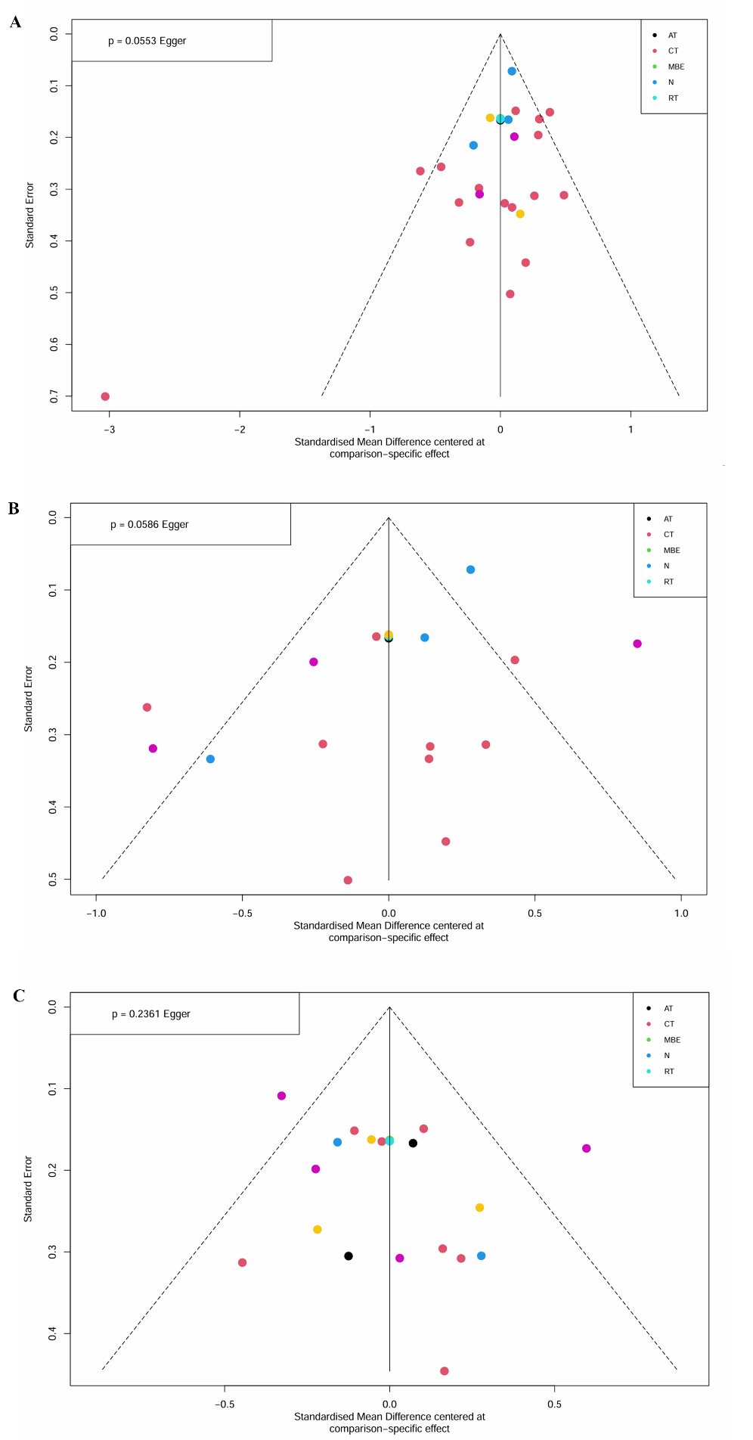
Funnel plots of publication bias for studies.A:depression,B:anxiety,C:self-esteem.

