Additional file 3: Forest plots
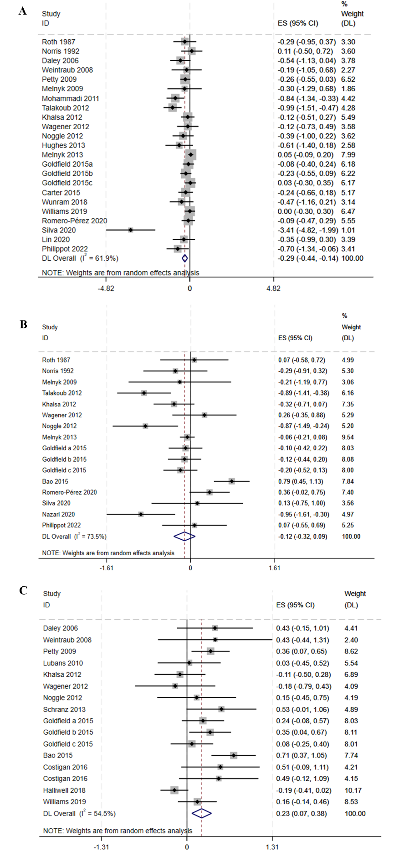
Forest plots.A:depression,B:anxiety,C:self-esteem.

