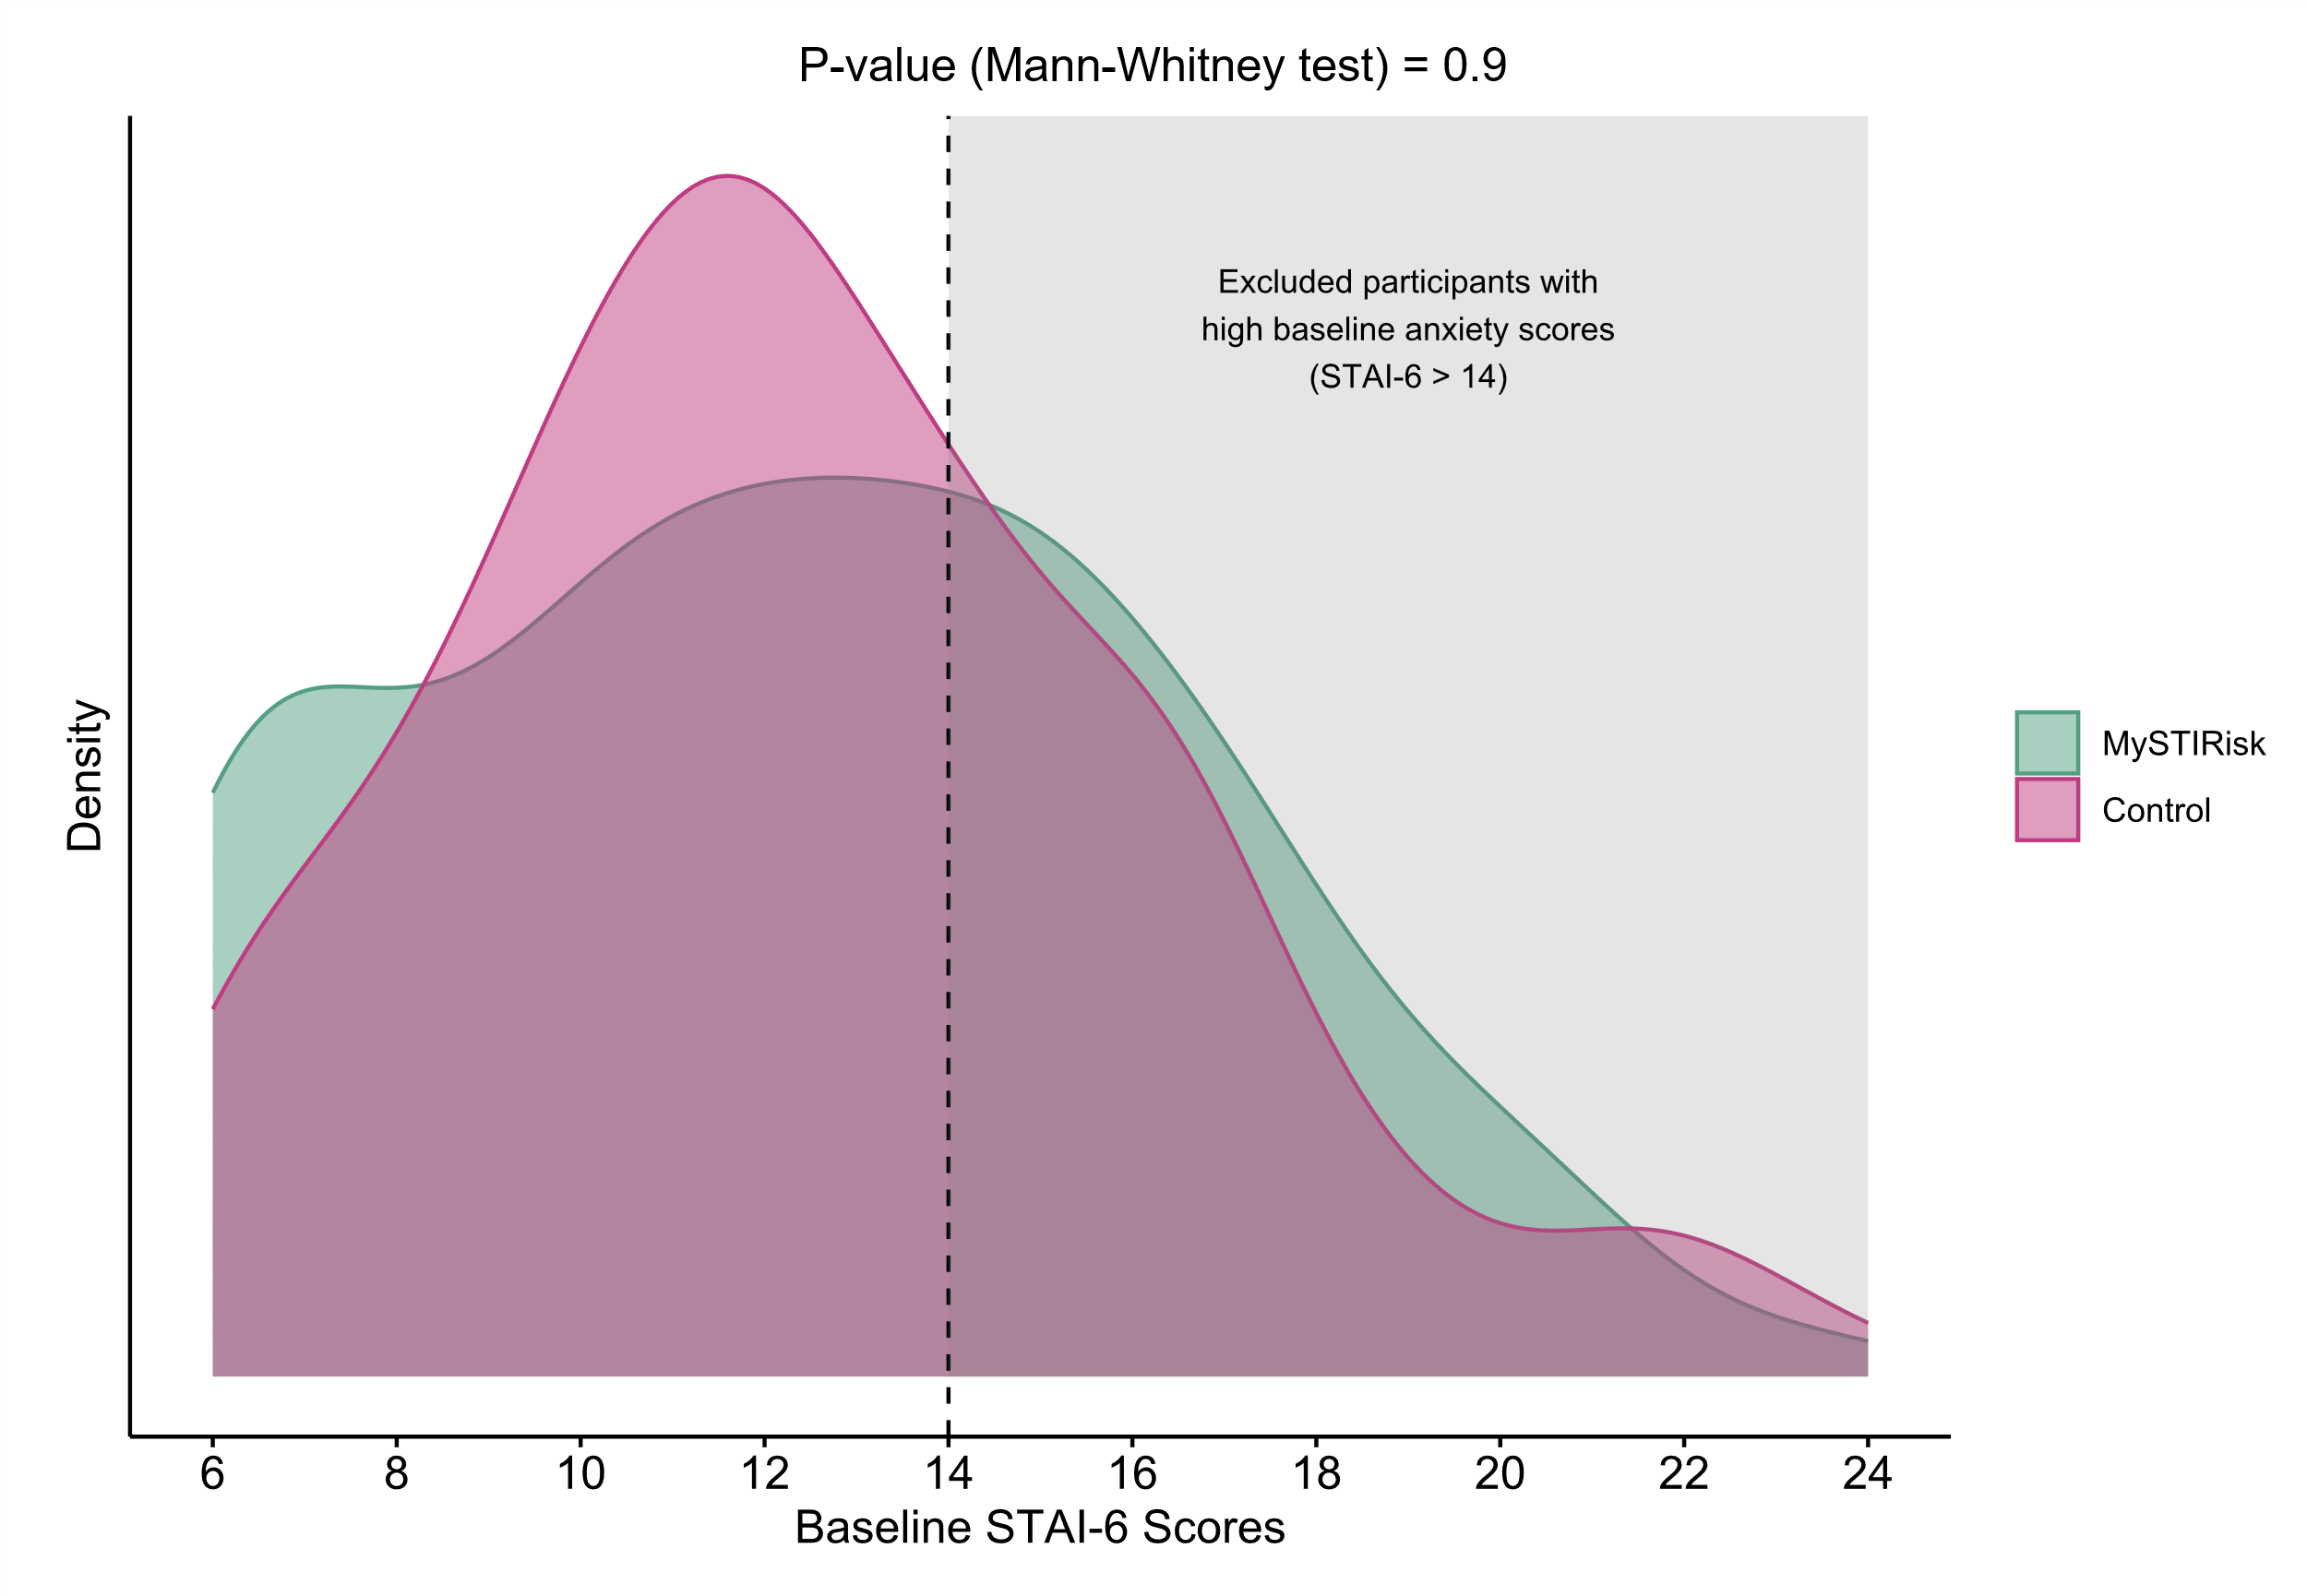
Figure S1. Distribution of Baseline STAI-6 scores for 530 Participants Before Excluding Those with High Baseline Anxiety Scores (STAI-6 >14) and Incomplete Responses

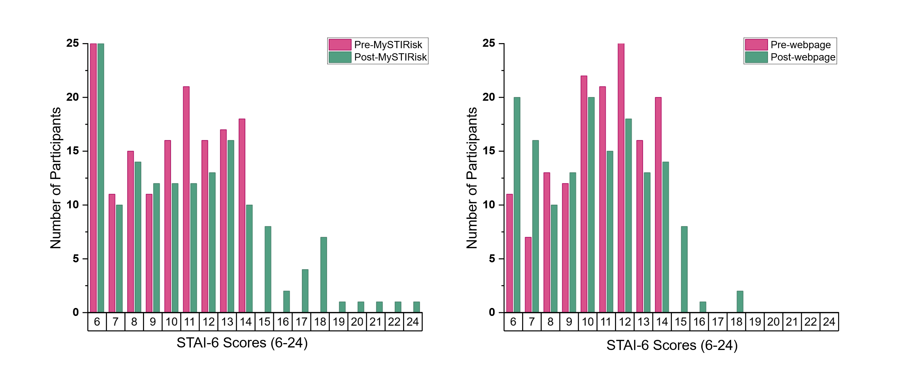
Figure S2. Distribution of STAI-6 scores Before and After Website Use by Group
Table S1. The Six-item State-Trait Anxiety Inventory (STAI-6) Scale*
 | Not at all | Somewhat | Moderately | Very Much
(1) I feel calm | 1 | 2 | 3 | 4
(2) I am tense | 1 | 2 | 3 | 4
(3) I feel upset | 1 | 2 | 3 | 4
(4) I am relaxed | 1 | 2 | 3 | 4
(5) I feel content | 1 | 2 | 3 | 4
(6) I am worried | 1 | 2 | 3 | 4
*Note: Each item is scored on a 4-point Likert scale (1-4). Items 1, 4, and 5 are reverse-coded during analysis. Total scores range from 6 to 24, with higher scores indicating greater anxiety. STAI-6 is a validated, shortened version of the original 20-item STAI-State scale.

Table S2. Testing History and Risk Perception for 530 Participants Before Excluding Those with High Baseline Anxiety Scores (STAI-6 >14) and Incomplete Responses
 | Total  (N = 530) | No Pre-existing Anxiety  [STAI-6 ≤14]  (n = 366) | High Anxiety  [STAI-6 > 14]  (n = 164) | P-value
Previous HIV/STI Diagnosis, n (%)
Yes | 372 | 272 (74.3%) | 100 (61.0%) | 0.002
No | 151 | 92 (25.1%) | 59 (36.0%)
Don't know/Prefer not to answer | 7 | 2 (0.5%) | 5 (3.0%)
Last HIV/STI Test, n (%)
Never tested | 24 | 12 (3.3%) | 12 (7.3%) | 0.2
Within the past 6 months | 451 | 316 (86.3%) | 135 (82.3%)
Within the past year | 19 | 14 (3.8%) | 5 (3.0%)
1-2 years ago | 22 | 14 (3.8%) | 8 (4.9%)
More than 2 years ago | 13 | 10 (2.7%) | 3 (1.8%)
Don't know/Prefer not to answer | 1 | - | 1 (0.6%)
Self-Perceived STI Risk, n (%)
High Risk | 81 | 55 (15.0%) | 26 (15.9%) | 0.5
Medium Risk (Average Risk) | 192 | 133 (36.3%) | 59 (36.0%)
Low Risk | 242 | 165 (45.1%) | 77 (47.0%)
Don't know/Prefer not to answer | 15 | 13 (3.6%) | 2 (1.2%)

Table S3. User Feedback on MySTIRisk Website (n=150)
Feedback Domain | MySTIRisk (n=150)
Ease of Use, n (%)
Very/Somewhat easy | 138 (92.0)
Neutral | 10 (6.7)
Very difficult | 1 (0.7)
Unsure/Prefer not to answer | 1 (0.7)
Information Clarity, n (%)
Very/Clear | 136 (90.7)
Neutral | 9 (6.0)
Very Unclear/Unclear | 3 (2.0)
Unsure/Prefer not to answer | 2 (1.3)
Anticipate Changing their Sexual Behaviour, n (%)
Yes | 49 (32.7)
No | 86 (57.3)
Unsure/Prefer not to answer | 15 (10.0)
Would Recommend to Others, n (%)
Yes | 109 (72.7)
No | 20 (13.3)
Unsure/Prefer not to answer | 21 (14.0)

