Supplementary Table 1 PICOS statement for the research question in the present SRMA
Participants | e-cigarette users
Intervention(s)
Comparison | Non-e-cigarette users
Outcome(s) | Myocardial infarction or Stroke
Study design | Case control OR cohort OR cross-sectional

Supplementary Table 2 Characteristics of the studies included in the present systematic review and meta-analysis
First Author | Country of Study | Year of study | Type of Study | Sample size | OR/RR (95% CI) | Code | Quality of study | Confounder adjusted
Myocardial Infarction
Hirschtick 2023¹¹ | USA | 2013-2019 | cohort | 448 – e-cig users  10583 – non-users | 0.61 (0.12-3.04) |  | high | sociodemographic factors, smoking history, and baseline risk factors
Falk 2022¹⁰ | USA | 2014,2016-2018 | cross sectional | 12369 – e-cig users  47937 – non-users | 0.98 (0.55-1.74) | Non-smoker | low | Sex, BMI, age
 |  |  |  |  | 2.45 (1.88-3.19) | Former smoker | low | Sex, BMI, age
Vindhyal 2020¹³ | USA | 2014,2016-2018 | cross sectional | - | 4.09 (1.29-12.98) | Non-smoker | low | age sex, and body mass index
 |  |  |  |  | 3.71 (1.89-7.28) | Former smoker | low | age sex, and body mass index
Nakama 2021¹² | Japan | 2019 | cross sectional | 713 – e-cig users  8193 – non-users | 2.81 (1.29-6.10) |  | low | age, sex, cigarettes use, equivalent household income, education, and drinking status.
Alzahrani 2023⁹ | USA | 2014-2021 | cross sectional | 1237 – e-cig users  139697 – non-users | 2.62 (1.44-4.77) |  | low | age, sex, BMI, HTN, DM, cholesterol, cig smoking
Bajaña 2024¹⁴ | USA | 2020 | Cross sectional | 4884 – e-cig users  148440 – non-users | 1.08 (0.77-1.52) | Daily user | Low | Age, sex, race, marital status, education, income, exercise, cigarette smoking, alcohol, BMI, DM
Bajaña 2024¹⁴ | USA | 2020 | Cross sectional | 6095 – e-cig users  148440 – non-users | 1.52 (1.11-2.09) | Some day user | Low | Age, sex, race, marital status, education, income, exercise, cigarette smoking, alcohol, BMI, DM
Bajaña 2024¹⁴ | USA | 2020 | Cross sectional | 39090 – e-cig users  148440 – non-users | 1,23 (1.09-1.40) | Former user | Low | Age, sex, race, marital status, education, income, exercise, cigarette smoking, alcohol, BMI, DM
Naqvi & Searles 2025¹⁵ | USA | 2015-2018 | Cross sectional | 2417 – e-cig users  8772 – non-users | 2.60 (1.36-4.95) | Former user | Low | Age, sex, race, tobacco smoking, DM, HTN, hypercholesterolemia, BMI
STROKE
Chelikam 2022¹⁷ | USA | 2013-2018 | cross sectional | 29012 – e-cig users  235728 – non-users | 0.78 (0.73-0.83) | ever | low | not adjusted
Nakama 2021¹² | Japan | 2019 | cross sectional | 713 – e-cig users  8193 – non-users | 2.81 (1.29-6.13) |  | low | age, sex, cigarettes use, equivalent household income, education, and drinking status.
Parekh 2020¹⁸ | USA | 2016-2017 | Cross sectional | 7641 – e-cig users  133077 – non-users | 0.69 (0.34-1.42) | non-smoker | low | demographics (age, sex, race, education, income, marital status, and health insurance), BMI, physical activity, alcohol use, and diabetes
 |  |  |  |  | 2.54 (1.16-5.56) | former smoker | low
Shi 2023¹⁹ | USA | 2017-2018 | cross sectional | 201 – e-cig users  3821 – non-users | 2.07 (1.04-3.81) | non-smoker | low | age, gender, education attainment, race, total-to-HDL cholesterol, diabetes, hypertension, and alcohol consumption
Hirschtick 2023¹¹ | USA | 2013-2019 | cohort | 680 – e-cig users  23828 – non-users | 1.74 (0.55-5.49) | Non-smoker | high | sociodemographic factors, smoking history, and baseline risk factors
Falk 2022¹⁰ | USA | 2014,2016-2018 | cross sectional | 12369 – e-cig users  47937 – non-users | 1.06 (0.58-1.91) | Non-smoker | low | Sex, BMI, age
 |  |  |  |  | 1.65 (1.24-2.19) | Former smoker | low | Sex, BMI, age
Vindhyal 2020¹³ | USA | 2014,2016-2018 | cross sectional | - | 1.22 (0.36-4.18) | Non-smoker | low | Age, sex, and BMI
 |  |  |  |  | 1.92 (1.12-3.29) | Former smoker | low | Age, sex, and BMI
Bricknell 2021¹⁶ | USA | 2016 | cross sectional | 15179 – e-cig users  391581 – non-users | 1.62 (1.18-2.31) | daily user | low | Age, sex, BMI, kidney disease, diabetes, traditional cigarette smoking, smokeless tobacco use
 |  |  |  |  | 1.28 (1.02-1.61) | some days user | low
Ding 2025²⁰ | USA | 2015-2018 | Cross sectional | 2437 – e-cig users  8836 non-users | 0.93 (0.85-1.03) |  | Low | Age, sex, race, income, marital status, education, exercise, weight, BMI, diabetes, heart disease
Ding 2025²⁰ | USA | 2020-2021 | Cross sectional | 50464 – e-cig users  211291 – non-users | 0.91 (0.84-0.99) |  | Low
Naqvi & Searles 2025¹⁵ | USA | 2015-2018 | Cross sectional | 2417 – e-cig users  8772 – non-users | 1.22 (0.66-2.28) |  | Low | Age, sex, race, tobacco smoking, diabetes, hypertension, hypercholesterolemia, BMI

Supplementary Table 3 GRADE Assessment of the included studies for quality of evidence
First Author | Design of study | Consistency | Directness | Other considerations | Quality
Hirschtick 2023¹¹ | Cohort | No serious inconsistency | No uncertainty | None | High
Falk 2022¹⁰ | Cross sectional | No serious inconsistency | No uncertainty | None | Low
Vindhyal 2020¹³ | Cross sectional | No serious inconsistency | No uncertainty | None | Low
Nakama 2021¹² | Cross sectional | No serious inconsistency | No uncertainty | None | Low
Alzahrani 2023⁹ | Cross sectional | No serious inconsistency | No uncertainty | None | Low
Chelikam 2022¹⁵ | Cross sectional | No serious inconsistency | No uncertainty | None | Low
Parekh 2020¹⁶ | Cross sectional | No serious inconsistency | No uncertainty | None | Low
Shi 2023¹⁷ | Cross sectional | No serious inconsistency | No uncertainty | None | Low
Bricknell 2021¹⁴ | Cross sectional | No serious inconsistency | No uncertainty | None | Low
Ding 2025²⁰ | Cross sectional | No serious inconsistency | No uncertainty | None | Low
Naqvi & Searles 2025¹⁵ | Cross sectional | No serious inconsistency | No uncertainty | None | Low

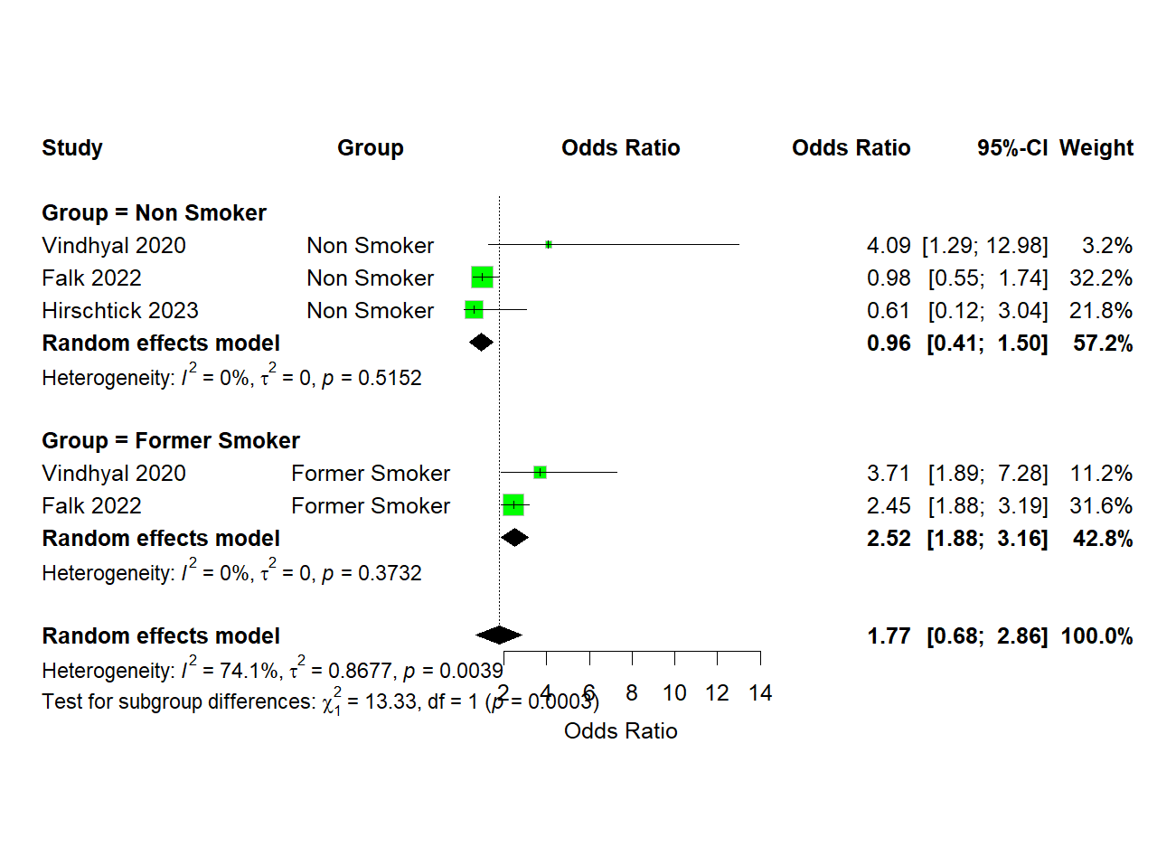
Supplementary Figure 1 Forest plot of meta-analysis for association of e-cigarette use and myocardial infarction among non-smokers and former smokers, random-effect model.

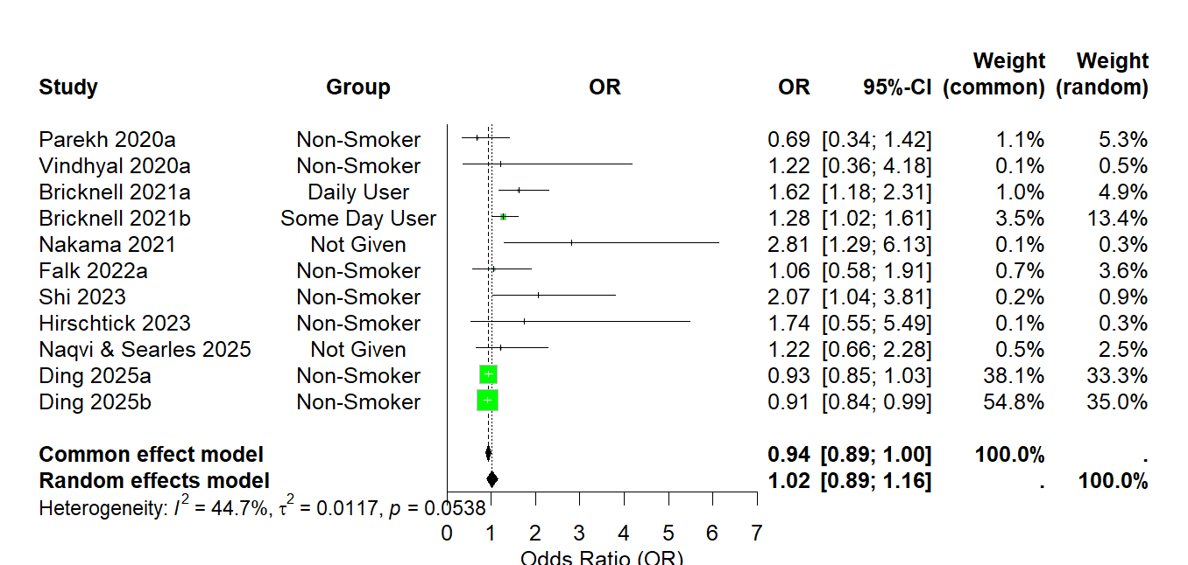
Supplementary Figure 2 Forest plot of meta-analysis for association of e-cigarette use and stroke including studies adjusting smoking as a confounder, random-effect model

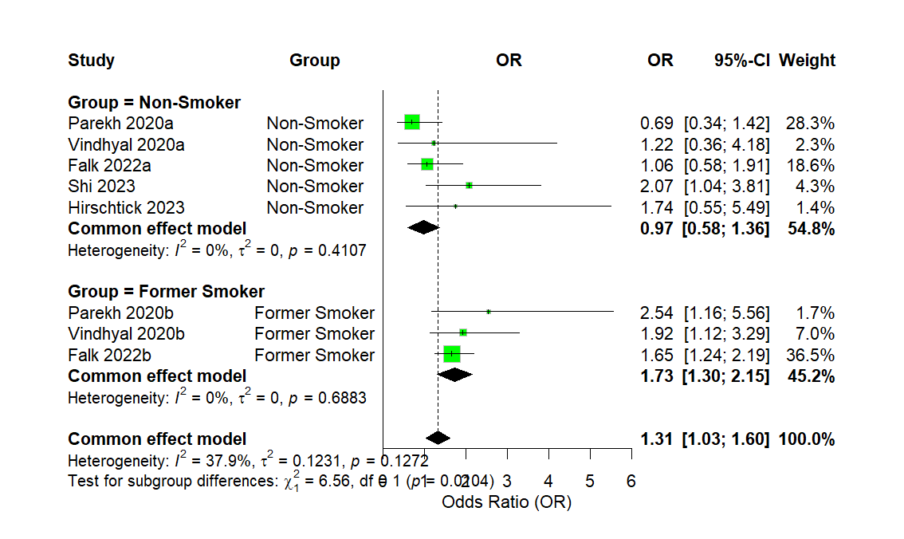
Supplementary Figure 3 Forest plot of meta-analysis for association of e-cigarette use and stroke among non-smokers and former smokers, random-effect model
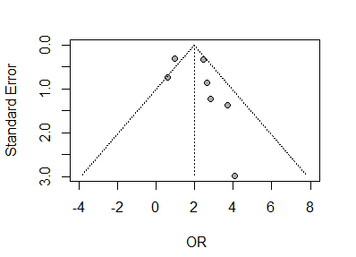

Supplementary Figure 4 Funnel plot for publication bias among studies on e-cigarette use and myocardial infarction
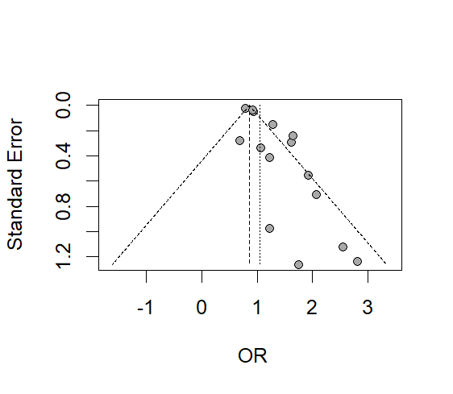

Supplementary Figure 5 Funnel plot for publication bias among studies on e-cigarette use and stroke

