Appendix I (Stimulus pictures)

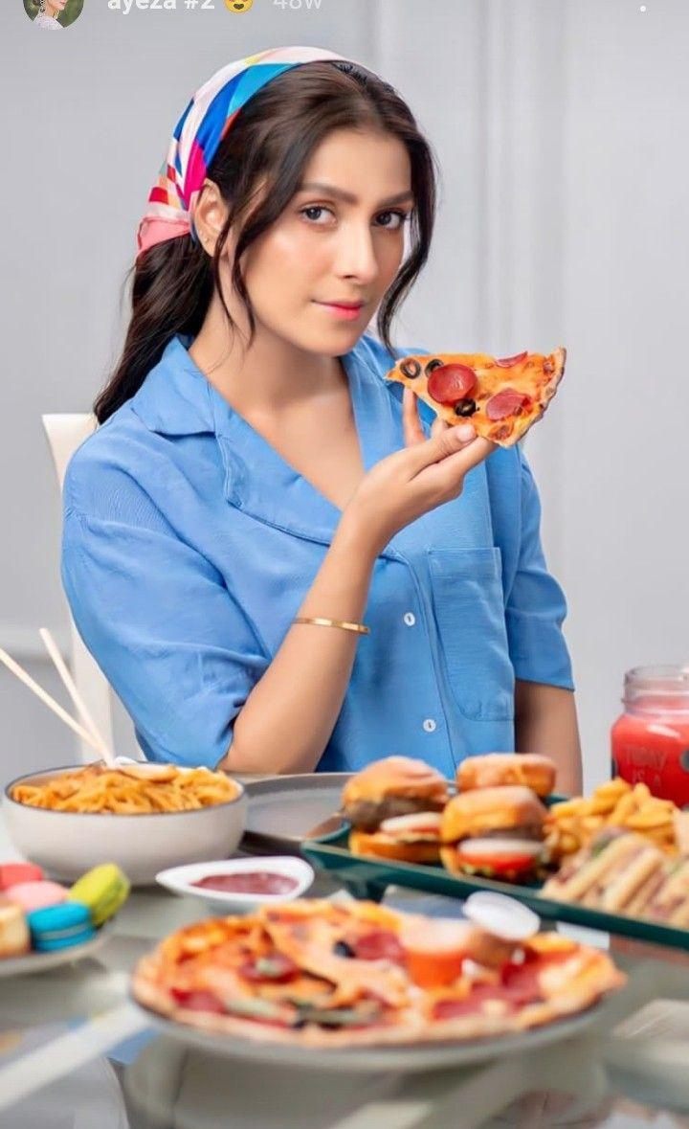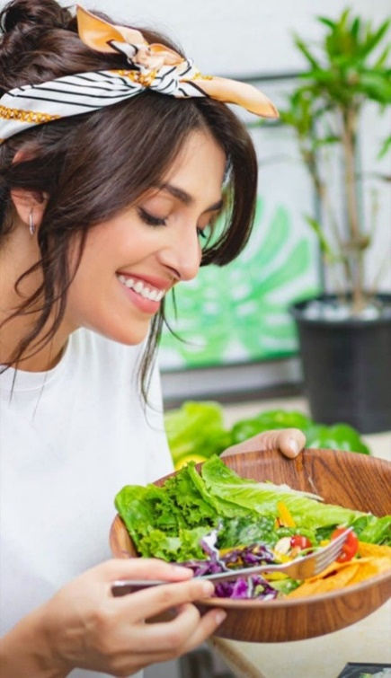

Celebrity (Ayeza Khan) Instagram post with healthy and unhealthy food

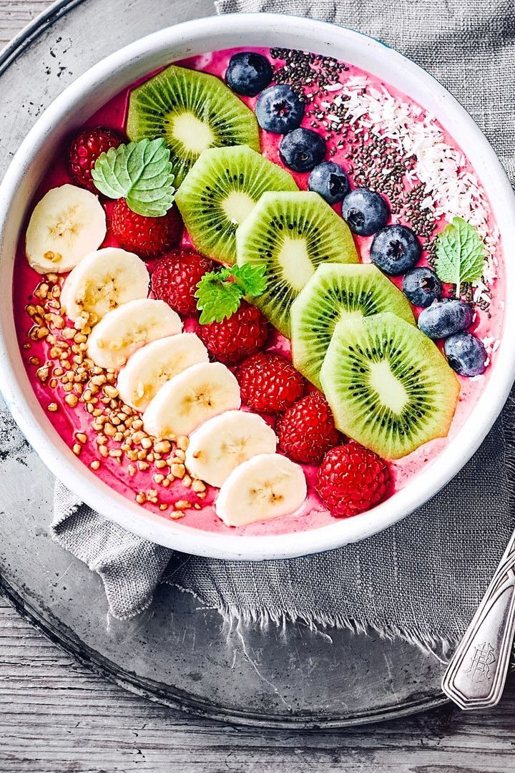
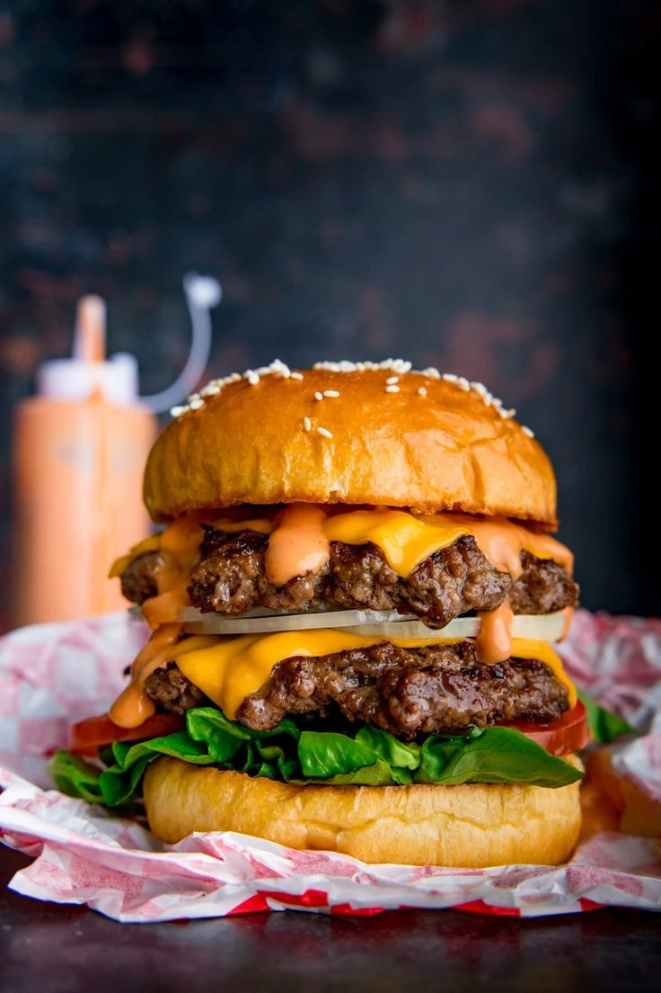

Pictures of healthy and unhealthy food without a celebrity

Appendix II: Scales
Digital engagement
“The Instagram picture makes me want to respond that I like the picture”
“The Instagram picture makes me want to share it with my friends and others in my network by using @mention commenting”
“The Instagram picture makes me want to post my comments to it”
“The Instagram picture makes me want to follow the Instagram account that posted this picture”
“The Instagram picture makes me want to post a video with a product like this”
“The Instagram picture makes me want to post a picture with myself with a product like this”
“The Instagram picture makes me want to use a hashtag related to it”
Celebrity-self congruency
“This celebrity is consistent with how I see myself”
“This celebrity and I are in the same circle”
“This celebrity is similar to me”
What do you think of influencer/ celebrity in food picture?” (celebrity attractiveness)
“attractive”
“classy”
“beautiful”
“plain”
“sexy”
Eating Intention
“Please indicate the extent to which you would like to eat each food you saw on the celebrity’s Instagram page” (1 = very unlikely 5 = highly likely)”
Involvement with healthy food
“I think about healthy food products a lot”
“I am very interested in healthy food products”
“Healthy food products are important to me”
“I pay a lot of attention to healthy food products”
“I think a lot about my choices when it comes to healthy food products”
“I place great value in making the right decision when it comes to healthy food products”
“Making a purchase decision for healthy food products requires a lot of thought”
“I attach great importance to purchasing healthy food products”
“Eating healthy food products is important to me”
“I feel a sense of personal satisfaction when I eat healthy food products”
“Eating healthy food products is a significant part of my life”
“Eating healthy food products means a lot to me”

