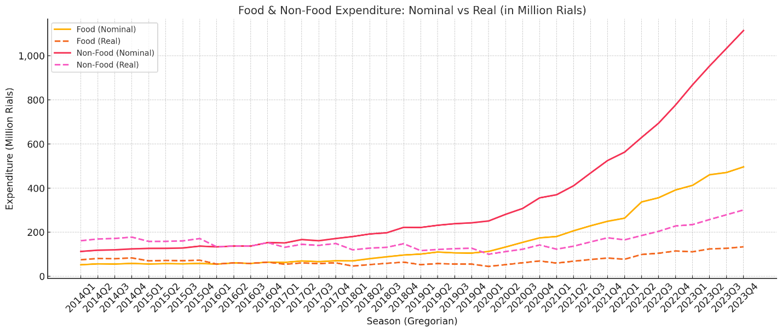
Supplementary Figure 1. Trends in Nominal and Real Household Expenditures on Food and Non-Food Categories

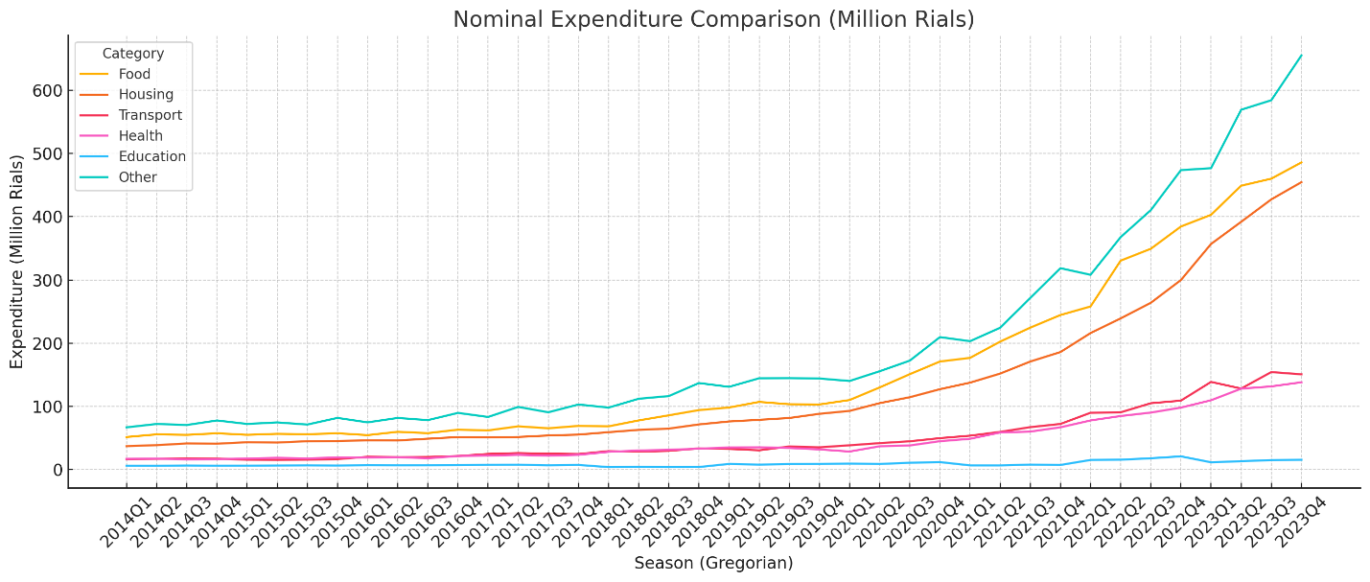
Supplementary Figure 2. Nominal Household Expenditures by Category

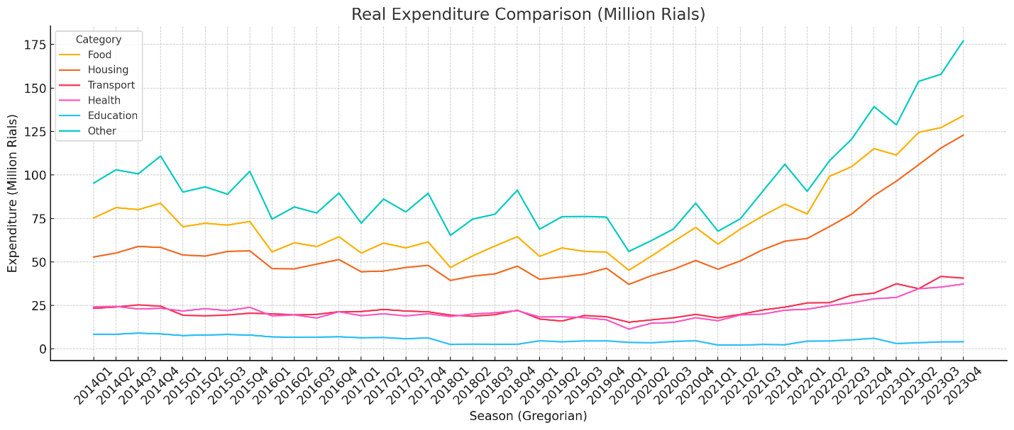
Supplementary Figure 3. Real Household Expenditures by Category

Supplementary Table1. Unit Root Analysis of Real Household Expenditure Categories
Category | ADF Statistic | p-value | Stationary at 5%?
Food | 0.42 | 0.997 | No
Housing | 0.71 | 1 | No
Transport | 0.07 | 0.995 | No
Health | 0.03 | 0.995 | No
Education | -2.44 | 0.356 | No
Other | 1.94 | 1 | No

Supplementary Table 2. ITS Regression Estimates for Subcategories of the Non-Essential Expenditure Group
Subcategory | Pre-COVID Trend | COVID Level Change |  | Post-COVID Level Change |  | COVID Trend Change | Post-COVID Trend Change | R²
 | million rials | million rials | % | million rials | % | million rials | million rials
Tobacco | −0.010 (n.s.) | −0.98 (n.s.) | −12.0% | 0.449 | +1.3% | 0.45 | 0.72 | 0.911
Clothing | −0.316 | −7.99 | −40.0% | −4.27 (n.s.) | −21.4% | 2.65 | +1.359 (n.s.) | 0.686
Furnishings | −0.177 | +0.097  (n.s.) | +1.0% | −0.67 (n.s.) | −6.9% | 0.79 | +0.097  (n.s) | 0.886
Communication | −0.138 | +0.495 (n.s.) | +9.1% | −1.01 | −18.5% | 0.34 | −0.11 | 0.877
Recreation | −0.115 | −1.01 | −20.9% | 0.28 | +13.0% | 0.28 | +0.389 (n.s.) | 0.709
Restaurants | −0.158 | −1.13 | −15.9% | −0.56 (n.s.) | −7.8% | 0.65 | 0.86 | 0.767
Miscellaneous | −0.211 | −3.05 | −11.8% | −2.30 | −8.9% | 1.78 | 1.8 | 0.979
Residual other | −0.084 | −0.68 | −17.0% | +0.141 | +15.5% | 0.14 | 0.24 | 0.886
n.s= non-significant

