Supplementary Table 1. Definition of healthy factors in the UK Biobank
Healthy factors | Source and definition | Data field ID
Regular physical activity | At least one of the following:  1. ≥150 minutes/week of moderate activity;  2. ≥75 minutes/week of vigorous activity;  3. (moderate activity + 2*vigorous activity) ≥150 minutes/week;  4. ≥5 days/week of moderate activity (10+ minutes continuously at a time);  5. ≥3 days/week of vigorous activity (10+ minutes continuously at a time). | 884, 894, 904, 914
Higher grip strength | Grip strength above sex-specific median | 46, 47
Lower sedentary time | Total sedentary time <6 hours/day | 1070, 1080, 1090
Appropriate sleep duration | Sleeping 7-8 hours/day | 1160

Supplementary Table 2. UK Biobank data fields used to derive the outcome variables
Data field ID | Description
53 | Date of attending assessment center
Stroke
42006 | Date of stroke
42007 | Source of stroke report
42008 | Date of ischemic stroke
42009 | Source of ischemic stroke report
42010 | Date of intracerebral hemorrhage
42011 | Source of intracerebral hemorrhage report
42012 | Date of subarachnoid hemorrhage
42013 | Source of subarachnoid hemorrhage report
20002 (1081-1083, 1086, 1491, 1583) | Self-reported stroke or other cerebrovascular diseases at baseline (excluded)
Dementia
42018 | Date of all cause dementia report
42019 | Source of all cause dementia report
42020 | Date of Alzheimer's disease report
42021 | Source of Alzheimer's disease report
42022 | Date of vascular dementia report
42023 | Source of vascular dementia report
42024 | Date of frontotemporal dementia report
42025 | Source of frontotemporal dementia report
20002 (1263) | Self-reported dementia/Alzheimers/cognitive impairment at baseline (excluded)

Supplementary Table 3. Definition of diet quality score in the UK Biobank
 | Components | UK Biobank field ID
Diet quality score (total range: 0-5) | 1. Red and processed meat <3.5 servings/week AND processed meat <1 serving/week;  2. Fresh fruit ≥3 servings/day OR fresh vegetables ≥3 servings/day OR a combination ≥4.5 servings/day;  3. Whole grain ≥3 servings/day;  4. Refined grain <1.5 servings/day;  5. Fish ≥2 servings/week.  (Serving size: fresh fruit-1 piece; cooked/raw vegetables-3 heaped tablespoons; bran/oat/muesli cereal-1 bowl; whole-meal/ whole-grain bread-1 slice; biscuit/other (e.g., cornflakes, frosties) cereal-1 bowl; white/brown/other bread-1 slice.) | 1369, 1379, 1389, 1349, 1309, 1289, 1299, 1458, 1468, 1438, 1448, 1329, 1339

Supplementary Table 4. Subgroup analysis for the association of healthy factors with risk of stroke for participants from the UK Biobank
Subgroup | Cases/participants | Score of healthy factors |  |  |  | P for trend | P for interaction
Subgroup | Cases/participants | 0-1 | 2 | 3 | 4 | P for trend | P for interaction
Age, y
<65 | 3000/386,824 | 1.00 (Referent) | 0.83 (0.74-0.92) | 0.74 (0.67-0.82) | 0.65 (0.58-0.74) | <.001 | .68
≥65 | 1992/88,159 | 1.00 (Referent) | 0.88 (0.78-1.00) | 0.67 (0.59-0.76) | 0.67 (0.56-0.78) | <.001
Sex
Men | 2947/216,414 | 1.00 (Referent) | 0.82 (0.74-0.91) | 0.71 (0.64-0.78) | 0.65 (0.57-0.74) | <.001 | .64
Women | 2045/258,569 | 1.00 (Referent) | 0.90 (0.79-1.03) | 0.72 (0.63-0.82) | 0.67 (0.57-0.78) | <.001
Smoking status
Never | 2192/260,605 | 1.00 (Referent) | 0.94 (0.82-1.07) | 0.79 (0.69-0.90) | 0.69 (0.60-0.81) | <.001 | .41
Former | 1919/163,973 | 1.00 (Referent) | 0.75 (0.66-0.86) | 0.66 (0.58-0.75) | 0.66 (0.57-0.77) | <.001
Current | 849/48,846 | 1.00 (Referent) | 0.93 (0.78-1.11) | 0.70 (0.58-0.84) | 0.54 (0.41-0.70) | <.001
Body mass index, kg/m²
<25 | 1372/158,773 | 1.00 (Referent) | 0.91 (0.76-1.09) | 0.79 (0.66-0.94) | 0.71 (0.58-0.86) | <.001 | .92
25 to <30 | 2142/202,026 | 1.00 (Referent) | 0.82 (0.73-0.93) | 0.69 (0.61-0.78) | 0.66 (0.57-0.77) | <.001
≥30 | 1455/113,187 | 1.00 (Referent) | 0.89 (0.78-1.02) | 0.76 (0.66-0.88) | 0.67 (0.55-0.81) | <.001
Hypertension
Yes | 3756/263,378 | 1.00 (Referent) | 0.85 (0.78-0.93) | 0.71 (0.65-0.78) | 0.63 (0.56-0.71) | <.001 | .21
No | 1236/211,605 | 1.00 (Referent) | 0.90 (0.76-1.07) | 0.77 (0.65-0.91) | 0.79 (0.65-0.96) | <.001
Dyslipidemia
Yes | 1568/82,965 | 1.00 (Referent) | 0.76 (0.67-0.86) | 0.63 (0.55-0.72) | 0.56 (0.46-0.68) | <.001 | .0075
No | 3424/392,018 | 1.00 (Referent) | 0.95 (0.85-1.05) | 0.80 (0.72-0.89) | 0.75 (0.66-0.84) | <.001
Diabetes
Yes | 699/27,793 | 1.00 (Referent) | 0.78 (0.65-0.93) | 0.66 (0.54-0.81) | 0.48 (0.34-0.67) | <.001 | .055
No | 4293/447,190 | 1.00 (Referent) | 0.91 (0.83-0.99) | 0.77 (0.70-0.84) | 0.73 (0.65-0.81) | <.001
Where appropriate, results were adjusted for age, sex, ethnic background (White, Asian/Asian British, Black/Black British, mixed), Townsend deprivation index (in quintile), smoking status (never, former, current), pack-years of smoking (for current smokers), alcohol drinking (never, former, current: <1, 1 to <3, 3 to <7, ≥7 drinks/week), and diet quality score (0-5).

Supplementary Table 5. Subgroup analysis for the association of healthy factors with risk of dementia for participants from the UK Biobank
Subgroup | Cases/participants | Score of healthy factors |  |  |  | P for trend | P for interaction
Subgroup | Cases/participants | 0-1 | 2 | 3 | 4 | P for trend | P for interaction
Age, y
<65 | 874/386,824 | 1.00 (Referent) | 0.70 (0.58-0.83) | 0.58 (0.48-0.70) | 0.38 (0.30-0.49) | <.001 | .095
≥65 | 1246/88,159 | 1.00 (Referent) | 0.77 (0.66-0.89) | 0.68 (0.58-0.79) | 0.48 (0.38-0.60) | <.001
Sex
Men | 1183/216,414 | 1.00 (Referent) | 0.75 (0.65-0.88) | 0.60 (0.51-0.70) | 0.44 (0.35-0.55) | <.001 | .55
Women | 937/258,569 | 1.00 (Referent) | 0.72 (0.60-0.86) | 0.68 (0.57-0.81) | 0.43 (0.34-0.55) | <.001
Smoking status
Never | 946/260,605 | 1.00 (Referent) | 0.74 (0.62-0.89) | 0.64 (0.54-0.77) | 0.41 (0.32-0.53) | <.001 | .73
Former | 926/163,973 | 1.00 (Referent) | 0.72 (0.61-0.86) | 0.63 (0.52-0.74) | 0.44 (0.34-0.57) | <.001
Current | 233/48,846 | 1.00 (Referent) | 0.77 (0.55-1.07) | 0.63 (0.45-0.90) | 0.50 (0.30-0.82) | <.001
Body mass index, kg/m²
<25 | 676/158,773 | 1.00 (Referent) | 0.65 (0.51-0.81) | 0.62 (0.49-0.77) | 0.39 (0.29-0.52) | <.001 | .36
25 to <30 | 904/202,026 | 1.00 (Referent) | 0.75 (0.63-0.89) | 0.58 (0.48-0.70) | 0.41 (0.32-0.52) | <.001
≥30 | 522/113,187 | 1.00 (Referent) | 0.76 (0.62-0.95) | 0.69 (0.55-0.86) | 0.53 (0.37-0.75) | <.001
Hypertension
Yes | 1528/263,378 | 1.00 (Referent) | 0.75 (0.66-0.86) | 0.66 (0.57-0.75) | 0.46 (0.38-0.56) | <.001 | .19
No | 592/211,605 | 1.00 (Referent) | 0.71 (0.56-0.89) | 0.59 (0.47-0.74) | 0.37 (0.27-0.51) | <.001
Dyslipidemia
Yes | 762/82,965 | 1.00 (Referent) | 0.74 (0.62-0.89) | 0.61 (0.50-0.74) | 0.43 (0.32-0.58) | <.001 | .66
No | 1358/392,018 | 1.00 (Referent) | 0.75 (0.64-0.88) | 0.67 (0.58-0.78) | 0.46 (0.37-0.56) | <.001
Diabetes
Yes | 308/27,793 | 1.00 (Referent) | 0.69 (0.53-0.90) | 0.54 (0.40-0.73) | 0.37 (0.21-0.65) | <.001 | .17
No | 1812/447,190 | 1.00 (Referent) | 0.77 (0.68-0.88) | 0.68 (0.60-0.78) | 0.47 (0.39-0.56) | <.001
Where appropriate, results were adjusted for age, sex, ethnic background (White, Asian/Asian British, Black/Black British, mixed), Townsend deprivation index (in quintile), smoking status (never, former, current), pack-years of smoking (for current smokers), alcohol drinking (never, former, current: <1, 1 to <3, 3 to <7, ≥7 drinks/week), and diet quality score (0-5).

Supplementary Table 6. Sensitivity analysis for the association of healthy factors with risk of stroke and dementia for participants from the UK Biobank
 | Score of healthy factors |  |  |  | P for trend
 | 0-1 | 2 | 3 | 4 | P for trend
All stroke
Excluding baseline coronary heart disease and cancer
No. of cases/participants | 725/48,967 | 1295/113,415 | 1370/158,716 | 594/95,487
HR (95% CI) | 1.00 (Referent) | 0.86 (0.78-0.94) | 0.73 (0.67-0.80) | 0.66 (0.59-0.74) | <.001
Excluding stroke cases in the first 4 years of follow up
No. of cases/participants | 569/57,652 | 1013/130,202 | 1066/179,223 | 461/106,023
HR (95% CI) | 1.00 (Referent) | 0.87 (0.79-0.97) | 0.75 (0.69-0.83) | 0.68 (0.60-0.78) | <.001
All dementia
Excluding baseline coronary heart disease and cancer
No. of cases/participants | 361/48,967 | 551/113,415 | 583/158,716 | 165/95,487
HR (95% CI) | 1.00 (Referent) | 0.73 (0.64-0.83) | 0.64 (0.56-0.73) | 0.42 (0.34-0.50) | <.001
Excluding dementia cases in the first 4 years of follow up
No. of cases/participants | 367/57,930 | 586/130,708 | 612/179,715 | 174/106,249
HR (95% CI) | 1.00 (Referent) | 0.79 (0.69-0.90) | 0.69 (0.61-0.79) | 0.47 (0.39-0.56) | <.001
Results were adjusted for age, sex, ethnic background (White, Asian/Asian British, Black/Black British, mixed), Townsend deprivation index (in quintile), smoking status (never, former, current), pack-years of smoking (for current smokers), alcohol drinking (never, former, current: <1, 1 to <3, 3 to <7, ≥7 drinks/week), and diet quality score (0-5).

Supplementary Table 7. Association of healthy factors with risk of stroke in participants from the UK Biobank, further adjusting for education levels*
 | Score of healthy factors |  |  |  | P for trend
 | 0-1 (n = 58,040) | 2 (n = 130,834) | 3 (n = 179,825) | 4 (n = 106,284) | P for trend
All stroke
No. of cases | 957 | 1645 | 1668 | 722
Model 3 (HR [95% CI]) | 1.00 (Referent) | 0.89 (0.82-0.96) | 0.76 (0.70-0.83) | 0.71 (0.64-0.78) | <.001
Model 3 + education | 1.00 (Referent) | 0.89 (0.82-0.96) | 0.77 (0.71-0.83) | 0.72 (0.65-0.79) | <.001
Ischemic stroke
No. of cases | 790 | 1288 | 1271 | 534
Model 3 (HR [95% CI]) | 1.00 (Referent) | 0.87 (0.79-0.95) | 0.74 (0.68-0.81) | 0.69 (0.62-0.78) | <.001
Model 3 + education | 1.00 (Referent) | 0.87 (0.80-0.95) | 0.75 (0.68-0.82) | 0.71 (0.63-0.79) | <.001
Intracerebral hemorrhage
No. of cases | 155 | 272 | 287 | 116
Model 3 (HR [95% CI]) | 1.00 (Referent) | 0.85 (0.69-1.04) | 0.72 (0.59-0.89) | 0.61 (0.48-0.79) | <.001
Model 3 + education | 1.00 (Referent) | 0.85 (0.69-1.03) | 0.72 (0.59-0.89) | 0.61 (0.48-0.79) | <.001
Subarachnoid hemorrhage
No. of cases | 69 | 188 | 196 | 110
Model 3 (HR [95% CI]) | 1.00 (Referent) | 1.23 (0.93-1.62) | 0.95 (0.72-1.26) | 0.94 (0.69-1.29) | .23
Model 3 + education | 1.00 (Referent) | 1.23 (0.93-1.62) | 0.95 (0.72-1.25) | 0.94 (0.69-1.29) | .23
*Education levels were grouped as follows: College or University degree, A levels/AS levels or equivalent, O levels/GCSEs or equivalent, CSEs or equivalent, NVQ or HND or HNC or equivalent, Other professional qualifications (eg: nursing, teaching),

Supplementary Table 8. Association of healthy factors with risk of dementia in participants from the UK Biobank, further adjusting for education levels*
 | Score of healthy factors |  |  |  | P for trend
 | 0-1 (n = 58,040) | 2 (n = 130,834) | 3 (n = 179,825) | 4 (n = 106,284) | P for trend
All dementia
No. of cases | 477 | 712 | 722 | 209
Model 3 (HR [95% CI]) | 1.00 (Referent) | 0.74 (0.66-0.83) | 0.64 (0.56-0.72) | 0.44 (0.37-0.51) | <.001
Model 3 + education | 1.00 (Referent) | 0.74 (0.66-0.84) | 0.65 (0.57-0.73) | 0.45 (0.38-0.53) | <.001
Alzheimer's disease
No. of cases | 171 | 278 | 286 | 85
Model 3 (HR [95% CI]) | 1.00 (Referent) | 0.78 (0.64-0.94) | 0.67 (0.55-0.81) | 0.47 (0.36-0.62) | <.001
Model 3 + education | 1.00 (Referent) | 0.79 (0.65-0.95) | 0.69 (0.56-0.83) | 0.49 (0.38-0.65) | <.001
Vascular dementia
No. of cases | 107 | 144 | 124 | 37
Model 3 (HR [95% CI]) | 1.00 (Referent) | 0.73 (0.57-0.94) | 0.57 (0.44-0.75) | 0.43 (0.29-0.64) | <.001
Model 3 + education | 1.00 (Referent) | 0.74 (0.57-0.95) | 0.58 (0.45-0.76) | 0.45 (0.31-0.66) | <.001
*Education levels were grouped as follows: College or University degree, A levels/AS levels or equivalent, O levels/GCSEs or equivalent, CSEs or equivalent, NVQ or HND or HNC or equivalent, Other professional qualifications (eg: nursing, teaching),

Supplementary Table 9. HR (95% CI) for the association of healthy factors with risk of stroke and dementia in participants from the UK Biobank
 | Score of healthy factors |  |  | P for trend
 | 0-1 | 2 | 3 | P for trend
All stroke
Removing physical activity | 1.00 (Referent) | 0.83 (0.78-0.89) | 0.74 (0.68-0.81) | <.001
Removing grip strength | 1.00 (Referent) | 0.86 (0.81-0.93) | 0.78 (0.72-0.84) | <.001
Removing sedentary time | 1.00 (Referent) | 0.88 (0.82-0.93) | 0.78 (0.72-0.85) | <.001
Removing sleep duration | 1.00 (Referent) | 0.85 (0.80-0.91) | 0.76 (0.71-0.83) | <.001
All dementia
Removing physical activity | 1.00 (Referent) | 0.77 (0.70-0.84) | 0.54 (0.47-0.62) | <.001
Removing grip strength | 1.00 (Referent) | 0.82 (0.73-0.91) | 0.68 (0.60-0.76) | <.001
Removing sedentary time | 1.00 (Referent) | 0.77 (0.70-0.84) | 0.55 (0.48-0.63) | <.001
Removing sleep duration | 1.00 (Referent) | 0.77 (0.70-0.84) | 0.54 (0.48-0.62) | <.001
Results were adjusted for age, sex, ethnic background (White, Asian/Asian British, Black/Black British, mixed), Townsend deprivation index (in quintile), smoking status (never, former, current), pack-years of smoking (for current smokers), alcohol drinking (never, former, current: <1, 1 to <3, 3 to <7, ≥7 drinks/week), and diet quality score (0-5).

Supplementary Table 10. Association of healthy factors with risk of stroke subtypes for participants from the UK Biobank
Healthy factors | HR (95% CI) | P value
Ischemic stroke
Regular physical activity | 0.91 (0.85-0.98) | .009
Higher grip strength (above sex-specific median) | 0.83 (0.78-0.89) | <.001
Lower sedentary time (<6 hours/day) | 0.81 (0.76-0.87) | <.001
Appropriate sleep duration (7-8 hours/day) | 0.84 (0.79-0.89) | <.001
Intracerebral hemorrhage
Regular physical activity | 0.80 (0.68-0.93) | .004
Higher grip strength (above sex-specific median) | 0.82 (0.71-0.95) | .007
Lower sedentary time (<6 hours/day) | 0.95 (0.82-1.10) | .49
Appropriate sleep duration (7-8 hours/day) | 0.89 (0.77-1.02) | .10
Subarachnoid hemorrhage
Regular physical activity | 1.06 (0.87-1.29) | .55
Higher grip strength (above sex-specific median) | 0.94 (0.79-1.12) | .51
Lower sedentary time (<6 hours/day) | 0.92 (0.76-1.10) | .35
Appropriate sleep duration (7-8 hours/day) | 0.97 (0.82-1.16) | .76
Results were adjusted for age, sex, ethnic background (White, Asian/Asian British, Black/Black British, mixed), Townsend deprivation index (in quintile), smoking status (never, former, current), pack-years of smoking (for current smokers), alcohol drinking (never, former, current: <1, 1 to <3, 3 to <7, ≥7 drinks/week), diet quality score (0-5), and the remaining three factors.

Supplementary Table 11. Association of healthy factors with risk of dementia subtypes for participants from the UK Biobank
Healthy Factors | HR (95% CI) | P value
Alzheimer's disease
Regular physical activity | 1.03 (0.88-1.21) | .71
Higher grip strength (above sex-specific median) | 0.60 (0.51-0.70) | <.001
Lower sedentary time (<6 hours/day) | 0.86 (0.74-1.00) | .049
Appropriate sleep duration (7-8 hours/day) | 0.84 (0.73-0.97) | .017
Vascular dementia
Regular physical activity | 0.83 (0.67-1.03) | .089
Higher grip strength (above sex-specific median) | 0.57 (0.46-0.72) | <.001
Lower sedentary time (<6 hours/day) | 0.76 (0.62-0.93) | .008
Appropriate sleep duration (7-8 hours/day) | 0.81 (0.67-0.99) | .042
Results were adjusted for age, sex, ethnic background (White, Asian/Asian British, Black/Black British, mixed), Townsend deprivation index (in quintile), smoking status (never, former, current), pack-years of smoking (for current smokers), alcohol drinking (never, former, current: <1, 1 to <3, 3 to <7, ≥7 drinks/week), diet quality score (0-5), and the remaining three factors.

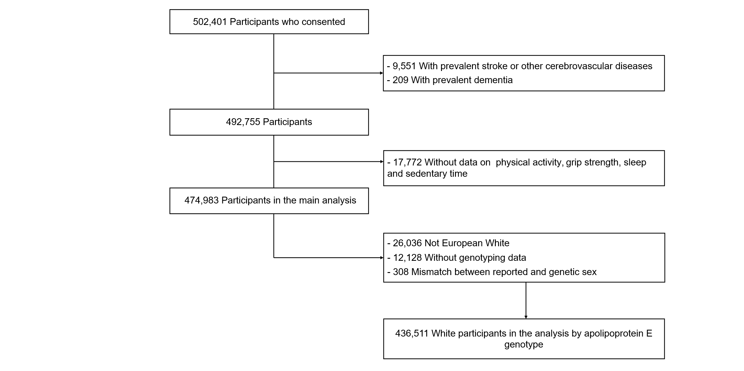

Supplementary Figure 1. Flow diagram of participant selection.

Supplementary Figure 2: Kaplan survival probability for stroke and dementia according to 4 groups of the healthy factors in participants from the UK Biobank

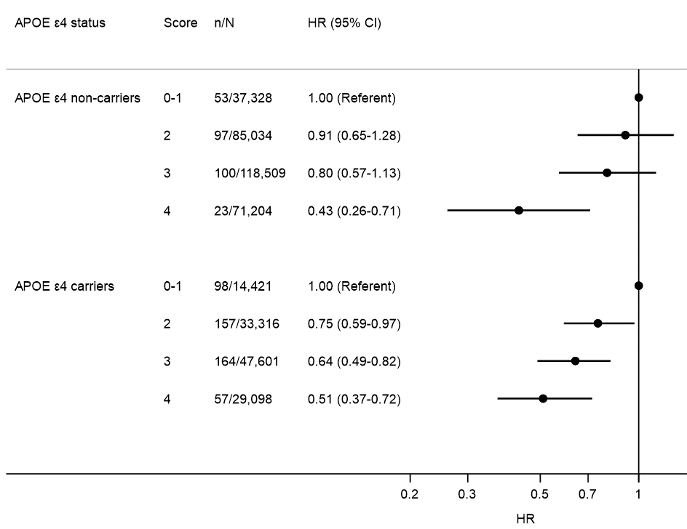

Supplementary Figure 3. Association of healthy factors with risk of Alzheimer's disease according to apolipoprotein E genotype in participants from the UK Biobank
Analyses were conducted among 436,511 European white individuals who had genotyping data.
Results were adjusted for age, sex, Townsend deprivation index (in quintile), smoking status (never, former, current), pack-years of smoking (for current smokers), alcohol drinking (never, former, current: <1, 1 to <3, 3 to <7, ≥7 drinks/week), diet quality score (0-5), and the first 10 principal components of ancestry.
P values for interaction with apolipoprotein E genotype was .84.
n/N indicates the number of cases/participants.

