Supplementary file 9

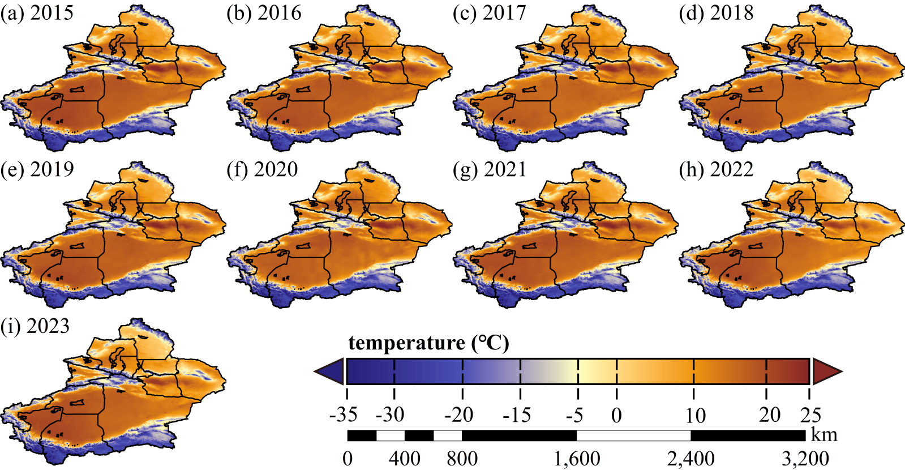
Fig.S5 Spatiotemporal distribution characteristics of temperature in Xinjiang from 2015 to 2023

