Supplementary file 6

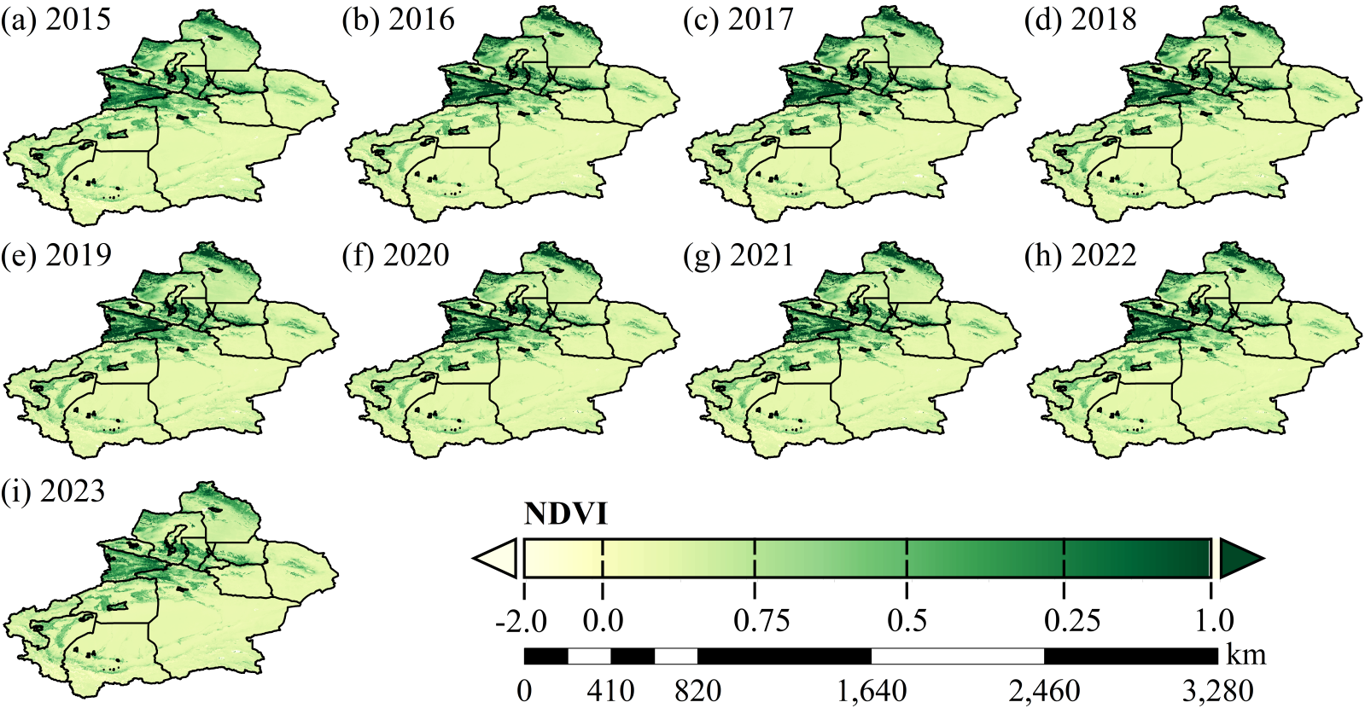
Fig.S2 Spatiotemporal distribution characteristics of NDVI in Xinjiang from 2015 to 2023

