Supplementary file 8

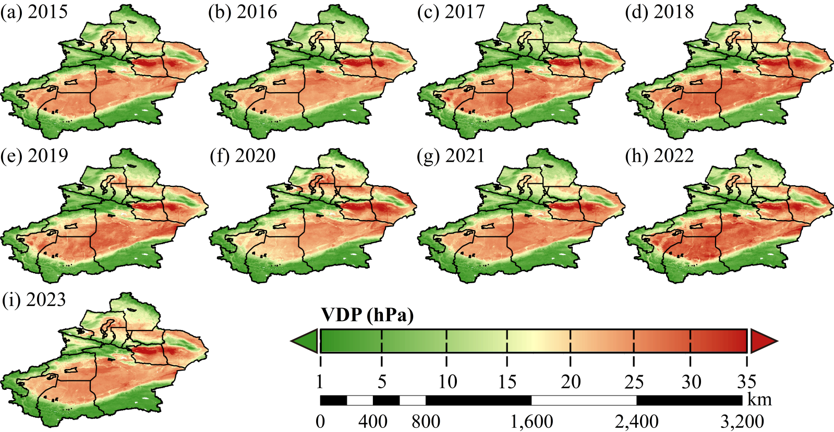
Fig.S4 Spatiotemporal distribution characteristics of Vapor Pressure Deficit(VDP) in Xinjiang from 2015 to 2023

