10. Supplementary Tables and Figures

S.Tb1: ICD codes used for analyses

Cause-specific death categories | ICD-codes
WHO-defined categories
Cancers (Malignant neoplasms) | C00-C97
Cardiovascular diseases | I00-I99
Neuropsychiatric conditions | F01-F99, G06-G98 (minus G14), U07.0, X41, X42, X44, X45
Constructed category for study with detail of subcategories
Others
Communicable, maternal, perinatal and nutritional conditions | A, B, U, D50-53 & D64.9, E00-02 & E40-46 & E50-64, J00-J22, N70-73
Non-communicable diseases | K, L, M, Q , D0-48 & D55-64 (minus D64.9) & D65-89, E03-07 & E10-34 & E65-88, J30-J98, N00-64 & N75-98
Injuries | V, W, X (except X41-42 & X44-45)
Ill-defined diseases | R (except for R95)

S.Tb2: Descriptive statistics of causes of specific deaths (N= 1754)

Cause of death | Categories | N | %
Cancers |  | 630 | 100
 | Respiratory System | 137 | 21.8
 | Digestive System | 132 | 21.0
 | Sex-specific organs (Prostate/Breast/Cervix uteri/Corpus Uteri/Ovary) | 117 | 18.6
 | Hormone Regulator Organs (Thyroid/Pancreas) | 66 | 10.5
 | Lymphomas/M.myeloma | 57 | 9.1
 | Cleansing Organs (Kidney/Liver) | 53 | 8.4
 | Ill defined | 23 | 3.7
 | Brain & Nervous system | 17 | 2.7
 | Melanoma/Skin cancer | 14 | 2.2
 | Other | 13 | 2.1
 | Larynx | 1 | 0.2
Cardiovascular diseases |  | 442 | 100
 | Ischemic Heart Disease | 136 | 30.8
 | Cerebrovascular Heart Disease | 126 | 28.5
 | Other Circulatory Diseases | 123 | 27.8
 | Ill-defined | 42 | 9.5
 | Inflammatory Heart Disease | 9 | 2.0
 | Hypertensive Heart Disease | 6 | 1.4
Neuropsychiatric conditions |  | 228 | 100
 | Alzheimer/Dementia/Parkinsons | 186 | 81.6
 | Illicit Substance Disorder (Alcohol/Drugs) | 22 | 9.7
 | Other | 12 | 5.3
 | Epilepsy & Insomnia | 7 | 3.1
 | Unipolar depressive disorders | 1 | 0.4
Other causes |  | 454 | 100
 | Respiratory infections & diseases | 166 | 36.6
 | Uninentional injury | 72 | 15.9
 | Digestive diseases | 47 | 10.4
 | Ill defined diseases | 32 | 7.1
 | Covid & Other infectious diseases | 32 | 7.1
 | Genitourinary diseases | 27 | 6.0
 | Endocrine disorders & Diabetes | 26 | 5.7
 | Other neoplasm(non malignant) | 17 | 3.7
 | Nutritional defiency | 12 | 2.6
 | Self inflicted injuries | 9 | 2.0
 | Musculoskeletal disorders | 4 | 0.9
 | Skin diseases | 4 | 0.9
 | Congenital anomalies | 2 | 0.4
 | Diarrhoeal disease | 2 | 0.4
 | Violence | 2 | 0.4

S.Tb3: Hazard ratios for all-cause mortality according to SII groups in the total study population and by age groups. The Tromsø Study 1994-2016.

 | Study Sample (N=9879) |  |  | [25-52]y. (N=6785) |  | [53-59]y. (N=1679) |  |  |  | [60-65]y. (N=846) |  |  |  | [66-74]y. (N=569)
Models | Medium SII | Low SII |  | Medium SII | Low SII | Medium SII |  | Low SII |  | Medium SII |  | Low SII |  | Medium SII |  | Low SII
Model 0 (Crude) | 1.21  (1.07; 1.38) | 1.4  (1.13; 1.74) |  | 1.23  (0.95; 1.59) | 1.64  (1.03; 2.61) |  | 1.56  (1.18; 2.06) |  | 2.18  (1.39; 3.43) |  | 1.07  (0.83; 1.38) |  | 1.41  (0.95; 2.09) |  | 1.1  (0.87; 1.4) |  | 1  (0.67; 1.49)
Model 1 (all confounders) | 1.15  (1.02; 1.31) | 1.42  (1.14; 1.76) |  | 1.12  (0.87; 1.45) | 1.4  (0.87; 2.24) |  | 1.46  (1.1; 1.93) |  | 2.17  (1.38; 3.43) |  | 1.01  (0.78; 1.3) |  | 1.4  (0.93; 2.1) |  | 1.12  (0.87; 1.43) |  | 1.15  (0.76; 1.75)
Model 1a (Model 1  + all health  behaviors) | 1.08  (0.95; 1.23) |  | 1.26  (1.01; 1.57) | 1.06  (0.81; 1.37) | 1.2  (0.75; 1.94) |  | 1.36  (1.02; 1.81) |  | 1.88  (1.19; 2.98) |  | 0.94  (0.72; 1.22) |  | 1.29  (0.85; 1.97) |  | 1.06  (0.82; 1.37) |  | 1.08  (0.7; 1.65)
Model 1b (Model 1 + perceived health & difficulties) | 1.1  (0.97; 1.25) | 1.31  (1.05; 1.63) |  | 1.06  (0.82; 1.38) | 1.17  (0.72; 1.9) |  | 1.31  (0.99; 1.74) |  | 1.95  (1.23; 3.09) |  | 0.95  (0.73; 1.24) |  | 1.31  (0.86; 1.98) |  | 1.1  (0.85; 1.41) |  | 1.13  (0.74; 1.72)
Model 1c (Model 1 + BHS) | 1.15  (1.01; 1.3) | 1.38  (1.11; 1.73) |  | 1.12  (0.86; 1.45) | 1.37  (0.85; 2.19) |  | 1.43  (1.08; 1.9) |  | 2.05  (1.3; 3.24) |  | 1.01  (0.78; 1.3) |  | 1.44  (0.96; 2.17) |  | 1.1  (0.86; 1.41) |  | 1.11  (0.72; 1.7)
Model 1c bis (Model 1 + all treatment drugs + BHS) | 1.14  (1; 1.29) | 1.39  (1.11; 1.74) |  | 1.11  (0.86; 1.44) | 1.37  (0.85; 2.2) |  | 1.44  (1.08; 1.92) |  | 2.08  (1.31; 3.3) |  | 1.02  (0.79; 1.31) |  | 1.5  (0.99; 2.27) |  | 1.07  (0.83; 1.39) |  | 1.14  (0.73; 1.78)
Model 2 (fully adjusted) | 1.04  (0.92; 1.18) | 1.19  (0.95; 1.49) |  | 1.01  (0.78; 1.31) | 1.04  (0.64; 1.69) |  | 1.27  (0.94; 1.7) |  | 1.73  (1.08; 2.77) |  | 0.92  (0.71; 1.21) |  | 1.27  (0.83; 1.96) |  | 1.02  (0.78; 1.34) |  | 1.1  (0.71; 1.71)

S.Tb4: Hazard ratios for cause-specific mortality according to SII groups in the total study population (N=9879). The Tromsø Study 1994-2016.

 | Cancers  (N= 9879, N_{cancer death}=630) |  | Cardiovascular diseases (CVD)  (N= 9879, N _{CVD death}=442) |  | Neuropsychiatric conditions  (N= 9879, N neuropsychiatric conditions death = 228) |  | Other causes  (N= 9879,  N_{other causes} = 454)
Models | Medium SII | Low SII | Medium SII | Low SII | Medium SII | Low SII | Medium SII | Low SII
M 0 (Crude) | 1.28  (1.03; 1.58) | 1.38  (0.97; 1.98) | 1.22  (0.94; 1.57) | 1.29  (0.83; 1.99) | 1.08  (0.75; 1.55) | 1.24  (0.71; 2.18) | 1.2  (0.93; 1.55) | 1.61  (1.11; 2.33)
M1 (all confounders) | 1.22  (0.98; 1.51) | 1.35  (0.93; 1.94) | 1.15  (0.89; 1.49) | 1.33  (0.85; 2.07) | 1.06  (0.73; 1.53) | 1.44  (0.82; 2.56) | 1.12  (0.87; 1.45) | 1.58  (1.08; 2.31)
M1a (M1 + all health behaviors) | 1.14  (0.92; 1.42) | 1.21  (0.84; 1.75) | 1.07  (0.83; 1.39) | 1.18  (0.75; 1.85) | 0.98  (0.67; 1.43) | 1.33  (0.75; 2.37) | 1.05  (0.81; 1.37) | 1.38  (0.94; 2.03)
Model 1b (M1 + perceived health & difficulties) | 1.18  (0.95; 1.47) | 1.28  (0.89; 1.85) | 1.1  (0.85; 1.43) | 1.22  (0.78; 1.91) | 0.97  (0.67; 1.41) | 1.3  (0.73; 2.31) | 1.06  (0.82; 1.38) | 1.46  (1; 2.15)
M1c (M1 + BHS) | 1.21  (0.98; 1.5) | 1.32  (0.91; 1.9) | 1.15  (0.89; 1.48) | 1.27  (0.81; 1.99) | 1.06  (0.73; 1.53) | 1.45  (0.82; 2.57) | 1.11  (0.86; 1.44) | 1.53  (1.05; 2.25)
M1c bis (M1 + all treatment drugs + BHS) | 1.21  (0.98; 1.5) | 1.32  (0.91; 1.9) | 1.12  (0.86; 1.45) | 1.34  (0.85; 2.11) | 1.07  (0.74; 1.55) | 1.44  (0.81; 2.55) | 1.1  (0.85; 1.42) | 1.51  (1.03; 2.23)
M2 (fully adjusted) | 1.12  (0.9; 1.39) | 1.16  (0.8; 1.68) | 1.02  (0.78; 1.33) | 1.12  (0.71; 1.78) | 0.92  (0.63; 1.35) | 1.26  (0.7; 2.25) | 1.01  (0.77; 1.32) | 1.29  (0.87; 1.91)

S.Tb5:Hazard ratios for all-cause mortality according to SII groups in complete cases. The Tromsø Study 1994-2016.

 | Study Sample (N=6486)
Models | Medium SII | Low SII
Model 0 (Crude) | 1.24 (1.06; 1.44) | 1.56 (1.2; 2.02)
Model 1 (all confounders) | 1.2 (1.03; 1.39) | 1.61 (1.24; 2.1)
Model 1a (Model 2 + all health behaviors) | 1.1 (0.94; 1.29) | 1.47 (1.12; 1.91)
Model 1b (Model 2 + perceived health & difficulties) | 1.12 (0.96; 1.3) | 1.41 (1.08; 1.84)
Model 1c (Model 2 + BHS) | 1.19 (1.02; 1.39) | 1.63 (1.25; 2.13)
Model 1c bis (Model 2 + all treatment drugs + BHS) | 1.2 (1.03; 1.4) | 1.67 (1.28; 2.18)
Model 3 (fully adjusted) | 1.06 (0.91; 1.24) | 1.35 (1.03; 1.76)

S.Fig1: Kaplan Meier Curves by SII over participant’s age* (staggered participant entry) in the total study population (N=9879). The Tromsø Study 1994-2016
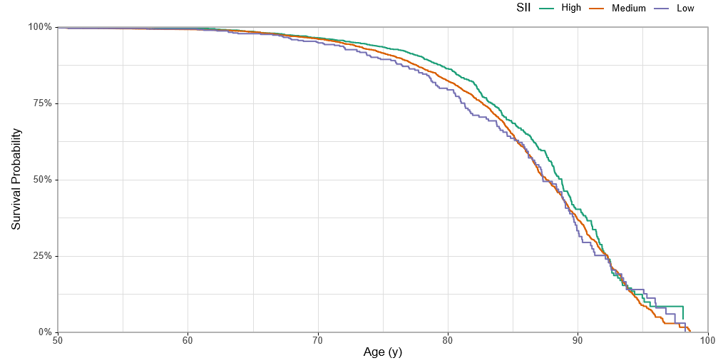

* : the x-axis represents age as a time-scale, using participants’ age at wave 6 as entry points and age at death or on the censoring date as exit points.

S.Fig2: Kaplan Meier Curves by SII over participant’s age* (staggered participant entry) in age-stratified samples. The Tromsø Study 1994-2016.
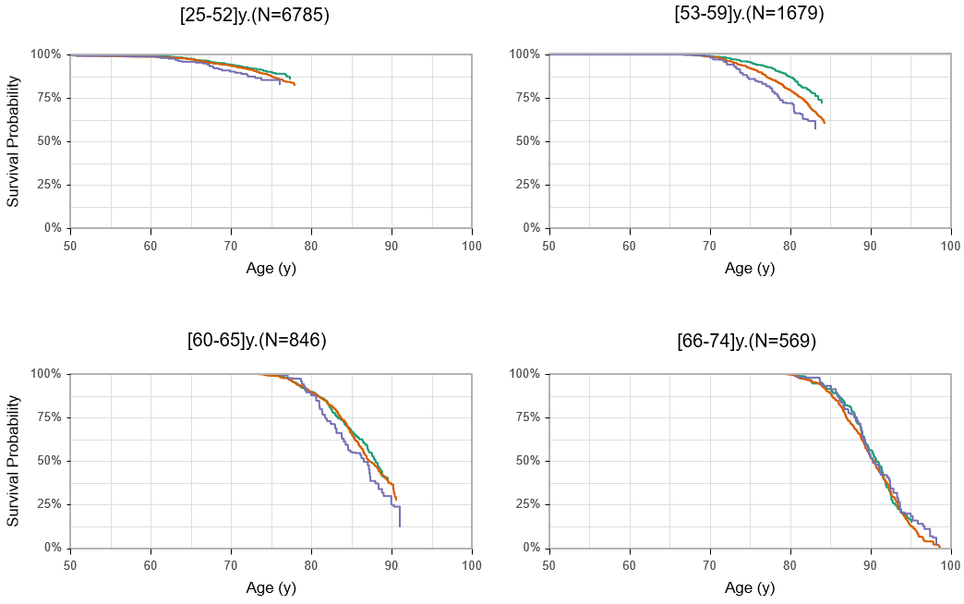

* : the x-axis represents age as a time-scale, using participants’ age at wave 6 as entry points and age at death or on the censoring date as exit points.

S.Fig 3: Hazard ratios for all-cause mortality according to SII groups in sex-stratified samples in each age-group sample. The Tromsø Study 1994-2016.

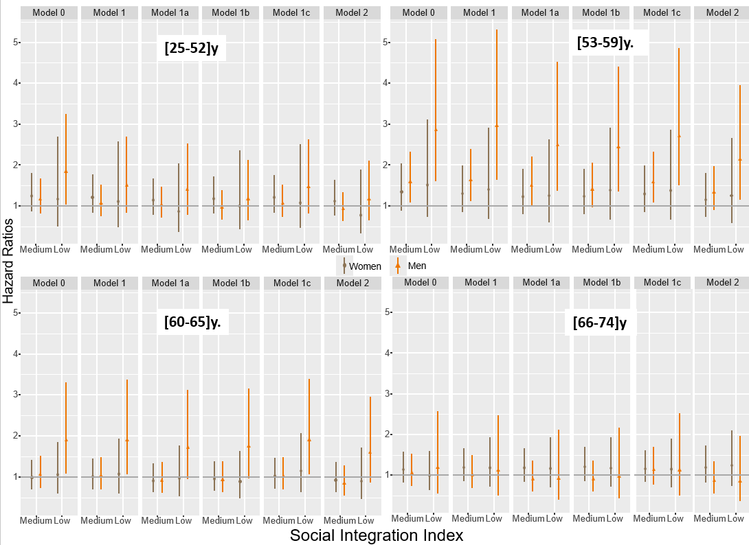

1

Model 0: crude; Model 1: adjusted for all confounders; Model 1a: model 1 + health behaviours; Model 1b: model 1 + perception variables;
Model 1c: model 1 + BHS; Model 2 fully adjusted

S.Fig4: Hazard ratios for cause-specific mortality according to SII groups in the total study population (N=9879). The Tromsø Study 1994-2016
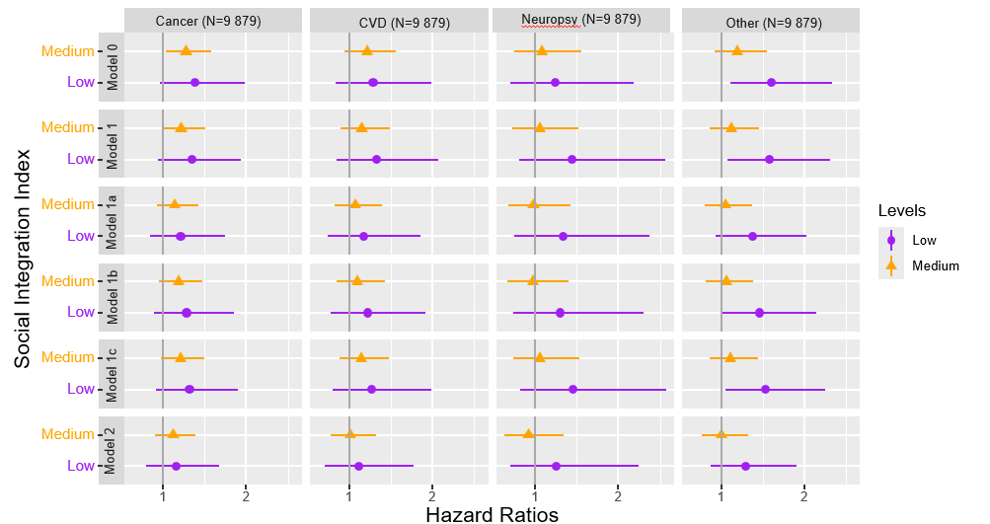
BHS: biological health score; CVD: cardiovascular disease; neuropsy: neuropsychiatric conditions.
Model 0: crude; Model 1: adjusted for all confounders; Model 1a: model 1 + health behaviours; Model 1b: model 1 + perception variables;
Model 1c: model 1 + BHS; Model 2 fully adjusted

