Prevalence of cigarette and e-cigarette dual use and associated factors among smokers in China aged 20-69 years

Supplementary Figure S1 The flowchart of participants inclusion process in this study
Supplementary Figure S2 The flowchart of sampling procedure of the survey
Supplementary Table S1 Quality control of the survey at all stages
Supplementary Table S2 Data missingness of the covariates
Supplementary Table S3 Prevalence of dual-use of cigarette and e-cigarette in provinces across China
Supplementary Text S1 2018 China Health Literacy Survey Questions (Tobacco Component Related Questions)

Supplementary Figure S1 The flowchart of participants inclusion process in this study

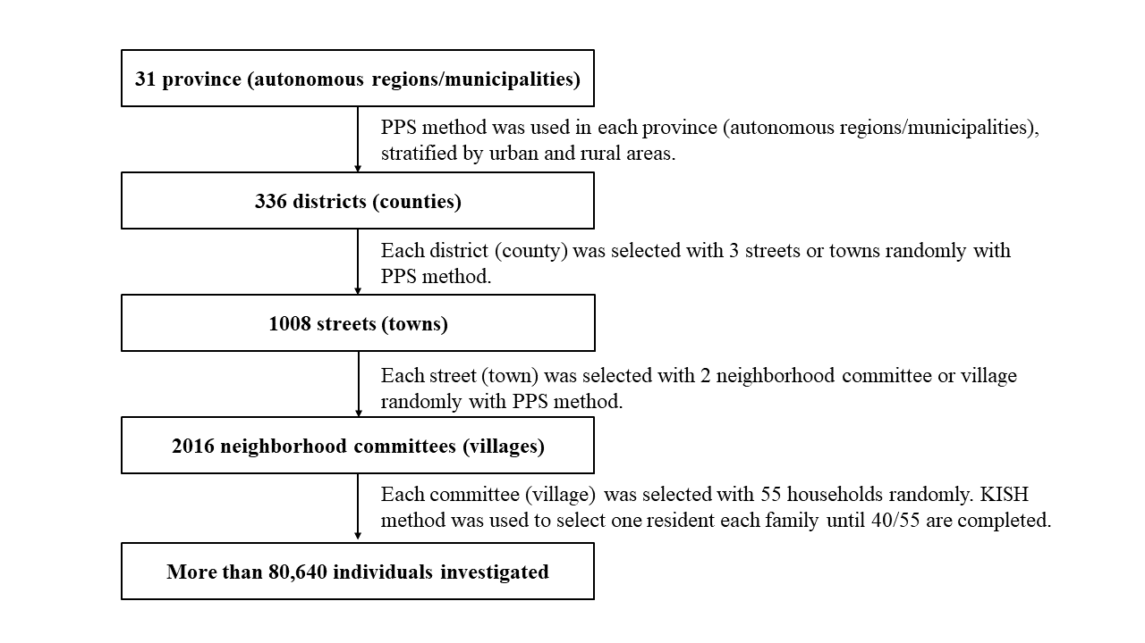
Supplementary Figure S2 The flowchart of sampling procedure of the survey
Notes: The number of monitoring sites in each province is determined based on factors such as the size of the population in each province, the ratio of urban to rural population and meeting the minimum sample requirement for the survey. All county-level units whose administrative divisions are districts are considered urban monitoring sites, and those whose administrative divisions are counties are considered rural monitoring sites. The proportion of urban and rural monitoring points in each province is allocated according to the proportion of urban and rural households in that province.
Abbreviation: PPS, population proportionate sampling.

Supplementary Table S1 Quality control of the survey at all stages
Stage | Quality control measures
Pre-survey | - Field surveys strictly follow the designated sampling method to complete the multistage sampling.  - Provincial training is completed at the national level, and the provincial level takes responsible for training municipal level and monitoring staff in the use of a unified procedure and operational manual.
During the survey | - Conduct field surveys in strict accordance with the monitoring implementation plan. Obtain full participation from relevant local agencies and survey respondents.  - Use a uniform questionnaire to conduct the survey. In principle, survey respondents should complete the questionnaire on their own, without any explanation from the surveyor. If the respondents have difficulties in reading or writing and cannot complete the questionnaire independently, they will be asked by the surveyor, without inducing or suggestive language.  - The surveyor should check the questionnaire on the spot, and the quality control officer should review all questionnaires for the day and fill in the quality control records.  - One monitoring site is randomly selected for review at the national level in each province (autonomous regions/municipalities). All monitoring sites in the province are reviewed at the provincial level. (15 questionnaires are selected from each monitoring site. If unqualified questionnaires exceed three, the on-site survey and must be re-surveyed.
Data processing and analysis phase | - National level staff carefully verified the information collected and compared a sample of answer cards with the original questionnaires. Data was entered and verified using machine readable answer cards scanned for entry.  - Data was cleaned and logically checked using data analysis software, and failed questionnaires were removed. Monitoring sites with a high number of non-conforming questionnaires were highlighted for verification.

Supplementary Table S2 Data missingness of the covariates
Factors | Number of missing values (N) | Percentage of missing values (%)
Sex | 0 | 0.00%
Ethnicity | 23 | 0.11%
Marital status | 16 | 0.07%
Education level | 36 | 0.17%
Income | 47 | 0.22%
Self-reported health status | 62 | 0.29%
Region | 0 | 0.00%
Smoking status | 0 | 0.00%
Nicotine dependence | 0 | 0.00%
FTND | 0 | 0.00%
Continue to use tobacco after it caused physical problems | 5 | 0.02%
Continue to use tobacco after it caused mental problems | 12 | 0.06%
Trying to quit or cut down on tobacco but failed | 9 | 0.04%
Smoking duration | 4653 | 21.56%
Cigarette smoked per day | 124 | 0.57%
Smoking pack-years | 4343 | 20.12%
Smoking starting mean age | 111 | 0.51%
Notes: We used different methods for different types of values: Ordered categorical variables were filled with the median; Unordered categorical variables were imputed with the largest category. Abbreviations: FTND, Fagerström Test for Nicotine Dependence.

Supplementary Table S3 Prevalence of dual-use of cigarette and e-cigarette in provinces across China
 | Ever-users |  |  |  | Current users
 | Overall | Exclusive cigarette use | Dual-use of cigarette and e-cigarette | Proportion (%) | Overall | Exclusive cigarette use | Dual-use of cigarette and e-cigarette | Proportion (%)
Anhui | 6647291 | 6302189.8 | 345101.2 | 5.19 | 5799138.8 | 5454037.6 | 345101.2 | 5.95
Beijing | 2906514 | 2393670.9 | 512843.5 | 17.64 | 2476040.5 | 1993929.4 | 482111.1 | 19.47
Chongqing | 5084173 | 5065914.5 | 18258.5 | 0.36 | 4743555.7 | 4730817.6 | 12738.1 | 0.27
Fujian | 5693433 | 5423312.8 | 270120.4 | 4.74 | 5031638.2 | 4765501.8 | 266136.4 | 5.29
Gansu | 6091300 | 5966611.7 | 124687.9 | 2.05 | 5741780.6 | 5617092.7 | 124687.9 | 2.17
Guangdong | 30533784 | 29453165.5 | 1080619 | 3.54 | 27307743.9 | 26257588.9 | 1050155.0 | 3.85
Guangxi | 8021506 | 7637289.0 | 384217.4 | 4.79 | 7252003.4 | 6898360.6 | 353642.8 | 4.88
Guizhou | 13279816 | 12858607.7 | 421208.4 | 3.17 | 12662740.6 | 12247820.4 | 414920.2 | 3.28
Hainan | 2674487 | 2619612.4 | 54874.9 | 2.05 | 2599774.2 | 2544899.4 | 54874.9 | 2.11
Hebei | 9208713 | 8789395.7 | 419317.4 | 4.55 | 8558891.3 | 8146023.4 | 412867.9 | 4.82
Heilongjiang | 4787049 | 4727876.3 | 59172.7 | 1.24 | 4491134.4 | 4455683.3 | 35451.1 | 0.79
Henan | 12590277 | 12140571.8 | 449705.4 | 3.57 | 11113633.2 | 10679907.5 | 433725.7 | 3.90
Hubei | 9324637 | 9158555.4 | 166081.3 | 1.78 | 8487978.3 | 8348186.7 | 139791.6 | 1.65
Hunan | 8250817 | 8117570.8 | 133245.9 | 1.61 | 7507169.2 | 7379160.2 | 128009.0 | 1.71
Jiangsu | 20506992 | 19460405.8 | 1046586 | 5.1 | 17162876.0 | 16338463.6 | 824412.4 | 4.80
Jiangxi | 7753137 | 7634522.9 | 118614.1 | 1.53 | 6904341.3 | 6785727.2 | 118614.1 | 1.72
Jilin | 3997808 | 3935980.5 | 61827 | 1.55 | 3585497.4 | 3523670.4 | 61827.0 | 1.72
Liaoning | 5782294 | 5440400.5 | 341893.8 | 5.91 | 5152249.6 | 4831051.9 | 321197.7 | 6.23
Neimeng | 5188533 | 4990593.2 | 197940.1 | 3.81 | 4943853.6 | 4745913.4 | 197940.1 | 4.00
Ningxia | 691855.9 | 667161.4 | 24694.5 | 3.57 | 631648.4 | 613771.9 | 17876.6 | 2.83
Qinghai | 1630928 | 1595868.4 | 35059.4 | 2.15 | 1530275.3 | 1495215.9 | 35059.4 | 2.29
Shaanxi | 4558419 | 4396991.5 | 161427.6 | 3.54 | 4229718.0 | 4068290.3 | 161427.6 | 3.82
Shandong | 7621434 | 7610522.5 | 10911.9 | 0.14 | 7039559.1 | 7028647.2 | 10911.9 | 0.16
Shanghai | 2559441 | 2521833.7 | 37606.8 | 1.47 | 2312777.8 | 2278467.1 | 34310.7 | 1.48
Shanxi | 7177915 | 7005187.8 | 172727.6 | 2.41 | 6727812.5 | 6593616.2 | 134196.3 | 1.99
Sichuan | 19835486 | 19553451.4 | 282034.7 | 1.42 | 18473913.7 | 18272769.9 | 201143.8 | 1.09
Tianjin | 2023183 | 1954981.5 | 68201.6 | 3.37 | 1760390.6 | 1692189.0 | 68201.6 | 3.87
Xinjiang | 2126284 | 2100301.9 | 25982.5 | 1.22 | 2007469.5 | 1983053.3 | 24416.2 | 1.22
Xizang | 295646.9 | 289151.4 | 6495.5 | 2.2 | 247129.9 | 245545.9 | 1584.0 | 0.64
Yunnan | 14872960 | 14648584.8 | 224375 | 1.51 | 14047909.4 | 13823534.4 | 224375.0 | 1.60
Zhejiang | 9240518 | 8866416.2 | 374102.2 | 4.05 | 7874919.6 | 7521401.2 | 353518.4 | 4.49
Notes: Hong Kong, Macao, and Taiwan were not included in the survey.

Supplementary Text S1 2018 China Health Literacy Survey Questions
(Tobacco Component Related Questions)

E01. Do you smoke?
①Daily smoking (Please turn to "E02")
②Occasional smoking (Please turn to "E03")
③Quit smoking (Smoking cessation is defined as not smoking for 24 hours or more.) (Note: For the following questions, if no time is required, answer the status before you quit, and if time is required, e.g., "in the past year," answer the status one year before you quit.)
④Never smoking (End of questionnaire.)

E02. Age of initiation of regular smoking: years old.

E03. Age of first cigarette smoking: years old.

E04. Average number of cigarettes smoked per day:

E05. Duration of smoking: years months

E06. Do you consider yourself addicted to smoking?
①YES
②NO

E07. Do you find it difficult to control your smoking behavior?
①YES
②NO

E08. In the past year, on average, how long did it take you to wake up in the morning and smoke your first cigarette?
①Less than or equal to 5 minutes
②6-30 minutes
③31-60 minutes
④More than 60 minutes

E09. Which cigarette was the hardest for you to give up?
①First cigarette in the morning
②After meals
③Before bed
④To the restroom
⑤Work
⑥Other:

E10. In the past year, did you have to increase the number of cigarettes you smoked to get the same feeling you had before you smoked?
①YES
②NO

E11. In the past year, have you been able to refrain from smoking in places where smoking is prohibited?
①YES
②NO

E12. Do you know the dangers of smoking but still smoke?
①YES
②NO

E13. Do you still smoke when you are sick in bed?
①YES
②NO

E14. In the past year, have you given up or reduced other activities and preferences in order to smoke?
①YES
②NO

E15. When stopping smoking or reducing the amount of cigarettes you smoke, do you experience any of the following? (Multiple answers allowed)
①None ② Urge to smoke ③ Anxiety ④ Depression ⑤ Difficulty concentrating
⑥ Fidgeting ⑦ Activity ⑧ Easily loses temper ⑨Irritability, frustration, or anger
⑩ Depressed mood ⑪ Mouth ulcers ⑫ Increased appetite ⑬ Increased weight
⑭ Indigestion ⑮ Constipation ⑯ Unconscious trembling of hands ⑰ Headache
⑱ Low pulse rate ⑲ Drowsiness ⑳Other

E16. Are you planning to quit smoking?
①Yes, within the last month.
②Yes, within the last six months.
③Yes, within one year.
④Yes, after one year.
⑤No.
⑥Not applicable. (for those who have quitted smoking)

