Supplementary table 1: Characteristics of included studies
Author year | Country | WHO region | Study population | Age (mean/range) | Male (%) | Study design | Sample size | NCHTN | P
CDC 2011 (1) | USA | Americas | Adult hypertensive patients | 18-65 | 0.30 | Cross-sectional | 10037 | 6468 | 64.44
Abd El-Aty 2015 (2) | Oman | Eastern Mediterranean | Adult hypertensive patients | 18-60 | 52.07 | Cross-sectional | 3478 | 2278 | 65.50
Abdisa 2022 (3) | Ethiopia | African | Adult hypertensive patients | 50 | 53.01 | Cross-sectional | 415 | 199 | 47.95
Aberhe 2020 (4) | Ethiopia | African | Adult hypertensive patients | 52.5 | 43.99 | Cross-sectional | 391 | 190 | 48.59
Abid 2022 (5) | Tunisia | Eastern Mediterranean | Adult hypertensive patients | 64.4 | 44.67 | Cross-sectional | 23601 | 11395 | 48.28
Abu Farha 2016 (6) | Jordan | Eastern Mediterranean | Adult hypertensive patients | 59.7 | 39.50 | Cross-sectional | 200 | 97 | 48.50
Adeniyi 2016 (7) | South Africa | African | Adult living with T2DM and hypertension |  | 28.30 | Cross-sectional | 265 | 200 | 75.47
Ahluwalia 2010 (8) | US | Americas | Adult hypertensive patients | 40-64 | 0.00 | Cross-sectional | 410 | 156 | 38.05
Ahmed 2008 (9) | Pakistan | Eastern Mediterranean | Adult hypertensive patients | 55.8 | 24.72 | Cross-sectional | 89 | 66 | 74.16
Akhtar 2023 (10) | Pakistan | Eastern Mediterranean | Adult hypertensive patients | 56.09 | 26.02 | Cross-sectional | 246 | 172 | 69.92
Al Bannay 2014 (11) | Bahrain | Eastern Mediterranean | Adult hypertensive patients | 54.6 | 67.12 | Cross-sectional | 371 | 125 | 33.69
Alam 2016 (12) | Pakistan | Eastern Mediterranean | Adult hypertensive patients | 51 | 51.67 | Cross-sectional | 120 | 82 | 68.33
Alam 2003 (13) | US | Americas | Adult hypertensive patients | 65 | 0.00 | Cross-sectional | 585 | 245 | 41.88
Alami 2017 (14) | Morocco | Eastern Mediterranean | Adult hypertensive patients | 56.8 | 37.62 | longitudinal study | 909 | 505 | 55.56
Alba-Leonel 2016 (15) | Mexico | Americas | Adult hypertensive patients | 61.2 | 0.00 | Cross-sectional | 281 | 176 | 62.63
Almalki 2020 (16) | Saudi Arabia | Eastern Mediterranean | Adult living with T2DM and hypertension | 26-65 | 38.54 | Cross-sectional | 1178 | 846 | 71.82
Almas 2014 (17) | Pakistan | Eastern Mediterranean | adult hypertensive patients | 57.7 | 50.11 | Cross-sectional | 447 | 124 | 27.74
Al-Nimer 2017 (18) | Iraq | Eastern Mediterranean | adult hypertensive patients | 61 | 30.93 | Cross-sectional | 97 | 80 | 82.47
Alonso Moreno 2005 (19) | Spain | European | adult hypertensive patients | 63.3 | 42.70 | Cross-sectional | 12754 | 8150 | 63.90
Alonso-Moreno 2008 (20) | Spain | European | adult hypertensive patients | 64.6 | 46.30 | Cross-sectional | 10520 | 6165 | 58.60
Al-Saadi 2011 (21) | Oman | Eastern Mediterranean | adult hypertensive patients | 57 | 31.63 | retrospective | 411 | 251 | 61.07
Alsairafi 2010 (22) | Kuwait | Eastern Mediterranean | adult hypertensive patients | <40->50 | 36.25 | Cross-sectional | 240 | 106 | 44.17
Amaike 2024 (23) | Nigeria | African | adult hypertensive patients | 35-65 | 27.10 | Cross-sectional | 321 | 261 | 81.31
Amar 2003 (24) | France | European | adult hypertensive patients |  | 1.62 | Cross-sectional | 4019 | 2486 | 61.86
Amar 2002 (25) | France | European | adult hypertensive patients | <=55->55 | 0.00 | Cross-sectional | 14066 | 9607 | 68.30
Ammann 2023 (26) | US | Americas | adult hypertensive patients | 70 | 49.01 | retrospective cohort study | 207705 | 62312 | 30.00
Angell 2008 (27) | US | Americas | adult hypertensive patients | 20-65+ | 43.19 | Cross-sectional | 389 | 206 | 52.96
Antignac 2018 (28) | Sub-Saharan African countries | African | adult hypertensive patients | 58.3 | 39.76 | Cross-sectional | 2198 | 1692 | 76.98
Arabzadeh 2014 (29) | Iran | Eastern Mediterranean | adult hypertensive patients | 61.1 | 48.25 | Cross-sectional | 114 | 71 | 62.28
Arambam 2022 (30) | India | South-East Asia | adult hypertensive patients | <40->60 | 0.00 | Cross-sectional | 335 | 211 | 62.99
Asgedom 2016 (31) | Ethiopia | African | adult hypertensive patients | 54.8 | 53.85 | Cross-sectional | 286 | 142 | 49.65
Ataro 2023 (32) | Ethiopia | African | adult hypertensive patients |  | 0.00 | Cross-sectional | 384 | 142 | 36.98
Azeez 2020 (33) | Nigeria | African | adult hypertensive patients | 59.3 | 20.35 | Cross-sectional | 403 | 239 | 59.31
Azizi 2002 (34) | Iran | Eastern Mediterranean | adult hypertensive patients | 20-69 | 0.00 | Cross-sectional | 654 | 392 | 59.94
Babiker 2013 (35) | Sudan | African | adult hypertensive patients |  | 46.00 | Cross-sectional | 200 | 68 | 34.00
Bahrey 2019 (36) | Ethiopia | African | adult hypertensive patients | 54.14 | 49.83 | Cross-sectional | 578 | 250 | 43.25
Balijepalli 2014 (37) | Germany | European | adult hypertensive patients | 18-84< | 44.52 | Cross-sectional | 19567 | 7603 | 38.86
Balint 2016 (38) | Germany | European | adult hypertensive patients | 64.1 | 72.73 | Cross-sectional | 143 | 82 | 57.34
Banegas 2014 (39) | Spain | European | adult hypertensive patients | 59 | 51.72 | Registry | 14840 | 4608 | 31.05
Baray 2023 (40) | Afghanistan | Eastern Mediterranean | adult hypertensive patients | 47.5 | 50.53 | Cross-sectional | 853 | 659 | 77.26
Barbosa 2019 (41) | Brazil | Americas | adult hypertensive patients | 52 | 0.00 | Cross-sectional | 3396 | 977 | 28.77
Barbosa 2020 (42) | Brazil | Americas | adult hypertensive patients | 54 | 0.00 | Cross-sectional | 8435 | 2777 | 32.92
Barega 2023 (43) | Ethiopia | African | adult hypertensive patients | 55.5 | 50.95 | Cross-sectional | 369 | 222 | 60.16
Barletta 2021 (44) | Brazil | Americas | adult hypertensive patients | 66.09 | 0.00 | Cross-sectional | 181 | 101 | 55.80
Barochiner 2019 (45) | Argentina | Americas | adult hypertensive patients | 58.6 | 51.46 | Cross-sectional | 103 | 23 | 22.33
Basta 2024 (46) | UK | European | adult hypertensive patients |  | 0.00 | Cross-sectional | 44648 | 20895 | 46.80
Basu 2023 (47) | India | South-East Asia | adult hypertensive patients | 15-49 | 0.00 | Cross-sectional | 20697 | 5580 | 26.96
Bauk 2015 (48) | Argentina | Americas | adult hypertensive patients | 56.8 | 50.60 | Cross-sectional | 83 | 56 | 67.47
Bawazir 2018 (49) | Indonesia | South-East Asia | adult hypertensive patients | 53.05 | 29.41 | Cross-sectional | 646 | 575 | 89.01
Ben-Hamouda-Chihaoui 2011 (50) | Tunisie | Eastern Mediterranean | adult hypertensive patients | 61.2 | 0.00 | Cross-sectional | 300 | 230 | 76.67
Benner 2008 (51) | US | Americas | adult hypertensive patients | 40-79 | 55.56 | Cross-sectional | 1575 | 247 | 15.68
Berhe 2019 (52) | Singapore | Western Pacific | adult hypertensive patients | 40-60 | 47.07 | Cohort | 3178 | 1983 | 62.40
Bøg-Hansen 2003 (53) | Sweden | European | adult hypertensive patients | 40-79 | 42.17 | Cross-sectional | 894 | 384 | 42.95
Borghi 2016 (54) | European countries | European | adult hypertensive patients | 65.5 | 47.85 | Cross-sectional | 5220 | 2691 | 51.55
Brandt 2020 (55) | Germany | European | adult hypertensive patients | 62.9 | 0.00 | Cross-sectional | 2289 | 1540 | 67.28
Brenner 2011 (56) | Switzerland | European | adult hypertensive patients | 65.1 | 0.00 | Cross-sectional | 1376 | 702 | 51.02
Buckley 2020 (57) | Ireland | European | adult hypertensive patients | 64.7 | 46.22 | Cross-sectional | 1534 | 861 | 56.13
Çalışkan 2022 (58) | Türkiye | European | adult hypertensive patients | 62.2 | 43.01 | Cross-sectional | 186 | 89 | 47.85
Carlsson 2009 (59) | Sweden | European | adult hypertensive patients | 60 | 48.16 | Cross-sectional | 4228 | 2984 | 70.58
Castillo-Nájera 2016 (60) | Mexico | Americas | adult hypertensive patients | 61.2 | 38.08 | Cross-sectional | 281 | 176 | 62.63
Cha 2012 (61) | Korea | South-East Asia | adult hypertensive patients | 51 | 48.56 | Cross-sectional | 1217 | 649 | 53.33
Charpentier 2002 (62) | France | European | adult living with T2DM and hypertension |  | 0.00 | Cross-sectional | 3085 | 2362 | 76.56
Cherfan 2020 (63) | France | European | adult hypertensive patients | 59.8 | 56.32 | Cross-sectional | 10710 | 6003 | 56.05
Cherfane 2024 (64) | France | European | adult hypertensive patients | 59.4 | 0.00 | Cross-sectional | 11760 | 6045 | 51.40
Chew 2012 (65) | Malaysia | Western Pacific | adult living with T2DM and hypertension | 58.32 | 39.91 | Cross-sectional | 56503 | 43223 | 76.50
Cho 2016 (66) | Korea | South-East Asia | adult hypertensive patients | 56.1 | 51.86 | Cohort | 6506 | 1925 | 29.59
Choo 2014 (67) | Korea | South-East Asia | adult living with T2DM and hypertension | 63 | 57.00 | Cross-sectional | 621 | 163 | 26.25
Farhadi 2023 (68) | Iran | Eastern Mediterranean | adult hypertensive patients | 61.1 | 41.25 | longitudinal study | 4388 | 2709 | 61.74
Chotruangnapa 2022 (69) | Tailand | South-East Asia | adult hypertensive patients | 62.94 | 39.40 | Cross-sectional | 1406 | 622 | 44.24
Choudhary 2016 (70) | India | South-East Asia | adult hypertensive patients | 57.06 | 64.72 | Cross-sectional | 958 | 600 | 62.63
Chu 2015 (71) | Korea | South-East Asia | adult hypertensive patients | 73 | 36.02 | Cross-sectional | 733 | 150 | 20.46
Chudek 2021 (72) | Poland | European | adult hypertensive patients | 60 | 49.85 | Cross-sectional | 12289 | 8051 | 65.51
Coll-Brito 2021 (73) | Spain | European | adult hypertensive patients | 64.9 | 0.00 | Cross-sectional | 102 | 31 | 30.39
Coly 2008 (74) | US | Americas | adult hypertensive patients | 45.7 | 45.02 | Cross-sectional | 2039 | 1596 | 78.27
Cordero 2011 (75) | Spain | European | adult hypertensive patients | 66.1 | 50.10 | Cross-sectional | 10743 | 4794 | 44.62
Cortez-Dias 2013 (76) | Portugal | European | adult hypertensive patients | 64.5 | 39.90 | Cross-sectional | 8925 | 5730 | 64.20
Costa 2018 (77) | Brazil | Americas | adult hypertensive patients | 58.6 | 30.80 | Cross-sectional | 43647 | 25812 | 59.14
Coyle 2019 (78) | UK | European | adult hypertensive patients |  | 0.00 | Cross-sectional | 196052 | 49499 | 25.25
Czernichow 2012 (79) | France | European | adult obese hypertensive patients | 18-54 | 0.00 | Cross-sectional | 644 | 469 | 72.83
Dave 2013 (80) | US | Americas | adult hypertensive patients | 18-55+ | 30.64 | Cross-sectional | 2663 | 480 | 18.02
De Feo 2021 (81) | Italy | European | adult living with T2DM and hypertension | <35-65< | 0.00 | Cross-sectional | 27269 | 16630 | 60.99
De Giusti 2012 (82) | Italy | European | adult hypertensive patients | 60.3 | 56.91 | Cross-sectional | 376 | 199 | 52.93
Dedefo 2020 (83) | Ethiopia | African | adult living with T2DM and hypertension | 51.2 | 44.62 | Cross-sectional | 186 | 82 | 44.09
Del Pinto 2024 (84) | Italy | European | adult hypertensive patients | 59.99 | 58.18 | Cross-sectional | 636 | 353 | 55.50
Desta 2024 (85) | Ethiopia | European | adult living with T2DM and hypertension | <30-50< | 55.82 | Cross-sectional | 378 | 312 | 82.54
DeVore 2010 (86) | US | African | adult hypertensive patients | 66.4 | 51.24 | Cross-sectional | 121 | 49 | 40.50
Dhungana 2022 (87) | Nepal | Americas | adult hypertensive patients | 15-69 | 44.27 | Cross-sectional | 2792 | 2686 | 96.20
Di Bari 1999 (88) | Italy | South-East Asia | adult hypertensive patients | >=65 | 0.00 | Cross-sectional | 692 | 119 | 17.20
Dieteren 2021 (89) | Mexic | European | adult hypertensive patients | 70.07 | 44.66 | Cohort | 945 | 328 | 34.71
Du 2021 (90) | China | Western Pacific | adult hypertensive patients |  | 43.91 | Cross-sectional | 2462 | 896 | 36.39
Egan 2011 (91) | USA | Americas | adult hypertensive patients | 58.3 | 48.16 | Cross-sectional | 3555 | 1907 | 53.64
Eimicke 2021 (92) | Italy | European | adult hypertensive patients | 74.5 | 0.00 | Cross-sectional | 13162 | 9187 | 69.80
El Kardoudi 2022 (93) | Morocco | Eastern Mediterranean | adult hypertensive patients | 55.78 | 33.10 | Cross-sectional | 580 | 430 | 74.14
El Mawardy 2017 (94) | Egypt | Eastern Mediterranean | adult hypertensive patients | 55 | 56.27 | Cross-sectional | 4139 | 2630 | 63.54
El-Badawy 2005 (95) | Oman | Eastern Mediterranean | adult hypertensive patients | 20->60 | 43.00 | Cross-sectional | 100 | 73 | 73.00
Elperin 2014 (96) | USA | Americas | adult hypertensive patients |  | 45.88 | Cohort | 661075 | 107016 | 16.19
Essayagh 2019 (97) | Morocco | Eastern Mediterranean | adult hypertensive patients | 61.4 | 22.23 | Cross-sectional | 922 | 675 | 73.21
Fakhri 2020 (98) | Lebanon | Eastern Mediterranean | adult hypertensive patients | >=65 | 38.28 | Cross-sectional | 256 | 171 | 66.80
Filipiak 2018 (99) | Poland | European | adult hypertensive patients | 59.3 | 0.00 | Registry | 34919 | 15262 | 43.71
Galvis-Acevedo 2022 (100) | Colombia | European | adult hypertensive patients |  | 0.00 | Cross-sectional | 2656 | 1188 | 44.73
Gao 2022 (101) | China | Western Pacific | adult hypertensive patients | 61 | 52.84 | Cross-sectional | 1039 | 452 | 43.50
Gee 2012 (102) | Canada | Americas | adult hypertensive patients | 20->60 | 0.00 | Cross-sectional | 878 | 363 | 41.34
Ghazali 2020 (103) | Malaysia | Western Pacific | adult hypertensive patients | 28-93 | 42.39 | Cross-sectional | 460 | 211 | 45.87
Gijón-Conde 2015 (104) | Spain | European | adult hypertensive patients | 72.3 | 51.25 | Cross-sectional | 720 | 464 | 64.44
Gooding 2014 (105) | US | Americas | adult hypertensive patients | 29 | 0.00 | Cross-sectional | 3303 | 2531 | 76.63
Goverwa 2014 (106) | Zimbabwe | African | adult hypertensive patients | 63 | 37.29 | Cross-sectional | 354 | 238 | 67.23
Grassi 2011 (107) | eastern European countries | European | adult hypertensive patients | 60.1 | 0.00 | Cross-sectional | 1537 | 1160 | 75.47
Guessous 2012 (108) | Switzerland | European | adult hypertensive patients | 51.5 | 0.00 | Cross-sectional | 1099 | 446 | 40.58
Hakami 2022 (109) | Saudi Arabia | Eastern Mediterranean | adult hypertensive patients | 18-60+ | 48.31 | Cross-sectional | 354 | 210 | 59.32
Ham 2011 (110) | South Korea | Western Pacific | adult hypertensive patients | 62.4 | 38.84 | Cross-sectional | 690 | 315 | 45.65
He 2002 (111) | US | Americas | adult hypertensive patients | 57 | 47.66 | Cross-sectional | 5886 | 4566 | 77.57
Hikmayani 2024 (112) | Indonesia | South-East Asia | adult hypertensive patients | 57.3 | 17.68 | Cross-sectional | 164 | 75 | 45.73
Hirani 2024 (113) | India | South-East Asia | adult hypertensive patients | 65.2 | 51.91 | Cross-sectional | 732 | 441 | 60.25
Jafar 2018 (114) | Bangladesh, Pakistan, and Sri Lanka | South-East Asia | adult hypertensive patients | 59.7 | 30.44 | Cross-sectional | 1718 | 997 | 58.03
Jarab 2023 (115) | Jordan | Eastern Mediterranean | adult living with T2DM and hypertension | 62 | 51.15 | retrospective study | 522 | 326 | 62.45
Lee 2022 (116) | US | Americas | adult hypertensive patients | 20 | 0.00 | Cross-sectional | 468 | 357 | 76.28
Katatwir 2023 (117) | Tanzania | African | adult hypertensive patients |  | 0.00 | Cross-sectional | 266 | 120 | 45.11
Lima 2016 (118) | Canadá | Americas | adult hypertensive patients | 70.1 | 42.46 | Cross-sectional | 179 | 66 | 36.87
Kanungo 2017 (119) | India | South-East Asia | adult hypertensive patients | 18 | 36.48 | Cross-sectional | 18028 | 548 | 3.04
Khanam 2015 (120) | Bangladesh | South-East Asia | adult hypertensive patients |  | 784.87 | Cross-sectional | 390 | 214 | 54.87
Lloyd-Jones 2002 (121) | US | Americas | adult hypertensive patients |  | 0.00 | Cohort | 3578 | 1103 | 30.83
Kanj 2018 (122) | Lebanon | Eastern Mediterranean | adult hypertensive patients | 67.3 | 79.17 | Cross-sectional | 216 | 67 | 31.02
Kilonzo 2017 (123) | Tanzania | African | adult hypertensive patients | 57 | 65.05 | Cross-sectional | 206 | 174 | 84.47
Lubianca 2003 (124) | Brazil | Americas | adult hypertensive patients |  | 0.00 | Cross-sectional | 171 | 126 | 73.68
Knight 2001(125) | US | Americas | adult hypertensive patients |  | 0.00 | Cross-sectional | 728 | 525 | 72.12
Masilela 2020 (126) | Africa | African | adult hypertensive patients | ≥18 | 18.54 | Cross-sectional | 329 | 187 | 56.84
Muleta 2017 (127) | Ethiopia | African | adult hypertensive patients | >18 | 0.00 | Cross-sectional | 131 | 74 | 56.49
Makukule 2023 (128) | South Africa | African | adult hypertensive patients | 50 | 0.00 | Cross-sectional | 400 | 227 | 56.75
Meelab 2019 (129) | Thailand | South-East Asia | adult hypertensive patients | 63.6 | 0.00 | Cross-sectional | 406 | 221 | 54.43
Ordúñez 2008 (130) | USA | Americas | adult hypertensive patients | 25-74 | 0.00 | Cross-sectional | 251 | 88 | 35.06
Romano 2023 (131) | Italy | European | adult hypertensive patients | 65.26 | 107.56 | Cohort | 26949 | 13146 | 48.78
Gebremichael 2019 (132) | Ethiopia | African | adult hypertensive patients |  | 49.06 | Cross-sectional | 318 | 168 | 52.83
Omaygenç, 2020 (133) | Turkey | European | adult hypertensive patients | 47.83 | 63.61 | Cross-sectional | 404 | 230 | 56.93
Oftedal 2018 (134) | Norway | European | adult hypertensive patients | 48 | 145.70 | Cohort | 186 | 104 | 55.91
Roca 2005 (135) | Spain | European | adult hypertensive patients | 68 | 53.56 | Cross-sectional | 2205 | 1384 | 62.77
Owolabi 2017 (136) | South Africa | African | adult hypertensive patients | 18 | 103.22 | Cross-sectional | 311 | 191 | 61.41
Raji 2017 (137) | Nigeria | African | adult hypertensive patients | 65 | 311.21 | Cohort | 214 | 165 | 77.10
Ragot 2016 (138) | France | European | adult hypertensive patients | 58.5 | 49.66 | Cross-sectional | 2185 | 847 | 38.76
Yang 2017 (139) | China | Western Pacific | Elderly hypertensive patients | 65-85 | 45.14 | Cross-sectional | 44987 | 26946 | 59.90
Yang 2014 (140) | China | Western Pacific | elderly hypertensive patients | 70.3 | 48.07 | Cross-sectional | 10644 | 5897 | 55.40
Sakboonyarat 2019 (141) | Thailand | South-East Asia | adult hypertensive patients | 63.9 | 37.82 | Cross-sectional | 65667 | 16122 | 24.55
Wang 2021 (142) | China | Western Pacific | adult hypertensive patients | 53.7 | 56.73 | Cross-sectional | 1856 | 1653 | 89.06
Sarganas 2016 (143) | Germany | European | adult hypertensive patients | 18-79 | 0.00 | Cross-sectional | 2205 | 836 | 37.91
Sohrabi 2022 (144) | Iran | Eastern Mediterranean | adult hypertensive patients | 54.99 | 50.17 | Cross-sectional | 303 | 153 | 50.50
Yaqoob 2022 (145) | Pakistan | Eastern Mediterranean | adult hypertensive patients | 20 | 34.35 | Cross-sectional | 425 | 259 | 60.94
Zhao 2020 (146) | China | Western Pacific | adult hypertensive patients | 45 | 0.00 | Cohort | 4874 | 3548 | 72.79
Zallman 2013 (147) | USA | Americas | adult hypertensive patients | 18 | 49.24 | Cross-sectional | 27596 | 15509 | 56.20
Yan 2018 (148) | China | Western Pacific | adult hypertensive patients | 49.5 | 62.38 | Cohort | 2238 | 952 | 42.54
Saasita 2021 (149) | Uganda | African | adult hypertensive patients |  | 26.21 | Cross-sectional | 206 | 170 | 82.52
Wu 2016 (150) | China | Western Pacific | adult hypertensive patients | 54.3 | 79.49 | Cross-sectional | 668 | 452 | 67.66
Sun 2022 (151) | China | Western Pacific | adult hypertensive patients | 18 | 82.14 | Cross-sectional | 39917 | 23982 | 60.08
Satoh 2017 (152) | Japan | Western Pacific | adult hypertensive patients | 59 | 43.04 | Cohort | 2623 | 441 | 16.81
Vidal-Petiot 2018 (153) | France | European | adult hypertensive patients | 58.7 | 68.18 | Cohort | 1782 | 786 | 44.11
Khosravi 2014 (154) | Iran | Eastern Mediterranean | adult hypertensive patients | 60.8 | 0.00 | retrospective cohort study | 1918 | 1732 | 90.30
Kapoor 2021 (155) | India | South-East Asia | adult hypertensive patients | 62.5 | 42.47 | Cross-sectional | 897 | 414 | 46.15
Tozivepi 2021 (156) | Zimbabwe | African | adult hypertensive patients | 67.11 | 34.86 | Cross-sectional | 350 | 205 | 58.57
McNagny 1997 (157) | Georgia | European | adult hypertensive patients | 56.5 | 27.31 | Cross-sectional | 216 | 86 | 39.81
Okai 2020 (158) | Ghana | African | adult hypertensive patients | 61.9 | 29.17 | Cross-sectional | 360 | 276 | 76.67
Rabizadeh 2021 (159) | Iran | Eastern Mediterranean | adult hypertensive patients | 55.91 | 95.44 | Cross-sectional | 944 | 536 | 56.78
Araújo 2022 (160) | Brazil | Americas | adult hypertensive patients | 61.6 | 44.31 | Cross-sectional | 2643 | 1226 | 46.39
Lee 2010 (161) | Korea | Western Pacific | adult hypertensive patients | 69.7 | 35.33 | Cohort | 1506 | 1259 | 83.60
Sun 2022 (162) | China | Western Pacific | adult hypertensive patients | 70 | 38.21 | Cohort | 45808 | 27221 | 59.42
Mirza 2016 (163) | Saudi Arabia | Eastern Mediterranean | adult hypertensive patients | 30 | 63.64 | Cross-sectional | 770 | 130 | 16.88
Mulazzi 2009 (164) | France | European | adult hypertensive patients | 67.9 | 74.39 | Cross-sectional | 10293 | 5005 | 48.63
Satish 1998 (165) | USA | Americas | adult hypertensive patients | 73 | 69.59 | Cross-sectional | 1861 | 1396 | 75.01
Tonstad 2004 (166) | Norway | European | adult hypertensive patients |  | 45.18 | Cross-sectional | 13946 | 4031 | 28.90
Sehestedt 2007 (167) | Denmark | European | adult hypertensive patients | 49 | 48.26 | Cross-sectional | 6784 | 2467 | 36.36
Muntner 2004 (168) | China | Western Pacific | adult hypertensive patients | 35-74 | 0.00 | Cross-sectional | 4066 | 3715 | 91.37
Wagaye 2024 (169) | Ethiopia | African | adult hypertensive patients | 25 | 41.51 | Cross-sectional | 383 | 183 | 47.78
Yaméogo 2013 (170) | Burkina Faso | African | adult hypertensive patients |  | 43.20 | Cross-sectional | 456 | 253 | 55.48
Teshome 2018 (171) | Australia | Western Pacific | adult hypertensive patients | 58 | 46.17 | Cross-sectional | 392 | 224 | 57.14
Roux 2006 (172) | France | European | adult hypertensive patients | 59.7 | 57.40 | Cross-sectional | 4702 | 3861 | 82.11
Mallat 2014 (173) | Lebanon | Eastern Mediterranean | adult hypertensive patients |  | 54.96 | Cross-sectional | 988 | 321 | 32.49
Mahabaleshwarkar 2023 (174) | USA | Americas | adult hypertensive patients | 18 | 44.55 | retrospective cohort study | 213836 | 63565 | 29.73
Kjeldsen 2008 (175) | 12 European countries | European | adult hypertensive patients | 61.4 | 49.47 | Cross-sectional | 3370 | 2423 | 71.90
Mesli 2015 (176) | Algeria | African | adult hypertensive patients | 57.9 | 37.55 | Cross-sectional | 253 | 176 | 69.57
Neuhauser 2015 (177) | Germany | European | adult hypertensive patients | 18-79 | 49.70 | Cross-sectional | 7095 | 3463 | 48.81
Petersen 2020 (178) | UK | European | adult hypertensive patients | 40-69 | 46.89 | Cross-sectional | 4376 | 3696 | 84.46
Mirzaei 2020 (179) | Iran | Eastern Mediterranean | adult hypertensive patients |  | 37.99 | Cross-sectional | 3685 | 2924 | 79.35
Marshall 2016 (180) | UK | European | adult hypertensive patients | 50-84 |  | Cross-sectional | 7221 | 2991 | 41.42
Kika 2016 (181) | Congo | African | adult hypertensive patients | 64.1 |  | Cross-sectional | 298 | 231 | 77.52
Mokwena 2022 (182) | South Africa | African | adult hypertensive patients | 40 |  | Cross-sectional | 327 | 191 | 58.41
Unmuessig 2016 (183) | Netherlands | European | adult hypertensive patients | 18 |  | Cross-sectional | 702 | 362 | 51.57
Thuy 2021 (184) | Vietnam | Western Pacific | adult hypertensive patients |  |  | Cross-sectional | 220 | 89 | 40.45
Monower 2024 (185) | Bangladesh | South-East Asia | adult hypertensive patients |  |  | Cross-sectional | 554 | 315 | 56.86
Prejbisz 2015 (186) | Poland | European | adult hypertensive patients | 63 |  | Cross-sectional | 9315 | 3457 | 37.11
Sabater-Hernández 2015 (187) | Spain | European | adult hypertensive patients |  |  | Cross-sectional | 98 | 24 | 24.49
Vemulapalli 2019 (188) | USA | Americas | adult hypertensive patients | 73.5 |  | Cross-sectional | 8383 | 2032 | 24.24
Zuo 2016 (189) | China | Western Pacific | adult hypertensive patients | 35-55 |  | Cross-sectional | 3038 | 1569 | 51.65
Yang 2010 (190) | Korea | Western Pacific | adult hypertensive patients | 59.8 |  | Cross-sectional | 861 | 465 | 54.01
Tripathy 2017 (191) | India | South-East Asia | adult hypertensive patients | 18-69 |  | Cross-sectional | 611 | 238 | 38.95
Oh 2023 (192) | Korea | Western Pacific | adult hypertensive patients | 40-80 |  | Cohort | 440249 | 155765 | 35.38
Sanz 2010 (193) | Spain | European | adult hypertensive patients |  |  | Cross-sectional | 30 | 12 | 40.00
Xu 2013 (194) | China | Western Pacific | adult hypertensive patients | 66 |  | Cross-sectional | 3279 | 2684 | 81.85
Tziomalos 2013 (195) | Greece | European | adult hypertensive patients | 55 |  | Cross-sectional | 1587 | 1185 | 74.67
Mutua 2014 (196) | Kenya | African | adult hypertensive patients |  |  | Cross-sectional | 452 | 256 | 56.64
Pales 2016 (197) | Slovakia | European | adult hypertensive patients | 71.17 |  | Cross-sectional | 114 | 85 | 74.56
Obara 2005 (198) | Japan | Western Pacific | adult hypertensive patients | 66.2 |  | Cross-sectional | 2035 | 1277 | 62.75
Lee 2021 (199) | Korea | Western Pacific | adult hypertensive patients | 61 |  | Cohort | 468 | 357 | 76.28
Leiria 2015 (200) | Brazil | Americas | adult hypertensive patients | 57.1 |  | Cross-sectional | 140 | 57 | 40.71

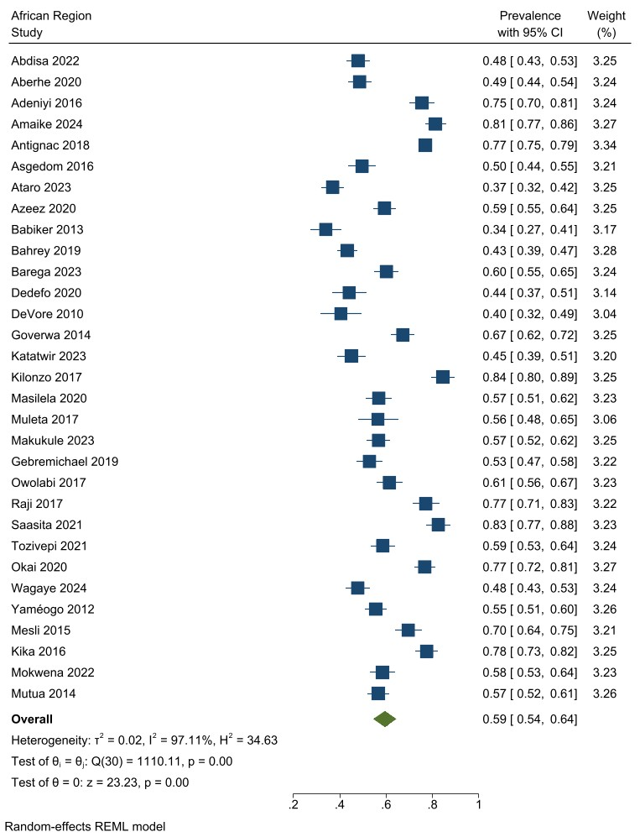
Supplementary figure 1: forest plot for pooled prevalence of uncontrolled hypertension in African WHO region

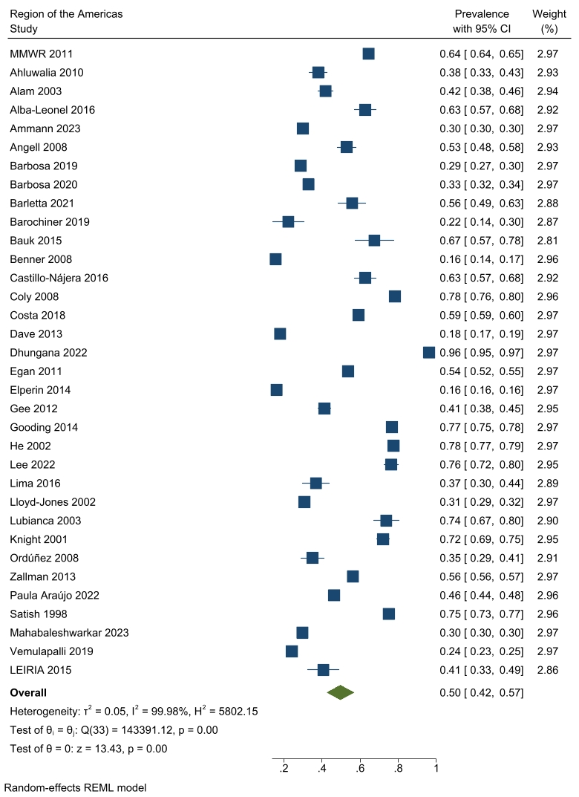
Supplementary figure 2: forest plot for pooled prevalence of uncontrolled hypertension in Americas WHO region

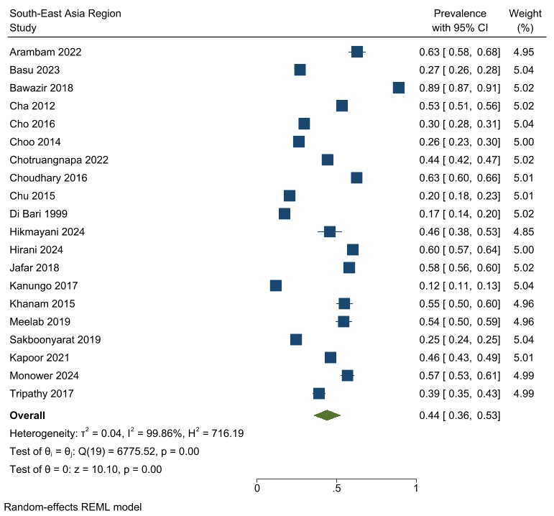
Supplementary figure 3: forest plot for pooled prevalence of uncontrolled hypertension in South-East Asia WHO region

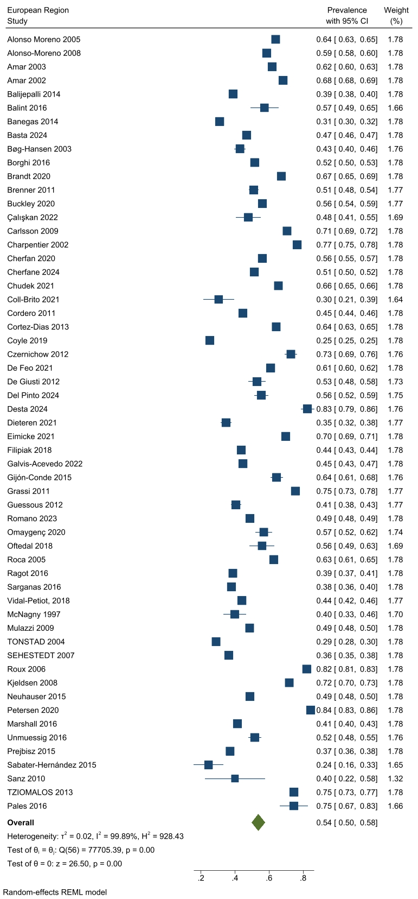
Supplementary figure 4: forest plot for pooled prevalence of uncontrolled hypertension in European WHO region

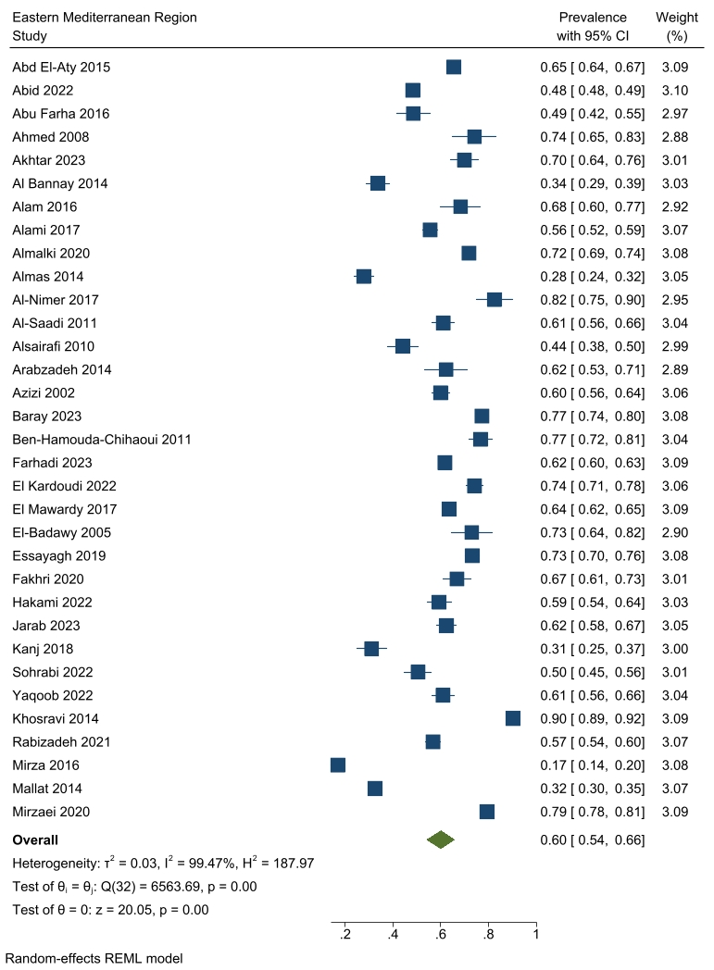
Supplementary figure 5: forest plot for pooled prevalence of uncontrolled hypertension in Eastern Mediterranean WHO region

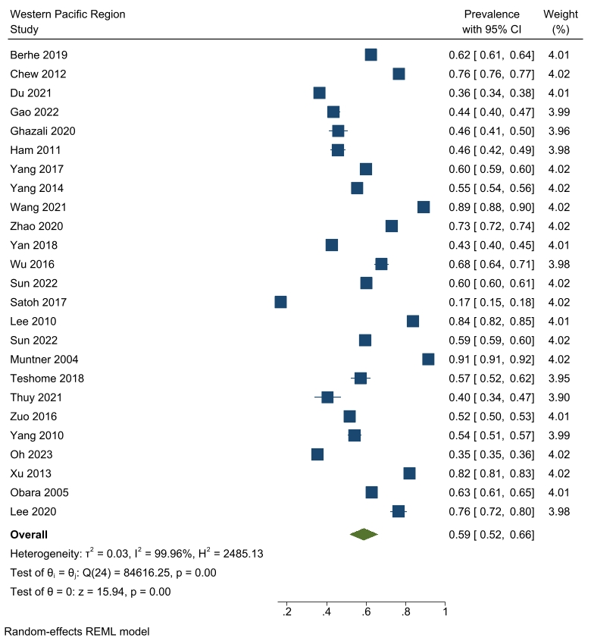
Supplementary figure 6: forest plot for pooled prevalence of uncontrolled hypertension in Western Pacific region of WHO

References
1. Centers for Disease Control and Prevention. Vital signs: prevalence, treatment, and control of hypertension--United States, 1999-2002 and 2005-2008. MMWR Morbidity and mortality weekly report. 2011;60(4):103-8.
2. Abd El-Aty MA, Meky FA, Morsi MM, Al-Lawati JA, El Sayed MK. Hypertension in the adult Omani population: Predictors for unawareness and uncontrolled hypertension. Journal of the Egyptian Public Health Association. 2015;90(3):125-32.
3. Abdisa L, Girma S, Lami M, Hiko A, Yadeta E, Geneti Y, et al. Uncontrolled hypertension and associated factors among adult hypertensive patients on follow-up at public hospitals, Eastern Ethiopia: A multicenter study. Sage Open Medicine. 2022;10.
4. Aberhe W, Mariye T, Bahrey D, Zereabruk K, Hailay A, Mebrahtom G, et al. Prevalence and factors associated with uncontrolled hypertension among adult hypertensive patients on follow-up at Northern Ethiopia, 2019: cross-sectional study. The Pan African medical journal. 2020;36:187.
5. Abid L, Hammami R, Chamtouri I, Drissa M, Boudiche S, Bahloul MA, et al. Epidemiologic features and management of hypertension in Tunisia, the results from the Hypertension National Registry (NaTuRe HTN). BMC Cardiovascular Disorders. 2022;22(1).
6. Abu Farha R, Basheti I, Abu Al Ruz H, Alsaleh A, AbuRuz S. Assessment of drug-related problems and their impact on blood pressure control in patients with hypertension. European Journal of Hospital Pharmacy. 2016;23(3):126-30.
7. Adeniyi OV, Yogeswaran P, Longo-Mbenza B, Goon DT. Uncontrolled hypertension and its determinants in patients with concomitant type 2 diabetes mellitus (T2DM) in rural South Africa. PloS one. 2016;11(3).
8. Ahluwalia IB, Tessaro I, Greenlund KJ, Ford ES. Factors associated with control of hypertension, hypercholesterolemia, and diabetes among low-income women in West Virginia. Journal of Women's Health. 2010;19(3):417-24.
9. Ahmed N, Abdul Khaliq M, Shah SH, Anwar W. Compliance to antihypertensive drugs, salt restriction, exercise and control of systemic hypertension in hypertensive patients at Abbottabad. Journal of Ayub Medical College, Abbottabad : JAMC. 2008;20(2):66-9.
10. Akhtar Y, Afridi MAR, Ali Z. Factors affecting blood pressure control in hypertensive patients visiting a tertiary care hospital in Khyber Pakhtunkhwa. Khyber Medical University Journal-Kmuj. 2023;15(1):4-8.
11. Al Bannay R, Husain A, Böhm M. Blood pressure control and predictors of uncontrolled hypertension. Bahrain Medical Bulletin. 2014;36(3):163-8.
12. Alam AY, Akhtar N, Ahmed W, Rahman AA, Butt M, Zubair M, et al. Uncontrolled hypertension: Is the care optimal? Rawal Medical Journal. 2016;41(2):175-80.
13. Alam MG, Barri YM. Systolic blood pressure is the main etiology for poorly controlled hypertension. American Journal of Hypertension. 2003;16(2):140-3.
14. Alami M, El Hattaoui M, Seqat M, Sadik J, Aouad A, Benghanem Gharbi M. Control of blood pressure and cardiovascular risk in Moroccan patients with newly diagnosed hypertension: a 3-month observational study in primary care. Therapeutic advances in cardiovascular disease. 2017;11(2):49-56.
15. Alba-Leonel A, Carvajal A, Fierro I. Prescription patterns of antihypertensives in a community health centre in Mexico City: a drug utilization study. 2016;30(3):276-81.
16. Almalki ZS, Albassam AA, Alhejji NS, Alotaibi BS, Al-Oqayli LA, Ahmed NJ. Prevalence, risk factors, and management of uncontrolled hypertension among patients with diabetes: A hospital-based cross-sectional study. Primary Care Diabetes. 2020;14(6):610-5.
17. Almas A, Bhamani F, Khan AH. Better physician-patient communication; an important milestone in control of hypertension, a multicenter study from Karachi, Pakistan. Journal of the College of Physicians and Surgeons--Pakistan : JCPSP. 2014;24(12):952-4.
18. Al-Nimer MSM, Hussein II. Subclinical ventricular repolarization abnormality in uncontrolled compared with controlled treated hypertension. Indian Heart Journal. 2017;69(2):136-40.
19. Alonso Moreno FJ, Divisón Garrote JA, Llisterri Caro JL, Rodríguez Roca GC, Lou Arnal S, Banegas JR, et al. [Primary care physicians behaviour in inadequate blood pressure control]. Atencion primaria. 2005;36(4):204-10.
20. Alonso-Moreno FJ, Llisterri Caro JL, Rodríguez-Roca GC, Ferreiro Madueño M, González-Segura Alsina D, Divisón Garrote JA, et al. Primary care physicians behaviour on hypertensive patients with poor blood pressure control. The PRESCAP 2006 study. Revista Clinica Espanola. 2008;208(8):393-9.
21. Al-Saadi R, Al-Shukaili S, Al-Mahrazi S, Al-Busaidi Z. Prevalence of uncontrolled hypertension in primary care settings in Al Seeb Wilayat, Oman. Sultan Qaboos University Medical Journal. 2011;11(3):349-56.
22. Alsairafi M, Alshamali K, Al-Rashed A. Effect of physical activity on controlling blood pressure among hypertensive patients from mishref area of Kuwait. European Journal of General Medicine. 2010;7(4):377-84.
23. Amaike C, Salami OF, Bamidele OT, Ojo AM, Otaigbe I, Abiodun O, et al. Association of depression and anxiety with uncontrolled hypertension: A cross-sectional study in Southwest Nigeria. Indian Journal of Psychiatry. 2024;66(2):157-64.
24. Amar J, Chamontin B, Genes N, Cantet C, Salvador M, Pierre Cambou J. Why is hypertension so frequently uncontrolled in secondary prevention? Journal of Hypertension. 2003;21(6):1199-205.
25. Amar J, Vaur L, Perret M, Bailleau C, Etienne S, Chamontin B, et al. Hypertension in high-risk patients: beware of the underuse of effective combination therapy (results of the PRATIK study). Journal of Hypertension. 2002;20(4):779-84.
26. Ammann EM, O'Brien ES, Milentijevic D, Kharat AA, Talbot DA, Canovatchel W, et al. Characteristics, management, and blood pressure control in patients with apparent resistant hypertension in the US. Heliyon. 2023;9(2).
27. Angell SY, Garg RK, Gwynn RC, Bash L, Thorpe LE, Frieden TR. Prevalence, Awareness, Treatment, and Predictors of Control of Hypertension in New York City. Circulation-Cardiovascular Quality and Outcomes. 2008;1(1):46-53.
28. Antignac M, Diop IB, De Terline DM, Kramoh KE, Balde DM, Dzudie A, et al. Socioeconomic status and hypertension control in sub-saharan Africa the multination EIGHT study (evaluation of hypertension in Sub-Saharan Africa). Hypertension. 2018;71(4):577-84.
29. Arabzadeh S, Sadeghi M, Rabiei K, Sarrafzadegan N, Taheri L, Golshahi A. Determinants of uncontrolled hypertension in an Iranian population. ARYA Atherosclerosis. 2014;10(1):25-31.
30. Arambam P, Khashoo R, Tewari D, Saleem Z, Shekhawat S, Kaul U. Uncontrolled hypertension in a rural population of Jammu and Kashmir. Indian Heart Journal. 2022;74(6):484-7.
31. Asgedom SW, Gudina EK, Desse TA. Assessment of Blood Pressure Control among Hypertensive Patients in Southwest Ethiopia. PloS one. 2016;11(11).
32. Ataro BA, Mulatu G, Mengistu D. Compliance With Guidelines of Hypertension Management, and Associated Factors Among the Health Practitioners. Inquiry-the Journal of Health Care Organization Provision and Financing. 2023;60.
33. Azeez IA, Ige OM, Ilori T, Yusuf IB. Prevalence of uncontrolled hypertension at a secondary health care center in South-Western Nigeria. African Journal of Biomedical Research. 2020;23(2):207-11.
34. Azizi F, Ghanbarian A, Madjid M, Rahmani M. Distribution of blood pressure and prevalence of hypertension in Tehran adult population: Tehran Lipid and Glucose Study (TLGS), 1999-2000. Journal of human hypertension. 2002;16(5):305-12.
35. Babiker FA, Elkhalifa LA, Moukhyer ME. Awareness of hypertension and factors associated with uncontrolled hypertension in Sudanese adults. Cardiovascular journal of Africa. 2013;24(6):208-12.
36. Bahrey D, Gebremedhn G, Mariye T, Girmay A, Aberhe W, Hika A, et al. Prevalence and associated factors of chronic kidney disease among adult hypertensive patients in Tigray teaching hospitals: a cross-sectional study. BMC research notes. 2019;12(1):562.
37. Balijepalli C, Bramlage P, Lösch C, Zemmrich C, Humphries KH, Moebus S. Prevalence and control of high blood pressure in primary care-results from the German metabolic and cardiovascular risk study (GEMCAS). Hypertension Research. 2014;37(6):580-4.
38. Balint EM, Boseva P, Schury K, Guendel H, Rottbauer W, Waller C. High prevalence of posttraumatic stress in patients with primary hypertension. General hospital psychiatry. 2016;38:53-8.
39. Banegas JR, Ruilope LM, de la Sierra A, de la Cruz JJ, Gorostidi M, Segura J, et al. High prevalence of masked uncontrolled hypertension in people with treated hypertension. European heart journal. 2014;35(46):3304-12.
40. Baray AH, Stanikzai MH, Wafa MH, Akbari K. High Prevalence of Uncontrolled Hypertension Among Afghan Hypertensive Patients: A Multicenter Cross-Sectional Study. Integrated Blood Pressure Control. 2023;16:23-35.
41. Barbosa E, Eibel B, Brandão AA, Feitosa ADM, Miranda RD, Kobeissi E, et al. May Measurement Month 2017: Brazilian results - Americas. European Heart Journal, Supplement. 2019;21:D25-D7.
42. Barbosa E, Eibel B, Feitosa ADM, Brandão AA, Bortolotto LA, Neves MFT, et al. May measurement month 2018: An analysis of blood pressure screening results from Brazil. European Heart Journal, Supplement. 2020;22:H26-H9.
43. Barega B, Seifu L, Melkie A, Abebe S, Taye M. Blood Pressure Control among Adults with Hypertension at a Tertiary Hospital in Ethiopia. Ethiopian journal of health sciences. 2023;33(4):563-70.
44. Barletta PH, de Magalhães EFS, de Almeida VF, Moreira JL, da Silva MJ, Macedo C, et al. Clinical Characteristics and Therapeutic Adherence of Women in a Referral Outpatient Clinic for Severe Hypertension. International Journal of Cardiovascular Sciences. 2021;34(4):400-8.
45. Barochiner J, Posadas Martínez ML, Martínez R, Giunta D. Reproducibility of masked uncontrolled hypertension detected through home blood pressure monitoring. Journal of clinical hypertension (Greenwich, Conn). 2019;21(7):877-83.
46. Basta K, Ledwaba-Chapman L, Dodhia H, Ashworth M, Whitney D, Dalrymple K, et al. Hypertension prevalence, coding and control in an urban primary care setting in the UK between 2014 and 2021. Journal of Hypertension. 2024;42(2):350-9.
47. Basu S, Malik M, Anand T, Singh A. Hypertension Control Cascade and Regional Performance in India: A Repeated Cross-Sectional Analysis (2015-2021). Cureus Journal of Medical Science. 2023;15(2).
48. Bauk L, Costa HA, Caligiuri SI. Clinical utility of home blood pressure monitoring in patients under treatment. Hipertension y Riesgo Vascular. 2015;32(2):62-70.
49. Bawazir LA, Sianipar WPH. Determinants of blood pressure control and prevalence of hypertension in adults in 2017: A population-based study in West Jakarta. Open Hypertension Journal. 2018;10(1):15-27.
50. Ben-Hamouda-Chihaoui M, Kanoun F, Ftouhi B, Lamine-Chtioui F, Kamoun M, Slimane H. [Evaluation of blood pressure control by ambulatory blood pressure monitoring and study of factors associated with poor blood pressure control in 300 treated hypertensive type 2 diabetic patients]. Annales de cardiologie et d'angeiologie. 2011;60(2):71-6.
51. Benner JS, Smith TW, Petrilla AA, Klingman D, Goel S, Tang SSK, et al. Estimated prevalence of uncontrolled hypertension and multiple cardiovascular risk factors and their associated risk of coronary heart disease in the United States. Journal of the American Society of Hypertension. 2008;2(1):44-53.
52. Berhe KK, Zemichael TM, Liew SJ, Lee JT, Tan CS, Koh CHG, et al. Sociodemographic factors in relation to hypertension prevalence, awareness, treatment and control in a multi-ethnic Asian population: a cross-sectional study. BMC cardiovascular disorders. 2019;9(5):e025869.
53. Bøg-Hansen E, Lindblad U, Gullberg B, Melander A, Råstam L. Metabolic disorders associated with uncontrolled hypertension. Skaraborg hypertension and diabetes project. Diabetes, Obesity and Metabolism. 2003;5(6):379-87.
54. Borghi C, Tubach F, De Backer G, Dallongeville J, Guallar E, Medina J, et al. Lack of control of hypertension in primary cardiovascular disease prevention in Europe: Results from the EURIKA study. International journal of cardiology. 2016;218:83-8.
55. Brandt I, Puth MT, Kersting C, Moebus S, Erbel R, Jöckel KH, et al. No difference in medication regimes and dosing in study participants with and without blood pressure control: longitudinal data of the population-based Heinz Nixdorf Recall Study. Journal of Hypertension. 2020;38(3):504-10.
56. Brenner R, Waeber B, Allemann Y. Medical treatment of hypertension in Switzerland: The 2009 Swiss Hypertension Survey (SWISSHYPE). Swiss Medical Weekly. 2011;141(MARCH).
57. Buckley B, Shanahan E, Colwell N, Turgonyi E, Bramlage P, Perry IJ. Blood Pressure Control in Hypertensive Patients in Irish Primary Care Practices. Journal of Clinical Hypertension. 2009;11(8):432-40.
58. Çalışkan O, Güçlü YA, Altındağ B. Evaluation of Medication Adherence Levels of Hypertensive Patients in an Education Family Health Center. Anatolian Journal of Family Medicine. 2022;5(3):169-75.
59. Carlsson AC, Wändell PE, Journath G, de Faire U, Hellénius ML. Factors associated with uncontrolled hypertension and cardiovascular risk in hypertensive 60-year-old men and women-a population-based study. Hypertension Research. 2009;32(9):780-5.
60. Castillo-Nájera F, Campos-Ramos O, Villa-Romero A, Molina-Guarneros J, Asgary R, Sckell B, et al. Rates and Predictors of Uncontrolled Hypertension Among Hypertensive Homeless Adults Using New York City Shelter-Based Clinics. Fundamental & clinical pharmacology. 2016;14(1):41-6.
61. Cha SH, Park HS, Cho HJ. Socioeconomic disparities in prevalence, treatment, and control of hypertension in middle-aged Koreans. Journal of epidemiology. 2012;22(5):425-32.
62. Charpentier G, Genes N, Vaur L, Clerson P, Amar J, Gueret P, et al. Hypertension management in patients with type 2 diabetes. Archives des Maladies du Coeur et des Vaisseaux. 2002;95(7-8):661-5.
63. Cherfan M, Vallée A, Kab S, Salameh P, Goldberg M, Zins M, et al. Unhealthy behaviors and risk of uncontrolled hypertension among treated individuals-The CONSTANCES population-based study. Scientific Reports. 2020;10(1).
64. Cherfane M, Vallêe A, Kab S, Salameh P, Goldberg M, Zins M, et al. Risk factors for uncontrolled blood pressure among individuals with hypertension on treatment: the CONSTANCES population-based study. International Journal of Epidemiology. 2024;53(2).
65. Chew BH, Mastura I, Shariff-Ghazali S, Lee PY, Cheong AT, Ahmad Z, et al. Determinants of uncontrolled hypertension in adult type 2 diabetes mellitus: an analysis of the Malaysian diabetes registry 2009. Cardiovascular diabetology. 2012;11:54.
66. Cho J, Kim C, Kang DR, Park JB. Hyperuricemia and uncontrolled hypertension in treated hypertensive patients K-MetS Study. Medicine. 2016;95(28).
67. Choo EH, Kim JJ, Hwang BH, Choi IJ, Chang M, Lim S, et al. Status of hypertension and coronary stenosis in asymptomatic type 2 diabetic patients: analysis from Coronary Computed Tomographic Angiography Registry. International journal of cardiology. 2014;174(2):282-7.
68. Farhadi F, Aliyari R. Prevalence of uncontrolled hypertension and its associated factors in 50-74 years old Iranian adults: a population-based study. 2023;23(1):318.
69. Chotruangnapa C, Thammarux T, Thongdang P. Prevalence and Clinical Characteristics including Patterns of Antihypertensive Drug Administration of the Different Home Blood Pressure Phenotypes in Treated Hypertensive Patients. International Journal of Hypertension. 2022;2022.
70. Choudhary R, Sharma SM, Kumari V, Gautam D. Awareness, treatment adherence and risk predictors of uncontrolled hypertension at a tertiary care teaching hospital in Western India. Indian heart journal. 2016;68 Suppl 2(Suppl 2):S251-s2.
71. Chu SH, Baek JW, Kim ES, Stefani KM, Lee WJ, Park YR, et al. Gender differences in hypertension control among older korean adults: Korean social life, health, and aging project. Journal of preventive medicine and public health = Yebang Uihakhoe chi. 2015;48(1):38-47.
72. Chudek A, Owczarek AJ, Ficek J, Olszanecka-Glinianowicz M, Wieczorowska-Tobis K, Walencka Z, et al. A Stronger Effect of Body Mass Index and Waist Circumference on the Prevalence of Uncontrolled Hypertension among Caucasian Men than Women. Kidney & blood pressure research. 2021;46(3):298-309.
73. Coll-Brito V, Calero F, Arias P, Ayasreh N, Ochoa J, Ramos A, et al. Improved office blood pressure control by automatic delayed-reading oscillometric device. Hipertension Y Riesgo Vascular. 2021;38(3):119-24.
74. Coly G, Kotchen JM, Grim CE, Yang HY, Ow AJ, Krishnaswami S, et al. Characteristics of inner-city African-Americans with uncontrolled hypertension. Journal of the American Society of Hypertension. 2008;2(5):366-71.
75. Cordero A, Bertomeu-Martínez V, Mazón P, Fácila L, Bertomeu-González V, Cosín J, et al. Factors Associated With Uncontrolled Hypertension in Patients With and Without Cardiovascular Disease. Revista Espanola De Cardiologia. 2011;64(7):587-93.
76. Cortez-Dias N, Martins SR, Belo A, Fiuza M, Investigators VS. Association of metabolic risk factors with uncontrolled hypertension: comparison of the several definitions of metabolic syndrome. Journal of Hypertension. 2013;31(10):1991-7.
77. Costa FF, Timerman A, Saraiva JFK, Magalhaes CC, Pinto IMF, Oliveira GBF, et al. Independent predictors of effective blood pressure control in patients with hypertension on drug treatment in Brazil. Journal of Clinical Hypertension. 2018;20(1):125-32.
78. Coyle R, Feher M, Jones S, Hamilton M, de Lusignan S. Variation in the diagnosis and control of hypertension is not explained by conventional variables: Cross-sectional database study in English general practice. PloS one. 2019;14(1).
79. Czernichow S, Castetbon K, Salanave B, Vernay M, Barry Y, Batty GD, et al. Determinants of blood pressure treatment and control in obese people: evidence from the general population. Journal of hypertension. 2012;30(12):2338-44.
80. Dave GJ, Bibeau DL, Schulz MR, Aronson RE, Ivanov LL, Black A, et al. Predictors of uncontrolled hypertension in the stroke belt. Journal of Clinical Hypertension. 2013;15(8):562-9.
81. De Feo M, Del Pinto R, Pagliacci S, Grassi D, Ferri C, Italian Soc H. Real-World Hypertension Prevalence, Awareness, Treatment, and Control in Adult Diabetic Individuals: An Italian Nationwide Epidemiological Survey. High Blood Pressure & Cardiovascular Prevention. 2021;28(3):301-7.
82. De Giusti M, Dito E, Pagliaro B, Burocchi S, Laurino FI, Tocci G, et al. A survey on blood pressure levels and hypertension control in a sample of the Italian general population. High blood pressure & cardiovascular prevention : the official journal of the Italian Society of Hypertension. 2012;19(3):129-35.
83. Dedefo MG, Gemechu DB, Fekadu G, Dibessa TT. Blood Pressure Control among Hypertensive Diabetic Patients on Follow-Up at Chronic Clinic of Nekemte Referral Hospital in West Ethiopia. International Journal of Hypertension. 2020;2020.
84. Del Pinto R, Agabiti Rosei C, Borghi C, Cipollini F, Cottone S, De Giorgi GA, et al. May Measure Month 2022 in Italy: A Focus on Fixed-dose Combination, Therapeutic Adherence, and Medical Inertia in a Nationwide Survey. High Blood Pressure and Cardiovascular Prevention. 2024;31(3):309-20.
85. Desta F, Mengesha S, Belayneh F, Woldeyohannes D, Tekalegn Y, Zenbaba D, et al. Blood Pressure Control and Associated Factors among Hypertension Comorbid Type 2 Diabetic Patients in Southeast Ethiopia. International Journal of Hypertension. 2024;2024.
86. DeVore AD, Sorrentino M, Arnsdorf MF, Ward RP, Bakris GL, Blankstein R. Predictors of Hypertension Control in a Diverse General Cardiology Practice. Journal of Clinical Hypertension. 2010;12(8):570-7.
87. Dhungana RR, Pedisic Z, Dhimal M, Bista B, de Courten M. Hypertension screening, awareness, treatment, and control: a study of their prevalence and associated factors in a nationally representative sample from Nepal. Global health action. 2022;15(1):2000092.
88. Di Bari M, Salti F, Nardi M, Pahor M, De Fusco C, Tonon E, et al. Undertreatment of hypertension in community-dwelling older adults: a drug-utilization study in Dicomano, Italy. Journal of Hypertension. 1999;17(11):1633-40.
89. Dieteren CM, Donnell OO, Bonfrer I. Prevalence and inequality in persistent undiagnosed, untreated, and uncontrolled hypertension: Evidence from a cohort of older Mexicans. PLOS Global Public Health. 2021;1(12).
90. Du W, Jia X, Su C, Wang Z, Wang H, Zhang C, et al. Association between hypertension and mild cognitive impairment among people aged 55 years and above in four provinces of China. Journal of Environmental and Occupational Medicine. 2021;38(8):825-32.
91. Egan BM, Zhao Y, Axon RN, Brzezinski WA, Ferdinand KC. Uncontrolled and apparent treatment resistant hypertension in the United States, 1988 to 2008. Circulation. 2011;124(9):1046-58.
92. Eimicke JP, Teresi JA, Williams O, Ogedegbe G, Spruill TM, Rita DP, et al. Impact of Guidelines on Hypertension Control in the Elderly. BMJ open. 2021;27(16):1952-9.
93. El Kardoudi A, Chetoui A, Kaoutar K, Boutahar K, Elmoussaoui S, Chigr F, et al. Factors associated with poor blood pressure control in Moroccan hypertensive patients. Annales de Cardiologie et d'Angeiologie. 2022;71(3):141-7.
94. El Mawardy R, Okba A. Antihypertensive treatment and blood pressure control in patients with hypertension in daily clinical practice: a cross-sectional, multicenter, observational study in Egypt. Current Medical Research and Opinion. 2017;33(1):39-45.
95. El-Badawy AM, Al-Kharusi HM, Al-Ghanemy SA. Health habits and risk factors among Omanis with hypertension. Saudi medical journal. 2005;26(4):623-9.
96. Elperin DT, Pelter MA, Deamer RL, Burchette RJ. A large cohort study evaluating risk factors associated with uncontrolled hypertension. Journal of clinical hypertension (Greenwich, Conn). 2014;16(2):149-54.
97. Essayagh T. Prevalence of uncontrolled blood pressure in Meknes, Morocco, and its associated risk factors in 2017. Journal of endovascular therapy : an official journal of the International Society of Endovascular Specialists. 2019;14(8):e0220710.
98. Fakhri G, Assaad S, Chaaya M. Hypertension prevalence and control among community-dwelling lebanese older adults. Journal of Clinical Hypertension. 2020;22(9):1727-31.
99. Filipiak KJ, Tomaniak M, Platek AE, Szymanski FM, Tykarski A. Negative predictors of treatment success in outpatient therapy of arterial hypertension in Poland. Results of the CONTROL NT observational registry. Kardiologia Polska. 2018;76(2):353-61.
100. Galvis-Acevedo S, Candamil-Castillo AF, Herrera-Murgueitio JA, Calzada-Gutiérrez MT. Social, clinical and psychosocial determinants associated with uncontrolled arterial hypertension in older adults. SABE Survey Colombia 2016. Revista Espanola de Geriatria y Gerontologia. 2022;57(3):139-45.
101. Gao ZP, Chen SQ, Huang XY, Ye JF, Liu J, Huang ZD, et al. Risk Prediction Model for Uncontrolled Hypertension in Chinese Community. Frontiers in Cardiovascular Medicine. 2022;8.
102. Gee ME, Bienek A, McAlister FA, Robitaille C, Joffres M, Tremblay MS, et al. Factors associated with lack of awareness and uncontrolled high blood pressure among Canadian adults with hypertension. The Canadian journal of cardiology. 2012;28(3):375-82.
103. Ghazali R, Lukman KA, Naing DKS, Kadir F, Jeffree MS, Robinson F, et al. Factors associated with uncontrolled hypertension among hypertensive patients reported from different primary health clinics in Tuaran, Sabah, Malaysia: A cross sectional study. Turkiye Klinikleri Journal of Medical Sciences. 2020;40(1):52-8.
104. Gijón-Conde T, Graciani A, López-García E, Guallar-Castillón P, Rodríguez-Artalejo F, Banegas JR. Impact of Ambulatory Blood Pressure Monitoring on Control of Untreated, Undertreated, and Resistant Hypertension in Older People in Spain. Journal of the American Medical Directors Association. 2015;16(8):668-73.
105. Gooding HC, McGinty S, Richmond TK, Gillman MW, Field AE. Hypertension awareness and control among young adults in the national longitudinal study of adolescent health. Journal of general internal medicine. 2014;29(8):1098-104.
106. Goverwa TP, Masuka N, Tshimanga M, Gombe NT, Takundwa L, Bangure D, et al. Uncontrolled hypertension among hypertensive patients on treatment in Lupane District, Zimbabwe, 2012. BMC research notes. 2014;7:703.
107. Grassi G, Cifkova R, Laurent S, Narkiewicz K, Redon J, Farsang C, et al. Blood pressure control and cardiovascular risk profile in hypertensive patients from central and eastern European countries: results of the BP-CARE study. European Heart Journal. 2011;32(2):218-25.
108. Guessous I, Bochud M, Theler JM, Gaspoz JM, Pechère-Bertschi A. 1999-2009 Trends in prevalence, unawareness, treatment and control of hypertension in Geneva, Switzerland. PloS one. 2012;7(6):e39877.
109. Hakami NM, Elmahdy MH, Majrashi SM. Uncontrolled hypertension and associated factors among hypertensive patients in primary health care centers in Jazan Region, Saudi Arabia: A cross-sectional study. Medical Science. 2022;26(127).
110. Ham OK, Yang SJ. Lifestyle Factors Associated With Blood Pressure Control Among Those Taking Antihypertensive Medication. Asia-Pacific Journal of Public Health. 2011;23(4):485-95.
111. He J, Muntner P, Chen J, Roccella EJ, Streiffer RH, Whelton PK. Factors associated with hypertension control in the general population of the United States. Archives of internal medicine. 2002;162(9):1051-8.
112. Hikmayani AA, Rachmawan YP. Profile of hypertensive Indonesian patients in a cardiovascular hospital using ambulatory blood pressure monitoring focused on resistant hypertension. Clinical Epidemiology and Global Health. 2024;28.
113. Hirani MM, Gandhi R, Thakkar DG, Kateshiya N, Murugan Y. Investigating the Prevalence and Predictors of Uncontrolled Hypertension: A Cross-Sectional Study in Gujarat, India. Cureus Journal of Medical Science. 2024;16(4).
114. Jafar TH, Gandhi M, Jehan I, Naheed A, de Silva HA, Shahab H, et al. Determinants of Uncontrolled Hypertension in Rural Communities in South Asia-Bangladesh, Pakistan, and Sri Lanka. American Journal of Hypertension. 2018;31(11):1205-14.
115. Jarab AS, Al-Qerem W, Alqudah S, Heshmeh SRA, Mukattash TL, Alzoubi KH. Blood pressure control and its associated factors in patients with hypertension and type 2 diabetes. Electronic Journal of General Medicine. 2023;20(3).
116. Lee SY, Waring ME, Park CL, Blake EC. Do Depressive Symptoms Predict Blood Pressure Control in US Veterans? Journal of General Internal Medicine. 2022;37(1):57-63.
117. Katatwire DD, Meremo A. Prevalence of and factors associated with uncontrolled hypertension among patients with early chronic kidney disease attending tertiary hospitals in Dodoma, Tanzania: a cross-sectional study. International journal of epidemiology. 2023;13(12):e074441.
118. Lima NKC, Moriguti JC, Ferriolli E. Uncontrolled hypertension in older patients: Markers and associated factors to masked and white-coat effect. Journal of Geriatric Cardiology. 2016;13(8):672-8.
119. Kanungo S, Mahapatra T, Bhowmik K, Saha J, Mahapatra S, Pal D, et al. Patterns and predictors of undiagnosed and uncontrolled hypertension: observations from a poor-resource setting. Journal of Human Hypertension. 2017;31(1):56-65.
120. Khanam MA, Lindeboom W, Razzaque A, Niessen L, Smith W, Milton AH. Undiagnosed and uncontrolled hypertension among the adults in rural Bangladesh: findings from a community-based study. Journal of hypertension. 2015;33(12):2399-406.
121. Lloyd-Jones DM, Evans JC, Larson MG, Levy D. Treatment and control of hypertension in the community: a prospective analysis. Hypertension. 2002;40(5):640-6.
122. Kanj H, Khalil A, Kossaify M, Kossaify A. Predictors of Undiagnosed and Uncontrolled Hypertension in the Local Community of Byblos, Lebanon. Health Services Insights. 2018;11.
123. Kilonzo SB, Gunda DW, Bakshi FA, Kalokola F, Mayala HA, Dadi H. Control of Hypertension among Diabetic Patients in a Referral Hospital in Tanzania: A Cross-Sectional Study. BMC geriatrics. 2017;27(5):473-80.
124. Lubianca JN, Faccin CS, Fuchs FD. Oral contraceptives: a risk factor for uncontrolled blood pressure among hypertensive women. Contraception. 2003;67(1):19-24.
125. Knight EL, Bohn RL, Wang PS, Glynn RJ, Mogun H, Avorn J. Predictors of uncontrolled hypertension in ambulatory patients. Hypertension. 2001;38(4):809-14.
126. Masilela C, Pearce B, Ongole JJ, Adeniyi OV, Benjeddou M. Cross-sectional study of prevalence and determinants of uncontrolled hypertension among South African adult residents of Mkhondo municipality. BMC public health. 2020;20(1):1069.
127. Muleta S, Melaku T, Chelkeba L, Assefa D. Blood pressure control and its determinants among diabetes mellitus co-morbid hypertensive patients at Jimma University medical center, South West Ethiopia. Clinical Hypertension. 2017;23(1).
128. Makukule A, Modjadji P, Thovhogi N, Mokgalaboni K, Kengne AP. Uncontrolled Hypertension, Treatment, and Predictors among Hypertensive Out-Patients Attending Primary Health Facilities in Johannesburg, South Africa. Healthcare (Switzerland). 2023;11(20).
129. Meelab S, Bunupuradah I, Suttiruang J, Sakulrojanawong S, Thongkua N, Chantawiboonchai C, et al. Prevalence and associated factors of uncontrolled blood pressure among hypertensive patients in the rural communities in the central areas in Thailand: A cross-sectional study. 2019;14(2):e0212572.
130. Ordúñez P, Barceló A, Bernal JL, Espinosa A, Silva LC, Cooper RS. Risk factors associated with uncontrolled hypertension: findings from the baseline CARMEN survey in Cienfuegos, Cuba. Journal of hypertension. 2008;26(4):663-71.
131. Romano S, Rigon G, Albrigi M, Tebaldi G, Sartorio A, Cristin L, et al. Hypertension, uncontrolled hypertension and resistant hypertension: prevalence, comorbidities and prescribed medications in 228,406 adults resident in urban areas. A population-based observational study. 2023;18(7):1951-9.
132. Gebremichael GB, Berhe KK, Zemichael TM. Uncontrolled hypertension and associated factors among adult hypertensive patients in Ayder comprehensive specialized hospital, Tigray, Ethiopia, 2018. BMC cardiovascular disorders. 2019;19(1):121.
133. Omaygenç MO, Özcan ÖU, Çakal B, Karaca O. Cystatin C and uncontrolled hypertension. Anatolian Journal of Cardiology. 2020;24(5):309-15.
134. Oftedal Å, Gerdts E, Waje-Andreassen U, Fromm A, Naess H, Linde A, et al. Prevalence and covariates of uncontrolled hypertension in ischemic stroke survivors: the Norwegian stroke in the young study. Blood pressure. 2018;27(3):173-80.
135. Roca B, Suárez C, Ceballos Á, Varela JM, Nonell F, Montes J, et al. Control of hypertension in patients at high risk of cardiovascular disease. QJM: An International Journal of Medicine. 2005;98(8):581-8.
136. Owolabi EO, Ter Goon D, Adeniyi OV, Seekoe E. Social epidemiology of hypertension in Buffalo City Metropolitan Municipality (BCMM): cross-sectional study of determinants of prevalence, awareness, treatment and control among South African adults. BMJ open. 2017;7(6).
137. Raji YR, Abiona T, Gureje O. Awareness of hypertension and its impact on blood pressure control among elderly nigerians: report from the Ibadan study of aging. Pan African Medical Journal. 2017;27.
138. Ragot S, Beneteau M, Guillou-Bonnici F, Herpin D. Prevalence and management of hypertensive patients in clinical practice: Cross-sectional registry in five countries outside the European Union. Blood Pressure. 2016;25(2):104-16.
139. Yang ZQ, Zhao Q, Jiang P, Zheng SB, Xu BA. Prevalence and control of hypertension among a Community of Elderly Population in Changning District of shanghai: a cross-sectional study. Bmc Geriatrics. 2017;17.
140. Yang L, Xu X, Yan J, Yu W, Tang X, Wu H, et al. Analysis on associated factors of uncontrolled hypertension among elderly hypertensive patients in Southern China: a community-based, cross-sectional survey. BMC public health. 2014;14:903.
141. Sakboonyarat B, Rangsin R, Kantiwong A, Mungthin M. Prevalence and associated factors of uncontrolled hypertension among hypertensive patients: A nation-wide survey in Thailand. BMC Research Notes. 2019;12(1).
142. Wang L, Li N, Heizhati M, Li M, Yang Z, Wang Z, et al. Association of depression with uncontrolled hypertension in primary care setting: A cross-sectional study in less-developed northwest China. International Journal of Hypertension. 2021;2021.
143. Sarganas G, Neuhauser HK. Untreated, Uncontrolled, and Apparent Resistant Hypertension: Results of the German Health Examination Survey 2008–2011. Journal of Clinical Hypertension. 2016;18(11):1146-54.
144. Sohrabi M, Karami M, Mirmoeini RS, Cheraghi Z. The Relationship between Health Literacy and Hypertension Control: A Cross-Sectional Study. Journal of Tehran University Heart Center. 2022;17(4):243-8.
145. Yaqoob S, Yaseen M, Jarullah FA, Saleem A, Mohan A, Essar MY, et al. Awareness, treatment, and practices of lifestyle modifications amongst diagnosed hypertensive patients attending the tertiary care hospital of Karachi: A cross-sectional study. Annals of Medicine and Surgery. 2022;82.
146. Zhao Y, Oldenburg B, Zhao SQ, Haregu TN, Zhang LW. Temporal Trends and Geographic Disparity in Hypertension Care in China. Journal of Epidemiology. 2020;30(8):354-61.
147. Zallman L, Himmelstein DH, Woolhandler S, Bor DH, Ayanian JZ, Wilper AP, et al. Undiagnosed and Uncontrolled Hypertension and Hyperlipidemia among Immigrants in the US. Journal of Immigrant and Minority Health. 2013;15(5):858-65.
148. Yan Z, Wang Y, Li SM, Wang JW, Zhang LX, Tan HB, et al. Hypertension Control in Adults With CKD in China: Baseline Results From the Chinese Cohort Study of Chronic Kidney Disease (C-STRIDE). American Journal of Hypertension. 2018;31(4):486-94.
149. Saasita PK, Senoga S, Muhongya K, Agaba DC, Migisha R. High prevalence of uncontrolled hypertension among patients with type 2 diabetes mellitus: a hospital-based cross-sectional study in Southwestern Uganda. The Pan African medical journal. 2021;39:142.
150. Wu YK, Hu GP, Pan FJ, Liu JH, Mo XY, Xie YP, et al. Obstructive sleep apnea hypopnea syndrome was a risk factor for uncontrolled hypertension in adult snorers in South China. Clinical and Experimental Hypertension. 2016;38(5):429-34.
151. Sun Z, Hao Y, Liu J, Yang N, Qi Y, Hu D, et al. Prevalence, awareness, treatment, and control rates of hypertension in patients hospitalized with atrial fibrillation in China: Findings from the CCC-AF project. Frontiers in Cardiovascular Medicine. 2022;9.
152. Satoh A, Arima H, Ohkubo T, Nishi N, Okuda N, Ae R, et al. Associations of socioeconomic status with prevalence, awareness, treatment, and control of hypertension in a general Japanese population: NIPPON DATA2010. Journal of Hypertension. 2017;35(2):401-8.
153. Vidal-Petiot E, Metzger M, Faucon AL, Boffa JJ, Haymann JP, Thervet E, et al. Extracellular Fluid Volume Is an Independent Determinant of Uncontrolled and Resistant Hypertension in Chronic Kidney Disease: A NephroTest Cohort Study. Journal of the American Heart Association. 2018;7(19).
154. Khosravi A, Pourheidar B, Mousavi M, Hajiannejad A, Bidram P, Roohafza H, et al. Evaluating factors associated with uncontrolled hypertension: Isfahan cohort study, Iran. ARYA Atherosclerosis. 2014;10(6):311-8.
155. Kapoor M, Dhar M, Mirza A, Saxena V, Pathania M. Factors responsible for Uncontrolled Hypertension in the Adults over 50 years of age: A pilot study from Northern India. Indian heart journal. 2021;73(5):644-6.
156. Tozivepi SN, Takawira S, Chikaka E, Mundagowa P, Chadambuka EM, Mukora-Mutseyekwa F. The nexus between adherence to recommended lifestyle behaviors and blood pressure control in hypertensive patients at mutare provincial hospital, zimbabwe: A cross-sectional study. Patient Preference and Adherence. 2021;15:1027-37.
157. McNagny SE, Ahluwalia JS, Clark WS, Resnicow KA. Cigarette smoking and severe uncontrolled hypertension in inner-city African Americans. American Journal of Medicine. 1997;103(2):121-7.
158. Okai DE, Manu A, Amoah EM, Laar A, Akamah J, Torpey K. Patient-level factors influencing hypertension control in adults in Accra, Ghana. BMC Cardiovascular Disorders. 2020;20(1).
159. Rabizadeh S, Gholami B, Mahmoudzadeh Kani S, Rajab A, Farrokhpour H, Esteghamati A, et al. Uncontrolled hypertension in patients with type 2 diabetes: What are the correlates? Journal of Clinical Hypertension. 2021;23(9):1776-85.
160. Araújo TP, Borges LGS, Barroso WKS, Brandão AA, Barbosa ECD, Feitosa ADM, et al. Factors associated with uncontrolled blood pressure in hypertensive Brazilians. Journal of clinical hypertension (Greenwich, Conn). 2022;24(7):814-24.
161. Lee HS, Park YM, Kwon HS, Lee JH, Yoon KH, Son HY, et al. Factors associated with control of blood pressure among elderly people diagnosed with hypertension in a rural area of South Korea: The Chungju Metabolic Disease Cohort Study (CMC study). Blood Pressure. 2010;19(1):31-9.
162. Sun K, Lin DZ, Li MA, Mu YM, Zhao JJ, Liu C, et al. Association of education levels with the risk of hypertension and hypertension control: a nationwide cohort study in Chinese adults. Journal of Epidemiology and Community Health. 2022;76(5):451-7.
163. Mirza AA, Elmorsy SA. Diagnosis and Control of Hypertension as Indicators of the Level of Awareness Among Relatives of Medical Students in Saudi Arabia. High blood pressure & cardiovascular prevention : the official journal of the Italian Society of Hypertension. 2016;23(2):123-32.
164. Mulazzi I, Cambou JP, Girerd X, Nicodeme R, Chamontin B, Amar J. Six-item self-administered questionnaires in the waiting room: an aid to explain uncontrolled hypertension in high-risk patients seen in general practice. Journal of the American Society of Hypertension. 2009;3(3):221-7.
165. Satish S, Stroup-Benham CA, Espino DV, Markides KS, Goodwin JS. Undertreatment of hypertension in older Mexican Americans. Journal of the American Geriatrics Society. 1998;46(4):405-10.
166. Tonstad S, Furu K, Rosvold EO, Skurtveit S. Determinants of control of high blood pressure. The Oslo Health Study 2000-2001. Blood Pressure. 2004;13(6):343-9.
167. Sehestedt T, Ibsen H, Jorgensen T. Awareness, treatment and control of hypertension in Denmark. The Inter99 study. Blood Pressure. 2007;16(5):312-9.
168. Muntner P, Gu DF, Wu XQ, Duan XF, Gan WQ, Whelton PK, et al. Factors associated with hypertension awareness, treatment, and control in a representative sample of the Chinese population. Hypertension. 2004;43(3):578-85.
169. Wagaye M, Kumar P, Yimam W, Seid F, Anteneh S, Girma M, et al. Factors associated with uncontrolled blood pressure in adult hypertensive patients on follow-up at Enat General Hospital, Amhara, Ethiopia, 2021. International Journal of Africa Nursing Sciences. 2024;20.
170. Yaméogo NV, Kagambèga LJ, Millogo RC, Kologo KJ, Yaméogo AA, Mandi GD, et al. [Factors associated with poor blood pressure control in hypertensive black Africans: cross-sectional study of 456 hypertensive patients from Burkina Faso]. Annales de cardiologie et d'angeiologie. 2013;62(1):38-42.
171. Teshome DF, Demssie AF, Zeleke BM. Determinants of blood pressure control amongst hypertensive patients in Northwest Ethiopia. PloS one. 2018;13(5).
172. Roux O, Chapellier M, Czernichow S, Nisse-Durgeat S, Safar ME, Blacher J. Determinants of hypertension control in a large French population of treated hypertensive subjects. Blood Pressure. 2006;15(1):6-13.
173. Mallat SG, Abu Samra S, Younes F, Sawaya MT. Identifying predictors of blood pressure control in the Lebanese population - a national, multicentric survey - I-PREDICT. BMC public health. 2014;14.
174. Mahabaleshwarkar R, Bond A, Burns R, Taylor YJ, McWilliams A, Schooley J, et al. Prevalence and Correlates of Uncontrolled Hypertension, Persistently Uncontrolled Hypertension, and Hypertensive Crisis at a Healthcare System. American journal of hypertension. 2023;36(12):667-76.
175. Kjeldsen SE, Naditch-Brule L, Perlini S, Zidek W, Farsang C. Increased prevalence of metabolic syndrome in uncontrolled hypertension across Europe: the Global Cardiometabolic Risk Profile in Patients with hypertension disease survey. Journal of hypertension. 2008;26(10):2064-70.
176. Mesli MF, Raïah M, Mohammedi B, Dida A. Factors associated with poor blood pressure control in 253treated hypertensive patients. Annales de Cardiologie et d'Angeiologie. 2015;64(1):32-8.
177. Neuhauser HK, Adler C, Rosario AS, Diederichs C, Ellert U. Hypertension prevalence, awareness, treatment and control in Germany 1998 and 2008-11. Journal of human hypertension. 2015;29(4):247-53.
178. Petersen J, Malyutina S, Ryabikov A, Kontsevaya A, Kudryavtsev AV, Eggen AE, et al. Uncontrolled and apparent treatment resistant hypertension: a cross-sectional study of Russian and Norwegian 40-69 year olds. BMC cardiovascular disorders. 2020;20(1):135.
179. Mirzaei M, Mirzaei M, Bagheri B, Dehghani A. Awareness, treatment, and control of hypertension and related factors in adult Iranian population. BMC public health. 2020;20(1).
180. Marshall A, Nazroo J, Feeney K, Lee J, Vanhoutte B, Pendleton N. Comparison of hypertension healthcare outcomes among older people in the USA and England. Journal of epidemiology and community health. 2016;70(3):264-70.
181. Kika TM, Lepira FB, Kayembe PK, Makulo JR, Sumaili EK, Kintoki EV, et al. Uncontrolled hypertension among patients managed in primary healthcare facilities in Kinshasa, Democratic Republic of the Congo. Cardiovascular journal of Africa. 2016;27(6):361-6.
182. Mokwena K, Modutoane M. Poorly controlled hypertension among adults treated for hypertension in Tshwane District, South Africa. Journal of Family Medicine and Primary Care. 2022;11(11):7048-54.
183. Unmuessig V, Fishman PA, Vrijhoef HJM, Elissen AMJ, Grossman DC. Association of Controlled and Uncontrolled Hypertension With Workplace Productivity. Journal of Clinical Hypertension. 2016;18(3):217-22.
184. Thuy LQ, Thanh NH, Trung L, Tan PH, Nam HTP, Diep PT, et al. Blood Pressure Control and Associations with Social Support among Hypertensive Outpatients in a Developing Country. Biomed Research International. 2021;2021.
185. Monower MM, Al Abid SU, Abrar AK, Choudhury SR. Salt intake across the hypertension care cascade in the Bangladeshi adult population: a nationally representative cross-sectional study. BMJ open. 2024;14(4).
186. Prejbisz A, Klocek M, Gąsowski J, Topór-Mądry R, Leśniak W, Kabat M, et al. Factors associated with resistant hypertension in a large cohort of hypertensive patients: the Pol-Fokus study. Polskie Archiwum Medycyny Wewnetrznej. 2015;125(4):249-59.
187. Sabater-Hernández D, Sendra-Lillo J, Jiménez-Monleón JJ, Benrimoj SI, Durks D, Martínez-Martínez F, et al. Identifying masked uncontrolled hypertension in the community pharmacy setting. Blood Pressure Monitoring. 2015;20(3):138-43.
188. Vemulapalli S, Inohara T, Kim S, Thomas L, Piccini JP, Patel MR, et al. Blood Pressure Control and Cardiovascular Outcomes in Patients With Atrial Fibrillation (From the ORBIT-AF Registry). The American journal of cardiology. 2019;123(10):1628-36.
189. Zuo H, Wang J, Lin Y, Deng L, Su J, Zhang J. Gender-specific associations of sleep duration with uncontrolled blood pressure in middle-aged patients. Clinical and experimental hypertension (New York, NY : 1993). 2016;38(2):125-30.
190. Yang SJ, Jung D, Choi AS. Prediction model of blood pressure control in community-dwelling hypertensive adults in Korea. Nursing & Health Sciences. 2010;12(1):105-12.
191. Tripathy JP, Thakur JS, Jeet G, Chawla S, Jain S. Alarmingly high prevalence of hypertension and pre-hypertension in North India-results from a large cross-sectional STEPS survey. PloS one. 2017;12(12).
192. Oh SH, Kim D, Hwang J, Kang JH, Kwon Y, Kwon JW. Association of Uncontrolled Hypertension or Diabetes Mellitus With Major Adverse Cardiovascular Events and Mortality in South Korea: Population-Based Cohort Study. Jmir Public Health and Surveillance. 2023;9.
193. Sanz J, García-Vera MP, Espinosa R, Fortún M, Magán I, Segura J. Psychological, factors associated with poor hypertension control: differences in personality and stress between patients with controlled and uncontrolled hypertension. Psychological Reports. 2010;107(3):923-38.
194. Xu D, Chen W, Li X, Zhang Y, Li X, Lei H, et al. Factors Associated with Blood Pressure Control in Hypertensive Patients with Coronary Heart Disease: Evidence from the Chinese Cholesterol Education Program. PloS one. 2013;8(5).
195. Tziomalos K, Kirkineska L, Baltatzi M, Efthymiou E, Psianou K, Papastergiou N, et al. Prevalence of resistant hypertension in 1810 patients followed up in a specialized outpatient clinic and its association with the metabolic syndrome. Blood pressure. 2013;22(5):307-11.
196. Mutua EM, Gitonga MM, Mbuthia B, Muiruri N, Cheptum JJ, Maingi T. Level of blood pressure control among hypertensive patients on follow-up in a Regional Referral Hospital in Central Kenya. Pan African Medical Journal. 2014;18:278.
197. Pales J, Kamensky G, Payer J. Predictors of blood pressure control in patients with resistant hypertension. Bratislava Medical Journal-Bratislavske Lekarske Listy. 2016;117(10):571-6.
198. Obara T, Ohkubo T, Kikuya M, Asayama K, Metoki H, Inoue R, et al. Prevalence of masked uncontrolled and treated white-coat hypertension defined according to the average of morning and evening home blood pressure value: from the Japan Home versus Office Measurement Evaluation Study. Blood pressure monitoring. 2005;10(6):311-6.
199. Lee CJ, Ha JH, Kim JY, Kim IC, Ryu SK, Rhee MY, et al. Office blood pressure threshold of 130/80 mmHg better predicts uncontrolled out-of-office blood pressure in apparent treatment-resistant hypertension. Journal of Clinical Hypertension. 2021;23(3):595-605.
200. Leiria LF, Severo MD, Ledur PS, Becker AD, Aguiar FM, Massierer D, et al. White coat effect and masked uncontrolled hypertension in treated hypertensive-diabetic patients: Prevalence and target organ damage. Journal of diabetes. 2015;7(5):699-707.

