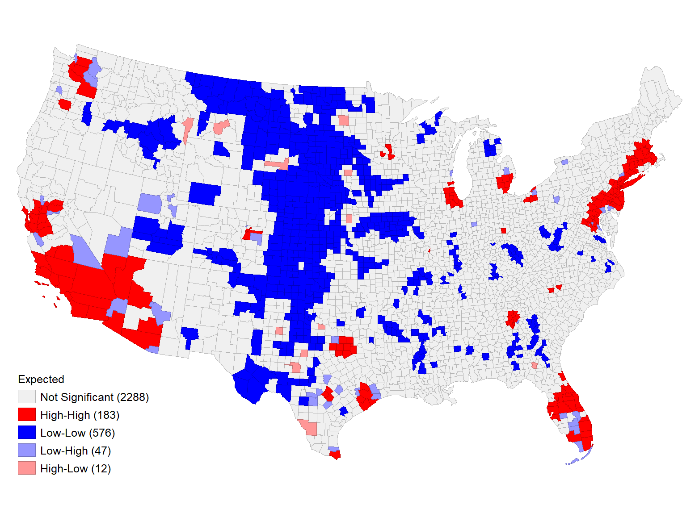
Fig 1: LISA map for the expected number of Diabetes cases
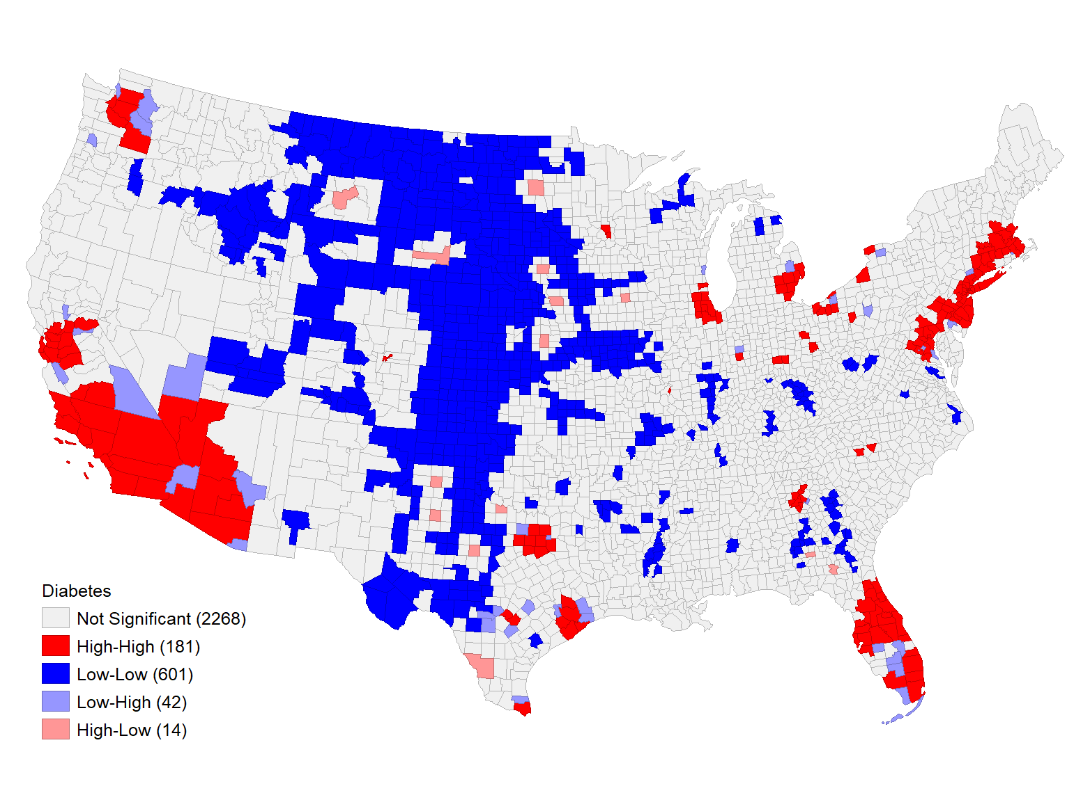
Fig 2: LISA map for observed cases of Diabetes.

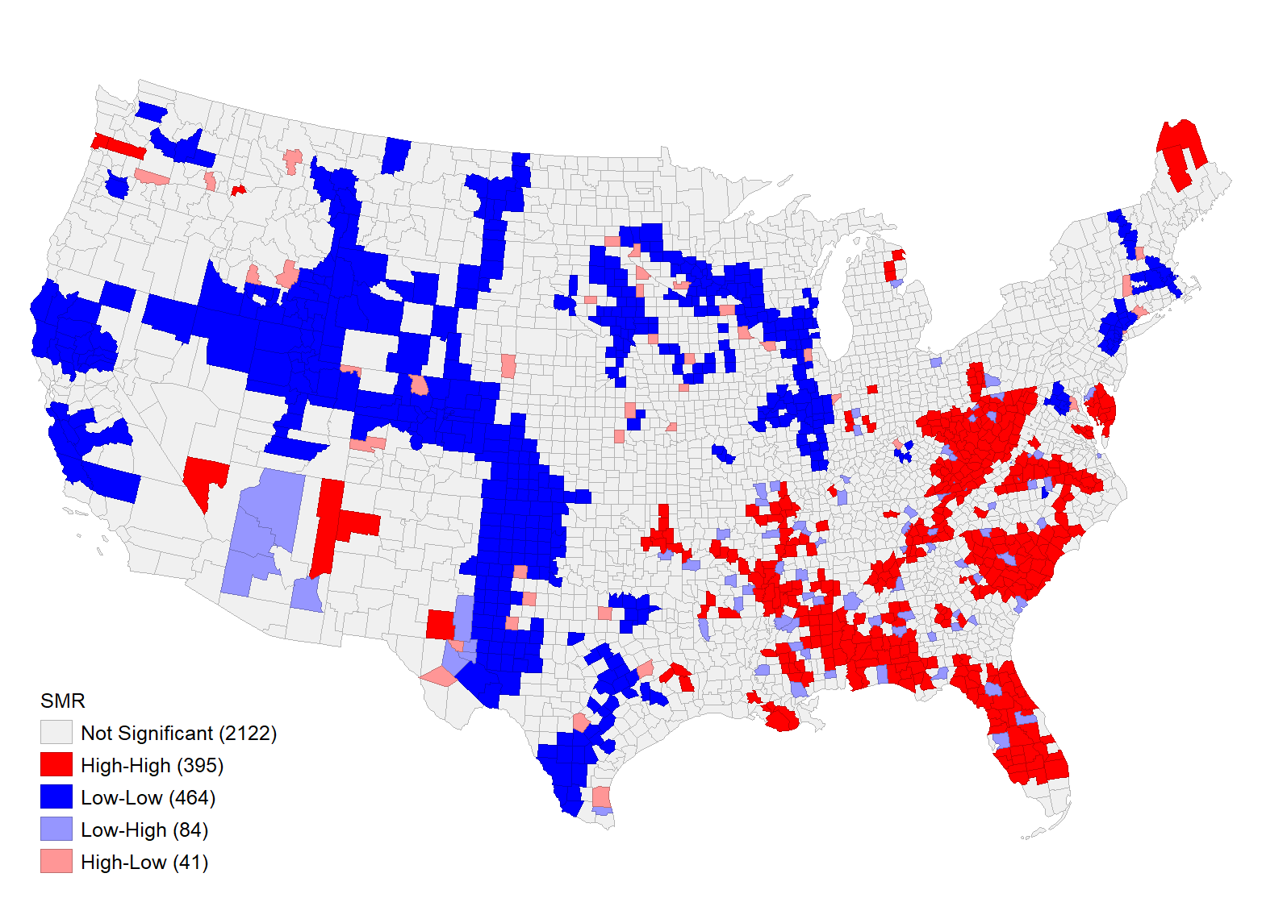
Fig 3: LISA map for SMR
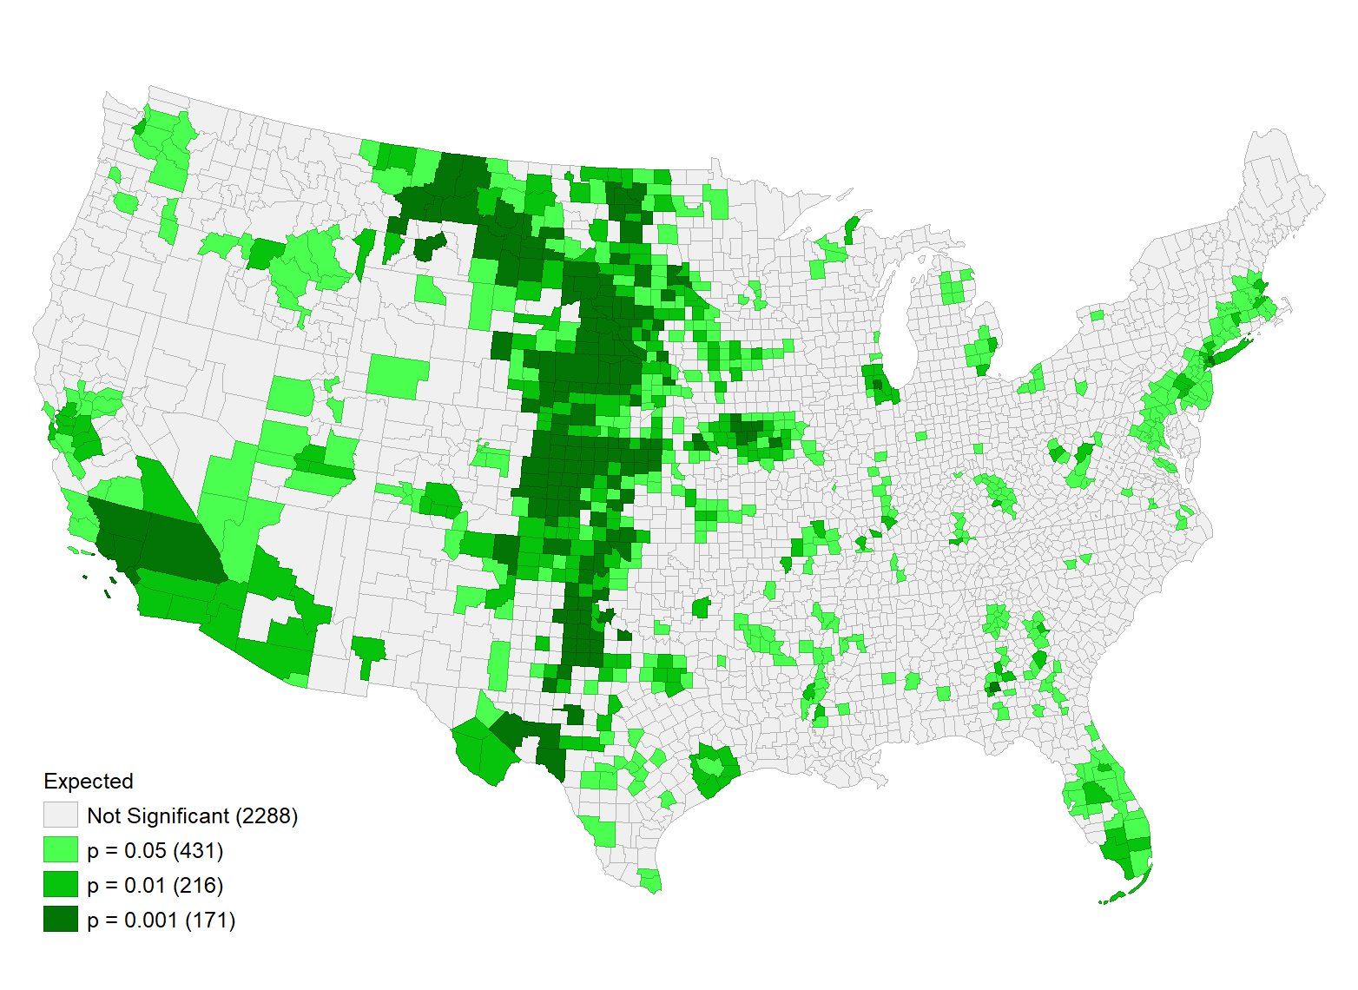
Fig 4: P-value for LISA for expected cases of diabetes
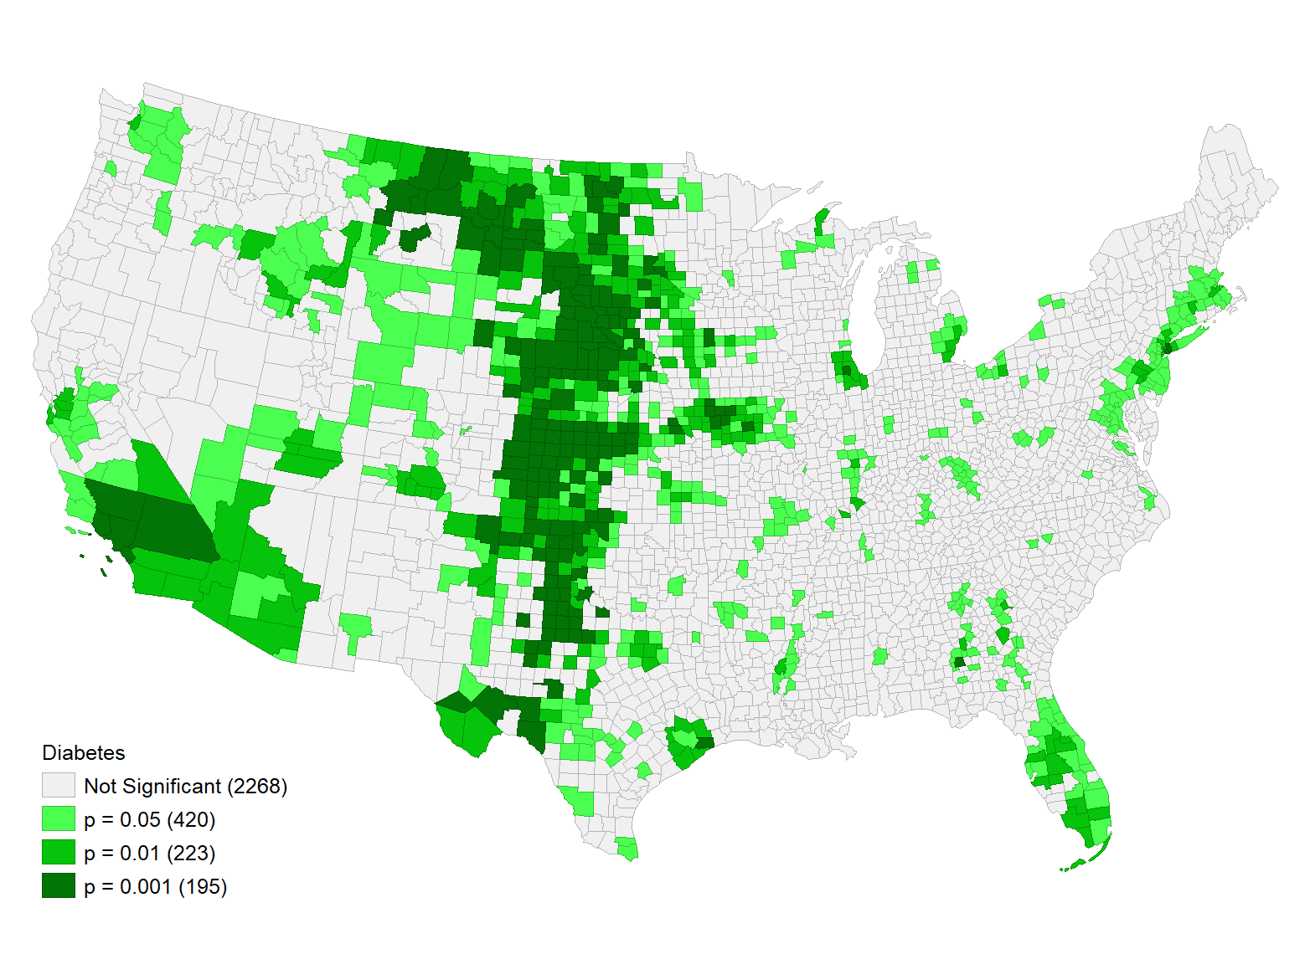
Fig 5: P-value for Diabetes cases clustering
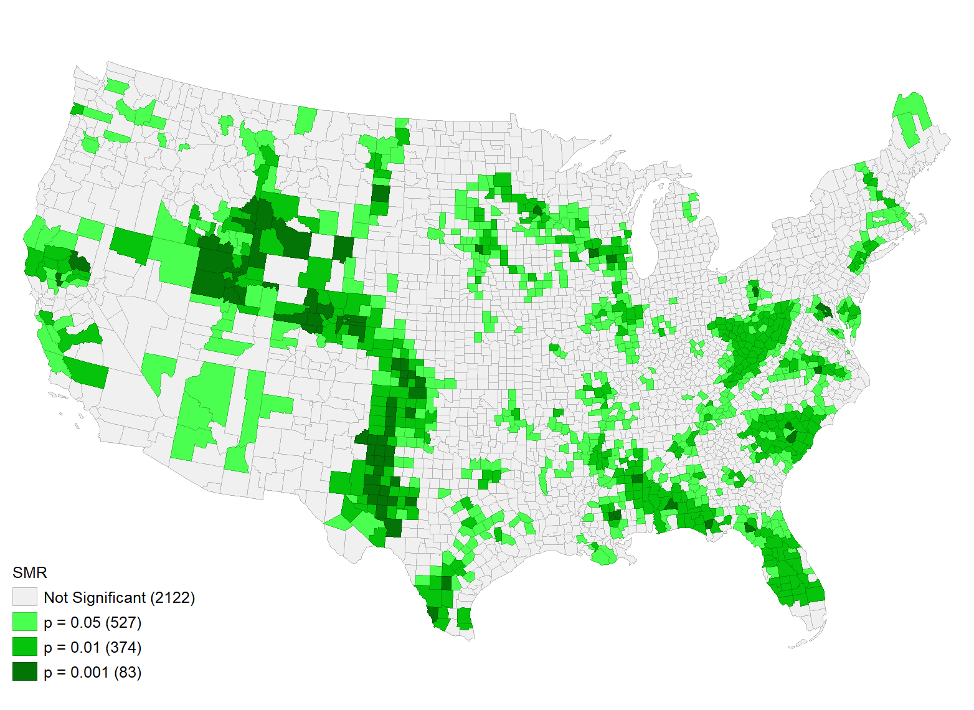
Fig 6: P-value for diabetes SMR clustering

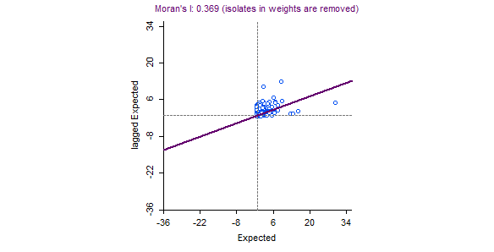
Fig 7 Moran, I scatter plot for expected cases of diabetes
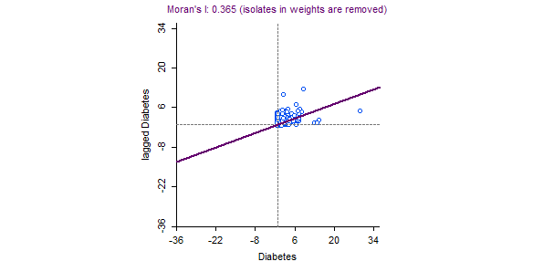
Fig 8; Moran’s I for observed cases of diabetes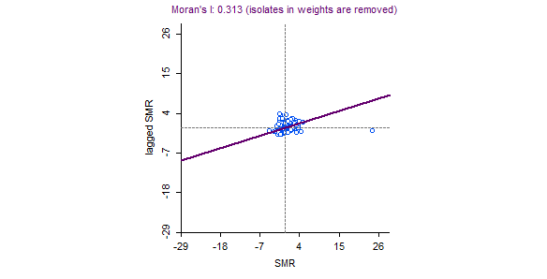
Fig 9: Moran’s I for SMR of diabetes
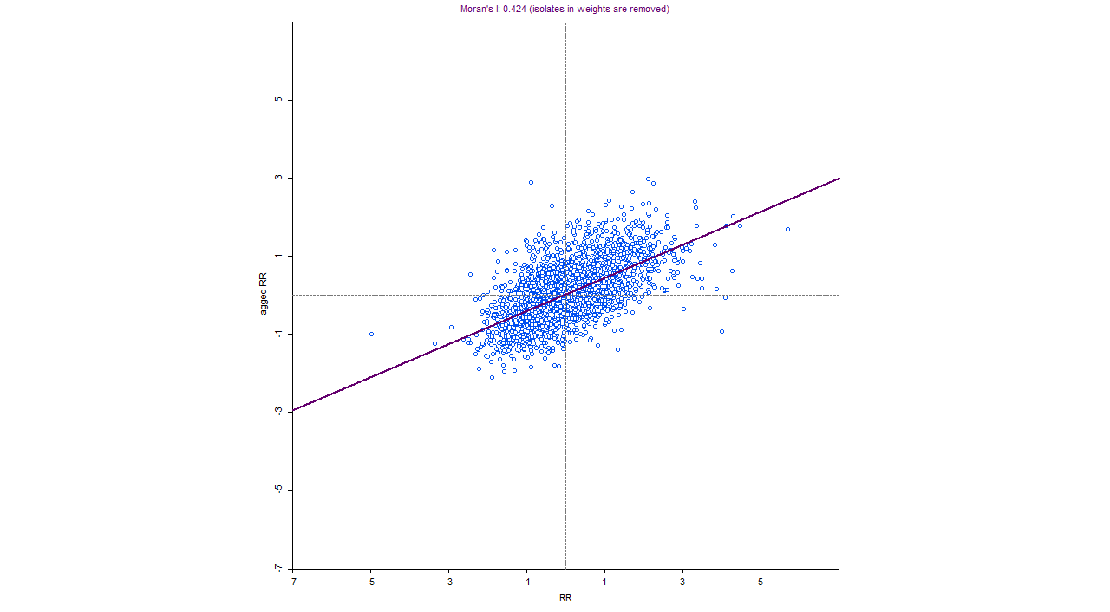
Fig 10: Moran’s scatter plot for RR of diabetes

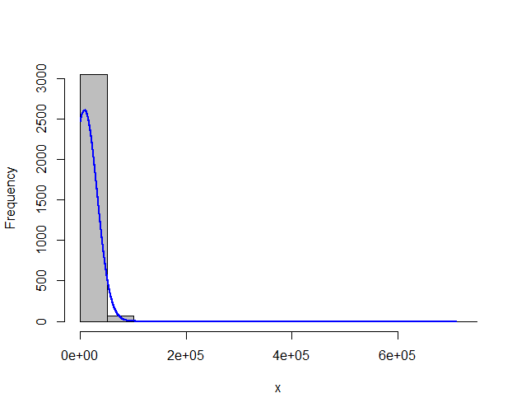
Fig 10: Histogram of observed diabetes cases
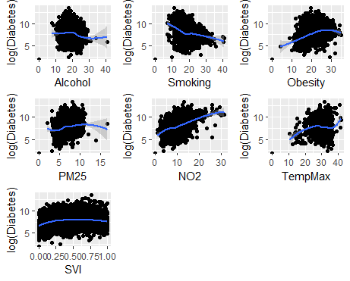
Fig 11: Bivariate association between diabetes and predictors
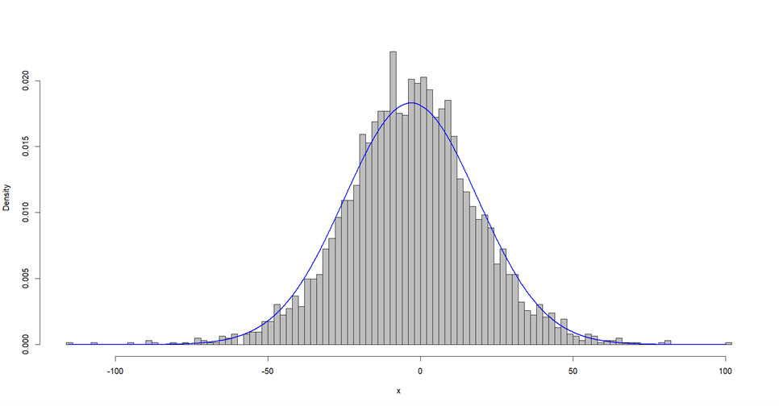
Fig 12: INLA-based model residuals of diabetes cases
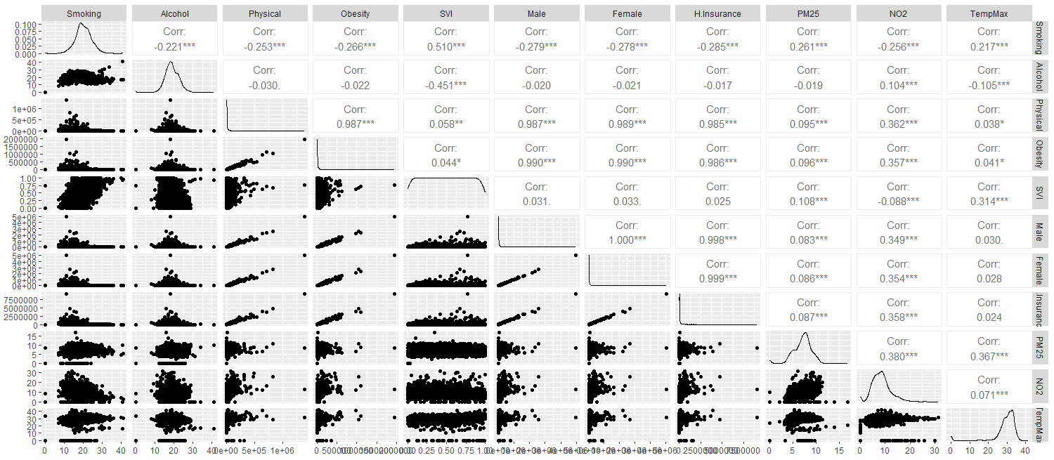
Fig 14: Correlation matrix

Table 4: Estimated cases of DM in the state with 95% credible intervals.
States | Estimate | 95% LL | 95% UL
Alabama | 454585 | 410131.2 | 502599.9
Alaska | 48778.45 | 43155.1 | 54859.88
Arizo0 | 567589.4 | 509004.8 | 631234.1
Arkansas | 260004 | 234293.4 | 287764.4
California | 2709477 | 2407545 | 3039428
Colorado | 350605.2 | 315557.7 | 388173
Connecticut | 247626.4 | 220953.1 | 276561.7
Delaware | 89331.42 | 79917.59 | 99579.31
Florida | 1894023 | 1679708 | 2128260
Georgia | 851403 | 767552.5 | 941625.5
Hawaii | 104088.5 | 89716.58 | 120204.6
Idaho | 128184.7 | 114772.1 | 142666.2
Illinois | 847015.1 | 761577.8 | 939770.9
Indiana | 547297.8 | 493957.7 | 604950.6
Iowa | 232549 | 210466.6 | 256232.5
Kansas | 221149.1 | 199696.1 | 244239.3
Kentucky | 356563.2 | 321852.5 | 393851.2
Louisia0 | 399111.4 | 358122.5 | 443524.6
Maine | 110288 | 97819.36 | 123901.6
Maryland | 461251.6 | 411709.4 | 515328.8
Massachusetts | 445986.1 | 395827 | 500719.6
Michigan | 801033.7 | 715092 | 894453.3
Minnesota | 380987.6 | 343326.9 | 421365.5
Mississippi | 276946.1 | 249336.7 | 306770.9
Missouri | 470348.4 | 423991.8 | 520259.1
Monta0 | 77679.66 | 69944.83 | 86023.9
Nebraska | 142160.9 | 128064.9 | 157346.5
Nevada | 247685.3 | 223659.8 | 273834.6
New Hampshire | 100693.5 | 90467.75 | 111714.2
New Jersey | 620301.7 | 554430.6 | 692060.6
New Mexico | 160454.6 | 144034.5 | 178229.5
New York | 1409444 | 1247830 | 1587164
North Carolina | 867142.8 | 781099.4 | 959562.4
North Dakota | 56979.91 | 51224.16 | 63162.38
Ohio | 977175.6 | 881198.9 | 1080768
Oklahoma | 323424.7 | 291834.7 | 357431.7
Oregon | 307848.7 | 276143.5 | 342068
Pennsylvania | 997483.3 | 899620.6 | 1102867
Rhode Island | 79846.73 | 71357.05 | 89081.97
South Carolina | 483757.7 | 435855.7 | 535721.9
South Dakota | 62204.34 | 56120.42 | 68724.89
Tennessee | 582183 | 526533.2 | 642058.1
Texas | 2108670 | 1894573 | 2339650
Utah | 185754.2 | 166844.8 | 205986.1
Vermont | 42949.49 | 38423.68 | 47824.61
Virginia | 665239.1 | 595828.2 | 740462.2
Washington | 540733.4 | 483482 | 602623.2
West Virginia | 181900 | 164024.5 | 201264.7
Wisconsin | 406400.5 | 364145.9 | 452066
Wyoming | 40424.46 | 36445.7 | 44654.26
Total | 24924761 | 22328272 | 27740676
UL=95% upper limit; LL=95% lower limit.

