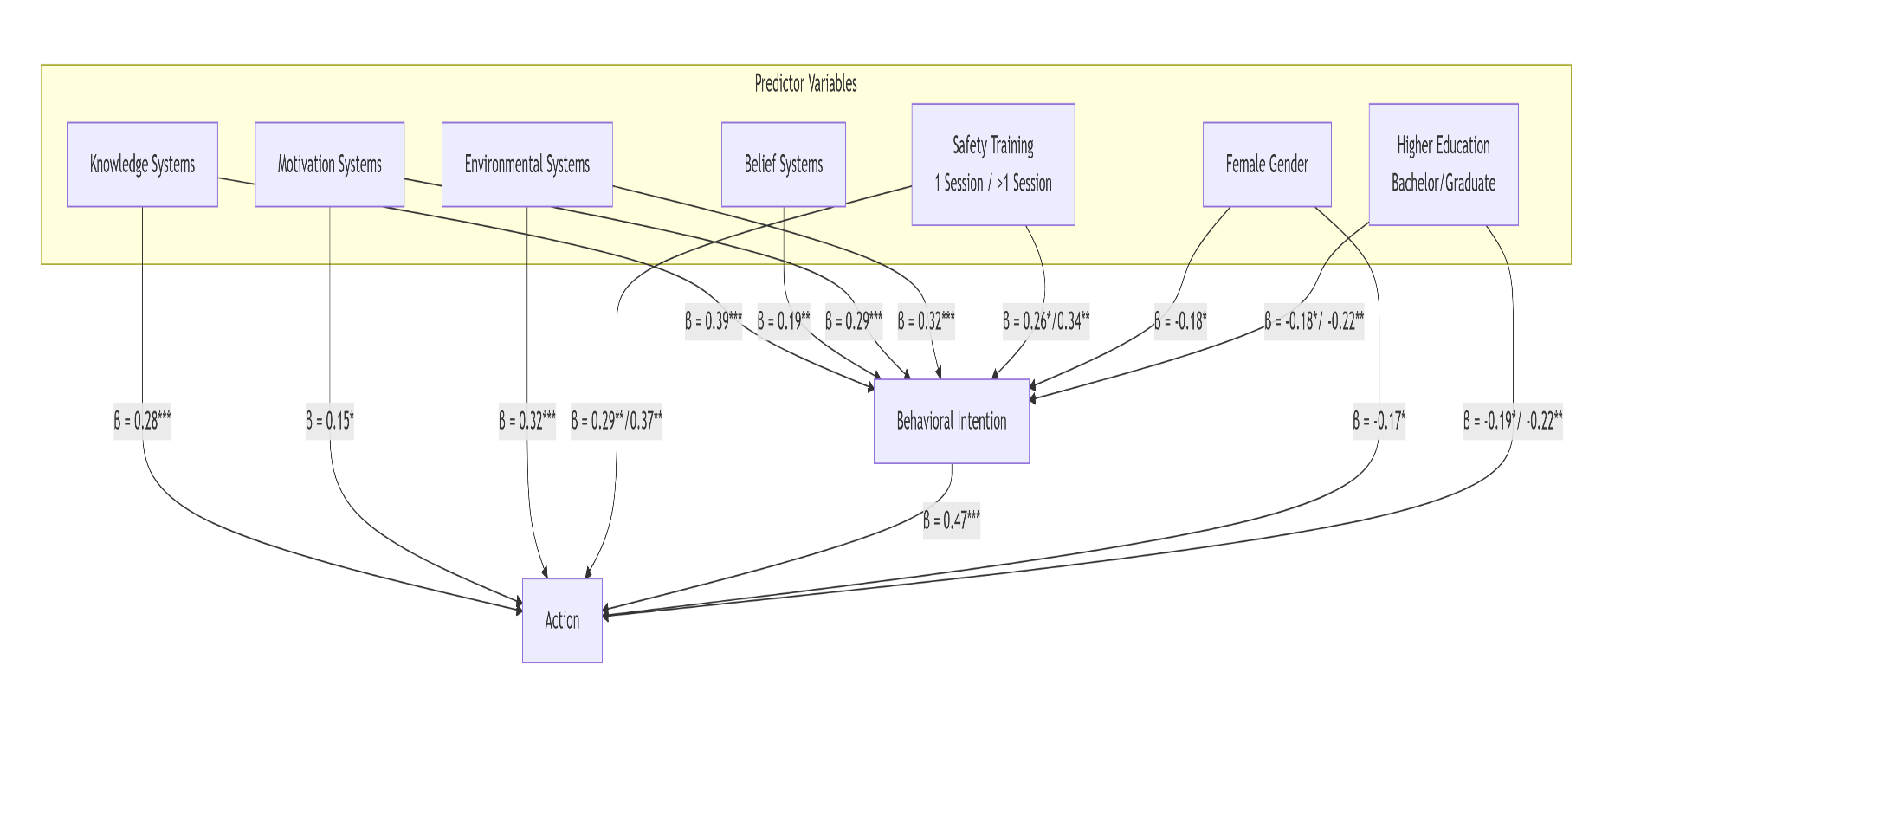
Figure 1. Significant predictive pathways of the Health Action Model for pesticide safety behaviors. The model illustrates standardized beta coefficients (β) for relationships that were statistically significant (*p < 0.05, **p < 0.01, ***p < 0.001). The analysis reveals knowledge and environmental systems as the strongest predictors, while also demonstrating a significant intention-action gap (β = 0.47). Negative coefficients for gender and education indicate these demographic factors were associated with decreased safety intention and action.

