Physical Activity, Sedentary Behavior and Risk of Inflammatory Bowel Disease: A Prospective Cohort Study in the UK Biobank

Supplemental materials
Supplementary Methods 1: Physical activity measurements
Physical activity (PA) which was a modified version of the International Physical Activity Questionnaire (IPAQ),¹ was assessed by capturing the frequency and duration of walking, moderate, and vigorous PA performed over the last seven days. Data were analyzed in accordance with the IPAQ scoring protocol.² MET levels included walking (3.3), moderate-intensity (4.0), and vigorous-intensity (8.0).¹ For both measures, the MET score for PA (MET min/week) was calculated by multiplying the frequency, duration, and MET values¹. Then we calculate the first quartile (Q1) and the third quartile (Q3) of the MET score for PA. The interquartile range is IQR = Q3 - Q1. Define the limits: the upper limit is Q3 + 1.5 * IQR, and the lower limit is Q1 - 1.5 * IQR. Data points that are below the lower limit or above the upper limit are considered outliers and should be removed.
References
1. Ainsworth BE, Haskell WL, Whitt MC, et al. Compendium of physical activities: an update of activity codes and MET intensities. Medicine and science in sports and exercise 2000, 32(9; SUPP/1): S498-S504.
2. IPAQ scoring protocol - International Physical Activity Questionnaire [https://sites.google.com/site/theipaq/scoring-protocol]

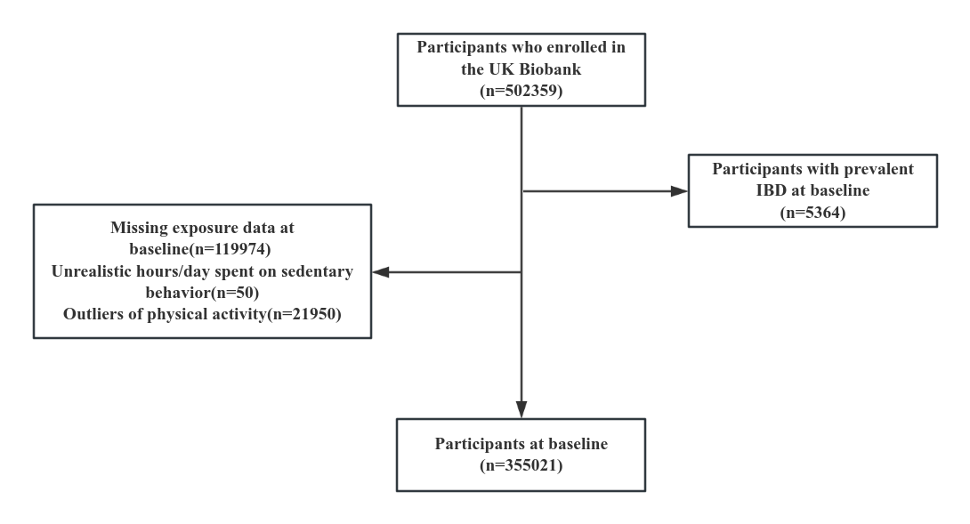
Supplementary Fig. 1: Flowchart of study participants in the UK Biobank.

Supplementary Table 1: PA and SB questions in the UK Biobank.
Questions | Potential responses
In a typical week, on how many days did you walk for at least 10 min at a time? (Include walking that you do at work, traveling to and from work, and for sport or leisure) | Number of days, “do not know,” “unable to walk,” or “prefer not to answer”
How many minutes did you usually spend walking on a typical day? | Quantity of minutes, “do not know” or “prefer not to answer”
In a typical week, on how many days did you do 10 min or more of moderate physical activities like carrying light loads, cycling at normal pace? (Do not include walking) | Number of days, “do not know” or “prefer not to answer”
How many minutes did you usually spend doing moderate activities on a typical day? | Quantity of minutes, “do not know” or “prefer not to answer”
In a typical week, how many days did you do 10 min or more of vigorous physical activity? (These are activities that make you sweat or breathe hard such as fast cycling, aerobics, heavy lifting) | Number of days, “do not know” or “prefer not to answer”
How many minutes did you usually spend doing vigorous activities on a typical day? | Quantity of minutes, “do not know” or “prefer not to answer”
In a typical day, how many hours do you spend driving? | Number of hours, “less than an hour a day”, “do not know” or “prefer not to answer”
In a typical day, how many hours do you spend using the computer? (Do not include using a computer at work; put 0 if you do not spend any time doing it) | Number of hours, “less than an hour a day”, “do not know” or “prefer not to answer”
In a typical day, how many hours do you spend watching TV? (Put 0 if you do not spend any time doing it) | Number of hours, “less than an hour a day”, “do not know” or “prefer not to answer”

Supplementary Table 2: Diagnostic code for inflammatory bowel disease

 | ICD-10 | Self-reported fields
Inflammatory bowel disease | K51, K510, K511, K512,  K513, K515, K518, K519,  K50, K500, K501, K508,  K509, K514, | 1461, 1462, 1463,
Crohn's disease | K50, K500, K501, K508,  K509, | 1462,
Ulcerative colitis | K51, K510, K511, K512,  K513, K515, K518, K519,  K514, | 1463,
Abbreviations: ICD, International Classification of Disease

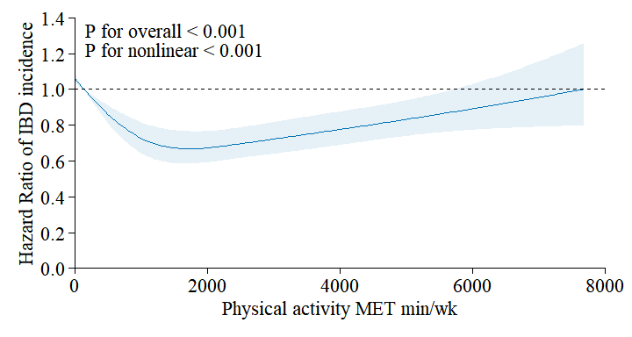
Supplementary Fig. 2: Dose-response relationship between PA and IBD incidence.
Abbreviations: IBD, inflammatory bowel disease; MET min/wk=metabolic equivalent task minutes per week.
Data is presented as hazard ratios (HRs) and 95% confidence interval (CI). All models adjusted for age, sex, ethnicity, smoking status, alcohol drinker status, education level, household income, TDI.
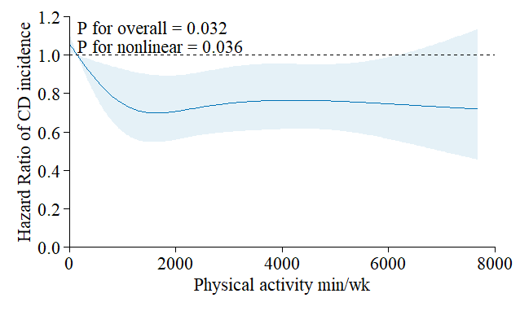
Supplementary Fig. 3: Dose-response relationship between PA and CD incidence.

Abbreviations: CD, Crohn’s disease; MET min/wk=metabolic equivalent task minutes per week.Data is presented as hazard ratios (HRs) and 95% confidence interval (CI). All models adjusted for aAll models adjusted for age, sex, ethnicity, smoking status, alcohol drinker status, education level, household income, TDI, PRS of CD.
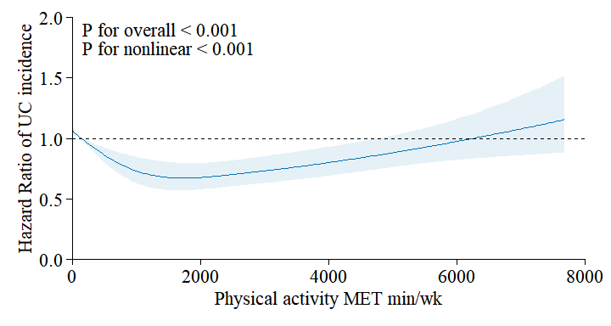
Supplementary Fig. 4: Dose-response relationship between PA and UC incidence.
Abbreviations: UC, ulcerative colitis; MET min/wk=metabolic equivalent task minutes per week.
Data is presented as hazard ratios (HRs) and 95% confidence interval (CI). All models adjusted for age, sex, ethnicity, smoking status, alcohol drinker status, education level, household income, TDI, PRS of UC.

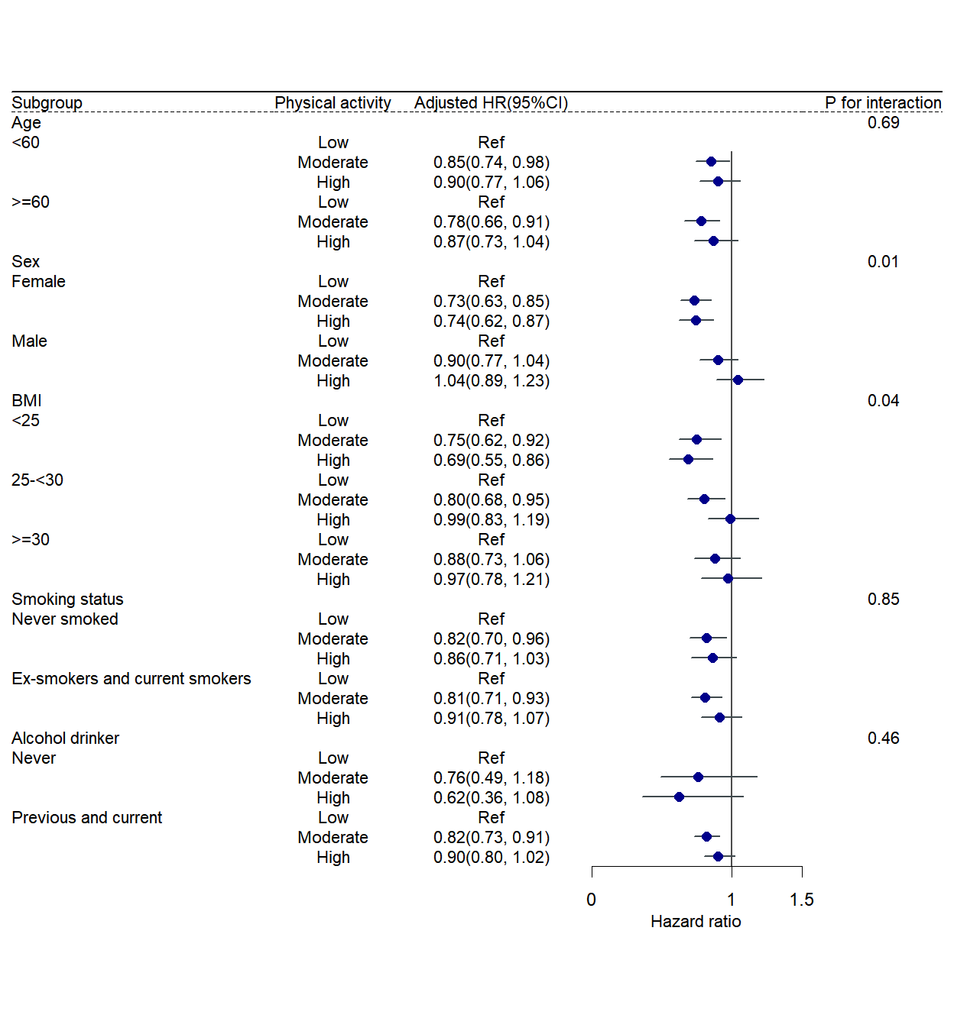

Supplementary Fig. 5: Subgroup analyses of associations of PA with risk of IBD.
HRs and 95% CIs were estimated with adjustment for age, sex, Ethnicity, smoking status, alcohol drinker status, education level, household income, TDI, and BMI.
Abbreviations: CI, confidence interval; HR, hazard ratio; BMI, body mass index
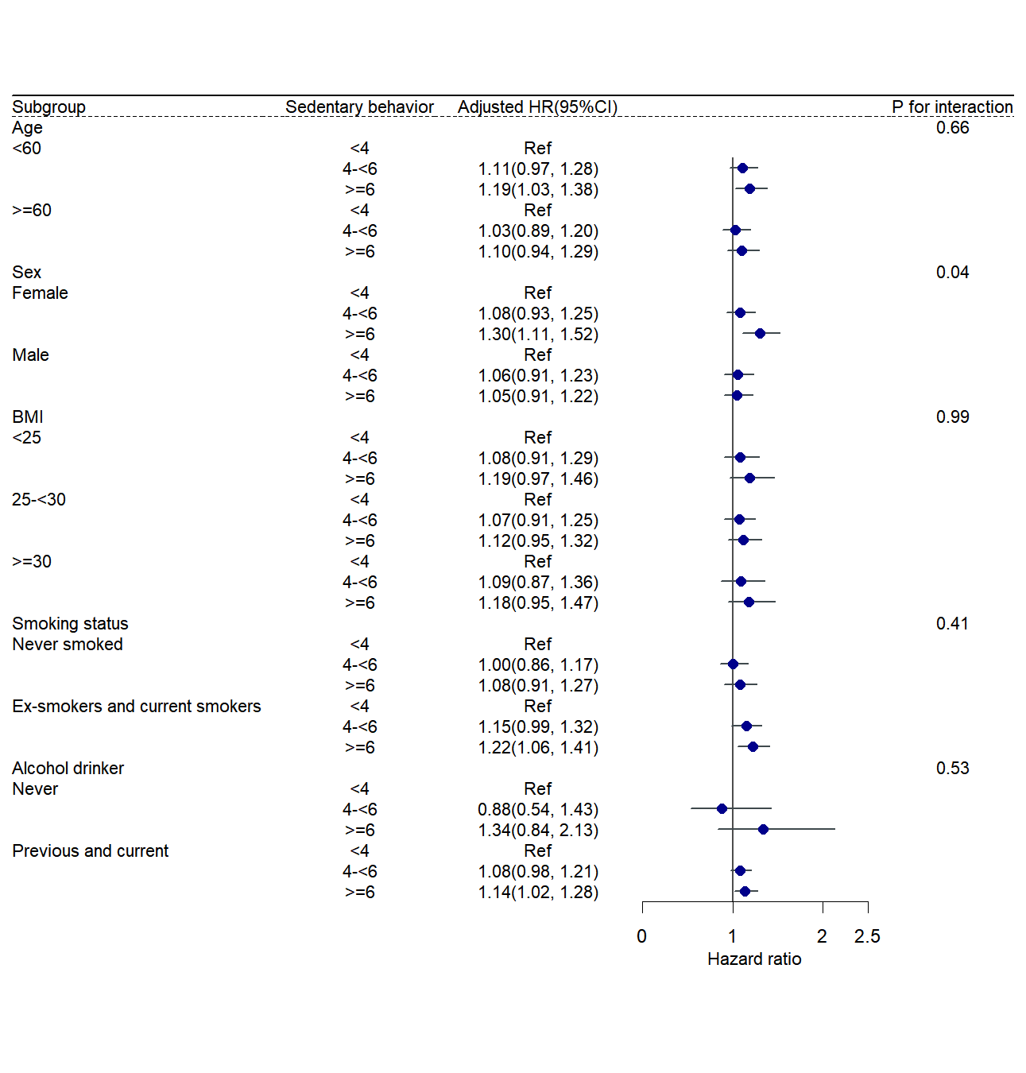

Supplementary Fig. 6: Subgroup analyses of associations of SB with risk of IBD.
HRs and 95% CIs were estimated with adjustment for age, sex, Ethnicity, smoking status, alcohol drinker status, education level, household income, TDI, and BMI.
Abbreviations: CI, confidence interval; HR, hazard ratio; BMI, body mass index

Supplementary Table 3: Association between PA, SB and incident IBD, after excluding participants with a follow-up time of fewer than 2 years in the sensitivity analysis.
Exposure | Level | Case /n | Model1ª |  | Model2^{b} |  | P value for trend
Exposure | Level | Case /n | HR (95%CI) | P value | HR (95%CI) | P value | P value for trend
Physical activity | Low | 459/68185 | 1 [Reference] |  | 1 [Reference] |  | 0.18
Physical activity | Moderate | 1005/189334 | 0.78(0.70, 0.87) | <0.001 | 0.82(0.73, 0.92) | <0.001
Physical activity | High | 564/93498 | 0.88(0.78, 1.00) | 0.04 | 0.90(0.79, 1.01) | 0.08
Sedentary behavior | Per hour/day | 2028/351017 | 1.03(1.01, 1.05) | <0.001 | 1.06(1.04, 1.07) | <0.001 | <0.001

Abbreviations: CI, confidence interval; HR, hazard ratio
ªAdjusted for age, sex
^{b}Adjusted for age, sex, Ethnicity, smoking status, alcohol drinker status, education level, household income, TDI.

Supplementary Table 4: Association between PA, SB and incident IBD in the sensitivity analysis.

Exposure | Level | Case /n | Model3ª |  | P value for trend
Exposure | Level | Case /n | HR (95%CI) | P value | P value for trend
Physical activity | Low | 509/68717 | 1 [Reference] |  | 0.16
Physical activity | Moderate | 1109/190171 | 0.83(0.74, 0.92) | <0.001
Physical activity | High | 624/93891 | 0.91(0.81, 1.03) | 0.13
Sedentary behavior | Per hour/day | 2242/352779 | 1.02(1.01, 1.04) | 0.004 | <0.001

Abbreviations: CI, confidence interval; HR, hazard ratio
ªAdjusted for age, sex, Ethnicity, smoking status, alcohol drinker status, education level, household income, TDI, BMI, healthy diet scores, CVD, cancer, diabetes, Vitamin D supplementation.

Supplementary Table 5: Association between moderate-vigorous intensity physical activity (MVPA) and incident IBD in the sensitivity analysis.
Exposure | Level | Case /n | Model1ª |  | Model2^{b} |  | P value for trend
Exposure | Level | Case /n | HR(95%CI) | P value | HR(95%CI) | P value | P value for trend
Physical activity | Quintile 3 | 886/122225 | 1 [Reference] |  | 1 [Reference] |  | <0.001
Physical activity | Quintile 3 | 665/117061 | 0.78(0.70, 0.86) | <0.001 | 0.80(0.73, 0.89) | <0.001
Physical activity | Quintile 3 | 691/113493 | 0.82(0.74, 0.91) | <0.001 | 0.84(0.76, 0.93) | <0.001

Abbreviations: CI, confidence interval; HR, hazard ratio
ªAdjusted for age, sex
^{b}Adjusted for age, sex, Ethnicity, smoking status, alcohol drinker status, education level, household income, TDI.

