Supplementary Material
A: FGDs for teachers, students, frontline healthcare workers, MHPSS officers, people with lived experiences, and policy experts.

 | Please use the following questions and cover all areas to facilitate a discussion with the community members, and note down their responses.
1 | What community services are currently available (in your area) for people with mental health conditions?
2 | What challenges have you observed in accessing mental healthcare in your area?
3 | What are the constraints and challenges to provide mental healthcare in the community?
4 | What are the common attitudes, beliefs, and practices of the community towards mental health crises in your area?
5 | What cultural aspects must be considered while developing a community intervention?
6 | What role can community members like you can play in providing psychosocial support?
7 | How effective are the existing PFA trainings in developing psychosocial skills?
8 | What are the possible barriers in sustaining psychosocial support services in your area?
9 | How can we engage community members to support implementation and scale-up?

B: KII for Mental Health Experts

 | Please use the following questions and cover all areas to facilitate a discussion with the MH experts and MHPSS officers, and note down their responses.
1 | How do gaps in mental health literacy impact help-seeking at the community level?
2 | How do gaps in knowledge and skills impact service provision at the community level?
3 | What strategies can help increase awareness and reduce stigma?
4 | How can training be adapted to address the needs of vulnerable groups?
5 | What systemic or institutional barriers limit effective implementation of PFA training and service delivery?
6 | What is the existing referral mechanism in your area?
7 | What is the role of stakeholders and community structures in strengthening the mental health services?
8 | What are the key challenges in sustaining mental health initiatives?
9 | What measures can be taken to scale up the mental health initiative?

C- Adaptation semi-structured questionnaire (ADAPT checklist)
- What adaptations can be proposed in response to identified constraints and facilitators?
- What cultural considerations are important in adapting PFA guide for our community setting?
- Which cultural beliefs, idioms of distress, or social norms, rights of people need to be considered during adaptation?
- How can the PFA Guide be more accessible, and feasible, considering different levels of literacy and learning preferences in our context?
- What resources are needed to deliver an adapted intervention?
- Which scalable modalities can be used to train a workforce in resource-limited settings while maintaining quality?
- How do we measure training efficacy?
- What adaptations are needed for the sustainability of the intervention?

D- Content of the Hamdard Force guides (Modules)
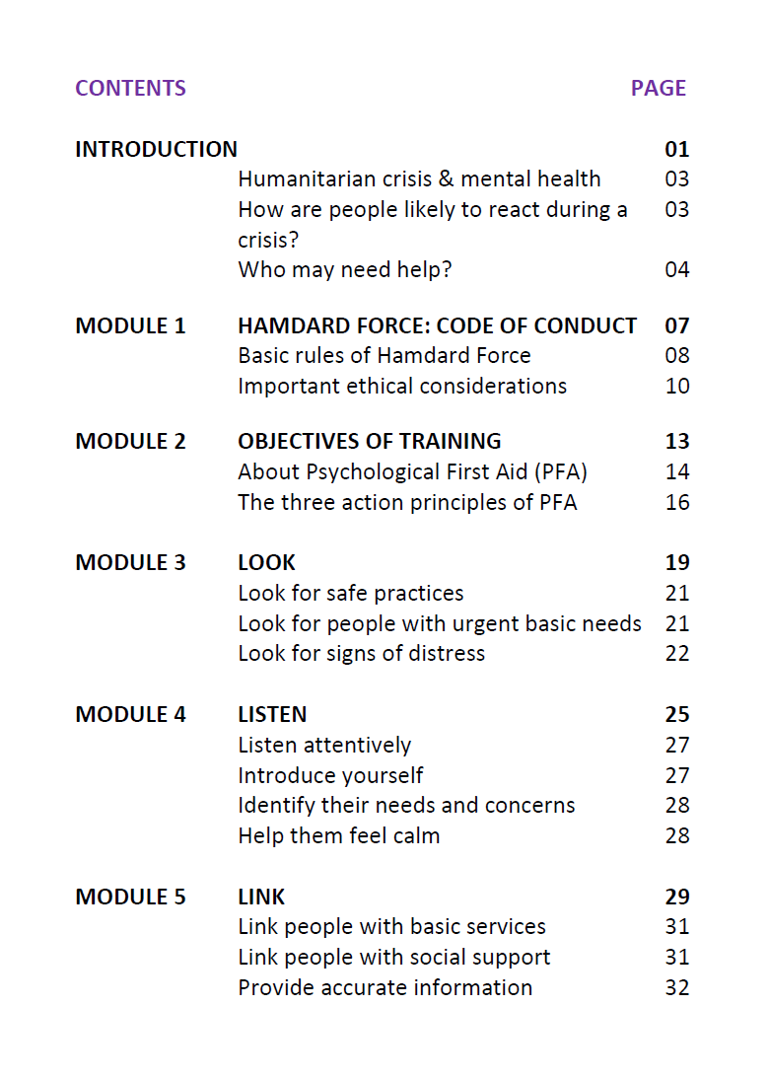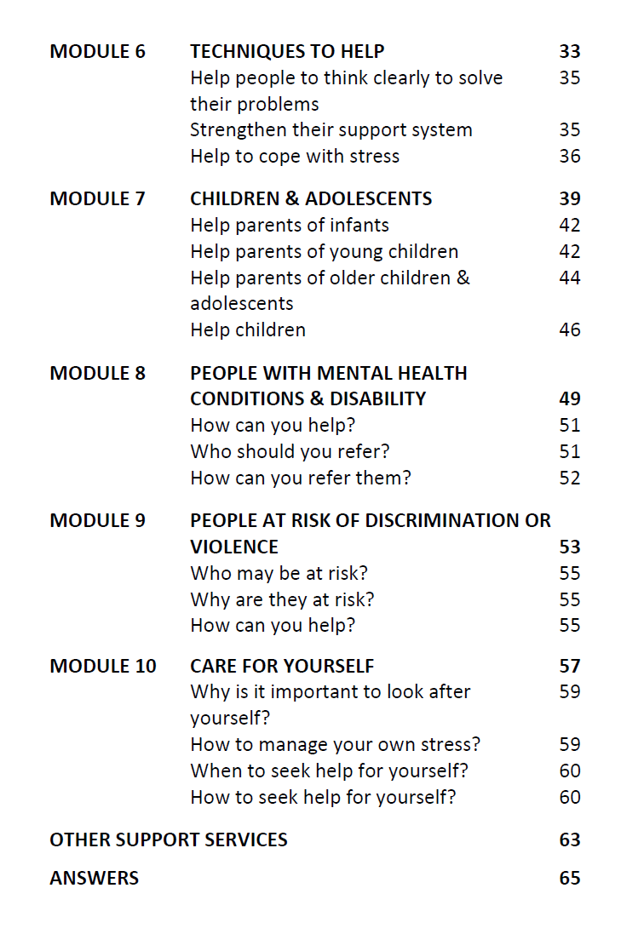
E- Inclusion criterion for recruiting Hamdard Force:
- High school education (FSc /A Levels / intermediate)
- Active engagement with the community
- Effective communication skills
- Commitment to promote mental health in the community
- Aspiration for continuous professional development
- Good standing in their communities

F- FRAME Reporting
FRAME reporting adaptations

1 | When the modification was made | Pre-implementation/planning/pilot
2 | Whether the modification was planned/proactive or unplanned/reactive, | Planned/proactive
3 | Who participated in the decision to modify?  Optional: Who made the ultimate decision | The modifications were planned by the core team based on FGDs/KIIs. Part of the team included community members, recipients, health administrator, intervention team, practitioners.  Experts team finalized the modifications.
4 | What is modified?  Type or nature of context or content-level modifications | Content- addition, deletion, tailoring, shortening, substituting  Structural- format, reordering, spreading  Training an evaluation – format, setting, adding elements  Implementation and scale-up activities – delivery mode, mobile application development, system level integration  (see tables)
5 | At what level of delivery the modification is made | Target intervention group – community level
6 | The extent to which the modification is fidelity-consistent | Core elements of original content are preserved
7 | The reasons for the modification, including  (a) the intent or goal of the modification (e.g., improve fit, adapt to a different culture, reduce costs, etc.) and  (b) contextual factors that influenced the decision. | Rationale is presented in Table X with each modification.  it broadly covers modifications due to improve fit to a new culture and setting.

G. Consort diagram of recruited Hamdard Force
