Supplementary materials
Catalogue
Figure S1. KM curves of baseline FPG groups in age groups 2
Figure S2. The non-linear analysis between baseline constant FPG and IS 4
Figure S3. Box plots of FPG trajectory groups 5
Table S1. Baseline characteristics of included and excluded participants 6
Table S2. Association between baseline FPG with incidence of IS in aged 65 to 70 years old 9
Table S3. Association between baseline FPG with incidence of IS in aged above 70 years old 10
Table S4. Association between baseline FPG and incident IS with model fit assessed by AIC 11
Table S5. Model evaluation and model selection for the FPG trajectory group 12
Table S6. Baseline characteristics of FPG trajectory groups 13
Table S7. IS incident cumulative rate of each trajectory group 16
Table S8. Association between FPG trajectory and incident IS with model fit assessed by AIC 17

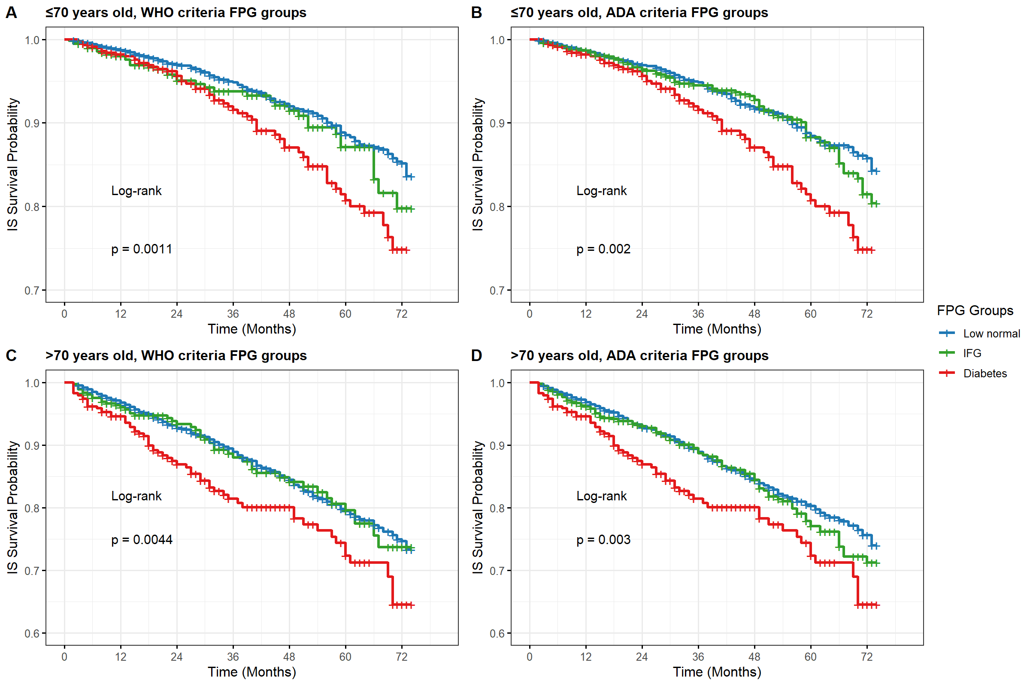

Figure S1. KM curves of baseline FPG groups in age groups
NOTES:
(A) Participants aged ≤70 years, IFG defined by WHO criteria (6.1–6.9mmol/L);
(B) Participants aged >70 years, IFG defined by WHO criteria (6.1–6.9mmol/L);
(C) Participants aged ≤70 years, IFG defined by ADA criteria (5.6–6.9mmol/L);
(D) Participants aged >70 years, IFG defined by ADA criteria (5.6–6.9mmol/L).

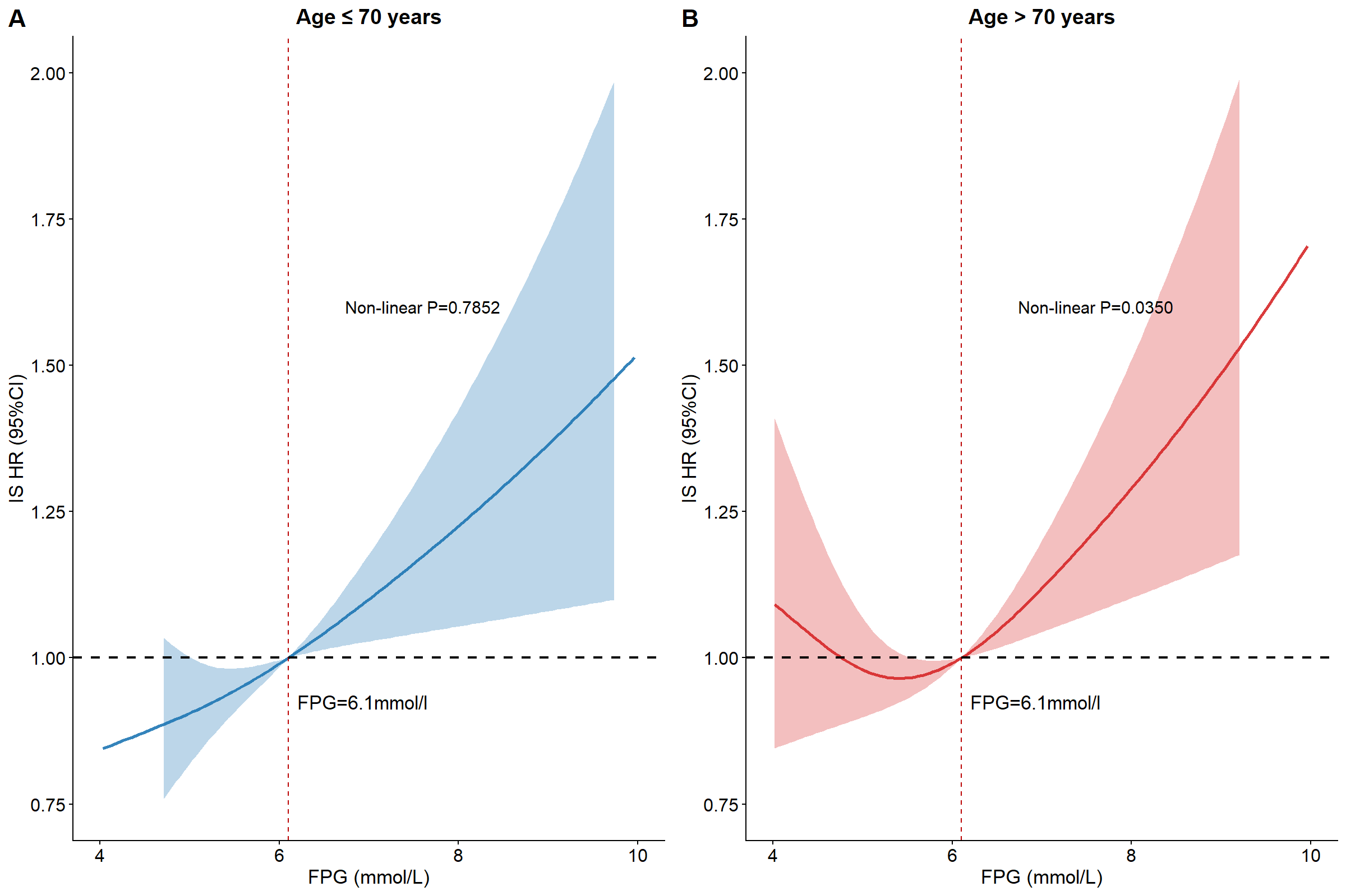

Figure S2. The non-linear analysis between baseline constant FPG and IS
NOTES:
(A) Participants aged ≤70 years;
(B) Participants aged >70 years.
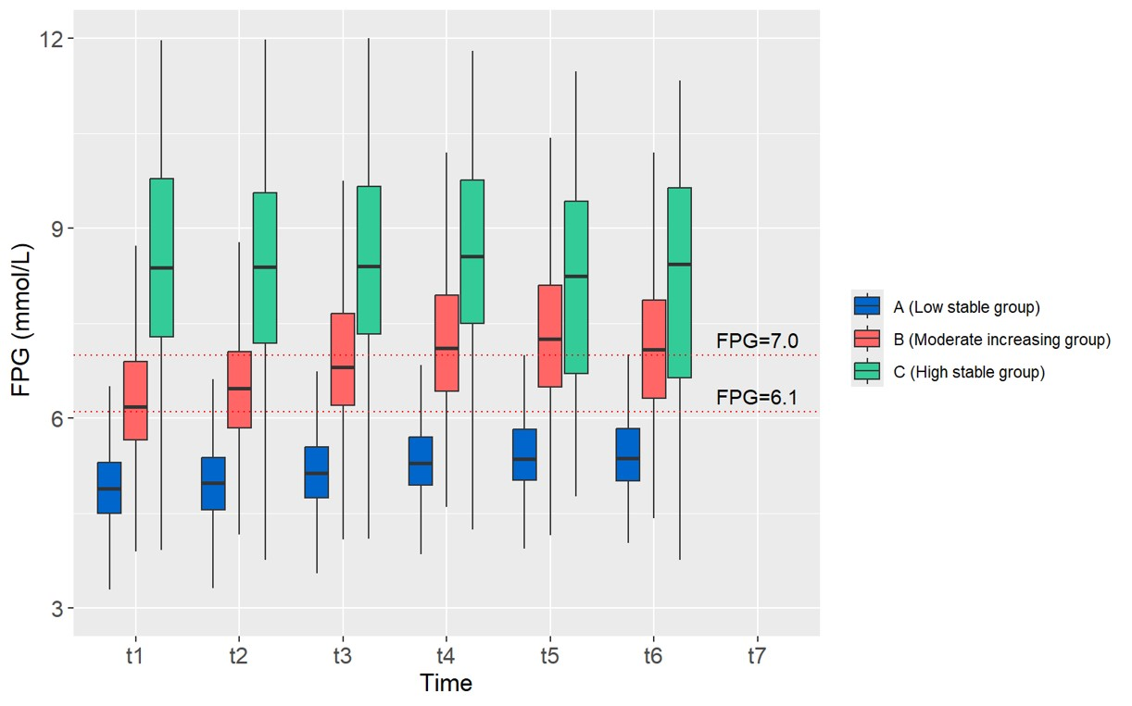

Figure S3. Box plots of FPG trajectory groups

Table S1. Baseline characteristics of included and excluded participants
Variables | Total  (N=10369) | Included |  | P
Variables | Total  (N=10369) | No (n=943) | Yes (n=9426) | P
Age (year) | 70.29 (5.46) | 72.71 (6.55) | 70.04 (5.27) | <0.001
Gender, n (%) |  |  |  | 0.049
Female | 5616 (54.2) | 540 (57.3) | 5076 (53.9)
Male | 4753 (45.8) | 403 (42.7) | 4350 (46.1)
Education, n=10354 (%) |  |  |  | 0.266
Primary school or below | 6358 (61.4) | 567 (60.2) | 5791 (61.5)
Junior high school | 2924 (28.2) | 263 (27.9) | 2661 (28.3)
Senior high school or above | 1072 (10.4) | 112 (11.9) | 960 (10.2)
BMI (kg/m²) | 24.08 (3.23) | 24.37 (3.38) | 24.05 (3.21) | 0.005
BMI groups, n (%) |  |  |  | 0.021
Normal (<24 kg/m²) | 5269 (50.8) | 445 (47.2) | 4824 (51.2)
Overweight or Obesity (>=24kg/m²) | 5100 (49.2) | 498 (52.8) | 4602 (48.8)
WHtR | 0.53 (0.06) | 0.54 (0.06) | 0.53 (0.06) | <0.001
History of hypertension，n (%) |  |  |  | <0.001
No | 6628 (63.9) | 294 (31.2) | 6334 (67.2)
Yes | 3741 (36.1) | 649 (68.8) | 3092 (32.8)
History of diabetes, n (%) |  |  |  | <0.001
No | 8961 (86.4) | 712 (75.5) | 8249 (87.5)
Yes | 1408 (13.6) | 231 (24.5) | 1177 (12.5)
Smoking status,  n =10355 (%) |  |  |  | 0.345
No | 7279 (70.3) | 676 (71.7) | 6603 (70.2)
Yes | 3076 (29.7) | 267 (28.3) | 2809 (29.8)
Drinking status,  n=10353 (%) |  |  |  | 0.001
No | 6782 (65.5) | 664 (70.4) | 6118 (65.0)
Yes | 3571 (34.5) | 279 (29.6) | 3292 (35.0)
Lack of exercise,  n=10356 (%) |  |  |  | 0.86
No | 8712 (84.1) | 794 (84.4) | 7918 (84.1)
Yes | 1644 (15.9) | 147 (15.6) | 1497 (15.9)
FPG (mmol/L) | 5.53 (1.29) | 5.71 (1.37) | 5.51 (1.28) | <0.001
FPG groups, n (%) |  |  |  | <0.001
Normal FPG group  (FPG< 6.1) | 8271 (79.8) | 706 (74.9) | 7565 (80.3)
IFG group (6.1<=FPG<7.0) | 1047 (10.1) | 110 (11.7) | 937 (9.9)
Diabetes level group (FPG>=7.0) | 1051 (10.1) | 127 (13.5) | 924 (9.8)
LDL-c (mmol/L) | 2.76 [2.26, 3.27] | 2.62 [2.04, 3.17] | 2.77 [2.28, 3.28] | <0.001
HDL-c (mmol/L) | 1.48 [1.27, 1.75] | 1.47 [1.26, 1.74] | 1.49 [1.27, 1.75] | 0.103
TC (mmol/L) | 5.11 [4.47, 5.80] | 4.95 [4.21, 5.69] | 5.13 [4.49, 5.81] | <0.001
TG (mmol/L) | 1.30 [0.96, 1.84] | 1.29 [1.00, 1.85] | 1.30 [0.96, 1.84] | 0.185
SBP (mmHg) | 140.01 (18.28) | 140.51 (18.43) | 139.96 (18.27) | 0.386
DBP (mmHg) | 83.24 (10.96) | 82.16 (11.08) | 83.35 (10.94) | 0.001
PP (mmHg) | 56.77 (13.39) | 58.35 (13.92) | 56.62 (13.33) | <0.001
Abbreviation: BMI, body mass index; WHtR, waist-to-height ratio; FPG, fasting plasma glucose; LDL-c, low-density lipoprotein cholesterol; HDL-c, high-density lipoprotein cholesterol; TC, total cholesterol; TG, triglyceride; SBP, Systolic Blood Pressure; DBP, Diastolic Blood Pressure; PP, Pulse Pressure.

* The excluded participants were generally older and had higher BMI, WHtR, and FPG levels, as well as a higher prevalence of hypertension and diabetes, but lower LDL-c, TC, and alcohol consumption. These differences are expected, as excluded individuals predominantly had pre-existing IS or metabolic disorders.

Table S2. Association between baseline FPG with incidence of IS in aged 65 to 70 years old
Variables | HR (95% CI) |  |  | E-value^{d}
Variables | Model 1 | Model 2 | Model 3 | E-value^{d}
Constant FPG | 1.12 (1.06,1.19) ª | 1.11 (1.05,1.18) ª | 1.10(1.04,1.17) ª | 1.45(1.24)
WHO^{b} criteria FPG groups
Low normal FPG group | Reference | Reference | Reference | Reference
IFG group | 1.29(0.93,1.79) | 1.29 (0.93,1.79) | 1.25(0.90,1.74) | 1.80(1.00)
Diabetes group | 1.65(1.25,2.19) ª | 1.58(1.19,2.09) ª | 1.51(1.13,2.01) ª | 2.38(1.52)
P for trend | <0.001 | <0.001 | 0.003
ADA^{c} criteria FPG groups
Low normal FPG group | Reference | Reference | Reference | Reference
IFG group | 1.12(0.88,1.43) | 1.14(0.89,1.45) | 1.10(0.87,1.41) | 1.45(1.00)
Diabetes group | 1.66(1.25,2.20) ª | 1.58(1.19,2.11) ª | 1.51(1.13,2.02) ª | 2.38(1.51)
P for trend | 0.001 | 0.002 | 0.009
Model 1 was unadjusted. Model 2 adjusted for age, gender. Model 3 further adjusted for education level, WHtR, drinking status, smoking status, exercise, baseline SBP and DBP on the basis of Model 2. ªP＜0.05.
^{b}: WHO, World Health Organization, defines IFG as FPG of 6.1–6.9mmol/L.
^{c}: ADA, the American Diabetes Association sets the IFG range at 5.6–6.9mmol/L.
^{d}: E-value and minimum effect (confidence interval closest to the null) based on HR estimates with model 3.

Table S3. Association between baseline FPG with incidence of IS in aged above 70 years old
Variables | HR (95% CI) |  |  | E-value^{d}
Variables | Model 1 | Model 2 | Model 3 | E-value^{d}
Constant FPG | 1.08(1.01,1.15) ª | 1.08(1.01,1.15) ª | 1.07(1.01,1.15) ª | 1.36(1.09)
WHO^{b} criteria FPG groups
Low normal FPG group | Reference | Reference | Reference | Reference
IFG group | 1.01(0.75,1.37) | 1.03(0.76,1.39) | 1.00(0.73,1.35) | 1.10(1.00)
Diabetes group | 1.56(1.19,2.04) ª | 1.58(1.21,2.07) ª | 1.56(1.19,2.04) ª | 2.48(1.65)
P for trend | 0.004 | 0.003 | 0.005
ADA^{c} criteria FPG groups
Low normal FPG group | Reference | Reference | Reference | Reference
IFG group | 1.11(0.89,1.38) | 1.10(0.88,1.37) | 1.07(0.85,1.33) | 1.33(1.00)
Diabetes group | 1.60(1.22,2.10) ª | 1.61(1.23,2.12) ª | 1.58(1.20,2.09) ª | 2.54(1.69)
P for trend | 0.002 | 0.002 | 0.005
Model 1 was unadjusted. Model 2 adjusted for age and gender. Model 3 further adjusted for education level, WHtR, drinking status, smoking status, exercise, baseline SBP and DBP on the basis of Model 2. ªP＜0.05.
^{b}: WHO, World Health Organization, defines IFG as FPG of 6.1–6.9mmol/L.
^{c}: ADA, the American Diabetes Association sets the IFG range at 5.6–6.9mmol/L.
^{d}: E-value and minimum effect (confidence interval closest to the null) based on HR estimates with model 3.

Table S4. Association between baseline FPG and incident IS with model fit assessed by AIC
Variables | HR (95% CI)
Variables | Model 1 | Model 2 | Model 3
Aged 65 to70 years old
Constant FPG | 6475.981 | 6455.605 | 6450.149
WHOª criteria FPG groups | 6478.45 | 6458.484 | 6453.248
ADA^{b} criteria FPG groups | 6479.69 | 6459.589 | 6454.223
Aged 65 to70 years old
Constant FPG | 7309.729 | 7307.023 | 7302.163
WHOª criteria FPG groups | 7307.411 | 7304.545 | 7299.317
ADA^{b} criteria FPG groups | 7306.633 | 7303.855 | 7299.009
Abbreviation: AIC, the Akaike Information Criterion
Model 1 was unadjusted. Model 2 adjusted for age and gender. Model 3 further adjusted for education level, WHtR, drinking status, smoking status, exercise, baseline SBP and DBP on the basis of Model 2.
ª: WHO, World Health Organization, defines IFG as FPG of 6.1–6.9mmol/L.
^{b}: ADA, the American Diabetes Association sets the IFG range at 5.6–6.9mmol/L.
Among the models, Model 3 always demonstrated the best fit by using AIC.

Table S5. Model evaluation and model selection for the FPG trajectory group
Group  (Subgroup order) | Avepp(%) | OCC | P_{j}(%) | π_{j}(%) | BIC
1Group (3) | 100.00 | . | 100.00 | 100.00
2Group (1 2) | 99.14-96.76 | 22.3-153.8 | 83.94-16.06 | 83.73-16.27 | 3816.07
3Group (1 1 1) | 97.61-88.81-91.54 | 12.0-44.0-134.7 | 77.99-14.37-7.64 | 77.29-15.28-7.44 | 611.84
4Group (1 1 1 2) | 97.09-87.17-89.99-90.98 | 10.8-38.6-121.4-377.0 | 76.43-14.01-6.97-2.59 | 75.53-14.97-6.89-2.61 | 326.34
5Group (1 2 2 2 2) | 96.82-85.03-86.34-91.12-90.91 | 10.5-33.3-105.7-302.1-462.7 | 75.33-13.73-5.69-3.18-2.08 | 74.39-14.56-5.64-3.29-2.12 | 282.89
6Group (1 2 2 2 2 2) | 78.00-94.32-81.02-84.72-90.42-91.63 | 18.7-7.3-63.3-141.7-351.1-535.2 | 14.42-71.18-6.10-3.72-2.61-1.97 | 15.97-69.33-6.32-3.77-2.62-2.01 | 153.47

Abbreviation：
AvePP, average posterior probability;
OCC, odds of correct classification;
P_{j}: Proportion of group distribution obtained based on posterior probability of group members;
π_{j}: Proportion of group distribution obtained based on probability of group members;
BIC, Bayesian information criterion.

Table S6. Baseline characteristics of FPG trajectory groups
Variables | Total  (N=3903) | Low stable group  （n=3044） | Moderate increasing group  （n=561） | High stable group  （n=298） | P
Age (year) | 70.04±4.82 | 70.02±4.89 | 70.27±4.68 | 69.78±4.34 | 0.330
Gender, n (%) |  |  |  |  | 0.126
Female | 2208 (56.6) | 1704 (56.0) | 319 (56.9) | 185 (62.1)
Male | 1695 (43.4) | 1340 (44.0) | 242 (43.1) | 113 (37.9)
Education, n (%) |  |  |  |  | 0.126
Primary school or below | 2560 (65.6) | 2021 (66.4) | 362 (64.5) | 177 (59.4)
Junior high school | 1019 (26.1) | 770 (25.3) | 156 (27.8) | 93 (31.2)
Senior high school or above | 324 (8.3) | 253 (8.3) | 43 (7.7) | 28 (9.4)
BMI (kg/m²) | 24.30±3.21 | 24.05±3.17 | 25.09±3.16 | 25.36±3.24 | <0.001
BMI groups, n (%) |  |  |  |  | <0.001
Normal (<24 kg/m2) | 1876 (48.1) | 1569 (51.5) | 202 (36.0) | 105 (35.2)
Overweight or Obesity (>=24kg/m2) | 2027 (51.9) | 1475 (48.5) | 359 (64.0) | 193 (64.8)
WHtR | 0.54±0.06 | 0.53±0.06 | 0.55±0.06 | 0.56±0.06 | <0.001
Abnormal WHtR, n (%) |  |  |  |  | <0.001
No | 981 (25.1) | 838 (27.5) | 98 (17.5) | 45 (15.1)
Yes | 2922 (74.9) | 2206 (72.5) | 463 (82.5) | 253 (84.9)
Central obesity, n (%) |  |  |  |  | <0.001
No | 2580 (66.1) | 2114 (69.4) | 310 (55.3) | 156 (52.3)
Yes | 1323 (33.9) | 930 (30.6) | 251 (44.7) | 142 (47.7)
History of hypertension, n (%) |  |  |  |  | <0.001
No | 2411 (61.8) | 1984 (65.2) | 274 (48.8) | 153 (51.3)
Yes | 1492 (38.2) | 1060 (34.8) | 287 (51.2) | 145 (48.7)
History of diabetes, n (%) |  |  |  |  | <0.001
No | 3361 (86.1) | 2954 (97.0) | 331 (59.0) | 76 (25.5)
Yes | 542 (13.9) | 90 (3.0) | 230 (41.0) | 222 (74.5)
Smoking status, n (%) |  |  |  |  | 0.966
No | 2909 (74.5) | 2267 (74.5) | 418 (74.5) | 224 (75.2)
Yes | 994 (25.5) | 777 (25.5) | 143 (25.5) | 74 (24.8)
Drinking status, n (%) |  |  |  |  | 0.753
No | 2745 (70.3) | 2135 (70.1) | 402 (71.7) | 208 (69.8)
Yes | 1158 (29.7) | 909 (29.9) | 159 (28.3) | 90 (30.2)
Lack of exercise, n (%) |  |  |  |  | 0.003
No | 3214 (82.3) | 2474 (81.3) | 480 (85.6) | 260 (87.2)
Yes | 689 (17.7) | 570 (18.7) | 81 (14.4) | 38 (12.8)
FPG (mmol/L) | 5.40±1.40 | 4.90±0.68 | 6.37±1.17 | 8.64±1.85 | <0.001
FPG groups, n (%) |  |  |  |  | <0.001
Normal FPG group | 3192 (81.8) | 2922 (96.0) | 250 (44.6) | 20 (6.7)
IFG group | 313 (8.0) | 100 (3.3) | 179 (32.9) | 34 (11.4)
Diabetes level group | 398 (10.2) | 22 (0.7) | 132 (23.5) | 244 (81.9)
LDL-c (mmol/L) | 2.71 [2.25, 3.20] | 2.70 [2.24, 3.19] | 2.71 [2.22, 3.22] | 2.81 [2.23, 3.32] | 0.476
HDL-c (mmol/L) | 1.42 [1.24, 1.65] | 1.44 [1.25, 1.67] | 1.35 [1.18, 1.57] | 1.36 [1.21, 1.56] | <0.001
TC (mmol/L) | 5.07 [4.44, 5.71] | 5.07 [4.46, 5.71] | 5.02 [4.33, 5.65] | 5.08 [4.39, 5.86] | 0.223
TG (mmol/L) | 1.32 [0.98, 1.86] | 1.27 [0.94, 1.77] | 1.54 [1.13, 2.09] | 1.58 [1.16, 2.26] | <0.001
SBP (mmHg) | 139.19±17.31 | 138.32±17.16 | 141.52±17.18 | 143.67±18.03 | <0.001
DBP (mmHg) | 82.23±10.10 | 82.09±10.08 | 82.76±10.21 | 82.65±10.14 | 0.268
PP (mmHg) | 56.96±13.38 | 56.23±13.08 | 58.76±13.77 | 61.03±14.58 | <0.001
Ischemic stroke |  |  |  |  | 0.001
No | 3395 (87.0) | 2679 (88.0) | 472 (84.1) | 244 (81.9)
Yes | 508 (13.0) | 365 (12.0) | 89 (15.9) | 54 (18.1)
Abbreviation:
BMI, body mass index; WHtR, waist-to-height ratio; FPG, fasting plasma glucose; LDL-c, low-density lipoprotein cholesterol; HDL-c, high-density lipoprotein cholesterol; TC, total cholesterol; TG, triglyceride; TyG index, triglyceride-Glucose; SBP, Systolic Blood Pressure; DBP, Diastolic Blood Pressure;PP, Pulse Pressure.

Table S7. IS incident cumulative rate of each trajectory group
 | T1 (%) | T2 (%) | T3 (%) | T4 (%) | T5 (%) | T6 (%)
Low stable group | 0.09 | 2.36 | 4.89 | 7.72 | 10.77 | 12.58
Moderate increasing group | 0.35 | 3.74 | 7.66 | 10.69 | 14.082 | 16.04
High stable group | 0.33 | 4.02 | 7.71 | 11.40 | 15.10 | 18.12

Table S8. Association between FPG trajectory and incident IS with model fit assessed by AIC
Variables | HR (95% CI)
Variables | Model 1 | Model 2 | Model 3
AIC | 7962.756 | 7933.006 | 7936.707
C index | 0.537 | 0.596 | 0.611
Abbreviation: AIC, the Akaike Information Criterion; C index, the concordance index.
Model 1 was unadjusted. Model 2 adjusted for age and gender. Model 3 further adjusted for education level, WHtR, drinking status, smoking status, exercise, baseline SBP and DBP on the basis of Model 2.
*Among the models, the AIC of Model 3 is slightly higher than that of Model 2. However, Model 3 includes additional covariates, which better capture the relevant clinical factors and provide a more comprehensive analysis of the relationship between FPG trajectories and IS. Moreover, the concordance index (C index) for Model 3 (0.611) is slightly higher than that of Model 2 (0.596), indicating that Model 3 demonstrates a better discriminatory ability in predicting incident IS. This suggests that the inclusion of additional covariates improves the model's performance in terms of classification accuracy. Importantly, the direction of the effect of the FPG trajectory groups remains consistent between Model 3 and Model 2. Therefore, we chose to report the effect of Model 3.

