Supplemental file

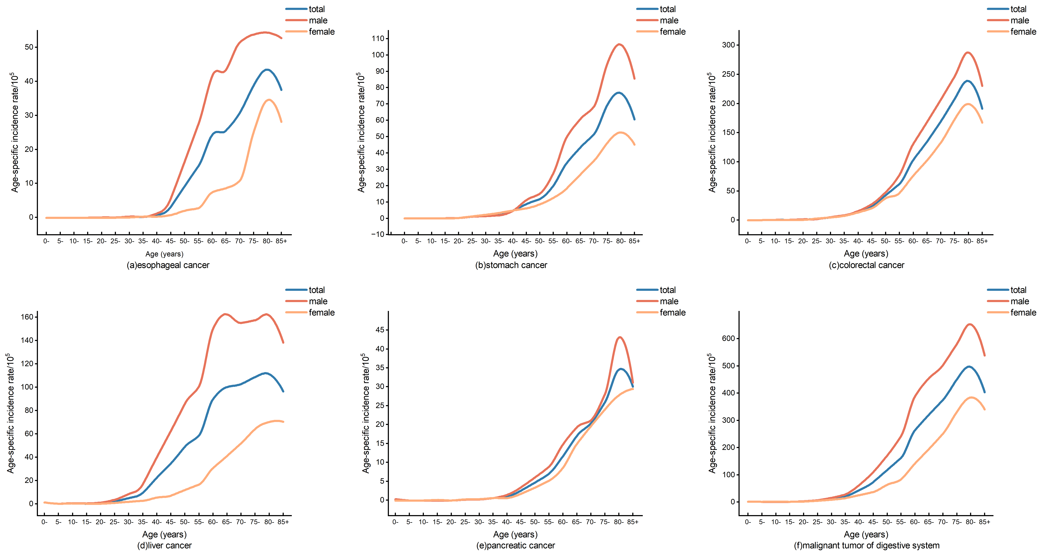

Figure S1 Age-specific incidence rates in different genders of five digestive system cancer in Guangdong. (A) Esophageal cancer; (B) Stomach cancer; (C) Colorectal cancer; (D) Liver cancer; (E) Pancreatic cancer; (F) All malignant neoplasms of the digestive system.

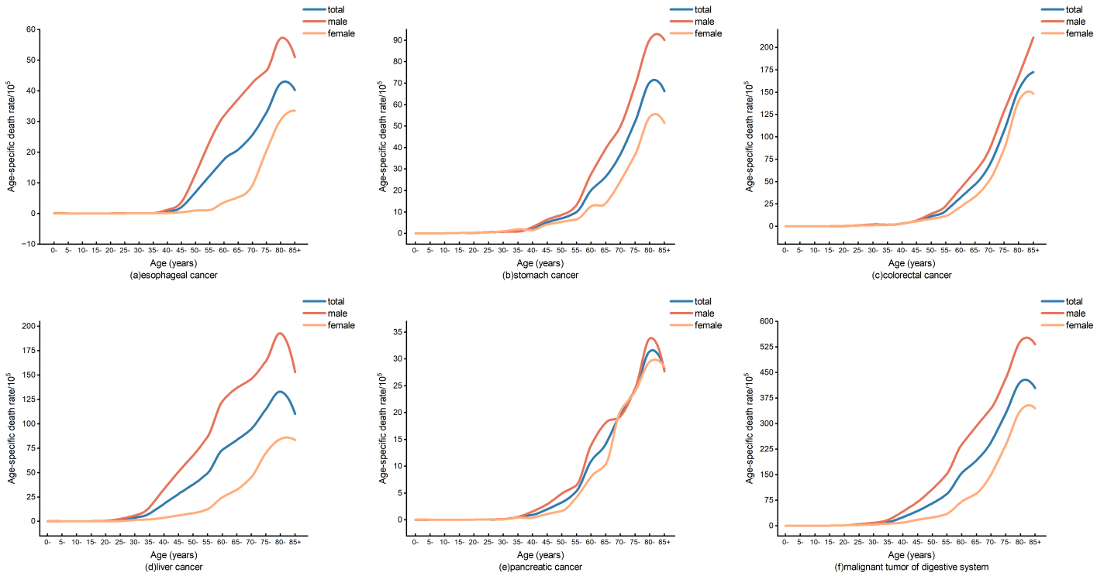
Figure S2 Age-specific death rates in different genders of five digestive system cancers in Guangdong. (A) Esophageal cancer; (B) Stomach cancer; (C) Colorectal cancer; (D) Liver cancer; (E) Pancreatic cancer; (F) All malignant neoplasms of the digestive system.

