ADDITIONAL FILE 1

Links between influenza epidemics, weather characteristics and all-cause mortality in the Czech Republic, 1982-2020

Hana Hanzlíková^{1,2}, Eva Plavcová¹, Jan Kyselý^{1,3}, Jan Kynčl^{4,5}, Marek Malý⁴, Aleš Urban^{1,3}

¹Institute of Atmospheric Physics of the Czech Academy of Sciences, Prague, Czech Republic
²Institute of Geophysics of the Czech Academy of Sciences, Prague, Czech Republic
³Faculty of Environmental Sciences, Czech University of Life Sciences, Prague, Czech Republic
⁴National Institute of Public Health, Prague, Czech Republic
⁵Third Faculty of Medicine, Charles University, Prague, Czech Republic

Corresponding author: Hana Hanzlíková, hanzlikova@ufa.cas.cz

Content:

Figure S1 Histogram of daily deaths in the Czech Republic, 1982–2020.
Table S1 Definition and descriptive statistics of the data sources used for the study. All datasets represent countrywide information for the Czech Republic, covering the period from January 1, 1982, to June 30, 2020.
Table S2 Characteristics of influenza epidemics grouped by the magnitude of excess mortality.
Table S3 Characteristics of epidemic and non-epidemic seasons over 1982–2020, divided by influenza virus type/subtype and ranked by cumulative excess mortality over each epidemic.
Table S4 Characteristics of influenza epidemics grouped by the date of peak ARI morbidity and excess mortality.
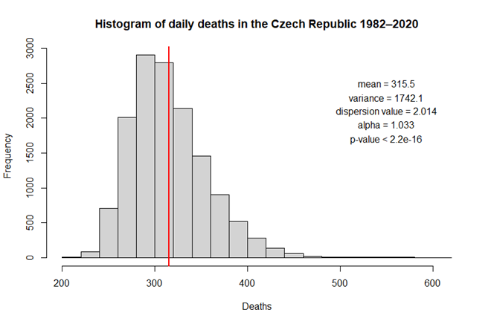
Figure S1 Histogram of daily deaths in the Czech Republic, 1982–2020. The red vertical line indicates the mean number of daily deaths. Alpha and p-value show the results of Cameron & Triverdi’s dispersion test. The dispersion value 2.014 and alpha > 0 correspond to overdispersion of a Poisson model and support the use of a quasi-Poisson family.

Table S1 Definition and descriptive statistics of the data sources used for the study. All datasets represent countrywide information for the Czech Republic, covering the period from January 1, 1982, to June 30, 2020.
Variable | Data source | Mean | Minimum | Maximum | Median | Standard Deviation | Variance
Daily mean temperature (°C) | Czech Hydrometeoorlogical Institute - mean from 7 weather stations | 8.6 | -20.7 | 28.1 | 8.9 | 8.1 | 65.1
Daily maximum temperature (°C) | Czech Hydrometeoorlogical Institute - mean from 7 weather stations | 13.2 | -17 | 36.1 | 13.5 | 9.4 | 88.7
Daily minimum temperature (°C) | Czech Hydrometeoorlogical Institute - mean from 7 weather stations | 4.3 | -24.9 | 20.4 | 4.6 | 7.1 | 49.8
Daily mean relative humidity (%) | Czech Hydrometeoorlogical Institute - mean from 7 weather stations | 76.3 | 35 | 98.2 | 77.7 | 10.9 | 118.7
Daily mean absolute humidity(g/m3) | Czech Hydrometeoorlogical Institute - mean from 7 weather stations | 7.0 | 0.9 | 16.4 | 6.6 | 3.0 | 8.8
Daily mean total cloud amount (tenth) | Czech Hydrometeoorlogical Institute - mean from 7 weather stations | 7 | 0 | 10 | 7 | 3 | 7
Daily sunshine duration (h) | Czech Hydrometeoorlogical Institute - mean from 7 weather stations | 4.7 | 0 | 15.15 | 3.78 | 4.1 | 16.5
Daily number of ARI cases (per 100,000 population) | National Institute of Public Health | 142.8 | 31 | 571 | 134 | 72.0 | 5176.9
Daily all-cause mortality (n) | Institute of Health Information and Statistics | 315.5 | 206 | 617 | 309 | 41.7 | 1742.1

Table S2 Characteristics of influenza epidemics grouped by the magnitude of excess mortality.

Table S3: Characteristics of epidemic and non-epidemic seasons over 1982-2020, divided by influenza virus type/subtype and ranked by cumulative excess mortality over each epidemic. 2wbs stands for a 14-day average two weeks before the start of the epidemics/IAPs, 2wbp stands for a 14-day average before the peak, and 2wap stands for a 14-day average after the peak of influenza epidemics/IAPs. For non-epidemic seasons, a 14-day average was calculated 4-3 weeks before the peak (2wbs), 2-1 weeks before the peak (2wbp), and 1-2 weeks after the peak (2wap) of ARI morbidity. Greater colour saturation corresponds to a positive deviation from the 50% percentile.
Table S4 Characteristics of influenza epidemics grouped by the date of peak ARI morbidity and excess mortality.

