Short-Term Exposure to Ambient Air Pollution and Onset of Severe Mental Disorders: A case-crossover study in northwestern China

Yajin Han^{1,†}, Guangrui Yang^{2,†}, Jinshi Wang¹, Weimin Pan^{3,*}, Xiaofeng Luo^{1,*}

Table S1. Spearman correlation coefficients between air pollutants and meteorological conditions during case and control days in Gansu Province, China, 2013-2020*.
Table S2. Variance Inflation Factors (VIF) for pollutants in the two-pollutant models.
Figure S1. Spatial distributions of 49,707 cases’ home addresses (dots) in Gansu province, China, from 2013 to 2020.
Figure S2. Percentage changes in ORs and 95% CI for onset of severe mental disorders associated with each interquartile range increase of exposures to PM_{2.5} (interquartile range, 23.1 μg/m³), PM₁₀ (57.5 μg/m³), SO₂ (19.1 μg/m³), NO₂ (11.9 μg/m³), CO (0.51 mg/m³), and O₃ (38.3 μg/m³) with different lag periods, restricted to Han race onset cases.
Figure S3. Percentage changes in ORs and 95% confidence intervals for onset of severe mental disorders associated with each interquartile range increase of exposures to PM_{2.5} (interquartile range，23.1 μg/m³), PM₁₀ (57.5 μg/m³), SO₂ (19.1 μg/m³), NO₂ (11.9 μg/m³), CO (0.51 mg/m³), and O₃ (38.3 μg/m³) with different lag periods, restricted to cases who diagnosed with “schizophrenia, schizotypal, and delusional disorders”.
Figure S4. Percentage changes in ORs and 95% confidence intervals for onset of severe mental disorders associated with each interquartile range increase of exposures to PM_{2.5} (interquartile range, 23.1 μg/m³), PM₁₀ (57.5 μg/m³), SO₂ (19.1 μg/m³), NO₂ (11.9 μg/m³), CO (0.51 mg/m³), and O₃ (38.3 μg/m³) with different lag periods, adjusting for temperature with a df of 3.

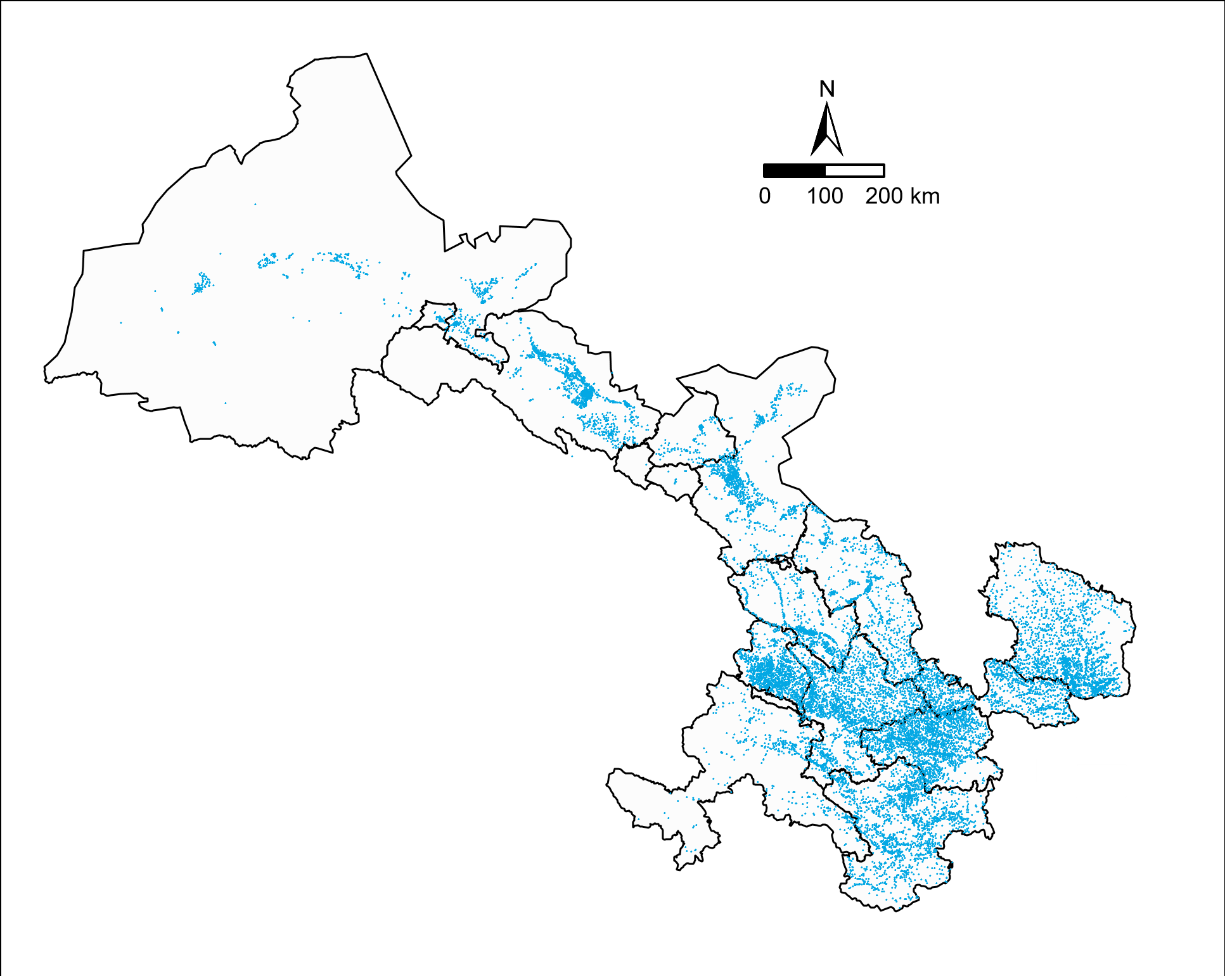
Figure S1. Spatial distributions of 49,707 cases’ home addresses (dots) in Gansu province, China, from 2013 to 2020. Each point indicates a case.

Table S1. Spearman correlation coefficients between air pollutants and meteorological conditions during case and control days in Gansu Province, China, 2013-2020*
 | PM_{2.5} | CO | NO₂ | O₃ | PM₁₀ | SO₂ | Relative humidity
CO | 0.67 | — | — | — | — | — | —
NO₂ | 0.51 | 0.61 | — | — | — | — | —
O₃ | -0.45 | -0.54 | -0.37 | — | — | — | —
PM₁₀ | 0.87 | 0.52 | 0.41 | -0.22 | — | — | —
SO₂ | 0.68 | 0.74 | 0.57 | -0.48 | 0.61 | — | —
Relative humidity | -0.14 | -0.09 | -0.13 | -0.25 | -0.33 | -0.17 | —
Temperature | -0.57 | -0.50 | -0.45 | 0.67 | -0.43 | -0.56 | -0.14
Abbreviations: PM_{2.5}, particulate matter with an aerodynamic diameter ≤2.5 μm; CO, carbon monoxide; NO₂, nitrogen dioxide; O₃, ozone; PM₁₀, particulate matter with an aerodynamic diameter ≤10 μm; SO₂, sulfur dioxide.
Notes*: All pairwise correlation coefficients were statistically significant(P<0.05)

Table S2. Variance Inflation Factors (VIF) for pollutants in the two-pollutant models.
 | PM_{2.5} | CO | NO₂ | O₃ | PM₁₀
CO | 1.57 | — | — | — | —
NO₂ | 1.29 | 1.82 | — | — | —
O₃ | 1.22 | 1.51 | 1.22 | — | —
PM₁₀ | 2.91 | 1.15 | 1.08 | 1.02 | —
SO₂ | 1.44 | 1.97 | 1.32 | 1.25 | 1.14
Abbreviations: PM_{2.5}, particulate matter with an aerodynamic diameter ≤2.5 μm; CO, carbon monoxide; NO₂, nitrogen dioxide; O₃, ozone; PM₁₀, particulate matter with an aerodynamic diameter ≤10 μm; SO₂, sulfur dioxide.

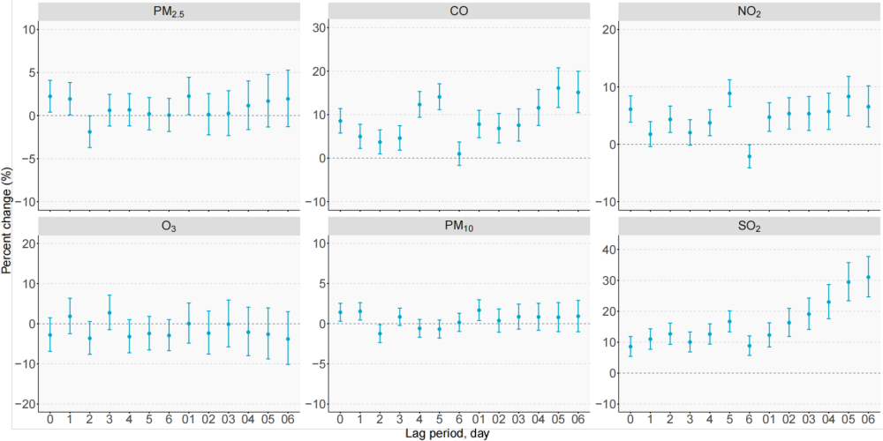
Figure S2. Percentage changes in ORs and 95% CI for onset of severe mental disorders associated with each interquartile range increase of exposures to PM_{2.5} (interquartile range, 23.1 μg/m³), PM₁₀ (57.5 μg/m³), SO₂ (19.1 μg/m³), NO₂ (11.9 μg/m³), CO (0.51 mg/m³), and O₃ (38.3 μg/m³) with different lag periods, restricted to Han race onset cases.
Abbreviations: PM_{2.5}, particulate matter with an aerodynamic diameter ≤2.5 μm; CO, carbon monoxide; NO₂, nitrogen dioxide; O₃, ozone; PM₁₀, particulate matter with an aerodynamic diameter ≤10 μm; SO₂, sulfur dioxide.
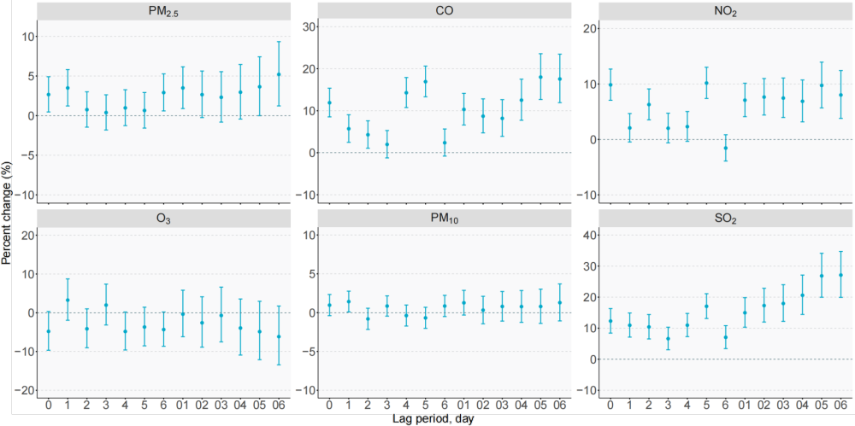
Figure S3. Percentage changes in ORs and 95% confidence intervals for onset of severe mental disorders associated with each interquartile range increase of exposures to PM_{2.5} (interquartile range，23.1 μg/m³), PM₁₀ (57.5 μg/m³), SO₂ (19.1 μg/m³), NO₂ (11.9 μg/m³), CO (0.51 mg/m³), and O₃ (38.3 μg/m³) with different lag periods, restricted to cases who diagnosed with “schizophrenia, schizotypal, and delusional disorders”.
Abbreviations: PM_{2.5}, particulate matter with an aerodynamic diameter ≤2.5 μm; CO, carbon monoxide; NO₂, nitrogen dioxide; O₃, ozone; PM₁₀, particulate matter with an aerodynamic diameter ≤10 μm; SO₂, sulfur dioxide.
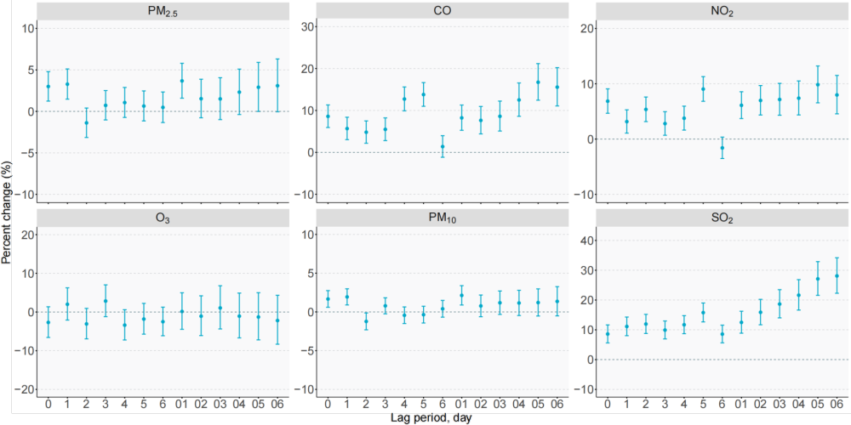
Figure S4. Percentage changes in ORs and 95% confidence intervals for onset of severe mental disorders associated with each interquartile range increase of exposures to PM_{2.5} (interquartile range，23.1 μg/m³), PM₁₀ (57.5 μg/m³), SO₂ (19.1 μg/m³), NO₂ (11.9 μg/m³), CO (0.51 mg/m³), and O₃ (38.3 μg/m³) with different lag periods, adjusting for temperature with a df of 3.
Abbreviations: PM_{2.5}, particulate matter with an aerodynamic diameter ≤2.5 μm; CO, carbon monoxide; NO₂, nitrogen dioxide; O₃, ozone; PM₁₀, particulate matter with an aerodynamic diameter ≤10 μm; SO₂, sulfur dioxide.

