Appendix 1
1.Verbatim item wording for both attention-check pairs
Table S1 Verbatim item wording for both attention-check pairs
Pair | Item (English) | Scale
Sleep | In the past month, how would you rate your overall sleep quality? | 5-point: very good → very poor
Sleep | I have been having trouble sleeping recently. | 5-point: strongly disagree → strongly agree
Health-information engagement | In the past month, how often have you actively paid attention to and searched for health-related information? | 5-point: never → very often
Health-information engagement | I don't pay attention to health knowledge and information. | 5-point: strongly disagree → strongly agree

1.Reliability and validity of the STDS
Table S2 Reliability and validity of the STDS
Subthreshold Depression | Mean±SD | Pearson correlation coefficient | p-value | Cronbach'α  coefficient | factor loadings | total explained variance
total score | 81.52±22.04 | 0.28-0.83 | <0.001 | 0.96 | 0.35-0.91 | 64.7%
social dysfunction | 26.32±7.23 | 0.43-0.81 | <0.001 | 0.88 | 0.35-0.83 | 15.4%
low self-concept | 21.78±6.26 | 0.44-0.87 | <0.001 | 0.88 | 0.35-0.88 | 8.1%
depression mood | 16.70±5.64 | 0.75-0.90 | <0.001 | 0.93 | 0.74-0.91 | 27.3%
physiological dysfunction | 16.71±5.17 | 0.72-0.81 | <0.001 | 0.87 | 0.70-0.81 | 13.9%

2.Reliability and validity of the RFQ-8
Table S3 Reliability and validity of the RFQ-8
mentalization | Mean±SD | Pearson correlation coefficient | p-value | Cronbach'α  coefficient | factor loading | explained variance
RFQ_C | 5.54±5.34 | 0.72-0.85 | <0.001 | 0.89 | 0.71-0.85 | 65.2%
RFQ_U | 2.97±3.30 | 0.71-0.79 | <0.001 | 0.76 | 0.69-0.82 | 49.3%

Appendix 2
- Characteristics of the demographic distribution of mentalization
Among the 3,330 surveyed individuals, the overall average score for RFQ_C was 5.54. A total of 880 individuals scored 0, accounting for 26.4%, 1,203 scored between 1-6, constituting 36.1%, and 1,247 scored between 7-18, representing 37.5%. Higher scores indicate higher levels of excessive mentalization. The overall average score for RFQ_U was 2.97. A total of 970 individuals scored 0, representing 29.1%, 1,925 scored between 1-6, accounting for 57.8%, and 435 scored between 7-18, making up 13.1%. Higher scores indicate higher levels of mentalization deficits. Demographic characteristics indicate that hypomentalizing are more pronounced in females. Significant differences are observed in hypermentalizing based on factors such as only-child status, family location, parental education, family income, university grades, and self-assessments of health status. Similarly, hypomentalizing significantly vary according to academic discipline, only-child status, family location, parental education, family income, and self-assessment of health.
Table S4 The demographic distribution characteristics of mentalization.
Demographic characteristics | RFQ_C |  | RFQ_U
Demographic characteristics | Mean±SD | Statistic，p-value | Mean±SD | Statistic，p-value
sex
male | 5.56±5.45 | W=1349250 | 2.85±3.27 | W=1288582
female | 5.52±5.17 | p =0.561 | 3.13±3.33 | p=0.005
grade
first grade | 5.36±5.25 |  | 3.09±3.33
second grade | 5.56±5.47 | H=5.185 | 2.97±3.26 | H=6.1004
third grade | 5.51±5.05 | p=0.159 | 2.87±3.25 | p=0.1068
fourth/fifth grade | 6.07±5.56 |  | 2.77±3.37
academic discipline
humanities and  social sciences | 5.61±5.10 | W=1088262 | 3.27±3.41 | W=1146726
science,engineering, medical, and agricultural | 5.52±5.40 | p= 0.234 | 2.87±3.26 | p<0.001
ethnic
Han nationality | 5.55±5.35 | W=492530 | 2.98±3.32 | W=492308
minority nationality | 5.44±5.13 | p= 0.990 | 2.88±3.10 | p= 0.999
only child or not
yes | 5.92±5.44 | W=1457380 | 2.89±3.27 | W=1270287
no | 4.97±5.10 | p<0.001 | 3.10±3.34 | p=0.045
family location
city^{Δ} | 5.94±5.37 |  | 2.84±3.13
townships | 5.39±5.35 | H=59.664 | 3.04±3.54 | H=11.591
countryside | 4.02±4.79*** | p<0.001 | 3.48±3.64*** | p=0.003
father's education
primary and below/junior high school education^{Δ} | 4.55±4.86 |  | 3.34±3.57
senior high school education/ college degree | 5.44±5.19*** | H=40.097 | 3.05±3.31 | H=16.552
bachelor's/master's degree and above | 6.16±5.59*** | p<0.001 | 2.71±3.12*** | p<0.001
mother's education
primary and below/junior high school education^{Δ} | 4.49±4.85 |  | 3.43±3.54
senior high school education/ college degree | 5.53±5.23*** | H=51.848 | 2.95±3.25** | H=28.02
bachelor's/master's degree and above | 6.32±5.64*** | p<0.001 | 2.66±3.13*** | p<0.001
parental marital status
marriage | 5.57±5.36 | W=479015 | 2.95±3.28 | W=462508
out of wedlock (divorced/widowed/other) | 5.29±5.02 | p= 0.550 | 3.14±3.52 | p= 0.662
monthly per capita family income
≤￥3000^{Δ} | 4.33±4.66 |  | 3.67±3.77
￥3001-6000 | 4.94±5.09 | H=54.328 | 3.07±3.43* | H=25.394
￥6001-9999 | 5.79±5.33*** | p<0.001 | 2.88±2.99*** | p<0.001
≥￥10,000 | 6.35±5.63*** |  | 2.69±3.20***
grade ranking
First 25%^{Δ} | 5.93±5.58 |  | 2.81±3.28
26%-50% | 5.74±5.31 | H=17.944 | 2.92±3.15 | H=7.743
51%-75% | 4.83±4.85*** | p<0.001 | 3.18±3.49 | p=0.052
76% onwards | 5.22±5.40 |  | 3.18±3.39
self-assessment of health status
excellent^{Δ} | 7.41±6.16 |  | 2.26±2.94
relatively good | 5.82±5.06*** | H=159.39 | 2.60±2.76 | H=128.18
average | 4.33±4.63*** | p<0.001 | 3.45±3.49*** | p<0.001
poor | 3.57±4.75*** |  | 5.36±4.87***
Note: The p-values for pairwise comparisons in ANOVA (Bonferroni method) are *p<0.05, **p<0.01, ***p<0.001; Δ represents the reference framework for pairwise comparisons in ANOVA.
- The correlation between mentalization and cognitive bias
Bivariate Spearman correlation analysis between mentalization and cognitive bias indicates that the level of hypermentalizing (Corr = -0.548, p<0.001) is negatively correlated with the level of cognitive bias, whereas the level of hypomentalizing (Corr = 0.262, p<0.001) is positively correlated with the level of cognitive bias.
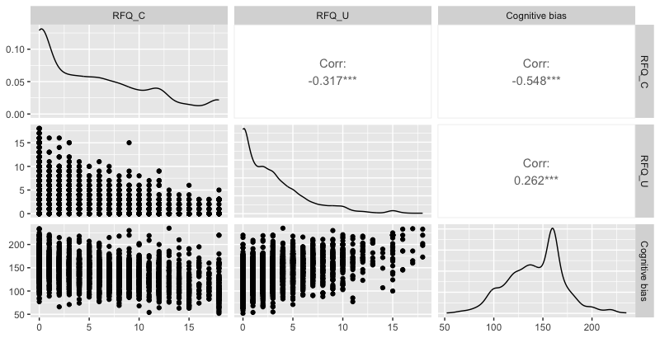
Fig S1 The schematic diagram of the correlation matrix for hypermentalizing, hypomentalizing, and cognitive bias
（RFQ_C=hypermentalizing，RFQ_U=hypomentalizing）
- The correlation between mentalization and subthreshold depression
Bivariate Spearman correlation analysis between mentalization and subthreshold depression reveals that the level of excessive mentalization (Corr = -0.564, p<0.001) is negatively correlated with the level of subthreshold depression, while the level of mentalization deficits (Corr = 0.413, p<0.001) is positively correlated with the level of subthreshold depression.
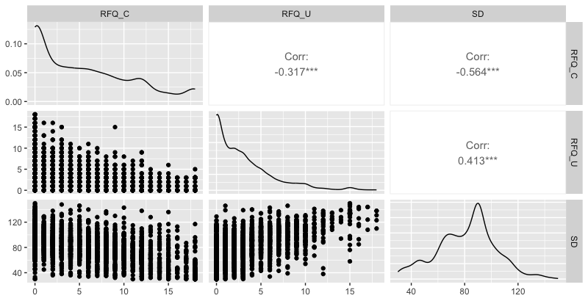
Fig S2 The schematic diagram of the correlation matrix for hypermentalizing, hypomentalizing, and subthreshold depression
（RFQ_C=hypermentalizing，RFQ_U=hypomentalizing，SD=subthreshold depression）

Table S5 One-way analysis of the correlation between subthreshold depression and mentalization
Subthreshold depression | RFQ_C |  | RFQ_U
Subthreshold depression | Mean±SD | W，p-value | Mean±SD | W，p-value
high level（≥90） | 2.64±3.59 | W=593816 | 4.22±4.00 | W= 1762357
low level（<90） | 7.60±5.40 | p<0.001 | 2.08±2.31 | p<0.001

