Table.S1 Descriptive Statistics
Variable | M | SD
AB1 | 3.868 | 0.850
AB2 | 3.867 | 0.823
AB3 | 3.920 | 0.789
AP1 | 4.070 | 0.622
AP2 | 3.972 | 0.822
SEC1 | 4.495 | 1.250
SEC2 | 4.940 | 1.081
SEC3 | 4.842 | 1.152
SEC4 | 4.266 | 1.068
Abbreviations: AB = Academic Burnout; AP = Academic Procrastination; SEC = Social-Emotional Competence; M = Mean; SD = Standard Deviation.

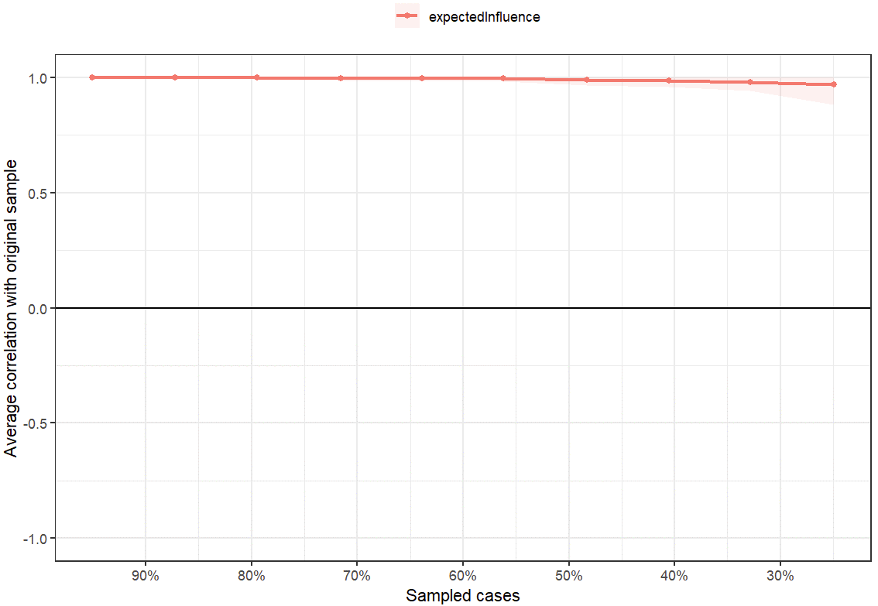
Fig.S1 Stability of centrality indices plot.
Note: The x-axis represents the percentage of cases in the original sample used at each step. The y-axis represents the average of correlations between the centrality in the original network and the centrality in the networks that were re-estimated after dropping increasing percentages of cases. Colorful areas indicate 95% Confidential Intervals.

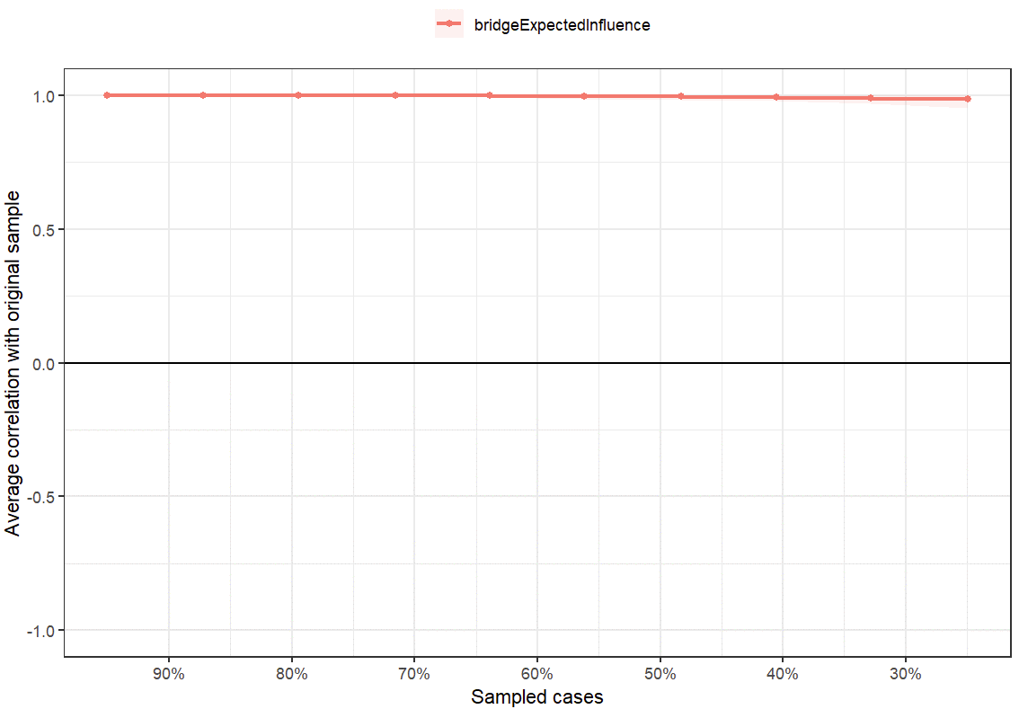
Fig.S2 Stability of bridge centrality indices plot.
Note: The x-axis represents the percentage of cases in the original sample used at each step. The y-axis represents the average of correlations between the bridge centrality in the original network and the bridge centrality in the networks that were re-estimated after dropping increasing percentages of cases. Colorful areas indicate 95% Confidential Intervals.

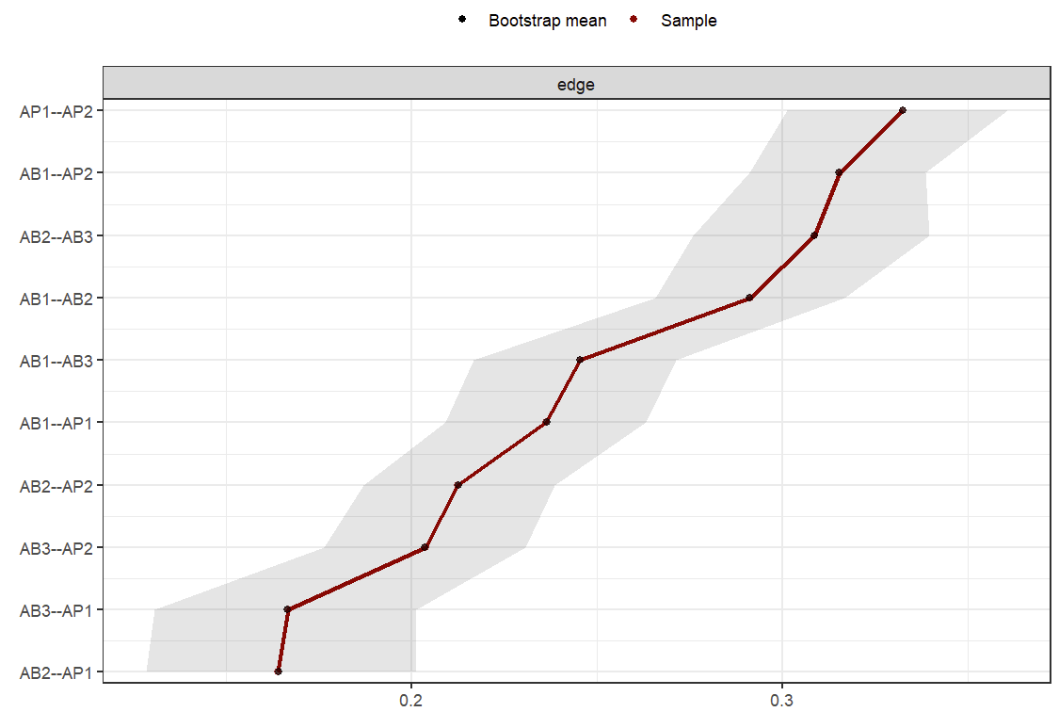
Fig.S3 Network of AB-AP comorbidity edge weights confidence intervals plot.

Note: Bootstrapped 95% confidence intervals (CIs) of estimated edge-weights are displayed by gray area. Red line denoted sample means, black line denotes bootstrap means of edges.

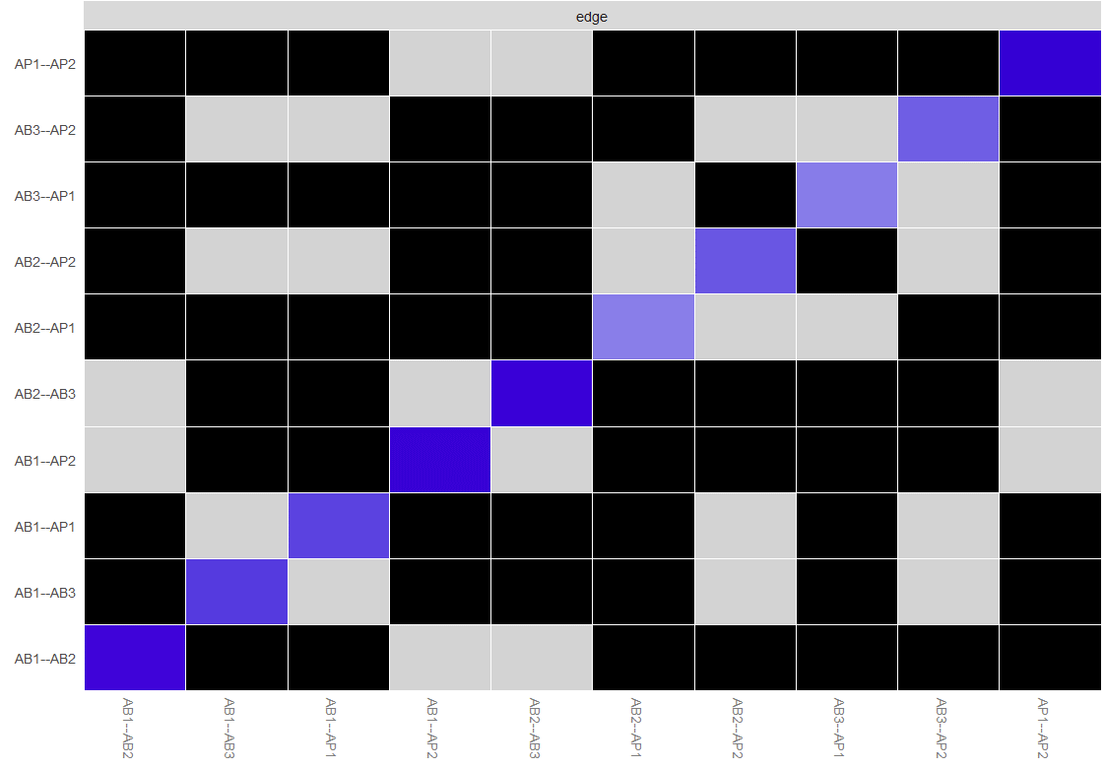
Fig.S4 Bootstrap difference test between edge weights in network of AB-AP comorbidity.

Note: Black boxes represent significant differences between nonzero estimated edges. Grey boxes indicate non-significant differences. The magnitude of each edge is indicated by the saturation of color of the diagonal boxes (ranging from blue to red) corresponding to the magnitude of the edge (positive to negative).

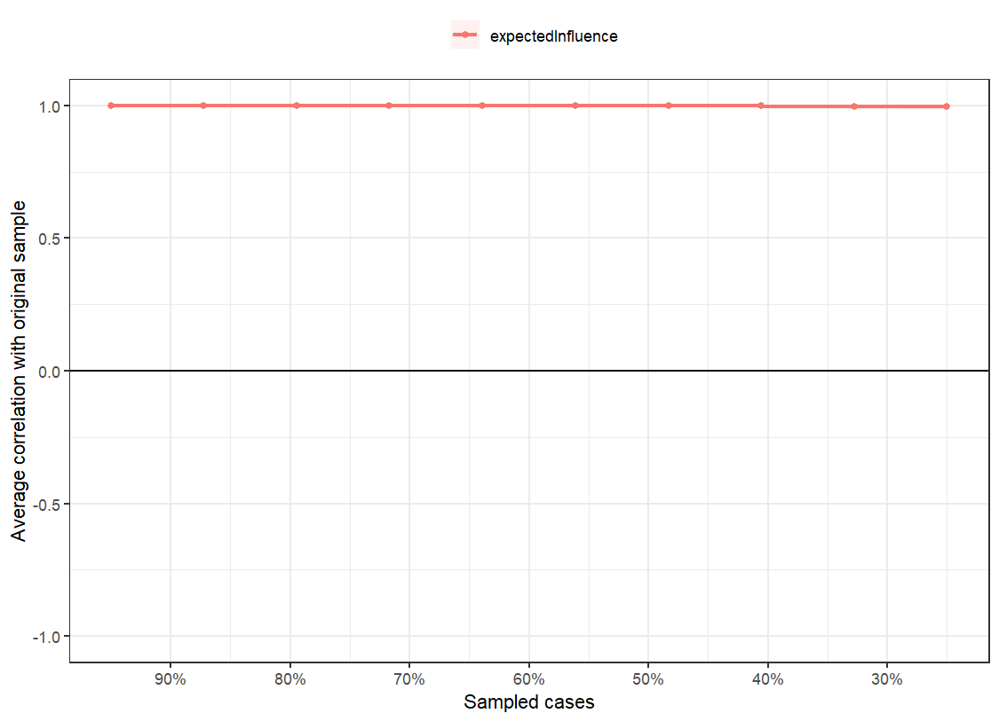
Fig S5 Stability of centrality indices plot.
Note: The x-axis represents the percentage of cases in the original sample used at each step. The y-axis represents the average of correlations between the centrality in the original network and the centrality in the networks that were re-estimated after dropping increasing percentages of cases. Colorful areas indicate 95% Confidential Intervals.
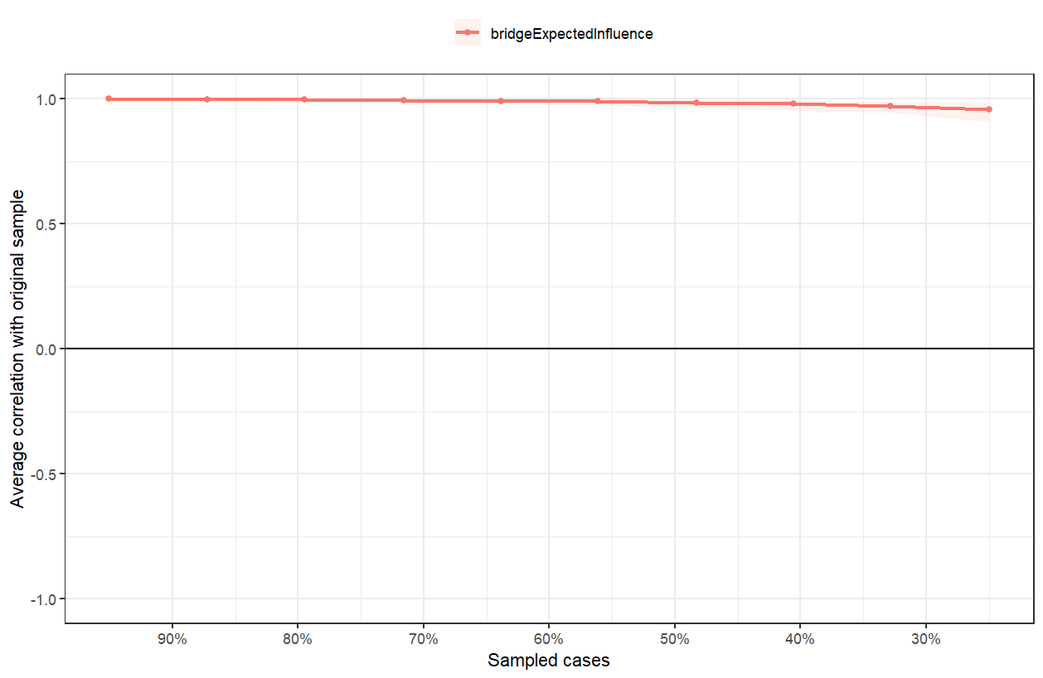
Fig.S6 Stability of bridge centrality indices plot.

Note: The x-axis represents the percentage of cases in the original sample used at each step. The y-axis represents the average of correlations between the bridge centrality in the original network and the bridge centrality in the networks that were re-estimated after dropping increasing percentages of cases. Colorful areas indicate 95% Confidential Intervals.

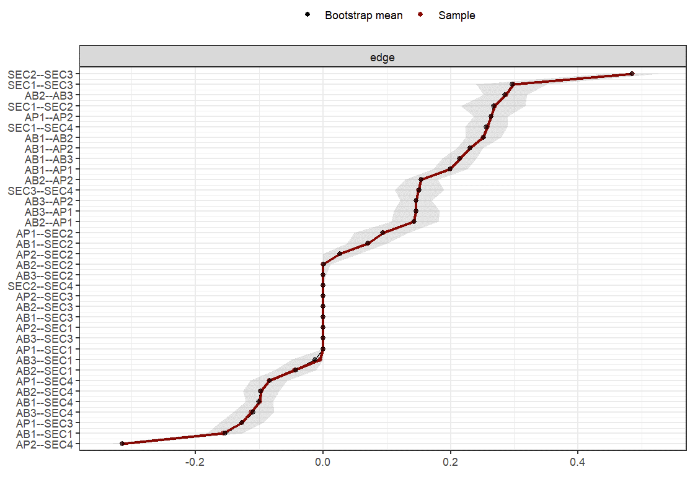
Fig.S7 Network of SEC and AB-AP comorbidity edge weights confidence intervals plot.

Note: Bootstrapped 95% confidence intervals (CIs) of estimated edge-weights are displayed by gray area. Red line denoted sample means, black line denotes bootstrap means of edges.
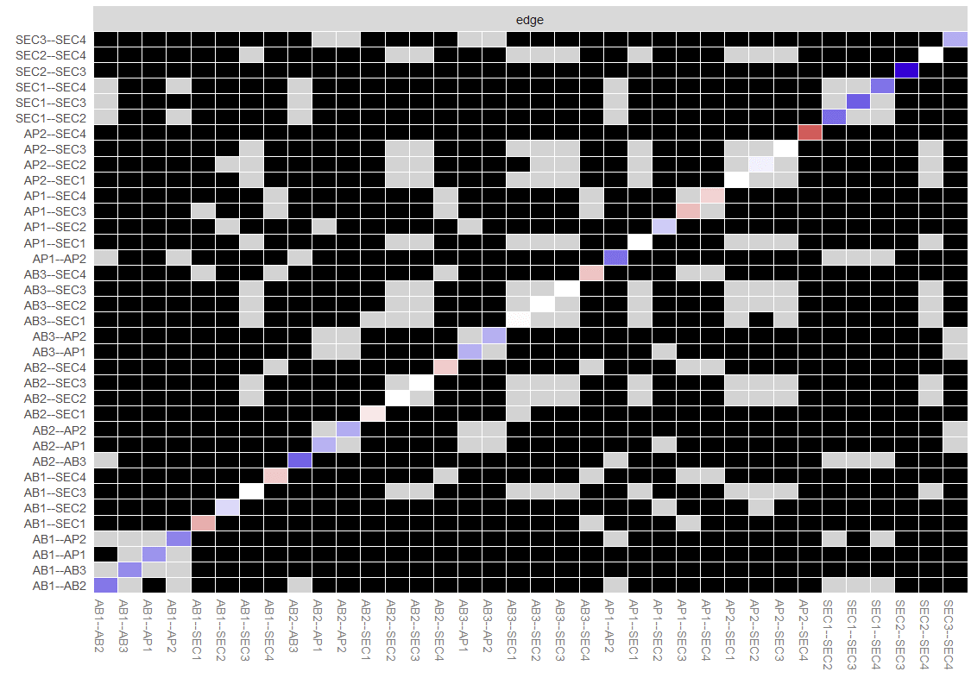
Fig.S8 Bootstrap difference test between edge weights in network of SEC and AB-AP comorbidity.

Note: Black boxes represent significant differences between nonzero estimated edges. Grey boxes indicate non-significant differences. The magnitude of each edge is indicated by the saturation of color of the diagonal boxes (ranging from blue to red) corresponding to the magnitude of the edge (positive to negative).

Supplementary Questionnaire

Part I: Basic information
Please select or fill in the option that best describes you.
1.Gender: □ Male □ Female
2.Age: _______
3.Residential Area: □ Urban □ Suburban/Town

Part II: Instructions
Please read each statement carefully. There are no "right" or "wrong" answers. We are interested in your genuine feelings and daily habits.
How to answer: Please tick the box that best reflects your current situation according to the scale below. Your first reaction is usually the most accurate.
- 1 = Strongly Disagree
- 2 = Disagree
- 3 = Slightly Disagree
- 4 = Neither Agree nor Disagree
- 5 = Slightly Agree
- 6 = Agree
- 7 = Strongly Agree
Your responses will be kept strictly confidential and used for research purposes only.
No. | Item | 1 | 2 | 3 | 4 | 5 | 6 | 7
Academic Burnout
1 | I feel emotionally drained by my studies. | □ | □ | □ | □ | □ | □ | □
2 | I feel exhausted at the end of a school day. | □ | □ | □ | □ | □ | □ | □
3 | I feel tired when I wake up because I have to face another day at school. | □ | □ | □ | □ | □ | □ | □
4 | Studying or attending classes is a real strain for me. | □ | □ | □ | □ | □ | □ | □
5 | I feel burned out from my studies. | □ | □ | □ | □ | □ | □ | □
6 | I have become less interested in my studies since my enrollment at this school. | □ | □ | □ | □ | □ | □ | □
7 | I have become less enthusiastic about my studies. | □ | □ | □ | □ | □ | □ | □
8 | I have become more cynical about the potential usefulness of my studies. | □ | □ | □ | □ | □ | □ | □
9 | I doubt the significance of my studies. | □ | □ | □ | □ | □ | □ | □
10 | I can effectively solve the problems that arise in my studies. | □ | □ | □ | □ | □ | □ | □
11 | I believe that I make an effective contribution to the classes that I attend. | □ | □ | □ | □ | □ | □ | □
12 | In my opinion, I am a good student. | □ | □ | □ | □ | □ | □ | □
13 | I feel stimulated when I achieve my study goals. | □ | □ | □ | □ | □ | □ | □
14 | I have learned many interesting things during the course of my studies. | □ | □ | □ | □ | □ | □ | □
15 | During class I feel confident that I am effective in getting things done. | □ | □ | □ | □ | □ | □ | □
Academic Procrastination
16 | I always wait until the last minute to start doing things. | □ | □ | □ | □ | □ | □ | □
17 | Even if something absolutely has to be done, I won't start doing it immediately. | □ | □ | □ | □ | □ | □ | □
18 | I can always complete my daily tasks at the required pace. | □ | □ | □ | □ | □ | □ | □
19 | I am often late for appointments or meetings. | □ | □ | □ | □ | □ | □ | □
20 | I use my free time between classes to finish what I need to do in the evening. | □ | □ | □ | □ | □ | □ | □
21 | I always start things too late to finish them on time. | □ | □ | □ | □ | □ | □ | □
22 | I often rush frantically to complete tasks right before the deadline. | □ | □ | □ | □ | □ | □ | □
23 | I always take a long time to procrastinate before starting something. | □ | □ | □ | □ | □ | □ | □
24 | If there is an important project, I start it as soon as possible. | □ | □ | □ | □ | □ | □ | □
25 | When the exam deadline is approaching, I often find myself still doing other things. | □ | □ | □ | □ | □ | □ | □
26 | I can always complete tasks on time. | □ | □ | □ | □ | □ | □ | □
27 | I only start working seriously when the deadline is approaching. | □ | □ | □ | □ | □ | □ | □
28 | I usually get to class on time. | □ | □ | □ | □ | □ | □ | □
Social-Emotional Competence
29 | I know my strengths and weaknesses. | □ | □ | □ | □ | □ | □ | □
30 | I believe I have the ability to complete the task. | □ | □ | □ | □ | □ | □ | □
31 | I can regulate my emotions and express them in appropriate ways. | □ | □ | □ | □ | □ | □ | □
32 | I can reflect on myself and improve. | □ | □ | □ | □ | □ | □ | □
33 | I can overcome obstacles and persevere to complete tasks. | □ | □ | □ | □ | □ | □ | □
34 | I can set long-term goals and work hard to achieve them. | □ | □ | □ | □ | □ | □ | □
35 | I respect myself and hope to be respected by others. | □ | □ | □ | □ | □ | □ | □
36 | I know how to be kind to others. | □ | □ | □ | □ | □ | □ | □
37 | I know I need to put myself in other people's shoes and sympathize with their feelings. | □ | □ | □ | □ | □ | □ | □
38 | I know to respect other people's thoughts, feelings and beliefs. | □ | □ | □ | □ | □ | □ | □
39 | I can understand and accept others' thoughts, emotions, and behaviors. | □ | □ | □ | □ | □ | □ | □
40 | I know that a sense of community is important. | □ | □ | □ | □ | □ | □ | □
41 | I identify with the collective values and behavioral norms of the group. | □ | □ | □ | □ | □ | □ | □
42 | I know that everyone in the group is equal and important. | □ | □ | □ | □ | □ | □ | □
43 | I actively integrate into the group and follow the rules. | □ | □ | □ | □ | □ | □ | □
44 | I can maintain the collective honor and actively contribute to the collective. | □ | □ | □ | □ | □ | □ | □
45 | I can work collaboratively with others to accomplish common group tasks. | □ | □ | □ | □ | □ | □ | □
46 | In a group, I can clearly distinguish my own responsibilities from those of others. | □ | □ | □ | □ | □ | □ | □
47 | I try my best to keep the collective learning and living atmosphere harmonious. | □ | □ | □ | □ | □ | □ | □
48 | I can take responsibility for my actions. | □ | □ | □ | □ | □ | □ | □
49 | I can judge between right and wrong. | □ | □ | □ | □ | □ | □ | □
50 | When I get into trouble, I don't blame others. | □ | □ | □ | □ | □ | □ | □
51 | I think twice before I act. | □ | □ | □ | □ | □ | □ | □
52 | The decisions I make are responsible not only for myself, but also for others and the collective. | □ | □ | □ | □ | □ | □ | □
53 | I can weigh the impact of the decisions I make on myself, others, and the collective good, and make appropriate adjustments when necessary. | □ | □ | □ | □ | □ | □ | □
54 | I take social safety and ethics into consideration when making choices or decisions. | □ | □ | □ | □ | □ | □ | □

