Supplementary materials
Relative Risk and DALYs Assessment of Indoor Air Pollutants in Residential Buildings - Taking Dalian as An Example
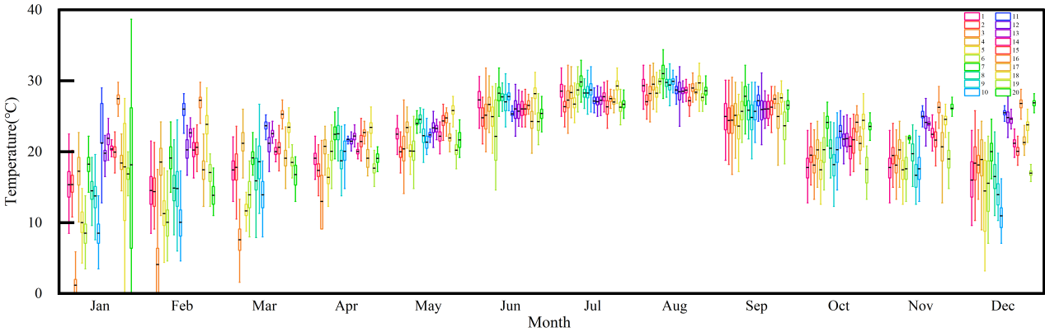
- Temperature
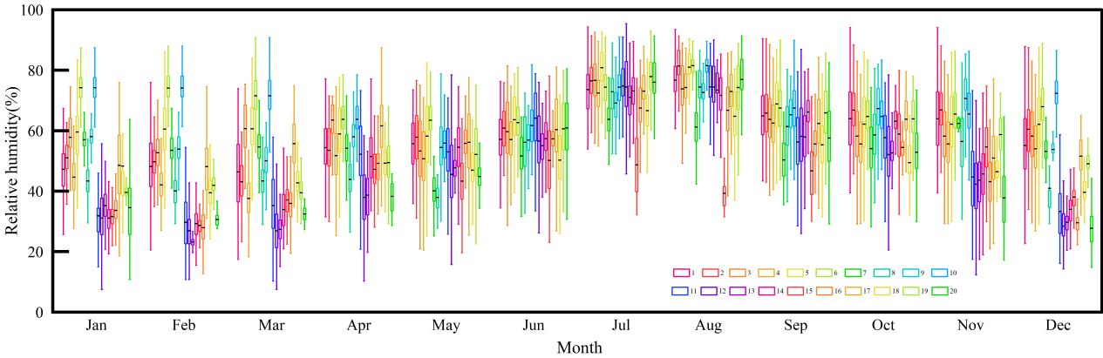
- Relative humidity
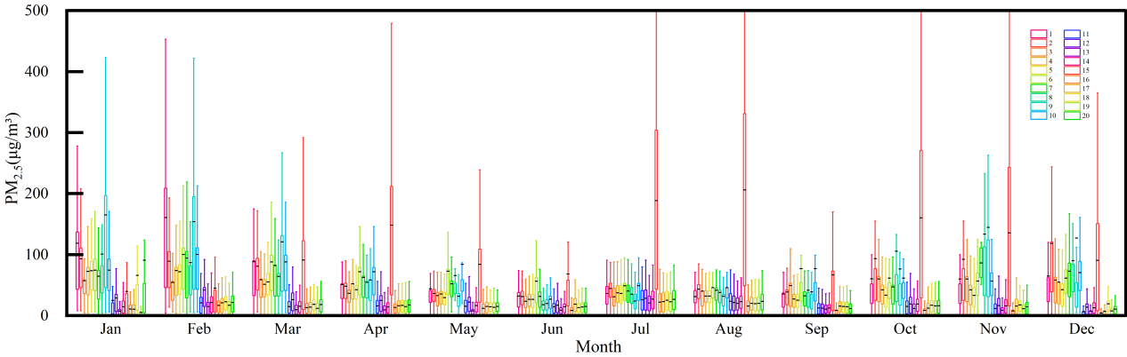
- PM_{2.5}
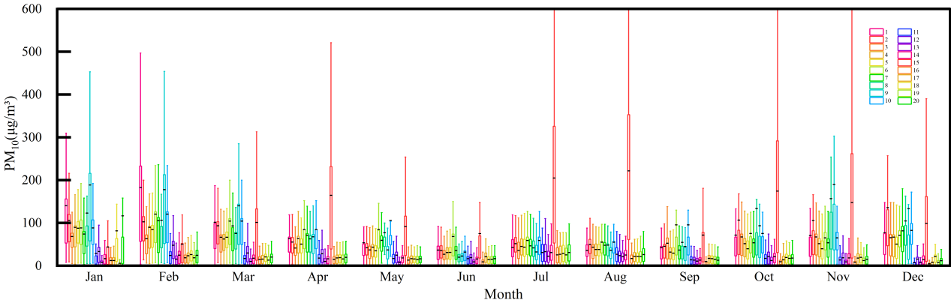
- PM₁₀
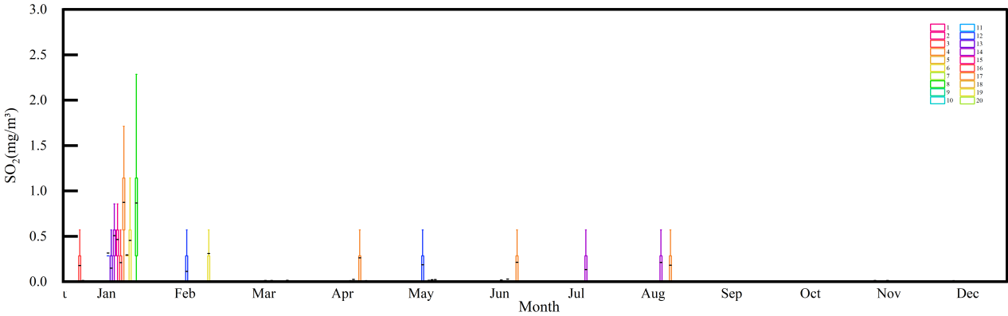
- SO₂
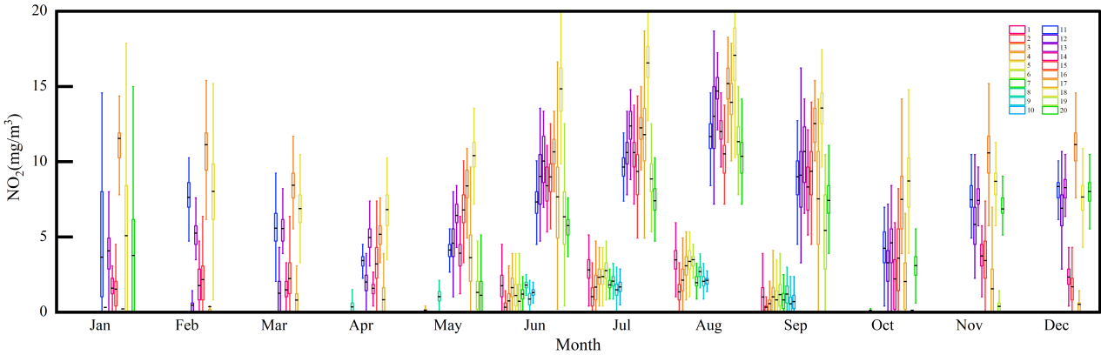
- NO₂
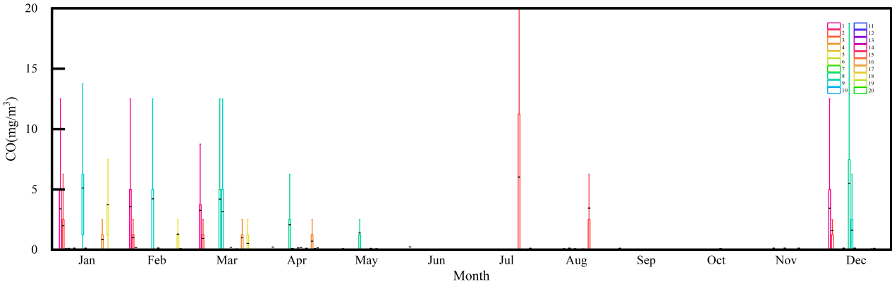
- CO
Fig. S1 Boxplots of monthly distributions of key indoor parameters (temperature, humidity, and air pollutants)

Table S1 Descriptive statistics of indoor air pollutant concentrations and meteorological parameters across the study area
Parameter | Overall mean (95% CI) | Urban mean (95% CI) | Rural mean (95% CI)
PM_{2.5} (μg/m³) | 40.846 (40.741-40.952) | 26.266 (26.151-26.380) | 60.303 (60.111-60.494)
PM₁₀ (μg/m³) | 47.110 (46.976-47.243) | 29.215 (29.084-29.347) | 70.832 (70.580-71.085)
NO₂ (mg/m³) | 1.889 (1.886-1.892) | 3.119 (3.114-3.123) | 0.315 (0.313-0.316)
SO₂ (mg/m³) | 0.011 (0.011-0.011) | 0.020 (0.019-0.020) | 0.002 (0.002-0.002)
CO (mg/m³) | 0.360 (0.357-0.363) | 0.209 (0.206-0.212) | 0.573 (0.567-0.579)
Temperature (°C) | 22.435 (22.428-22.442) | 23.698 (23.691-23.705) | 20.541 (20.529-20.554)
Relative humidity (%) | 55.118 (55.097-55.140) | 50.986 (50.955-51.018) | 60.190 (60.165-60.216)
Note: This table presents descriptive summaries of the exposure data. A formal statistical comparison of urban-rural differences was not conducted as the primary aim of this study was to estimate population-averaged exposure levels for the region, and the sample size was not powered for robust subgroup comparisons. The observed numerical differences can be used to inform hypotheses for future targeted studies.

Table S2 Characteristics of outpatient visits and demographic profile in the study
Health outcomes | Total | Male/female | Average age (95% CI) | Mortality
Lung cancer | 7,224 | 60.71%; 39.29% | 67.352 (67.150-67.554) | 1.36%
LRTI | 22,403 | 45.68%; 54.32% | 35.988 (35.664-36.311) | 1.68%
Vascular disease | 85,708 | 53.42%; 46.58% | 61.828 (61.729-61.926) | 0.00%
Ischemic heart disease | 24,261 | 70.32%; 29.68% | 67.304 (67.137-67.472) | 0.94%
COPD | 2,248 | 74.33%; 25.67% | 71.293 (70.799-71.786) | 0.89%
Stroke | 20,288 | 59.91%; 40.09% | 67.300 (67.127-67.473) | 1.52%
Diabetes | 89,796 | 53.73%; 46.27% | 59.656 (59.559-59.753) | 0.00%
Asthma | 3,163 | 41.04%; 58.96% | 46.983 (46.303-47.662) | 0.00%
Note: COPD, chronic obstructive pulmonary disease; LRTI, lower respiratory tract infection. The data presented in this table are derived from the aggregated, anonymized outpatient records used in the time-series analysis. Detailed information on area, education, and income was not available within the scope of this health-environment linkage study. The use of aggregated data is a characteristic of the time-series design, which controls for fixed population characteristics over the short term.

