Supporting Information
Confirmed case – Definitive laboratory evidence only
Laboratory definitive evidence:
- Isolation of respiratory syncytial virus by a cell culture
OR
- Detection of respiratory syncytial virus by nucleic acid testing
OR
- Detection of respiratory syncytial virus antigen
OR
- Seroconversion, or a significant increase in antibody level such as a fourfold or greater rise in titre, to respiratory syncytial virus between paired sera of immunoglobulin G (IgG) or total antibody

Supporting information, box 1: Respiratory syncytial virus Australian national notifiable diseases case definition, from: https://www.health.gov.au/resources/publications/respiratory-syncytial-virus-surveillance-case-definition (viewed April 2025).

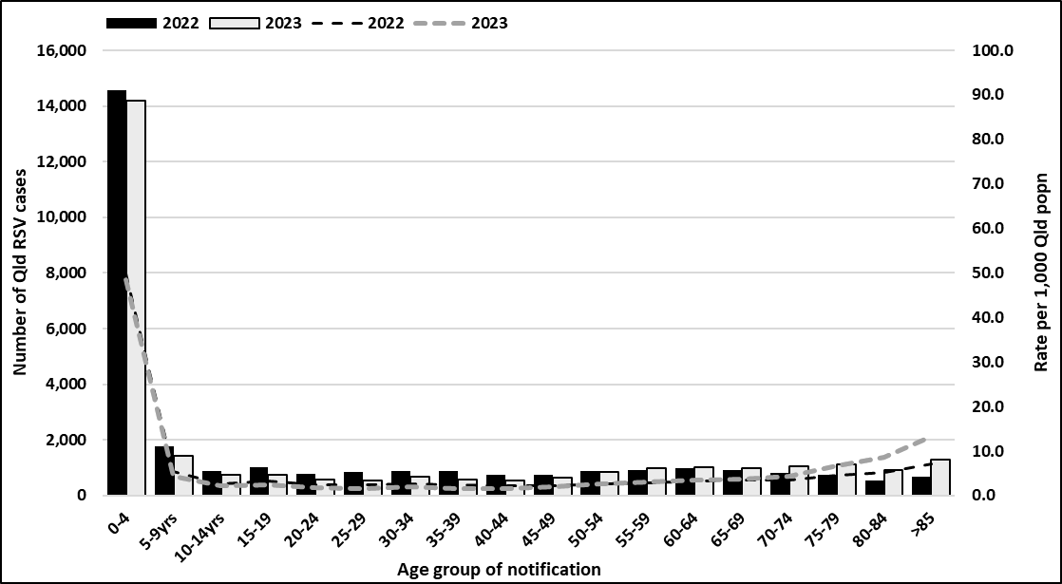
Supporting information, figure 1. Number and incidence of RSV notifications in Queensland 2022–2023 inclusive.

Supporting information, table 1. Number and incidence of RSV infections per 1,000 children aged <2 years in Queensland by completed month of age, 2022–2023 inclusive.
Age (months) | RSV notifications (count) | Incidence (95% CI)ª
0 | 550 | 58.12 (53.41-62.84)
1 | 914 | 96.59 (90.64-102.54)
2 | 802 | 84.75 (79.14-90.36)
3 | 779 | 82.32 (76.78-87.86)
4 | 779 | 82.32 (76.78-87.86)
5 | 796 | 84.12 (78.53-89.71)
6 | 813 | 85.91 (80.27-91.56)
7 | 845 | 89.30 (83.55-95.04)
8 | 845 | 89.30 (83.55-95.04)
9 | 870 | 91.94 (86.12-97.76)
10 | 825 | 87.18 (81.50-92.87)
11 | 880 | 93.00 (87.14-98.85)
12 | 915 | 96.69 (90.74-102.65)
13 | 907 | 95.85 (89.92-101.78)
14 | 852 | 90.04 (84.27-95.80)
15 | 904 | 95.53 (89.61-101.45)
16 | 795 | 84.01 (78.42-89.60)
17 | 751 | 79.36 (73.92-84.81)
18 | 704 | 74.40 (69.11-79.68)
19 | 670 | 70.80 (65.63-75.97)
20 | 635 | 67.10 (62.06-72.15)
21 | 640 | 67.63 (62.57-72.69)
22 | 638 | 67.42 (62.37-72.47)
23 | 575 | 60.76 (55.95-65.58)
TOTAL | 18,683 | 82.26 (81.13-83.39)

ªPopulation denominators derived from Australian Bureau of Statistics 2021 Census single-year age estimates for Queensland
^{b}Incidence per 1,000 children aged <2yrs, with 95% confidence interval (Wald)

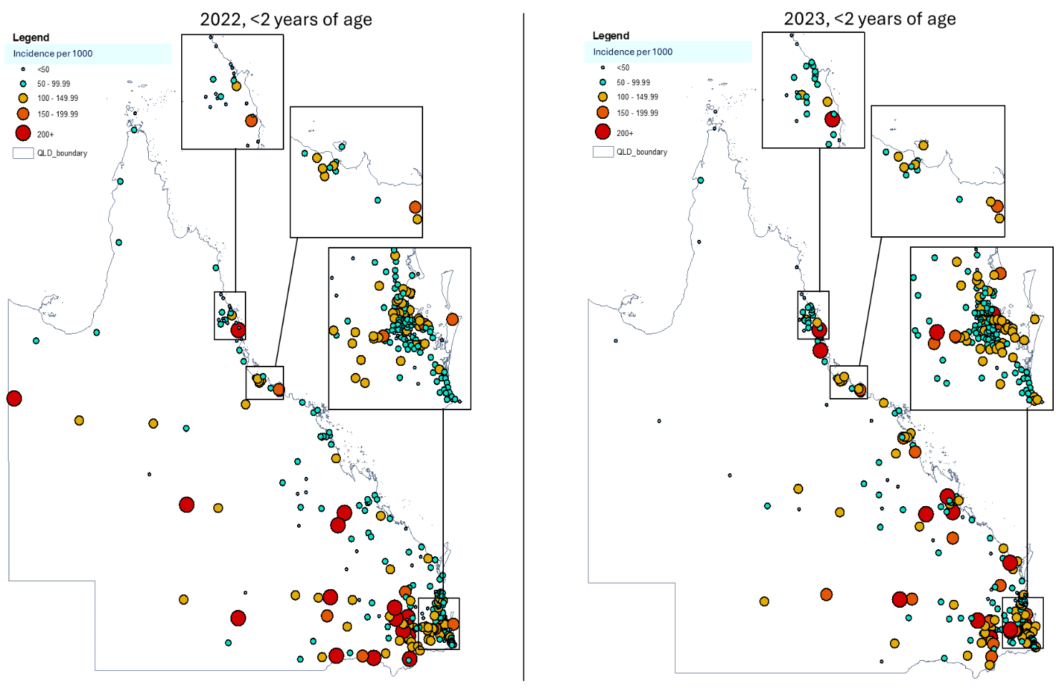
Supporting information, figure 2. Incidence of RSV notifications by postcode (location based on population weighted centroid) in Queensland per 1,000 children aged <2 years

Supporting information, table 2. Spatial cluster analysis of Queensland RSV infections among children aged <2 years, 2022–2023
Location of spatial clusters,  by year | Cases (n) | O/Eª ratio | Relative risk (p-value) | Climate zone^{b}
2022
1: Darling Downs region (Toowoomba) | 1189 | 1.34 | 1.39 (<0.001) | 2 & 5
2: Samford (Greater Brisbane) | 1060 | 1.25 | 1.28 (<0.001) | 2
3: Aboriginal Shire of Woorabinda | 24 | 5.19 | 5.20 (<0.001) | 3
4: Townsville and surrounds | 502 | 1.24 | 1.26 (<0.001) | 1
5: Redland (Greater Brisbane) | 496 | 1.17 | 1.18 (<0.001) | 2
6: Gold Coast | 410 | 1.19 | 1.20 (0.008) | 2
7: Longreach | 19 | 3.21 | 3.22 (0.039) | 3
2023
8: Darling Downs (Gatton) | 1223 | 1.42 | 1.48 (<0.001) | 2 & 5
9: Logan (Greater Brisbane) | 755 | 1.33 | 1.36 (<0.001) | 2
10: Moreton Bay (Greater Brisbane/Sunshine Coast) | 1016 | 1.13 | 1.14 (<0.001) | 2
11: Roma | 56 | 2.35 | 2.36 (<0.001) | 3
12: Townsville and surrounds | 450 | 1.15 | 1.16 (0.003) | 1
13: Hervey Bay-Maryborough | 357 | 1.27 | 1.28 (0.009) | 2
ªObserved/Expected ratio
^{b}Climate zone key:
1 = High humidity summer, warm winter (tropical)
2 = Warm humid summer, mild winter (subtropical)
3 = Hot dry summer, warm winter (semi-arid/arid)
5 = Warm temperate

Supporting information, table 3. Incidence of RSV notifications in Queensland per 1,000 children aged <2 years, by year, epidemiological week and climate zone of residence
Epidemiological week, by year | Incidenceª, zone 1 (tropical) | Incidenceª, zone 2 (subtropical) | Incidenceª, zone 3 (arid/semi-arid) | Incidenceª, zone 5 (warm temperate)
2022
1 | 0.17 | 0.14 | 0.22 | 0.00
2 | 0.42 | 0.11 | 0.00 | 0.00
3 | 0.34 | 0.07 | 0.00 | 0.00
4 | 0.42 | 0.08 | 0.00 | 0.00
5 | 0.08 | 0.03 | 0.00 | 0.00
6 | 0.17 | 0.11 | 0.00 | 0.00
7 | 0.00 | 0.10 | 0.00 | 0.00
8 | 0.34 | 0.17 | 0.00 | 0.00
9 | 0.42 | 0.35 | 0.00 | 0.00
10 | 0.51 | 0.32 | 0.00 | 0.18
11 | 0.51 | 0.50 | 0.00 | 0.00
12 | 0.42 | 0.53 | 0.00 | 0.18
13 | 0.76 | 0.69 | 0.00 | 0.00
14 | 0.42 | 1.09 | 0.00 | 0.18
15 | 0.25 | 1.38 | 0.00 | 0.37
16 | 0.68 | 1.48 | 0.00 | 0.18
17 | 0.17 | 1.61 | 0.00 | 0.37
18 | 0.68 | 2.86 | 0.43 | 1.29
19 | 0.76 | 3.56 | 0.22 | 2.40
20 | 2.12 | 6.05 | 0.65 | 4.06
21 | 1.78 | 7.38 | 0.86 | 7.20
22 | 2.55 | 8.18 | 1.51 | 6.83
23 | 3.65 | 6.78 | 1.51 | 10.90
24 | 5.01 | 6.02 | 3.45 | 12.74
25 | 5.78 | 5.10 | 6.47 | 10.90
26 | 5.86 | 4.87 | 10.78 | 7.39
27 | 4.84 | 3.67 | 6.04 | 5.73
28 | 3.14 | 3.10 | 7.33 | 5.73
29 | 3.57 | 2.33 | 5.61 | 3.32
30 | 3.23 | 1.68 | 8.84 | 4.99
31 | 2.46 | 1.67 | 4.74 | 3.51
32 | 1.70 | 1.28 | 6.04 | 3.32
33 | 1.53 | 0.81 | 4.53 | 1.85
34 | 1.95 | 0.69 | 1.72 | 1.11
35 | 1.36 | 0.43 | 2.37 | 1.11
36 | 0.85 | 0.46 | 2.37 | 0.18
37 | 1.36 | 0.41 | 1.08 | 1.29
38 | 1.10 | 0.38 | 0.65 | 0.37
39 | 0.25 | 0.27 | 1.51 | 0.37
40 | 1.02 | 0.16 | 0.43 | 0.00
41 | 0.34 | 0.31 | 0.86 | 0.37
42 | 0.51 | 0.19 | 0.00 | 0.00
43 | 0.93 | 0.26 | 0.43 | 0.00
44 | 0.17 | 0.25 | 0.22 | 0.37
45 | 0.34 | 0.15 | 0.43 | 0.00
46 | 0.51 | 0.23 | 0.00 | 0.00
47 | 0.42 | 0.26 | 0.65 | 0.00
48 | 0.59 | 0.24 | 0.22 | 0.18
49 | 0.85 | 0.26 | 0.00 | 0.18
50 | 0.85 | 0.27 | 0.00 | 0.00
51 | 0.17 | 0.27 | 0.00 | 0.18
52 | 0.42 | 0.26 | 0.00 | 0.00
2023
1 | 0.51 | 0.23 | 0.00 | 0.18
2 | 0.42 | 0.23 | 0.00 | 0.00
3 | 0.42 | 0.46 | 0.00 | 0.18
4 | 1.02 | 0.60 | 0.00 | 0.18
5 | 1.44 | 0.57 | 0.00 | 0.18
6 | 1.19 | 0.78 | 0.22 | 0.18
7 | 1.19 | 1.11 | 0.00 | 0.18
8 | 1.27 | 1.24 | 0.43 | 0.18
9 | 1.87 | 1.41 | 0.65 | 0.00
10 | 2.46 | 1.96 | 0.86 | 0.37
11 | 3.48 | 2.56 | 0.43 | 0.18
12 | 3.31 | 3.25 | 0.43 | 0.37
13 | 5.44 | 3.67 | 0.43 | 1.48
14 | 3.48 | 4.14 | 1.29 | 1.11
15 | 4.76 | 4.06 | 0.86 | 1.48
16 | 3.57 | 3.36 | 0.43 | 0.92
17 | 3.91 | 3.39 | 0.65 | 2.03
18 | 4.25 | 3.66 | 1.94 | 2.22
19 | 2.72 | 2.59 | 1.72 | 2.22
20 | 1.78 | 2.85 | 2.16 | 4.62
21 | 1.78 | 3.15 | 2.80 | 6.28
22 | 1.61 | 2.76 | 4.31 | 9.42
23 | 0.93 | 2.67 | 2.16 | 9.24
24 | 0.76 | 2.37 | 1.29 | 9.24
25 | 0.51 | 2.04 | 2.16 | 7.02
26 | 1.02 | 2.04 | 1.94 | 5.54
27 | 0.93 | 1.87 | 3.23 | 8.31
28 | 0.76 | 1.67 | 1.72 | 5.73
29 | 1.19 | 1.68 | 3.02 | 4.06
30 | 1.10 | 1.42 | 1.51 | 3.69
31 | 1.44 | 1.78 | 1.29 | 2.59
32 | 0.93 | 1.19 | 1.29 | 1.85
33 | 1.02 | 1.45 | 2.37 | 1.66
34 | 0.59 | 1.31 | 1.08 | 1.11
35 | 0.68 | 1.42 | 2.37 | 0.18
36 | 0.85 | 1.26 | 1.72 | 2.59
37 | 1.53 | 1.36 | 1.29 | 0.92
38 | 0.76 | 1.24 | 0.65 | 1.29
39 | 0.68 | 0.98 | 1.29 | 0.55
40 | 0.51 | 0.99 | 0.86 | 0.92
41 | 1.10 | 0.85 | 0.43 | 0.37
42 | 0.93 | 0.76 | 0.00 | 0.18
43 | 0.93 | 0.80 | 0.43 | 0.18
44 | 0.51 | 0.75 | 0.00 | 0.55
45 | 0.68 | 0.59 | 0.43 | 0.00
46 | 0.51 | 0.76 | 0.22 | 0.18
47 | 0.51 | 0.69 | 0.00 | 0.18
48 | 1.19 | 0.56 | 0.43 | 0.00
49 | 1.19 | 0.76 | 0.00 | 0.00
50 | 1.27 | 1.01 | 0.00 | 0.00
51 | 1.87 | 0.98 | 0.86 | 0.37
52 | 0.85 | 0.66 | 0.43 | 0.18

ªIncidence per 1,000 children

