Supplementary Material:

File 1: Risk of bias assessments for included studies.

Newcastle-Ottawa Scale (NOS) for Cohort Studies _Criteria
Selection
1. Representativeness of the exposed cohort.
2. Selection of the non-exposed cohort.
3. Ascertainment of exposure.
4. Demonstration that the outcome of interest was not present at the start of the study.

Comparability of cohorts on the basis of the design or analysis
A study controls for the most important factor.
B.study controls for any additional factor.

Outcome
1. Assessment of outcome.
2. Was the follow-up long enough for outcomes to occur?
3. Adequacy of follow-up of cohorts.
Response Options: Yes, No, Unclear, Not Applicable (NA).

Quality Rating: Low Quality 0–3; Moderate Quality 4–6; High Quality 7–9

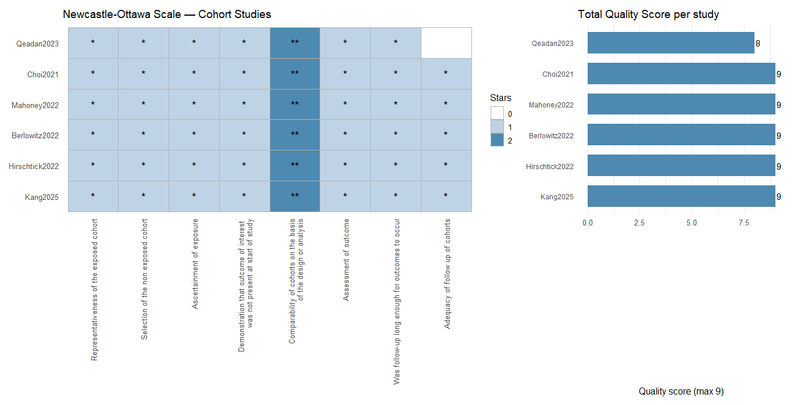

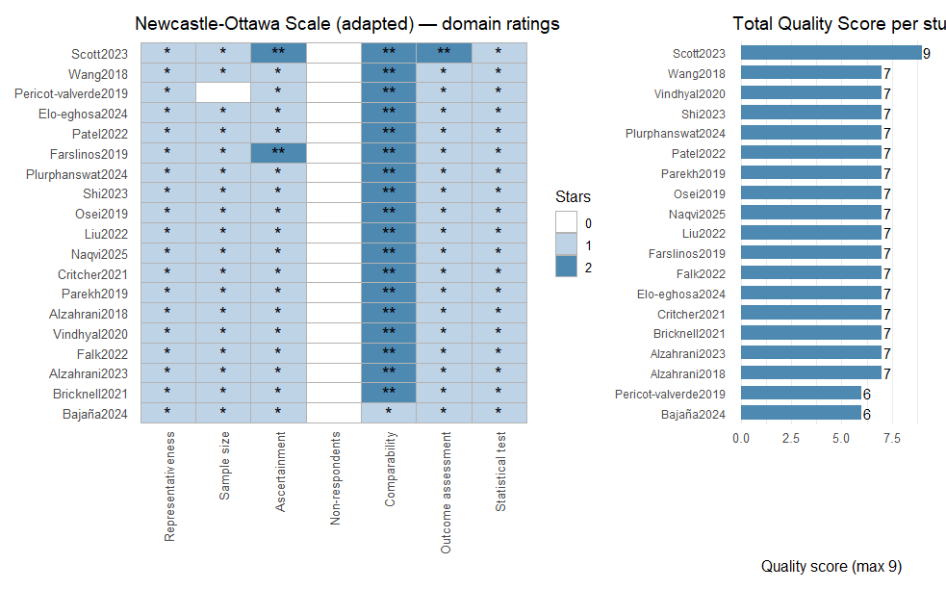

Supplementary Material File 2
Table S1: Search term strategy.
Database | String | Results
PubMed | (("Electronic Nicotine Delivery Systems" OR "Electronic Cigarettes" OR "E-cigarette*" OR "Electronic cigarette*" OR "Vaping" OR "Vape" OR "E-smoking" OR "Electronic nicotine delivery system*" OR "Pod-based e-cigarette*" OR "JUUL" OR "Dual use") AND ("Cardiovascular Diseases" OR "Myocardial Infarction" OR "MI"  OR "MACE" OR "Major Adverse Cardiovascular Event*" OR "Coronary Artery Disease" OR "CAD" OR "Acute Coronary Syndrome*" OR "Heart Attack*" OR "Cardiac Arrest" OR "Atherosclerosis" OR "Heart Disease*" OR "Stroke" OR "Arrhythmia*" OR "Cardiovascular Health" OR "Cardiovascular Outcome*" OR "Cardiovascular Mortality" OR "Heart Failure")) | 1338
Web of Science | (("Electronic Nicotine Delivery Systems" OR "Electronic Cigarettes" OR "E-cigarette*" OR "Electronic cigarette*" OR "Vaping" OR "Vape" OR "E-smoking" OR "Electronic nicotine delivery system*" OR "Pod-based e-cigarette*" OR "JUUL" OR "Dual use") AND ("Cardiovascular Diseases" OR "Myocardial Infarction" OR "MI"  OR "MACE" OR "Major Adverse Cardiovascular Event*" OR "Coronary Artery Disease" OR "CAD" OR "Acute Coronary Syndrome*" OR "Heart Attack*" OR "Cardiac Arrest" OR "Atherosclerosis" OR "Heart Disease*" OR "Stroke" OR "Arrhythmia*" OR "Cardiovascular Health" OR "Cardiovascular Outcome*" OR "Cardiovascular Mortality" OR "Heart Failure")) | 2549
Scopus | (("Electronic Nicotine Delivery Systems" OR "Electronic Cigarettes" OR "E-cigarette*" OR "Electronic cigarette*" OR "Vaping" OR "Vape" OR "E-smoking" OR "Electronic nicotine delivery system*" OR "Pod-based e-cigarette*" OR "JUUL" OR "Dual use") AND ("Cardiovascular Diseases" OR "Myocardial Infarction" OR "MI"  OR "MACE" OR "Major Adverse Cardiovascular Event*" OR "Coronary Artery Disease" OR "CAD" OR "Acute Coronary Syndrome*" OR "Heart Attack*" OR "Cardiac Arrest" OR "Atherosclerosis" OR "Heart Disease*" OR "Stroke" OR "Arrhythmia*" OR "Cardiovascular Health" OR "Cardiovascular Outcome*" OR "Cardiovascular Mortality" OR "Heart Failure")) | 1043
Embase | (("Electronic Nicotine Delivery Systems" OR "Electronic Cigarettes" OR "E-cigarette*" OR "Electronic cigarette*" OR "Vaping" OR "Vape" OR "E-smoking" OR "Electronic nicotine delivery system*" OR "Pod-based e-cigarette*" OR "JUUL" OR "Dual use") AND ("Cardiovascular Diseases" OR "Myocardial Infarction" OR "MI"  OR "MACE" OR "Major Adverse Cardiovascular Event*" OR "Coronary Artery Disease" OR "CAD" OR "Acute Coronary Syndrome*" OR "Heart Attack*" OR "Cardiac Arrest" OR "Atherosclerosis" OR "Heart Disease*" OR "Stroke" OR "Arrhythmia*" OR "Cardiovascular Health" OR "Cardiovascular Outcome*" OR "Cardiovascular Mortality" OR "Heart Failure")) | 2727

Table S2. Definitions of exposure and outcomes assessed in the included studies.
Exposure/Outcomes | Definitions
ENDS (Electronic Nicotine Delivery Systems) | Devices that deliver nicotine in an aerosolized form without combustion, including e-cigarettes, vape pens, and similar electronic vaping products.
Current E-cigarettes | Participants who currently use e-cigarettes on some days or every day.
Former E-cigarettes | Participants who had used e-cigarettes in the past but no longer use them.
Never E-cigarettes | Participants who have never used an e-cigarette.
Current Traditional cigarettes | Participants who currently smoke combustible cigarettes on some days or every day.
Former Traditional cigarettes | Participants who smoked in the past but no longer smoke.
Never Traditional cigarettes | Participants who have never smoked 100 cigarettes in their lifetime.
Dual Cigarettes | Participants who currently use both e-cigarettes and combustible cigarettes.
MACE | Major adverse cardiovascular events (composite outcome including MI, stroke, and cardiac death). Calculated as event number, total participants, and effect estimates (OR/HR with 95% CI).
Cardiovascular Mortality | Death specifically due to cardiac causes. Calculated as event number, total participants, and effect estimates (OR/HR with 95% CI).
Myocardial Infarction (MI) | Self-reported or adjudicated MI. Calculated as event number, total participants, and effect estimates (OR/HR with 95% CI)
Coronary Artery Disease (CAD) | Incident or prevalent CAD events. Calculated as event number, total participants, and effect estimates (OR/HR with 95% CI).
Stroke | Incident or prevalent Stroke events. Calculated as event number, total participants, and effect estimates (OR/HR with 95% CI).

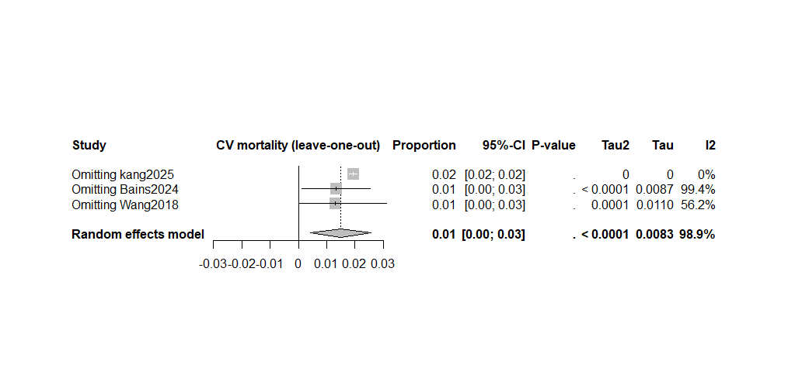Figure S1: Leave one analysis: Sensitivity analysis of pooled cardiovascular mortality estimates after sequential omission of individual studies in the meta-analysis of vaping-related cardiovascular mortality outcomes.

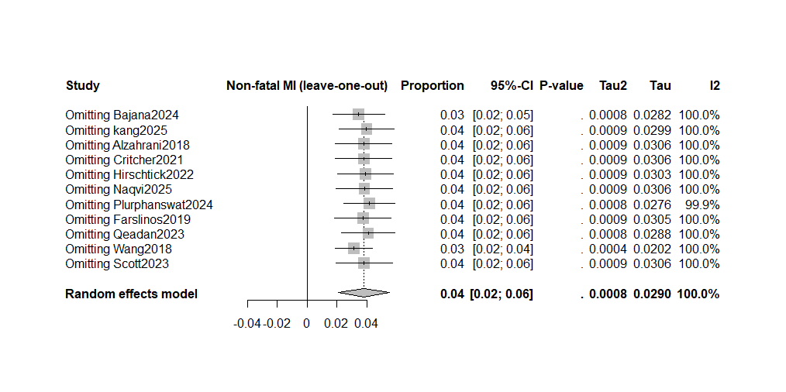Figure S2: Leave one analysis: Sensitivity analysis of pooled Non-fatal MI estimates after sequential omission of individual studies in the meta-analysis of vaping-related Non-fatal MI outcomes.

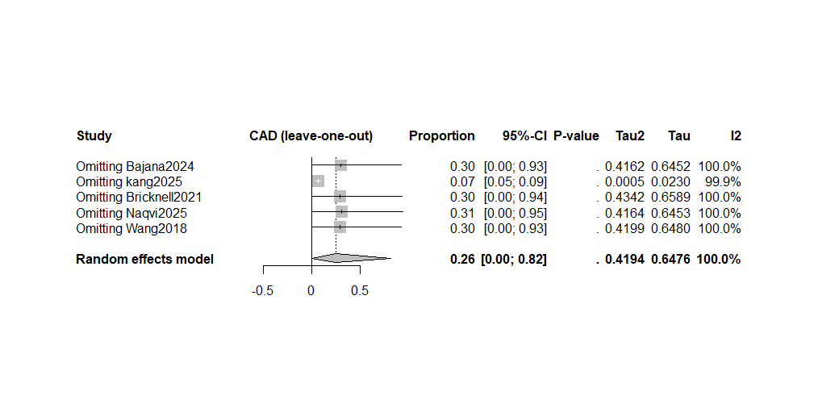Figure S3: Leave one analysis: Sensitivity analysis of pooled CAD estimates after sequential omission of individual studies in the meta-analysis of vaping-related CAD outcomes.

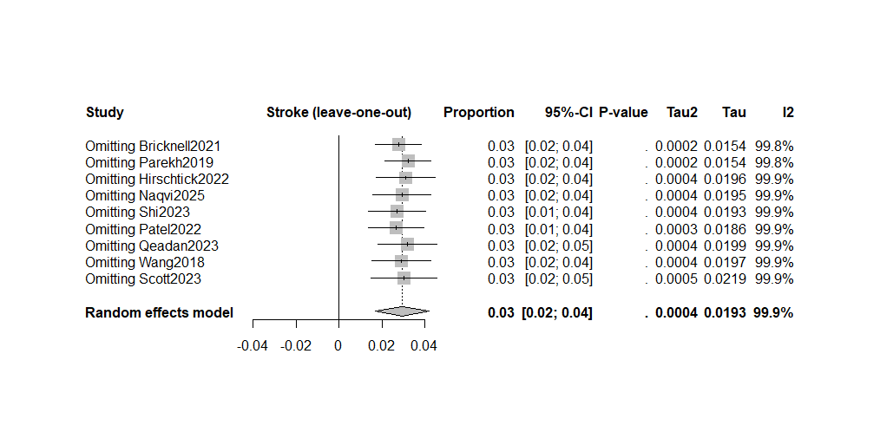Figure S4: Leave one analysis: Sensitivity analysis of pooled Stroke estimates after sequential omission of individual studies in the meta-analysis of vaping-related stroke outcomes.

