Supplementary material

Supplementary Table S1. The value assignment of cMIND diet 2
Supplementary Table S2. The specific variable categorization and assignment 3
Supplementary Table S3. Association of each cMIND diet indicator with all-cause mortality 4
Supplementary Table S4. Characteristics of the study participants at baseline by cMIND diet scores after PSM 5
Supplementary Table S5. Association of cMIND diet scores with all-cause mortality after PSM 8
Supplementary Table S6. Association of cMIND diet scores with all-cause mortality--Multiple Imputation by Chained Equations (N=16,204) 9
Supplementary Table S7. Association of cMIND diet scores with all-cause mortality--Exclusion of gastric or duodenal ulcer, hypertensive and diabetic patients（N=11,911) 10
Supplementary Figure 1. The pairwise Spearman correlation coefficient between different food groups. Pairwise Spearman correlation coefficients were presented. 11
Supplementary Figure 2. Mean Gini reduction. The bar graph represents the extent to which each cMIND diet indicator affects all-cause mortality and the rank of importance in the random forest model in female and male. 11
Supplementary Figure 3. Distribution of covariate density plots for the lowest and highest quartile groups of cMIND diet scores after matching. 12

Supplementary Table S1. The value assignment of cMIND diet
Components | Score
 | 0 | 0.5 | 1
Types of staple food | Rice / Whear | / | Whole grains
Amount of staple food | <250g or >400g | / | 250g-400g
Fresh vegetables | ≤2 servings/week | 3–5/week | ≥6 servings/week
Fresh fruit | ≤2 servings/week | 3–5/week | ≥6 servings/week
Cooking oil | Animal oil | / | vegetable oil
Fish | <1/month | 1–3/month | ≥1 meal/week
Food made from beans | <1 meal/week | 1–3/week | ≥4 meals/week
Nut | <1 serving/week | 1–4/week | ≥5 servings/week
Mushroom or algae | ≤1 meal/week | 1–3/week | ≥4 meals/week
Garlic | <1 meal/week | 1–3/week | ≥4 meals/week
Tea | Not almost every day | Other types of tea (almost every day) | Green tea (almost every day)
White sugar or candy | ≥2 servings/week | 1/month–1/week | <1 serving/month

Supplementary Table S2. The specific variable categorization and assignment
Variables | Questionnaire Items | Classification Criteria
Age | Current Age | Continuous variable
Sex | Sex | 0=Female
Sex | Sex | 1=Male
Ethnic group | Ethnic group | 0=Other
Ethnic group | Ethnic group | 1=Han
Residence | Current residence area of interviewee | 0=Rural
Residence | Current residence area of interviewee | 1=Urban
Years of schooling | How many years did you attend school? | 0=0 years
Years of schooling | How many years did you attend school? | 1=0-6 years
Years of schooling | How many years did you attend school? | 2=>6 years
Marital status | Current marital status | 0=Other
Marital status | Current marital status | 1=Married
Living arrangements | Co-residents | 0=Other
Living arrangements | Co-residents | 1=In a nursing home
Economic status | How do you rate your economic status compared with others in your local area? | 0=Rich
Economic status |  | 1=Normal
Economic status |  | 2=Poor
Smoking | Do you smoke at the present time? | 0=No
Smoking | Do you smoke at the present time? | 1=Yes
Drinking | Do you drink alcohol at the present time? | 0=No
Drinking | Do you drink alcohol at the present time? | 1=Yes
Exercise | Do you do exercises regularly at present? | 0=No
Exercise | Do you do exercises regularly at present? | 1=Yes
Gastric or duodenal ulcer | Are you suffering from Gastric or duodenal ulcer？ | 0=No
Gastric or duodenal ulcer | Are you suffering from Gastric or duodenal ulcer？ | 1=Yes
Diabetes | Are you suffering from diabetes? | 0=No
Diabetes | Are you suffering from diabetes? | 1=Yes
Hypertension | Are you suffering from hypertension? | 0=No
Hypertension | Are you suffering from hypertension? | 1=Yes
Body Mass Index(BMI) | Weight/Height, measured directly | 0=18.5-23.9
Body Mass Index(BMI) | Weight/Height, measured directly | 1=<18.5
Body Mass Index(BMI) | Weight/Height, measured directly | 2=24-28
Body Mass Index(BMI) | Weight/Height, measured directly | 3=≥28

Supplementary Table S3. Association of each cMIND diet indicator with all-cause mortality
cMIND diet | Overall  HR(95%CI) | P | Female  HR(95%CI) | P | Male  HR(95%CI) | P
Staple food (whole grains VS. refined grains) | 0.857(0.761, 0.964) | 0.010 | 0.971(0.838, 0.125) | 0.693 | 0.712(0.583, 0.868) | 0.001
Amount of staple food per day | 0.992(0.985, 0.998) | 0.008 | 0.999(0.992, 1.006) | 0.790 | 0.980(0.970, 0.991) | ＜0.001
Grease (vegetable oil VS. animal fat) | 0.914(0.863, 0.968) | 0.002 | 0.910(0.843, 0.981) | 0.014 | 0.919(0.841, 1.004) | 0.062
Fresh fruits | 0.915(0.894, 0.936) | ＜0.001 | 0.933(0.906, 0.961) | ＜0.001 | 0.893(0.862, 0.925) | ＜0.001
Fresh vegetables | 0.987(0.962, 1.014) | 0.337 | 1.003(0.969, 1.037) | 0.883 | 0.964(0.924, 1.005) | 0.084
Fish | 0.940(0.925, 0.956) | ＜0.001 | 0.952(0.932, 0.972) | ＜0.001 | 0.926(0.902, 0.950) | ＜0.001
Food made from beans | 0.989(0.973, 1.005) | 0.181 | 0.998(0.977, 1.019) | 0.852 | 0.976(0.952, 1.001) | 0.064
Sugar | 1.032(1.018,1.047) | ＜0.001 | 1.038(1.020,1.056) | ＜0.001 | 1.022(1.000,1.044) | 0.047
Tea | 0.990(0.978, 1.002) | 0.089 | 0.993(0.977, 1.009) | 0.398 | 0.986(0.968, 1.003) | 0.108
Garlic | 0.989(0.976, 1.003) | 0.119 | 0.992(0.974, 1.010) | 0.369 | 0.985(0.964, 1.006) | 0.169
Nut | 0.938(0.918, 0.958) | ＜0.001 | 0.944(0.916, 0.972) | ＜0.001 | 0.932(0.903, 0.962) | ＜0.001
Mushroom or algae | 0.931(0.911, 0.951) | ＜0.001 | 0.930(0.904, 0.956) | ＜0.001 | 0.935(0.905, 0.965) | ＜0.001
Note: HR: hazard ratio, CI: confidence interval

Supplementary Table S4. Characteristics of the study participants at baseline by cMIND diet scores after PSM
Variable | Total  (n = 4,894) | First quartile  (n = 2,447) | Fourth quartile  (n = 2,447) | Statistic | P | SMD
Age, n (%) |  |  |  | χ²=0.047 | 0.828
65-79 | 948 (19.37) | 471 (19.25) | 477 (19.49) |  |  | 0.006
≥80 | 3,946 (80.63) | 1,976 (80.75) | 1,970 (80.51) |  |  | -0.006
Sex, n(%) |  |  |  | χ²=2.397 | 0.122
Female | 1,945 (39.74) | 946 (38.66) | 999 (40.83) |  |  | 0.044
Male | 2,949 (60.26) | 1,501 (61.34) | 1,448 (59.17) |  |  | -0.044
Ethnic group, n(%) |  |  |  | χ²=0.003 | 0.957
Other | 365 (7.46) | 183 (7.48) | 182 (7.44) |  |  | -0.002
Han | 4,529 (92.54) | 2,264 (92.52) | 2,265 (92.56) |  |  | 0.002
Residence, n(%) |  |  |  | χ²=0.707 | 0.400
Rural | 3,198 (65.35) | 1,613 (65.92) | 1,585 (64.77) |  |  | -0.024
Urban | 1,696 (34.65) | 834 (34.08) | 862 (35.23) |  |  | 0.024
Marital status, n (%) |  |  |  | χ²=0.502 | 0.479
Other | 3,745 (76.52) | 1,883 (76.95) | 1,862 (76.09) |  |  | -0.020
Married | 1,149 (23.48) | 564 (23.05) | 585 (23.91) |  |  | 0.020
Living arrangements, n(%) |  |  |  | χ²=4.393 | 0.036
Other | 829 (16.94) | 387 (15.82) | 442 (18.06) |  |  | 0.058
In a nursing home | 4,065 (83.06) | 2,060 (84.18) | 2,005 (81.94) |  |  | -0.058
Economic status, n(%) |  |  |  | χ²=5.368 | 0.068
Rich | 604 (12.34) | 280 (11.44) | 324 (13.24) |  |  | 0.053
Normal | 3,517 (71.86) | 1,793 (73.27) | 1,724 (70.45) |  |  | -0.062
Poor | 773 (15.79) | 374 (15.28) | 399 (16.31) |  |  | 0.028
Years of schooling, n(%) |  |  |  | χ²=0.260 | 0.878
≤0 year | 3,385 (69.17) | 1,696 (69.31) | 1,689 (69.02) |  |  | -0.006
0-6 years | 1,174 (23.99) | 588 (24.03) | 586 (23.95) |  |  | -0.002
>6 years | 335 (6.85) | 163 (6.66) | 172 (7.03) |  |  | 0.014
Smoking, n(%) |  |  |  | χ²=5.446 | 0.020
No | 4,073 (83.22) | 2,067 (84.47) | 2,006 (81.98) |  |  | -0.065
Yes | 821 (16.78) | 380 (15.53) | 441 (18.02) |  |  | 0.065
Drinking, n(%) |  |  |  | χ²=3.280 | 0.070
No | 4,044 (82.63) | 2,046 (83.61) | 1,998 (81.65) |  |  | -0.051
Yes | 850 (17.37) | 401 (16.39) | 449 (18.35) |  |  | 0.051
Exercise, n(%) |  |  |  | χ²=0.175 | 0.676
No | 3,844 (78.55) | 1,928 (78.79) | 1,916 (78.30) |  |  | -0.012
Yes | 1,050 (21.45) | 519 (21.21) | 531 (21.70) |  |  | 0.012
BMI, n(%) |  |  |  | χ²=7.912 | 0.048
18.5-23.9 | 2,541 (51.92) | 1,310 (53.53) | 1,231 (50.31) |  |  | -0.065
< 18.5 | 1,788 (36.53) | 881 (36.00) | 907 (37.07) |  |  | 0.022
24-28 | 458 (9.36) | 206 (8.42) | 252 (10.30) |  |  | 0.062
≥28 | 107 (2.19) | 50 (2.04) | 57 (2.33) |  |  | 0.019
Gastric or duodenal ulcer, n (%) |  |  |  | χ²=0.822 | 0.365
No | 4,679 (95.61) | 2,346 (95.87) | 2,333 (95.34) |  |  | -0.025
Yes | 215 (4.39) | 101 (4.13) | 114 (4.66) |  |  | 0.025
Hypertension, n (%) |  |  |  | χ²=3.464 | 0.063
No | 4,014 (82.02) | 2,032 (83.04) | 1,982 (81.00) |  |  | -0.052
Yes | 880 (17.98) | 415 (16.96) | 465 (19.00) |  |  | 0.052
Diabetes, n (%) |  |  |  | χ²=1.491 | 0.222
No | 4,826 (98.61) | 2,418 (98.81) | 2,408 (98.41) |  |  | -0.033
Yes | 68 (1.39) | 29 (1.19) | 39 (1.59) |  |  | 0.033
Note: SMD: Standardized mean difference

Supplementary Table S5. Association of cMIND diet scores with all-cause mortality after PSM
Model | cMIND diet scores | P trend
Overall | Quartile 1 | Quartile 4
Overall | ＜4 | ≥6
Model 1 | Ref. | 0.762(0.710,0.818)*** | ＜0.001
Model 2 | Ref. | 0.703(0.636,0.777)*** | ＜0.001
Model 3 | Ref. | 0.759(0.707,0.814)*** | ＜0.001
Note: Data was weighted hazard ratio (95% confidence interval)
Model 1: Unadjusted variables.
Model 2: Adjusted for age, sex (for all participants only), ethnic group, years of schooling, marital status.
Model 3: Further adjusted for residence, living arrangements, smoking, drinking, exercise, BMI, hypertension, diabetes.

Supplementary Table S6. Association of cMIND diet scores with all-cause mortality--Multiple Imputation by Chained Equations (N=16,204)
Model | cMIND diet scores |  |  |  | P trend
Overall | Quartile 1 | Quartile 2 | Quartile 3 | Quartile 4
Overall | ＜4 | 4-5 | 5-6 | ≥6
Model 1 | Ref. | 0.800(0.757, 0.846)**** | 0.695(0.657, 0.735)*** | 0.553(0.522, 0.585)*** | ＜0.001
Model 2 | Ref. | 0.878(0.831, 0.928)*** | 0.803(0.759, 0.850)*** | 0.691(0.653, 0.732)*** | ＜0.001
Model 3 | Ref. | 0.917(0.868, 0.970)** | 0.864(0.816, 0.915)*** | 0.770(0.725, 0.817)*** | ＜0.001
Female | Quartile 1 | Quartile 2 | Quartile 3 | Quartile 4
Female | ＜3.5 | 3.5-4.5 | 4.5-5.5 | ≥5.5
Model 1 | Ref. | 0.762(0.703, 0.825)*** | 0.716(0.662, 0.773)*** | 0.553(0.513, 0.596)*** | ＜0.001
Model 2 | Ref. | 0.839(0.774, 0.909)*** | 0.853(0.789, 0.922)*** | 0.738(0.684, 0.796)*** | ＜0.001
Model 3 | Ref. | 0.864(0.797, 0.937)*** | 0.898(0.830, 0.972)** | 0.805(0.744, 0.871)*** | ＜0.001
Male | Quartile 1 | Quartile 2 | Quartile 3 | Quartile 4
Male | ＜4 | 4-5 | 5-6 | ≥6
Model 1 | Ref. | 0.791(0.722, 0.867)*** | 0.691(0.631, 0.756)*** | 0.541(0.496, 0.591)*** | ＜0.001
Model 2 | Ref. | 0.830(0.757, 0.909)*** | 0.738(0.674, 0.809)*** | 0.618(0.565, 0.676)*** | ＜0.001
Model 3 | Ref. | 0.875(0.798, 0.959)** | 0.808(0.736, 0.887)*** | 0.708(0.645, 0.778)*** | ＜0.001
Note: Data was weighted hazard ratio (95% confidence interval)
Model 1: Unadjusted variables.
Model 2: Adjusted for age, sex (for all participants only), ethnic grroup, years of schooling, marital status.
Model 3: Further adjusted for residence, living arrangements, smoking, drinking, exercise, BMI, hypertension, diabetes.

Supplementary Table S7. Association of cMIND diet scores with all-cause mortality--Exclusion of gastric or duodenal ulcer, hypertensive and diabetic patients（N=11,911)
Model | cMIND diet scores |  |  |  | P trend
Overall | Quartile 1 | Quartile 2 | Quartile 3 | Quartile 4
Overall | ＜4 | 4-5 | 5-6 | ≥6
Model 1 | Ref. | 0.815(0.765, 0.868)*** | 0.699(0.655, 0.746)*** | 0.587(0.550, 0.626)*** | ＜0.001
Model 2 | Ref. | 0.884(0.829, 0.942)*** | 0.798(0.748, 0.852)*** | 0.715(0.669, 0.764)*** | ＜0.001
Model 3 | Ref. | 0.916(0.860, 0.977)** | 0.849(0.795, 0.907)*** | 0.779(0.728, 0.834)*** | ＜0.001
Female | Quartile 1 | Quartile 2 | Quartile 3 | Quartile 4
Female | ＜3.5 | 3.5-4.5 | 4.5-5.5 | ≥5.5
Model 1 | Ref. | 0.791(0.721, 0.867)*** | 0.744(0.681, 0.813)*** | 0.598(0.548, 0.652)*** | ＜0.001
Model 2 | Ref. | 0.861(0.785, 0.944)** | 0.856(0.783, 0.936)** | 0.763(0.699, 0.832)*** | ＜0.001
Model 3 | Ref. | 0.889(0.810, 0.975)* | 0.900(0.822, 0.985)* | 0.825(0.754, 0.903)*** | ＜0.001
Male | Quartile 1 | Quartile 2 | Quartile 3 | Quartile 4
Male | ＜4 | 4-5 | 5-6 | ≥6
Model 1 | Ref. | 0.800(0.721, 0.888)*** | 0.694(0.625, 0.770)*** | 0.567(0.512, 0.627)*** | ＜0.001
Model 2 | Ref. | 0.832(0.749, 0.924)** | 0.728(0.655, 0.808)*** | 0.648(0.584, 0.718)*** | ＜0.001
Model 3 | Ref. | 0.872(0.785, 0.969)* | 0.782(0.703, 0.870)*** | 0.726(0.652, 0.808)*** | ＜0.001
Note: Data was weighted hazard ratio (95% confidence interval)
Model 1: Unadjusted variables.
Model 2: Adjusted for age, sex (for all participants only), ethnic group, years of schooling, marital status.
Model 3: Further adjusted for residence, living arrangements, smoking, drinking, exercise, BMI, hypertension, diabetes.

Supplementary Figure 1. The pairwise Spearman correlation coefficient between different food groups. Pairwise Spearman correlation coefficients were presented.
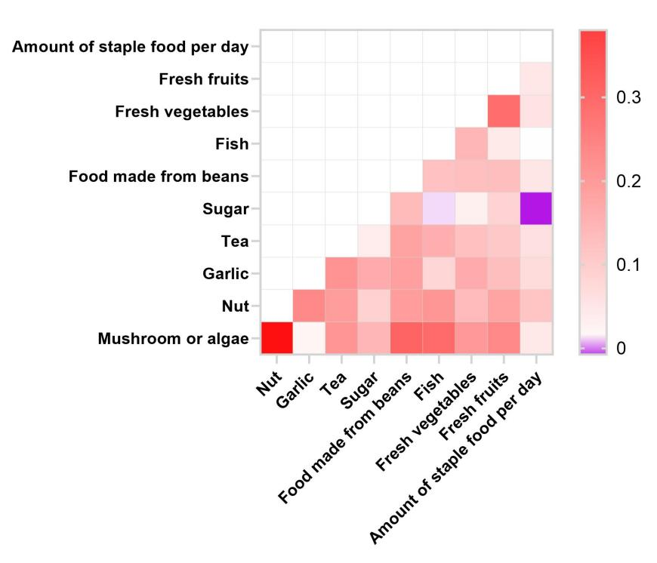

Supplementary Figure 2. Mean Gini reduction. The bar graph represents the extent to which each cMIND diet indicator affects all-cause mortality and the rank of importance in the random forest model in female and male.
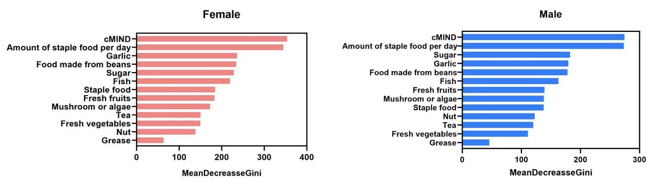

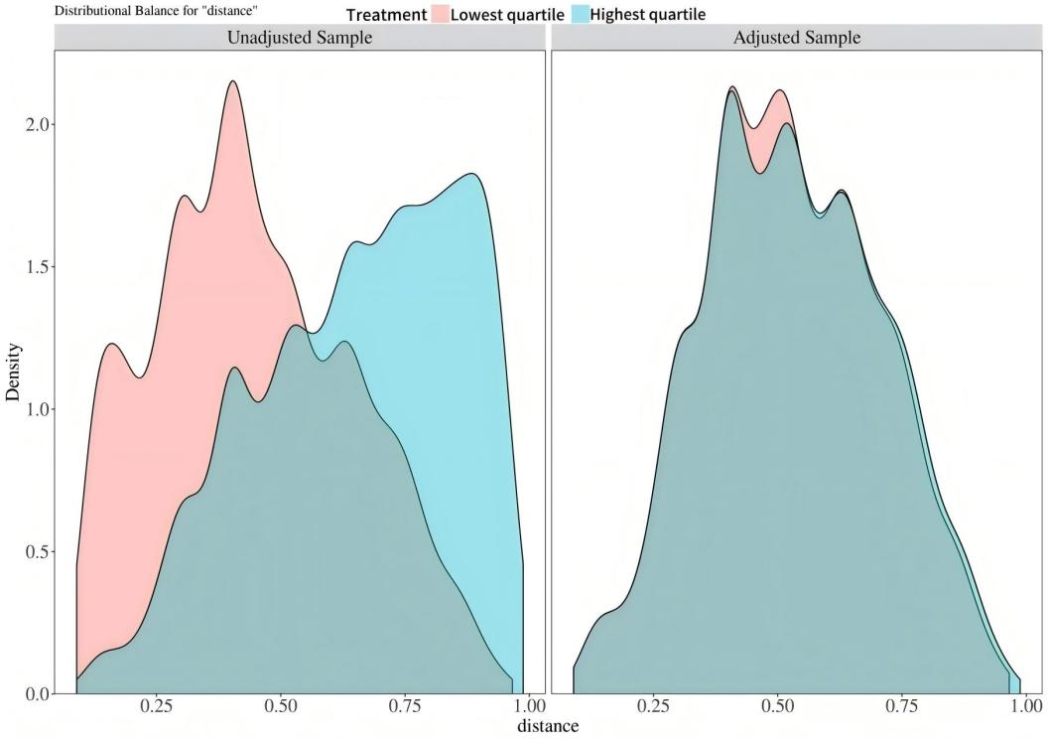
Supplementary Figure 3. Distribution of covariate density plots for the lowest and highest quartile groups of cMIND diet scores after matching.

