Chinese database：
CNKI：
Topic = (subcutaneous fat hyperplasia + fat hyperplasia + subcutaneous induration + fat hypertrophy) AND Topic = (insulin + insulin injection + inject insulin + subcutaneous insulin injection + subcutaneous injection of insulin). The number of retrieved literatures is 120, as follows:
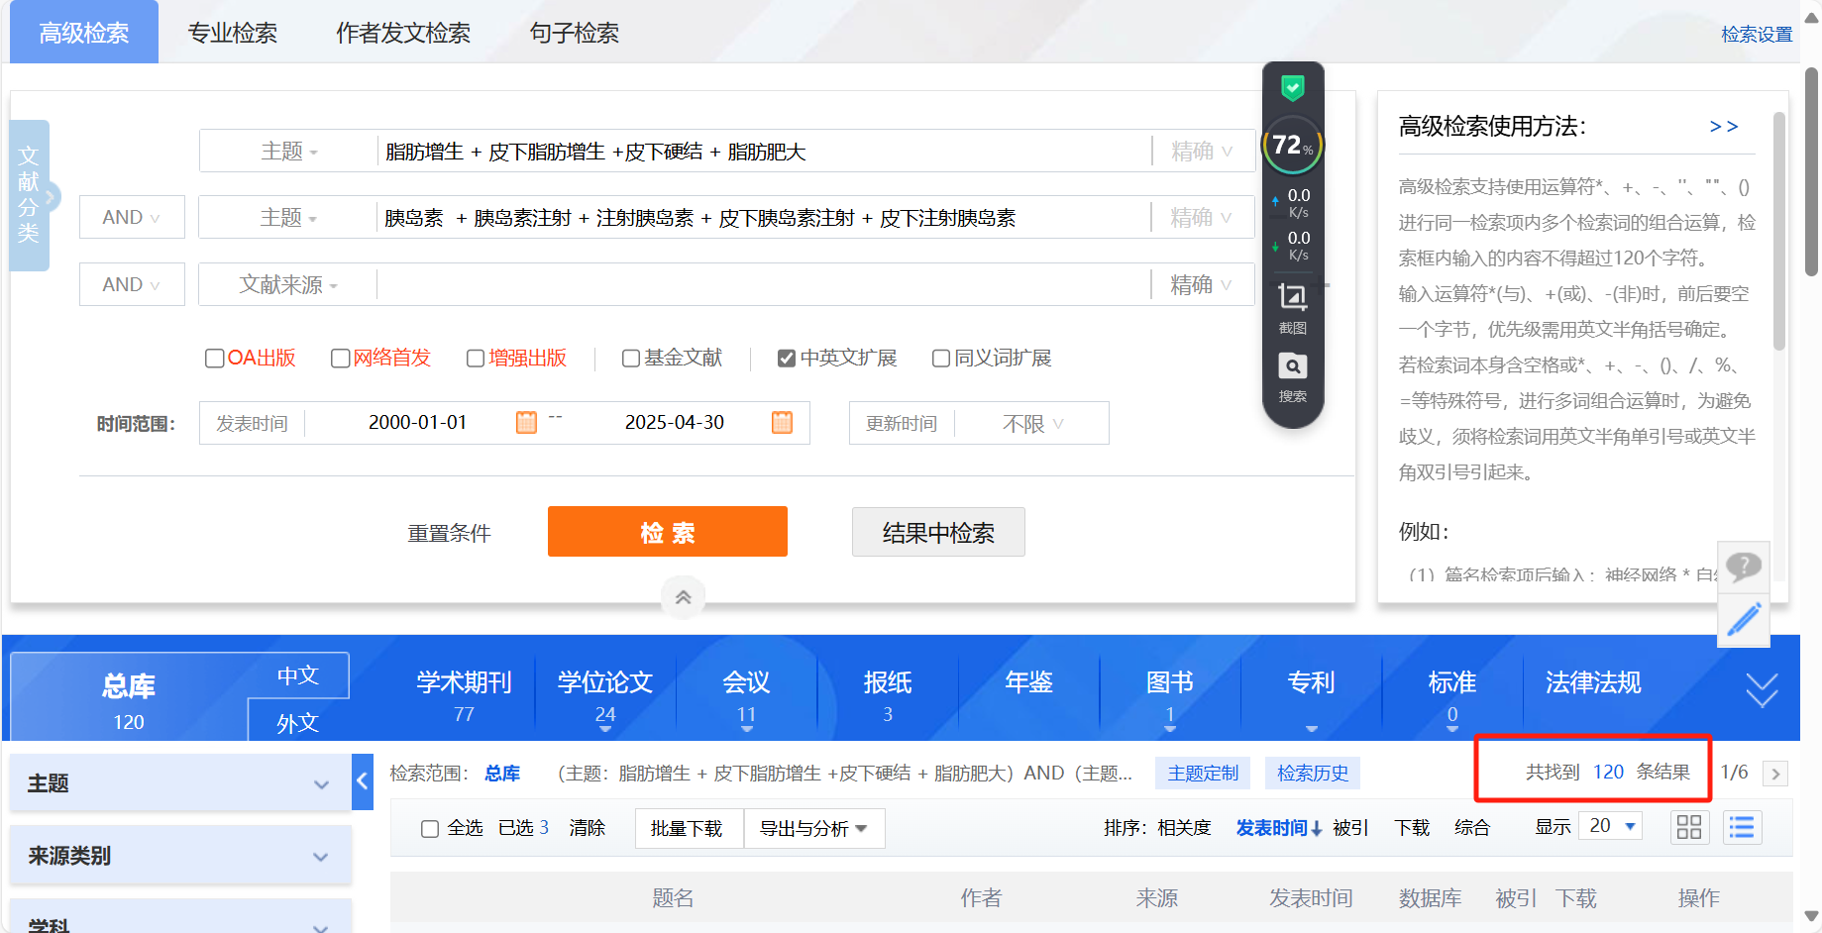

The China Biomedical Literature Database：
"Insulin"[Common Field: Intelligent] OR "Insulin injection"[Common Field: Intelligent] OR "Inject insulin"[Common Field: Intelligent] OR "Subcutaneous insulin injection"[Common Field: Intelligent] OR "Subcutaneous injection of insulin"[Common Field: Intelligent] AND "Fat Hyperplasia"[Common Field: Intelligent] OR "Subcutaneous Fat Hyperplasia"[Common Field: Intelligent] OR "Subcutaneous Induration"[Common Field: Intelligent] OR "Fat Hypertrophy"[Common Field: Intelligent]. The number of retrieved literatures is 177, as follows:

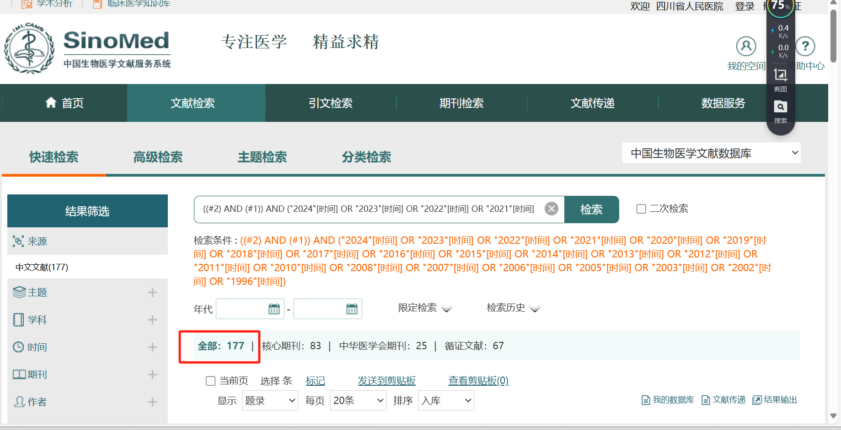

The Chinese Medical Journal Full-text Database：
All Fields = ((((Fat Hyperplasia) OR Fat Hypertrophy) OR Subcutaneous Fat Hyperplasia) OR Subcutaneous Induration) AND ((((Insulin) OR Insulin Injection) OR Inject Insulin) OR Subcutaneous Insulin Injection) OR Subcutaneous Injection of Insulin. The number of retrieved literatures is 214, as follows:
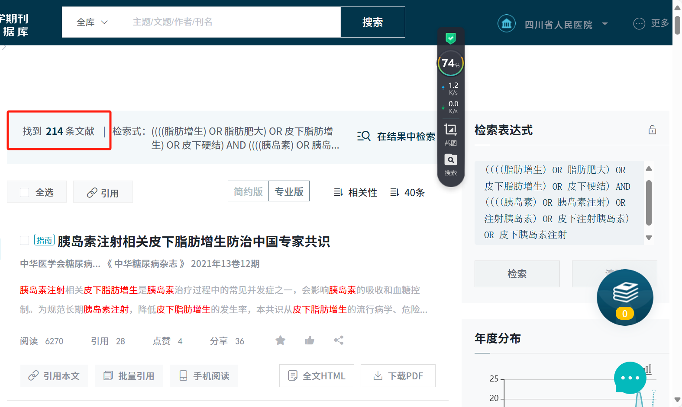

Wanfang Database：
Topic = (Insulin injection OR Inject insulin OR Subcutaneous insulin injection OR Subcutaneous injection of insulin) AND Topic = (Fat hyperplasia OR Subcutaneous fat hyperplasia OR Subcutaneous induration OR Fat hypertrophy). The number of retrieved literatures is 343, as follows:
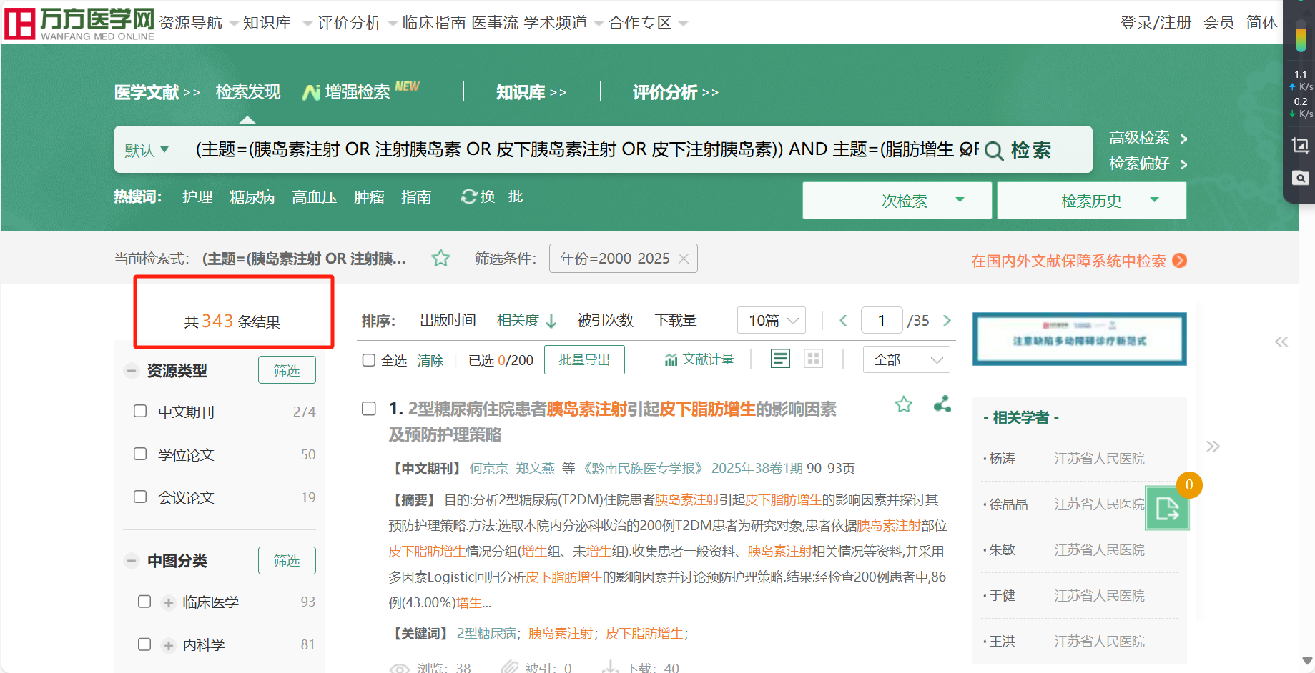

English database:
Cocorane Library：
#1=(Insulin, Regular):ab,ti,kw OR (Regular Insulin):ab,ti,kw OR (Soluble Insulin):ab,ti,kw OR (Insulin, Soluble):ab,ti,kw OR (Sodium Insulin):ab,ti,kw OR (Insulin, Sodium):ab,ti,kw OR (Novolin):ab,ti,kw OR (Insulin):ab,ti,kw
#2=(Subcutaneous hyperplasis):ab,ti,kw OR (Subcutaneous induration):ab,ti,kw OR (Lipohypertrophy):ab,ti,kw OR (subcutaneous lipohypertrophy):ab,ti,kw
#3=#1 AND #2
The number of retrieved literatures is 71, as follows:

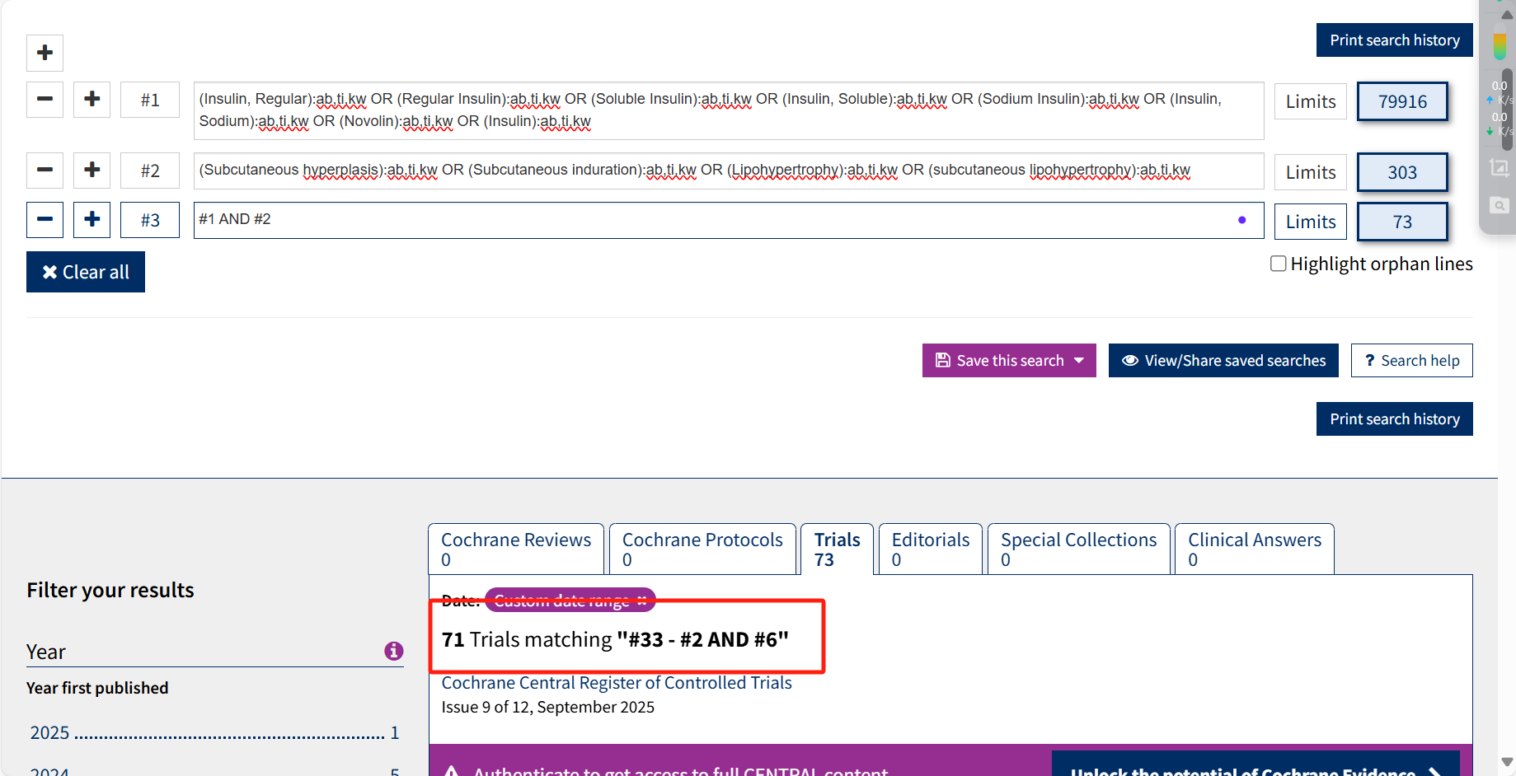
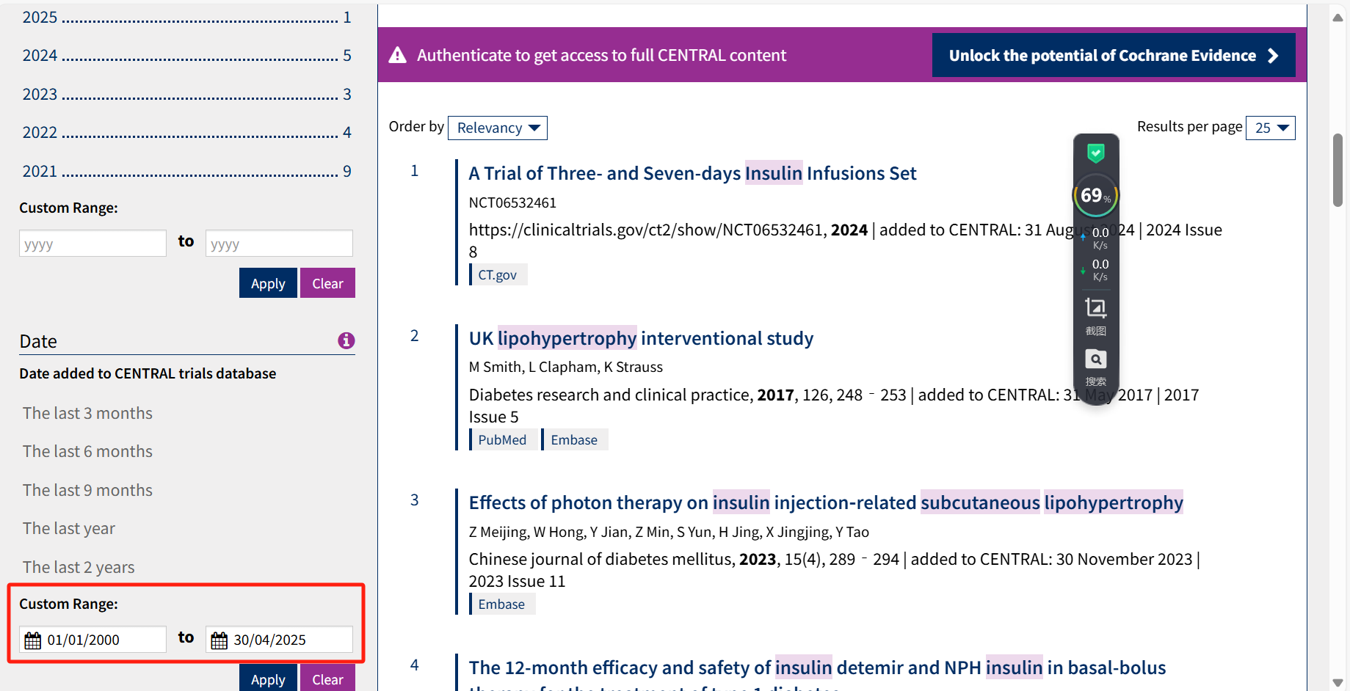
PubMed ：
MeSH Terms ="Insulin" OR title/Abstract="Insulin, regular/regular insulin/soluble insulin/insulin, soluble/sodium insulin/insulin, sodium/novolin" AND Title/Abstract ="Subcutaneous hyperplasis/Subcutaneous induration/Lipohypertrophy/subcutaneous lipohypertrophy". The number of retrieved literatures is 124, as follows:
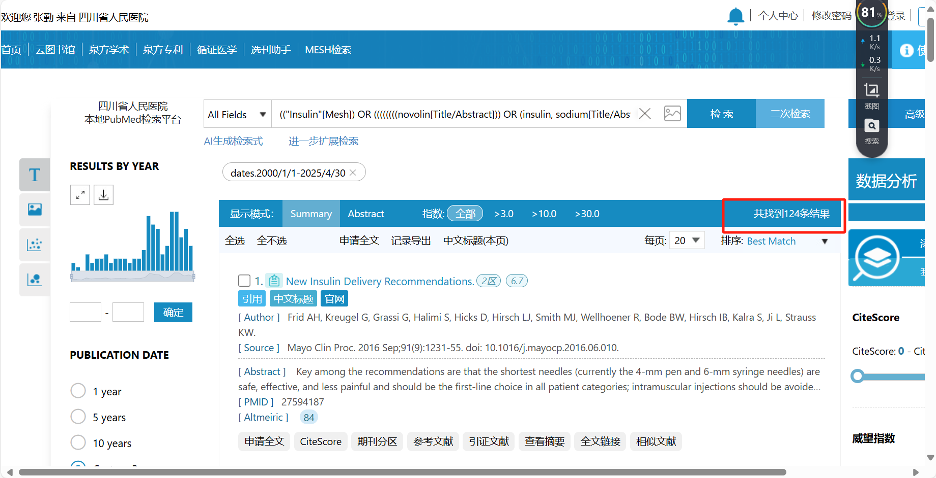
Embase:
'subcutaneous hyperplasis':ab,ti OR 'subcutaneous induration':ab,ti OR 'subcutaneous lipohypertrophy':ab,ti OR 'lipohypertrophy':ab,ti AND 'regular insulin':ab,ti OR 'soluble insulin':ab,ti OR 'insulin, soluble':ab,ti OR 'sodium insulin':ab,ti OR 'insulin, sodium':ab,ti OR 'novolin':ab,ti OR 'insulin':ab,ti. The number of retrieved literatures is 458, as follows:
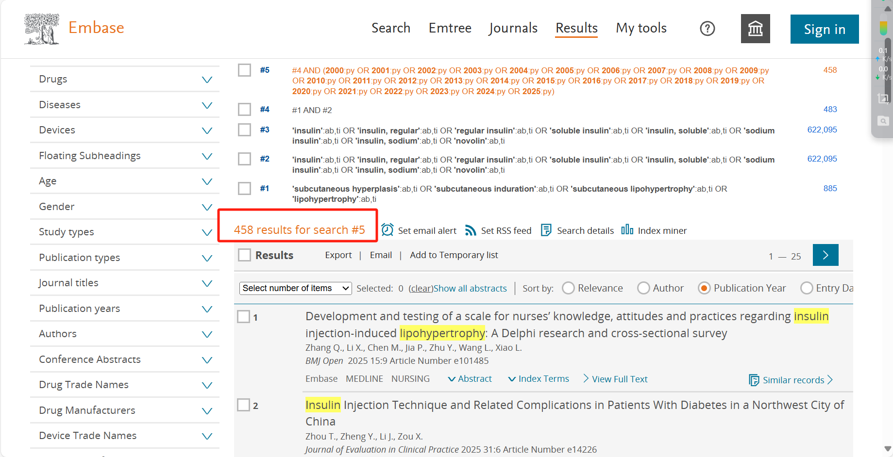
Web of Science:
Topic=(Subcutaneous hyperplasis or Subcutaneous induration or subcutaneous lipohypertrophy or Lipohypertrophy) AND Topic=(Insulin or Insulin, Regular or Regular Insulin or Soluble Insulin or Insulin, Soluble or Sodium Insulin or Insulin, Sodium or Novolin). The number of retrieved literatures is 475, as follows:
