Appendix 3

Figure S1. Residual diagnostics for models examining associations between the independent variables and the mediators (health checkup services and social support) using the DHARMa (Diagnostics for HierArchical Regression Models) package
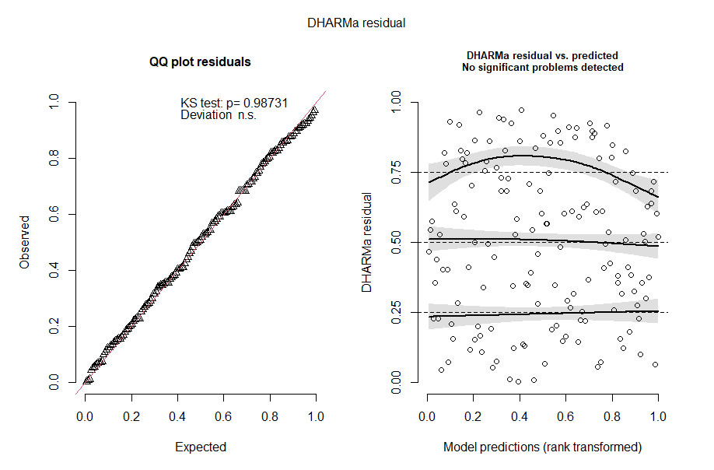
Note: This figure presents simulated residual diagnostics using DHARMa (Diagnostics for HierArchical Regression Models) for the regression models assessing associations between the independent variables and the mediators. The left panel shows a QQ plot of DHARMa residuals (Kolmogorov–Smirnov test; deviation not significant), and the right panel shows DHARMa residuals versus rank-transformed fitted values.

Figure S2. Residual diagnostics for models examining associations between the mediators and the dependent variable (social support and the SGDS score) using the DHARMa (Diagnostics for HierArchical Regression Models) package
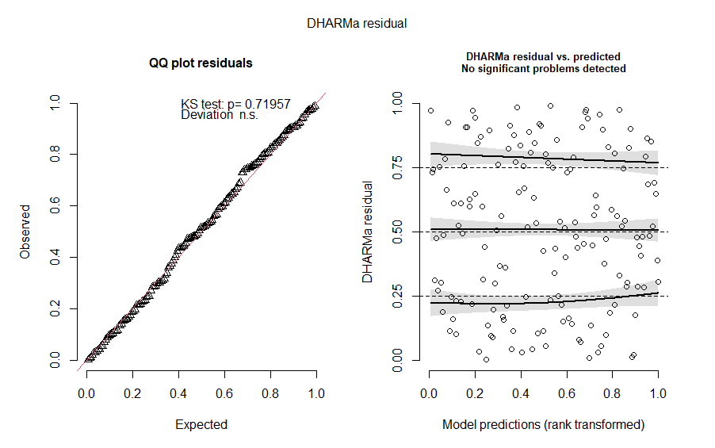
Note: This figure presents simulated residual diagnostics using DHARMa (Diagnostics for HierArchical Regression Models) for the regression models assessing associations between the independent variables and the mediators. The left panel shows a QQ plot of DHARMa residuals (Kolmogorov–Smirnov test; deviation not significant), and the right panel shows DHARMa residuals versus rank-transformed fitted values.

