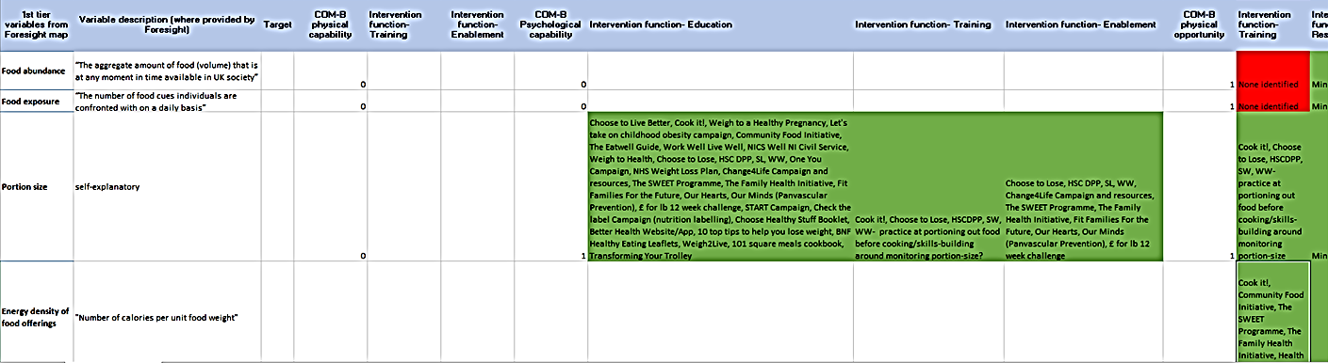

Example snapshot of cross-reference grid which informed the creation of the heat map

